Functions
By Michel Balamou
Check HW5

Injection  Horizontal line test does not intersect two points  $$∀(x,y∈A)\left(f\left(x\right)=f\left(y\right)→x=y\right)$$ | To prove: take two variables in the domain, such that $f(a_{1}) =f(a_{2})$. Plug both variables in the function and set them equal ($f(a_{1}) =f(a_{2})$). Now proof that each variable on the right side is equal to the variable on the left side (you can also use the domain restrictions to do so).  To Disprove: pick any two different values in the domain (A), that makes $f(a_{1}) =f(a_{2})$. (Example: a horizontal line) | 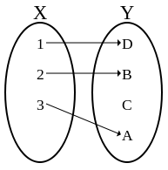
Surjective  $$∀(b∈B)∃(a∈A)(f\left(a\right)=b)$$  The function is defined on the whole codomain. | To Prove: take a variable in the codomain (B), calculate such a variable in the domain (A), that makes $f(a) =b$. (Here the variable a is written in terms of b) You can use systems of equations  To Disprove: pick a value in the codomain (B), such that it does not have and a that makes $f(a)=b, b∈B$. (Ex f(x)=1/x and 0 is in the codomain) | 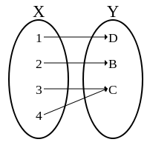
Bijection  $$∀\left(x,y∈A\right)\left(\begin{aligned}f\left(x\right)=f\left(y\right) \\ →x=y\end{aligned}\right)$$  $$∧∀\left(b∈B\right)∃\left(a∈A\right) \\ (f\left(a\right)=b)$$ | Every invertible function is a bijection | 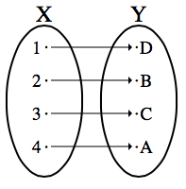

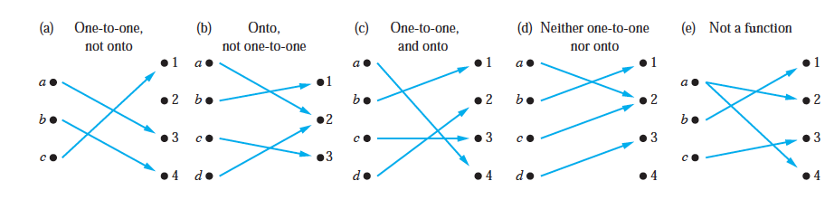

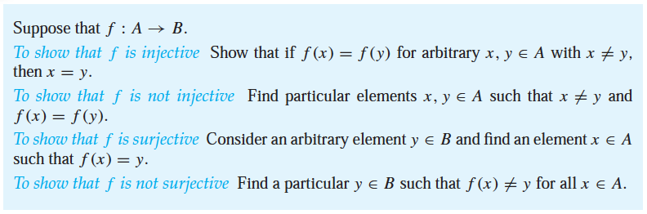

$$g\left(x,y\right)=(x+2y, 5)$$
Not injective since $g\left(1,1\right)=\left(3,5\right)=g(2,\frac{1}{2})$
Not Surjective since for $\left(0,0\right)∈R×Z$ there is no $(x,y)∈R^{2}$ s.t. $g\left(x,y\right)=\left(x+2y, 5\right)=(0,0)$

