Induction
(principle of mathematical induction)

Let $P(n)$ be a proposition about an integer $n$.

Ex: $P\left(n\right):1+2+3+…+n=\frac{1}{2}n(n+1)$

PRINCIPLE OF MATHEMATICAL INDUCTION
PMI: if
(1) $P\left(1\right)≡T$, and
(2) $∀k∈Z^{+}(P\left(k\right)→P\left(k+1\right))$
then $∀n∈Z^{+}(P\left(n\right))$
GENERALIZED
if
(1) $P\left(n_{0}\right)≡T$, and
(2) $∀k≥n_{0}(P\left(k\right)→P\left(k+1\right))$
then $∀n≥n_{0}(P\left(n\right))$
Step (1) I called the Basis of induction (BI)
Step (2) is called the Induction step (IS)
P(k) in step(2) is called the Induction Hypothesis (IH)

Analogy
BI: domino 1 falls to R
IS: for all k, domino $k$ falls to R $→$ domino $k+1$ falls to R
If both are $T$then all dominos fall to R
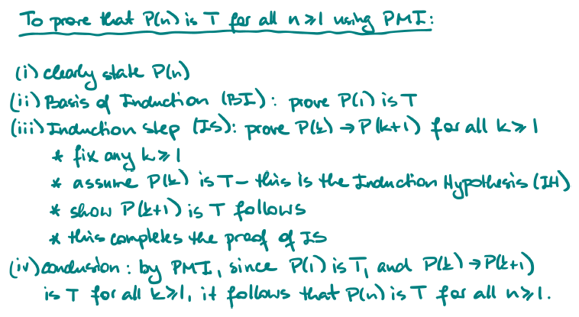

Examples
Question | Prove that $∀n∈Z^{+}:1+2+…+n=\frac{1}{2}n(n+1)$ using PMI
Proof | First define: $P\left(n\right):$”$1+2+…+n=\frac{1}{2}n(n+1)$”  We need to prove that $∀n≥1(P\left(n\right))$ (Fix a value)
BI | To prove P(1) is T
BI | Note that P(1) says “$1=\frac{1}{2}1⋅(1+1)$”  LHS of P(1): 1  RHS of P(1): $\frac{1}{2}1\left(1+1\right)=\frac{1}{2}⋅2=1$  LHS=RHS so P(1) is T
IS | To prove $P\left(k\right)→P\left(k+1\right)≡T$ for all k ≥ 1  Fix any $k≥1$. Now prove $P\left(k\right)→P(k+1)$ for this k
Assume $P\left(k\right)≡T$ (IH):”$1+2+…+k=\frac{1}{2}k(k+1)$”
We must show $P(k+1)$ follow
Note $P(k+1)$ says “$1+2+…+\left(k+1\right)=\frac{1}{2}(k+1)(k+2)$”
LHS of$P\left(k+1\right)$: $\left(1+2+…+k\right)+\left(k+1\right)\overset{IH}{=}\frac{1}{2}k\left(k+1\right)+\left(k+1\right)=\left(k+1\right)\left(\frac{1}{2}k+1\right)=\left(k+1\right)\left(\frac{\left(k+2\right)}{2}\right)=\underset{RHS of P(k+1)}{\underbrace{\frac{1}{2}\left(k+1\right)\left(k+2\right)}}$
CONCLUSION
So P(k+1) follows.

Conclusion by PMI, since P(1) is T, and $P\left(k\right)→P(k+1)$ is T for all $k≥1$, then $P(n)$ is T for all n ≥ 1. So $1+2+…+n=\frac{1}{2}n\left(n+1\right)$ for all n ≥ 1

Question | Prove that for all integers n ≥ 0 : “$3 divides n^{3}+2n$”
Proof | Define P(n): $3|n^{3}+2n$  We must prove P(n) is T for all integers $n≥0$
BI | To prove P(0):
BI | $P(0)$ says “3 divides $0^{3}+2⋅0$”  Verify: $0^{3}+2⋅0=0=0⋅3$, so 3 divides $0^{3}+2⋅0$  Hence P(0) is T
IS | To prove $P\left(k\right)→P\left(k+1\right)$ for all k ≥ 0:  Fix any k ≥ 0. Now prove $P\left(k\right)→P(k+1)$ for this k.
IS | Assume P(k) is T, i.e. assume 3 divides $k^{3}+2k$  We need to show $P(k+1)$ follows, where $P(k+1)$ says “$3|{\left(k+1\right)}^{3}+2(k+1)$”  Examine ${\left(k+1\right)}^{3}+2\left(k+1\right)=\left(k^{3}+3k^{2}+3k+1\right)+\left(2k+2\right)=\left(k^{3}+2k\right)+\left(3k^{2}+3k+3\right)= ⊛$  By IH: $k^{3}+2k=3l$ for some integer l  So $⊛=3l+3\left(k^{2}+k+1\right)=3(l+k^{2}+k+1)$  Since $l+k^{2}+k+1∈Z$, we have 3 divide ${\left(k+1\right)}^{3}+2\left(k+1\right)$
CONCLUSION
So P(k+1) follows

Hence $P\left(k\right)→P(k+1)$ is T for all k ≥ 0
Conclusion: by PMI, since P(0) is T, and $P\left(k\right)→P(k+1)$ is T for all k ≥ 0
P(n) is T for all n ≥ 0. This 3 divides $n^{3}+2n$ for all n ≥ 0.

Question | Prove that for all integers $n≥3$: $n^{2}-7n+12≥0$
Proof | Define P(n):”$n^{2}-7n+12≥0$”  Prove P(n) is T for all n ≥ 3
BI | To prove P(3) is T:
BI | P(3):”$3^{2}-7⋅3+12≥0$”  LHS: $3^{2}-7⋅3+12=9-21+12=0≥0=RHS$  So P(3) is T
IS | To prove $P\left(k\right)→P(k+1)$ for all k ≥ 3:  Fix any k ≥ 3. We need to prove $P\left(k\right)→P(k+1)$ for this k.
IS | Assume P(k)$:k^{2}-7k+12≥0(IH)$  We show P(k+1) follows, where P(k+1) says “${\left(k+1\right)}^{2}-7\left(k+1\right)+12≥0$”  Examine LHS of $P\left(k+1\right)$:  $${\left(k+1\right)}^{2}-7\left(k+1\right)+12=k^{2}+2k+1-7k-7+12$$  $$=\left(k^{2}-7k+12\right)+\left(2k-6\right)$$  $$\overset{by IH}{≥}0+\left(2k-6\right)=2k-6≥0=RH of P(k+1)$$  Hence P(k+1) follows.  So $P\left(k\right)→P(k+1)$ for all k ≥ 3
CONCLUSION
By PMI, since P(3) is T, and $P(k→P(k+1))$ is T
For all k ≥ 3, it follows that P(n) is T for all n ≥ 3
Thus $n^{2}-7n+12≥0$ for all n ≥ 3

Question | Prove that there are infinitely many primes
Proof | Define P(n): “There are ≥ n primes”  We prove P(n) is T for all n ≥ 1
BI | To prove P(1) is T:
BI | P(1): “There are $≥1$ primes”  So: 2 is a prime, so P(1) clearly T
IS | To prove $P\left(k\right)→P\left(k+1\right)$ for all k ≥ 1:  Fix any k ≥ 1, We will show $P\left(k\right)→P(k+1)$ for this k.
IS | Assume P(k):” there are ≥ k+1 primes” follows  Assume $p_{1},p_{2},…,p_{k}+1$  Let N = $p_{1}p_{2}…p_{k}+1$  Then N is not divisible by any of $p_{1},…,p_{k}$, so there must be another prime $p_{k+1}$($∵$ every integer is a product of primes)  So we have ≥ k+1 primes, and P(k+1) follows. So $P\left(k\right)→P(k+1)$ is T for all k ≥ 1.
CONCLUSION
By PMI since P(1) is T, and $P\left(k\right)→P(k+1)$ is T
For all k ≥ 1, it follows that P(n) is T for all n ≥ 1
Thus there are infinitely many primes

