Lab 3. Photosynthesis

ONE STEP AT A TIME
Part 1. Photosynthetic rate of Cabomba: Effects of Light Intensity and Illumination Spectrum

Table 1. Effects of light intensity and light spectrum on the photosynthetic rate of a ‘stem’ of Cabomba sp. immerged in a sodium bicarbonate solution.
 | Manometer height (mm)
 | Exp. 1. Distance between the lamp bulb and the test tube (cm) |  |  | Exp. 2. Filter Colour (Max λ) at a distance of 20 cm
Time (min.) | 20 | 30 | 40 | Blue (410 nm) | Green (535nm) | Red (650 nm)
0 | 0 | 0 | 0 | 0 | 0 | 0
2 | 1.9 | 1.9 | 0.2 | 1.4 | 0.7 | 0.4
4 | 3.8 | 2.6 | 0.5 | 2.8 | 1.4 | 1.0
6 | 6.8 | 3.1 | 0.7 | 5.0 | 2.0 | 1.3
8 | 9.1 | 4.3 | 1.0 | 5.4 | 2.8 | 1.4
Total volume of O₂ released (mL)* | 0.07147 | 0.03377 | 0.00785 | 0.04241 | 0.02199 | 0.01100
Photosynthetic rate  (mL O₂/min) | 0.00893 | 0.00422 | 0.00098 | 0.00530 | 0.00275 | 0.00137
*Volume of manometer tube = πr²h; 1 mL = 1 cm³ ; inner diameter of the capillary tube of the manometer = 1 mm.

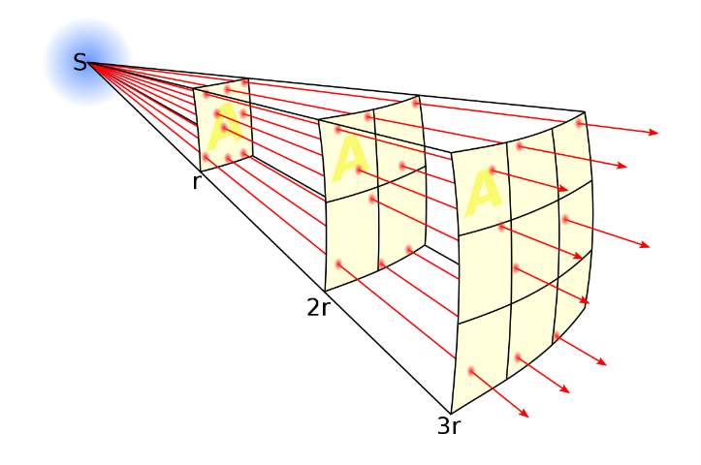
Figure 1: Graphic showing the change in area as distance increases

Establish a mathematical equation to predict the intensity of light as a function of distance knowing that the power of the halogen light bulb used was 500 Watts.

There is a mathematical equation that outlines the intensity as a function of distance. This equation is often known as the inverse square. This means that intensity is inversely proportional to the square of the light distance. Eg. Light intensity α 1/d². This can be determined because, similar to figure 1 above, the light spreads out over an increased area each time the distance is multiplied. This area is exponentially increased and thus the intensity must be inversely proportional to the distance squared. The 500W power of the halogen light did not change, and the photosynthetic rate decreased as the plant was moved further away from the light source. This allows for the understanding of the inversely proportional relationship of light intensity and distance squared.

Generate a plot displaying your photosynthetic rates as a function of distance. Is the trend line passing through your three data points linear or not? Should it be linear? Explain and justify your answer.

Figure 2: Graph displaying photosynthetic rate as a function of distance

The trend line which passes through the three data points is linear. The line has a negative slope. The line should indeed be linear because as the distance is increased at a constant rate, the photosynthetic rate will decrease. This is because the plant is being put further away from the light source that it needs in order to perform photosynthesis.

Generate a second plot displaying your photosynthetic rates (Y axis) as a function of the expected light intensity as predicted based on your equation generated above (X axis).

Figure 3: Graph displaying photosynthetic rate as a function of distance

We should now be able to address the important question that was initially asked: Is photosynthesis linearly related with the intensity of light? Explain and justify your answer.

Considering solely the graph of figure 3, yes, the relationship is linear. As the distance increases and the plant is moved further back, the intensity decreases by the distance squared. When this inversely proportional relationship is plotted, it should be linear. Using the correct equation for the relationship should allow for one to clearly see the linearity. This is because, when viewing the relationship correctly, it accounts for the square of the distance. When this is accounted for, the plot is a linear one.

Convert the photosynthetic rates reported in Table 3.1 from mL of oxygen per minute into moles of C₆H₁₂O₆ per min. Provide you explanation and full calculation for one sample, then fill out the rest of the table.

Table 2. Conversion table between mL and mmoles of Oxygen and Glucose

 | Exp. 1. Distance between the lamp bulb and the test tube (cm) |  |  | Exp. 2. Filter Colour (Max λ) at a distance of 20 cm
 | 20 | 30 | 40 | Blue (410 nm) | Green (535nm) | Red (650 nm)
Photosynthetic rate  (mL O₂/min) | 0.00893 | 0.00422 | 0.00098 | 0.00530 | 0.00275 | 0.00137
Photosynthetic rate  (mmole of O₂/min) | 0.00035224 | 0.00017224 | 0.00004 | 0.00021633 | 0.00011224 | 0.000056
Photosynthetic rate  (mmole of C₆H₁₂O₆/min) | 0.0010567 | 0.0005167 | 0.00012 | 0.000649 | 0.0003367 | 0.000168

Sample Calculation for mL mmol conversion
- Using value from lamp and plant at 20cm

0.00893 ml O2/min ($\frac{1mmol}{24.5mL})$ = 0.00035224 mmol O2/min

Sample Calculation for mmol O2 mmol C6H12O6 conversion
- Using value from lamp and plant at 20cm
There are 3x as many oxygen atoms in a glucose molecule
3(0.00035224) = 0.0010567 mmol glucose

Part 2. Absorption Spectrum of a Cabomba Extract

Table 3. Absorbance and transmittance readings of the Cabomba sp. extract.
Wavelength (nm) | Absorbance | Transmittance (%) | Relative absorbance of chlorophyll a | Abs. Cabomba/ Abs. chlorophyll a
400 | 1.029 | 9.3 | 0.60 | 1.715
420 | 1.218 | 6.1 | 0.91 | 1.338
440 | 1.227 | 5.9 | 0.87 | 1.410
460 | 0.933 | 11.7 | 0.49 | 1.904
480 | 0.472 | 33.8 | 0.26 | 1.815
500 | 0.110 | 77.6 | 0.16 | 0.688
520 | 0.054 | 88.2 | 0.09 | 0.600
540 | 0.059 | 87.3 | 0.08 | 0.738
560 | 0.061 | 86.8 | 0.08 | 0.763
580 | 0.075 | 84.1 | 0.09 | 0.833
600 | 0.099 | 79.6 | 0.10 | 0.990
620 | 0.142 | 72.1 | 0.13 | 1.092
640 | 0.192 | 64.3 | 0.16 | 1.200
660 | 0.414 | 38.6 | 0.24 | 1.725
680 | 0.253 | 55.8 | 0.60 | 0.422
700 | 0.023 | 94.8 | 0.04 | 0.575

How do your photosynthetic rates relate with the absorbance spectrum of the acetone extract of Cabomba sp.? How would you expect the action spectrum of photosynthesis to relate with the absorbance spectrum of the photosynthetic pigments contained in a plant? Explain, explicit and justify your answers.

When comparing the absorbance spectrum of the sample, to those that were experimentally collected using the colour filters, the results are incredibly similar. The data gathered by the spectrophotometer shows that the highest absorbance occurred in the 400-440nm range. This is the range associated with blue/violet. This accurately correlates with the data from the coloured filters. The blue filter in front of the plant produced the highest amount of oxygen per minute- almost two times more than the green and almost six times more than the red filters. The green filter did not produce as much oxygen as the blue filter, and this makes sense. Looking at the absorbance rates, it absorbed the least amount. The two sets of data have a very strong relationship in the results they give.

The action spectrum of photosynthesis relates strongly to that of the photosynthetic pigments in plants. When the wavelength is ideal for a plant to absorb light (red and blue are optimal) then the absorbance of the plant overall is in a greater ratio than the absorbance of chlorophyll a. However when the light is not ideal, such as the colour green, then the absorbance ratio falls in favour of the chlorophyll a. This discrepancy explains why plants are typically green, they don’t absorb that wavelength and thus it is reflected. The absorbance of chlorophyll a fluctuates with the wavelength, and it too is optimized at the blue wavelength. The action spectrum and the photosynthetic pigments are different, yet their patterns relate almost identically.

