Prologue
What is Psychology?
- Psychology “The scientific study of behaviour and mental processes”, utilizes the scientific method through systematic observation
- Encapsulation by the question: “Why do we act and think the way we do?”

Foundation of Psychology
- Wilhelm Wundt began the first psychology laboratory in University of Leipzig, 1879
- Designed experiments about sensory perception:
  - Do you react faster to a light, a sound, a touch?
  - Difference thresholds = how different two things have to be before they seem diff.
- He measured the composition of mental processes (automatic brain processes, “atoms of the mind”

Structuralism
- Edward Titchener termed “structuralism” school of thought
- Structuralism focused on the basic structural elements of conscious, mental experiences
- Introspection observation and reporting conscious mental experiences
  - Unreliable, experiences differed from person to person, thus structuralism died

Gestalt Psychology
- Max Wertheimer phi phenomenon (flip book)
- Gestalt Psychology emphasizes that people’s experiences are holistic or unified
  - Gestalt = whole, form, or pattern
- The whole is more than just the sum of the parts
  - Perceptions don’t arise just be adding independent sensations
  - Destroys structuralism

Functionalism
- William James philosopher, focussed on the function of human behaviour
- Functionalism focused on the functions of our thoughts, feelings, and behaviours
- James was influenced by Charles Darwin
  - What is the survival advantage of organisms’ physical attributes and behaviours?
  - What is the survival advantage of our mental behaviour? (eg. Conscious thinking)
- Made first psychology textbook, “the Principles of Psychology” (1890)

First Women in Psychology
- William James tutored Caulkins after all the other men dropped out when she joined.
- She was denied a Ph.D. from Harvard, only from women’s college (she refused)
- She became first female president of American Psychological Association (APA) in 1905
- First female Ph.D. was Washburn on the Animal Mind, second president of APA

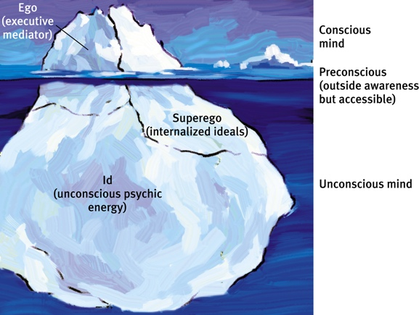
Freudian Psychology
- Sigmund Freud physician/neurological researcher
- Emphasized the importance of the unconscious mind
  - Unconscious mental forces were responsible for human nature (personality)
- Emphasized the importance of childhood experiences
  - Shape adult personality
- Psychoanalysis theory of personality & treatment of psychological disorders

Behaviourism
- John Watson & B. F. Skinner lead behaviourism
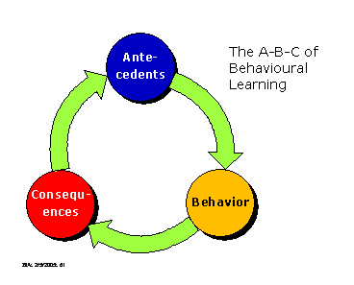
  - Said introspection through structuralism and functionalism is not science
  - Things like thoughts, feelings, perceptions are subjective
- Focussed on observable behaviour, should study the factors that influence learning and behaviour (so we can predict/influence behaviour).
- Promoted idea that behaviour is primarily determined by environmental factors
  - Ex) classical/operant (right) learning

Humanistic Psychology
- Abraham Maslow & Carl Rogers lead this approach
- Rejected psychoanalysis & behaviourism, the idea that we are ruled by unconscious forces and the idea that behaviour is completely determined by external influences
- Humanistic psychology emphasizes current environmental influences on our growth potential (people driven towards personal growth)
  - People make conscious choices, highlighting the need for love and acceptance (see Maslow’s hierarchy of needs)
- Theory of human nature/personality & therapy

Cognitive Revolution
- Cognitive revolution A return to focus on mental processes
- Cognitive psychology focussed on how the mind processes, perceives, and retains information
  - Sensation, perception, memory, language, reasoning, problem solving
  - Applied to therapy for psychological disorders
- Cognitive neuroscience modern brain-imaging techniques allow researchers to observe mental processes
  - Neurosciences focuses on the functioning of the central nervous system

Modern Definition of Psychology
- Psychology – the science of behaviour and mental processes.
- Behaviour – what an organism does, mental processes – internal experiences, science – asking + answering questions

Evolutionary Psychology & Behaviour Generics
- Evolutionary Psychology focuses on the common aspects of human thinking, feeling, and acting
  - Based on Darwin’s theory of natural selection
  - How are we humans alike because of our common biology and evolutionary history?
- Behaviour genetics focuses on the variation of aspects of human thinking, feeling , and acting
  - The relative influence of genes and environment on individual differences
  - How are we diverse because of our differing genes and environments?
  - Nature vs. Nurture debate
  - In contemporary science nurture works on what nature endows.

Cross-Cultural & Gender Psychology
- Cross-Cultural psychology emphasizes the cultural influences on thinking, feeling, and behaviour
  - Culture = behaviours, ideas, attitudes, values, and traditions
- Gender psychology focuses on the role that gender plays in our thinking, feeling, and behaviour
- Even when specific attitudes and behaviours vary by gender or across cultures, as they often do, the underlying causes are much the same.
  - Smiling, kissing, loneliness, language, learning disorders, all similar across cultures

Positive Psychology
- Martin Seligman and others call for research on human flourishing.
- Positive psychology focuses on the factors that influence positive human functioning.

Biopsychosocial Approach
- We have to look at everything from multiple perspectives to understand mental processes.

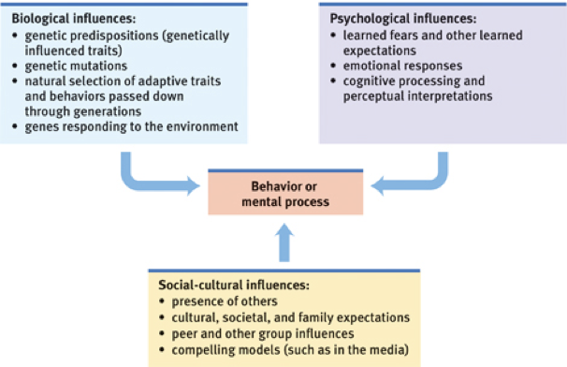

Current Perspectives in Psychology
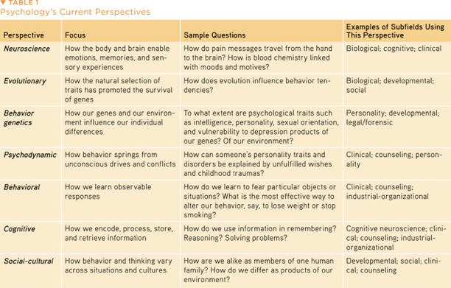

Psychology’s Subfields
- Quest – describing and explaining behaviour and the mind underlying it
- Basic research – builds psychology’s knowledge base.
- Biopsychology explores links between brain and mind
- Cognitive psychology how we think, perceive, and solve problems
- Developmental psychology studying our changing abilities from womb to tomb
- Personality psychology personal traits
- Social psychology how we view and affect one another
- Applied research – tackles practical problems
- Industrial-organizational psychology uses psychology to help employees
- Counseling psychology help people cope with challenges and crisis, improve function.
- Clinical psychology assess and treat people with various disorders.
- Psychiatry medical doctors that can prescribe drugs to treat disorders.
- Community psychology create social and physical environments that are healthy for all

Improve Your Retention – and Your Grades
- Testing effect repeated self-testing and rehearsal of previously studied material
- SQ3R Survey, Question, Read, Retrieve, Review
  - Survey – survey the headings and the chapter itself
  - Question – try and answer the learning objective question
  - Read – search for the question’s answer, read actively: ask questions take notes
  - Retrieve – retrieve the main ideas of the section
  - Review – read over any notes
- Distribute study time spaced practice > mass practice
- Learn to think critically
- Process class information actively
- Overlearn overlearning increases retention, we are prone to overestimating knowledge

1: Thinking Critically with Psychological Science
Hindsight Bias
- The inclination, after an event has occurred, to see the event as having been predictable, despite there having been little or no objective basis for predicting it.

Overconfidence
- We tend to think we are better than we are.
- Overconfidence can be generated by things like hindsight.

Perceiving Order in Random Events
- Our tendency to perceive patterns in random events leads to overestimation.

The Scientific Attitude: Curious, Skeptical, and Humble
- Psychologists approach the world of behaviour with a curious skepticism
- We must also exercise humility – an awareness of our own vulnerability to an error and openness to surprises and new perspectives.

Critical Thinking
- Critical thinking helps clear the lenses of our bias.
- Critical thinkers will consider credibility of sources, look at evidence, recognize multiple sources, expose themselves to news sources that challenge preconceiving ideas.

The Scientific Method
- Theory explains behaviours or events by offering ideas that organize what we have observed.
  - By linking facts with deeper principles, a theory offers a useful summary.
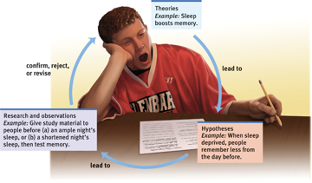
- Hypothesis a good theory produces testable predictions, called hypothesis.
  - Such predictions specify what results would support the theory and what results would disconfirm it.
- Observations (data collection)

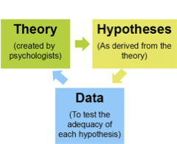
Theory vs. Hypothesis
- Theory an explanation using an integrated set of principles that organizes observations and predicts behaviours or events.
- Theories explain a variety of observations.
- They explain through an integrated set of principles (or principle).
- They offer testable predictions which are implied by the theory.
- Hypothesis testable prediction, often implied by a theory (logical connection between the principles of the theory and the hypothesis)

Theory: Observations
- Observations of the animal world:
- There exists a large variety of living organisms in the world.
- Each organism is equipped with traits that are ideal for surviving in their natural habitats
- Some organisms seem related to others in terms of appearance and/or behaviour
- Theory of Evolution explains everything through an integrated set of principles
  - Facts about animals led to the theory of natural selection (multiple observations by Charles Darwin)
- Principles of Natural Selection
  - There is a variation within any population of organisms
  - There is competition for finite resources
  - Certain variations are better than others for acquiring resources, which increases the chances of survival and reproduction.
  - Thus, in the next and successive generations will have proportionally more offspring from those with the more advantageous variations.

Major Depressive Disorder: A Cognitive Theory
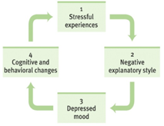
- Observations
  - People wo are depressed display: frequent thoughts of worthlessness, inappropriate feelings of guilt, feelings of helplessness
- Cognitive Theory Principles
  - People experience negative events
  - Some people display a negative explanatory style
  - Thinking colours of feelings (negative thoughts = negative feelings)
  - Negative thoughts and feelings impact behaviour
- Theory: Irrational thinking (appraisals) underlies a vicious cycle of depression (right)
- Neurobiological Theory
  - neurochemical activity underlies all of our feelings
  - Particular areas of the brain related to positive moods
  - Serotonin is associated with these brain areas
- Theory: neurochemical imbalance (low serotonin) underlies depression.

Hypotheses
- Testable predictions that logically flow from the principles of the theory (one from biological, one from neurobiological)
- Cognitive Theory of Depression
  - Irrational thinking (appraisals) underlies depression
  - Thus, altering appraisals should alleviate depression
- Neurobiological Theory of Depression
  - Neurochemical imbalance (low serotonin) underlies depression
  - Thus, drugs that increase serotonin should alleviate depression
- Generally, both theories work.

Operational Definitions
- A researcher must define the operations they went through to test the hypothesis
- Operational Definitions a carefully worded statement of the exact procedures used in a research study
  - A definition of a concept or variable in terms of a clearly specified set of operations, measures or procedures
  - The objectively observable definition of an abstract concept
  - ie) effect of alcohol on aggressive behaviour alcohol consumption (BAC), aggressive behaviour (# of insults)

Observations
Descriptive
The Case Study
- Examine a single individual in depth, usually over an extended period of time
  - Exploratory in nature (benefit is detailed description of behaviour)
  - Observation, interviews, psychological testing, uncommon disorders, brain injuries
- Drawback individual may not be representative of the majority of people
  - ie. unknown if observations are generalizable

The Survey
- Many cases in less depth (questionnaires or interviews)
- Ask people to report their behaviours, attitudes, experiences (drug use, opinions, etc.)
- Benefit is that it is relatively easy (and inexpensive) to obtain a large sample
- Sampling subset of population that is selected and studied
  - Representative sample A sample that is representative of the population of interest
  - Subgroups should be proportionately represented (obtained using random sampling)
  - Random sampling group or set chosen from a larger population or group of factors of instances in a random manner that allows for each member of the larger group to have an equal chance of being chosen.
- Drawback: wording effects

Naturalistic Observations
- Unobtrusively observe and record behaviour in natural environments
- Benefit: Observe natural, spontaneous behaviour (measured behaviour = changed behaviour)
- Drawback: no control

Correlations
- Measure the relationship between two attributes or behaviours
- A correlation coefficient helps us figure how closely two things vary together, and thus how well either one predicts the other.
- Scatterplots are used to view to what extent things can be related
  - Positive correlation, negative correlation, correlation coefficients
- Illusory correlation perceiving correlation based on memory even if there is none
- Regression Toward the Mean average results are more typical than extreme results.
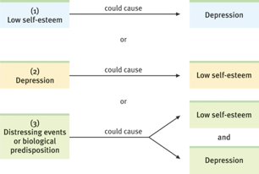

Experimentation
- Allows for conclusions about causations by
- Manipulating the factors of interest.
- Holding constant (“controlling) factors
- They do so by creating an experimental group, and a control group, to which researchers randomly assign people to the two conditions
- Eg. The longer children are breast-fed, the greater their later academic achievement
  - Manipulate amount of time breast-fed
  - Observe if there are differences in later academic achievement
Dependent & Independent Variables
- Independent variable the manipulated variable
  - Hypothesized to cause changes in dependent variable
- Dependent variable the measured variable
  - Hypothesized to change depending on the level of the independent variable

Experimental Control
- Confounding variables other factors which can potentially change results
- Must keep all experimental conditions constant except for the independent variable.
- Must ensure that groups are equivalent in terms of all characteristics except for the independent variable.
  - Thus, and differences between the groups can only be due to the independent variable
  - Control for group equivalence with random assignment
- Law of large numbers: as the size of a sample grows, it’s average gets progressively closer to the expected value.

- Placebo Effect
  - When response to treatment us due to expectation rather than actual treatment
  - Control group gets a placebo

- Experimenter Bias
  - Experimenter’s preconceived notions influence the behaviour of the participant

- To control both, use the double-blind technique
  - Neither the participant nor the experimenter knows who is in the experimental or control groups!

Predicting Real Behaviour
- An experiment’s purpose is not t ore-create exact behaviours of everyday life, but to test theoretical principles.
- It is the resulting principles – not the specific findings – that help explain everyday behaviour

Describing Data: Measures of Central Tendency
- A single value that best represents a set of data
  - Estimates the middle of the data
- Mean Arithmetic average, most common
- Median literally the mid-point
- Mode most repeated number

Measures of Variation
- Calculate a single value that will represent the group (value that best represents the degree to which the scores vary).
- Range the distance between highest and lowest scores (lowest-highest)
- Standard Deviation – estimation of the “average” difference amongst scores

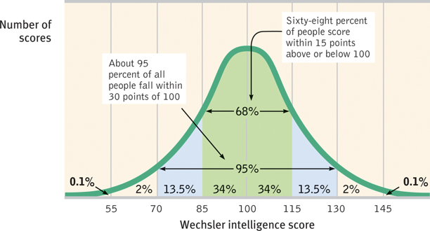
Probability Distributions
- The normal curve (right)

When is an Observed Difference Reliable?
- Representative samples are better than unbiased samples.
- Less-variable observations are more reliable than those that are more variable.
- More cases are better than fewer.

Statistical Significance
- When conducting experiments, looking at mean differences between groups
  - Through a statistical procedure, you can estimate the likelihood of obtaining differences between groups by pure chance
  - Groups will always have different means
    - But, is the difference statistically significant?
    - That is, is the difference unlikely to occur by chance?
    - Or, is the difference so big, that it is unlikely to have occurred by chance, and is likely to have occurred because the independent variable had an effect?
    - If it is less than 5% probability, it is statistically significant
- A statistical test will determine if the difference is statistically significant
  - Taking into account the means (mean difference) and the standard deviations from the groups
- A difference is more likely to be found to be statistically significant if:
  - 1) The difference is reliable
    - i.e., is it a number that we can have confidence in
    - Sample is representative
    - There is low variability
    - Many participants
  - 2) If the difference is large

2: Neural and Hormonal Systems
Neurons
- Neurons
  - Brain cells, or nerve cells
- Anatomy
  - Cell body (soma)
  - Dendrites, axon, terminal branches (terminal buttons), myelin sheath

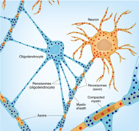
Glial Cells
- Structural support
- Nutrients
- Clean up debris (ions, neurotransmitters)
- Immune functions
- Help in guiding neural connections
- Myelin
- Participate in information transmission

Neuron at Rest
- Selectively permeable membrane
  - Some things can pass through, while others can not
  - Relatively impermeable to sodium and potassium
    - Na⁺ in higher concentration outside the cell
    - K⁺ in higher concentration inside the cell
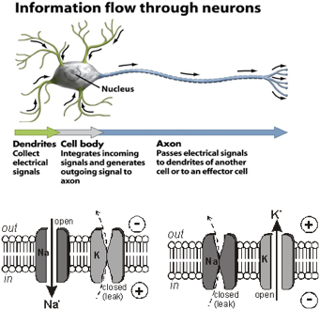
    - Chemical or concentration gradient
- Overall, the cell is negatively charged inside (-70 mV)
  - Electrical potential (gradient)
  - Resting (membrane) potential

Action Potential
- A brief electrical charge that travels down the axon
  - A “neural impulse”, the neuron is “firing”
- Electrical signal transmitted along the axon by the diffusion of charged atoms
  - The membrane becomes permeable to sodium (Na⁺) and Potassium (K⁺)
  - Series of channel openings along the axon that allows the diffusion (Voltage gated channels)
- Sodium channels open at the axon hillock
  - Sodium rushes in, since its positively charged, the inside becomes positive (depolarization)
- Resting membrane potential is then restored
  - Sodium channels close
  - Potassium channels open and potassium rushes out of the cell, making the cell negative on the inside again.
  - Sodium pumped back out, while potassium pumped back in (sodium-potassium pump)
  - Repolarization
  - Refractory period a period in which the neuron can not fire
- This occurs at successively adjacent portions of the axon
  - At the Nodes of Ranvier
- All-or-none (either fires or it doesn’t)
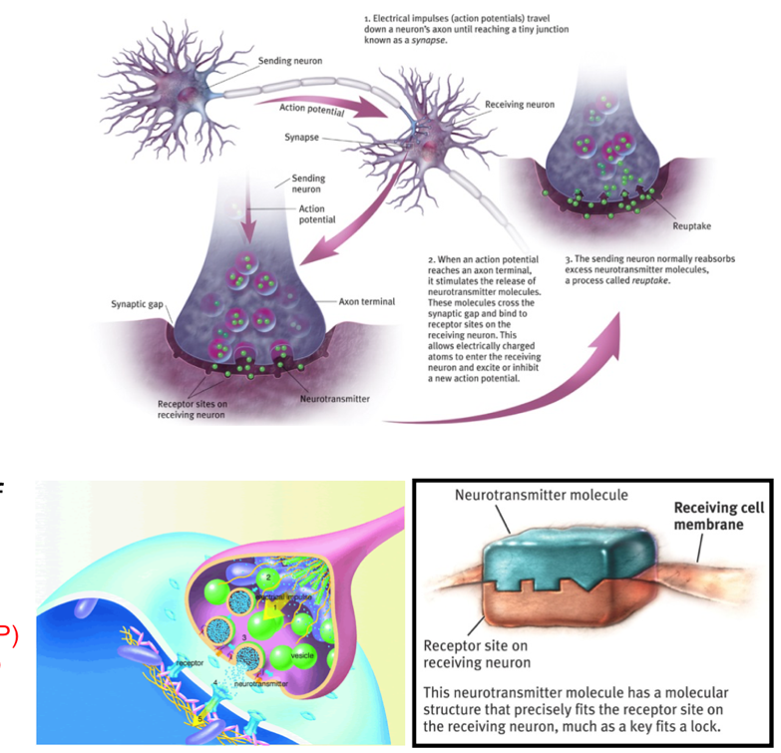
Synapse
- The junction between an axon terminal and a dendrite/cell body
- Synaptic gap (cleft)
- Axon terminals release neurotransmitters (synaptic vesicles)
- Neurotransmitter binds to a receptor
  - Dendrite or cell body of receiving neuron
  - Lock and key type relationship
- Trigger the opening (or closing) of ion channels
  - NOT an action potential
  - Postsynaptic potentials (PSPs)
    - Excitatory postsynaptic potential (EPSP)
    - Inhibitory postsynaptic potential (IPSP)

Threshold & Reuptake
- Dendrites/cell body receive signals from many neurons
  - Most excitatory, some inhibitory
  - Summation, threshold
- Reuptake
  - Taking back neurotransmitter

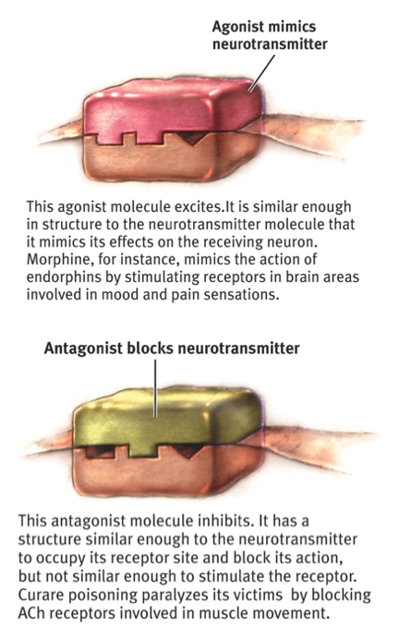
Neurotransmitters
- Several dozen
  - May operate in more than one brain pathway
- Endorphins areas related to mood and pain
- Acetylcholine (ACh) learning and memory, junction of motor neuron and muscle (ACh stimulates muscle to contract).

Acetylcholine Agonists & Antagonists
- Certain drugs/chemicals are structurally similar to neurotransmitters
- Agonists a molecule that increases a neurotransmitter’s actions
- Antagonists a molecule that inhibits a neurotransmitter’s action
- Agonists: black widow spider venom, Antagonist: curare, botulinum toxin

The Nervous System
- The body’s electrochemical network, consisting of all the nerve cells
- 2 major divisions
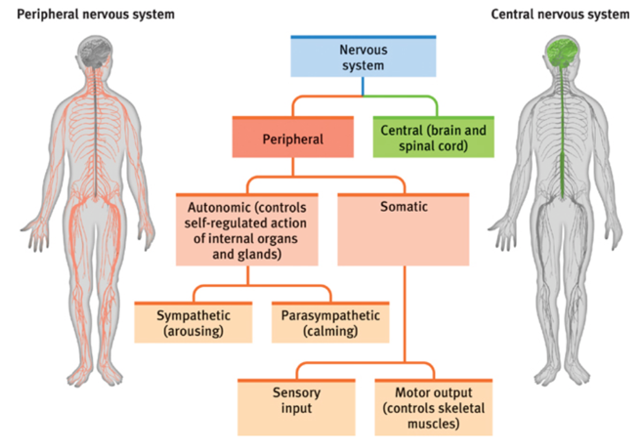
- The Central Nervous System
- The brain and spinal chord
- The Peripheral Nervous System
- Nerves (bundles of axons)
- Connects the CNS to sensory organs, muscles, glands, and internal organs

- 3 general types of neurons
- Sensory (afferent) neurons: messages from tissue/ sensory receptors brain
- Interneurons: processes information between sensory input and motor output
- Motor (efferent) neurons: carry instructions from CNS to muscles and glands

The Peripheral Nervous System
- Somatic Nervous System
  - Nerves from the sensory organs to the CNS and the CNS that stimulate the voluntary skeletal muscles

- Autonomic Nervous System
  - Controls the (mostly) involuntary muscles (hear, lungs, blood vessels, digestive system) as well as certain glands.

- Divided into sympathetic and parasympathetic nervous systems, work together to keep in homeostasis
  - Sympathetic fight or flight, expends energy
  - Parasympathetic rest-and-digest, conserves energy

The Central Nervous System
- Consists of the brain and spinal chord
- Brain 40 billion neurons, 10,000 connections, 400 trillion synapses
- Clustered into neural networks
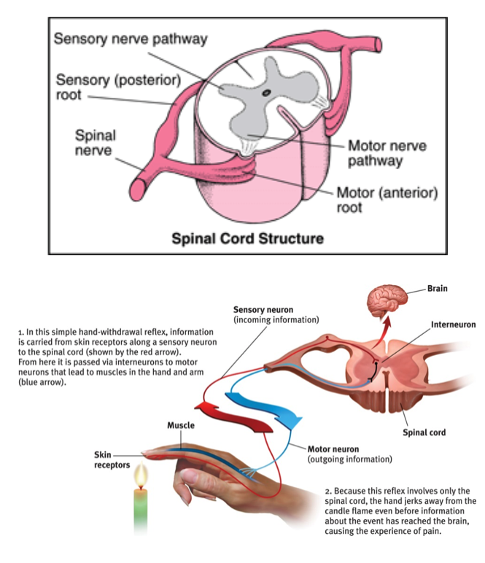
  - Multi-layered systems of connected neurons that learn functional skills through experience
  - Eg. Languages, physical skills, intellectual skills
  - “neurons that fire together, wire together”

- Spinal cord the connection between the brain and peripheral nervous system
  - Sensory neurons enter from sensory systems
  - Motor neurons conducting commands from the brain exit
- Reflexes a simple, automatic response to a sensory stimulus
  - Composed of networks that bypass the brain (interneuron within the spinal cord, sensory interneuron motor neuron)

The Endocrine System
- Glands that secrete hormones, which travel through the bloodstream.
- Endocrine is slower than nervous, but it’s effects tend to last longer.
- In danger, the AND orders adrenal glands (on top of kidneys) to release hormones
  - Epinephrine and norepinephrine (adrenalin) increase heart rate, blood pressure, blood sugar, providing a surge of energy.
- Pituitary gland located in the brain controlled by the hypothalamus
  - Releases a growth hormone that stimulates physical development
  - Oxytocin enables contractions with birthing, milk during nursing, and orgasm.
- Feedback system: brain pituitary other glands hormones body and brain

Structures of the Brain – The Brainstem: Medulla & Pons
- Electroencephalogram (EEG) measures electrical activity of the brain waves
- Positron emission tomography (PET) measures brain activity by glucose consumption
- Magnetic resonance imaging (MRI) magnetic field aligns spin of atoms, radio-wave pulse disorients, when they return to normal they emit signals that provide detailed pics

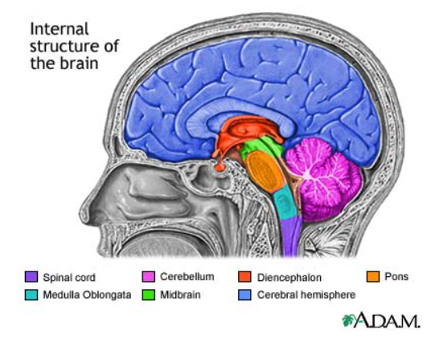
- Over the course of evolution, the brain has expanded by building on top of older structures
- Brainstem oldest part of the brain
- Medulla (oblongata) involved with basic life processes
- Pons involved in coordination of movement (closely associated with cerebellum)
- Midbrain reflexive movements in reaction to visual and auditory stimuli, pain modulation, gait, reinforcement of adaptive behaviours

Cerebellum
- Base of the brain, left and right portions exist
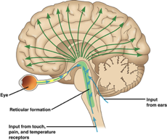
- Coordination of movement necessary for smooth, skilled movements
- Other functions
  - Non-verbal learning and memory
  - Judging time
  - Discriminating sounds and textures

Reticular Formation
- Network of neurons running through core of brainstem
- Involved with arousal (degree of wakefulness)
- Involved with relaying the sensory nerves to the thalamus
- Filtering incoming tactile and auditory information (habituation), pain modulation

The Thalamus
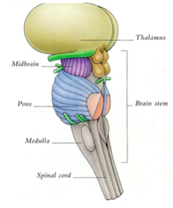
- On top of brainstem, two distinct connected sides
- Major relay station of the brain
- Relays information from the senses of touch, taste, sight and sound to the appropriate areas of higher processing (the cortex)
  - Relays return information from the cortex to the medulla and cerebellum
- Relays information from the cerebellum to the cortex
- Relays information from one area of the cortex to other areas of the cortex

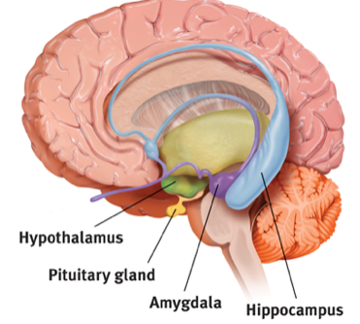
The Limbic System
- Neural systems involved in emotion, memory, and drives
- Hippocampus, amygdala, hypothalamus
- Hippocampus declarative (conscious) memory

Limbic System: Amygdala
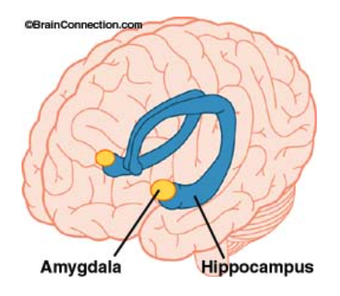
- Involved with emotions
  - Fear and aggression
  - Both the experience and perception
- Involved with processing of emotional memories
  - Closely associated with the hippocampus

Limbic System: Hypothalamus
- Hypothalamus below the thalamus
  - Body temperature, hunger, thirst, sexual behaviour, sleep/wake cycle
  - Controls the pituitary gland (homeostasis)
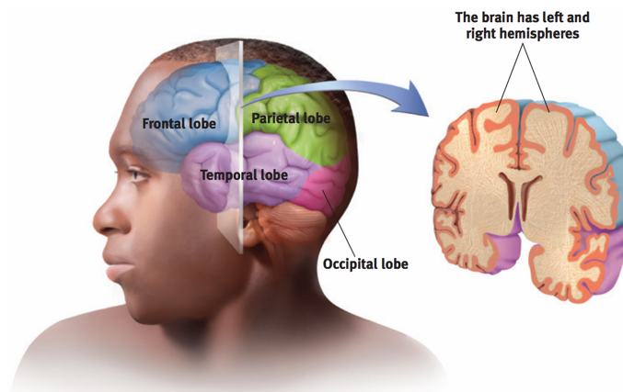
Cerebral Cortex
- Sensation & perception
- Thinking (eg. Reasoning, problem solving, planning for the future)
- Language
- Voluntary movement
- 3mm of grey matter
- 20-23 billion (of 40 billion) neurons
- The outermost covering the cerebrum
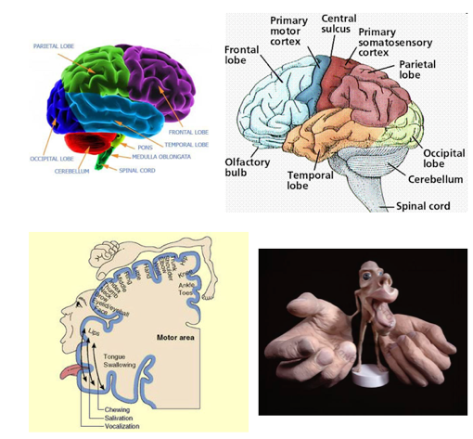
  - Made up of two cerebral hemispheres
- Four main loves, separated by prominent fissures
  - Frontal, parietal, temporal, occipital

Motor Cortex
- Responsible for voluntary muscular movements
- Rear border of the frontal lobe
- Contralateral control
- No direct correspondence between the size of the muscle and the size of the area of cortex which controls it
  - More cortical real estate means finer motor control

Brain-Computer Interfaces
- Predicting Movement
  - 100 tiny electrodes attached to a computer
    - Individual neurons
  - Measure motor cortex activity that occurs right before a movement
  - Train monkeys on a task
    - Joystick for moving a cursor
  - Computer program interprets neural signals
    - Determines pattern of firing that corresponds to particular movements
  - Program can now predict the movement before it happens
- Controlling Robotics with the Brain
  - Task now involves a joystick moving a robotic arm
  - Computer program again interprets neural signals
  - The computer that interprets the signals is then linked up with a robotic arm
    - Computer moves robotic arm in response to the pattern of neural firing
- Also done with humans
- Cognitive neural prosthetics

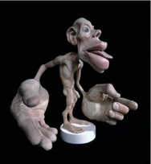
Somatosensory Cortex
- Responsible for sense of touch
  - Front border of the parietal lobe
  - Contralateral sensation
- No direct correspondence between the size of the sensory area and the size of the area of cortex which receives it’s sensory neurons
  - More cortical real estate means greater sensitivity
- Need sense of touch to move (need feedback)
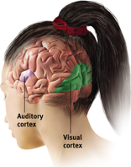
Other Sensory Areas
- Visual Cortex occipital lobe
- Auditory Cortex temporal lobe
- Olfactory Cortex temporal lobe
- Gustatory Cortex fronal lobe

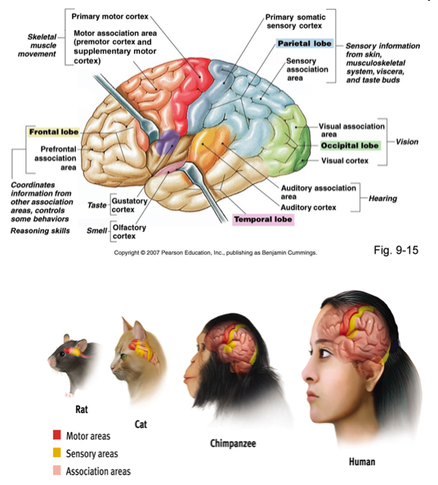
Association Areas
- Higher Cognitive Functions
  - Interpret the incoming sensory information
    - Compare incoming information to memories
    - Determine what is in the environment and it’s relevance to you
  - Determine an appropriate response
- Frontal lobes
  - The prefrontal cortex
  - Judgment, planning, memory formation
  - Inhibition
  - Integration of emotions in decision making
- Parietal lobes
  - Mathematical and spatial reasoning
- Temporal lobes
  - Facial recognition (right)

Plasticity
- Neurogenesis
  - The formation of new neurons
  - High rate in the hippocampus
- Plasticity
  - The brain’s ability to reorganize itself in the face of different environmental stimulation
  - Genes provide a first draft, organization in the absence
- For example:
  - Monkey fingers
  - Stroke
- Constraint-induced therapy
  - Visual or auditory impairment
  - Hemispherectomy

Vining et al. (1997)
- Review of outcomes of the hemispherectomies that had been performed at John Hopkins Hospital 1968 to 1996.
- 58 hemispherectomies
  - Rasmussen’s syndrome (chronic brain inflammation, ie. encephalitis)
  - Cortical dysplasia, vascular problems (developmental abnormalities)
  - All cases were having debilitating seizures (cognitive difficulties, motor difficulties)
- Of the 54 surviving children:
  - 54% were seizure free; 24% (non-handicapping seizures); 23% (residual seizures that somewhat interfered with normal functioning)
    - But everyone said the burden of illness was diminished
  - Improved motor ability
  - Improved cognitive ability
  - Language returns
  - Memory is normal
  - Personality, sense of humor is unchanged
  - The younger the better

Lateralization of Function
- Two cerebral hemispheres are intricately connected through the corpus callosum
  - Hemispheres work in coordination
  - But different functions, or different aspects of the same function are served by different hemispheres
- Left hemisphere
  - Analysis, focus is on the parts, processes information sequentially.
  - Verbal communication (language)
    - Reading, writing, speaking, comprehending speech, sign language
- Right hemisphere
  - Synthesis, focus on the whole, processes information holistically
  - Non-verbal communication
    - Tone of voice, intonation, figurative meaning, good at inference, emotion
- Spoken language calculation = sequential
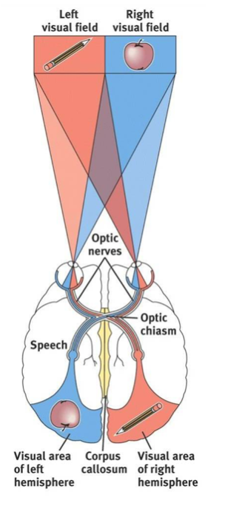
- Facial, emotional recognition = holistic

Split Brains
- A condition resulting from surgery that isolates the brain’s two hemispheres by cutting fibers (corpus callosum) connecting them
- Personality and intellect virtually unaffected
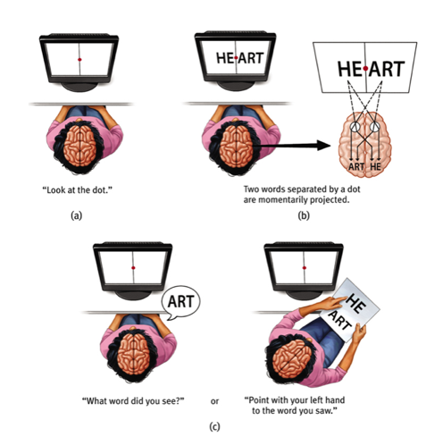
- The integration of perceptual information is interrupted
- The ability of the right hemisphere to express itself verbally is compromised.

6: Sensation and Perception
Difference Threshold
- The minimum difference a person can detect between any two stimuli half the time.
- Weber’s Law for an average person to perceive a difference, two stimuli must differ by a constant minimum percentage (value depending on stimuli).

Sensory Adaption
- When we are constantly exposed to an unchanging stimulus, we become less aware of it because our nerve cells fire less.
- We perceive the world not exactly as it is, but as it is useful for us to perceive it.

Vision
- The Stimulus Input
- Electromagnetic radiation
- Packets of energy given off by all things, particularly things that are high in energy (e.g., the sun)
- Different kinds of electromagnetic radiation
    - For example, X-rays, ultraviolet radiation, infrared radiation, microwaves, radio waves, light
    - What we call “light” is the portion of the spectrum that our eyes can detect

Electromagnetic Radiation: Wavelength
- Packets of electromagnetic radiation oscillate
- Degree of oscillation determines the wavelength
    - The greater the oscillation, the shorter the wavelength
    - The wavelength determines whether or not our eyes can detect it
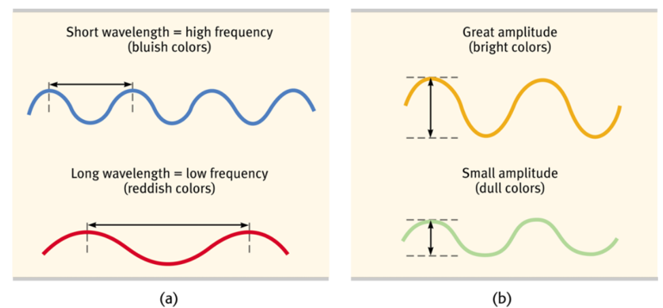
Wavelength and Amplitude
- Wavelength of light determines the hue that we will experience
    - Hue = colour
- Amplitude of the wavelength determines the brightness of the colour
    - Higher amplitude, brighter colour
    - Lower amplitude, duller colour

The Eye
- Detect and transduce electromagnetic radiation (light)
- Transduction is the conversion of one form of energy into another
    - Cornea light enters through here
    - Pupil light passes through this small adjustable opening
    - Iris colored muscle that dilates or constricts in response to light intensity.
    - Lens focusses incoming light rays into an image on the Retina via. accommodation
    - Retina what picks up the light and sends to brain
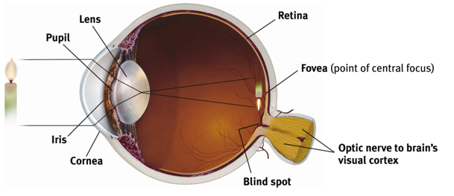

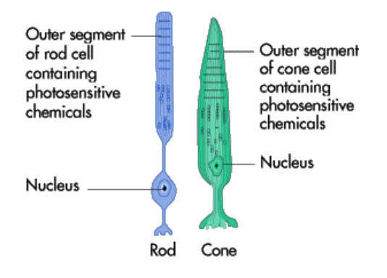
The Retina
- Several layers of cells
  - Photoreceptors
    - Rods and cones
    - 130 million rods and cones (mostly rods)
- Bipolar cells
- Ganglion cells
  - 1 million
  - Axons form the optic nerve
- Light rods & cones chemical change that sparks neural signals, activating bipolar cells ganglion cells (make up optic nerve)
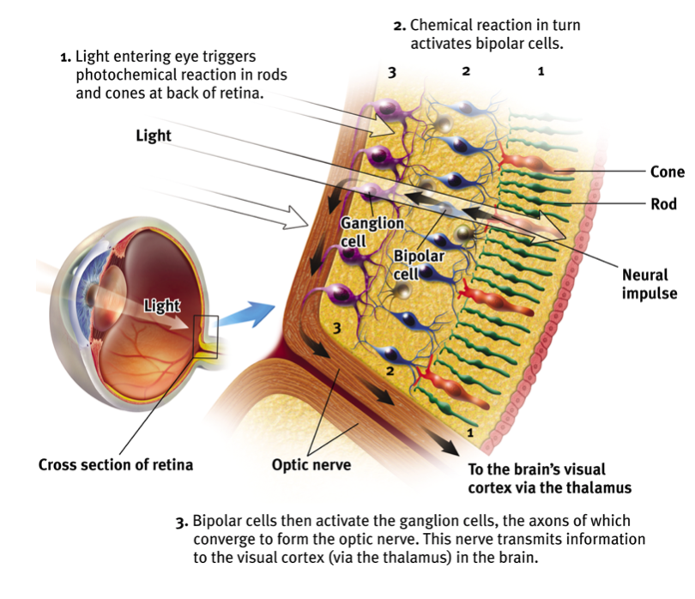

Rods and Cones
- Cones are concentrated in the centre of the retina (fovea)
  - Rods mostly in periphery
  - Hotline to the brain, activating a single bipolar cell
- Cones more sensitive to detail
  - Better ratio of connections to bipolar cells
- Only cones are sensitive to colour
  - Only absorb particular wavelengths of light
- Rods increase visual sensitivity when in dim light (why everything black and white in dark)
- Summary: retina’s neural layers don’t just pass on electrical impulse, they encode and analyze sensory information also.
- Look left, rub right side of eyelid. That’s your retinal cells firing because of pressure, but the brain think’s it’s seeing light.

Blind Spot
- Axons from the ganglion cells converge and leave the eye on the nose side of the retina
- There is a hole in your retina where there are no receptor cells
  - Brain has no direct information about a small area of your visual field
  - But it has indirect information (The other eye, Eye movements)
- Close one eye and keep the eyes still to notice the blind spot
  - The brain fills in the information by making its best guess based on the adjacent areas of the retina

Feature Detection
- Optic nerve carries information to the visual cortex
  - Thalamus
  - Areas of the visual field have corresponding areas of the visual cortex
- Feature detection cells (feature detectors) for each area of visual field
  - Form (edges: lines, angles), movements, colors, depth
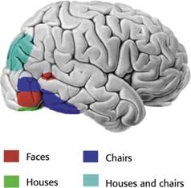
- Parallel processing
  - All features are detected simultaneously
  - Different brain regions for form, colour, movement, depth
  - Damage can impair perception of particular categories of features (eg. Motion)
- Supercell clusters in association cortex
  - Respond to complex patterns constructed from the combination of individual features
  - i.e., a gestalt (whole > sum of its parts)
  - E.g., faces or objects
- Specific examples of these gestalts are housed in long-term memory (cortex)
  - Damage can interfere with perception
  - E.g., prosopagnosia

Colour Vision
- Young-Helmholtz Trichromatic Theory
  - Any colour created by combining light waves of three primary colours
    - Red, green, blue
  - Theory was that brain worked the same way
  - Hypothesized that retina will have three different types of colour sensitive cells
    - Confirmed with research
- Colour blindness
  - Typically, missing red, green, or both red & green cones
    - Red and green look similar
- Problems with trichromatic theory
  - 1) Missing cones but perceiving yellow
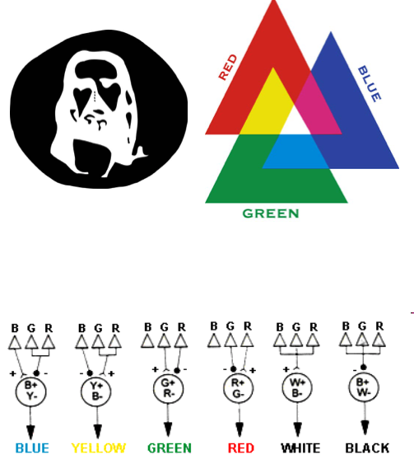
  - 2) Yellow seems pure (Not a combination of red and green)
- Colour vision is the result of opponent processes
  - Processes in which colour processing cells are stimulated by some cones, but inhibited by others
- Afterimages
  - Stare at a green square then look at a white piece of paper, you’ll see red (green’s opponent colour), same with yellow and blue. This is because we’re tiring out the greed, on red part of green pairing fires normally when looking at white (which has all colours)
- Red and green are opponent colours, Blue and yellow are opponent colours, (Black and white also)
- Opponent Process Theory
  - Opposing retinal processes enable full colour vision
  - E.g., red and green, blue and yellow, white and black
    - Some cells stimulated by green, inhibited by red
    - Others stimulated by red, inhibited by green
    - Thus, there is no reddish-green

Motion Perception
- Brain infers motion by the change in images on the retina
1) Same image taking up progressively more retinal space
  - Approaching object
2) Same image taking up progressively less retinal space
  - Retreating object
3) Same image displaced on the retina to the left, right, up, or down
  - Movement right, left, down, or up, respectively

Illusory Motion
- Phi phenomenon
  - An illusion of movement created when two or more adjacent lights blink on and off in quick succession
  - E.g., moving arrow, marquee lights
- Stroboscopic motion
  - The perception of movement in a rapid series of varying images
  - E.g., flip books, movies

Depth Perception
Binocular Cues
- Retinal Disparity
1) The object of focus
    - The greater the difference (disparity) between the two objects, the closer it is
2) Other objects
    - The difference between the retinal placement of the images
    - The more lateral the retinal image, the closer the object is
- 3-D movies

Monocular Cues
- Relative Height Things that are higher in your visual field tend to be perceived as farther away
- Relative Size If we assume that two objects are similar in size (2 cars, 2 people), then the one that takes up the least amount of retinal space will be perceived as farther away
- Interposition If one object partially blocks another one, we perceive it as closer
- Linear Perspective Parallel lines appear to converge in the distance, the more convergence, the farther they seem
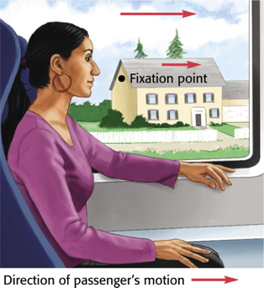
- Light Nearby objects reflect more light to our eyes
- Shadow/Shading Brain assumes that light comes from above, we can infer depth based on the shading

- Relative Motion (motion parallax) Objects that are closer are perceived as moving faster through our visual filed (right)

Perceptual Interpretation
- Kant we are born with the tools to perceive the world
- Locke through experiences we also learn to perceive the world.

Restored Vision and Sensory Restriction
- People born blind can’t distinguish items they knew by touch after regaining sight.
  - Cortical cells had not developed normal connections
- In adults, if you cover vision for months their vision wont deteriorate after.
- Suggesting a critical period an optimal period when exposure to certain stimuli or experiences is required.

Perceptual Adaption
- When given a new pair of glasses our perceptual adaption changes visual inputs to make it seem normal again, we can adapt to anything.

