Assignment 1: Sex Determination
Feb. 6th 2013

1.

Description | Female | Male
smooth nuchal area | F
narrow, rectangular shaped pubis |  | M
narrow sciatic notch |  | M
small, non-projecting mastoids | F
small, subtle ventral arc |  | M
long, narrow sacrum |  | M
preauricular sulcus | F
convex sub-pubic concavity |  | M
pointed chin | F
high, rounded forehead | F
sharp supraorbital margin | F

The sex of the individual is female.

2.

cranial length = 181.95 mm
cranial width = 132.55 mm
basion-bragma height = 133.69
bizygomatic width = 132.28
mastoid length = 28.44 mm

D = M1 (2.111) + M2 (1.000) + M3 (4.936) + M4 (8.037)
D = 384.09645 + 132.55 + 652.93408 + 228.57226
D = 516.64645 + 881.50636
D = 1398.15281

1387.72 =\p0oiuujbhsection point.
The sex of a “Black” skull with the following measurements is a male.

3.

glenoid fossa width = 29.1 mm = M
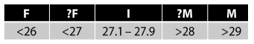

clavicle length = 148.2 mm = ?M
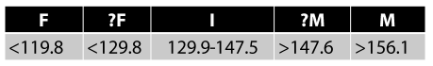

scapula height = 155.4 mm = ?M


femoral head diameter = 46.8 mm = ?M
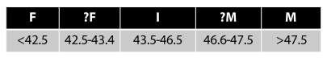

ischium length (“white”) = 94.3 mm
pubis length (“white) = 90.2 mm

Washburn’s ischium-pubic index (68% accuracy) = ( pubis length / ischium length ) x 100
,< 84 = male, > 94 = female
= 95.65 = female

The sex of an individual with the given measurements is a male.

4.

The sex of the modern Euro-American skull with the given scores is female.

orbital margin = 2 (probably female)
mental eminence = 1 (female)
glabella = 2 (probably female)
mastoid = 4 (probably male)
nuchal crest = 3 (ambiguous)

5.

Juvenile Sexing Methods

i1 = sciatic notch width (23.25 mm)
i2 = sciatic notch depth (7.21 mm)
i3 = iliac breadth (75 mm)
i4 = iliac length (64 mm)

Variables:

v1 = i1/i3 x 100
v2 = i1/i4 x 100
v3 = i3/i2 x 100
v4 = i3/i4 x 100

D = v1 (2.51989) + v2 (-2.35881) + v3 (-0.00327) + v4 (0.63066) - 62.76045

D < 0 = female
D > 0 = male

v1 = 23.25 / 75 x 100 = 31.00
v2 = 23.25 / 64 x 100 = 36.33
v3 = 75 / 7.21 x 100 = 1040.22
v4 = 75 / 64 x 100 = 117.19

D = 31.00 (2.51989) + 36.33 (-2.35881) + 1040.22 (-0.00327) + 117.19 (0.63066) - 62.76045
D = 78.12 + (-85.70) + (-3.40) + (73.91) - 62.76045
D = 62.93 - 62.76045
D = 0.17

Therefore, the sex of a juvenile individual with the given measurements is female.

