COMM 223 MIDTERM TEACHER NOTES
CHAPTER 5 – Managing Marketing Information to Gain Customer Insights

Marketing Information and Customer Insights:

Customer Insights:
  - Understanding of customers and the marketplace
  - Basis for creating customer value and relationships
- Develop competitive advantage
- Insights stem from many sources

Marketing Information System (MIS) :
    - Assess information needs
    - Develop needed information
    - Analyze and use information
    - Decision makers use the information to validate actionable customer and market insights
Explain the importance of information in gaining insights about the marketplace and customers.
- - Customer insight teams are replacing traditional market research departments

Assessing Marketing Information Needs
- A good MIS balances information wants, needs, and feasibility
  - An MIS has limitations – determine possibility
  - An MIS is costly – must consider ROI
- A good MIS balances the information users would like to have against what they really need and what is feasible to offer. Some managers will ask for whatever information they can get without thinking carefully about what they really need. Too much information can be as harmful as too little. Other managers may omit things they ought to know, or they may not know to ask for some types of information they should have. For example, managers might need to know about surges in favourable or unfavourable consumer discussions about their brands on blogs or online social media. But because they don’t know about these discussions, they don’t think to ask about them. The MIS must monitor the marketing environment to provide decision makers with information they should have to better understand customers and make key marketing decisions.

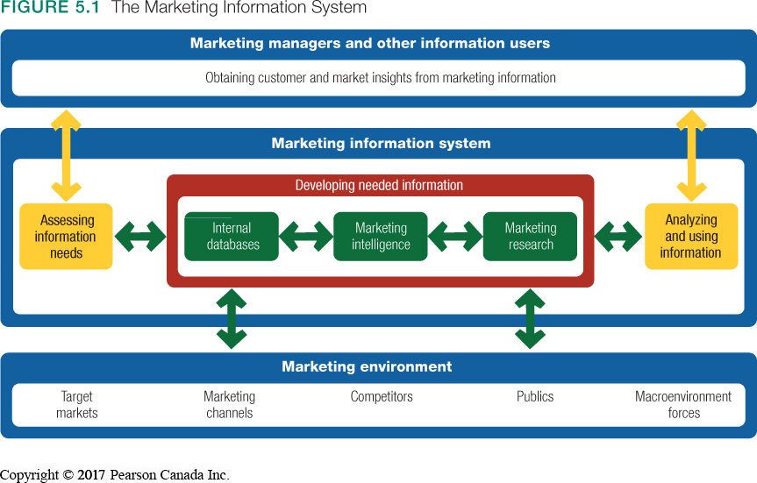
Developing Marketing Information
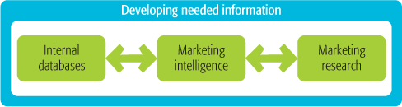
- internal : Information from sources within the company
- Accessed more efficiently
- Prone to gaps in knowledge
- - Electronic collections of consumer and market information obtained from data sources within the company network (e.g., customer databases)
- - Can be accessed more quickly and cheaply than other information sources
- - However, may be incomplete or in the wrong form for marketing decisions

- Marketing intel.: Environmental analysis
- Publically available information
- Ethical issues raised
- - Collection and analysis of publicly available information about consumers, competitors, and developments in the marketing environment (e.g., annual reports; brand discussions on blogs)
- - Can raise ethical issues as some techniques are considered shrewd
- Marketing research: Used when new problem exists
- Systematic collection, analysis, and reporting of data

Outline the steps in the marketing research process.

Marketing Research:
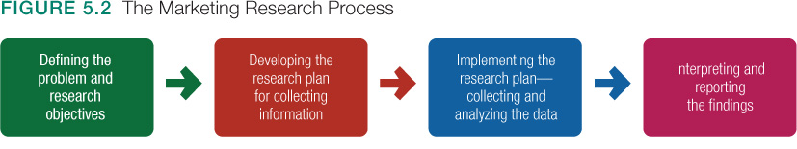
Marketing Research: Systematic design, collection, analysis, and reporting of data relevant to a specific marketing situation facing an organization.
Step 1 – Various objectives: (This can be the most difficult step)
- The objective of exploratory research is to gather preliminary information that will help define the problem and suggest hypotheses.

- The objective of descriptive research is to describe things, such as the market potential for a product or the demographics and attitudes of consumers who buy the product.

- The objective of causal research is to test hypotheses about cause-and-effect relationships.

Step 2 – Research plan outlines:
- Research objectives must be translated into specific information needs, which might include:
- Detailed customer characteristics
- Usage patterns
- Retailer reactions
- Sales forecasts
Research Plan:
- Present research plan in a written proposal
- Research plans may outline need for secondary and primary data

Step 2 – Collecting Data

Primary Data:
- Information collected for a specific problem
- Must be relevant, accurate, current, and unbiased

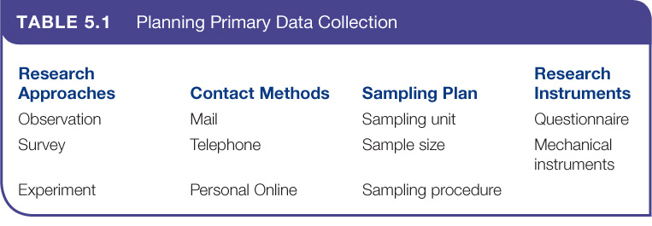
- research approaches, contact methods, the sampling plan, and research instruments.

Observational
- Gathers data by observing relevant people, actions, situations
- Impossible to observe feelings
- Ethnographic yields deeper observation
Survey
- Gathers data by asking people questions
- Most used method for primary data
- Suited for gathering descriptive information
Experimental
- Matches groups of people / looks for differences in responses
- Best suited for explaining cause-and-effect relationships
Gathering primary data by observing relevant people, actions, and situations
- Obtains information that people are unwilling or unable to provide
  - Cannot use to observe feelings, attitudes, motives, or long-term or infrequent behaviour
- Ethnographic research yields richer understanding of consumers:
  - Trained observers watch and interact with consumers in their “natural habitat”
- Survey Research:
- Gathers primary data by asking people questions about their knowledge, attitudes, preferences, and buying behaviour
- Most widely used method for primary data collection
- Best suited for gathering descriptive information
- Gathers primary data by selecting matched groups of subjects, giving them different treatments, controlling related factors, and checking for differences in group responses
- Best suited for explaining cause-and-effect (causal) relationships

Ethnographic research - A form of observational research that involves sending trained observers to watch and interact with consumers in their “natural environments.”

Contact Methods:
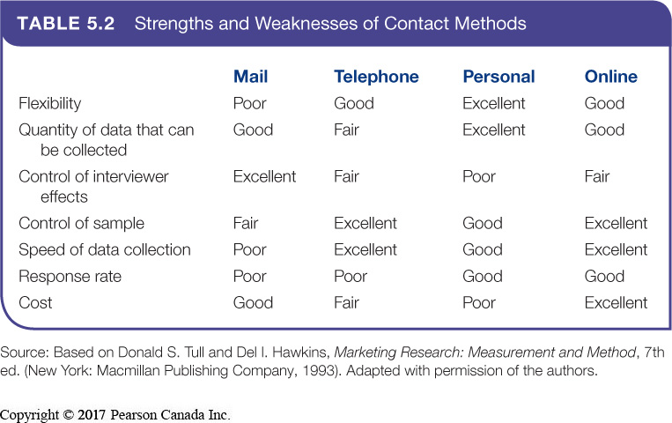
Information can be collected by mail, telephone, personal interview, or online. Table 5.2 shows the strengths and weaknesses of each contact method.
- Mail questionnaires can be used to collect large amounts of information at a low cost per respondent. Mail questionnaires are not very flexible; all respondents answer the same questions in a fixed order. Mail surveys usually take longer to complete, and the response rate—the number of people returning completed questionnaires—is often very low.

- Telephone interviewing is one of the best methods for gathering information quickly, and it provides greater flexibility than mail questionnaires.

- Personal interviewing takes two forms: individual interviewing and group interviewing. Individual interviewing involves talking with people in their homes or offices, on the street, or in shopping malls. Such interviewing is flexible.

- Group interviewing consists of inviting 6 to 10 people to meet with a trained moderator to talk about a product, service, or organization. Participants are normally paid a small sum for attending

- Focus group interviewing - Personal interviewing that involves inviting 6 to 10 people to gather for a few hours with a trained interviewer to talk about a product, service, or organization. The interviewer “focuses” the group discussion on important issues.

- Online Marketing Research
  - Well suited to quantitative research
  - Qualitative internet approach: online focus groups
- Online behavioural and social tracking and targeting

- The growth of the Internet has had a dramatic impact on how marketing research is conducted. Increasingly, researchers are collecting primary data through online marketing research Internet surveys, online panels, experiments, and online focus groups and brand communities.

- Behavioural targeting - Using online consumer tracking data to target advertisements and marketing offers to specific consumers

- The newest wave of Web analytics and targeting takes online eavesdropping even further—from behavioural targeting to social targeting. Whereas behavioural targeting tracks consumer movements across sites, social targeting also mines individual social connections and conversations from social networking sites. Research shows that consumers shop a lot like their friends and are much more likely to respond to ads from brands friends use.

- Sampling Plan: :
- Segment of the population selected to represent the population as a whole
- Need to determine:
- Who to survey; sampling unit
- How many people to survey; sample size
- How to chose the people in the sample; sampling procedure
- Probability and nonprobability samples:
- Probability (random) samples permit every subject in a given population to have equal opportunity to be contacted
- Non-probability (non-random) samples include participants obtained through methods other than randomly. As such Non-probability samples are not as accurate as probability samples
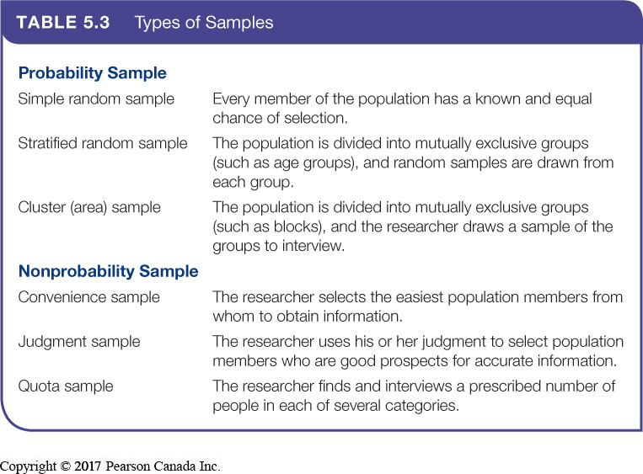
- Questionnaire:
  - Questions to ask
  - Style of questions; open-ended and/or closed-ended
  - Wording and ordering of questions
- Mechanical Instruments:
  - Monitor consumer behaviour
  - Includes people metres, checkout scanners, etc.

Step 3 - Implementing the Research Plan
Implementation:
COLLECT -> PROCESS -> ANALYSE
Collecting the data: Most expensive phase, Subject to error
- Processing the data: Check for accuracy, Code for analysis
- Analyzing the data: Tabulate results, Compute statistical measures

Step 4 – Interpreting and Reporting the Findings

- Interpret the findings
- Draw conclusions
- Report to management:
  - Present findings and conclusions that will be most helpful to decision making
Interpretation should not be left only to researchers. Although they are often experts in research design and statistics, the marketing manager knows more about the problem and the decisions that must be made. The best research means little if the manager blindly accepts faulty interpretations from the researcher
Analyzing and Using Marketing Information

- Customer Relationship Management (CRM):
  - Manages detailed information about individual customers to maximize customer loyalty
  - Captures and analyzes information from all customer sources
  - Findings may lead to new marketing opportunities
  - Marketing information systems must make information readily available for decision making:
  - - Routine information for decision making
  - - Non-routine information for special situations
  - - Intranets and extranets facilitate the information sharing process

Secondary (Existing) Data:
- Advantages:
  - Quicker and cheaper
- Disadvantages:
  - Relevance, currency, accuracy
  - Rarely provides all necessary information
  - Information may not be usable; must evaluate relevancy, accuracy, currency, and impartiality

Discuss the special issues some marketing researchers face, including public policy and ethics issues.

Other Marketing Information Considerations

Marketing Research in Small Businesses and Non-profit Organizations
  - Secondary data, observation, informal surveys and experiments can all be used by small organizations and NFPs

International Marketing Research:

- Many countries have no research services
- Good secondary data is scarce
- Cultural differences must be considered

**Discuss the special issues some marketing researchers face, including public policy and ethics issues.

Public Policy and Ethics in Marketing Research:

- Misuse of marketing research can harm consumers and firms’ reputations
  - Intrusions on consumer privacy
  - Misuse of research findings
- Questions to consider:
- Is it a good or bad thing that marketers track and analyze consumers’ online clicks and target ads to individuals based on their browsing and social networking behaviour?
- Should we worry when marketers track consumer locations via their mobile phones to issue location-based ads and offers?
- Should we care that some retailers use mannequins with cameras hidden in one eye to record customer demographics and shopping behaviour?
- Similarly, should we applaud or resent companies that monitor consumer discussions on YouTube, Facebook, Twitter, or other social media in an effort to be more responsive

CHAPTER 6 – Understanding Consumer and Business Buyer Behaviour

Consumer Markets and Buyer Behaviour

- Characteristics Affecting Consumer Behaviour:

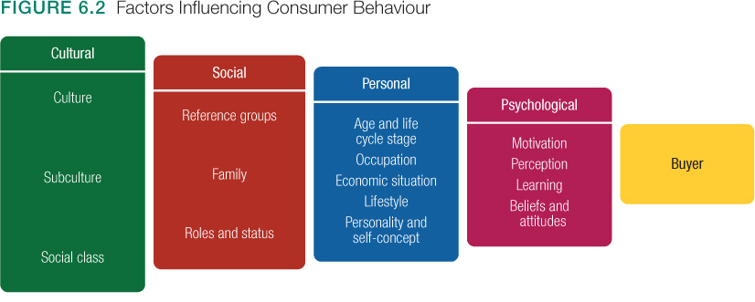

****Identify and discuss the stages in the buyer decision process.***

Buyer decision process:

- Five stages in the buyer decision process:

  - Need recognition

- triggered internally or externally.

  - 2. Information search

- proceeds through a variety of sources: personal, commercial, public & experiential sources

  - 3. Evaluation of alternatives

- depends on the buying situation and the consumer

  - 4. Purchase decision

- Influenced by:
- Attitudes of others
- Unexpected situational factors

  - 5. Post-purchase behaviour

- hinges on buyer’s expectations vs. actual
performance of product.
- Most major purchases result in cognitive dissonance.

**Describe the adoption and diffusion process for new products.

The Buyer Decision Process for New Products

Consumer  Orientation | Consumer  Action
Awareness | Becomes aware, but lacks information
Interest | Seeks information about the product
Evaluation | Considers whether to try the product
Trial | Tries new product in small sample
Adoption | Decides to use product regularly

The Adoption Process:

  - Innovators
  - Early adopters
  - Early majority
  - Late majority
  - Laggards

- Business-to-Business (B2B):
  - Buying behaviour of firms that buy products to produce other products or to resell to others
  - B2B market is huge and involves far more dollars and items than consumer markets

Business Markets:

- Market Structure and Demand:
  - Fewer but larger buyers
  - Demand is derived from consumers
- Nature of the Buying Unit:
  - More decision participants
  - Professional buying effort
- Types of Decisions
  - More complex & formal decisions

**************** business buyer model ******************

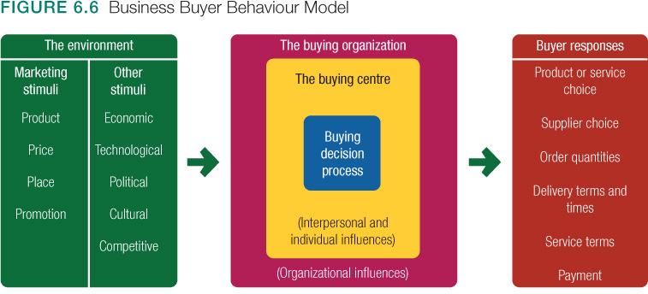

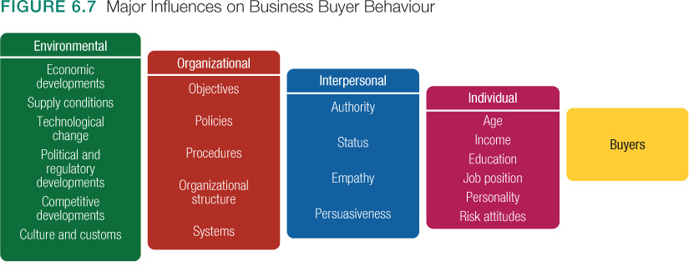

**How is derived demand linked to economic expansion and contraction?

***** Stages of the Business Buying Process

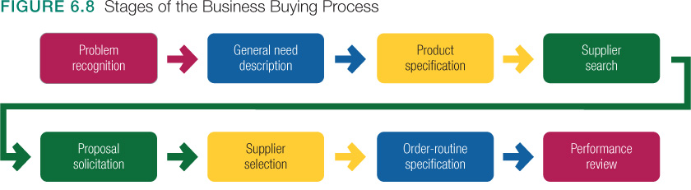
CHAPTER 7 – Segmentation, Targeting and Positioning

- Market segmentation involves dividing a market into smaller segments of buyers with distinct needs, characteristics, or behaviours that may require separate marketing strategies or mixes.

- Market targeting (targeting) consists of evaluating each market segment’s attractiveness and selecting one or more segments to enter.

- Differentiation involves actually differentiating the market offering to create superior customer value.

- Positioning consists of arranging for a market offering to occupy a clear, distinctive, and desirable place relative to competing products in the minds of target consumers.

Bases for Segmentation:
- Geographics
- Psychographics
- Behavioural
- Demographics

Geographic Segmentation:
- Global regions
- Countries
- Region of country
- Provinces
- Cities
- Neighborhoods

Demographic Segmentation:
- Age and Life-Cycle
- Household Income
- Ethnic or Cultural Group
- Tastes evolve with age
- Household income
- Race, religion, language

Segmentation Consumer Markets:

- 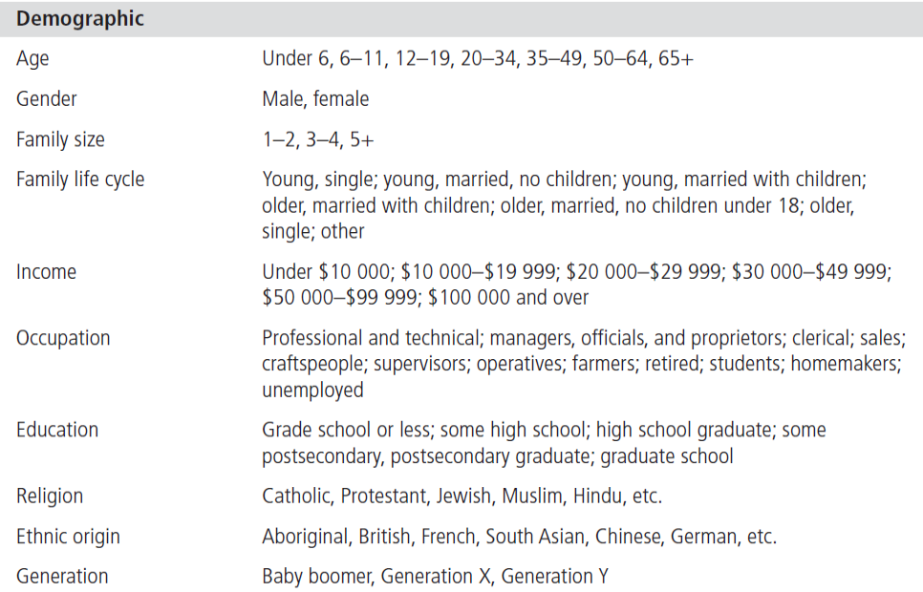

- Age and life-cycle stage segmentation is the process of offering different products or using different marketing approaches for different age and life-cycle groups.
- Gender segmentation divides the market groups based on gender.
- Income segmentation divides the market into different income groups.
- Psychographic segmentation divides buyers into different groups based on social class, lifestyle, or personality traits.

Behavioural Segmentation:
- Occasion-based purchases
- Benefits sought
- User status
- Usage rate
- Loyalty status
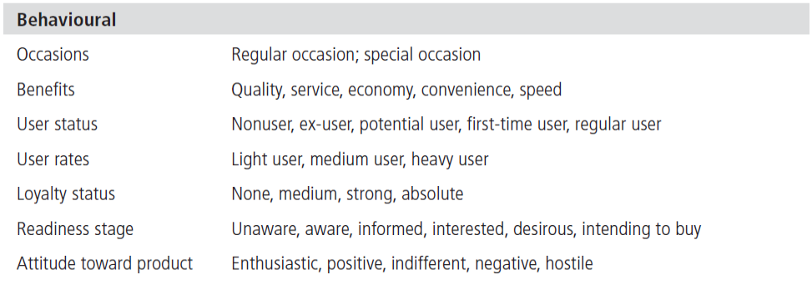

Segmenting International Markets

  - Geographic location
  - Economic factors
  - Political and legal factors
  - Cultural factors

- Intermarket Segmentation: Segmenting consumers who have similar needs and buying behaviour even though they are located in different countries

Requirements for Effective Segmentation:
- Measurable: The size, purchasing power, and profiles of segments can be measured.
- Accessible: The market segments can be effectively reached and served.
- Substantial: The market seems large or profitable enough to serve.
- Differentiable: The segments are conceptually distinguishable and respond differently to different marketing mix elements and programs.
- Actionable: Effective programs can be designed for attracting and serving the segments.

Target market consists of a set of buyers who share common needs or characteristics that the company decides to serve.

Difference between Market Targeting & Target Marketing?

Evaluating Market Segments:
- Structural factors that affect long-run segment attractiveness (“five forces”):
  - Competitors
  - New Entrants
  - Substitute products
  - Relative power of buyers
  - Power of suppliers
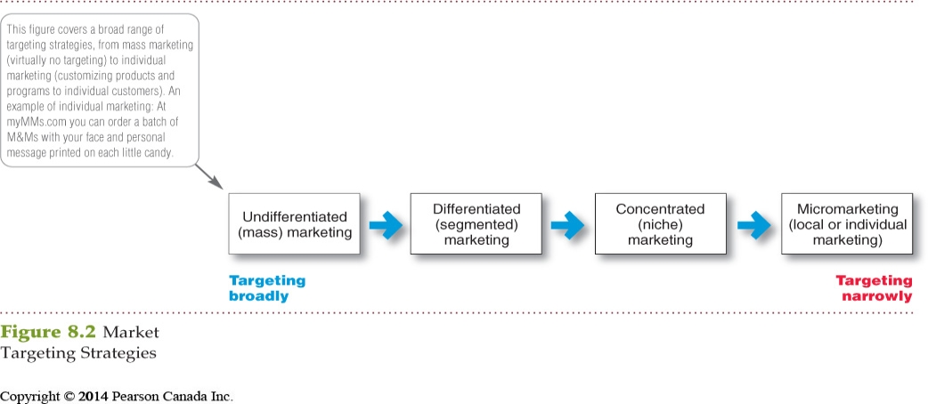

- Undifferentiated (mass) marketing targets the whole market with one offer.
  - Focuses on common needs rather than on what is different

- Differentiated (segmented) marketing targets several different market segments and designs separate offers for each
  - Goal is to achieve higher sales and stronger position.
  - More expensive than undifferentiated marketing.

- Concentrated (niche) marketing targets a large share of one or a few segments or niches.
  - Limited company resources
  - Knowledge of the market
  - More effective and efficient

- Micromarketing is the practice of tailoring products and
- marketing programs to suit the tastes of specific individuals
- and local customer groups. (Local & Individual Marketing)

- Local marketing involves tailoring brands and promotion to the needs and wants of local customer groups.
  - Cities
  - Neighborhoods
  - Stores

- Individual marketing involves tailoring products and marketing programs to the needs and preferences of individual customers.
- Also known as:
  - One-to-one marketing
  - Mass customization
  - Markets-of-one marketing

- Factors in choosing a targeting strategy:
  - Company resources
  - Product variability
  - Product’s life-cycle stage
  - Market variability
  - Competitors’ marketing strategies

- Social responsibility trumps profitability if efforts are seen as exploitative or irresponsible
    - Benefits customers with specific needs
    - Concern for vulnerable segments
    - Children
    - Alcohol
    - Cigarettes
    - Internet abuses

- Product Position:
  - Consumer perception of products
  - Place the product occupies in minds of consumers relative to competitors

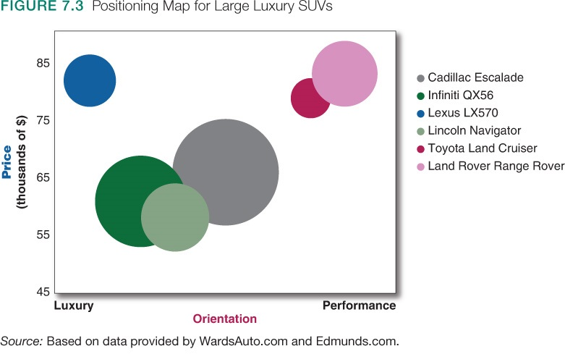

- A differentiation and positioning strategy involves:
  - Identifying competitive advantages
  - Selecting competitive advantage(s) on which to create position
  - Developing a positioning strategy
  - Identifying a set of differentiating competitive advantages upon which to build a position
  - Choosing the right competitive advantages
  - Selecting an overall positioning strategy
  - THEN
  - Effectively communicating and delivering the chosen position to the market

- Identifying competitive advantages:
  - Understand customer needs better than competitors, then deliver more value
  - Points of differentiation can occur anywhere in the entire customer experience

Product | Features, performance, style, design
Services | Expedient, convenient, cautious
Channels | Coverage, expertise, performance
People | Training, culture, morale
Image | Distinctive intangible benefits

- Competitive advantage is an advantage over competitors gained by offering greater customer value, either through lower prices or by providing more benefits that justify higher prices.
- Choosing a competitive advantage upon which to base positioning
  - One unique selling proposition (USP)
  - Multiple differences
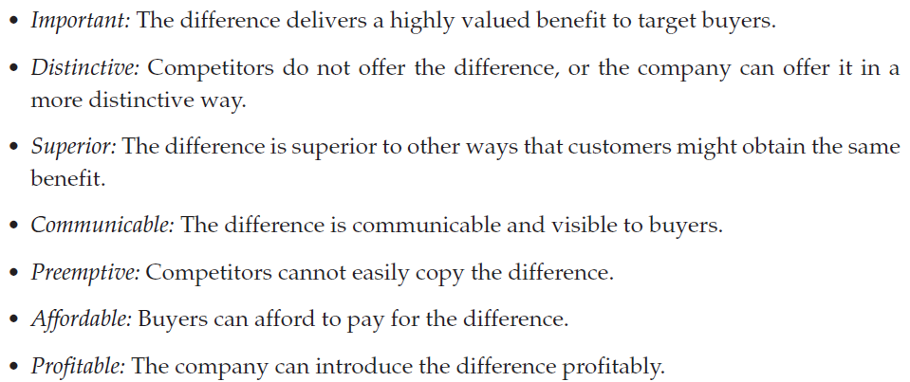

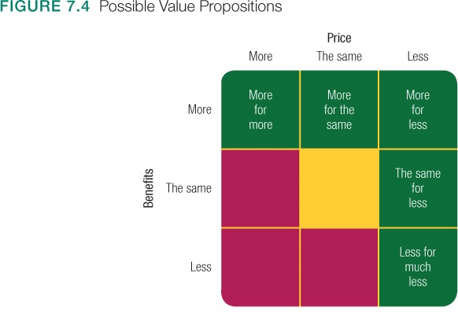
Positioning statement:
  - Format:
“To (target segment and need)
(our brand) is (a concept) that (point of difference).”
  - Example:
“To busy, mobile professionals who need to always be in the loop,
BlackBerry is a wireless connectivity solution that gives you an easier, more reliable way to stay connected to data, people, and resources while on the go.”

- Position must be monitored and sometimes adapted to match consumer needs, values, and attitudes as well as competitive fluctuations

CHAPTER 8 – Developing and Managing Products and Services

- Define product and describe and classify different types of product offerings

- List and define the steps in the new-product development process and the major considerations in managing this process, and explain why new products fail

- Describe the stages of the product life cycle and how marketing strategies change during the product’s life cycle

- Describe the decisions companies make regarding their individual products and services, product lines, and product mixes

- Identify the four characteristics that affect the marketing of services and the additional marketing considerations that services require

What is a product?

Services : Intangible activities, benefits, or satisfaction that do not result in the ownership of anything

Products : Anything offered to a market for attention, acquisition, use, or consumption that may satisfy a want or need

Levels of product : 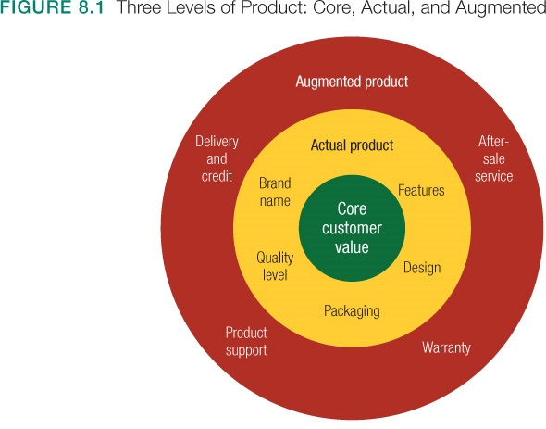
Product and services classifications

- Convenience products are consumer products and services that the customer usually buys frequently, immediately, and with a minimum comparison and buying effort:
  - Newspapers
  - Candy
  - Fast food
- Shopping products are consumer products and services that the customer compares carefully on suitability, quality, price, and style:
- Furniture
- Cars
- Appliances

- Specialty products are consumer products and services with unique characteristics or brand identification for which a significant group of buyers is willing to make a special purchase effort:
  - Medical services
  - Designer clothes
  - Rolex watches
- Unsought products are consumer products that the consumer does not know about or knows about but does not normally think of buying:
  - Life insurance
  - Funeral services
  - Blood donations
- 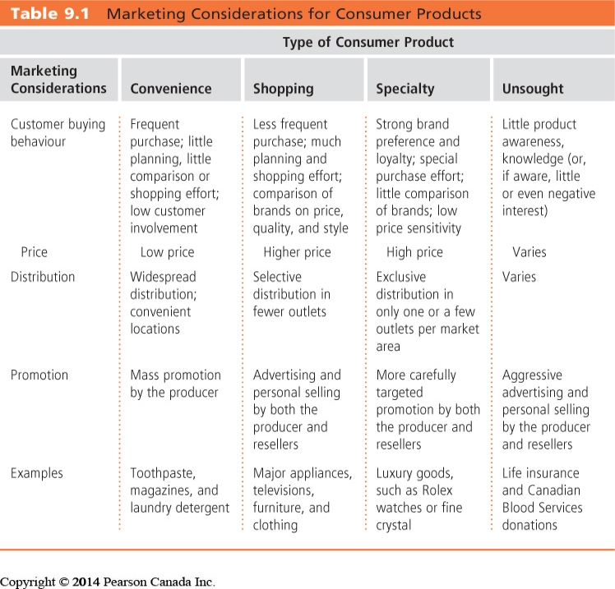

- Acquisition refers to the buying of a whole company, a patent, or a license to produce someone else’s product.

- New product development refers to original products, product improvements, product modifications, and new brands developed from the firm’s own research and development.
  - Development of original products, improvements, modifications, or new brands
  - New product innovation is expensive and risky
  - Most new products fail or underperform
  - Diffusion of innovations theory

  - Reasons for failure:

    - Overestimation of market size
    - Poor design
    - Incorrect positioning
    - Wrong timing
    - Priced too high
    - Ineffective promotion
    - Management influence
    - High development costs
    - Competition

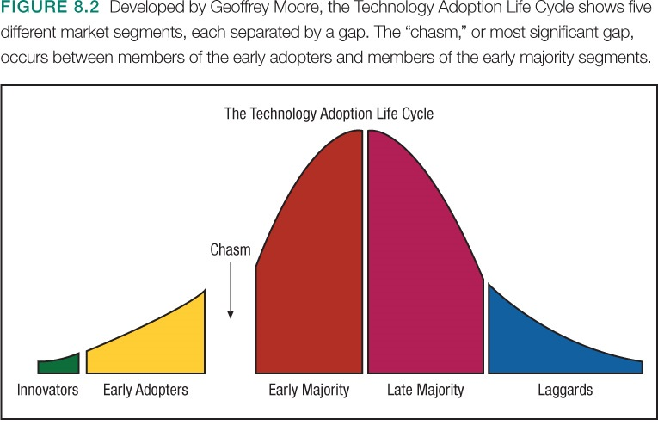

- Major stages in new-product development:

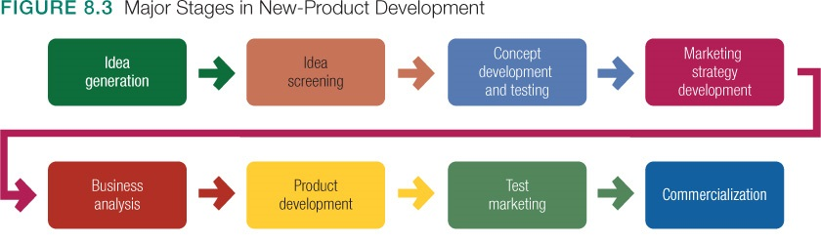

- Idea generation

- Internal sources:
    - Company employees at all levels

- External sources:
    - Customers
    - Competitors
    - Distributors and suppliers
    - Others

- Crowdsourcing

- Idea Screening:

  - - Keep good ideas and drop poor ones
  - - Describe product, target market, and competition
  - - Estimate market size, price, development time and costs, manufacturing costs, rate of return
  - - Evaluate new-product ideas against a set of company criteria

- Concept Development and Testing:

Product concept:
- New-product idea stated in meaningful consumer terms
In concept development, several descriptions of the product are generated to find out how attractive each concept is to customers. From these concepts, the best one is chosen.

Concept testing:
- Testing new-product concepts with groups of potential target consumers

- Marketing Strategy Development: An initial marketing strategy and a three-part marketing strategy statement
    - Describe the target market, planned value proposition, sales, market share, and profit goals
    - Outline the product’s planned price, distribution, and marketing budget
    - Describe the planned long-run sales and profit goals, marketing mix strategy

- Business Analysis:
  - Involves a review of the sales, costs, and profit projections to find out whether they satisfy the company’s objectives.
  - Positive review triggers product development

- Product Development:
  - Develops concept into a prototype
  - Prototypes are developed and tested

- Test marketing is the stage at which the product and marketing program are introduced into more realistic marketing settings.
  - Provides the marketer with experience in testing the product and entire marketing program before full introduction
  - Traditional or standard test markets, Controlled test markets, Simulated test markets
  - Benefits: The test market provides a vehicle by which the firm can obtain a good estimate of a product’s sales potential under realistic market conditions
- The test should identify weaknesses of the product and the proposed marketing strategy for the product and give management an opportunity to correct any weaknesses

Before Conducting a Test Market

- Weigh the cost and risk of failure against the probability of success and associated profits
2. Consider the likelihood and speed with which competitors can copy your product and introduce it on a national basis
3. Consider the investment required to produce the product for the test market versus the investment required to produce the product in the quantities necessary for a national rollout
4. Consider how much damage an unsuccessful new product launch would inflict on the firm’s reputation

Rolling Rollout:
- A product is launched in a certain region rather than in one or two
cities.
- Scanner data can provide information on how the product is doing in a few days resulting in the possible product launch in additional regions.
- General Mills has used this approach for products such as Multigrain Cheerios.

Lead Country Strategy:
- A product is tested in a foreign market before rolling it out globally.
- Colgate-Palmolive Company launched Palmolive Optims shampoo and conditioner in the Philippines, Australia, Mexico, and Hong Kong. Later, the products were rolled out in Europe, Asia, Latin America, and Africa.

- Commercialization is the introduction of the new product:
  - When to launch
  - Where to launch
  - Planned market rollout

Product Life Cycle

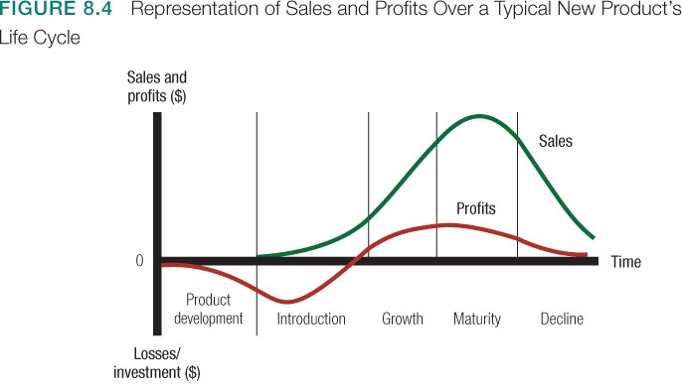

Introduction Stage
- Low sales
- High cost per customer
- Negative profits
- Innovator customers
- Few competitors
- Create product awareness and trial.
- Offer a basic product.
- Use cost-plus pricing.
- Build selective distribution.
- Build product awareness among early adopters and dealers.
- Use heavy sales promotions to entice trial.

Growth Stage
- Rapidly rising sales
- Average costs per customer
- Rising profits
- Customers as early adopters
- Growing number of competitors
- Promotion and manufacturing costs gain economies of scale
- Maximize market share.
- Offer product extensions, service, warranty.
- Price to penetrate market.
- Build intensive distribution.
- Build awareness and interest in the mass market.
- Reduce sales promotion to take advantage of heavy consumer demand.

Maturity Stage
- Slowdown in sales as they peak
- Low costs per customer
- High profits
- Customers are middle majority
- Substitute products are introduced, stable competition beginning to decline
- Increased promotion and R&D to support sales and profits
- Maximize profit while defending market share.
- Diversify product brand and models.
- Price to match or beat competitors.
- Build more intensive distribution.
- Stress brand differences and benefits.
- Increase sales promotion to encourage brand switching.
- Market modifying tries to increase consumption of the current product—looking for new users and market segments or inventing new uses for existing products.
- Product modifying changes characteristics of products, such as quality, features, style, or packaging to attract new users and to inspire more usage.

Decline Stage
- Declining sales
- Low costs per customer
- Declining profits
- Customers are laggards
- Declining number of competitors
- Reduce expenditures, and milk the brand.
- Phase out weak items.
- Cut prices.
- Selective distribution—phase out unprofitable outlets.
- Reduce advertising to level needed to retain hardcore loyalists.
- Reduce sales promotion to minimal level
- Carrying a weak product can be costly to a firm. Companies must decide what to do with declining products.
- Maintain the brand without change in the hope that competitors will leave the industry.
- Harvest the product by reducing various costs and hoping that sales hold up.
- Drop the product from the line.

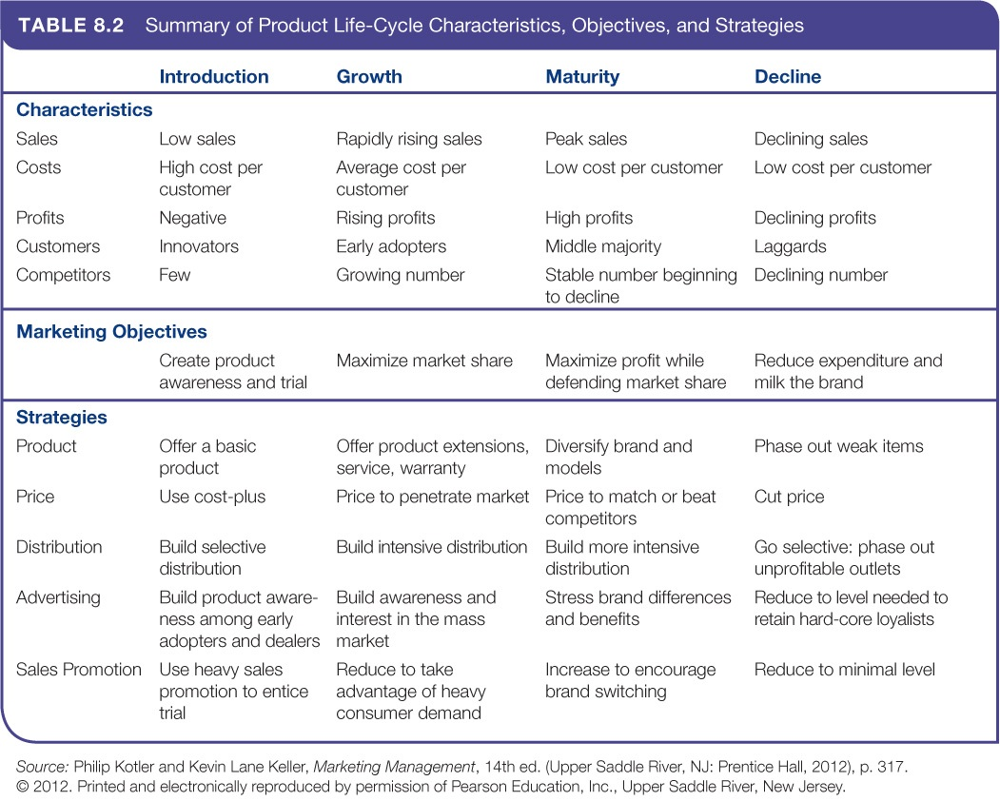

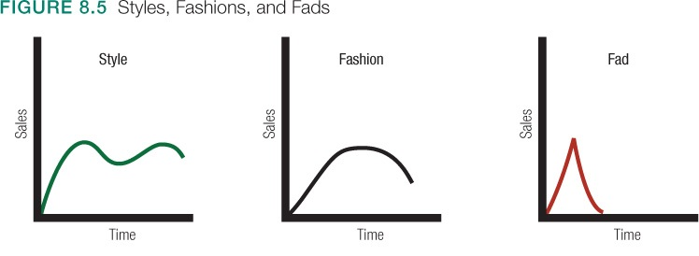

Six questions to help with predictions:
- Does it fit with basic lifestyle changes?
- What are the benefits?
- Can it be personalized?
- Is it a trend or a side-effect?
- What other changes have occurred in the market?
- Who has adopted the change?

- Product decisions:
  - Physical attributes such as quality and design
  - Packaging
  - Labelling
  - Sustainable packaging
  - Product support services

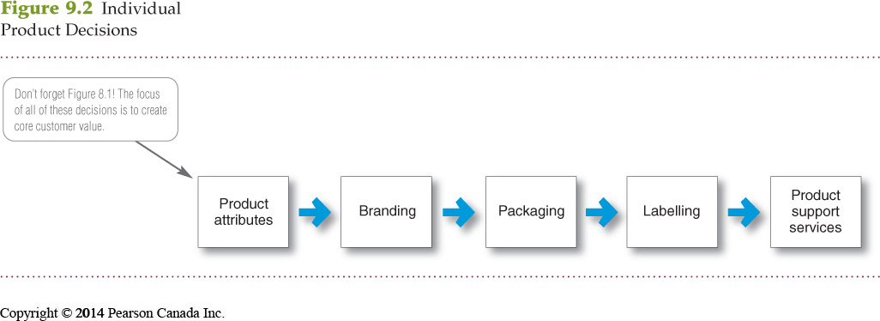

- Product attributes are the benefits of the product or service:
  - Quality
  - Features
  - Style and design
- Quality level is the level of quality that supports the product’s positioning.
- Total quality management (TQM) is an approach in which all the company’s people are involved in constantly improving the quality of products, services, and business processes.
- Conformance quality is the product’s freedom from defects and consistency in delivering a targeted level of performance.
- Product features are a competitive tool for differentiating a product from competitors’ products.
- Product features are assessed based on the value to the customer versus the cost to the company.
- Style describes the appearance of the product.
- Design contributes to a product’s usefulness as well as to its looks.
- Packaging involves designing and producing the container or wrapper for a product.
- Labels identify the product or brand, describe attributes, and provide promotion.
- Product line is a group of products that are closely related because they function in a similar manner, are sold to the same customer groups, are marketed through the same types of outlets, or fall within given price ranges.
- Product line decisions:
- Product line length
- Line filling or line stretching
- Product mix decisions deal with four dimensions:
- Width
- Length
- Depth
- Consistency

- Product mix width refers to the number of different product lines the company carries.
- Product mix length refers to the total number of items the company carries within its product lines.
- Product mix depth refers to the number of versions offered of each product in the line.
- Product mix consistency refers to how closely related the various product lines are in end use, production requirements, distribution channels, or some other way.
- Consider the example where Kraft Foods adapted the Oreo cookie for the Chinese market.
- Initially had the wrong segment
- Initially had the wrong flavour
- Packaging needed to be adapted

Services Marketing:

Government | For-Profit Businesses
Hospitals | Financial institutions
Military | Hospitality and tourism
Police and public safety | Real estate and land development
Schools | Professional services
Not-for-profit organizations | Entertainment

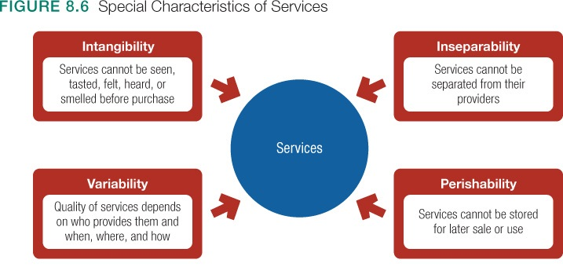

Intangibility – it is the word most commonly used to distinguish goods from services. Goods can be touched, felt, tasted before purchase. Purchasers can try on shoes at the shoe store, take a car for a test drive, or sample wine at the vineyard’s tasting room – all prior to making the purchase. To a certain extent this presents enormous challenges for service- producing companies. How do these companies entice first-time shoppers to use their services. List tactics that have drawn you into purchasing services such as a hair stylist, restaurant, or post-secondary institution.

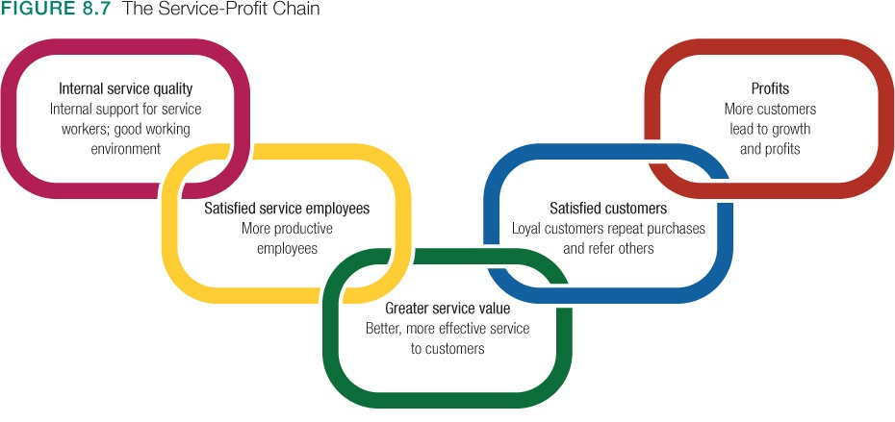

- Service-profit chain links service firm profits with employee and customer satisfaction:
  - Internal service quality
  - Satisfied and productive service employees
  - Greater service value
  - Satisfied and loyal customers
  - Healthy service profits and growth

- Internal marketing means that the service firm must orient and motivate its customer contact employees and supporting service people to work as a team to provide customer satisfaction.
- Internal marketing must precede external marketing.

- Three major marketing tasks to manage:
  - Service differentiation
  - Service quality
  - Service productivity

** Interactive marketing means that service quality depends heavily on the quality of the buyer-seller interaction during the service encounter

- Managing service differentiation creates a competitive advantage from the offer, delivery, and image of the service // higher quality than its competitors:
  - Offer can include distinctive features.
  - Delivery can include more able and reliable customer contact people, environment, or process.
  - Image can include symbols and branding.

