5.1 – Equity and efficiency
Are markets a good way to allocate scarce resources in view of the fact that they not only give rise to inequality and poverty, but also fail to capture the impacts of productive activity on non-market participants? All products generate secondary effects (mining on the environment, alcohol and tobacco on premature deaths). The analysis of markets in this larger sense involves not just economic efficiency; public policy additionally has a normative content because policies can impact the various participants in different ways and to different degrees.
Welfare economics assesses how well the economy allocates its scarce resources in accordance with the goals of efficiency and equity.
Equity deals with how society's goods and rewards are, and should be, distributed among its different members, and how the associated costs should be apportioned.
- Equity is also concerned with how different generations share an economy's productive capabilities (investing today for productive tomorrow, Greenhouse gas on the future enviro).
Efficiency addresses the question of how well the economy's resources are used and allocated.
Equity is also concerned with how different generations share an economy's productive capabilities
5.2 – Consumer and producer surplus
Consumer surplus is the excess of consumer willingness to pay over the market price.
Supplier or producer surplus is the excess of market price over the reservation price of the supplier.
Demand valuation: Highest valuation closest to the origin the consumer is willing to pay.
Reservation prices or values are the minimum prices that the suppliers are willing to accept.
(Apartment example)
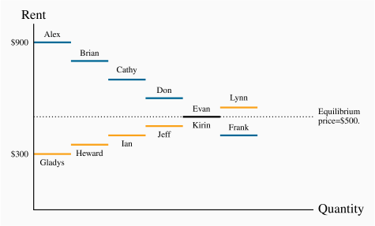
Table of 6 consumers (people looking to buy an apartment) and the amount of money each of them are willing to spend. Another table of 6 suppliers (people renting out apartments).
Equilibrium price is set at 500$. 5 apartments will be rented but the 6th, the supplier is only willing to lease it at 550, and consumer only wants it at 400. Equilibrium is 500, so each renter pays 500$ (each supplier receives 500).
The consumer surplus is the TOTAL excess of each renter (Alex willing to pay 900, but gets it at 500 =400, +Don willing to pay 600, gets it at 500=100 …).
The supplier surplus is the total excess money they got compared to their asking price (Heward was willing to sell at 350, but got 500=150 …).
Usually there are so many participants in the market that the differences in reservation prices on the supply side and willingness to pay on the demand side are exceedingly small, and so the demand and supply curves are drawn as continuous lines.
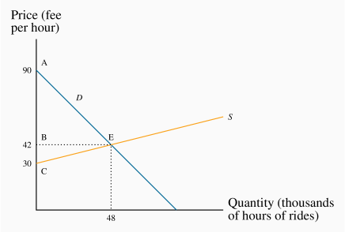
- Demand = willingness to pay (riders)
- Supply = willingness to supply (drivers)
- The demand intercept of $90 says that the person who values the ride most highly is willing to pay $90 per hour.
- On the supply side no driver is willing to supply his time and vehicle unless he obtains at least $30 per hour.
Consumer Surplus | =(demand value - price) = area ABE
 | =(1/2)×48×$48=$1,152
Producer Surplus | = (price - reservation supply value) = area BEC
 | =(1/2)×48×$12=$288
- Consumer surplus is the area ABE, supplier surplus is the area BCE.

The total surplus that arises in the market is the sum of producer and consumer surpluses, and since the units are in thousands of hours the total surplus here is ($1,152+$288) ×1,000=$1,440,000.

5.3 – Efficient Market Outcomes
An efficient market maximizes the sum of producer and consumer surpluses.
If 2 additional units are to be traded in the market (4850), consider the value of this at the margin. Suppliers value the supply more highly than the buyers are willing to pay. So on these additional 2 units negative surplus would accrue, thus reducing the total.
Second, potential buyers who would like a cheaper ride and drivers who would like a higher hourly payment do not get to participate in the market. On the demand side those individuals can take public transit, and on the supply side those drivers can allocate their time to alternative activities. Obviously, only those who participate in the market benefit from a surplus.
Third, economic environment plays a crucial role. Taxi example: Uber taxi rides is that the price varies with road and weather conditions. Poor weather conditions mean that there is an increased demand, and poor road or weather conditions mean that drivers are less willing to supply their services. When economic factors that influence the buyers' valuations (demand) or the suppliers' reservation prices (supply) change, then the efficient market outcome must be recomputed.
5.4 – taxation, surplus and efficiency
2 Fundamental tools of analysis – elasticities and economic surplus.
Consider: GST/PST taxes (ad valorem taxes, not specific) are percentage taxes.
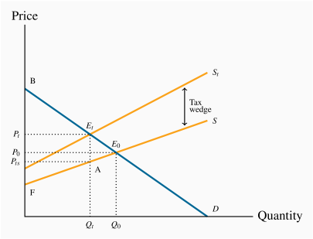
- A tax wedge is the difference between the consumer and producer prices
- Price received by the supplier is lower than original (if too high product wouldn’t sell)
- Post tax supply price (Pts)
- The revenue burden is the amount of tax revenue raised by a tax. The amount of tax revenue paid by the market participants and received by the government.
- On each of the Qt units sold, the government receives the amount (Pt−Pts (13%)).
- Tax revenue = PtEt/PtsA
The excess burden, or deadweight loss, of a tax is the component of consumer and producer surpluses forming a net loss to the whole economy.
A distortion in resource allocation means that production is not at an efficient output (because they lead the economy away from the efficient outcome).
5.5 - Market failures Externalities
An externality is a benefit or cost falling on people other than those involved in the activity's market. It can create a difference between private costs or values and social costs or values.
Externalities impact individuals who are not participants in the market in question, and the effects of the externalities may not be captured in the market price.
NEGATIVE EXTERNALITIES: (the cost to society and enviro.)
https://www.khanacademy.org/economics-finance-domain/microeconomics/consumer-producer-surplus/externalities-topic/v/negative-externalities
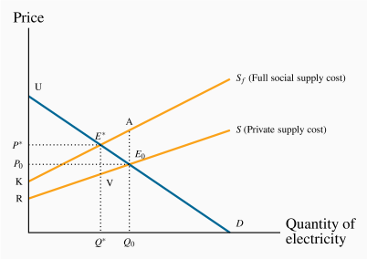
- Creates a divergence between private costs/benefits and social costs/benefits.
- S represents supply cost, Sf represents supply cost + bad air to the population. (shifts left).
- The difference between the two supply curves increases with output.
- Efficient level of production: Q*
- There is a pollution/health cost of AE0 associated with that unit of production.
- Banning pollution, society would forgo the possibility of earning the total real surplus UE∗K – advocate a policy that permits *tolerable* pollution level.
- Net benefit to society = difference between Marginal Benefit (MB or demand) and Total Marginal cost (MC) MB- TMC(with externality)shift the supply curve to the left
- Considered a benefit until new equilibrium (UE∗K).

A corrective tax seeks to direct the market towards a more efficient output. (most efficient for both sides, gov makes money and limits pollution, while supplier still makes money and isn’t harshly limited).

POSITIVE EXTERNALITIES
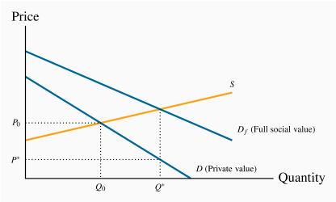
- D = demand for flu shots (willingness to pay) (private value)
- Social Value is greater, more flu shots available, less disease spread, less money spent on treating the inexistent diseases. New curve shifts upward(right)
- Convince market to switch from Q0Q* (subsidies, price reductions P0P*)

5.6 – Other market failures
- Profit-seeking monopolies, which restrict output in order to increase profits, create inefficient markets
- Or the market may not deal very well with what are called public goods. These are goods, like radio and television service, national defence, or health information: With such goods and services many individuals can be supplied with the same good at the same total cost as one individual.
- international externalities that cannot be corrected by national governments because the interests of adjoining states may differ: One economy may wish to see cheap coal-based electricity being supplied to its consumers, even if this means acid rain or reduced air quality in a neighbouring state.
- Markets may fail to supply an "efficient" amount of a good or service in all of these situations. Global warming is perhaps the best, and most extreme, example of international externalities and market failure.
5.7 -

