4.1- Price responsiveness of demand (How to measure responsiveness)
- A key component of the pricing decision is to know how responsive your market is to variations in your pricing.
- For consumers buying necessities (food) is less responsive to price changes (if food goes up in price, we will still buy). If textbooks go up in price, consumers will respond by searching for alternatives (more responsive)
- Responsiveness (how the consumer responds to change) = Elasticity
The price elasticity of demand is measured as the percentage change in quantity demanded, divided by the percentage change in price.
Price elasticity of demand (εd ) = $\frac{Percentage change in quantity demanded }{Percentage change in price}$ $\frac{\%∆Q}{\%∆P}$ $\frac{\frac{\left(Q2-Q1\right)}{Q(av)}}{\frac{P2-P1}{P(av)}}$
Average quantity Q = (Q1+Q2)/2
Average price P = (P1+P2)/2
Price($) | Qd | Elasticity value | Total revenue
10 | 0 |  | 0
9 | 1 | -9 | 9
8 | 2 | -4 | 16
7 | 3 | -2.33 | 21
6 | 4 |  | 24
5 | 5 | -1 | 25
4 | 6 |  | 24
3 | 7 | -0.43 | 21
2 | 8 |  | 16
1 | 9 | -0.11 | 9
0 | 10 |  | 0
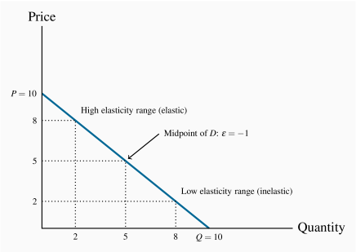
- To ensure that the elasticity value is the same regardless of whether we start at the higher price or the lower price, we use the mid-point.

- P1:10/P2:8 Average P: 10$8$ = [(10+8/2]= 9
- Q1:0/Q2:2/ Avergae Qd: 02 [(0+2)/2]= 1
- $\frac{(2-0)/1}{(8-10)/9}$$\frac{(\frac{2}{1})}{-(\frac{2}{9})}$ $-\left(\frac{2}{1}\right)x (\frac{9}{2})$ = -9
- Note that the price has declined in this instance and thus the change in price is negative. Continuing down the table in this fashion yields the full set of elasticity values in the third column.
- The demand elasticity is said to be high if it is a large negative number; the large number denotes a high degree of sensitivity.
- The term arc elasticity is also used to define what we have just measured, indicating that it defines consumer responsiveness over a segment or arc of the demand curve.
- When the price is high, a given price change represents a small percentage change, because the average price in the price-term denominator is large. At high prices the quantity demanded is small and therefore the percentage quantity change tends to be large due to the small quantity value in its denominator. In sum, at high prices the elasticity is large. By the same reasoning, at low prices the elasticity is small.

Point Elasticity of Demand:

$\frac{∆Q/Q}{∆P/P}$ $\frac{∆Q}{∆P} x \frac{P}{Q}$ $\frac{1}{SLOPE}$ x $\frac{Pa}{Qa}$

Extreme cases
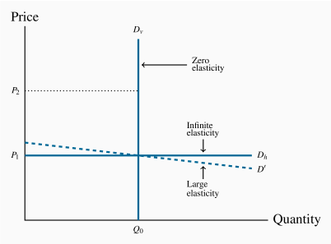
- When the demand curve is vertical, no quantity change results from a change in price from P1 to P2
- Numerator is 0, equation has elasticity value of 0
- In the horizontal case, we say that the elasticity is infinite, which means that any percentage price change brings forth an infinite quantity change
- Vertical: $\frac{1}{∞}$ x $\frac{Pa}{Qa}$ = $∞$
- Horizontal:$\frac{1}{0}$ x $\frac{Pa}{Qa}$ = 0

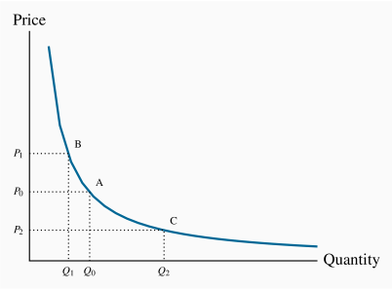

- If price increases from P0 to P1, the corresponding quantity change is given by (Q0−Q1). When the price declines to P2 the quantity increases from Q0 to Q2

Demand is elastic if the price elasticity is greater than unity. It is inelastic if the value lies between unity and 0. It is unit elastic if the value is exactly one (|Ed| = 1).

Determinants of price elasticity
Basic necessities: different tastes price variations of minimal effect on QD, thus relatively inelastic demand
How easily is it substituted? A supplier who increases her price will lose more sales if there are ready substitutes to which buyers can switch, than if no such substitutes exist.
Groups: if 1 type of tablet drops its prices, QD will spike. However if other tablet manufacturers drop their prices, the effect will be muted
Time dimension (see 4.3)

4.2-Price elasticities and public policy

- The price that generates the greatest expenditure is the midpoint of a linear demand curve
- If our existing price is high and our goal is to generate more revenue, then we should reduce the price. Conversely, if our price is low and our goal is again to increase revenue we should raise the price.
- Lower prices induce higher demand, and vice-versa: to find a middle
- The additional sales caused by the lower price need to more than compensate for this loss on the units being sold at the initial high price.
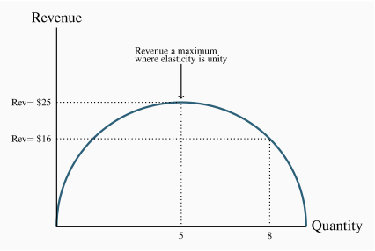
- Note next that the top part of the demand curve is elastic and the lower part is inelastic.
- A price decline (quantity increase) on an elastic segment of a demand curve necessarily increases revenue, and a price increase (quantity decline) on an inelastic segment also increases revenue.

Elastic: P - TR/ Unit Elasticity: P - TR constant/ Inelastic: P- TR
We now have a general conclusion: In order to maximize the possible revenue from the sale of a good or service, it should be priced where the demand elasticity is unity (|Ed| = 1).
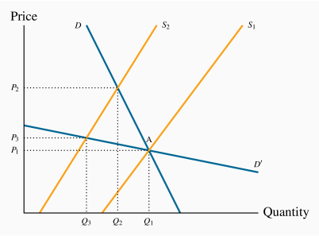
- In the lower part of the demand curve D, demand is inelastic: At the point A, a shift in supply from S1 to S2 induces a large percentage increase in price, and a small percentage decrease in quantity demanded. In contrast, for the demand curve D′ that goes through the original equilibrium, the region A is now an elastic region, and the impact of the supply shift is contrary: The %ΔP is smaller and the %ΔQ is larger.

4.3- The time horizon and inflation

4.4 – Cross-price elasticities

The cross-price elasticity of demand is the percentage change in the quantity demanded of a product divided by the percentage change in the price of another.
We write the cross price elasticity of the demand for x due to a change in the price of y as: $\frac{percentage change in quantity demandedof x}{percentage change in price of good y}$ $\frac{\%∆Qx}{\%∆Py}$
Ex. The legal price of marijuana should be just fractionally higher than the price in the illegal market. Otherwise marijuana users would avail of the illegal market supply, which is widely available and of high quality. This recommendation, if put into practice, means that tax revenue from marijuana sales will be small, but the size of the illegal market will decline substantially, thereby attaining a prime objective of legalization.
4.5 – income elasticity of demand
The income elasticity of demand is the percentage change in quantity demanded divided by a percentage change in income (is a unit free measure).
ηd = $\frac{percentage change in quantity demanded}{percentage change in income}$ $\frac{\%∆Qx}{\%∆I}$
The income elasticity of demand, in diagrammatic terms, is a percentage measure of how far the demand curve shifts in response to a change in income
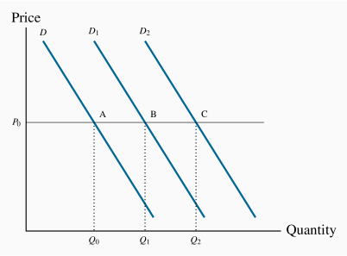
- Example for Normal Good (because the demand for it increases in response to income increases).
- Shift to D1 = change in Qd (Q1-Q0)
- Shift to D2 larger change in Qd (Q2-Q0)
- Because D2 > D1; the shift is more responsive to income. Resulting in a higher income elasticity.
- Income hasn’t changed, Qd has.
- Leftward shift in demand = negative income elasticity an inferior good.

A luxury good or service is one whose income elasticity equals or exceeds unity.
- If quantity demanded is so responsive to an income increase that the percentage increase in quantity demanded exceeds the percentage increase in income, then the elasticity value is in excess of 1, and the good or service is called a luxury.
A necessity is one whose income elasticity is greater than zero and less than unity.
- In contrast, if the percentage change in quantity demanded is less than the percentage increase in income, the value is less than unity, and we call the good or service a necessity.
Inferior goods have negative income elasticity.
- There exist higher-quality, more expensive, substitutes. For example, lower-income households tend to satisfy their travel needs by using public transit. As income rises, households normally reduce their reliance on public transit in favour of automobile use
1) if ε_{d(X, Y)} > 0 then the type of goods is a substitute.
2) if ε_{d(X, Y)} < 0 then the type of goods is a complement.
Empirical research indicates that goods like food and fuel have income elasticities less than 1; durable goods and services have elasticities slightly greater than 1; leisure goods and foreign holidays have elasticities very much greater than 1.
4.6 – Elasticity of supply
The elasticity of supply measures the responsiveness of quantity supplied to a change in the price.
$\frac{\%∆Qs}{\%∆P}$
Furthermore, and in contrast to the demand elasticity, the supply elasticity is generally a positive value because of the positive relationship between price and quantity supplied.
The more elastic, or the more responsive, is supply to a given price change, the larger will be the elasticity value. In diagrammatic terms, this means that "flatter" supply curves have a greater elasticity than more "vertical" curves at a given price and quantity combination.
4.7 – Elasticities and tax incidence
The spending and taxing activities of the government influence the use of the economy's resources. By taxing cigarettes, alcohol and fuel, the government can restrict their use; by taxing income, the government influences the amount of time people choose to work.
Tax Incidence describes how the burden of a tax is shared between buyer and seller.
Sales tax
Specific: tax involves a fixed dollar levy per unit of a good sold (e.g., $10 per airport departure).
Ad valorem: tax is a percentage levy, such as Canada's Goods and Services tax (e.g., 5 percent on top of the retail price of goods and services).
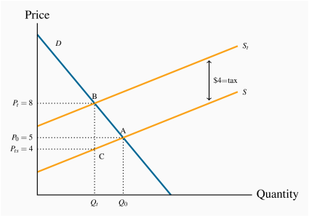
- Market for inexpensive wine
- Without tax Equi=5$ (A), Q0
- Gov imposes specific 4$ tax per bottle (upward shift in supply)
- No matter the consumer price, gov gets 4$
- consumers now face the supply curve St
- New equi = B, quantity is reduced
- Supplier is willing to supply Qt at C
- Incidence of tax falls mainly on consumer (consumer pays ¾$, supplier pays ¼$)
- Because supply is relatively elastic
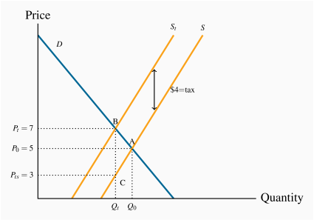
- Less elastic curve
- Price receive by supplier is lower, paid by consumer doesn’t rise much
- Consumer pays ¼$
- Supplier pays ¾$
- The supplier faces a lower supply price, and bears a higher share of the tax.
- Supplier and consumer split the tax price
- Imagine horizontal D (perfect elasticity) tax falls only on buyer
The difference between the pre-tax and post-tax equilibrium price is the portion of the tax that the consumer pays.
The difference between the tax imposed and the increase in price from the pre-tax to post-tax equilibrium price is the portion of the tax that the seller pays.
The more elastic is supply, the greater is the price increase in response to a given tax. Furthermore, a more elastic supply curve means that the incidence falls more on the consumer; while a less elastic supply curve means the incidence falls more on the supplier.

