3.1 – The marketplace

The market place is no longer a unique form, of buyers/ sellers physically interacting with one another. Some places do (supermarkets) but most are accessible online. The importance of the marketplace springs from its role as an allocating mechanism. Accommodations in private homes are supplied to potential visitors (buyers) through Airbnb. Taxi rides are mediated through Lyft or Uber. These institutions are all different types of markets; they serve the purpose of facilitating exchange and trade.
Schooling and health care are allocated in Canada primarily by government decree. In some instances the market plays a supporting role: Universities and colleges may levy fees, and most individuals must pay, at least in part, for their pharmaceuticals. Not only does it facilitate trade, it also provides a means of earning a livelihood.

3.2 – The market’s building blocks

- Demand is the quantity of a good or service that buyers wish to purchase at each possible price, with all other influences on demand remaining unchanged (negative relationship).
- Supply is the quantity of a good or service that sellers are willing to sell at each possible price, with all other influences on supply remaining unchanged (positive relationship).
- Quantity demanded defines the amount purchased at a particular price.
- Quantity supplied refers to the amount supplied at a particular price.
- Ceteris Paribus: All things being equal
  - For example, we assume on the demand side that the prices of other goods remain constant, and that tastes and incomes are unchanging. On the supply side we assume, for example, that there is no technological change in production methods. If any of these elements change then the market supply or demand schedules will reflect such changes.
Market Equilibrium
The equilibrium price equilibrates the market. It is the price at which quantity demanded equals the quantity supplied.

Excess supply exists when the quantity supplied exceeds the quantity demanded at the going price.
  - But excess supply means that there are suppliers willing to supply at a lower price, and this willingness exerts continual downward pressure on any price above the price that equates demand and supply.
Excess demand exists when the quantity demanded exceeds the quantity supplied at the going price.
  - In this situation, suppliers could force the price upward, knowing that buyers will continue to buy at a price at which the suppliers are willing to sell. Such upward pressure would continue until the excess demand is eliminated.
The short side of the market determines outcomes at prices other than the equilibrium
  - At high prices the quantity demanded is less than the quantity supplied, and it is the quantity demanded that is traded because buyers will not buy the amount suppliers would like to supply. At low prices the quantity demanded exceeds quantity supplied, and it is the amount that suppliers are willing to sell that is traded. In sum, when trading takes place at prices other than the equilibrium price it is always the lesser of the quantity demanded or supplied that is traded. Hence we say that at non-equilibrium prices the short side dominates.
3.3- Demand and Supply Curves
Demand Curve: graphical expression between price and quantity demanded (ceteris paribus)
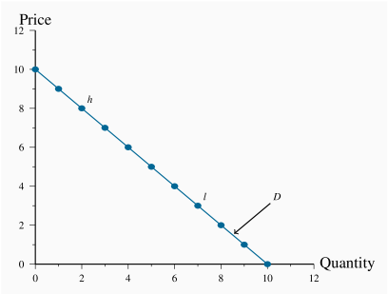
- In this case it is linear (not always)
- The demand curve slopes downward (technically we say that its slope is negative), reflecting the fact that buyers wish to purchase more when the price is less
- Demand: P=10−Q

Supply Curve: graphical expression of the relationship between price and quantity supplied (ceteris paribus).
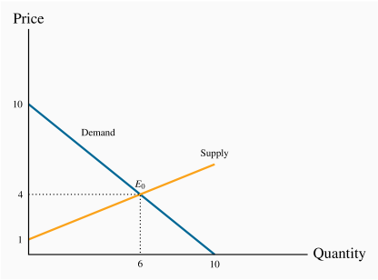
- positive slope
- Intersect at Eo Equilibrium
- At any price below this the horizontal distance between the supply and demand curves represents excess demand, because demand exceeds supply.
- Supply: P=1+(1/2)Q

3.4 – Non-price Influences on Demand
We assume all other influences on the purchase decision are unchanged (at least momentarily). These other influences fall into several broad categories: The prices of related goods; the incomes of buyers; buyer tastes; and expectations about the future.
The Price of Related goods
- Substitute goods: when a price reduction (rise) for a related product reduces (increases) the demand for a primary product, it is a substitute for the primary product. (Price of gas drops, coal becomes less desirable because it is more expensive. It is a substitute form of energy)
- Complementary goods: when a price reduction (rise) for a related product increases (reduces) the demand for a primary product, it is a complement for the primary product. (The use of a gas furnace compliments the use of gas as energy)
- Every product has substitutes and compliments: A rise in price of “x” will make the substitute more desirable. A reduction in price of a compliment (gas furnace) will make the product (gas) more desirable.
Buyer incomes – which goods to buy
The demand for most goods increases in response to income increases. Given this, the demand curve for gas will shift outward if household incomes in the economy increase. Household incomes may increase either because there are more households in the economy or because the incomes of the existing households grow.

Exceptions:
An inferior good is one whose demand falls in response to higher incomes
- For example, public transit demand may decline at any price when household incomes rise, because some individuals move to cars.
A normal good is one whose demand increases in response to higher incomes.
- More disposable income lets me buy more
Consequently, the distribution of income can be an important determinant of the demand for many commodities and services. (Countries with no real “middle class”, unable to buy things that aren’t a necessity).
Different Tastes among buyers (PS4 .v. Xbox / Fashion “In style”)
Homogeneity: items that other individuals buy or use frequently determine our own purchases. (Companies using the same computers and software’s).
Expectations / betting on future: expecting the price of gas to stay low for a few years we would tend to buy into gas. Current and future prices effect our decision. (Expectations: stock market).
Shifts in demand
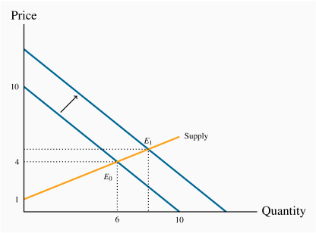
- Movement along the demand curve are solely based on price/ quantity.
- The shift represented here, could be the result of a rise in household incomes that increase the quantity demanded at every price. (SHIFT OUTWARD)
- Supply conditions are unchanged, this results in a new equilibrium (Greater quantity of purchases @ a higher price)
- The new equilibrium reflects a change in quantity supplied and a change in demand.

We could draw diagrams with all the other variables replacing price, but price plays the most important role. Focusing on price allows to the market to focus on reacting to excess supply and excess demand and try and maintain the market equilibrium.
Comparative static analysis compares an initial equilibrium with a new equilibrium, where the difference is due to a change in one of the other things that lie behind the demand curve or the supply curve. (Compare at a stopped point) Comparing one outcome with the other.
3.5 – Non-price influences on supply
We suggested earlier that the various producers of a particular good or service may have different levels of efficiency. If so, only the more efficient producers can make a profit at a low price, whereas at higher prices more producers or suppliers enter the market – producers who may not be as lean and efficient as those who can survive in a lower-price environment. This view of the world yields a positively-sloping supply curve.
Some suppliers simply choose a unique price and let buyers purchase as much as they want at that price. (Apple or Samsung: phones and electronics – fixed price with millions sold) –
This practice corresponds to a horizontal supply curve: The price does not vary and the market equilibrium occurs where the demand curve intersects this supply curve.
Fixed supply: Auctions – 1 or more items being sold at a price determined by the buyers - In this case the supply of a single property is represented by a vertical supply at a quantity of 1 unit.
SUPPLY CURVES ARE GENERALLY UPWARD
Technology – computers & fracking – Input costs
A technological advance may involve an idea that allows more output to be produced with the same inputs, or an equal output with fewer inputs.
Technology-induced cost saving is represented by moving the supply curve downward or outward: The supplier is now able and willing to supply the same quantity at a lower price because of the technological innovation. Or, saying the same thing slightly differently, suppliers will supply more at a given price than before.
Input costs: For example, a wage negotiation that grants workers a substantial pay raise will increase the cost of production. Any quantity supplied is now priced higher; alternatively, suppliers are willing to supply less at the going price.
Competing products: If competing products improve in quality or fall in price, a supplier may be forced to follow suit. This will result in the supply curve shifting downward.

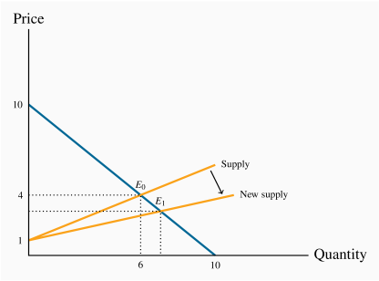
- These non-price influences are reflected by a shift in the supply curve
- The supply curve shifts, reflecting the ability of suppliers to supply the same output at a reduced price
- The resulting new equilibrium price is lower, since production costs have fallen. At this reduced price more gas is traded at a lower price.

3.6-Simultaneous supply and demand impacts
- In the real world, demand and supply frequently shift at the same time.
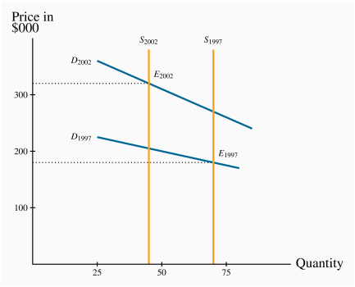
- Vertical curve (supply): means fixed number of suppliers (# of houses being sold)
- Household income & Mortgage rates (shifting demand curve upward)
- Buyers had more $, and better mortgage rates = willing to spend more
- Outward shift in demand would lead to a higher price /a reduction in supply would do likewise

- If the demand shift were strong and the supply shift weak then the demand forces would have dominated and led to a higher price. Conversely, if the supply forces were stronger than the demand forces.

3.7 – Market interventions – governments and interest groups
Quotas are physical restrictions on output.
Price controls are government rules or laws that inhibit the formation of market-determined prices.
  - Price controls come in the form of either floors or ceilings. Price floors are frequently accompanied by marketing boards.
Price ceilings: suppliers cannot legally charge more than a specific price (ex. Limits on apartment rents). In times of emergency price controls are imposed on food/supplies ot ensure that it’s not only those with income that have access. Price celling’s leave demand unsatisfied.

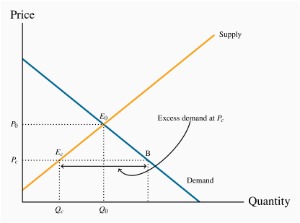
-Sudden growth in pop, rents increase. Equilibrium (Eo)
- Gov. decides it’s unfair for low/mid income class to increase rent Gov. imposes ceiling (Pc)
- This results in excess demand – Individuals want to rent more apartments then available.
- In a free market price would adjust itself to eliminate the demand, but it cannot in a controlled market.

Price floors – Minimum wage (add notes?)
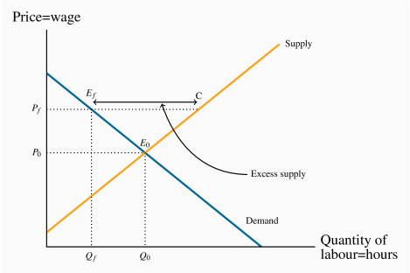
- Price floors are set above equilibrium
- Minimum wage (best example) Canadian provinces set minimum wages to protect low-skill workers
- the effective market outcome is the combination of price and quantity corresponding to the point Ef at the price floor, Pf Unemployment (more workers than needed)
Note that there is a similarity between the outcomes defined in the floor and ceiling cases: The quantity actually traded is the lesser of the supply quantity and demand quantity at the going price: The short side dominates.
Quotas- agriculture supply
- It is a means of keeping prices higher than the free-market equilibrium price. As an alternative to imposing a price floor, the government can generate a high price by restricting supply.
- In agriculture markets, farmers can supply only what they are permitted by the quota they hold
- The cost of purchasing quotas can thus easily outstrip the cost of a farm and herd.
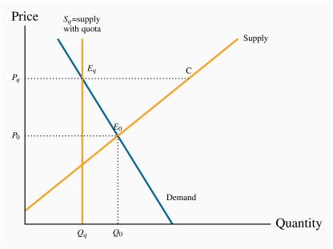
- The impact of all of these restrictions is to raise the domestic price above the free market price.
- Free market equilibrium (Eo)
- In order to raise price above (Po), Supply is restricted to (Qd)
- Producers can now produce less @ higher rate
- Total supply is restricted; otherwise production would be at C (excess supply)

A marketing board is a means of insuring that a quota or price floor can be maintained.
3.8 – Individual and market functions
Seeing as the market is composed of many individuals, with different demands
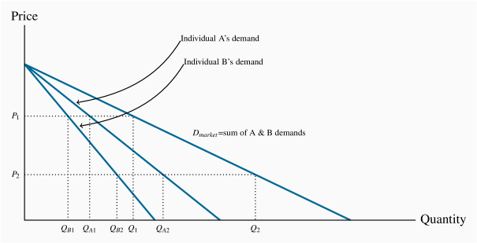
- The curves DA and DB indicate how many cookies A and B, respectively, will buy at each price.
- The market demand indicates how much they buy together at any price. At P1, Q1=QA1+QB1. At P2, Q2=QA2+QB2
- Market demand: the horizontal sum of individual demands.

