1.1 What it’s all about?
Economics is the study of human behaviour. Since it uses scientific methods it is called a social science. We study human behaviour to better understand and improve our world. During his acceptance speech, a recent Nobel Laureate in Economics suggested:
Economics, at its best, is a set of ideas and methods for the improvement of society. It is not, as so often seems the case today, a set of ideological rules for asserting why we cannot face the challenges of stagnation, job loss and widening inequality.
Christopher Sims, Nobel Laureate in Economics 2011
This is an elegant definition of economics and serves as a timely caution about the perils of ideology. Economics evolves continuously as current observations and experience provide new evidence about economic behaviour and relationships. Inference and policy recommendations based on earlier theories, observations and institutional structures require constant analysis and updating if they are to furnish valuable responses to changing conditions and problems.
Much of today's developed world still faces severe challenges as a result of the financial crisis that began in 2008. Unemployment rates among young people are at historically high levels in several economies, many government balance sheets are in disarray, and inequality is on the rise. In addition to the challenges posed by this severe economic cycle, the world simultaneously faces structural upheaval: Overpopulation, climate change, political instability and globalization challenge us to understand and modify our behaviour.
These challenges do not imply that our world is deteriorating. Literacy rates have been rising dramatically in the developing world for decades; child mortality has plummeted; family size is a fraction of what it was 50 years ago; prosperity is on the rise in much of Asia; life expectancy is increasing universally and deaths through wars are in a state of long-term decline.
Macroeconomics: the study of the economy as a system in which interactions and feedbacks among sectors determine national output, employment and prices.
Microeconomics: the study of individual behaviour in the context of scarcity.
Individual economic decisions need not be world-changing events, or motivated by a search for profit. Microeconomics is also about how we choose to spend our time and money. There are quite a few options to choose from: Sleep, work, study, food, shelter, transportation, entertainment, recreation and so forth. Because both time and income are limited we cannot do all things all the time. Many choices are routine or are driven by necessity. You have to eat and you need a place to live. If you have a job you have committed some of your time to work, or if you are a student some of your time is committed to lectures and study. There is more flexibility in other choices. Critically, microeconomics seeks to understand and explain how we make choices and how those choices affect our behaviour in the workplace, the marketplace, and society more generally.
A critical element in making choices is that there exists a scarcity of time, or income or productive resources. Decisions are invariably subject to limits or constraints, and it is these constraints that make decisions both challenging and scientific
Microeconomics also concerns business choices. The individual business operator or firm has to decide what to produce, how to produce it, how to sell it and in many cases, how to price it. To make and sell pizza, for example, the pizza parlour needs, in addition to a source of pizza ingredients, a store location (land), a pizza oven (capital), a cook and a sales person (labour). If revenue of from the sales > costs of production = Profit. No profit = failed businesss.
Paradox thrift
But one household's spending is another household's income. For the economy as a system, an increase in households' saving from say 5 percent of income to 10 percent reduces spending accordingly. But lower spending by all households will reduce the purchases of goods and services produced in the economy, and therefore has the potential to reduce employment and national incomes. Furthermore, with lower income the troublesome debt-to-income ratio will not fall, as originally intended. Hence, while higher saving may work for one household in isolation, higher saving by all households may not. The interactions and feedbacks in the economic system create a 'paradox of thrift'.
European economies with high debt loads cut spending and increased taxes to in order to balance their fiscal accounts. But this fiscal austerity reduced employment and the national incomes on which government tax revenues are based, making deficit and debt problems even more difficult. (Greece).

Mixed economy: goods and services are supplied both by private suppliers and government. ( (P)coffee, wireless network ….(G) Law enforcement and health care).
- Offer wide range of goods/services at various prices
- Use income to get what the individual wants
- Business sell goods in hopes to yield profits & cover costs
- Allows specialization & separation between production and use
  - Rather than each individual growing her own food, for example, she can sell her time or labour to employers in return for income. That income can then support her desired purchases.
- If Business can produce food more cheaply than individual; individual gains by acquiring food for less + working and making money. Extra income for desired goods
- Economics aims to explain how specialization yields gains for individuals in society
- Individuals goal = maximize profit/happiness
- Important government focus.
  - Gouv. Accounts for more than 1/3 of economic activity in modern mixed markets
  - Supply’s goods & services: health an education

1.2 Understanding through use of models
Model: is a formalization of theory that facilitates scientific inquiry.
- First, it is a stripped down, or reduced, version of the phenomenon that is under study.
- incorporates the key elements while disregarding what are considered to be secondary elements
- Accord with reality
- Be able to make meaningful predictions
Theory: is a logical view of how things work, and is frequently formulated on the basis of observation.
Ex. As an example of an economic model, suppose we theorize that a household's expenditure depends on its key characteristics: A corresponding model might specify that wealth, income, and household size determine its expenditures, while it might ignore other, less important, traits such as the household's neighbourhood or its religious beliefs.
The model reduces and simplifies the theory to manageable dimensions. From such a reduced picture of reality we develop an analysis of how an economy and its components work. A THEORY IS REQUIRED TO FORMULATE A MODEL
1.3 Opportunity Cost
No such thing as free. Everything has an opportunity cost. That cost may be financial; it may be measured in time, or simply the alternative foregone
Opportunity cost: What must be sacrificed when a choice is made.
Individuals and organizations have different opportunity costs that they enter into exchange agreements.
Ex. If you are a skilled plumber and an unskilled gardener, while your neighbour is a skilled gardener and an unskilled plumber, then you and your neighbour not only have different capabilities, you also have different opportunity costs, and you could gain by trading your skills
This “sensible” solution: Both parties achieving objectives while minimizing input – resembles the solution presented by the marketplace (see Specialization in1.2). Buying Services, Selling your Services.

1.4 A Model of Exchange and Specialization
 | Hours/ Fish | Hours/ veg. | Fish Specialization | Veg. Specialization
Amanda | 3 | 2 | 12 | 18
Zoey | 2 | 4 | 18 | 9

Each producer has a time allocation of 36 hours. By allocating total time to one activity, Amanda can produce 12F or 18V, Zoe can produce 18F or 9V. By splitting their time each person can also produce a combination of the two (A: 6F, 9V) (Z: 9F, 4.5V)

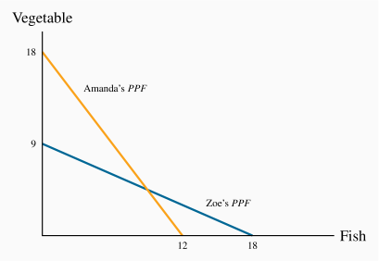
- They can’t produce goods beyond this line ()
- You can produce goods below the line, but you would not be using all her time (ex. Amanda :4F, 4V = 20hr)
Amanda is more efficient in producing V & Zoe is more efficient at producing F.
(PPF) Production Possibility Frontier: It is the combination of goods that can be produced while using all of the resources available (time).
Consider opportunity cost of this scenario (Amanda)
- For each unit of F she wishes to produce, it is evident from her PPF that she must sacrifice 1.5 units of V (3hr(f)/2hr(v))3/2 1.5
- This is because F requires 50% more hours than V. Her trade-off is 1.5:1.0.
- She could give up 18 units of V and produce 12 units of F instead; this again is a ratio of 1.5:1.0
Consider opportunity cost of this scenario (Zoey)
- Opportunity cost: 0.5 :1 (2hr(f)/4hr(v)) 2/40.5
- she must sacrifice one half of a unit of V to free up enough time to produce one unit of F

∴
- If both specialize, both can produce more than the other in area of expertise.
- Both of their opportunity costs are different, this translates into potential gains for each individual
Gains from Exchange
- If these individuals are self-sufficient, in the sense that they consume their own production, each individual's consumption combination will lie on their own PPF
- In the absence of exchange, PPF = CPF
Consumption Possibility Frontier (CPF): the combination of goods that can be consumed as a result of a given production choice
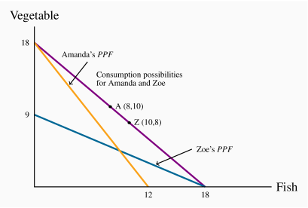
- Specialization & Trade rate = 1:1
- If Amanda trades 8V Zoe in return for 8F, Amanda moves to the point A(8,10) and Zoe to Z(10,8).
- A (0,18)(8,10)
- Z (18,0)(10,8)

Next they must agree to a rate at which to exchange V for F.
Since Amanda's opportunity cost is 1.5:1 and Zoe's is 0.5:1, suppose they agree to exchange V for F at an intermediate rate of 1:1 (1F=1V)
*They can now produce at their max (in Specialization) and trade at equal rate 1:1*
Consumption well-being has improved.
Post-Specialization Pre-Specialization (If Amanda wanted 8F & Zoey wanted 8V...)
A (0F, 18V) (8F, 10V) - A (8F, 6V)
Z (18F, 0V) (10F, 8C) - Z (2F,8V)

Trade is therefore not a zero-sum game. It has a positive net value because both parties can gain.
Zero-sum game: is an interaction where the gain to one party equals the loss to another party
1.5 Economy Wide Production Possibilities
The economy-wide PPF is the set of goods and services combinations that can be produced in the economy when all available productive resources are in use.
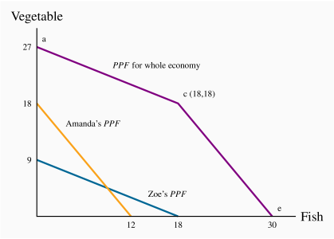
- The point on the V axis, a=27, represents the total amount of Vthat could be produced if both individuals devoted all of their time to it.
- The point e=30 on the horizontal axis is the corresponding total for fish.

Economy-wide PPF: the set of goods and services combinations that can be produced in the economy when all available productive resources are in use.
Ex. All resources are focused on Vegetables (0, 27)
- consider a reduction in V and an increase in F
- Most efficient way: Use individual whose OC is lower (Zoey 0.5 vs. Amanda 1.5)
- If we want more F, Zoey should do it (her specialization) until she has exhausted her time resource (18F) Economy Will be producing c(18,18)
- If economy wants to produce more F, V will be reduced by 1.5V/1F – represented by segment ce
- Graph is concave (kink outward)

Now, consider the PPF if the economy were composed of many persons with differing specializations. We would have a segment for each individual which would continue to have an outward concave form. (ex. A 4 person economy) represented by abcde
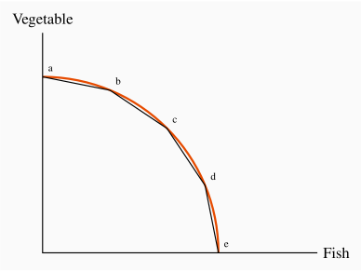
- As we produce less V and more F we progressively bring into play resources, or individuals, whose opportunity cost, in terms of reduced V is higher.
- This examples consider a work week of 36h
- In the case where workers work 36h+, PPF would be represented by an outward movement

1.6 Aggregate output, growth and business cycles
Aggregate Output: defined as output per worker or per hour, depends on
- Skill, Knowledge and experience of the labour force
- Capital Stock: Buildings, machinery, equipment and software the labour force has to work with
- Current state of technology
An economy's capital stock is the buildings, machinery, equipment and software used in producing goods and services.
Economy output is defined by Y; Y=(number of workers employed)×(output per worker)
Full employment output = that everyone willing to work at current wage rates and normal hours of work is working Yc=(number of workers at full employment)× (output per worker).
Now, suppose economy is operating with full employment of resources producing Goods & Services.
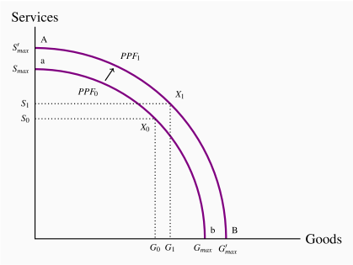
- Shows dif. Combination of G&S an economy can produce in a year using all resources (labour, capital, tech. avail at the time)
- Seen as an outward shift, seeing as we can produce more in both sectors (G&S)
(CONTINUE 1.6 p.4)
2 Broad categories of output:
Goods: products of agriculture, forestry, mining, manufacturing and construction industries
Services: provided by the wholesale and retail trade, transportation, hospitality, finance, health care, education, legal and other service sectors.
Output structures differ among economies with different income levels.
- High-income economies spend more on services than goods and produce higher ratios of services to goods.
- Middle income countries produce lower ratios of services to goods.
- Low income countries much lower ratios of services to goods.
Economic Growth
- The labour supply grows as the population expands
- the stock of capital grows as spending by business (and government) on buildings, machinery, information technology and so forth increases
- Labour-force productivity grows as a result of experience, the development of scientific knowledge combined with product and process innovations, and advances in the technology of production.
- All together these developments expand capacity output over time

Goal is to minimize unemployment (operating as close to the PPF as possible). Unpredictable changed occur in the business world (future profits, in consumer confidence, in financial markets, in commodity and energy prices, in the demand conditions in major trading partners, in government policy and many other events disrupt patterns of expenditure and output).
When these change the level of total expenditure (total demand output), some effect production (economies production capacity)
If expenditures on goods and services decline, the economy may experience a Recession: occurs when output falls below the economy's capacity output (unemployment rises).
Alternatively, times of rapidly growing expenditure and output may result in an economic boom: a period of high growth that raises output above normal capacity output (employment rises)
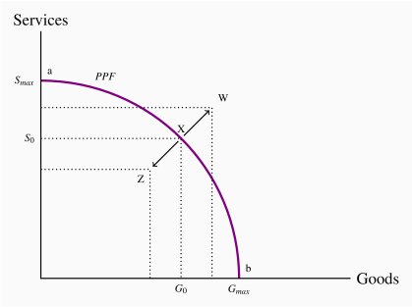
- Economic recession leave economy below normal (Z)
- Economic booms put economy above normal (W)

Recession
- Expenditures on goods and services have declined.
- Output is less than capacity output, unemployment is up and some plant capacity is idle.
- Labour income and business profits are lower.
- More people would like to work and business would like to produce and sell more output, but it takes time for interdependent product, labour and financial markets in the economy to adjust and increase employment and output
- The use of monetary and fiscal policies may be helpful to stimulate demand(lower taxesmore spending money), increase output and employment( create jobs)

Boom
- Increase in demand = increase in output and employment
- This would increase income and expenditures and effect higher output
- Economy would now use its resources more intensively
- Unemployment would fall, work would increase
- Extra production run equipment for longer than it can sustain
- “overworked” and now unsustainable

