Take a Cold Drink! An Analysis of Heat Transfer
By: Brittany Meraw 300006763 & Lyndsay Tran 300018762

For the course: CHM1311-F01
To TA: Tom Burns
Section: Tuesday 2:30-5:30 F01

Tuesday, September 26th, 2017
uOttawa Department of Chemistry and Biomolecular Science

Introduction:
The enthalpy of a reaction is defined as heat energy released or added to the system when a reaction occurs, thereby the change of heat energy. For endothermic reactions, enthalpy is denoted as positive, because heat is added to the reaction. Contrarily, for exothermic reactions, it is considered negative because it is released from the reaction. Enthalpy is calculated with the equation,
q=mcΔT
where q is enthalpy in joules, J, m is mass in grams (g), c is specific heat capacity in g/J℃, and ΔT is the change in temperature in degrees Celsius, ℃. The specific heat capacity refers to the amount of heat in joules that is required to raise one gram of the substance by one degree Celsius.
Heat energy is measured in temperature, which is also known as the average kinetic energy. In chemistry, it is important to note that energy is stored inside the bonds of chemical compounds. For the purposes of this lab, the ionic compound ammonium chloride (NH₄Cl) will be used; the energy between ammonium and chlorine ions will come from its dissociation in water, and will convert itself into heat energy, as energy is conserved in a closed system. For this specific type of reaction, the enthalpy is considered the enthalpy of dissolution. As shown in the Calculations, theoretically, 14.7g should be enough to raise 225 mL of water by exactly 5ºC.
Calorimetry is a method of measuring the heat transfer of a reaction. Heat energy can be transferred through conduction, convection, or by radiation. In concerns to calorimetry, heat is transferred via conduction. Styrofoam cups are often used as calorimeters because of its ability to insulate the heat of a reaction. It is important to maintain a closed system while measuring the enthalpy of a reaction so that none of the heat escapes into the external surroundings.
Both NH₄Cl and ammonium nitrate (NH₄NO₃) were considered for use in cooling down the product. The cost of these salts are $62.40/500g, and $64.52/500g respectively. NH₄Cl is the more cost-effective salt to use for production of the Gee Gee’s sports drink, however in hindsight, the cost is negligible and other aspects should be considered. According to MSDS labels, NH₄Cl is corrosive and irritating to the eyes and skin. It is however safer than using NH₄NO₃, which is a substance used in the production of bombs, which would not comply with the Health and Safety requirements. Due to its explosive nature, NH₄NO₃ is not available for purchase in bulk, whereas NH₄Cl is. Therefore, for this lab, NH₄Cl is used to safely cool the energy drink, as it has more predictable results. Additionally, NH₄Cl has a lower solubility than NH₄NO₃, which is beneficial to be more efficient with the quantity of salt.

Materials:
- 50 mL graduated cylinder
- 65 g of NH₄Cl
- 5 x 225 mL of distilled water
- LabQuest 2
- Temperature Probe
- Aluminum can
- Coffee cup calorimeter
- Electronic scale
- Stir stick

Procedure:
- A 50 mL graduated cylinder was used to measure 100 mL of the distilled water and it was poured into the can.
- A 50 mL graduated cylinder was used to measure 125 mL of distilled water which was poured in the calorimeter.
- LabQuest 2 was turned on and the temperature probe was attached.
- The can was placed inside the calorimeter and it was ensured that the can did not float above the top of calorimeter. The lid was placed on the calorimeter and the temperature probe was placed inside the calorimeter.
- The initial temperature was recorded.
- A scale was used to used to obtain the approximate mass of 9g. The exact mass reading from the scale was recorded.
- The ammonium chloride was added to the distilled water in the calorimeter and a stir stick was used to clarify that the solution had dissolved completely. The lid was placed back on the calorimeter immediately.
- The system was allowed to react to its lowest temperature before the final temperature was recorded.
- Steps 1 to 8 were repeated for 11g, 13g, 15g, and 17g.
- The solid waste and the liquid waste was disposed of in the designated waste bins.
- Waste disposal precautions were taken to ensure safe disposal.

Observations:
- The salt NH₄Cl is a white crystal solid and water is a clear colourless liquid.
- The reactions took less than 5 minutes to finish.
- The solution was a cloudy white when the water and NH₄Cl were mixed.

Table 1: Change of Temperature (℃) as Mass (in grams) is Increased
Mass of Can (g) | Mass of NH₄Cl (g) | T_{i} (℃) | T_{f} (℃) | ∆T (℃)
8.21 | 9.050 | 20.60 | 18.80 | -1.300
8.76 | 11.03 | 21.90 | 18.30 | -3.600
8.92 | 13.06 | 22.10 | 18.30 | -3.800
8.21 | 15.04 | 22.00 | 17.40 | -4.600
8.76 | 17.10 | 20.40 | 15.70 | -4.700

Figure 1: Relationship between Change of Temperature (℃) and Mass of NH₄ (g)
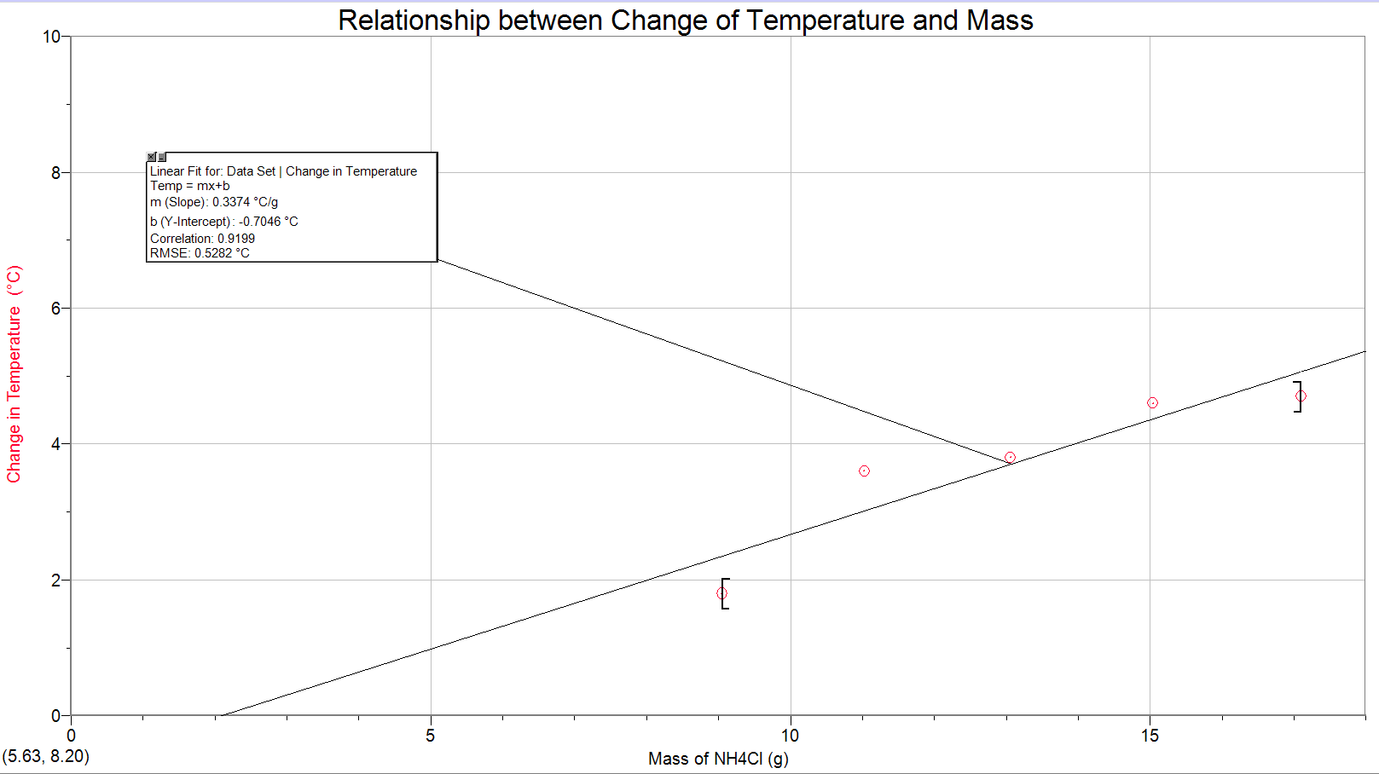
Calculations:
Ex. Heat energy
q_{can}= mc∆T
= (8.760g)(0.900J/g℃) (-5℃)
= 39.42 J
q_{water}=mc∆T
= (225 g)(4.185J/g℃)(-5℃)
= 4708.125 J
q_{salt}=q_{water} - q_{can}
= 4708.13 J - 39.42 J
= 4668.71 J = 4.66 kJ
Ex. Enthalpy of Dissolution
∆H_{sol}= ∆H_{lat} + ∆H_{hyd} NH₄Cl ⁺+ ∆H_{hyd} Cl⁻
= -(-705 kJ/mol) + (-307 kJ/mol) + (-381 kJ/mol)
= 17 kJ/mol
Ex. Theoretical Mass of NH₄Cl
m_{NH4Cl} = q_{salt} / ∆H_{sol} * molar mass of NH₄Cl
=(4.66 kJ) / (17 kJ/mol)
= 0.27523 mol
= (0.27523 mol)(53.5g/1 mol)
=14.7 g
Ex. Change in temperature
∆T=T_{f}-T_{i}
=18.80℃ - 20.60℃
=1.300℃
Ex. Actual mass of NH₄Cl to be used
m = (1/slope of graph)(∆T)
=(1/0.3374℃/g)(5℃)
=14.8 g

Discussion:
Firstly, Figure 1 shows a positive, and linear relation for the change in temperature as a function of the mass of NH₄Cl. The slope of the line of best fit is 0.3374℃/g, and the y-intercept was -0.7046℃. The slope represents the average change of temperature that occurred when one gram of NH₄Cl dissociated in water. Since the y-intercept is negative, it is evident that there were some errors in performing this lab. Theoretically, the line of best fit should pass through the origin (0,0); there should be no change in temperature when zero mass is added because there is no reaction occurring, and therefore no bond energy being transferred to heat energy.
As seen in Table 1, the mass that had the closest temperature change to 5℃ was 17.10 g, with 4.7℃. In Figure 1, a positive correlation is represented, meaning that to obtain 5℃, more mass would be needed. As mentioned in the Introduction, the theoretical mass of NH₄Cl needed was 14.9g. There are a few aspects of the experiment that could have contributed to the necessity for more NH₄Cl than called for. This contributed to the actual mass of NH₄Cl used which was 14.8g. The values for the ammonium chloride differ because the change of temperature was not exactly 5℃ and the theoretical mass was calculated based on this value. The actual change of temperature was 4.7℃ and since this value is less than 5℃ the required mass is lower.
Regarding sources of error, notably, there was residue of crystallized salt on the outsides of the cans before the trials began. Even with cleaning the can beforehand, there was still salt present. This excess salt would have altered the reaction because it would have taken in some of the heat released from the reaction which would have lowered the measured change in temperature from the drink inside the can. Moreover, the lid of the calorimeter did not close all the way which affected the measured heat of the system. As stated in the Introduction, calorimetry is only accurate in a closed or isolated system. By having a lid that did not close all the way, the system became an open system, which could have allowed heat to escape, instead of transferring all heat to the contents inside the can.
Since different pairs were performing trials for each mass, different sets of equipment were used. In specific, the aluminum cans that were used had different masses. Although it could be thought of as a significant source of error, this did not contribute a substantial amount of error because the specific heat capacity of aluminum is only 0.9g/J℃. The range in masses of the cans (8.21g, 8.76g, 8.92g) was only 0.71g. This would not have had any major impact on the reactions’ heat transfers.

Conclusion:
Conclusively, the mass of NH₄Cl needed to cool the Gee Gee’s sports drink by 5ºC is 14.8 grams.

References
Calorimetry. (n.d.). Retrieved October 02, 2017, from http://www.science.uwaterloo.ca/~cchieh/cact/c120/calorimetry.html
Helmenstine, P. A. (n.d.). What Is Enthalpy? Retrieved October 02, 2017, from
https://www.thoughtco.com/definition-of-enthalpy-605091

Methods of Heat Transfer. (n.d.). Retrieved October 02, 2017, from
http://www.physicsclassroom.com/class/thermalP/Lesson-1/Methods-of-Heat-Transfer

Torres, F., Kuhn, P., De Bruyker, D., Bell, A., Wolkin, M., Peeters, E., . . . Bruce, R. (2004). Enthalpy Arrays. Proceedings of the National Academy of Sciences of the United States of America,101(26), 9517-9522. Retrieved from http://www.jstor.org/stable/3372488

T., & V. (2005, November 10). Material Safety Data Sheet Ammonium chloride MSDS. Retrieved October 02, 2017, from http://www.sciencelab.com/msds.php?msdsId=9927431





