Lab #2 - The Kinetic Study of Nucleophilic Substitution

Student Names and Numbers: Humaira Mahfuz 8878921 and Maddie Bradey 8665839

Tuesday October 3rd, 2017

TA: Jesse Brown

CHM2123

Introduction:

This experiment aimed to target the topic of kinetics. Often times, an experiment can produce the desirable products, but the reaction may be too slow so it is deemed useless on an industrial scale. Hence, the study of kinetics enables us to identify whether the product can be made within a reasonable and cost-efficient time. To aid the reaction, it is vital to ensure optimal conditions are used to produce the best yield of product. In kinetics, the reaction conditions can be systematically altered to find out the ideal conditions that favours the products. The following parameters contribute towards finding the ideal conditions: temperature, pressure and catalyst. In this experiment, the concentration was changed over time to influence the rate of reaction. There are multiple methods of approach available to be able to monitor rate of reaction, one of which is through the monitoring of the disappearing reactant or the formation of product over time. The generalized equation of a reaction can be expressed as follows:
A + B C + D
where, A and B are the reagents and C and D are the products formed. The rate of reaction, r, can be shown in the following way:
r = k[A]^{x}[B]^{y}
The rate equation is given as the function of concentrations of reactant A and reactant B, multiplied by a rate constant, k.

In this lab, there were two reactions that were observed: S_{N}1 and S_{N}2. The aim was to determine rate of each reaction, which would lead to the determination of the rate constant and the order of each reaction. S_{N}1 reactions occur when an ideal leaving group, predominantly a weak base, leaves the molecule at the alpha carbon, with a carbocation intermediate remaining. The carbocation intermediate increases in thermodynamic stability as the degree of the carbocation increases.The nucleophile then attacks the alpha carbon of the carbocation species and donates its lone pair of electrons to the carbocation, thus forming a new bond.

Similarly, the principle for S_{N}2 reactions bears some resemblance to that of S_{N}1 reaction however, both the nucleophile and the electrophile are involved in the rate determining step. In S_{N}1 reactions, the rate determining step involves the substrate, and this reaction is often characterized by the presence of a strong leaving group on the organic compound and therefore does not require the nucleophilic attack to induce leaving. In S_{N}2 reactions, it is vital that the nucleophile is strong enough to stimulate the detachment of the leaving group.

In part A of the experiment, the aim was to be able to measure the rate of the reaction of the mechanism below (figure 1). By titrating with hydrochloric acid (HCl), the consumption of potassium hydroxide (KOH) can be measured at different time points. This is enabled through the use of an indicator such as phenolphthalein. The indicator is pink in alkaline conditions but as all the potassium hydroxide is neutralized and the solution turns slightly acidic, the solution will become colourless, thus the end point can be observed. Knowing the concentration differences between each time point allows for both the reaction constant, k, and the order of the reaction to be found.

In the mechanism below, an S_{N}2 reaction between 1-bromobutane and KOH can be observed. This is the following rate equation:
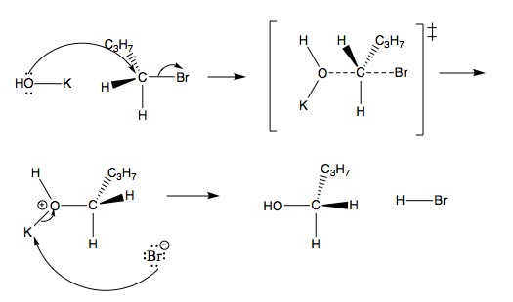
Rate= k [KOH] [R-Br]
Figure 1: The mechanism of the S_{N}2 reaction with 1-bromobutane and KOH.

In part B, the solvent conditions were changed to identify the effect it would have on the rate of reaction. The solvent conditions were changed from protic to aprotic conditions. The reaction involved the hydrolysis of tert-butyl chloride in the presence of water. The reaction mechanism is shown below in figure 2.
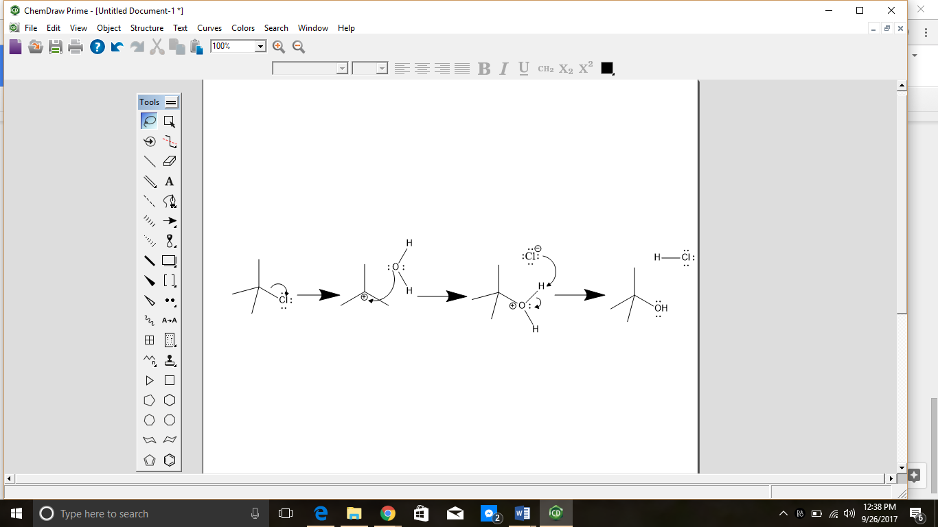
Figure 2: Mechanism of S_{N}1 Reaction between tert-butyl chloride and water

The hydrolysis of tert-butyl chloride undergoes an S_{N}1 mechanism, where tert-butyl chloride behaves as the electrophile and water molecules behave as a nucleophile. This reaction prefers the S_{N}1 mechanism pathway since the α-carbon is attached to three methyl groups so a tertiary carbocation will be produced. Due to the presence of the electron-donating methyl groups, the positive charge on the α-carbon will be stabilized thus reducing it’s energy. In addition to this, the presence of three methyl groups also present the nucleophile with steric hindrance and so the S_{N}1 mechanism is preferred. The chlorine bonded to the α-carbon is a good leaving group and they are often distinguished by being the conjugate bases of strong acids. The chlorine is weakly basic and since it is highly electronegative, it is relatively stable in its anionic state. Thus, the α-carbon does not need to be attacked by a nucleophile to induce the leaving of chlorine. The rate determining step of a S_{N}1 mechanism is characterized by the formation of the carbocation and so only the electrophile influences the rate of reaction. Once the rate determining step is complete, the nucleophile will proceed to attack the carbocation. The leaving group, a chloride ion, will combine with protons to form hydrochloric acid. The formation of hydrochloric acid enables bromothymol blue to change colours thus the solution turns yellow. The indicator is blue in the presence of a base whereas in the presence of an acid, the indicator changes to yellow. Thus, the colour change from blue to yellow was used as an indication of when the reaction ended. Since this reaction follows the S_{N}1 pathway, it is expected to obtain the following rate equation:
Rate = k[electrophile],

Where k represents the rate constant and the electrophile is tert-butyl chloride. The data collected will be used to obtain 1/[electrophile], which will then be used to plot a graph against time. A S_{N}1 reaction will produce a linear slope when 1/[electrophile] is plotted against time and through graphical analysis, the rate constant can be identified too.

Protocol:
View the laboratory manual from pages 40-44.

Modifications: In part A step 6, only 2mL was taken from the reflux condenser at the sixty minute time point.

McGilvary, Katherine. (2017). Experiment 2: The Kinetic Study of Nucleophilic Substitution. Laboratory of Organic Chemistry II. Pages 35-44.

Observations and Results:

Part A: Table 1 showing reagents involved in S_{N}2 Mechanism
Reagent | Observation | Key Step | Observation of Key Step
1-bromobutane | Clear and colorless liquid | Added to the round bottom flask | N/A
Potassium Hydroxide (KOH) and Ethanol (C₂H₆O) | Clear and colorless liquids | Added to the round bottom flask | Once both of these were added, the mixture began to bubble

Part B: Table 2 showing reagents involved in S_{N}1 Mechanism
Reagent | Observation | Key Step | Observation of Key Step
Sodium hydroxide solution | Clear and colourless liquid | Addition to acetone & distilled water | No change in colour.
Tert-butyl chloride | Clear and colourless liquid | Addition to acetone, distilled water, sodium hydroxide and bromothymol blue | Colour change from light blue to light yellow
Bromothymol blue | Blue liquid | Addition to acetone, distilled water and sodium hydroxide. | The solution goes from colourless to light blue.

Table of Reagents:
Part A: Table 3 showing measurements of reagents for S_{N}2 mechanism
Reagent | Molar Mass (g/mol) | Quantity  (mL) | Density (g/mL) | mmol | Eqiuvalents
0.5 M 1-bromobutane | 137.02 | 40 | 1.27 | 20 | 1
Hydrochloric Acid (HCl) | 36.46 | 25 | 1.19 | 2.5 | N/A
2M Potassium Hydroxide (KOH) | 56.11 | 10 | 2.12 | 20 | 1
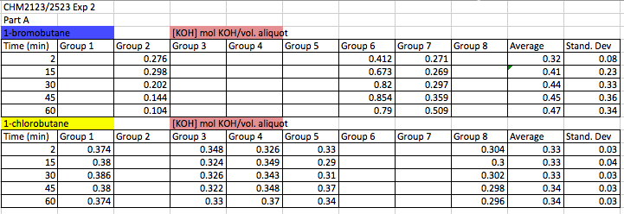
Figure 3. The TA data from experiment 2 with the average and standard deviation. Group 6 is the data collected from our group.

Part B: Table 4 showing measurements of reagents for S_{N}1 mechanism
Reagent | Molar Mass (g/mol) | Quantity  (mL) | Density (g/mL) | mmol | Eqiuvalents
Distilled Water | 18.0 | 12.5 | 1.00 | 694.44 | 25.52
Tert-butyl chloride | 92.6 | 3.0 | 0.84 | 27.21 | 1
Acetone | 58.1 | 3.0 | 0.79 | 40.79 | -
Sodium Hydroxide solution | 40.0 | 1.5 | 2.14 | 80.25 | 2.95

Table 5 showing group data vs personal data
Conversion | Average Time (Seconds)
Conversion | Group |  |  |  | Personal Data
Conversion | 85:15 H₂O:Acetone | 70:30 H₂O:Acetone | Standard Deviation for 85:15 H₂O:Acetone | Standard Deviation for 70:30 H₂O:Acetone | 85:15 H₂O:Acetone | 70:30 H₂O:Acetone
10% | 11.94 | 54.13 | 3.09 | 23.50 | 8.00 | 93.60
20% | 21.12 | 158.95 | 3.36 | 39.52 | 20.67 | 126.00
30% | 66.85 | 304.81 | 16.08 | 74.94 | 44 | 256.00
40% | 159.53 | 481.09 | 84.54 | 139.43 | 75.33 | 305.33

Calculations:

Part A:
To find the [KOH] neutralized:
Using the 2 minute time point: Mols of [KOH] = 0.0021, V aliqout (L) = 0.0051L
Mol [KOH] / volume of aliquot (L)
(0.0021mol of KOH) / (0.0051L) = 0.412M
Therefore the concetration of KOH neutralized is 0.412M.

Part B:
- Finding out the [tBuCl] remaining in the solution after 10% conversion
Initial concentration of tert-Butyl Chloride: 0.10M
Finding out concentration of tert-Butyl Chloride after dilution:
C₁V₁=C₂V₂
(0.1M) x (0.003L) = C2 x 0.02L
C2 = 0.015M
After 10% conversion, 90% of tert-Butyl Chloride will be left in the solution.
So, [tBuCl] = 0.015 x 0.9 = 0.0135M

2. Finding out ln([tBuCl])
[tBuCl] = 0.0135M
ln(0.0135) = -4.31
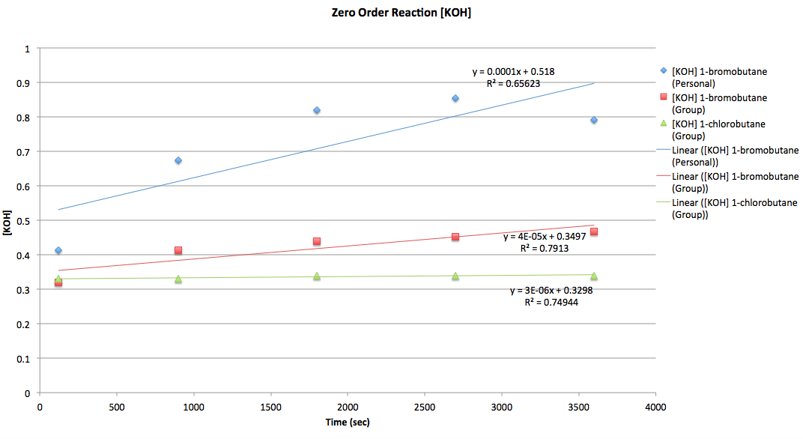
Graphs:
Figure 4: Graph showing [KOH] vs Time for a 2nd order reaction
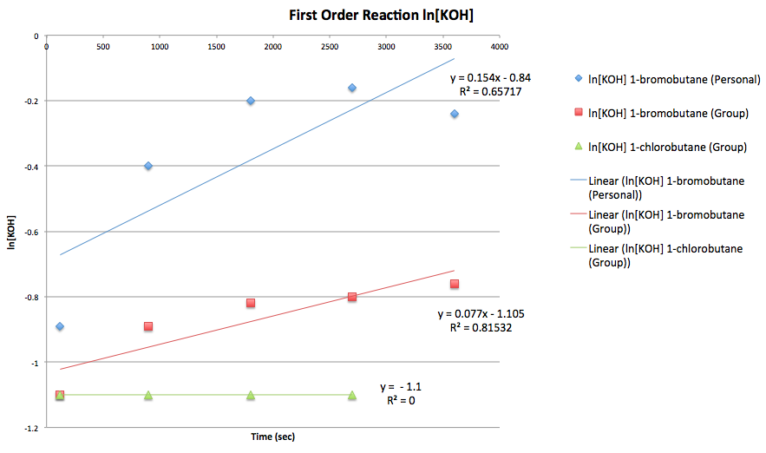
Figure 5: Graph showing ln[KOH] vs Time for a 2nd order reaction

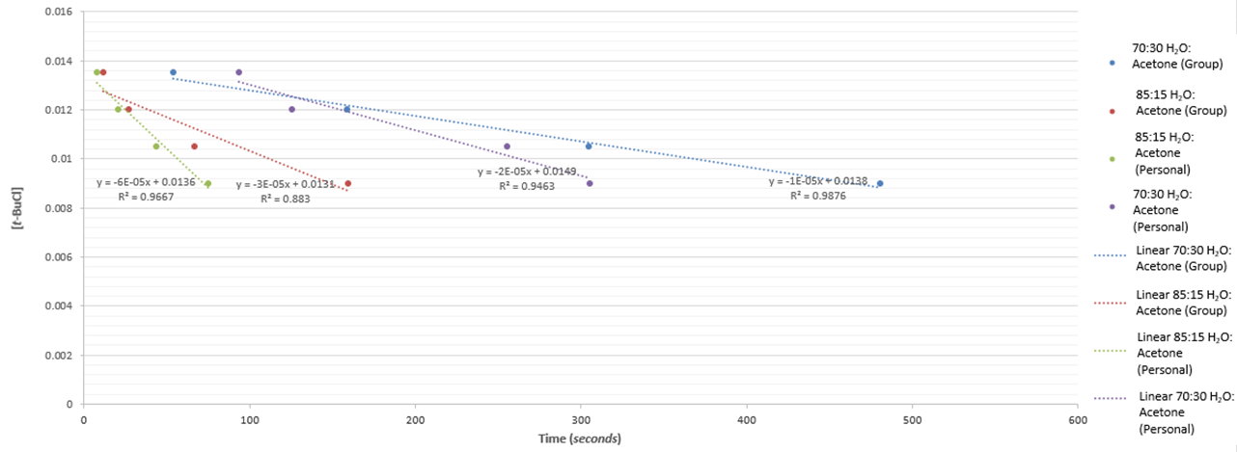
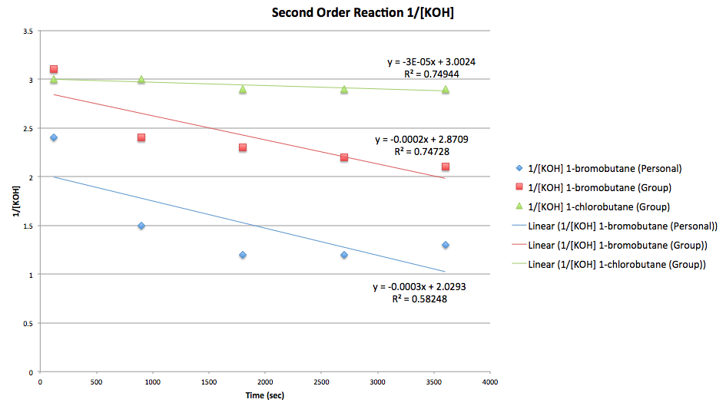
Figure 6: Graph showing 1/[KOH] vs Time for a 2nd order reaction
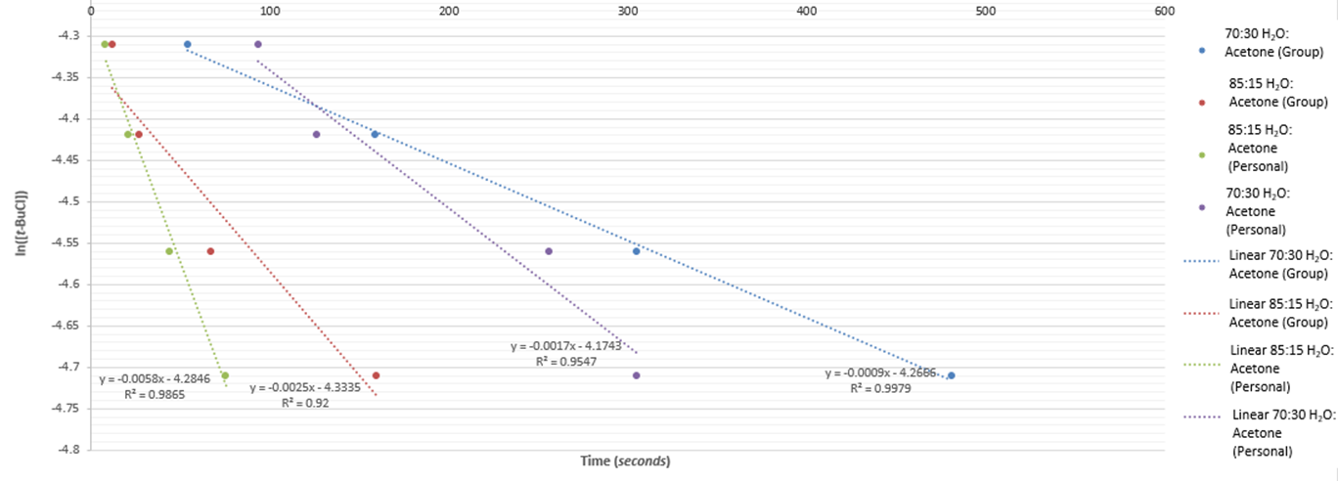
Figure 7: Graph showing [t-BuCl] vs Time for a 1st Order Reaction
Figure 8: Graph showing ln[t-BuCl] vs time for a 1st Order reaction

Discussion:

In part A, the reaction was monitored by measuring the concentration of potassium hydroxide at time intervals of: 2 minutes, 15 minutes, 30 minutes, 45 minutes and 60 minutes. At each time interval, aliquots were taken and titrated against hydrochloric acid. As the reaction progressed, at the fifteen minute time point, it was noticed that the heating mantle was too hot which resulted in some of the solvent being boiled off. This posed a problem because S_{N}2 reactions require the presence of a solvent and since there was a depletion in the amount of solvent, less KOH was reacting with the 1-bromobutane. Henceforth, when the aliquot was obtained and titrated with hydrochloric acid, the amount of hydrochloric acid required to neutralize the aliquot increased. This also meant that the amount of KOH being neutralized at each interval of time was increasing, instead of decreasing. Consequently, as shown in figures 4 and figures 5, the slope produced was positive whilst the slope in figures 6 was negatives. However, in each case, the slopes should have been opposite to the ones observed. Due to previous knowledge, it was known that the reaction follows the S_{N}2 pathway however because of the error described above, this was not the case.

Although, the personal data differs from the group’s data, the standard deviation suggests that the data across all groups were consistent and therefore reliable. The R² values tend to differ from graph to graph, but on the second order graph they are moderately similar to each other. This suggests that the data do follow somewhat of a linear trend, thus reinforcing that this is a second order reaction. There are some similarities between the group data and the personal data as both slopes are positive in the zero and first order graphs whilst it is negative in the second order graph. This suggests that other groups may have also lost some solvent, causing the same error. These graphs appear to conflict the theories of kinetics since the positive slopes are meant to be negative and vice versa (the concentration should have been going down but according to our data it went up).

The curve produced by the group data is different to the global curve with respect to 1-bromobutane. The global curve for the second order graph showed a positive slope and had a R² value of 0.93 whereas the group data curve has a R² value of 0.75. So besides the slope being negative, the group data curve is also poorly correlated compared to the global curve. With regards to the 1-chlorobutane, though, it did resemble the global data but the concentration didn’t appear to increase or decrease much, it stayed relatively the same. A possible reason for this could be that this reaction occurred quickly, resulting in a stable amount of KOH present in the aliquot.

In this part B of the experiment, the hydrolysis of tert-butyl chloride was explored in the presence of differing solvent systems. The time required for the reaction to reach 10%, 20%, 30% and 40% completion was recorded. The stability of the carbocation is influenced by the solvent system. In the first solvent system, where the ratio of water to acetone was 85:15, the reaction occurred much faster compared to when the solvent system was 70:30 water:acetone. The first solvent system is much more polar due to the greater ratio of water present and since the polar water molecules can surround the carbocation, this stabilizes the positive charge thus S_{N}1 mechanisms prefer a protic solvent system.

The data collected were used to generate graphs as shown in figures 7 and figures 8. Due to prior knowledge, it was known that the reaction mechanism will follow the S_{N}1 pathway. Through graphical analysis of figure 7, it can also be concluded that the data collected correspond to the S_{N}1 pathway as the rate constants for the group data and the personal data are similar. Similarly, the results yielded a stronger line of best for the 1st order graph as the R² values were higher than the R² values obtained from the 0 order graph. However, there was an exception where the R² for 70:30 Water:Acetone (group) was higher in the 0 order graph than that of the 1st order graph. Overall, since the 1st order graph had higher R² values, it shows that the 1st order graph had higher correlated results, which corresponds to the idea that: concentration of the electrophile influences the rate of reaction. Through observation of the group data, it can be concluded that the rate equation for 85:15 Water:Acetone is:
Rate = -0.0025[tBuCl],
whilst the rate equation for 70:30 Water:Acetone is:
Rate = -0.0009[tBuCl].

The analysis of the global data shows that the 1st order graph also had higher R² values than the 0 order graph. Through comparison between global data and group data, the group R² value of 0.998 for 70:30 Water:Acetone is higher than the global value of 0.994. Although, the global R² value of 0.984 for 85:15 Water:Acetone is higher than the group value. Overall, even though there are slight differences between the R² values, the general trend of obtaining greater correlated results from the 1st order for both group data and global data confirms that the reaction follows a S_{N}1 pathway.

Although, the results are highly correlated. Table 5 shows the standard deviation for the group results. The standard deviations are very high and this is often an indication of poor reliability of data. The data is spread out over a large range and is therefore not consistent. This may be caused due to a number of errors such as inconsistent stirring of the reaction mixture. A magnetic stirrer was not used to mix the reactant mixtures and since each individual would mix at different speeds, this would result in the reaction occurring faster or slower amongst different groups. Another source of error is also due to the inconsistency in the equipments used. Different groups may have used different volumes of graduated cylinders to measure the reactants, in which case the intervals are different and therefore some measurements were more accurate than others. Lastly, timing is also a source of error, as there is a lag between noticing the colour change to stopping the stop-watch. In addition to this, the colour change is brought about by the presence of hydrochloric acid so sufficient hydrochloric acid to be produced before the indicator changes colour thus it would take longer to notice the end of reaction.

Conclusion:

In part A of the experiment, there was a second order reaction, with the rate constant for 1-bromobutane being 3x10⁻⁴ s⁻¹ M⁻¹ and 1-chlorobutane being 3x10⁻⁵ s⁻¹ M⁻¹.

