Chapter1: Psychology Yesterday and Today (pg. 1-13)
Dr. Joanne Lee
October 15, 2016
- What is psychology?
- Psychology: is the study of mental processes and behaviours
- Examining the mind and behaviour, and how they are influenced by the psychobiology of an organism and the external environment
- Mental Processes: brain activity when we are thinking, processing information, and using language.
- Engage complex experiences, such as memory (remembering), thinking and imagining
- Behaviour: observable actions, which are usually the response to environmental cues

- 4 Goals of Psychology:
- Description:
- Describe specifically what you observe
- i.e. how we fall in love, how babies learn to talk, why we make certain decisions, etc.
- Explanation:
- Key goal is to answer the question of “why?”
- Develop hypotheses and theories, to explain a wide range of events
- i.e. why we get hungry, why people develop addictions
- Prediction:
- Predict circumstances, under which a wide variety of behaviours and mental processes may rise.
- i.e. predict the conditions under which people are most likely to help a stranger in need
- Control:
- Situations in which we want to limit certain behaviours/ mental processes (our own or others)
- i.e. how to limit unhealthy stress, how to increase what you remember from class.

- Levels of Analysis in Psychology:
Level | What is Analyzed | Example: Using Social Media
The Brain | How brain structure and cell activity vary from person to person, and situation to situation | What are the patterns of brain activation when a person interacts with “friends” online?
The person | How the content of a persons’ mental processes affects their behaviour | Are there personality factors which influence how much a person uses different types of social media? Can online social support/ crisis resources help a persons’ decision making and quality of life?
The Group | How behaviour is shaped by the social and cultural environments | What features of social networking sites, such as relative anonymity, ease of access, and lack of face-to-face contact, increase or decrease users’ feelings of belonging and connectedness?

Extra Info (adding to the chart above)
- At the brain level, psychologists look at neural activity (brain cell), that occurs during the transmission and storage of information
- They also look at the structure of the brain and the genes that guide its formation.

- The person level includes ideas such as: consciousness, intelligence, personality and motivation
- Personality and motivation is unique to everyone

- The group level, in most cases includes a large group, which share a culture----- a set of common, beliefs, practices, values and history that is transmitted over generations.

- The levels are all interconnected. For example, changes in the biology of our brain can cause significant differences in our general state of being

- Psychology’s Roots in Philosophy:
- Myths are used to rationalize the unknown origins of many events, phenomena (which are both mysteries), in order to make sense of people and the natural world.

- Philosophy: the study of knowledge, reality, nature and meaning of life.
- Ancient Greek philosophers wondered how the brain connected to the body. And wondered weather knowledge was inborn or if it had to be learned from experience

- Greek philosophers also emphasized that theories are never final, but can still be improved upon

- Hippocrates:

- Hippocrates, suggested that and individual’s physical and psychosocial health is influenced by a lack of bodily humors.

- Hippocrates believed the 4 bodily fluids: phlegm, blood, yellow bile, and back bile) determined a persons’ personality and character, and determined how they would react to environmental situations, and also their well being.

- was the first to recognize the importance of fresh air, good food and rest

- could affectively cure epilepsy and pneumonia

- determined that the brain was responsible for feelings, thoughts and ideas, not the heart

- Made theories based from direct observations and dissections

- Socrates and Plato wondered weather the body and the brain were one, or weather each functioned separately
- Concluded that the mind and body are separate, because the mind continues after the body dies

- Believed that “truth” lies in the mind, and that this quality is innate--- inborn. Depends upon our perceived and subjective states

- For example, Socrates determined why something is beautiful, and what qualities it must possess to be beautiful

- Plato believed that certain ideas and concepts were pure and had an ultimate reality
- Plato believed that we could use reasoning to uncover the core ideas deeply embedded to every human soul.

- Aristotle was one of the first to promote empirical, or testable, investigations of the natural world.

- Psychology’s Roots in Physiology and Psychophysics:
- by the 1600 the spiritual way of thinking was almost diminished, and replaced by a more scientific point of view.
- Many ideologies were now based on mechanics and mathematics
- The dominant view was that the brain controlled the body by moving fluids from one area to another

- Francis Bacon is the creator of empiricism---- the view that knowledge originates from experience.

- Also, established and popularized the scientific method, analyzing data and performing experiments

- Rene Descartes, followed the route of Socrates and Plato. He viewed all truths as ultimately linked. And believed that the meaning of the natural world could be explained by mathematics and science
- Determined that the point of contact between the mind and body is the pineal gland

- John Locke (influenced by Descartes and Bacon), determined that we learn from our experiences
- he called the mind a “blank slate” when born--- void of all characters and ideas

- Psychophysics--- the combination of established facts with philosophical thinking

- Johannes Müller studied the relationship between stimuli and their psychological affects. (i.e. how much light/ sound needs to be present, to be detected).

- Herman von Helmholtz---- was the first to measure the speed of nerve impulses, and determined that nerve impulses happen over a period of time, not instantaneously. This finding lead to understanding, that movement and thought are linked, but not the same.

- Gustav Fechner, in his book lays out many of the possible methods and study techniques, that would come into use, in the emerging field of psychology
- His evidence of the relationship between physical and mental events demonstrated that psychology has the potential to be a qualified science
- Considered to be the founder of psychophysics; experimental psychology

- Early Days of Psychology:
- The Founding of Psychology:
- Wilhelm Wundt:
- Opened a laboratory in Leipzig, for Psychology only
- Believed that study of the mind and body should be conducted experimentally. Experimental methods used in other scientific fields like chemistry, biology and physics
- Trained students to form empirically (testable)-driven experiments in psychology.

- Wundt did an experiment where a clock was on a pendulum. Wundt found that when determining the exact location of the pendulum at a specific time, his observations were always off by 1/10 of a second
- Through this he determined that humans have limited attention capacity, and that it takes 1/10 of a second to shift focus from one object to another

- Wundt studied consciousness--- the awareness of immediate behaviours and mental processes. Believed that the consciousness could be broken down into individual compartments (much like “atoms” of the mind).
- Will was an area of particular interest, and how it influences individuals to attend to their environments
- He believed that will organizes the mind’s content into higher level, more complex, thought processes
- Also believed that behaviour is motivated (i.e. behaviour could be altered to adjust to changing circumstance)
- Attention is focused for an explicit reason
- Voluntarism: refers to voluntary and willful acts of decision in the human behaviour (distinguish between automatic and controlled acts)

- Structuralism: Looking for Components of Consciousness
- Structuralism (Edward Titchener): philosophical approach which studies the structure of conscious experience

- Titchener wanted to break down the conscious into simpler elements (i.e. like the parts of a bicycle), and examine that.

- Introspection (originated by Wundt): study involving careful evaluation of mental processes and how simple thoughts expand to complex ideas. Critics claim no real acts of introspection could occur

- Structuralism was also criticized because they did not use animals for experimentation, and that it was unable to explain abnormal behaviour

- Structuralism merely describe the response, reaction, etc. It did not apply this knowledge further.

- Functionalism: Toward the Practical Application of Psychology
- Functionalism (William James): a philosophical approach that considers how mental processes adapt to changing environments

- William James argued that humans must have evolved to have conscious thought, and that this adaption helped humans survive.

- Analogy: Functionalism looked at how, the car engine or bicycle worked under given conditions, rather than examine the parts.

- Focused on the causes and consequences of behaviour

- Identifies differences between individuals, rather than similarities

- Emphasized that research should include: animals, children and people with mental disorders. To understand both normal and abnormal psychological functioning.

- Functionalism also helped in social situations. For example, an experiment was done to see how fast telegraph operators could learn necessary typing skills. This study was then used to improve training for railroad telegraphers.

- Gestalt Psychology: More than putting Together the Building Blocks
- Gestalt Psychology: we have inborn tendencies to structure what we see in particular way, to “change” our perceptions into broad perceptual units, rather than individual sensations.

- The whole is greater than its individual elements. Humans have an inborn tendency to look in broad units.

- Researchers using this approach studies how individual perceptions varied from objective reality (for example, when looking at a screen, we see a whole picture, instead on tiny dots that make up the picture. This is because the brain likes to integrate these dots into a picture)

- Gestaltists tie learning to perception—recognition and identification of stimuli through our senses.

Chapter2: Psychology as a Science
September 20, 2016
What is Science?
- Two characteristics that the sciences share are:
- Similar principles/ beliefs (about how to best understand the world)
- Reliance on the scientific method as a way to discovering and sharpening knowledge

- Scientific Principles:
- Science is built on the foundation of core beliefs about the world, two essential beliefs are:
- The universe operates according to certain natural laws:
- Everything around us happens in an orderly fashion
- Can be used describing laws/ rules
- The natural law of cause and effect. For example- suggests that when something is in motion, it affects other things around it
- Psychologists look for the laws that describe mental processes and behaviour
- Such laws are discoverable and testable:
- By observing the natural world, we can see the laws governing those events
- In turn, we can use these laws to predict what might happen, and we can experiment to see if those predictions will come true
- Psychology operates according to those 2 core beliefs
- Psychology also shares, with other sciences, a logical approach to discovering and testing laws about how things happen: The Scientific Method.

- The Scientific Method:
- Relies on processes of logical reasoning derived from philosophy

- Deductive reasoning: starting with broad, general ideas (broad basic principle) and applying those to specific situations.
- Example of deductive reasoning: if you bet that the home team in a football game will win, because the home team has an advantage. The deductive reasoning is--- home teams win more often than visitors (basic principle), so I bet the home team wins (applying it to the situation).

- Bias: distorted beliefs based on a person’s subjective sense of reality

- Philosopher Francis Bacon, suggests that deductive reasoning is susceptible to bias. Example--- we all want our football team to win, and that changes our perspective on the outcome, as to who will win the game.

- Widely accepted conventional wisdom can be incomplete, bias and untrue. For example----- a person tends to believe they are independent thinkers, and follow their own decisions; but studies suggest, when confronted by an authority figure or a small group, people change their decisions based on the views of others.

- How might we try to avoid this bias?
- Start small and focused and build up to bid understanding
- Example---- what if we made careful observation of how a number of teams do at home and away over the course of several seasons, and then use the number of home and away wins, to see whether or not they would do better at the home arena.

- Inductive Reasoning: reasoning process proceeding from small specific situations, to big truths.
- Use controlled direct observations to generate broad conclusions, and overtime these conclusions are combined to achieve non-biased truths about the universe.

- Psychologists using inductive reasoning would begin the search for natural laws by taking empirical, or objectively testable, observations of mental processes and behaviours (what do people actually do or think).

- Empirical: able to be tested in objective ways

- Their cumulative observations would allow them to develop theories, or big ideas about the laws that govern those processes and behaviours

- Hypothetico-deductive reasoning: a blended model of both inductive and deductive reasoning. (look at Figure 2-1 on pg 39, for more info)
- Begin with an educated guess (perhaps based on past research), about how the world works.
- And then think about designing small controlled observations to support or invalidate your hypothesis.

- To test the “soundness” of their theories, researchers use hypotheses---- specific statements that can be proven wrong
- If a hypothesis is not valid, it can be modified, and through the repetition of this process, theories can develop and more accurate explanations can be set.

- Example: To produce a scientific theory about the effects of violence and aggression on behaviour, a scientific approach should be used, to avoid bias:
- Make observations: examine what teenagers do after playing a virtually violent/aggressive video game. Do they engage in behaviour that suggests increased levels of violence/aggression, in social settings?
- Develop hypothesis: after observation, make a hypothesis (testable statement) of what led them to exhibit this behaviour. Sample hypothesis--- players increase their levels of aggressiveness in social interaction in response to spending two hours virtually interacting with violent game characters.
- Test hypothesis: conduct studies to see if the hypothesis can be disapproved
- Build a theory: if the hypothesis is disapproved, then the hypothesis can be modified. For example--- if our original study was about the affects a specific video game has on behaviour, we may want to see the affects of certain video games on behaviour. If the results continue to support the hypothesis, then the hypothesis can become a theory. A theory can then be used to generate more hypotheses.

- Theories: ideas about laws and governed phenomena

- Why is Psychology a Science?
- The theory of evolution and advances in biology, raised questions of how humans interact with their surrounding environment
- Also, how human actions are tied to innate biological functions

- Goals of Psychology:
- Psychology and the physical sciences vary in many aspects, for example the area of description.

- The physical sciences explain how the smallest element contribute to the larger whole. For example---- in biology, its how cells affect the function of organisms, and in physics/ chemistry they talk about how the atom/ subatomic particles make up almost all structures.

- Psychology is more complex, in terms of examining behaviours. Behaviour cannot be broken down into a standard set of element, that work the same for every person. Like, the atoms that make up gold is the same for all the gold in the world, but is not the case with behaviour

- The idea behind psychological research is to isolate the relative contributions of such factors (i.e. how the anticipation of an upcoming exam, effects how a person behaves when reading a textbook), and to think about how these factors come together across different situations, to influence human behaviour.
- Another challenge for psychologists is that there is no clear and observable physical reality (unlike the basic units of other studies in science)

- Behaviours, sensations and psychological responses can be directly observed, measured and explained.

- Values and the Application of Psychology:
- Psychology different from other sciences, in regards to: values, morality, and personal preference

- People are inclined to use psychological information to decide issues which overlap with philosophy, religion and the law. Examples:
- The death penalty: studies show that it does not reduce the homicide rate
- Bullying: research shows that solutions require relationship changes
- Physical punishment of children: findings indicate that it is an ineffective way of controlling a child’s behaviour and it models aggressive behaviour for the child.

- Misrepresentation of Psychology:
- Like other sciences, psychology cannot answer fundamental and subjective questions about human nature (i.e. what are people like?)

- Pseudopsychology: does not use the scientific method, and feigns to be science related.
- Usually have some sort of goal, like implementing religious/moral values

- Difference between psychology and pseudopsychology: psychologists do not guarantee an answer to life’s major questions, while pseudopsychology claims to know all answers.

- Example of Pseudopsychology: Astronomy

- How do Psychologists Conduct Research?
- Observation is the first step in the scientific method

- State a Hypothesis:
- How psychologists conduct research:
- Identify the Question of Interest
- Develop a Testable Hypothesis
- Select a Research Method (choose participants and collect data)
- Analyze Data/ Reject or Accept hypothesis
- Seek Scientific Review
- Build Theory

- Variable: can be many things--- i.e. situation, condition or event
- Independent Variable: a variable that causes change in another variable
- Dependent Variable: is the variable that is changed

- Operationalize: setting precise definitions for the independent and dependent variable, so that they can be measured/tested (i.e. 0, 1, 2 and then 3 cans of energy drink were consumed, over a span of one hour each independent variable)

- The energy drink example may pose as a problem, if the energy drinks affect the participants’ ability to store what is being read, a researcher conducting how effectively a participant could recall the material; will not be able to measure/ test this affectively.

- Choose Participants:
- Sample: a select number of people, from the desired population (i.e. male’s vs females), to participate in the study

- Researchers prefer random selection—selecting people in the desired population, in such a way that everyone has an equal opportunity of becoming a participant.
- Helps minimize sampling biases (you avoid choosing people you know will support your hypothesis)

- Researchers/ psychologists try to choose an age group where the results can be relevant to other age groups as well

- Pick a Research Method:
- Descriptive Research Methods (also called correlational studies): allow researchers to expose the area of interest, but not specify the relationship (or what they are trying to find). Includes:
- Case studies
- Naturalistic observations
- Surveys

- Can also describe experiments—allow researchers to describe the cause of certain behaviours

- Case Studies: focus on a single person
- is a good resource in developing early ideas of a phenomena

- disadvantage: researcher bias. Can only see what they expect to see. (i.e. after providing treatment to those individuals, researchers may only notice their good behaviours)

- Another disadvantage: a researcher has nothing to compare to. For example, if a researcher does a case study of a person playing aggressive video games, who exhibits violent behaviour, but then says they are a gentle/ non-violent person; you would wonder if this was the norm or an exceptional behaviour)

Type of Research | Purpose | Advantages | Disadvantages
Descriptive | Observe, collect and record data | -good for developing early ideas  -reflective of actual behaviour  -easier to collect data | -little/no control of variables  -researcher/participant bias  -cannot explain cause and effect
Experimental | Manipulation and Control of Variables | -Identify cause and effect  -allows researchers to have more control of variables | -ethical issues  -limitations  -labs are artificial  -confounding variables  -researcher/ participant bias

- Naturalistic Observation: when the researcher observed the specific population in their natural environments, without making it obvious that they are observing them. (i.e. observing gorillas in the mountain, or children at daycare)

- Advantage of having more realistic observations of human behaviour
- Disadvantage: Researcher bias. Researchers may only observe what they want to see. And there is most-likely no one with them, so they could compare the observations.

- Disadvantage: the presence of the researcher or a camera may effect how people behave
- Many people become nicer/ considerate when they know people are watching
- Hawthorne Effect: People being observed in a study or at work, perform better, because they know they’re being watched. This behaviour is not a response to experimental manipulation

- Solutions to solve the disadvantages:
- More people can be observing, this reduces bias
- The observer can spend more time in that location, so they become an accepted member, and wont draw that much attention

- Surveys: researchers ask people a series of questions (most frequently used in psychological research)

- Researchers may ask participants questions through: questionnaires, telephone, in-person or email interviews
- Advantages:
- Allow researcher to obtain information that may not be obtained through naturalistic research or case studies (for example, researchers wouldn’t know a person is avoiding aggressive behaviour, because they think it’s the right thing to do)

- Allows the researcher to make strong connections between the variables. How strong the relationship is between variables.

- Disadvantages:
- Participant Bias: participants may not answer truthfully, and may select answers which are socially acceptable.

- i.e. people taking a survey for a video game may say they are less aggressive, because being aggressive is not a favourable trait

- participants may not read the question the same way (i.e. people may think being really angry is aggressive, and some people may think being annoyed is being aggressive)

- surveys cannot tell us the direction of the relationship between variable. (i.e. questions like: do people who play violent video games get more aggressive, or are highly aggressive people drawn to play a lot more violent video games?). Surveys can’t really answer those questions

- Experiments: controlled observation. Done by manipulating the independent variable, to see changes in the dependent variable.
- Experimental group: the one exposed to the independent variable (i.e. video games)
- Control group: is not exposed to the independent variable (i.e. no video games)

- Most experiments use various degrees of the independent variable. For example, there may be many experimental groups, but each group may vary on how violent each game is, or for how long each group played the game.
- This kind of design is called an interaction effect--- more realistic for the real world

- Random Assignment: ensures that everyone in the sample, have the same chance of being in the controlled group or experimental group. And that the people are evenly distributed, in terms of any factor or variable that may affect the results (i.e. a person with anger issues in the control group may affect results—that’s a factor)

- Researchers have to make their control group do something, such as playing a non-violent video game (i.e. basketball video game). And then compare the levels of aggressiveness between the two groups.

- Researchers must avoid biases: subject (when participants act a certain way, because they know what is being studied, so they act the way the researcher is testing) and researcher bias.

- Demand Characteristic: Undesired effect. Where the researcher unintentionally conveys the point of the research, and the participants then behave the way the experimenters want to see. I.e. in the survey many people may understate their level of aggression.

- In many experiments, the one conducting the study (with the groups), is usually unaware of the hypothesis of the study, to avoid this effect

- Double-blind procedure: the participant nor the experimenter know which group is controlled and which one is experiment.
- This helps avoid researcher and subject biases

- How do Psychologists Make Sense of Research Results?
- Psychologists use statistics to determine the relationships (differences and similarities) between groups

- Correlations: Measure of Relationships
- Correlation: a predictable relationship between 2+ variables
- Correlation Coefficient:
- More detailed information on correlation

- Range from -1.00 to +1.00

- Positive or negative sign tell us the direction of the relationship

- Positive correlation: when scores on both variables get bigger together (i.e. positive correlation between playing violent video games and aggressive behaviour. As the time increases, so does the aggressive behaviour)

- Negative Correlation: when one variable increases, and the other decreases (i.e. as the time increases, the aggression decreases)

- The larger the correlation coefficient the stronger the relationship, and the data is more tightly packed

- Correlation of -1.00 or +1.00= perfect correlation. The variables scores are always perfectly related

- Example: -0.7 has a stronger relationship, than +0.2. Depends on how big the number is

- Correlations help with predictions
- Correlations do not tell us causality---- whether or not a change in one variable causes a change in another.
(i.e. we get a positive correlation if playing violent video games makes a person aggressive, but we get the same results if an aggressive person likes to play violent video games)

- Experimental Analyses: Establishing Cause and Effect
- Experimental analyses: examining differences between these groups and the cause of these differences
- Experimental analysis is sometimes divided into two categories:
- Descriptive Statistics:
- Summarize data collected from study

- Inferential Statistics:
- Tells researchers what they can conclude, or infer, more broadly from their results

- In order to find differences between the experimental and control group, the mean and standard deviation are used:
- Mean: average scores of all participants in group. (a big difference between the means of the control and experiment group, suggest big differences)

- Standard Deviation: helps explain how much variation there is between a group (the higher the standard deviation, the higher the variation).

- t-tests are used to compare the means between 2 groups
- analyses of variance is used to compare means between more than 2 groups
- these procedures help determine whether or not the differences found between the groups are statistically significant---- how likely it is that the differences are due to manipulation, and not chance.

- A statistically significant test, would yield a probability statistic of less than p= 0.05 (there is likely a real difference that is due to manipulation, between the groups).
- P= 0.05 means there is a 5/100 chance, that u got this by chance

- Effective size: describes the strength of the relationship between 2 variables (i.e. large effective size would mean that violent video games strongly increases aggressive behaviour)

- Using Statistics to Evaluate and Plan Research
- Replication: taking the data from one observation, and using it to see if it holds under other conditions, and in multiple samples; to see if the hypothesis is feasible. (Hypothesis is not accepted only after one success)

- Replications allow hypotheses to become theories, which can then become laws

- Researchers can try different research methods (i.e. surveys, independent observations, etc.), while using the same hypothesis. To see if they get similar results
- Theories will give rise to more hypotheses. It can be possible to further test the affect of violent video games, by changing the video game used, changing the behaviour you are looking for (instead of aggression, try too test empathy or a sense of fair play). To build on theory.

- What Ethical Guidelines Do Psychologists Follow?
- Animal and human participants are to be protected

- Psychologists have a higher obligation to care for others in society, more than the people in the society have towards each other.

- 3 main grant agencies:
- Canadian Institutes of Health Research (CIHR)
- The Natural Science and Engineering Research Council of Canada (NSERC)
- The Social Sciences and Humanities Research Council of Canada (SSHRC)

- Research Ethics Boards (REB’s): a group that oversees the research “plan” in order to protect the rights of humans. See weather research is ethical (can be conducted in university, private agency, medical school, etc.)

- REB’s require that psychologists do the following steps, before using humans (to protect them) in research:
- Obtain informed consent: tell participants about the procedures, risks and benefits, so they can decide if they want to participate

- Protect participants from harm and discomfort: researchers must avoid putting participants in emotional stress

- Protect Confidentiality: protect participants’ identity and their responses

- Make Participation Voluntary: participants have the option of not participating in the study and wont be treated differently. Participants can also decline to answer some questions, during the study

- Do not use deception or incomplete disclosure: methods of the study should be fully disclosed. Mood manipulation is not permitted, that may affect test results (false feedback)

- Provide complete debriefing: at the end of the research, the researchers should tell the participant what the study was about.

HPcVD/inc/disD

- the ethics board also looks at how much compensation is being given to participants, because the participants may take part in dangerous situations, because of high levels of compensation

- ethics board also sees if one type of group (men, women, etc.) are singled out unnecessarily.

- The Canadian Council on Animal Care (CCAC), is an ethics council which protects the rights of animals, some guidelines include:

- The use of animals in research, testing, and teaching is ONLY acceptable if the use of the animals, helps gain more knowledge of fundamental biology principles. And if the experiment could provide reasonable benefits to humans/ animals

- Animals should only be used if the researcher’s efforts to find an alternative have failed

- Researcher should employ humane methods on the smallest number of appropriate animals, needed to obtain valid information

- Limit pain and distress, and ensure recovery periods, the most humane way possible

- These procedures not only help for better ethics, but better science as well.

Chapter 3: Neuroscience
Dr. Joanne Lee
October 18, 2016

Field of Neuroscience
- Study of the brain & nervous system

Reciprocity of Biology and Experience
- Experience in the environment also influences the brain & nervous system
- Example: athletes as well as fans of a winning team tend to experience a rise in testosterone

Methods
- recording and imaging of brain activity opened whole new areas of inquiry to biological psychologists
Technology
Magnetic Resonance Imaging (MRI) | - imaging brain & structure  - functional MRI, engaging in a task while imaging the brain  - realigns hydrogen atoms in the brain  - uses radio waves/ makes imaging of organs in body
fMRI | - activity in the brain area increase, oxygen increase  - (need more oxygen to keep up with the activation of brain cells) –red part is more active on the brain, yellow means less O2 is going to that brain area  - based on the amount of O2 in blood  - measures activity in brain  - function & structure  - technique measures amount of O2 to the brain
CT Scan | - x-ray type images  - different angles/ helps create cross-sections  - measures brain structures
DTI (diffusion tensor imaging) | - measures orientation and integrity of white matter to assess brain injury (e.g., concussions)  - how fast water molecules move from one area to another
Electroencephalography (EEG) | - measures electrical activity in the brain  - sensors placed on the scalp measure electrical activity in the brain
Electrical Stimulation of the Brain | - patients are awake and alert during this procedure  - opening up the brain  - use electric current to stimulate brain cells
How Nervous System is Organized
- neurons process information by communicating with each other
- glia & neurons are the basic components
Terms (PNS)
Somatic NS | All peripheral nerves that transmit information about body sensation & movement to and from CNS
Autonomic NS | operates mostly without help of CNS
Sympathetic Ns | Activated under conditions of stress “fight or flight system”
Parasympathetic Ns | Activated during restful times “rest and digest”

Central NS
- includes the reflex circuit (only involves spinal cord = rapid reaction , information later sent to brain to process)

Neurons (nerve cells)
- basic structural and functional unit NS
- specialized cells that carry messages throughout the NS
- neural communication involves two kinds of signals:
- electrical signals within a single neuron
-chemical signals from one neuron to another (between group) – called neurotransmitters
- differ in shape, size & function
- brain contains 86 billion neurons

Types of Neurons
Afferent neurons (sensory) | - relay information from the senses to the brain and spinal cord  - sensory neurons respond to pressure, temperature & pain
Efferent neurons (motor) | - send information from the CNS to the glands and muscles, enabling body to move
Interneurons | - carry information between neurons in the brain & spinal cord (CNS)  - communicate with both sensory & motor neurons

Various Neuron Shapes: Common Features
- all covered by specialized membrane that surrounds entire neuron, including axon + dendrites
- membrane allows it to be capable of communicating with other cells by chemical & electrical signals
Anatomy of Neuron
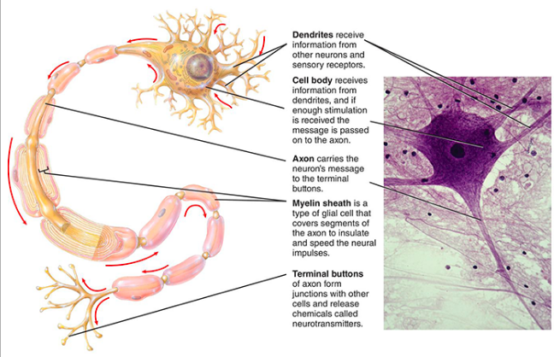

Glial Cells: the NS’s support staff
- provide physical structure to hold neuron in place
- removes toxins from neurons, destroys + removes diseased & dead neurons
- creates a blood brain barrier
- control nutrient supply to neurons
- provides axons with myelin sheath (Oligodendroglia)
- modulate neurotransmission
Types of Glial Cells
Astrocytes | - creates blood-brain barrier (regulates passage of molecules from blood to brain) which influences communication between neurons (controls nutrient support/oxygenation)  - helps heal brain damage  - absorb/clean up chemicals
Oligodendroglia | - provides myelin sheath to speed up transmission of neurons  - loss of myelin = insufficient transmission of electrical information = vision loss, pain, muscle weakness
Microglia | - cleans up dead cells and prevents infection in the brain

How Do Neurons Work?
- Electrochemical interactions: chemicals that cause an electrical signal to be generated within neuron
- neurons can respond to incoming chemical signals by becoming either DEPOLARIZED (inside of neuron becomes less negative) or HYPERPOLARIZED (inside of neuron becomes more negative)
Resting potential
- when a neuron is at rest = negatively charged (-70 mv) [because of ions it is negative]
- inside (intracellular) relative to the outside (extracellular)
Components
- membrane is not permeable
- Sodium potassium pump- 3 Na, 2K (protein molecule that push out Na, and push in K) returns membrane to resting potential
- threshold

Action Potential [nodes of Ranvier is where action potential occurs]
- Travels from axon to terminal buttons
- Resting potential (-70mv)
- action potential stimulated
- 65mv (THRESHOLD OF EXCITATION) [influence of other neurons succeeds in causing a neuron to initiate an action potential]
- peek of activation – (+50) mv, after that it comes down
- channels in membrane open
- positively charged sodium ions enter (inside less negative)
- shift in electrical charge
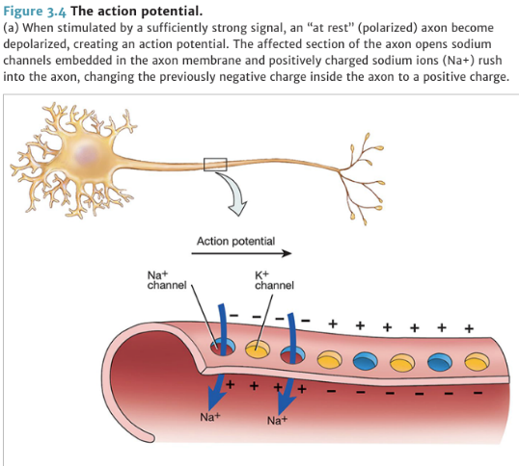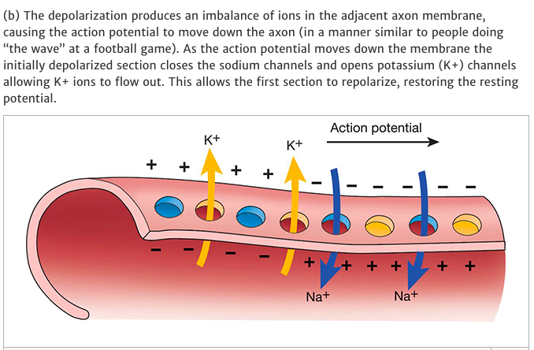

Absolute Refractory Period
- channels close (nothing happens)
- during refractory period, nothing happens
- another action potential can only be fired when membrane back to resting potential
- relative refractory period: just after ARP in which neuron can only fire if it receives stimulus stronger than usual threshold
All-or-None Principle
- if impulse doesn’t reach threshold, an action potential won’t be fired
- neuron either fires or it doesn’t because of the refractory period
- intensity is conveyed by: more neurons firing, frequency of neuron firing

Firing a Neuron

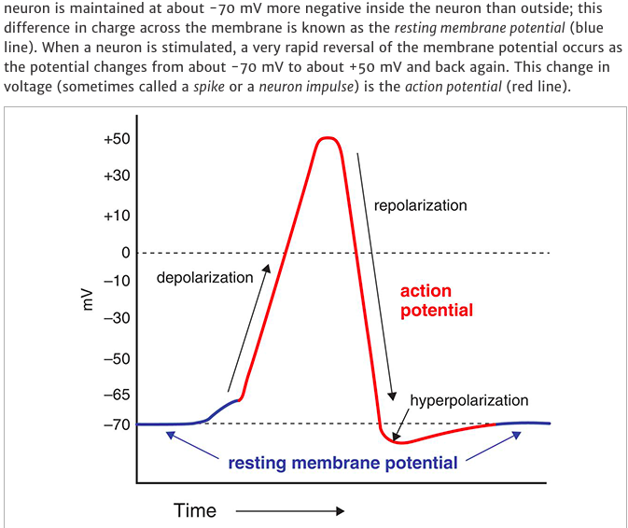

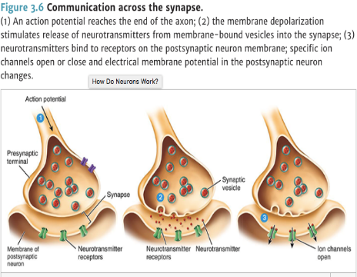
Communication Across Synapse
Chemical signals in the brain
- the system switches from an electrical signaling system to a chemical signaling one, once action reaches the axon terminal
- neurons not physically connected to one another, communicate through synapse (gap between axon terminal of one neuron and other neuron)
- synaptic vesicle: neurotransmitters stored
- neurotransmitter: chemicals that travel (chemical messengers)
Neurotransmission
- electrical charge travels from cell body to axon to axon terminal
- synaptic vesicle fuses with the axon membrane and releases neurotransmitter
- neurotransmitter push into synaptic gap
- neurotransmitter connect with the receptors
Types of Neurotransmitters
- researchers have identified more than 50 different chemicals that act as neurotransmitter
Excitatory Neurotransmission | Inhibitory Neurotransmission
- helps to depolarize cell membrane for action potential to occur  - this increases probability of an action potential  - this excitatory input serves to “pass the message along” to the next neuron | - act to increase the polarization of the nearby cell  - decreases the probability of an action potential  - helps prevent impulse from firing

Summation
- neurons “decide” whether to generate an action potential by adding up excitatory and inhibitory input
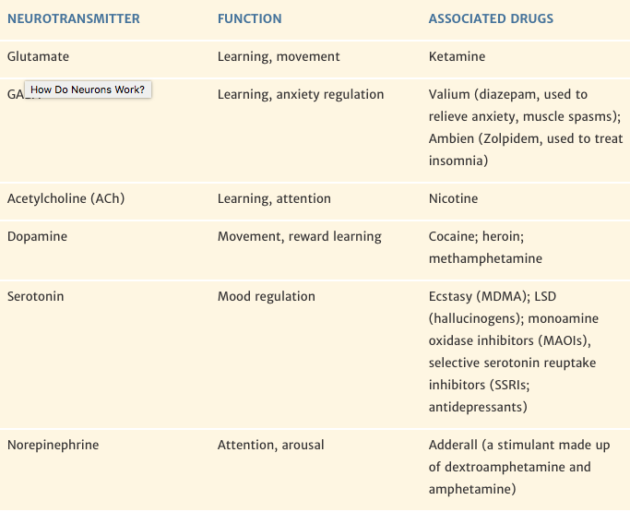
Functions of Neurotransmitters
Neurotransmitter | Functions | Problems
GABA | - contributes to learning, thought and emotions  - regulates anxiety & sleep  - inhibitory neuro, reduces activity of neurons = no firing  - reduction of arousal | - abnormal levels = eating disorder
Acetylcholine | - neurons instruct muscles to contract  - found in autonomic NS  - role in communicating b/w sensory & motor neurons  - supports leaning & memory  - also found in weapons 3 | - loss of Ach = Alzheimer’s disease
Dopamine | - dopamine circuits support anticipation of rewards  - motor control  - controlled cognition  - mood, control of voluntary movement | - deterioration of Dopamine producing cells = Parkinson’s disease  - too much = ADHD & schizophrenia (found in frontal lobe)
Serotonin | - used in brain areas that regulate sleep cycles, memory & learning  - regulates mood, appetite | - low levels of serotonin= depression
Norepinephrine | - involved in the “fight or flight” behaviour (SNS)  - released in the brain & leads to arousal and vigilance  - excitatory neurotransmitter  - learning, memory, sleep & emotion | - abnormalities in norepinephrine= PTSD, bipolar disorder  - excessive levels causes anxiety  - fear & anger causes increase in heart rate +muscle strength

How Drugs Mimic Neurotransmitters
- most drugs & poisons have their effects by interfering w/ normal neurotransmission processes;
4 types
Receptor Agonists | - mimic neurotransmitters  - (excitatory)- activates receptors on dendrites and cell walls (increase action of neurotransmitters) | - alcohol can activate dopamine receptors in the brain’s reward circuits, morphine
Receptor Antagonists | - block neurotransmitter from activating receptors (decrease action) | - poison curare clocks acetylcholine receptors, = paralysis & death
Reuptake Inhibitors | - prevent axon terminals from recycling neurotransmitters, leaving them in synaptic gap to activate other receptors | - selective serotonin reuptake inhibitors (SSRI’s) such as Prozac are used to treat depression
Enzyme inhibitors | - prevent enzymes from breaking down extra neurotransmitters, leaving them in synaptic gap to activate other receptors | ^
[Midterm: Given scenario; if someone is taking this drug – what is the mechanism (the 4 types)]
OVERVIEW
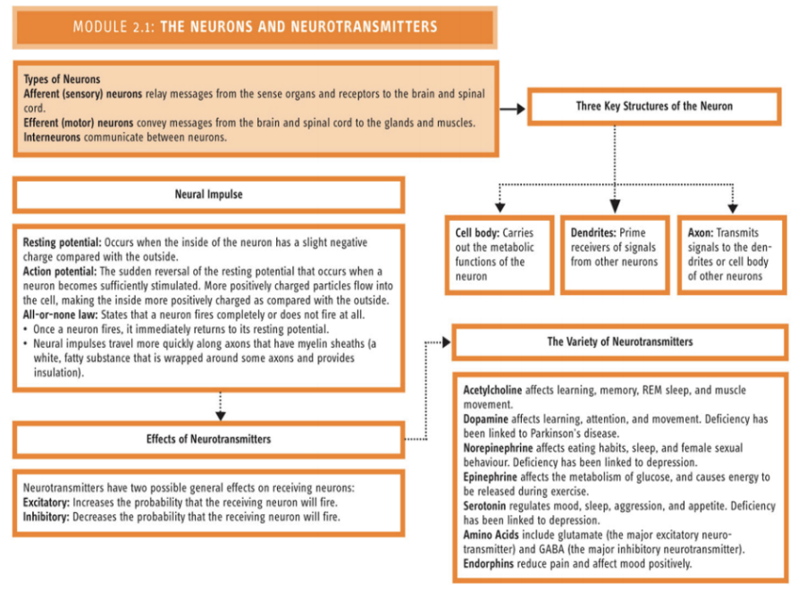
Hormones & Endocrine System
- glands that secrete hormones into the bloodstream
- hormones= molecules that influence particular organ; blood stream
-affect bodily functions
-work less faster than neurotransmitters
Glands & Hormones
Pituitary Gland | - master gland, impacts other glands, signals other glands to action (works with the hypothalamus) (fight, flight, feed, & mate)  - oxytocin released
Pancreas | - releases hormones insulin & glucagon  - too little insulin = diabetes (can’t break down sugars)  - too much insulin = hypoglycemia (low blood sugar)
Adrenal Glands | - (aka emergency centres of our body)  - activated by the sympathetic NS (specifically the hypothalamus) to release hormones  - epinephrine (anger)-surges of energy, adrenaline & cortisol  - also control salt balance
Endorphin | - hormone, but acts like a neurotransmitter  - natural “morphine”  - modulate senses of pain and pleasure & enjoyment, as well as feelings like “runner’s high”

Structures of the Brain
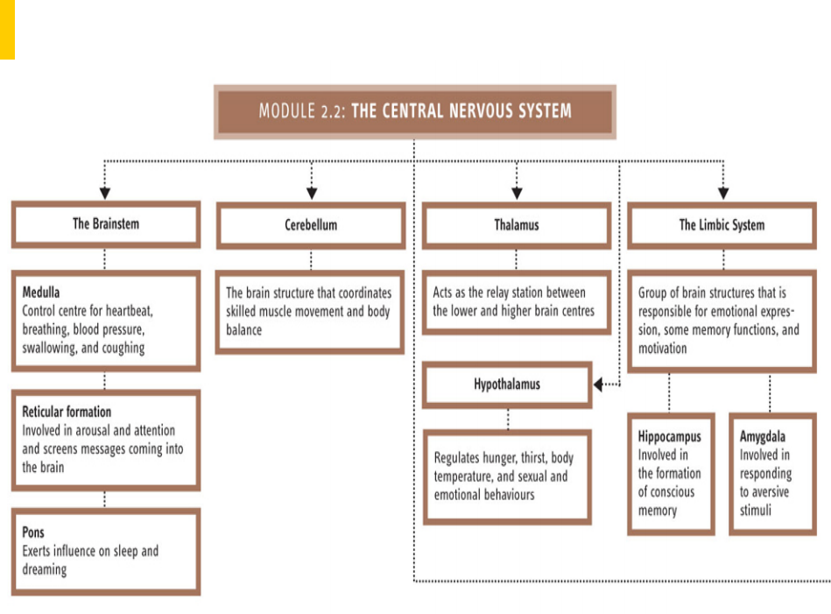
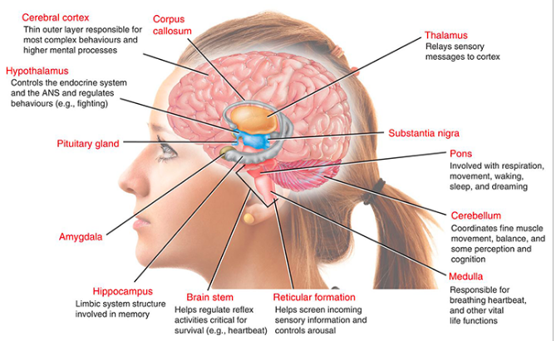
Parts of the Brain
- hindbrain-reticular formation, cerebellum, medulla, pons
- midbrain- substantia Nigra
- forebrain- cerebral hemisphere

Hindbrain (closest to spinal cord)
Reticular formation | - regulates sleep/wake cycle, main source of the neurotransmitter serotonin  - important for mood and activity levels
Medulla | - closest to spinal cord  - controls vital bodily functions such as the heartbeat, breathing, blood pressure, circulation, coughing & swallowing  - damage = stroke or trauma
Cerebellum | - deep convolutions, motor coordination  - controls bodily balance & muscular coordination, integrates information from muscles, tendons, and joints  - damage= difficulty reaching for objects without trembling
Pons | - sends signals to and from the forebrain and cerebellum  - assists in control of movement, important for sleep, breathing, swallowing, eye movements, and facial sensation & expression  - contains locus coerleus

Midbrain
- contains several neural centers that control some motor reactions and some sensory functions
Substantia Nigra | - produces and sends neurotransmitter dopamine to the forebrain as means of communication  - involved in movement control (i.e. eye movement, fluid body movements)  - damaged in Parkinson’s disease
Forebrain
- largest and most complex region, makes us more superior than other animals
Includes…
- subcortical structures
1)thalamus
2)hypothalamus
3)limbic system
4) cerebrum
- cerebral cortex (divided into two cerebral hemispheres that are connected by corpus callosum)

Subcortical Structures
Thalamus | - relay system for al sensory info except for smell
Hypothalamus | - regulation of basic drives  -fighting, hunger, thirst, mating, maternal behaviour  - control of the endocrine system (body’s temperature regulation)
Cingulate Cortex | - emotion and memory
Limbic system | - structures involved in regulation of Motivation (habenula), emotion, learning & memory  Amygdala  - involved with fear  - located in temporal lobe  Hippocampus  - Memory & learning  - Temporary stores information  -also includes hypothalamus & thalamus
Basal Ganglia | - Regulates & coordinates voluntary movement control by exerting inhibitory effect on motor systems  Striatum  - Dopamine from midbrain comes here  Nucleus Accumbens  - Motivation & reward learning

Cerebrum
- integration of complex sensory and neural functions
- initiation + coordination of voluntary activity in body
Cerebral Cortex (covers cerebral)
- involved in complex functions such as consciousness, language & thought
Subdivisions
Primary Sensory/Motor Areas- processing basic sensory information & directions for voluntary movements
Association Cortex-complex functions, higher-order sensory processing, integrating information from different senses, thinking, planning

The two hemispheres
- like mirror images of each other
- compromised of 4 lobes: frontal, parietal, occipital, temporal
Corpus Callosum
- connects the 2 hemispheres
- contains dense bundle of neural fibres (axons) that allow communication of information from one side of the brain to the other
*no need to label, but you do need to know the functions
-what kind of things will we lose if one of the lobes is injured or damaged
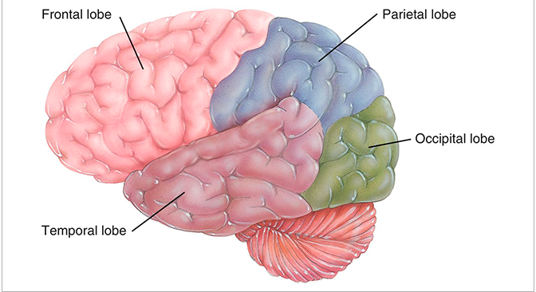

Frontal Lobe | - planning, logical reasoning, problem solving & judgement  - motor cortex- directing voluntary movement
Parietal Lobe | - somatosensory cortex (tongue and lower lips, hands and fingers)  - somatosensory strip- processes tactile (touch, pressure, vibration, & pain) information from different body parts  - sense of touch (pain, temperature)  - position in space
Occipital Lobe | - primary vision cortex  - process minute details of visual information (e.g., object borders, shading, colour & movement)
Temporal Lobe | - primary auditory cortex (processes sound frequency)  - processes language  - complex processing of sound  - regions that are important for: recognizing and labelling visual objects

Two hemispheres-speech areas
- Broca’s area (in the left frontal lobe)-speech production
- Wernicke’s area (in the left temporal lobe) –speech/language comprehension 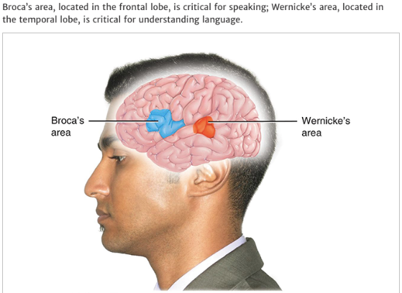
- Damage results in speech impairment despite having normal language comprehension
- Location of W & B depends on if you are right-handed or left- handed
Hemispheres: Lateralization
- Specialization-left &right
- Left: language, mathematics, analytic, sequential
Right: visual, spatial, holistic, understanding humor language, creativity, intuition
(VICHUS)
Where does the signal come from & where does it go?
- much of our primary functions are connected to the opposite side of the body
- things happening on the left are processes by the right hemisphere of the brain
- things happening on the right are processed by the left hemisphere
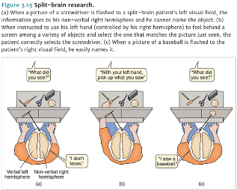
Split-brain Patients
- have their corpus callosum severed
- right & left brain cannot talk to each other
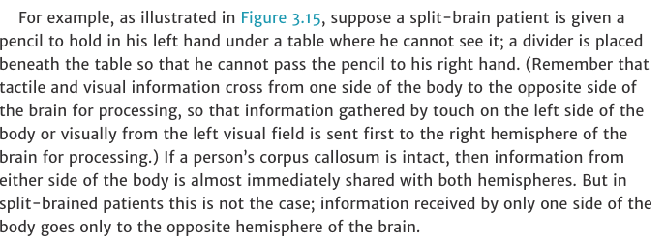
- right brain controls everything on left side of the body (vice versa)
- Language centers in the left hemisphere

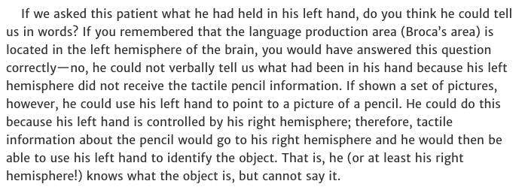

Neuroplasticity
- brains ability to create new neural pathways as a result of experience or following an injury
- reorganize & compensate for brain damage, a change in function & structure (repairs it)

Old view: once damaged, it is all over | New findings
- developmental literature saying neurons in place prenatally  - proliferation vs Growth- key points developmentally | - Neurogenesis: hippocampus (limbic system-learning & memory), olfactory bulb (area that helps you to smell stuff)  - neurogenesis not just a replacement, could be repaired  - flexibility in the system

How does Neuroplasticity work?
- network of neurons in the brain changes over development in 4 ways:
1) Growth of dendrites & axons
2) Synaptogenesis, the formation of new synapses
3) Pruning, consisting of the death of certain neurons and the retraction of axons to remove connections that are not useful
4) Myelination, the insulation of axons with a myelin sheath
(PMS Girl)
Neuroplasticity= new neural pathways (in brain). Ability to rewire itself, in response to stimuli and experience
Neurogenesis= recovery of tissue (in brain). Ability to form new neurons, and connects between neuron, also called synaptogenesis
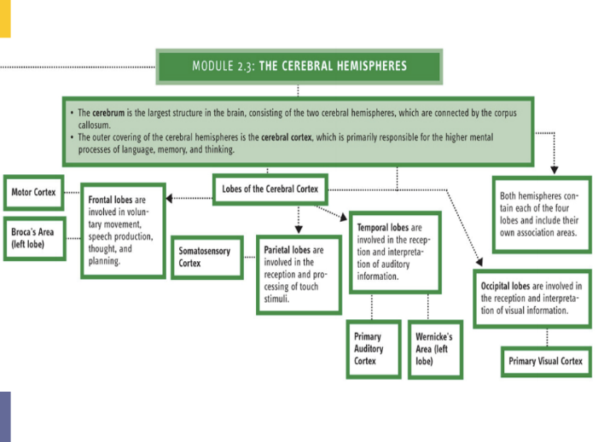

Appendix B: Statistics in Psychology
Dr. Joanne Lee
October 18, 2016
- descriptive statistics: help describe and summarize data
- inferential statistics: help draw conclusions about data

- Descriptive Statistics:
- With a data set, the first thing a person may want to do is order it from lowest to highest.

- Frequency distributions:
- There are two types of frequency distributions:
- Ungrouped Frequency Distribution: the number of times that each unique score occurs is recorded (i.e. how many students got a 32, a 36, a 38…)
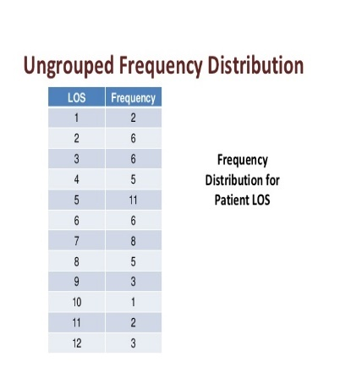

- To create an ungrouped frequency distribution, a table with 2 columns needs to be made. One for the test scores of the students (smallest to largest), and one for how frequently they occur

- The instructor can see where people range with their marks. I.e. how many people got a certain mark. Which was the highest mark, which was the lowest mark.

- This type of frequency distribution may become a bit hectic when dealing with a lot of data.

- Grouped Frequency Distribution: grouping data in order to determine frequencies.
- An instructor will set a range for the scores (for example with a width of 5 scores), then she will determine the frequency of marks in each range. For example, there were two marks which ranged between 11-15, and so on….
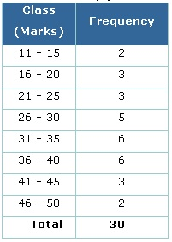
- Histograms (bar chart showing data, of how often certain marks occurred)
- Graphically represent the grouped frequency distributions
- Frequency in the y-axis and scores on the x-axis

- Frequency Polygons (like a histogram, but in line form. Used for grouped frequency distributions):

- Need to determine the midpoint of the range of scores. The midpoints will be used on the x-axis, with the frequency on the y-axis. (i.e. the midpoint of 16-20 is 18. Which means 18 will be plotted on the x-axis, and the y-value will be 3)
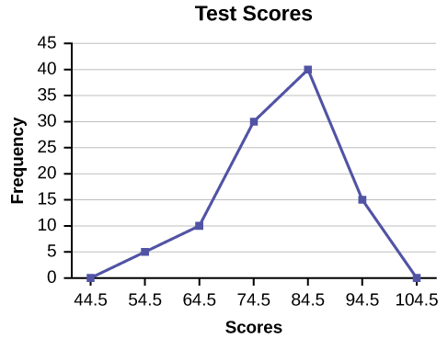 midpoints

- Measures of Central Tendency: numbers used to summarize data sets (mean, median and mode)
- Mean: average of the data set
- Median: the midpoint or center of an ordered set of data
- Mode: most frequently occurring score or observation

- Measures of Variability: tells us how different the numbers in the set are from one another.
- Range:
- Simplest measure of variability
- Difference between the highest and lowest score
- Disadvantage: these two are the extreme scores. Does not account for other scores
- Total of the deviation scores with always be 0, through this method

- Variance: is the squared deviation scores.
- the larger the squared deviation (score-mean, squared. Each scores squared answer is given, and then added, and divided by how many there are), the further the observation is from the mean

- Disadvantage: variance is not the same metric as original scores

- Standard deviation= square-root of the variance

- Frequency Distributions—Again
- Normal Distribution (bell curve): distribution in which the middle portion has the most scores, and either sides have smaller scores.

- For example, when considering heights, there are a wide range of people who are relatively in the same range (middle-ish), while there are also extremes (short and tall), which are on either side of the frequently occurring heights. This produces a bell-curve.

- Normal distribution= symmetrical distribution (bottom half shape, is same as top half shape)

- Mean goes in the middle

- Normal distribution falls within one standard deviation of the mean (plus or minus one standard deviation)

- Positively skewed distribution (skewed to the right): when most values occur at the lower-end of the scale
- The mean is most-likely going to be bigger than the median, because there are less people with the higher salaries, than lower. But the higher salaries make the mean greater.

- Mode tends to be less than the median, since there are more people with lower salaries than higher salaries

- Negatively Skewed Distribution (skewed to the left): most values occur at the upper end of the scale
- Mean is smaller than the median. The mean is influenced more by the smaller scores, since most of the scores are higher.

- Mean is also less than the mode, since higher scores were more frequent

- An example can be: a teacher giving an easy test, and people getting high scores, and some people getting low scores.

- The mean in both cases may not be the most reliable since it is easily influenced by higher or lower scores. The median or mode would be a better option.

- Measures of Association: summarize the degree of the relationship or association between variables. Using descriptive statistics

- Scatter Plot: a way to graph/ plot values of one variable (or measure association), with the values of another variable or measure.

- Pearson product-moment correlation coefficient (r) (PPMCC- try remembering it like this):

- most common measure of association between two variables
- value of correlation coefficients can range from +1 to -1
- value of correlation coefficients, help determine the magnitude and the direction of the relationship, b/t two variables
- (r>0.00) = positive (direct) relationship
- higher value of one variable = higher value of the other variable
- lower values of one variable = lower values of another variable

- (r<0.00) = negative (inverse) relationship
- Decrease in one variable = increase in another variable (i.e. increase in video games= decrease in marks)

- Perfect relationships= r= +1 or r= -1 (scatter plot will be straight line)

- To determine the magnitude, we need to take the absolute value of r (not considering whether it is positive or negative). The higher r value the stronger the magnitude (relationship) between the variables.

- Coefficient of Determination: square the correlation coefficient to understand the magnitude of the relationship.

- For example, if the relationship between life expectancy and smoking is r=0.80. That means that we could predict with 64% accuracy a person’s life expectancy based on how much they smoke.

- Inferential Statistics:

- Populations and Samples:
- In the beginning of the study the people in each group are randomly selected and evenly distributed; including any differences that may have existed between two groups

- Hypothesis Testing: used to determine whether there is enough evidence collected from the sample group, to apply it to the whole population. Also determined by looking at the differences between the control/ experimental groups.

- With hypothesis testing, psychologists set up two hypotheses:

- Null Hypothesis: no significant difference between two groups. Was ineffective. (i.e. the memory drug was ineffective)

- Alternative Hypothesis: there is a significant difference between the two groups. Was effective. (i.e. the memory drug helped the memory of those who took it, compared to those who didn’t)

- Sampling distribution: wide range of different outcomes, which could apply to the whole population

- Significance level/ Rejection level: level of risk researchers would be willing to take in terms of making an incorrect conclusion

- Effective Size:
- Strength of the relationship between 2 variables. Relationship or size difference between the difference of two variables.

- Two common categories of effect size:

- Estimate the magnitude of the differences between two or more groups (magnitude difference)
- Estimate the degree of shared variation between 2 or more variables (shared variation)

- Cohen’s d (for experimental studies) is the most commonly effect size for the difference in average performance between two groups.

- Standardized difference between two population means, which can be estimated by taking the difference of the means of the populations and dividing it by the standard deviation for the data.

