Hudson Bay’s Kaufhof Acquisition: Managing Growth both Inline and Online



ADM 3318 X
Professor Sharma Parkash
Kinanah Alhaj
7782330
June 7, 2017
Executive Summary

Primary Problem

Managing Kaufhof’s growth both inline and online by Hudson’s Bay management.

Secondary Problems

- How Hudson’s Bay will maintain competitiveness both at Germany and at home. Responding to Nordstrom entrance to the Canadian market?
- How Hudson’s Bay will introduce Fifth Saks brands to Germany without failing?
- How the cultural gap between Hudson’s Bay management and the Kaufhof team will be bridged?
- How Hudson’s Bay management of Kaufhof will make it responsive to social and cultural changes in the marketplace among consumers?

Alternatives

- Global strategy coupled with a joint-venture entry mode into the German market.
- Transnational strategy coupled with owning a wholly owned subsidiary entry mode
- Multidomestic strategy joined by a turnkey project entry to the market.

Recommendation

The recommended solution is to use alternative II; a transnational strategy coupled with a wholly-owned subsidiary entry mode. Its strong emphasis on geographical and physical expansion of Kaufhof and Fifth Saks stores in Germany, while also ramping up its online presence to compete with leading online retailers in the industry. It is the alternative that minimizes the controls cost while opening up many branches for sales. And it also takes into consideration the human aspect in this acquisition by taking the time to understand the German culture, to bridge the gap between management of Hudson’s Bay and Kaufhof employees and to tailor its offerings to German consumers. This alternative can also be used a the strategy to use to address the entrance of Nordstrom to the Canadian market to prevent it from capturing a big portion of the market share of the department store industry.

Primary Problem

The primary problem that Hudson’s Bay is facing in the Kaufhof division is its management and growth from a physical and e-commerce business aspect. In the 21st century technological advances have increased the rate at which globalization is spreading around the world. And the emergence of the worldwide web and internet, e-commerce businesses such as Amazon have become a competitive threat to traditional brick-and-mortar retail stores. Figure 1.1 in the appendix supports this idea. This is also illustrated in the case as Volker Bosse (analyst at Baadar Bank) stated that German retailers are lagging behind in the area of e-commerce, and as a result Kaufhof and even its major competitor Karstadt have been struggling to compete with Amazon and other online brands.
Secondary Problems

- One challenge and issue of the Kaufhof acquisition in Germany is the Hudson’s Bay ability to stay competitive and responsive in its home country. With so much effort and attention focused on the Kaufhof acquisition, it may lose its awareness to environmental and market changes at home, thus losing competitiveness and as a consequence, sales. This comes in the form of the Nordstrom’s entrance to the Canadian market. It already has 4 stores spread throughout Toronto, Ottawa, Yorkdale, and Vancouver, and plans to further this expansion in the near future. Figure 2.1 illustrates Nordstrom projected growth in Canada in red of $1 billion in sales opportunity.
- Another issue to consider is how Hudson’s Bay management plans to introduce the Saks Fifth Avenue and Saks Off 5th Banners to Germany as well as Belgium. Examples such as Wal-Mart have demonstrated to the world economy that entrance to the German market is far from easy, and so as a result, Hudson’s Bay must devise a cunning strategy to introduce and maintain the Saks Fifth brand in Germany to capture more market share and increase its revenues and profits.
- A challenge to the personnel of the organization is bridging the team and personnel who are involved on an operational and managerial level from Kaufhof with the team and personnel that Hudson’s Bay will bring to Germany. There can be differences in authority, with respect to culture and Hofstede’s 5 cultural dimensions, namely gender differences between the two cultures, power distances differences, time orientation differences, interpretations of individualism and collectivism, as well as language barriers.
- Apart from the cultural differences internal to the company, Hudson’s Bay must also consider the cultural differences external to the company. This includes analyzing consumer behaviour of Germans with respect to culture to better tailor the offerings and services of Kaufhof to the German market. Hudson’s Bay management must ensure that going forward after the acquisition that the offerings and operations of Kaufhof remain the same and not deviate to a North American way of doing business.
Implications on the Organization

If Hudson’s Bay’s management does not address the primary and secondary problems and obstacles, the following implications will affect the organization:
- Kaufhof will continue to struggle financially as companies such as Amazon capture more and more market share of the retail industry thus leading to;
  - Closing of more Kaufhof stores
  - Losses in liquidation expenses
  - Forgoing revenues and profits
  - Hudson’s Bay will be regarded as Wal-Mart 2.0 in the global marketing economy, losing its reputation credibility to ever expand into foreign markets again.
- Hudson’s Bay will not be able to introduce the Saks Fifth brand to Germany as it failed in its growth and management of Kaufhof.
- Poor analysis of culture, and thus poor personnel cohesion between the Hudson’s Bay team and personnel and that of Kaufhof, leading to inefficient operations and conflicts among the two teams.
  - Operations would be affected in the form of lower productivity and as a result lower revenues or greater costs.
- Misalignment between the cultural offering of management and the expectation of German consumers will result in mismatched goods and services offered, thus incurring cost to the organization and forgoing sales.
Implications on the Personnel

The implication of said problems on the personnel of the organization are outlined below:
- Inadequate growth and management strategies of Kaufhof by Hudson’s Bay management will result in the continuation of Kaufhof stores closing down in Germany.
  - Higher employee layoff rate
  - Decrease in job security
    - Decrease in employee morale and job productivity
- Operational managers of Kaufhof also being laid-off with workers of stores closing down.
  - Increase in corporate pressure leading to decrease in job security
  - Distrust between management and higher company executives
- Executives of both Kaufhof and Hudson’s Bay will feel pressure from managers and employees for closing down stores.
  - Pressure from stockholders due to losses and of liquidation and decrease in sales.
  - Executives held responsible in the light of the public for failure of Kaufhof resulting in decreased morale among executives resulting in lack of direction, organization, and leadership of the entire organization.
Implications on the Environment

Environmental implications due to the primary and secondary problems and obstacles are as follows:
- Failing of Hudson’s Bay management of Kaufhof in Germany will further confirm the inability of North American companies to effectively and efficiently enter European markets, such as Wal-Mart’s failure in Germany, Dasani’s failure in the UK, and Uber in the Netherlands.
  - Loss of reputation of North American Foreign expansion abilities
  - May force European governments to start regulating the expansion of North American companies into European companies as a result of so many failures.
    - More regulation, increase in political and business barriers put in place for future.
- Distrust of German consumers to future North American businesses entering Germany as a result of the failures of Wal-Mart, Hudson’s Bay.
- Decline and ultimate failure of Kaufhof will create a gap in the retail market that will increase competition from competitor Karstadt, medium-sized department-store competitors, as well as Amazon.
Alternative Solutions

- Global Strategy
Another alternative to consider is a global strategy coupled with a joint-venture entry mode into the German market.

A global strategy will allow Hudson’s Bay to exploit location economies by taking over the sites of major Kaufhof outlet locations, benefiting from its established reputation. In addition, using a possible joint-venture entry tactic, with a real-estate company for example, will allow Hudson’s Bay to finance the buying of other major urban locations, where the company may establish other Kaufhof stores or even the Fifth Saks brand. By saving so much money, the company will be able to direct some of its financial resources to multi-channel commerce growth, namely e-commerce.

This alternative majorly depends on seeking out a possible real-estate company to set u a joint-venture with. Since Hudson’s Bay is already acquiring the Kaufhof brand and its store locations, the only thing it should focus on to reap even more benefits of location economies in Germany is to establish a joint-venture with a real-estate company, financing the buying of populated and active urban areas, and sharing the revenues of sales with the company. This strategy will be excellent in maximizing the company’s physical exposure throughout Germany and acquiring more stores to capture more market share of the department industry. It will also be the strategy that minimizes the lowest amount of cost which is beneficial to Hudson’s Bay entrance to a foreign market in the long-run.
The alternative’s advantages and disadvantages are outlined below:
ADVANTAGES | DISADVANTAGES
- Exploitation of location economies to maximize sales  - Minimization of costs  - Diversification of risk with joint-venture company  - Relatively straightforward alternative | - Company is not responsive to changing market demands  - Little knowledge of cultural environment
This alternative will solve the primary problem because by minimizing costs and capturing more sales by being located in active urban areas, the company will be able to expand its online presence by investing more in e-commerce growth strategies. It will also be able to use the relationship it has with the real-estate joint-venture company to finance the venues for the Fifth Saks brand stores in Germany. It will also be able to use this strategy to partner up with another real-estate joint-venture in Canada to bring Kaufhof to Canada to put stronger competitive pressure on Nordstrom.
- Transnational Strategy
One possible strategy to implement to enter and compete in a global market is the transnational strategy coupled with owning a wholly owned subsidiary entry mode.

A transnational strategy for Hudson’s Bay management of Kaufhof ensures that Kaufhof in Germany remains responsive to cultural norms, values, and beliefs of German consumers, further tailoring the brand’s services and goods to their needs and wants, while controlling costs associated with the acquisition and e-commerce growth of the Kaufhof Brand. As well, Hudson’s Bay will introduce the Fifth Saks brand to Germany through establishing green ventures, separate from Kaufhof, as well as converting few well-known Kaufhof locations to Fifth Saks stores to benefit from location economies.

Performing multiple marketing analyses to understand the German consumer market ensures business offerings are in accordance with cultural norms and addresses Kaufhof’s responsiveness obstacle to changes in the market. The company must also use this cultural analysis to bridge together the Hudson’s Bay and Kaufhof team for effective team performance. In addition to that, Hudson’s Bay’s Kaufhof team will perform an IT-based competitive analysis, using online retailers such as Amazon to measure up against their performance, market share, and core competencies. The company will then use this to evaluate how it will use its $50 million in e-commerce growth initiatives to better compete with Amazon and other online retailers. And finally it will use green ventures and wholly-owned subsidiaries to introduce the Fifth Saks brand into Germany, using a similar process of marketing, cultural, and IT-based analyses to enter the European market to be aligned with the business operations and effectiveness of the Kaufhof brand that the German people trust and accept.

Below is a table outlining the advantages and disadvantages of a transnational alternative coupled with wholly-owned subsidiary entry mode:
ADVANTAGES | DISADVANTAGES
- Exploiting experience curve effects and location economies to control costs and increase revenues  - Using already established Kaufhof’s to introduce Fifth Saks brand  - Cost-cutting, using wholly-owned subsidiary (Kaufhof) and green ventures Fifth Saks to capture more market share  - Establishing the company as culturally aware in an evolving and dynamic consumer market, making it responsive to consumer demands with respect to culture.  - Bridging gap between management of Hudson’s Bay and Kaufhof operations to operate effectively and efficiently | - Difficult to implement: too many variables may disorient the organization resulting in lack of coordination  - Requires enormous amount of attention; may take Hudson’s Bay attention from competition in home country (Nordstrom), thus lowering its responsiveness in Canada
By following this alternative the primary problem will be solved because through the exploitation of location economies and cost-cutting, the company will have sufficient funds (other than the $50 million already set aside) to spend on multi-channel growth strategies such as e-commerce coupled with time and money invested in cultural analysis of Germany to bridge the company’s executives to Kaufhof staff and to German consumers. And through its effective operations it would be able to introduce the Fifth Saks Brand by transforming acquired well-known Kaufhof locations into Fifth Saks stores, thus successfully entering the European market. And by managing Kaufhof in Germany, Hudson’s Bay may then consider expanding the brand back into its home country to compete with Nordstrom. The Canadian market for department stores is far from saturated and there is a lot of market share to be captured. And so having 2 stores, both owned by Hudson’s Bay will result in the company capturing more market share and competing in a greater degree with Nordstrom.

- Multidomestic Strategy
A final strategy to consider is a multidomestic strategy joined by a turnkey project entry to the market.

This strategy will require Hudson’s Bay team to fully concentrate on customization and responding to local changes in the market. And the best way to do this is to improve the e-commerce aspect of Kaufhof to offer more variety, choices, and customization when browsing the store and the online website. And since Kaufhof has been lacking in this area, then it is recommended that a turnkey project be handled to an IT company that is specialized in experienced in e-commerce to redesign Kaufhof’s online website to compete with that of Amazon’s.

The major emphasis of this project is product variety and customization. And this is a very costly alternative, especially since Hudson’s Bay will be contracting a turnkey project to an IT firm to give them an improved website. As a result, Hudson’s Bay may want to restructure a little but and shift some of Kaufhof’s brick and mortar resources to its e-commerce project and initiative, thus closing down a few stores and liquidating to finance this turnkey project. The company at the end will have a fully functioning online website, available with a variety of offerings, including some customization features in terms of the clothing sold. This will put the company in a strategic position to capture more sales made from online, opening up new sources of income, and driving sales.

Below is a table outlining this alternatives advantages and disadvantages;
ADVANTAGES | DISADVANTAGES
- Exploiting experience curve effects  - Customization will attract new demographic, attracting new customers and more sales  - Downsizing will cut some costs  - Specialized firm will create e-commerce website | - Very costly turnkey project  - Taking down stores and laying off employees creates distrust and decrease in employment security
This alternative will solve the primary problem because it will address Kaufhof’s weakness in e-commerce and give them a new e-commerce website that is up to par with Amazon to retain current and event attract new consumers. And since this strategy will include a lot of marketing analyses that act as a measure to understanding German consumers and the German environment, Hudson’s Bay management will be able to appropriately approach Kaufhof employees and consumers with respect to culture. It may also use a combination of transforming Kaufhof stores to Fifth Saks, and using the new website to introduce the Fifth Saks brand to Germany and Belgium. The company will be able to minimize its risk by introducing 1 or 2 Fifth Saks stores will pushing the brand primarily on its e-commerce website to observe how consumers respond to the brand and its offerings before further expansion.

Recommended Solution

The recommended solution is to use alternative II; a transnational strategy coupled with a wholly-owned subsidiary entry mode. Even though this alternative may be regarded as the most difficult to implement, it is however the one that if implemented correctly would address the primary and all the secondary problems outlined in this case. It is also one that combines the outcomes of the remaining 2 solutions. Its strong emphasis on geographical and physical expansion of Kaufhof and Fifth Saks stores in Germany, while also ramping up its online presence to compete with leading online retailers in the industry. It is the alternative that minimizes the controls cost while opening up many branches for sales. And it also takes into consideration the human aspect in this acquisition by taking the time to understand the German culture, to bridge the gap between management of Hudson’s Bay and Kaufhof employees and to tailor its offerings to German consumers. This alternative can also be used a the strategy to use to address the entrance of Nordstrom to the Canadian market to prevent it from capturing a big portion of the market share of the department store industry.
Implementation Plan

- Immediate
  - Finalize the closing of Hudson’s Bay’s Kaufhof acquisition.
  - Perform cultural analysis for use towards assessing nature the cultural approach to take towards Kaufhof employees as well as German consumers. Use official Geert Hofstede website to view Germany’s standing in the five cultural dimensions.
  - Introduce the Hudson’s Bay team to the Kaufhof team allowing social cohesion for trust and better team performance and productivity within the hierarchal chain.
  - Perform SWOT and competitive analysis to understand the department store industry to understand the nature of the competition that is both inline and online.
  - Commencement of e-commerce research to launch new online selling platform
- Short-Term
  - Release of new e-commerce website.
  - Collect reviews from consumers about the website for further adjustments.
  - Survey and study which Kaufhof locations will be converted to Fifth Saks stores.
  - Collect more information about the social cohesion between the Kaufhof and Hudson’s Bay team to ensure satisfaction with company jobs, vision, and chain of command.
- Long-Term
  - Unveil Fifth Saks stores in Germany and record consumer’s response to them as well as tracking financial metrics to measure monetary success.
  - Make any adjustments or maintenance to the e-commerce website.
- Very Long-Term
  - If Fifth Saks stores have positive ratings and yield sales and profits, expand and open up more stores in Germany.
  - Bring the Kaufhof brand to Canada through either transforming some Hudson’s Bay stores or setting up a joint-venture with a real estate company to finance buying venues for Kaufhof stores. Target cities and locations where Nordstrom is set up in.
  - Manage overall growth in Germany and Canada.

Appendix
Figure 1.1
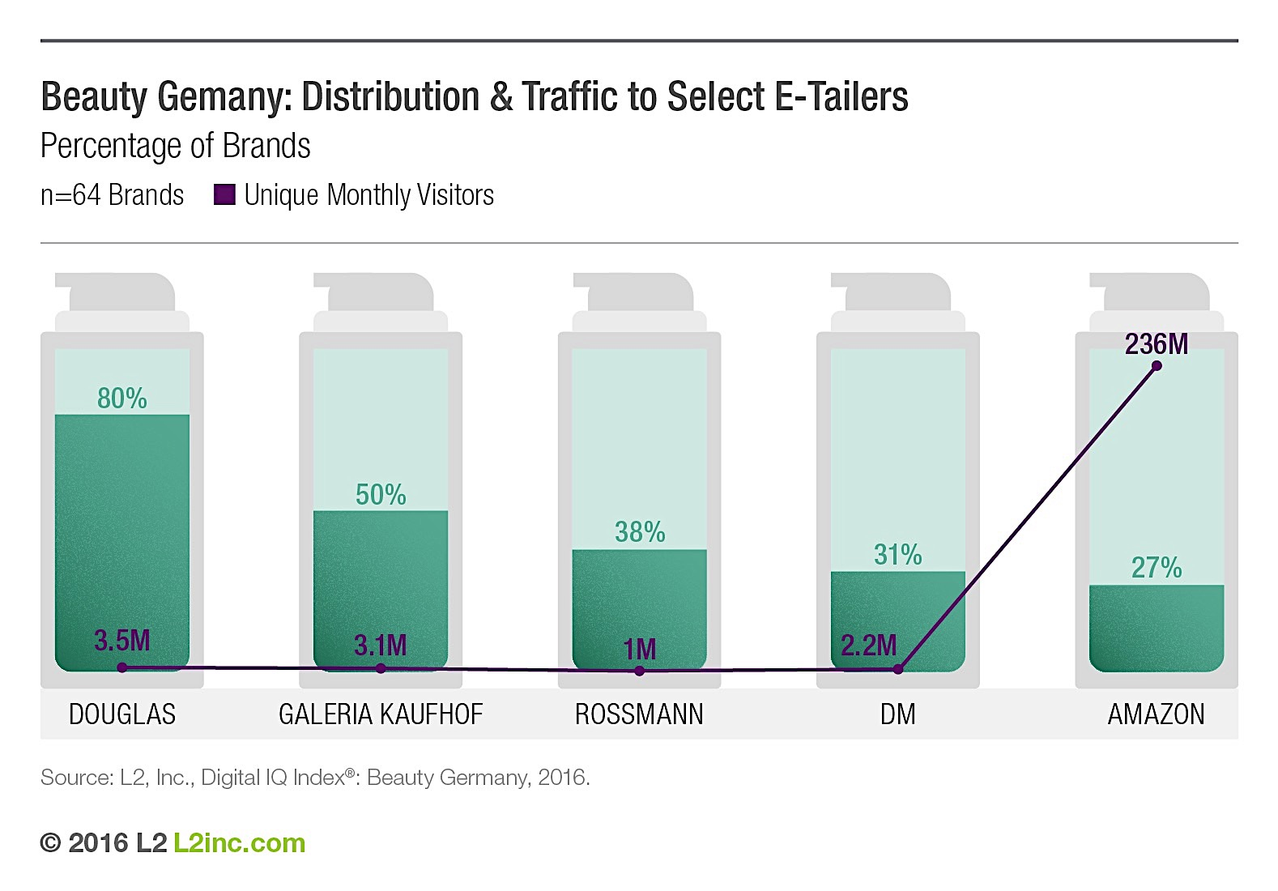
Figure 1.2
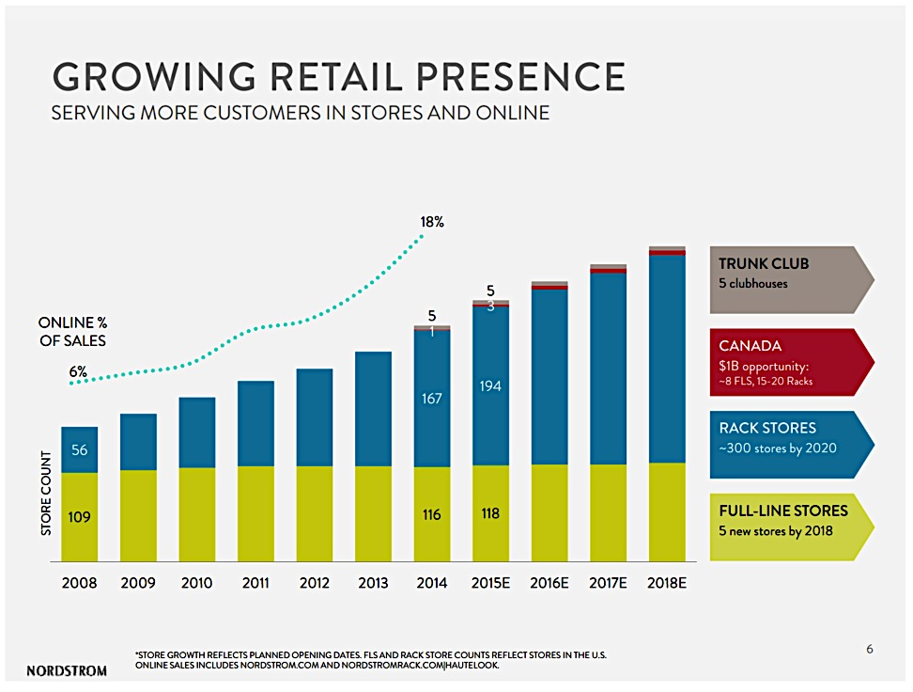
References

Pair-Wise Investments Arbitrage, Deep Value, event-driven, special
situations. (2015, June 29). Nordstrom: A Retirement Stock To Have In Your 401(K). Retrieved June 01, 2017, from https://seekingalpha.com/article/3288515-nordstrom-a-retirement-stock-to-have-in-your-401-k

Rosen, E. (2016, June 29). Brands Struggle With Amazon Inventory.
Retrieved June 02, 2017, from https://www.l2inc.com/daily-insights/brands-struggle-with-amazon-inventory

Colin, N. (2016, January 28). 11 Notes on Amazon (Part 2) – Welcome to The
Family. Retrieved May 31, 2017, from https://salon.thefamily.co/11-notes-on-amazon-part-2-e55aecf38a98

Denning, S. (2004, March 21). Stories spoil Dasani launch for Coke in the UK.
Retrieved October 9, 2015, from http://www.stevedenning.com/Storytelling-in-the-News/95-coke-dasani-launch.aspx

Hofsteded, G. (n.d.). Geert Hofstede. Retrieved June 03, 2017, from https://geert-
hofstede.com/germany.html

