Sept. 26, 2017 – Lecture 3, Ch.4

Taxable Income and Tax Payable For Individuals

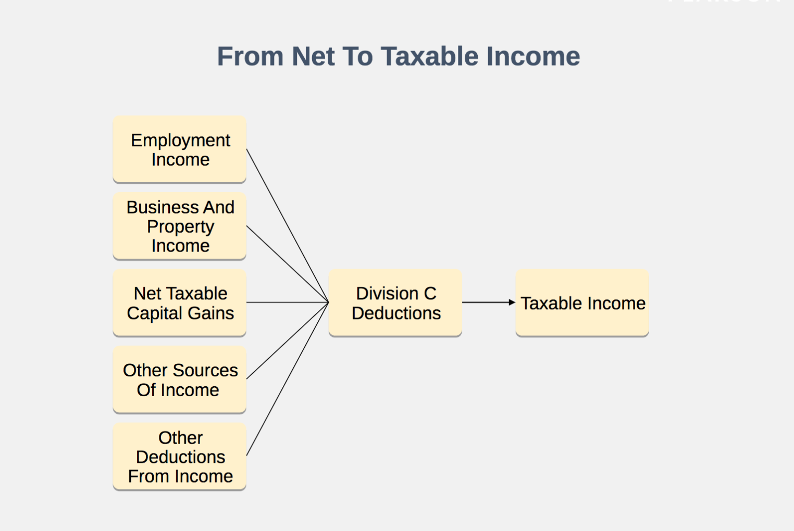
Available Deductions
•Employee Stock Options (Chapter 3)
•Deductions For Payments
•Home Relocation Loan (Not available subsequent to 2017)
•Lump Sum Payments
•Lifetime Capital Gains Deduction (Chapter 11)
•Northern Residents Deductions
•Loss Carry Overs (Chapter 11)

Deduction For Payments
•Tax treaty exemptions
•Worker’s compensation – Removes from net income
•Income from employment with prescribed international organizations
•Social assistance payments – Removes from net income

Example: An employee receives a $100,000, interest free loan from his employer on July 1, 2017. During the remainder of the year, assume the relevant prescribed rate is 2%.
ITA 80.4 Benefit [(2% - Nil)($100,000)(6/12)] $1,000
Lesser Of:
$1,000; and
[(2%)($25,000)(1/2)] = $250 ( 250)
Net Benefit $ 750
•Available for 5 years only
•Can use rate at inception or go quarter to quarter
Repealed For 2018 And Subsequent Years

Home Relocation Loan Deduction The Basic System
Example For 2017, an individual has Taxable Income of $100,000 and only his basic personal tax credit of $1,745 [(15%)($11,635)].
Tax On First $91,831 $16,300
Tax On Next $8,169 ($100,000 - $91,831) At 26% 2,124
Total Federal Tax Before Credit $18,424
Basic Personal Credit ( 1,745)
Federal Tax Payable $16,679

Tax Credit System
•Refundable Vs. Non-Refundable.
•In general, minimum rate applied to a base (15% for 2017).
•Some credits have income threshold.
•Provinces have similar credits.

2017 Personal Tax Credits
- •Individuals
  - –ITA 118(1)(a): If Married
  - –ITA 118(1)(c): If Single
  - –[(15%)($11,635)] = $1,745
- •If spouse has physical or mental infirmity:
  - –[(15%)($11,635 + $2,150)] = 2,068

2017 Personal Tax Credits
- •Spouse Or Common-Law Partner – ITA 118(1)(a)
–If healthy (15%)($11,635 – Net Income Of Spouse)
–If mentally or physically impaired (15%)($11,635 + $2,150 - Net Income Of Spouse)
–Maximum = $1,745 (healthy) or $2,068 (impaired)

2017 Personal Tax Credits
•Amount for Eligible Dependant ITA 118(1)(b)
–Same amount as spouse or common-law partner
•$1,745 if dependant healthy
•$2,068 if dependant impaired

Amount For Eligible Dependant
•Conditions: you are single, divorced, separated, or widowed and you supported a dependant:
–who is under 18 (unless parent, grandparent, or infirm)
–living with the individual
–related by blood, marriage, or adoption
–resident of Canada (except child)
–dependent on individual for support

2017 Personal Tax Credits
•Canada Caregiver For Child – ITA 118(1)(b.1)
–Under 18 at end of year
–Mentally or physically impaired
–[(15%)($2,150)] = $323

Canada Caregiver – ITA 118(1)(d)
•Conditions
–Care for a dependant over 17 (does not have to be in-home)
–Resident of Canada (unless child or grandchild)
–Mental or physical infirmity
–Not available if eligible dependant available
–Not available for a spouse or common-law partner

Canada Caregiver – ITA 118(1)(d)
•Value
–[(15%)($6,883)]
–Reduced by the dependant’s income in excess of $16,163
–Maximum = $1,032 [(15%)($6,883)]

Canada Caregiver Additional Amount – ITA 118(1)(e)
•Additional amount for spouse or eligible dependant
–If base for spousal or eligible dependant credits is less than the regular Canada caregiver amount base;
–Then, additional amount is available
Actual spousal or eligible dependant, less
Income adjusted Canada caregiver amount

Canada Caregiver Additional Amount – ITA 118(1)(e)
•Infirm spouse with income of $18,163
•Regular spousal credit equal nil
•Additional amount = $4,883 [$6,883 – ($18,163 – $16,163)]

Age - ITA 118(2)
•Reach 65 In The Year
•$1,084 = [(15%)($7,225)]
•Reduction
–15% Of Income > $36,430
–Gone when income reaches $84,597

Pension Income – ITA 118(3)
•Amount = 15% Of 1st $2,000 = $300
•Not Indexed

Pension Income – ITA 118(3)
•Qualifying Amounts
–Age 65 Or Older At End Of Year
Most Non-Government
< Age 65 At End Of Year
•Life Annuities
•Amounts Resulting From Death Of Spouse
–No CPP, OAS, Or Provincial (QPP)

Canada Employment – ITA 118(10)
•15 percent of the lesser of $1,178 or employment income.
•Maximum = $177

Adoption Expenses – ITA 118.01
•Up to $2,351 [(15%)($15,670)]

Adoption Expenses – ITA 118.01
•Eligible Child
–Has not attained age 18
–Issued adoption order
•Eligible Expenses
–Fees to agency
–Court and legal fees
–Reasonable travel costs
–Mandatory fees related to immigration
–Other reasonable expenses incurred after the adoption file is opened

Public Transit Passes – ITA 118.02
•15% of cost
–Individual
–Spouse and children under 19
–Qualifying pass
•Unlimited travel for 28 days
•5 day passes if they cover 20 out of 28 days
•Electronic cards with at least 32 one-way trips.
•2017 Budget
  - –Only available for payments made prior to July 1, 2017
  - –Gone completely after 2017

Home Accessibility – ITA 118.041
•Qualifying individuals
–An individual over 65
–An individual eligible for the disability tax credit
•Eligible dwelling: Housing unit located in Canada
•Qualifying costs: Allows qualifying individual to be more mobile or more functional within an eligible dwelling
•Lesser of $10,000 and the amount of qualifying costs
•Some costs will also be added to the medical expense credit base.

First Time Home Buyer’s Tax Credit
- •$750 [(15%)($5,000)]
- •Can be claimed by individual or spouse
- •No home purchase in preceding 4 years

Volunteer Firefighter’s – ITA 118.06
•$450 [(15%)($3,000)]
–Requires 200 hours of volunteer firefighting

Volunteer Search And Rescue Workers ITA 118.07
•$450 [(15%)($3,000)]
–Requires 200 hours of volunteer search and rescue work

Charitable Donations – ITA 118.1
Calculation
[(15%)(A)] + [(33%)(B)] + [(29%)(C)] where:
A = The first $200 of eligible gifts.
B = The lesser of:

  - –Total gifts, less $200; and
  - –Taxable Income, less $202,800 (for 2017)
C = The excess, if any, by which the individual's total gifts exceed the sum of $200 plus the amount determined in B.

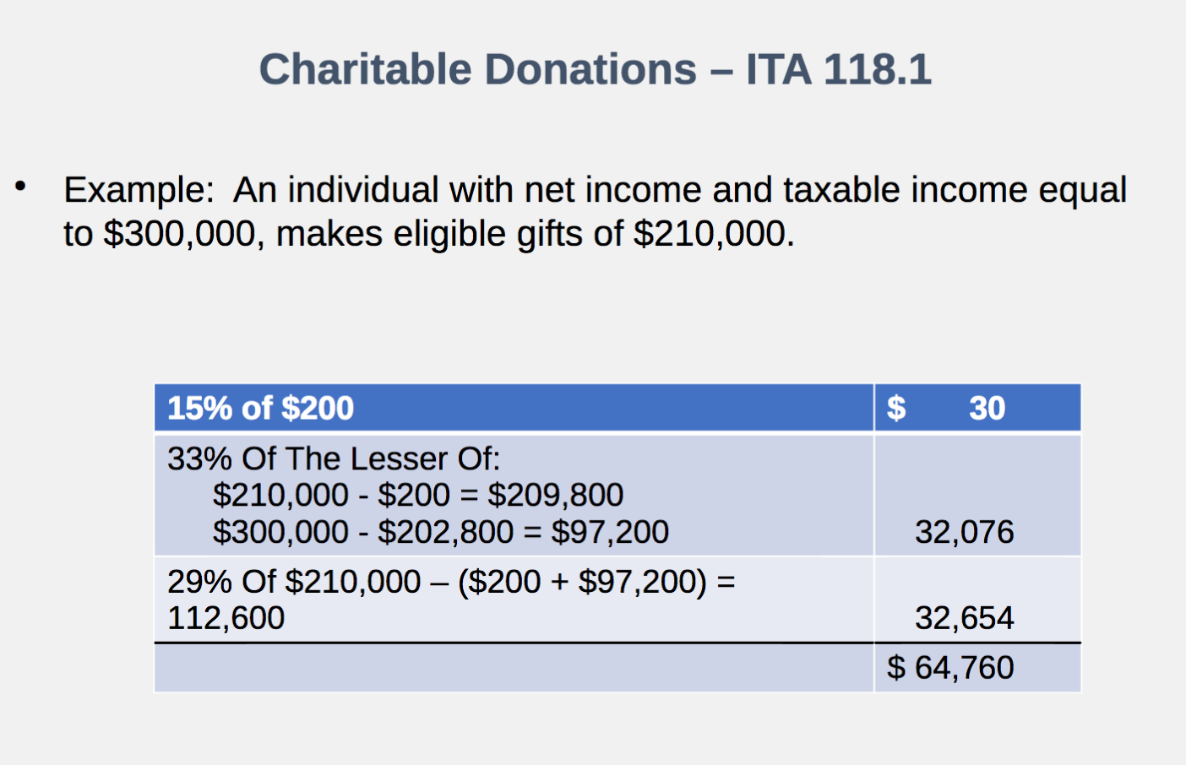

Charitable Donations – ITA 118.1
•Super Credit For First-Time Donors
–40% (1st $200) + 54% (next $800) + 29% of additional
–Can be claimed one time only
–Last year to claim is 2017

Charitable Donations – ITA 118.1
•General Rules
–Limit: 75% Of Net Income (100% in individual’s year of death and preceding year), plus
–25% of taxable capital gains on gifts of capital property (See Chapter 11), plus
–25% of recapture on gifts of capital property (See Chapter 11)

Charitable Donations – ITA 118.1
•General Rules
–Carry Forward: 5 Years
–Subject to the same limitations

Medical Expenses – ITA 118.2
•General Rules
- 15% of eligible costs
- Reduced by the lesser of
- 3% of Net Income
- $2,268 (3%)($75,600) – The 2017 Figure
- Any 12 month period ending in the year

Medical Expenses – ITA 118.2
•Spouse And Minor Dependants
–No Additional Reduction
•Dependants Over 17 Years Of Age
–Calculated For Each Dependant
–Each Dependant’s Medical Expenses, Reduced By The Lesser Of:
•$2,268
•3% Of Dependant’s Net Income

Medical Expenses – ITA 118.2
Example: An individual with income > $100,000 and medical expenses of $3,000. His 20-year-old child has medical expenses of $10,000 and net income of $9,000.
Taxpayer’s Expenses $ 3,000
Threshold (Maximum) ( 2,268)
Subtotal $ 732
Dependant Expenses - $10,000 Reduced By Lesser Of:
•(3%)($9,000) = $270
•$2,268 9,730
Allowable Amount Of Medical Expenses $ 10,462
Credit (15%) $ 1,569

Disability Amount – ITA 118.3
•Must Be Severe And Prolonged
–Significantly Restricts Basic Living Activities
–A Continuous Period Of At Least 12 Months
•Requires Form T2201

Disability Amount – ITA 118.3
•15% Of $8,113 = $1,217
•No Income Test
•No Claim If:
–More Than $10,000 For Full Time Attendant Care Or
–Costs Of Nursing Home Are Claimed
•Can Be Transferred To Individual Making Claim Under ITA 118(b), (c.1) Or (d)

Disability Supplement
•If under 18 at end of year:
–15% Of $4,733 = $710
–Combined Provides $1,927 [(15%)($8,113 + $4,733)]
–The $4,733 is reduced by costs in excess of $2,772 for
•Child care costs deducted;
•Amounts deducted under the disability supports deduction; or
•Attendant care amounts claimed for the medical expense tax credit

Tuition Credit - ITA 118.5
•Tuition
–15% Of Actual
–Post-Secondary
–Cost > $100
–No Upper Limit

Tuition Credit - ITA 118.5
•Tuition
–Includes all ancillary, including examination fees, if mandatory
–Includes $250 of ancillary fees and $250 of examination fees even if not mandatory
–Unlimited carry forward by student

Interest on Student Loans
•Interest On Student Loans
  - –15% Of Amounts Paid
  - –Loans Under The Canada Student Loans Act, the Canada Student Financial Assistance Act, Or A Provincial Statute

CPP And EI - ITA 118.7
•15% Of Actual Payments
•Maximums For 2017
–EI = [(1.63%)($51,300)] = $836
15% of $836 = $125
–CPP = [(4.95%)($55,300 - $3,500)] = $2,564
15% of $2,564 = $385

Transfer Of Credits
•Spouse - ITA 118.8
–Eligible
•Age
•Pension
•Disability
•Current year tuition
–After Personal, CPP, EI, credits under 118.01 through 118.07 Used

Transfer Of Credits
•Tuition
–N/A If Student’s Spouse Claims Credit
–Unused Amount After Personal, CPP, EI, And Disability
–To Parent Or Grandparent
–Max = 15%($5,000) = $750
–Carry Forward By Student Only If Unused

Political Contributions
•3/4 First $400
•1/2 Next $350
•1/3 Next $525
•Max = $650 For $1,275
•Not Allowed For Corporations

Political Contributions
•Federal Accountability Act
–Individuals limited to $1,550 (2017) for
•registered party
•candidate or leadership contestant
•nomination contestant
Limit increases by $25 on January 1 of each year.
–Corporations
•Totally banned

Labour Sponsored Funds (LSVCCs)
•First registered holder
•Federal credit for provincially registered funds
–15% of cost
–The provincial credit must be at least 15% of cost
–60% of the fund’s investments must be in small and medium sized enterprises

Refundable Tax Credits
•Most credits can only be used against Tax Payable
•Refundable credits are paid to the taxpayer, without regard to whether there is a Tax Payable balance.
•Discussed Here
–GST/HST
–Medical Expense Supplement
–Working Income Tax Benefit (Limited Discussion)
–Teacher And Early Child Educator’s Supplies

Refundable GST Credit
•$280 Individual
•$280 Qualified Relation
•$280 Eligible Dependant
•$147 Qualified Dependant
•Less: 5% Of Family Income > $36,429

Refundable Medical Expense Supplement
•Eligibility
–Must be 18 or over at end of year
–Must have earned income (employment or business) of at least $3,514

Refundable Medical Expense Supplement
•The credit is the lesser of:
  - –$1,203
  - –25/15 of the medical expense tax credit claimed
•Reduced by:
  - –Family net income in excess of $26,644

Refundable Medical Expense Supplement
- •John Lux and his spouse have medical expenses of $4,500. He has Net Income of $29,000 while her Net Income is nil. As a result, the family net income is $29,000.
- •His medical expense tax credit would be:
$545 [15%][$4,500 – (3%)($29,000)]
•His supplement would be the lesser of:
  - –$1,203
  - –$908 [(25/15)($545)
- •Reduced by $118 [(5%)($29,000 - $26,644)]
- •The refundable credit would be $ 790 ($908 - $118)

Working Income Tax Benefit
- •The problem:
At minimum wage, an individual may be better off not working
  - –Reductions in social assistance
  - –Loss of subsidized housing
  - –Other low income benefits
- •Calculations Very Complex (Not Covered In Text)

Refundable Teacher School Supply
- •15 percent of the cost of eligible supplies up to $1,000
- •Eligible Educator
  - –A teacher will need a teacher’s certificate
  - –Early childhood educator needs either a teacher's certificate or a diploma in early childhood education
•Eligible Supplies
    - •Durable goods (games, puzzles, educational support software)
    - •Consumable goods (construction paper, items for science projects, art supplies)

Clawback of EI
- •Applicable if EI recipient’s net income exceeds $64,125
- •30 percent of the lesser of:
  - –EI benefits received
  - –Excess of net income over $64,125

Clawback of OAS
•Lesser Of
  - –Payments Received
  - –15% Of Income In Excess Of $74,788
- •Disappears At $121,038
- •OAS Not Paid If Income Is High In Previous Two Years

