Oct. 3, 2017 – Chapter 14: Long Term Financial Liabilities

- Issuing Long-Term Debt
- Obligations not payable within one year, or one business operating cycle—whichever is longer
- Examples include:
  - Bonds payable
  - Long-term notes payable
  - Mortgages
  - Pension liabilities
  - Lease liabilities
- Often with restrictive covenants (terms) attached

- Bonds
- Most common type of long-term debt
- A bond indenture is a promise (by the lender to the borrower) to pay:
  - a sum of money at the designated date, and
  - periodic interest (usually paid semi-annually) at a stipulated rate on the face value.
- A bond issue may be sold:
  - either through an investment banker, or
  - by private placement.

- Notes Payable
- Similar in nature to bonds
  - Require repayment of principal at a future date
  - Require periodic interest payments
- The difference is that notes do not normally trade on public markets
- Accounting for bonds and notes is the same in many respects
- Like a bond, a note is recorded at the PV of future interest and principal, and any premium/discount is amortized over the life of the note

- Types of Bonds/Notes
- Bearer (coupon) bonds: are freely transferable by current owner
- Secured debt: secured by collateral (real estate, stocks)
- Serial bonds: mature in installments
- Income and revenue bonds: interest payments tied to some form of performance
- Deep-discount bonds: little or no interest payments; sold at a substantial discount
- Callable bonds: give issuer right to call and retire debt prior to maturity
- Convertible bonds: can be converted into other corporate securities

- Bond Ratings
- Companies such as Moody’s Investors Service and Standard & Poor’s Corporation assess credit ratings of company bonds and preferred shares
- Bonds ratings range from a quality of “Prime” to “Very speculative”
- AAA rating indicates a rating of “Prime”, while a B rating indicates a “very speculative” rating

- Defeasance
- A company way want to extinguish debt before its due date but there may be legal reasons why this is not permitted.
- Defeasance refers to when sufficient funds are set aside (i.e. in a trust) to pay off principal and interest of debt
- “Legal defeasance” occurs when the creditor no longer has claim on the assets of the original issuer
  - Trust held responsible for repayment

- Types of Companies with Significant Debt Financing
- Financing can be obtained from borrowing, issuing equity (shares) or using internally generated funds
- Capital-intensive industries have a greater ability to borrow funds because the loans are secured by the underlying tangible assets
  - Examples include transportation and hotel companies

- Information for Decision-Making
- It is important for companies to monitor financial ratios in order to ensure that they take advantage of leverage without becoming overextended
  - Cash flows must be managed in order to continue to operate, maximize profit and benefit from opportunities

- Bond Measurement:
Determining Bond Prices
- The price of a bond is determined by finding the present value (PV) of future cash flows:
  - the PV of the interest payments (at the stated, coupon or nominal rate of interest) plus
  - the PV of the principal amount (also called the face value, par value or maturity value)
- Both amounts are discounted at the market (yield) rate of interest in effect at issue date

- Bond Measurement:
Determining Bond Prices
- When the effective yield (market rate) = stated rate ⇒ bond sells at par
- When the effective yield (market rate) > stated rate ⇒ bond sells at a discount
- When the effective yield (market rate) < stated rate ⇒ bond sells at a premium

- Bond Measurement: Bond Price Calculation
Given:
- Face value of bond issue: $100,000
- Term of issue: 5 years
- Stated interest rate: 9% per year, payable annually at year end
- Market rate of interest: 11%
Determine the issue price of the bonds

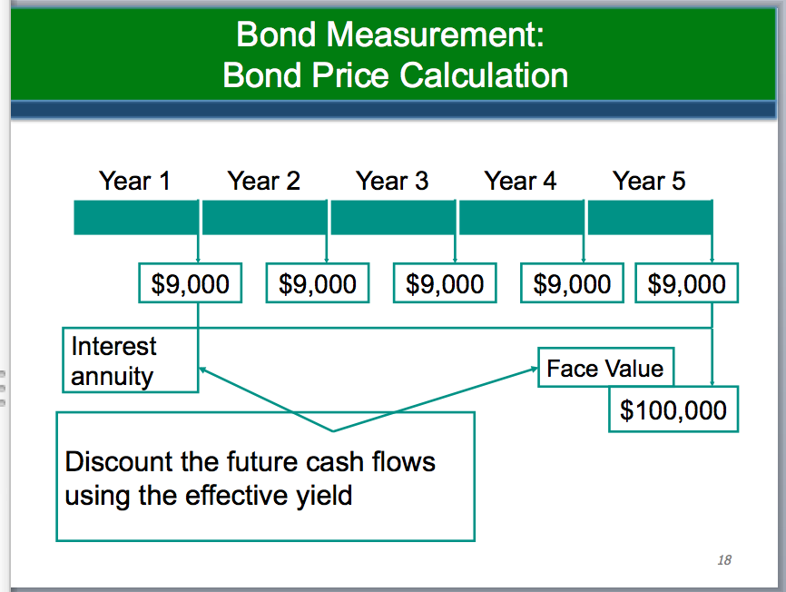
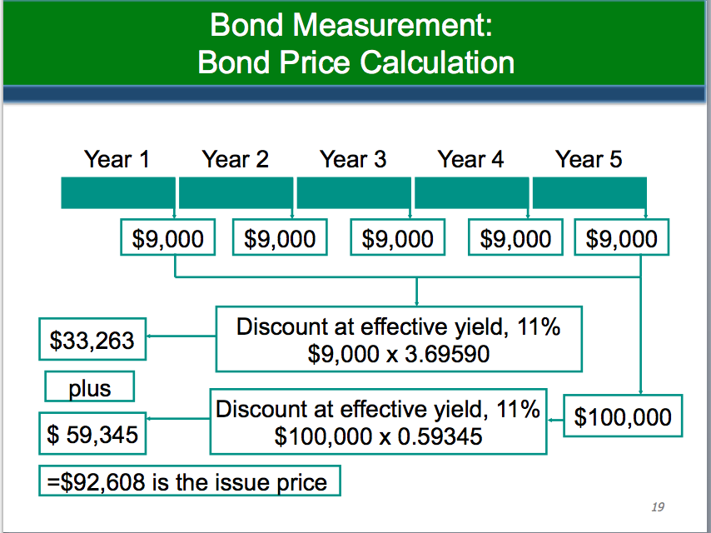

- Amortizing the Bond Premium/Discount
- A premium effectively decreases the annual interest expense for the corporation
- The discount effectively increases the annual interest expense for the issuing corporation

- Amortizing the Bond Premium/Discount
- Two methods available for amortization
  - Straight-Line
    - Allocates the same amount of discount (or premium) to each interest period
    - Acceptable under ASPE
  - Effective Interest [E14-4]
    - Allocates the discount or premium over the bond term (i.e. amortizes the discount or premium)
    - Required under IFRS
- The total discount or premium amortized is the same under both methods

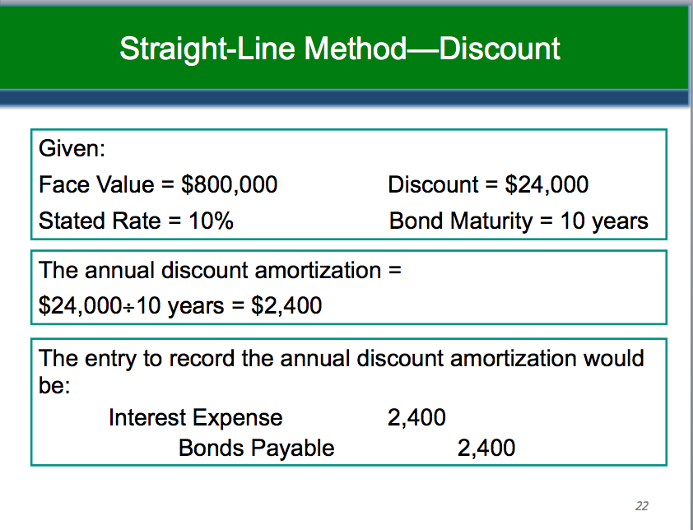

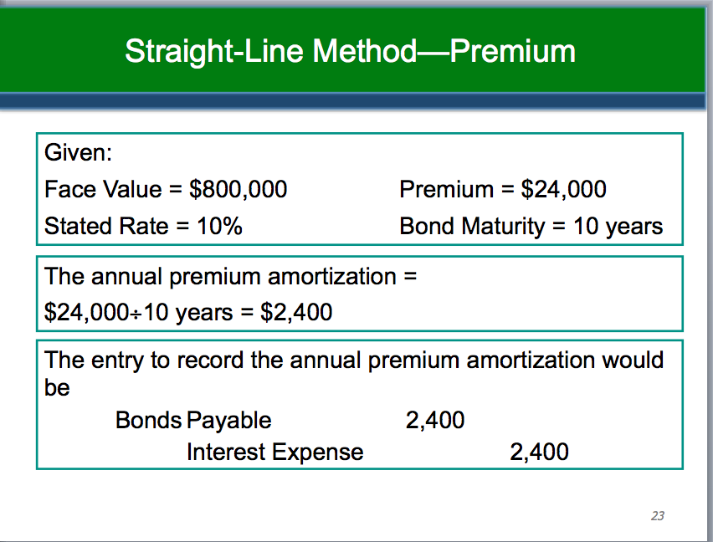

- Effective Interest Method
- Produces a periodic interest expense equal to a constant percentage of the carrying value of the bond
  - The percentage used is the effective yield
- The amortization of the discount or premium is determined by comparing the interest expense with the interest paid
- Total interest expense over the life of the bond is the same as that using the straight-line method

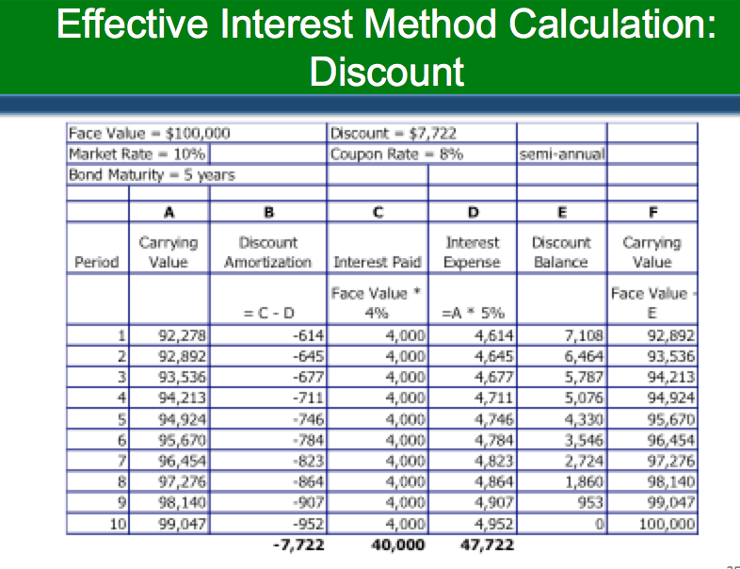
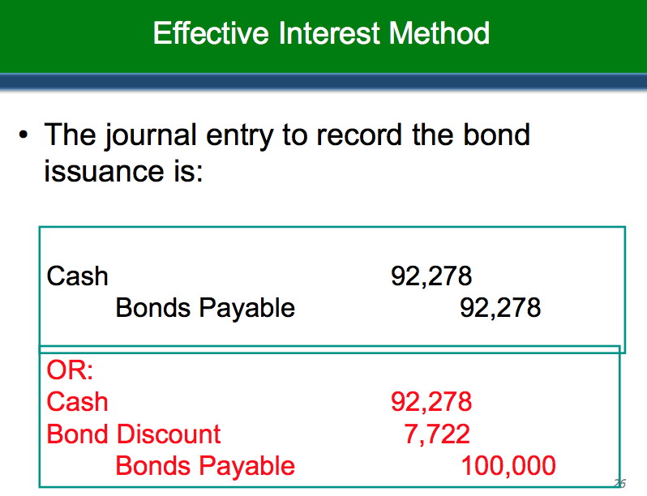
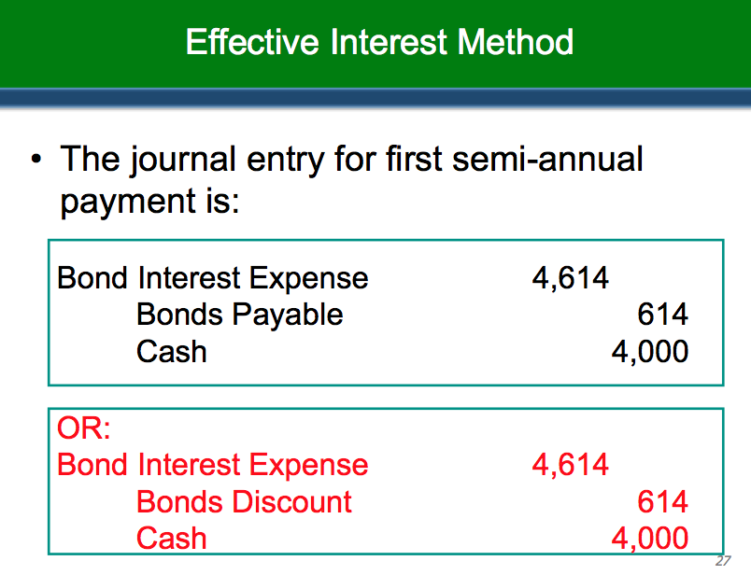

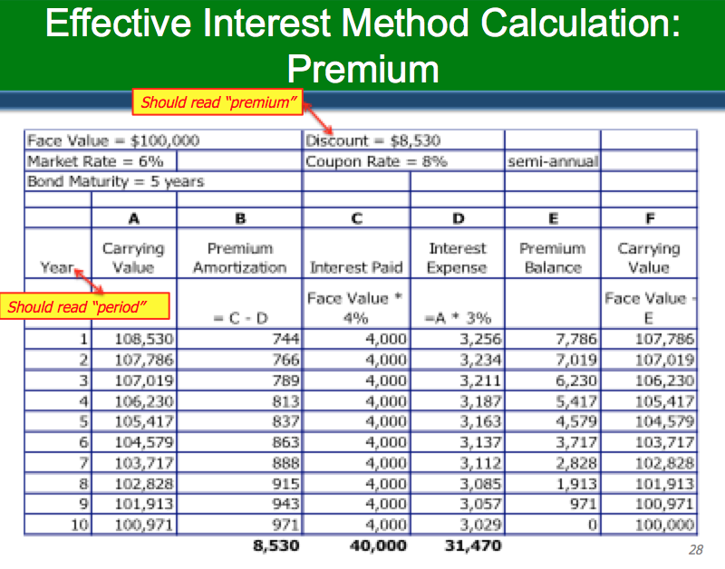

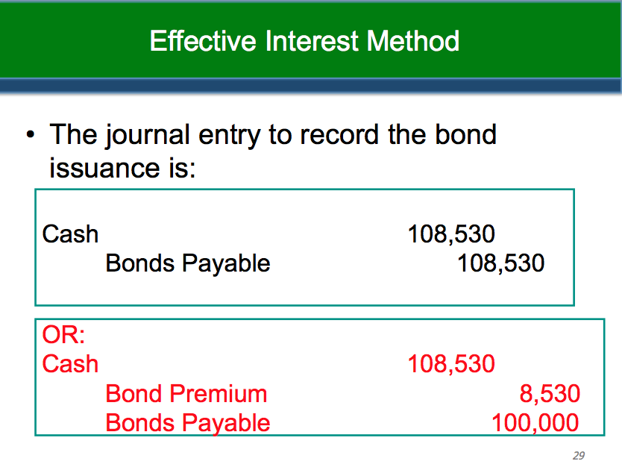
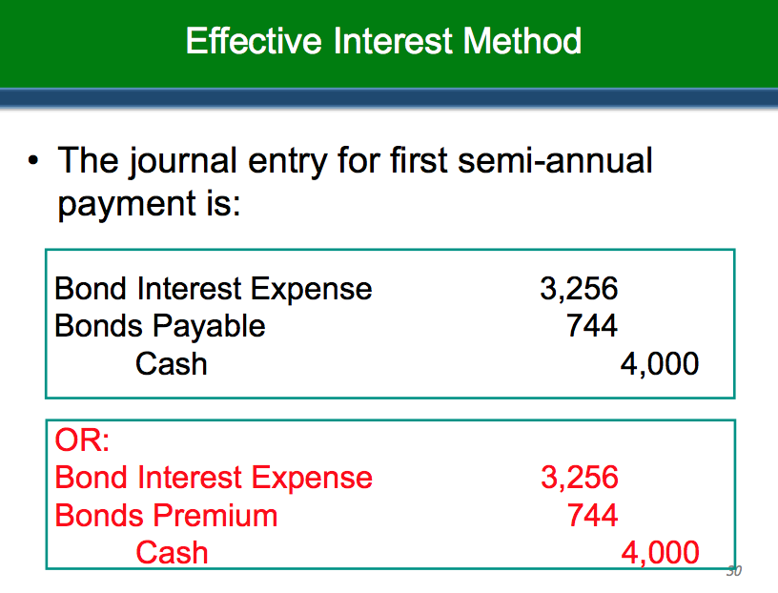

- Bonds Issued Between Interest Dates
[P14-5 part 1; P14-6]
- Interest for the period between the issue date and the last interest date is paid by the bondholder in addition to the issue price of the bonds
- At the specified interest date, interest is paid for the entire interest period (semi-annual or annual)
- Premium or discount is also amortized from the date of sale

- Non-Market Rates of Interest (Marketable Securities)
- If bond issued for cash, and is marketable, its fair value = cash received by issuer
- Implicit interest rate is the rate that causes the PV (of future cash flows) to equal cash received
- Difference between face amount and PV is the discount
  - Amortized over life of the bond/note

- Non-Market Rates of Interest (Marketable Securities) Example
- $10,000 3-year zero-interest-bearing marketable bond issued
- Cash received at issuance: $7,722
- Implied interest rate is therefore 9%
- Discount equal to:
Maturity Value $10,000
Less: Cash Received 7,722
$ 2,278

- Non-Market Rates of Interest (Non-Marketable Instruments)
- Non-marketable Instruments
  - Cash consideration might not be equal to fair value – there might be additional value being transferred
  - Must measure fair value of loan by discounting the cash flows using a market rate of interest
  - Any difference is booked to net income unless it meets the definition of an asset or liability

- Non-Market Rates of Interest (Non-Marketable Instruments) Example
Given:
- Government gives a 5 year, $100,000 note payable to a company on January 1st to help it finance the construction of a building
- The note is zero-interest bearing
- The market rate is 10%
- Recipient company has an additional benefit beyond the debt financing – the government is forgiving the interest that the company would normally be charged. This is a government grant.
Journalize in issuer’s books

- Non-Market Rates of Interest (Non-Marketable Instruments) Example
Books of the Issuer:
Cash 100,000
Notes Payable 62,092
- Building - Government Grant 37,908
(PV of 100,000 at 10%, (n=5) = 62,092)
(100,000 – 62,092 = 37,908)
- The discount is amortized to interest expense over the term of note
- The government grant is amortized to net income as the building is depreciated

- Note Issued for Cash and Other Rights
Books of the Issuer:
Cash 62,092
Discount on Note Payable 37,908
Note Payable 100,000
Cash 37,908
Building - Government Grant 37,908
- PV of 100,000 at 10%, (n=5) = 62,092
100,000 – 62,092 = 37,908

- Notes Issued for Property, Goods, and Services
- If the issued debt is a marketable security, the value of the transaction would be equal to fair value of the marketable security
- If the issued debt is not a marketable security:
  - May try to value debt by discounting cash flows at market rate of interest, or
  - May use the fair value of the property, goods, services.
- Any discount or premium amortized over life of the note

- Fair Value Option
- Long-term debt, being a financial liability, is generally measured at amortized cost however it can also be measured at fair value
  - IFRS requires the fair value option only if it results in more relevant information
  - IFRS requires that non-performance risk be included in the fair value measurement.
  - ASPE allows the fair value option for all financial instruments

- Extinguishment of Debt
- Extinguishment of debt is recorded when:
  - The debtor pays the creditor, or
  - The debtor is legally released from paying the creditor (due to cancellation, expiry etc.)

- Repayment before Maturity Date
- When debt is paid out prior to maturity, the amount paid is called the reacquisition price
  - May be for the full amount of debt or a portion
  - Includes any call premium and expenses
- At the time of reacquisition all outstanding premiums, discounts, and issue costs are amortized to the date of reacquisition

- Repayment before Maturity Date
- If the net carrying amount of the debt is more than the reacquisition price, this results in a gain from extinguishment
- If the reacquisition price exceeds the net carrying amount of the debt, this results in a loss from extinguishment
- Any gain or loss from the reacquisition is reported with other gains and losses

- Repayment before Maturity Date: Example
Given:
- Existing debt, face value: $800,000
- Called and cancelled at: $808,000
- Unamortized discount: $ 14,400
- (therefore, the carrying amount = $785,600 = $800,000-$14,400)
Note: Discount has been amortized up to the date of cancellation of debt.
Give the journal entry for the extinguishment.

- Repayment before Maturity Date: Example
Bonds Payable 785,600
Loss on Redemption of Bonds 22,400
  - Cash 808,000
  - (800,000 – 14,400 = 785,600, which is the net carrying amount of bond redeemed after subtracting the unamortized discount)

- Troubled Debt Restructurings
- When a creditor grants a favourable concession to a debtor
- Two basic types of transactions
  - Settlement of debt at less than carrying value
  - Continuation of debt with modification of terms

- Settlement of Debt [E14-26; P14-18]
- Old debt, as well as all related discount, premium and issuance costs are removed from books (derecognized)
- A gain is usually recognized since creditor generally makes concessions in settlement of troubled debt (settled at less than carrying value)

- Substantial Modification of Terms [E14-26; P14-18]
- If debt is continued with substantial modification of terms, the transaction is treated like a settlement
  - Old liability is derecognized
  - New (substantially modified) liability is recognized
  - The difference between the old and new liability is recorded as a gain
- Modification of terms is substantial if either:
  - Discounted PV under new terms is at least 10% different from discounted PV of remaining cash flows under old debt, or
  - Old debt is legally discharged and there is a new creditor

- Non-Substantial Modification of Terms [E14-24]
  - No gain or loss recognized
  - New effective interest rate must be found
    - Imputed using the rate that equates the carrying value of old debt to cash flows of newly arranged debt

- Defeasance Revisited
- “Legal defeasance” occurs when the creditor no longer has claim on the assets of the original issuer
  - The debt may be derecognized
- “In-substance defeasance” occurs when the creditor is not aware of the trust arrangement
  - The debt may not be derecognized

- Off-Balance-Sheet Financing
- Off-balance-sheet financing represents borrowing arrangements that are not recorded
- The amount of debt reported in the statement of financial position does not include such financing arrangements
  - This is not acceptable and is usually done to improve certain financial ratios (such as debt-equity ratio)
- In general, increased note disclosure is the accounting profession’s response to off-balance sheet financing

- Non-consolidated entities
  - Under present GAAP, a parent company does not have to consolidate an investment in a company where <50% owned and no control
  - Therefore, the liabilities of the company would not be reflected on the balance sheet of the parent company, although the parent may be ultimately liable for the debt

- Special Purpose Entities (SPEs) or Variable Interest Entities (VIEs)
- A company may create a special purpose entity or variable interest entity to perform a special project or function
- This is a concern if SPEs/VIEs are used primarily to disguise debt
- As a general rule, the companies should be consolidated if the company is the main beneficiary of the SPE/VIE

- Operating Leases
- Another way to reduce a company’s debt is to lease assets rather than to own them
- If a lease is considered an operating lease, the company would need to record rent expense each period with note disclosure (further covered in chapter 20)
- A recently revised leasing standard capitalizes many arrangements previously deemed operating leases
  - Debt:asset ratio implications?
  - Bond covenant implication?

- Presentation of Long-Term Debt
- Current versus long-term
  - Debt to be refinanced treated as current unless specific refinancing conditions met
  - IFRS requires that the financing be in place by the date of the statement of financial position
- Debt versus equity
  - Dependent on nature of the instrument
[to be discussed in Ch 16]

- Disclosures
- Include:
  - Nature of the liability
  - Maturity date
  - Interest rate
  - Call provision
  - Conversion privilege
  - Any restrictions imposed
  - Assets designated or pledged as security
- Any assets pledged as security for the debt should be shown in the assets section of the statement of financial position
- Fair value of the long-term debt should also be disclosed

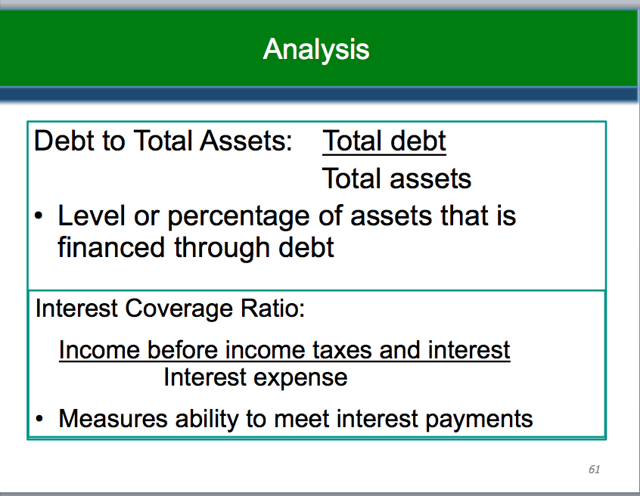

Recognition
Pay interest
Interest accrual
Settlement/de-recognition/extinguishment/retirement
Maturity

