Sept. 21, 2017 – Lecture 3, Ch.5, 6

- Chapter 5 – Preliminary Audit Planning: Understanding the Auditee’s Business

Audit Process: Overview of FS Audit
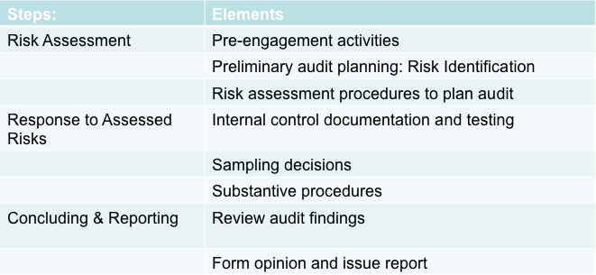

- The Audit Process: Ongoing Activities
- Communications among audit team members throughout the process
- Documentation of the audit decisions and findings
- Revisions to risk assessments and planned responses if appropriate due to knowledge obtained during audit process
- Communications with those charged with the auditee’s governance and its management

- Independent Audit Engagement Characteristics
- A wide variety of organizations, or “entities,” are required to produce financial statements to meet their external stakeholders’ information needs, and to have them independently audited.
- At the outset of an audit engagement, it is important for the auditors to understand what kind of entity is being audited, who the people are who are charged with governance of the entity, the stakeholders to whom they are accountable, and the client’s reasons for wanting an audit.

- Pre-engagement Activities
- Auditors undertake two types of activities before beginning an audit:
  - Risk management:
    - Auditors try to reduce the risk (probability of something going wrong) by carefully managing the engagement.
  - Quality management:
    - Auditors manage audit in accordance with quality control standards.

- Audit Engagement Acceptance and Continuance
- Client selection and retention:
  - An important element of an accounting firm’s quality control policies and procedures is a system for deciding:
(a) to accept a new client, and
(b) whether to resign from audit engagements.
  - Accounting firms are not obligated to accept undesirable clients, nor retain existing audit clients.

- Audit Engagement Acceptance and Continuance
- Client acceptance and retention procedures should include:
  - Obtaining and reviewing financial information about prospective client.
  - Evaluation of independence.
  - Evaluation of competency and resources.

- Audit Engagement Acceptance and Continuance
- Client acceptance and retention procedures should include:
  - Understand business risks and determine management’s willingness to accept responsibility for financial statements.
  - Look for news reports, consult with auditee’s banker, legal counsel or others to assess integrity of management.
  - Communication with previous auditor.

- Determining Auditability
- The auditor considers:
  - Whether the financial statements presented in accordance with GAAP.
  - Whether management understands its responsibility for preparing the financial statements, and for designing and implementing adequate internal controls.
  - Management’s commitment to providing written representations or other scope limitations.

- Auditee Retention
- Decisions to continue auditing an organization are similar to acceptance decisions.
  - The public accounting will have more first-hand experience with the auditee.
  - Annual retention reviews take into account changes for the auditee.

- Communication Between Predecessor and Successor Auditors
- When companies change auditors, the former auditor is the predecessor auditor, and the new auditor is the successor auditor.
  - Rules of professional conduct require the successor auditor to contact the predecessor auditor.
    - Ask if there are issues that should be considered in accepting the client.
    - Obtain information from the predecessor auditor for planning the audit.
  - Predecessor auditor is required by the rules of conduct to respond to the communication.

- Communication Between Predecessor and Successor Auditors
- Successor auditor should ask the client to consent to discussions with the predecessor auditor.
  - Consent is not required, the communication must take place.
  - Consent allows the predecessor auditor to relay more information.
    - Predecessor auditor still has a duty to maintain confidentiality.
    - Audit files belong to the auditor, not the client.
  - Auditor should be wary of any client who refuses consent.

- Auditor’s Risk From Accepting An Audit Engagement
- Key Factors to consider:
  - How widely distributed are the audited financial statements?
  - How strong is the financial condition of the auditee?
  - How trustworthy is auditee’s management?
  - How complex is the financial reporting required?
  - How knowledgeable are the people likely to be using the financial statements?

- Engagement Letters
- When a new audit client is accepted an engagement letter must be obtained.
  - The engagement letter forms the contract for the audit.
    - Standards require the auditor and management to agree on the terms of the audit engagement.
  - A new engagement letter should be obtained every year of a continuing audit.

- Staff Assignment
- When the new client is obtained, accounting firms assign a full-service team to the new client.
    - Engagement partner
    - Audit manager
    - One or more senior audit staff members
    - Staff assistants
    - Specialists
    - A tax partner, a consulting services partner and a second audit partner
  - For a small firm or client, the audit team may be just one or two people.
- Time Budget
- The partner or manager propose a plan for the timing of the work based on previous experience and knowledge of the business.
  - The time budget allows the audit firm to spread its workload between interim and year-end periods.
    - Interim — weeks or months before the statement date.
    - Year-end — shortly before or after the statement date.

- Time Budget
- Everyone on the audit reports the time taken to perform the audit procedures.
  - Time reports are recorded by the time budget categories to all for:
    - evaluation of the efficiency of audit team members,
    - billing the client, and
    - planning the next audit of the client.

- Example of simple time budget

- Understanding the Auditee’s Business, Environment and Risks
- Understanding the client’s business and operating environment is very important in an audit.
  - It helps to assess the risk that financial statements might contain material misstatements.
  - Used to establish and overall audit strategy, design the audit plan and audit programs.

- Understanding Client Business – Significant Risks
AUDITOR RISK ASSESSMENT | IMPLICATIONS
What needs to be considered? | Why is this considered?
What is the entity’s underlying  economic reality? | This is what the financial statements should capture and communicate to users.
What could have gone wrong in  preparing the financial statements? | This will lead to misstating  the financial statements.
Is there any significant risk that  any of these things have gone  wrong? | This is the auditor’s assessment of risk of material misstatement at the  financial statement level.
If there are one or more  significant risks, what evidence  can auditors obtain to confirm  or dispel suspicions that the  events occurred/exists? | This will guide the auditors  overall audit strategy,  and planned audit  procedures.

- Understanding the Client’s Business — Business Environment Risks
- In order to design an effective audit, auditors must understand the business and the economic environment of the business including factors such as:
  - national economic condition and policies,
  - geographic location,
  - developments in taxation and regulation, and
  - specific industry characteristics.

- Analytical Procedures Requirements
- Although particular analytical procedures are not required by audit standards, the timing of these procedures is specified:
  - at the beginning of the audit when planning is taking place, and
  - at the end of the audit when the partners in charge review the overall quality of the work and form an opinion.

- General Analytical Procedures
- Five types of general analytical procedures:
  - Compare current-year account balances with one or more comparable periods.
  - Compare current-year account balances and financial relationships with similar information for the auditee’s industry.
  - Compare current-year account balances with the company’s anticipated results.
  - Evaluate the relationships of current-year balances to other current-year balances for conformity to predictable patterns.
  - Study the relationships of current-year balances to relevant nonfinancial information.

- Preliminary Analytical Procedures
- Analytical procedures are most effective when integrated with other sources of information.
- Many other early information gathering activities can also be considered analytical procedures:
  - Review of accounting misstatements discovered in prior years
  - Conversations with the auditee personnel
  - Review of corporate charter and bylaws (or partnership agreement)
  - Review of contracts, agreements, and legal proceedings
  - Reading and study of the minutes of meetings

- Preliminary Analytical Procedures
- Auditors look for relationships in accounts as indicators of problems and to plan further audit work.
  - Horizontal analysis: examination of numbers and ratios across two or more years.
  - Vertical analysis: examination of amounts expressed each year as proportions of a base (sales or total assets).

- Applying Analytical Procedures to Management’s Draft Financial Statements
- Analysis of the draft statements may show relationships that do not make sense.
  - Indicates problem areas where misstatements may exist.
  - The analysis of the draft statements is attention directing.

- Applying Analytical Procedures to Management’s Draft Financial Statements
- Preliminary analytical procedures also:
  - Provide for an organized approach, they provide considerable familiarity with the client’s business and provide a standard starting point,
  - describe financial activities by identifying relationships and changes in data, and
  - allow the auditor to ask relevant questions.

- Applying Analytical Procedures to Management’s Draft Financial Statements
- In addition, the auditor should analyze the cash flow statement for irregularities, such as cash deficits from operations.
  - The cash flow statement will reveal aspects of the clients business not evident in the financial statements.

- Materiality Levels for Audit Planning
- Materiality is one of the first important judgments the auditor must make, since it affects every other planning, examination, and reporting decision.
  - Materiality is the largest amount of uncorrected misstatement that might exist in financial statements that still fairly present the company’s financial position and results of operations.

- Materiality Levels for Audit Planning
- Financial statement materiality:
  - Information is material and should be disclosed if it is likely to influence the economic decisions of financial statement users.
    - Focus on users of financial statements.

- Materiality Levels for Audit Planning
- Accounting numbers are not perfectly
accurate because of the nature of
accounting.
  - Estimates are used, and honest mistakes happen.
  - Some inaccuracy is unavoidable.
    - Unimportant inaccuracies do not affect users.
    - Cost of finding and correcting small errors is too great.
    - Time to find all errors would delay statements.

- Materiality Levels for Audit Planning
- To leave room for error and reduce the probability that the total misstatement exceeds materiality, auditors will determined an amount of performance materiality.
  - The difference between financial statement materiality and performance materiality is a cushion for misstatements that were undiscovered by the auditors.

- Materiality Judgment Criteria
- Materiality is both a quantitative and a qualitative judgment.
  - Auditors cannot rely solely on quantitative benchmarks.

- Materiality Judgment Criteria
- Small misstatements may be material in some cases.
- In particular:
  - intentional misstatements,
  - intentional violations of the law, or
  - intentional earnings management,
must be considered material.

- Materiality Judgment Criteria
- Small misstatement are also considered material if they:
  - mask a change in earnings or other trends,
  - hide a failure to meet analysts’ consensus expectations for the client,
  - change a loss into net income or vice versa,
  - concern a segment of the business that is considered significant,
  - affect the client’s compliance with regulatory requirements,
  - involve concealment of unlawful transactions, or
  - have the effect of increasing management compensation.

- Materiality Judgment Criteria — Quantitative
- Auditors are generally left without definite, quantitative guidelines to determine materiality.
  - Quantitative guidelines:
    - 5% of income from continuing operations,
    - 5% of net income before bonus,
    - ½ to 2% of revenues or expenses for non-for profit entities,
    - ½ to 1% of net asset value for the mutual fund industry, or
    - 1% of revenue for the real estate industry.

- Materiality Judgment Criteria — Quantitative
- In some circumstances, the auditor may also select alternative financial statement items for establishing materiality.
- When income measures are used as a basis, they should be normalized or averaged.

- Materiality Judgment Criteria — Qualitative
- In addition to quantitative guidelines, the auditor should consider other factors as well.
  - User related factors
  - Nature of the item or issue
  - Other circumstances
  - Effect on share price

- Cumulative Effects of Errors
- Auditors must consider the sum of known or potential misstatements.
  - Considering five errors of $15,000 each to be immaterial is inappropriate when materiality is determined to be $50,000.

- Overall Audit Strategy
- Audit planning is an ongoing, iterative process.
  - The preliminary planning activities are the basis for the overall audit strategy.
  - The audit strategy guides development of the detailed audit plan, which details the nature, extent and timing of the audit procedures.

Chapter 6
Assessing Risks In an Audit Engagement

- Business Risk-Based Approach to Auditing
- The business risk-based approach to auditing requires the auditor to understand the auditee’s business risks, management’s strategy for addressing those risks, and the business processes it uses to implement the strategy.

- Business Risk Analysis
- There are two parts of business analysis:
  - Strategic analysis, and
  - Business process analysis.
  - At the end of the business analysis, the auditor should be able to determine if there are any weaknesses in the client’s risk management process that could lead to misstatement on the financial statements.

- Strategic Analysis
- Gain an understanding from senior client management about:
  - business objectives,
  - key strategies employed to meet those objectives, and
  - risks that threaten achievement of those objectives.

- Business Process Analysis
- Management will minimize risks through well-designed business processes.
  - Business success depends on how well management can execute the main aspects of strategy.
- Business process analysis deepens the auditor’s understanding of the client’s operations.
  - It may also highlight risks and possible note disclosures.
- Business processes should also be designed to ensure compliance with laws and regulations. (CAS 315, A84).

- Effects of IT and E-Commerce on Business Risk
- Analyzing the effects of IT and e-commerce is also an important component of business risk analysis.
  - More involvement in e-commerce and more complex information systems create new business risks.
  - The auditor needs to understand how e-commerce and IT integrate into the business processes.

- Business Performance Analysis and Management’s Financial Statements
- Business performance analysis will consider financial and nonfinancial performance measures and the interrelationships between the two.
  - Is the analysis of business performance reflected in the financial statements?

- Financial Performance Analysis
- Financial performance analysis continues the analytical procedures started earlier.
  - Includes a review of management’s significant accounting policy choices.
  - Includes benchmarking accounting policies against the industry.
  - Consider the quality of earnings – this the extent to which the reported earnings number represents actual economic performance, rather than selective accounting policy choices or management manipulation.

- Nonfinancial Performance Analysis
- Analyzing the relationships among the business’s resources, the processes for using resources and the ability to compete in the markets for products or services.
  - Determine if the resources available, and the processes used are consistent with marketplace results.

- Interrelationships Between Financial and Nonfinancial Performance
- The auditor considers whether the financial results and nonfinancial performance are consistent.

- Financial Statement Assertions and Audit Objectives
- Assertions are claims management makes in financial statements.
  - Managements accounting system produces a trial balance.
  - Management arranges the trial balance in financial statements, making assertions.
  - Auditors take the assertions as focal points for audit work.

- Management Assertions and Audit Objectives
- The practical audit objectives are to obtain and evaluate evidence about assertions made by management in financial statements.
  - Five principal assertions cover the claims made by management in the financial statements:
    - Existence (occurrence)
    - Completeness
    - Ownership (rights and obligations)
    - Valuation (measurement and allocation)
    - Presentation (classification and disclosure)
    - Accuracy

- Existence(Occurrence)
- Establish with evidence that:
  - assets, liabilities and equities actually exist,
  - that revenue and expense transactions actually occurred as of a proper date, and
  - there are cut-off considerations to existence:
    - no transactions from the next period should be recorded at the statement date.

- Completeness
- Establish with evidence that all transactions and accounts that should be presented in the financial reports are actually included.
  - No items belonging to the financial statement have been missed.
  - There are cut-off considerations:
    - All transactions from the period are actually recorded in the period.

- Ownership
(Rights and Obligations)
- Establish with evidence that amounts reported as assets of the company represent property rights and the amounts reported as liabilities represent obligations.

- Valuation
(Measurement and Allocation)
- Determine whether proper values have been assigned to assets, liabilities, equities, revenues, and expenses.

- Presentation
(Classification and Disclosure)
- Determine whether the accounting principles are properly selected and applied and whether disclosures are adequate.

- Misstatement at the Assertion Level
- Assertions are the fundamental management claims to be audited.
  - They are the focal point for all audit procedures.
  - The auditor uses the assertion to ask “what could go wrong?”
    - Evidence produced by each procedure must relate to one or more of the specific assertions.

- Audit Risk Assessment
- Auditing is fundamentally a risk management process.
  - Audit risk is related to information risk that financial statements are materially misstated.
    - Auditors strive to lower audit risk by performing audit work that gives a high level of assurance that statements are correct.
    - Auditors need to assess risk in audit related terms; inherent risk, control risk and detection risk.

- Audit Risk
- The probability that an auditor will fail to express a reservation that financial statements are materially misstated is audit risk.
  - Audit risk is greater if there is poor planning or poor execution of the audit.
  - Audit risk is inversely proportionate to risk of getting sued.
  - Audit risk is dependent on user reliance.
  - Audit risk is also applied to individual account balances and disclosures.
- Audit Risk Model
AR = IR × CR × DR
- Audit risk will occur when:
  - a material misstatement has been made in the transactions or balances (inherent risk),
  - and internal controls fail to detect or correct the misstatement (control risk), and
  - audit procedures also fail to detect the misstatement (detection risk).
    - Auditors usually like to limit audit risk to less than 5%.

- Inherent Risk
- The probability of material misstatement occurring in transactions entering the accounting system or being in the account balances is inherent risk.
  - Auditors do not create or control “inherent risk”.
    - Auditors only try to assess its magnitude based on prior experience, management bias, and nature of the transactions.
    - The auditor will consider the characteristics of the client’s business, types of transactions, and effectiveness of accountants.

- Control Risk
- The risk that the client’s internal control system will not prevent or detect a material misstatement is control risk.
  - Auditors do not create or control “control risk”; they simply evaluate or assess probability of failure to detect material misstatements.
    - This assessment of effectiveness may be tested by the auditor in the audit.
  - Assessment is based on study and evaluation of the company’s control system.

- Control Risk
- Several control frameworks are available to the auditor in assessing controls.
  - CPA Canada’s (CICA’s) Criteria of Control Committee (CoCo)
    - Includes evaluation criteria.
  - Committee of Sponsoring Organizations of the Treadway Commission (COSO)
    - Includes a set of evaluation tools.
  - Control Objectives for Information and Related Technology (COBIT)

- Control Risk
- Control risk assessment provides only an indirect assessment of monetary misstatements in the financial statements.
  - Control testing or compliance testing are detailed procedures used to assess control risk.
  - Control risk should not be assessed so low that auditors rely entirely on controls, and thus do no substantive work.
- Combined Inherent Risk and Control Risk: The Risk of Material Misstatement
- Auditing standards refer to risk of material misstatement rather than to inherent risk and control risk separately.
  - It is often difficult to separate the two risks.
    - Some controls are preventative and reduce inherent risk, some controls are only effective when misstatements occur.
  - The auditor may make a combined assessment of inherent and control risks.

- Detection Risk
- The risk that any material misstatement that has not been corrected by the client’s internal control will not be detected by the auditor is detection risk.
  - Auditors can control this risk by conducting substantive (balance audit) tests.
    - Substantive tests include audit of details of transactions and balances, and analytical procedures applied to dollar amounts in the accounts.

- How Materiality and Audit Risk are Related
- Materiality refers to the magnitude of a misstatement; audit risk refers to the level of assurance that material misstatement does not exist.
  - The auditor will make these assessments independently.
  - Both deal with sufficiency of evidence and extent of audit evidence that will be collected.

- Business Risk and Extension of the Audit Risk Model
- Business risk is an event of action that will adversely affect an organization’s ability to achieve its objectives and execute its strategies.
  - Auditors need to assess the ways that business risk affects the risk of material misstatement in financial statements.

- Accounting Processes and the Financial Statements
- There are two important points to remember about client financial statements:
  - Management is responsible for preparing them, and they contain management’s assertions about economic actions and events.
  - The financial statement numbers are produced by the company's accounting system and are summarized on the trial balance.

- Management’s Financial Statements
- To simplify the audit plan, auditors typically group the accounts into several accounting processes.
(1) revenues and collection
(2) acquisition and expenditure
(3) production and conversion
(4) finance and investment
  - The purpose of using business processes is to group together related accounts by transactions that normally affect them.
- Business Risk and the Risk of Material Misstatement
  - Risks can be managed in any of four ways. Risk can be:
    - avoided by not performing activities that cause the risk,
    - reduced to acceptable levels through management control,
    - tolerated on a cost/benefit basis, or
    - transferred to another party by contract, as in insurance.
  - Classifying Business Risks
  - After understanding the business risks, the auditor will have to classify them.
    - First, the auditor should assess the likelihood of risk occurrence. The auditor may use a three point scale for this (unlikely, possible, probable).
    - Second, the auditor should consider the economic magnitude of the risk. Again, a three point scale can be used (insignificant, moderate, significant).
    - This analysis can be plotted on a grid.

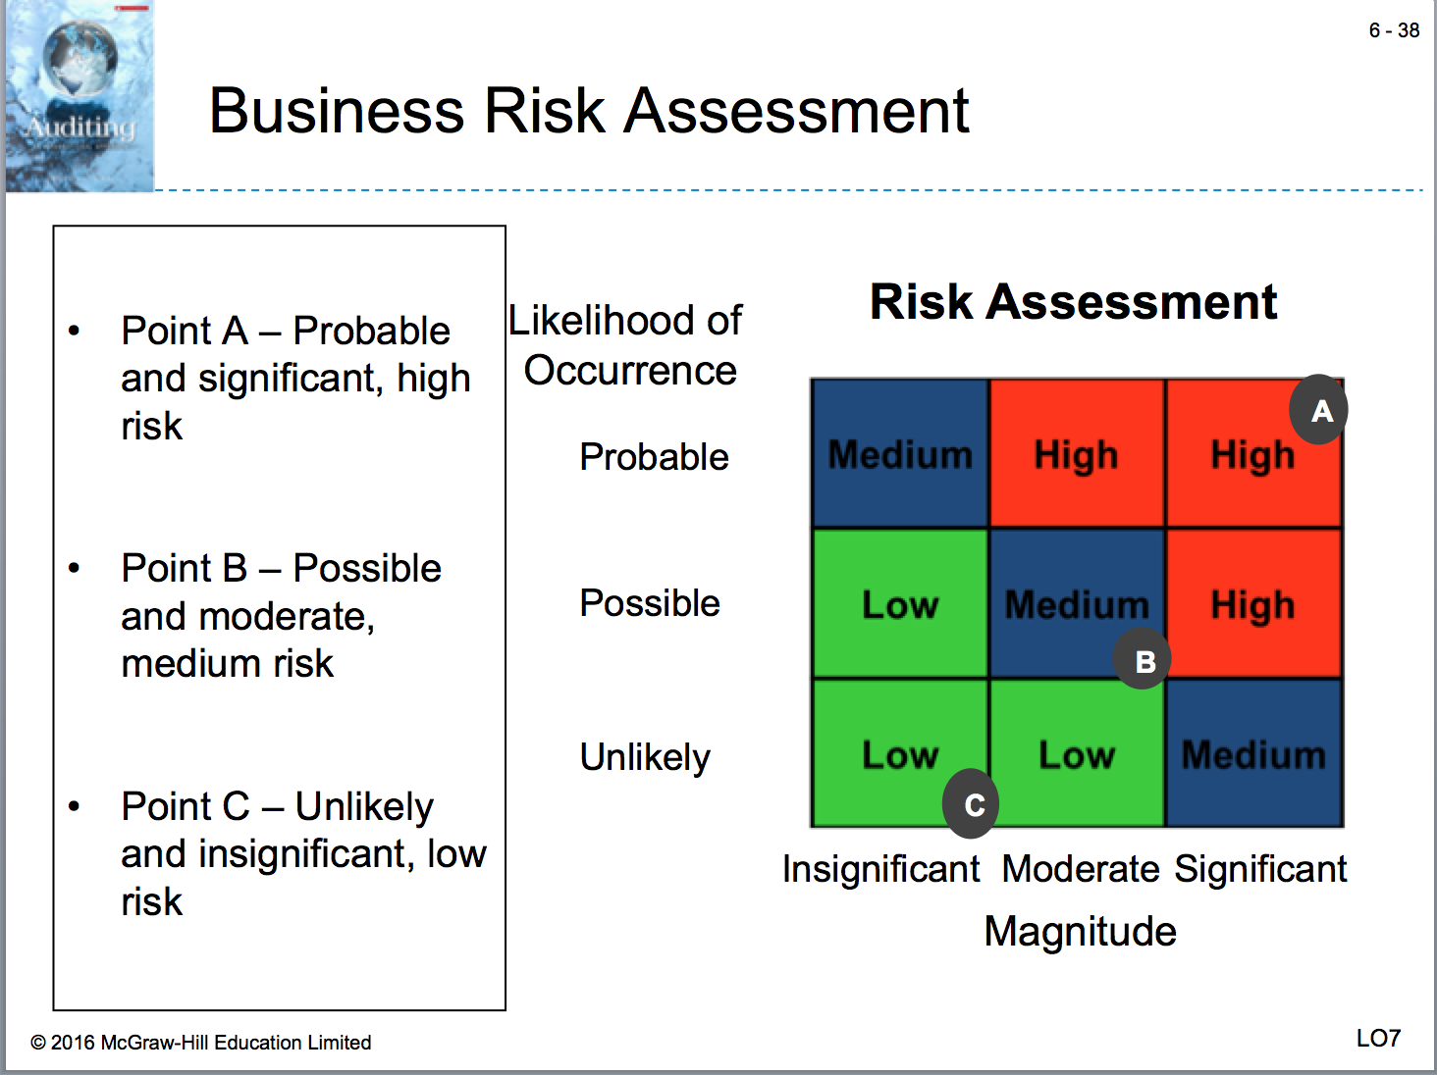
- Business Risk Assessment
- Once the auditor has categorized each business risk, management controls over those risks are assessed.
  - Some risks may be re-categorized if the relevant controls are effective at controlling the risk.
  - Risks that remain medium to high represent areas that need to be examined carefully in the audit.

