Lecture 1
Lab office: BSC106 (Tues, 10:30-11:00)
Biolab1.uottawa.ca
Prof Office – Gendron 376. Mon and Wed, 10:00 – 12, Chapleau@uottawa.ca
Midterm 1 – Sat, Sept 30 Midterm 2 – Sat, November 4
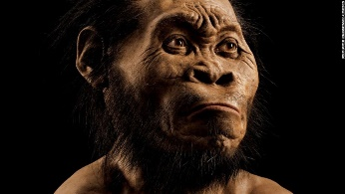
Science and Scepticism
- Homo Naledi, species found in SA, in cave. They’re our ancestors
  - They thought it was oldest species, like 3 million years old. But, it is 300,000 years old, so its young. Our species is 200,000 years old.
  - Brain size slightly larger than chimp. Primitive human species had that size of brain, which is why we thought it was primitive.
- Found 15 skeletons in same spot.
- Science is never definitive. Skepticism is important aspect of science. Different kind of skepticism. With influence of South border, in our society skepticism takes whole new perspective as now were rejecting old/solid hypothesis instead of providing new ones.
Flatfish
- Have 2 eyes on same side of head – Developmental process
- Larvae is a plaggic species with both eyes normal and at one point there is metamorphosis. Eye migrates from one side to the other and dorsal fins expands and creates flatfish typical morphology.
- Darwin attempted to answer this because he was confused by this
- This process of evolution is unknown
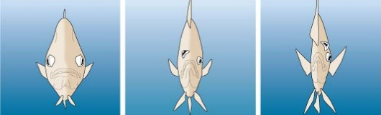
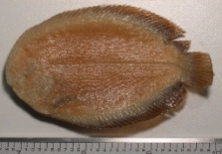
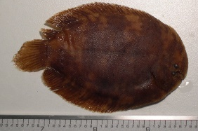

Example of evolution: Cheetah (Discovery of Darwin)
- Gets to speed 110km/h
- Morphology is little, evolved from ancestors of cheetah
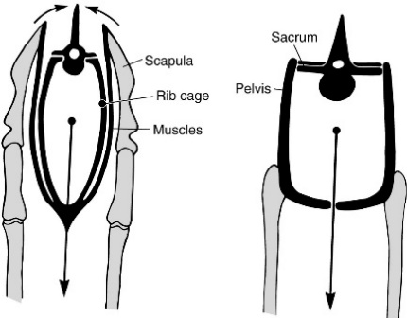
Hunting success relies on surprise effect and how quick it runs, lasts for around 30 seconds. Gets 100m from prey and burst into speed.
- Hindlegs fused to hips and hips fused to vertebral column
- Pelvic gridle (pelvis) fused to vertebral columns (propulsion)
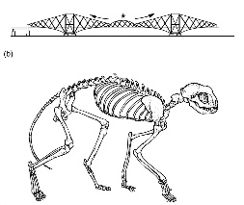
- Pectoral gridle (scapula) not directly attached to vertebral column (slides on ribcage, propulsions, orientation, stride length). Forelegs are not fused to column. This allows it to run fast. All shock absorbed by legs and their head doesn’t move
- Preys usu. same morphology
- Cheetah achieved morphology that is very efficient; lean body, extendable column but there is a compromise with advantage and disadvantages. It’s disadvantage is it never defends prey bc since success rate is high and cheetahs evolved in a strategy where they don’t get caught in attack for same prey. They see other predators and run off. Cheetah eats quick off prey so other predators don’t steal their prey.
- Morphology is like a bridge. Node points of construction of bridge relates to Cheetah
- Cheetah didn’t evolve their legs (hind legs), going back in history fish had similar legs (not unique feature of cheetah, but old feature; 440myr).
- Pelvic gridle fused to the vertebral column (385myr). Fusion of the hips evolved from primitive amphibian (tetrapod). Tetrapod’s pectoral girdle Is fused to the head and now not anymore. This is main evolution feature of tetrapod because it allowed evolution of a nic.
- Rotation of the knee and elbow under body (erect posture: 220myr). Mammals limps became under body for beneficial position, got their knees and elbows rotated (sprawl position). Feature evolved in all mammals therefore not unique to cheetah
- Cheetah walked on their toes, most carnivores walk on their fingers (digitigrade, 65myr). Adaptation: Increasing length of leg/limbs due to being on their toes, increases speed to catch prey. Cheetah inherited this from ancestors
  - Preys walk on their nails. Have simple leg because they don’t need claws.
- All cats (lion, tiger, cat..) have retractable claws (25myr) again not unique feature.
- Cheetahs have semi-retractable claws; 5.5myr (FIRST unique feature). This helps them steer, provides them additional grip on their toes and claws will always be visible.
- This hindlegs of a cheetah is the result of 440myr years of evolution. Fins and limbs are analogous
- Adaptions of vertebrates in cheetahs – locomotion organs (fins or limbs)
- Adaptions of terrestrial tetrapod’s in cheetahs - Pectoral girdle (scapula) detached from skull. Pelvic gridle (pelvis) fused to the vertebral column
- Adaptions of Mammals in cheetahs – rotation of knees and elbows under body (support and speed)
- Adaptions of the family Carnivores in the Cheetahs – walk on fingertips (digitgrade)

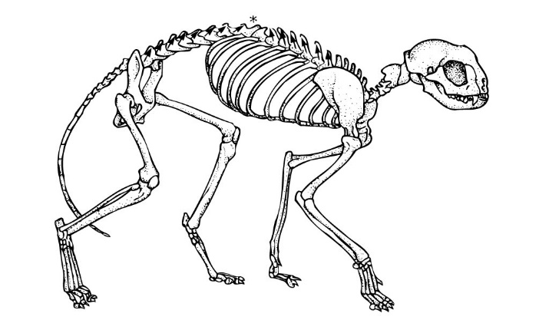
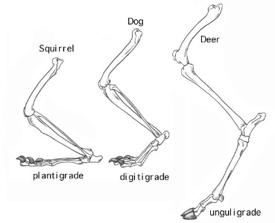
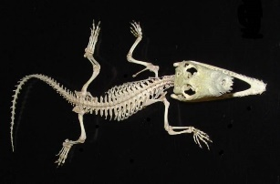

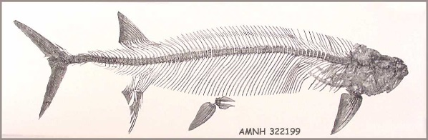
440 Myr
220 Myr

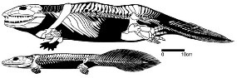
65 Myr
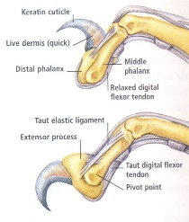
385 Myr

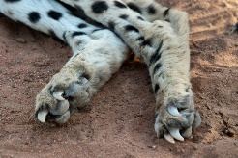

25 Myr
5.5 Myr

Unique features
  - Fur pigmentation
  - Long, thin limbs in distal end (stride length)
  - Lightweight, muscular body, slender and flexibility of spine (speed, stride length)
  - Wide nostrils, heart and lungs with high functional capacity
- Cheetah is a mammal characterized by a few derived traits from other feline species. Result 3,500myr of evolution for all species as they share common DNA (no 2 ways to transmit genes, only 1 way). Only 1 percent is unique, 99% of morphology result of evolution from ancestors
- Has history from ancestors than own history. Applies to humans as well.
- No doubt fins and limbs are homologous. All features discussed are characteristics of vertebrates
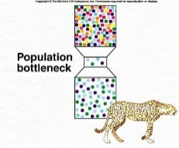
- All goes back to Darwin, that we all share a common ancestor since we have a few unique features. Range of cheetahs are restricted and high density of cheetahs are found in Africa (Number is low)
- Very little genetic variability in Cheetahs, like clones of one another. High vulnerability of disease from one cheetah to all bc there is no genetic variability and if there is a disease all will die quickly bc there will be no resilience due to little genetic variability. This is because cheetah got into pop. bottle neck (genetic variability decreases). At one point there was a very small pop. of cheetahs and it ended up with not a lot of mutation/variability when reproduction of cheetahs increased.
- Royal cheetah – Turned out to be only a mutation which is why it is extinct as it was random.
- Arms race: predator tries to catch prey, prey evolves to get faster. Pronghorn evolved fast speed and the fossil Miracinonyx is referred to as American Cheetah when its not a cheetah. Possible pronghorn evolved fast speed in co-evolution with Cheetah. ‘American Cheetah’ was extinct for 20,000 years

Lecture 2
The Scientific Method (Ch.1, 17-23)
Science: knowledge related to categories of facts, phenomena or objects obeying laws that are verifiable through experimental methods. Scientific inquiry aims for new knowledge.
- 2 Approaches
  - Description-based (ex. Describing nature)
  - Hypothesis-based (ex. Explaining nature)
Scientific Method:
- Inductive reasoning (linked to descriptive-based approach)
  - Making generalization based on specific observations (look at clouds outside and made an inductive reason (generalization) that it is going to rain)
  - Particular -> general
  - Ex. Observer from outside Marion looks at students going in Marion and makes reasoning that there is a class in Marion. Possibility that it may be false, does not address nature of generalization.
- Deductive reasoning (linked to a hypothesis-based approach)
  - Stating hypothesis and drawing conclusions (after experimentation/observation) from hypothesis. Elaborate explanation and verifiy it
  - General -> particular
  - Ex. Observer goes in Marion and verifies there is a class going on
Scientific process (Observations Generalizations)
- Obs: This orange is sweet
- Gen: All oranges are sweet
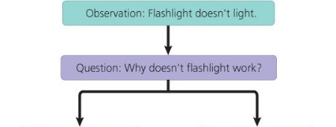
- All scientific inquiry starts with one or multiple obs. Subsequently, the scientific process must be implemented
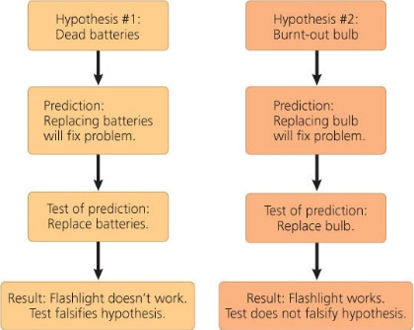
- Scientific hypotheses must be verifiable, refutable, reproducible. Fig. 1.24
- From a hypothesis, you can elaborate a prediction
- Predication are testable and verify result
  - If… then ... statement (for predictions)
- Hypothesis can be falsified or not. Wrong hypothesis is eliminated
- We can not pretend a hypothesis is the scientific truth, can never have the ultimate truth.
- Pred: If I taste all kinds of oranges, then they will always be sweet
- Tests: Tasting all kinds of oranges
  - Travel to Madagascar: tasted sour orange (Hypothesis is falsified)
- Obs Hypothesis Predictions Tests More tests if hypothesis is not refuted OR New hypothesis if it is refuted. Some hypotheses are never refuted/falsified when it is strongly supported by evidence: evolution. Becomes theory then even a fact.
- Follow four clauses: skepticism, realism, rationality and methodological materialism (ALL IN HYPOTHESIS)
- Contract between science and knowledge (or ability to know). Science has progressed because of clauses of contract. Must follow these clauses to do science.
  - Initial skepticism on facts
    - Asking honest q’s on facts and hypothesis (tangible/real things) and always retest what was found. Always questioning own and other work. Can not just refuse to accept a theory.
  - Realism
    - The world is older and exists independently from our perception (realm of ideas doesn’t have priority over real world). World existed before us and will exist after. If you put religious or social notions into interpretation of nature than you’re getting out realm of science.
  - Rationality
    - Logic: demonstrations from a scientist results from coherent steps
    - Parsimony: methodologic principle stating acceptable theories are hypothetically most economical in assumptions. If you want to explain something and you use complicated theories. In science we like simple things
      - Ex. Hear galloping, first answer to think what behind us is a horse but you wouldn’t think it would’ve been a zebra. This is because horse is most simple explanation and highest probability.
      - Crop circles: In the past they saw one and thought it was made by UFOs or something crazy. Scientists and Nasa tried to figure it out. Reality is 2 guys made it from something. 10 years went by and the 2 guys finally came clean. The simplest explanation was the real one.
  - Methodological materialism
    - What’s experimentally accessible in real world is material. If you don’t do this, you can not verify your hypothesis or prediction because you need to build your scientific knowledge on reality.
- Mimicry (ex. Of hypothesis accepted for long time but recently rejected)
  - Monarch feeds on milkweed which has chemical component and Monarch are toxic to birds for own survival from birds. Viceroy (looks like Monarch) are non-toxic but mimicked the monarchs for protection so birds don’t eat them (mimicry/bait-ism mimicry). This hypothesis is wrong; Viceroy is toxic, bird spit out viceroy without the coloured wings). It is not Batesian mimicry but Mullerian mimicry (two toxic look-alikes provide stronger image of toxicity)
- Case Study: Fur colouration in Peromyscus polionotus, odd field mouse
  - Hypothesis: In this species, fur colouration patterned has evolved as camouflage in their native environments (to be invisible to predators, in 2010 they tested to see if true).
  - Prediction: If mice have a colouration that doesn’t match their habitat then they will be preyed on more heavily than the native well-matched mice
  - Test:
    - Plasticine mice spray-painted in beach or inland colours
    - Spread both colours models (control and exp.) in equal numbers in both habitats
    - Count signs of attacks
    - Result: light model attacked less then brown in beach habitat, brown less attacked than white in inland habitat; therefore TRUE
- Case Study: Intro of fish in Gatineau Park
  - Intro has impact on fish biodiversity. Value of lake linked with quality of fishing. Intro of species for fishing enhance value of lake
  - Fish species often piscivorus (prey on other usu smaller fish species and are easier to catch)
  - Gatineau Park has dozens of small lakes where species were introduced for recreational fishing
  - Obs: Small lakes in which recreational fishing species (piscivores) have been introduced don’t have schools of small fish near shore. Thought Piscivorous fish should be introduced if they need value on lake
  - Sample Area: Gatineau Park; intro of piscivores species in 20 small lakes (less than 60 hectares) at beginning of 20th century (exp group), There is still 25 lakes without piscivores species (control group). Brook Trout was fished out and decided to put other predator to sustain pop.
  - Hypothesis: Intro of piscivore fish species in small lakes would resulted in a decline in the numbers of smaller species. (his observation)
  - Pred.: In lakes with equivalent SA, if lakes contain introduced piscivorous species then they will have fewer smaller fish species than lakes without introduced piscivorous fish species
  - Testing pred.: Determining number of fish species in both types of lakes by sampling them all. Making a comparative analysis of fish species diversity in a region with small lakes with introduced piscivorus and small lakes without piscivores
  - Result: Lakes without introduced piscivorus fish species have significantly more (50%) small-sized fish species than lakes where they were introduced. If u put piscivore in small lake than for sure 50% disappear and for fishing it will take a lot of effort to catch the rest of the small species.
  - Was interested in small pieces cuz large fish are protected from predation due to its size but small species don’t have this protection.
  - Recommendation: Banning intro of piscivorous species in Gatineau Park lakes to preserve parks biodiversity
  - Established pattern and lake reacted to it
- Conclusion: A valid scientific process needs to respect the clauses of contract btwn acquisition of knowledge and science. Breaking one of the clauses invalids contract because whole process becomes corrupted and we don’t acquire knowledge in proper fashion

Lecture 3 – Ch.2 Evolutionary Thinking Before Darwin
Transformism in Antiquity (Midterm – associating names with concepts and know whos before who not actual date)
- Anaximander (610-546 BCE)
  - First philosopher to write his thoughts. He focused on water, life coming from water
  - Says Animals are born from the sea, by solar heat on water. They were first wrapped in spiny bark … as they aged, they migrated on the mainland. When the bark burst, they survived briefly in new lifestyle
  - The simplest forms preceded from complex ones
  - He believed we birthed from dirt
  - This is how thinkers perceived nature at that time
  - Thus, humans originated from fishes that attempted to invade the mainland. Explanation: Most species can find their food quickly after birth, whereas humans were weakened after a long time. This long maternal dependency means humans didn’t appear as they’re now. Humans were created inside creatures resembling fish and stayed until maturity. Creatures burst and release men and women capable of defending themselves and for their own food.
  - Water is the central element of this universe. Life came from water, transformism approach.
- Empedocles (482-423 BCE)
  - All structures of the world (matter) are made of 4 elements: earth, water, air and fire. All these elements combined to form animal/plant life. These are simple, eternal and unalterable. Their nature and forces created beings
  - 2 major forces interact constantly on these elements; love (attraction/harmony) and strife or hate (repulsion or discord). Combination of these forces that created everyone.
  - When love (internal heat) dominates, elements join to form matter. Random arrangement of matter into parts of beings and random assemblages of these parts led to creation of living beings with a harmonious morphology. Beings lacking a harmonized morphology disappeared quickly and more harmonious forms survived.
  - Believed in a succession of fauna.
- Democritus (460-360)
  - Most scientific of Greek philosophers
  - 2 realities: Atoms and emptiness. Mixing both resulted in diversity of objects and life forms
  - Matter: Group of atoms in movement. An atom cannot be created or destroyed (atomic theory). You can split and split atoms until you get to the point where you can not split it anymore.
  - Didn’t believe in an underlying driving force behind creation of living beings. There is an intrinsic property, a force of atoms that creates shapes/forms. Thought things would glue together and when we die we reassemble back into atoms to create another human or an animal.
  - Human and animals are born from dirt by the result of chance (spontaneous generation). Humans through a random process emerged from water and slime. We would glue together and have harmonious living beings.
- Acts of creations aren’t due to gods but due to the innovative power of matter
- The origin of all things is not theological (no ultimate goal), but is the result of chance or an irrational need. This means that there is no purpose to a process (a cat … is just a cat)
Origin of evolutionary thinking can be found in the philosophical/theological tradition dating back more than 2000 years. During last two centuries, progression of evolution increased because of refinement of research methods.
Classical Thinkers
- Socrates (469-399 A.D) – Plato (427-347 A.D)
  - With the classical tradition, the materialistic approach of past philosophers gives way to more abstract q’s and to the contemplation of the soul. Lack of interest in nature and looked at finding notions that define human spirit
  - The important q’s aren’t materialistic but linked to a search for beauty, kindness, human spirit, justice and sanity
  - Arguments about logical, ethical and political q’s are more interesting than the search for truth.
  - Answers aren’t found in nature, but within the self. They still have influence today on perception of life and society
  - Theories of Ideal forms (Essentialism, defining the essence of things) the visible, imperfect and changing realm which surrounds us is a poor imitation of an Ideal World (permanent and perfect world that we possess at birth: the world of ideal forms). We are born with a concept of perfection stuck in our head. We have innate view of things and materials and we spend our life to get this form back and materialize it.
  - Notion of beauty is eternal since it belongs to world of forms. Variability within forms isn’t important. A triangle, whatever its angles are, is still a triangle. Its an ideal form of a triangle.
  - The variation of forms isn’t important only the quest to define the ideal form is important, must find essence of things.
  - Plato modified concept of spontaneous generation by adding action of an external creative force.
  - Philosophy will have a lasting impact on our perception of nature and that Gods are creative forces
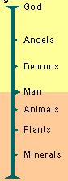
- Aristotle (384-322) (Student of Plato)
  - He does not believe in the ideal innate world, we cannot define the essence of things
  - Important to describe living things by their essence; this essence can be observed in nature. Didn’t think variability is important but essence of things are in nature.
  - Surprised by lack of resemblance between larvae and adult stages within same species (epigenetic concept of development vs a preformist concept).
  - Emphasized importance of describing animals or living beings by their essence. Morphological variation was only illusion or imperfection.
  - He and Plato were vitalists (believed living organisms had a soul). They believed a living being was more than the sum of it parts because it contained a vital force which cant be described in physical or chemical terms
  - Aristotle perceives multiple levels of souls with cumulative effects: vegetal (plants), animate (animals) and rational soul (humanity). This is the Great Chain of Being.
  - The scala naturae species are in a static (unchangeable) hierarchy. Important concept and still today use it for classification. Thus, morphological variability is illusion and imperfection.
- Plato vs Aristotle
  - Plato says there is a world of ideas or forms that is totally separate from the material world. Everything or living beings that we observe with our senses is poor imitation of its perfect representation in the world of forms. This world of forms Is innate, we have it at birth. We must contemplate our soul to find this form.
  - Aristotle says there is no need to postulate the hypothetical existence of an innate world of ideas or forms. We can find the essence of things by carefully examining the world around us. We must observe nature.
  - They both have two visions of the Theory of Forms (Essentialism)
    - Plato: we have from birth a picture of the ideal shape of a pigeon. Nature offers meaning only imperfect forms in relation to this ideal form. Knowledge comes from reasoning rather than from the use of the senses and the observation of nature.
    - Aristotle: the use of the senses is necessary to acquire knowledge. It is by observing the pigeons that one can define the essence of a pigeon. Contrary to Plato, Aristotle would have based his description of the pigeon on characteristics common to individuals of the species. Probably he would have lingered on the shape of the body, beak and wings.
    - For Plato and Aristotle, variability bwn the pigeons is not important/interesting since it does not make it possible to recognize the ideal shape/ essence.
    - 2000 years later, Charles Darwin was the first scientist to understand the importance of this morphological variability.
Impact of Christianism
- With the decline of the Roman empire, Christianity becomes the main ideology in the western world.
- Great chain of being – seen as the plan for creation of the world
- This will be the dark age for transformism (evolutionary thought). Perception of life change, freedom of speech disappeared
- God becomes the measure of all things, and the Christian bible, the word of the day. God created all.
- The concept of scala naturae becomes purely metaphysical proclaiming the perfection of the creator. If you find new species just put them in the level of souls in the scale, don’t worry about relationships.
- All objects that existed are more perfect than all identical objects that do not exist, thus God created all degrees of imperfection because the omission of one of the degree would have made creation difficult.
From Fixity of Species to Transformism
- Renaissance in Europe (14th to 17th century):
  - Back to nature (great expeditions and discoveries)
  - Power of religion is progressively challenged, more freedom of thought.
  - Period of enlightenment, the vale of progress became evident and there was a new perception of nature, More open-mindness. Vision of hierarchy of life was still important.
  - Protestant reform attacked Pope’s authority by indicating every human can interpret the Holy Scriptures as he wishes and should always listen to his own conscience.
- French Revolution (end of the 18th century)
  - Challenge of ordered systems (monarchy) for an active pursuit of progress
  - More open-mindedness towards science
  - Search for ordered systems morphed into a quest for progress. French and industrial revolution represented progress and government and social stems reoriented themselves on a quest for progress.
- There was a rejection of the notion of fixity in the western civilization of the 19th century
- The concept of a static, unchangeable world in a western theological thought goes with the concept of creation of the world.
- During and immediately after the renaissance, there was a return towards experimentation and the observation of nature. There remain attempts to classify living organism within the Great Chain of Being. (Humans on top of this hierarchy and its like scala nature but with more divisions). The Chain represents order of how God created the world and how life is organized.
- Linnaeus (1707-1778)
  - The influential Swedish scientist, father of modern taxonomy (Systema Naturae, 1758). Was inspired by Aristotle
    - Hierarchical classification
    - Binomial system of nomenclature (ex. We are Homo sapiens) (2 identifiers)
  - Discovering each piece of the ultimate puzzle, the Plan of the Creation. Wanted system to order nature.
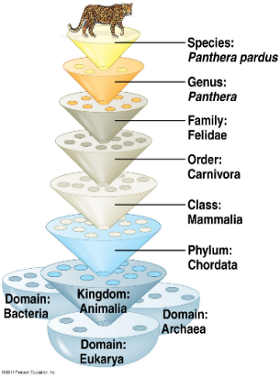
  - Linnaeus’s work remains an important contribution and his perfect application to the essentialism of Aristotle. Didn’t care about variability like Aristotle. Defining essence of things
  - Recognized different phyla (animals, plants and minerals). He divided animals into classes (mammals, birds, amphibians, fishes, insects, worms). Every class was also divided into orders that included one or multiple genera, the system of words allowing him to describe all animals and plants.
  - He started to think there must have been something else, a link between species that look similar. Doubted concept of fixity of species. His work is a masterpiece filled with essentialism
- Buffon (1707-1788)
  - Objective: describe nature (made encyclopedia, 44 volumes)
  - He wrote (around 1740):
    - “Every family, from animals to plants, has a common origin, all animals derive from one animal, which through time produces all animal species in existence today”
    - His theory established the age of Earth to be around 75 000 years. At that time people thought it was only 10,000 therefore big impact from this theory. According to Buffon, the initial tempe of the Earth was very high. Since then the climate has mellowed out/cooled down. And in another 75,000 years Earth will be cold. He said the presences of fossils is explained by environmental changes associated with change in temp.
  - The faculty of Theology of the Sorbonne censored, in 1751, many of Buffon’s theories because of its conflicts with religious views (the Bible). Not good to promote his ideas.
  - Thus, he decided to abandon his evolutionary ideas and to focus on observing nature. Better for him to be quiet about his theories and not lose his job.
- Lamarck
  - Hired by Buffon to tutor his son
  - Took interest in invertebrates and was director of department of invertebrates at museum
  - First evolutionist (someone who believes in a gradual modification of a species through time) that wrote a theory (species modify their morphology through time). Theory criticized
  - Uses the environment as a factor of change and that animals change because of it (Environmental determinism). Animals appear spontaneously and transform gradually from simple to complex. -> TRANSFORMISM. No static ladder, an escalator. Changing environment influencing needs of organisms and its characteristics.
    - The inheritance of acquired characteristics
  - 2 principles (affects individuals):
    - Principal of usage and non-usage. Use an organ gets larger, don’t use organ it disappears.
    - Principle of inheritance of acquired characteristics.
  - Ex. Giraffe reaching for food on tree and it stretched its neck. This trait descends to new progeny. Using right arm for tennis, right arm becomes stronger.
  - Gradual mechanism, adaptive and involves an innate ability (internal force) of organisms to become more complex. Species adapting to get best resource possible.
  - Spontaneous generation explains the presence of simple organisms and then organisms get complex and we get what we have today.
  - Theory not well received by his peers, since it contradicted religious theories. Lamarck didn’t prove his theory. Cuvier, his university professor, rejected Lamarck’s transformism and Lamarck did not oppose his mentor.
  - Theory was/is falsified, what you acquire during life you don’t pass on those traits or inherit them (morphology and traits).
- Cuvier (1769 – 1832)
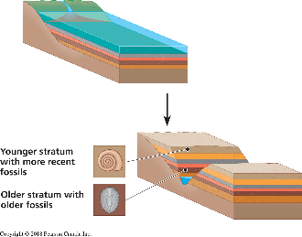
  - French scientist interested in mammal fossils
  - Says every part of an animal had an essential function
  - Established the fundamental concepts of paleontology. Father of paleontology.
    - The older the stratum the more dissimilar its fossils were to current species
    - From one layer to the next species appear and disappear
  - Theory of correlation of parts (correlation of organs, ex. Jaws of carnivores.) – Possible from a bone (ex. A toe) to completely reconstruct an animal. Fossils become complete can redraw animal (the correlation)
  - Ex. Looking at fossils, you can classify them form hints they provide into what they used to look like and related it to animals today (look at jaws, teeth)
  - Saw fossils were different than current species, the deeper you go the less they looked alike. Recognized phenomenon of extinction
  - Believed in the fixity of species and catastrophism and used this to develop concepts in accordance with religious beliefs.
    - Catastrophism: Natural catastrophes are responsible for periodical annihilation of all animals in a specific era. These cataclysms are followed by the creation of species. Fauna wiped out and new fauna appeared, believed god created new fauna.
    - Progressionism: Doctrine which stipulates that God improved quality, complexity and perfection of his creations after each catastrophe.
  - Strikes the final blow to the unifying concept of the great chain of beings, proclaiming God as the Creator of 4 major types of animals (independent change of being). (Radiata, Mollusca, Articuluta, Vertebrata). Thought species did not change and planet has gone through catastrophes. This is his way of explaining presence of fossils
- Hutton (1728-1797) and Lyell (1797-1875) - Geologists
  - Rejected theory of catastrophism because the basis of the theory is theoretical and can’t be verified in nature.
  - Geological changes result from a slow, gradual and continuous processes. Hutton’s thinking brought up the idea of Earth being a lot older (millions of years)
  - Principle of Uniformity (uniformitarianism): The laws of nature are not affected by the passage of time. Confirmed forces that created and shaped Earth are identical to forces that are affecting it now.
  - If one believes Earth has gone through a lot of natural changes and processes, one should not believe Earth is only 10,000 years old.
  - The present is the key to the past. By observing the present, you can postulate the past.
  - Vision of the world: ‘With respect to human observation. This world has neither a beginning nor an end. Process is slow, continuous and eternal. Reason can’t perceive due to slow speed of the processes compared to our own longevity.
  - However, meticulous observation allows us to perceive certain changes like large rocks falling from side of mountain. Once it falls, it breaks into smaller rocks which breaks because of environmental factors. Rocks become gravel, then becomes sand which is carried towards the oceans.
  - Creating force that counterbalances this progressive degradation is the Earth’s heat, volcanoes and pressure of the crust.
  - Lyell is the first to establish a geology as a scientific discipline. And convinced peer’s validity of Hutton’s ideas. Lyell adopted principle of uniformity and reaffirmed Hutton’s ideas. Darwin believed their theories that the planet is old and we can use this thinking for animal life.
  - Ex. Hoodoo- there was a rock at end of each of them. They are geological structures erosion occurred around rock and not under rock. When erosion was very high, these hoodos would have collapsed.
Lecture 4
Ch. 3 – Charles Darwin (1809 – 1882) and Evolution
Charles Darwin
- Born Feb, 12th, 1809
- Father was a doctor and Mother was from Wedgwood family (porcelain)
- Married in 1838 to his cousin Emma Wedgwood (1808-1896) and had 10 children
- He abandons his studies in medicine and takes more serious interest in religion (CambridgeU)
  - Prerequisite to become a pastor: Bachelor of Arts
- Became interested in nature: Taxidermy, insects collecting, botany, etc
- Voyage on the Beagle
  - 1831 – Leave on beagle, a ship commissioned by the British gov. to cartography the South Americas coast
  - Darwin was invited on board as a companion of the captain Fitzroy but quickly become the naturalist of the voyage
  - Travels the world and spends time on land to sample the fauna and flora and to study the South American geology
  - Voyage planned for 2 years, lasted for 5.
  - During voyage, 2 books greatly influences Darwin
    - William Paley (1743-1805) “Theology, or evidences of the existence and attributes of the deity”. He is the father of theology of Nature. This theology advocated that harmony and design of nature as indicators of the existence and the act of God (today= intelligent design (what science can’t explain, God did it). Said that some things like an eye are so complex that it had to be created by God. God in action. For a watch to work, you need all mechanisms to work if you take one out the watch stops. So how are mechanism independent?
    - Charles Lyell: “Principles of Geology”. His work had great impact on Darwin. He started his expedition thinking like a good protestant believing in the Great flood and in Cuvier’s catastrophism. When he returned 5 years later, he agreed with Lyell and Hutton’s Principle of Uniformity.
  - Started voyage form Europe, mapped South America, went to New Zealand, Australia, South Africa, etc. He touched all continents. Was known for his book on adventure.
  - When he was in Chile,for ex. There was an earthquake. Island took some height. Mapping of island now wrong. He saw a dynamic process and thought about Lyell’s Book and was convinced of his view bc of all the changes that could’ve occurred from millions of years go. Thought of evolution and relating this to animals.
  - The very distinct Fauna of SA had a big effect on Darwin
    - Why do the fauna and flora of Africa, Europe, Australia and South America have relatively few species in common?
    - Why are the animals and plants of the temperate zones of South America resemble the species living in the tropical zones of South America but not the species in temperate Europe? – Proves Lamarck is wrong. In SA species in temperate looked like species in tropical zone. DIFFERENT ENVIRONEMNTS
    - Why are the mammal fossils of South America absent from the current fauna (e.g. Giant Sloth)? Why do these fossils show resemblance with current species found only in South America (e.g. Three-toed Sloth)? Why do we not find them anywhere else?
  - Fauna on the Galapagos island surprises Darwin
    - The fauna on the islands is unique. Why?
    - Why does it show resemblance with species on the American continent?
    - Why is there so much shell variability in the terrestrial tortoises in the Galapagos – Environment is similar, different morphology of shells.
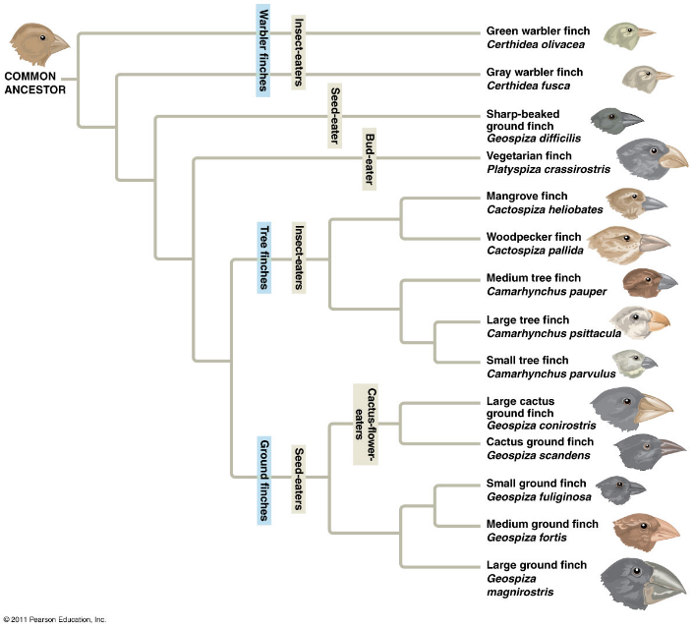
    - For the finches of the Galapagos Island, Why so much morphological variability in one group? Why does each island, in most cases, have their own species?
      - Finches had some morphology but the beaks are the only diff. Belonged to same group but ate different.
      - Finches are similar because they share a common ancestor. Related to one another at one point.
      - There were gaps in evolutionary branches as they finish in a dead end, meaning if there are common ancestors you should see all the intermediate steps. Therefore fossils must fill gaps.
  - Evolution and Natural Selection
    - 1837 – Find Darwin’s notes the first mention that species resemble themselves because they share a common ancestor (not a common environment). Not created independently. Published in 1859, was pushed to publish
      - Rejects fixity of species and accepts the concept of descent with modification (evolution).
      - It is a very materialistic vision, thus in contradiction to the religious dogma of the time.
      - Rejects Lamarck’s evolutionary mechanism (environmental determinism)
    - Begins search for evolutionary mechanism.
    - Examples to look at: Rock Hyrax, African elephant and Dugong
    - In 1838, Darwin read “An essay on the principle of population” (1798) written by economist Thomas R. Malthus. This reading became on of the main sources that brought him to formulate his famous theory of natural selection.
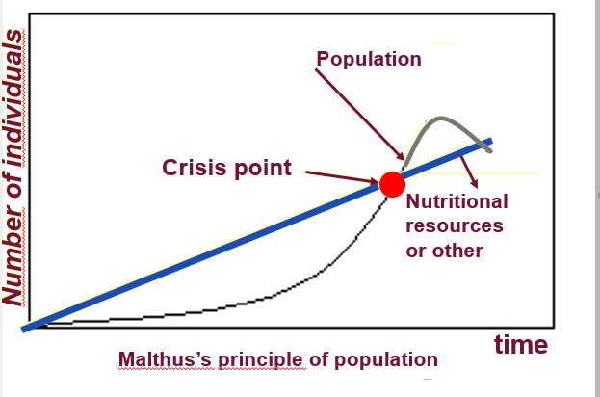
      - In the book, Malthus wrote “Every human population tends to increase geometrically whereas the available resources to feed these populations increase arithmetically.
      - The human pop. increases faster than its capacity to feed itself. This leads to chaos (famine, sickness, war, etc.) and eventually to a substantial reduction in pop. size. At Crisis point – there is losers and winners, losers die.
    - Darwin’s first observation: All species can produce more offspring than their environment can sustain and many of these offspring fail to survive and reproduce. Billions of spores in one puffball most of them don’t survive but percentage does.
    - Darwin’s Second observation: Members of a population often vary in their inherited traits. Darwin didn’t know about genes that time but knew only inherited traits would be transmitted from one gen. to the other.
      - This was a major switch from previous thinking
      - Natural selection: one inherited trait can increase and be more preferred
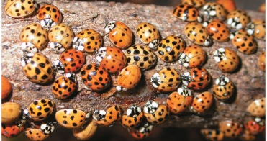
        - Selection of pressure of change – in a diff. environment it can provide one trait with an advantage. Variability is the key.
    - Two Inferences:
      - Individuals whose inherited traits gives them a higher probability of surviving and reproducing in each environment tend to leave more offspring than other individuals. People who don’t have enough resources die. Nature producing more abundant progeny than nature can sustain.
      - From generation to generation, this unequal capacity of survival and reproduce (differential reproductive success) results in an accumulation of favourable traits in a population. Ex. Blue fish had advantage from red fish bc predator didn’t see them therefore blue fish in next generation increases. Environment could change and elective of traits change, like predator would choose blue instead of red.
        - This is Natural Selection it enables the emergence of adaptation
        - Only inherited traits will be selected. Individuals inheritance will give them higher probability of surviving or reproducing in given environment tend to leave more offspring than other. Inherited traits are key.
    - It is a letter from Alfred Russel Wallace (1823-1913) received in 1853, that forces Darwin to publicly release his ideas
    - Wallace came to same conclusions as Darwin concerning the theory of natural selection by observing the fauna of Indonesia
    - Thus, it was 23 years after his voyage on the beagle that Darwin publicly released his views on the evolution of species. Wanted credit for what Wallace was about to publish.
    - One the same day, 1858, Darwin and Wallace presented a resume of their ideas on natural selection to the Linnean Society of London
    - 1859 – Darwin publishes the first edition of his book “Origin of Species”. The book became an instant bestseller and created great controversy
    - The 6th and last edition of his book, published in 1872, contains a chap. dedicated to the most important arguments of his theory. Most of these coming from his creationist colleagues. Tackled arguments nicely.
    - Important in Natural selection
      - Individuals do not evolve, populations evolve. We are carrier of genes, whatever we did in our life won’t affect that.
      - Only hereditary traits are subject to Natural selection
      - For evolution to occur, we need genetic variability. It tells us the possibility that species will change. Remember cheetah has no genetic variability and is prone to extinction.
      - Natural selection corresponds to differential reproductive success within a population from generation to generation
      - With time, natural selection enables individuals to become better adapted to their environment. (Adaptation comes from natural selection)
      - Environmental factors vary in time and space. Thus, the selective forces are variable
      - Traits in pop.’s will change and can modify species.
    - For Darwin, this mechanism is valid because:
      - It respects the principle of uniformity of Lyell and Hutton. No reason to think what you see now didn’t happen before. Darwin added biology to their geology theory as he understood it.
      - The results of natural selection are visible in nature
      - The mechanism can be verified on current pop’s. (e.g. Artificial selection)
      - It’s a material concept, no need for divine intervention (Like God)
        - Mechanism is not random. Natural selection enables individuals that are better adapted to their environment to become more abundant than those who are not (differential reproductive success). Population responds to selective pressure.
        - Not a quest for perfection, no perfect colour for fish (evolution is not a directed progress). It does not lead to the appearance of perfect traits only adapted traits. Organisms only adapt to their environment.
    - Source of genetic variability can be a mutation.
    - Artificial Selection: Is finalized because the goal, fixed well in advance, perfects the causes. Result can be obtained in a few generations. Ex. Breeding dogs: got dog to reproduce and chose ones they want, wild mustard (created all kind of vegetables we eat from it like broccoli or cabbage)
    - Natural Selection: Not finalized. Can take a long time for changes to occur (geological time scale). Have history.
    - Peppered Moth Ex.
      - Lived in dark/light environment and got eaten by birds. Birds choose the most visible moth.
      - Moth on a dark trunk, dark due to uncleanliness of city (white coloured moth ). The predator, bird, would eat the moth/butterfly because of the contrast. Natural selection will occur and moths will be darker in colour for the purpose to not get eaten (survive). Same concept if dark butterflies go on white trunk.
    - Climate and the Medium Ground Finch
      - Birds from Galabagos, study done by Grant scientists and measured all birds. Observed hieght of peak
      - Drought in 1977 (also in 1980,1982). Population 1200 adults to 80.
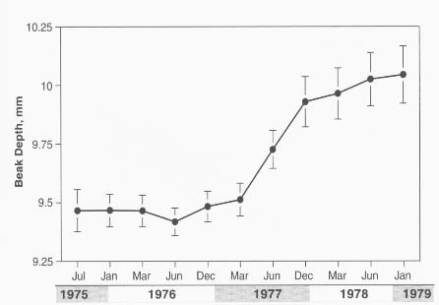
      - Selection favours individuals that have bigger and stronger beaks to break available seeds during the drought. Smaller seeds gone and smaller birds vanished – selective pressure.
      - Changes in the height of the medium groundfinch’s beak (Geospiza fortis) on Daphne major island during the 1977 drought. Had so much data and could compare child to parent and see if genetics were involved.
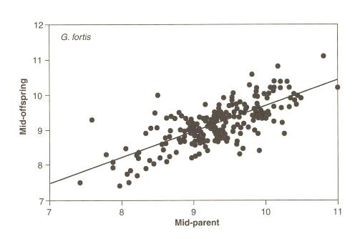
      - Correlation between the height of the beak in parents and offspring for G. fortis on Daphne Major Island. The slope of the relation is 0.74; which indicates that the traits are inherited from their parents (74%)
    - Mountain life: Adaptation to altitude
      - People can adjust to change of altitude overtime. Our body reacts to compensate such changes. Reacts in weird way.
      - Over 2,000m the partial pressure of O2 is insufficient for a normal saturation of hemoglobin for a traveller in high altitudes
        - Shortness of breath, altitude sickness
      - Physiological response (acclimatization): After a few days at high altitude, body compensates the low partial pressure by increasing the concentration of red blood cells in our blood. That’s great but do you have the system that can carry that much. Also, accumulation of water can affect brain and lungs resulting to death. Serious health risks: thrombosis, pulmonary edema, problem when pregnant etc). Probability of stroke if health comes in the way of adaption
      - The guy in his trip came from family who is adapted to living in high altitudes. Some people can have adaptation to high altitude with out knowing.
      - Say people who don’t have the genetic trait that allows them to survive and reproduce in high altitudes. If they disperse from somewhere in the Lowlands of Asia to Qinghai, after a few generations they will acquire that trait that allows them not to survive [Adaptations don’t evolve when you were there, originally the adaptation was already there].??
      - Many regions in high altitude were independently colonized by humans. On the Qinghai-Tibet Plateau, human adaptation to high altitude differs from the Andes. (Andes – 11,000 Years, 550 generations), (Qinghai- Tibet Plateau – 22,000 years) 1,100 generations)
        - Adaptation was there before humans got at that high altitude. Adaptation in lowland pop by mutation, a random process, many may have it but don’t know it.
        - Reproductive success was associated with presence of adaptation to high altitude.
        - Adaptation evolved bc ppl went to high altitude, no adaptation was here way before and was favoured in high altitude. Don’t say they went to high altitude and adaptation appeared, realize original pop must have few individuals with adaptation. Mutation possible but rare. Chapleau didn’t adapt, he was resilient when he went to high altitude.
      - Adaptation
        - Andes – increase in hemoglobin conc. (red blood cells per ml).
        - Qinghai-Tibet Plateau – Increases blood flow
        - Natural selection keeps the individuals with the genetic traits that allow adaptation to high altitude. This means that individuals that have the mutation are at an advantage for survival and reproduction (production of offspring).
        - But, adaptation can be a great consequence
    - In all three cases (moths, finches and humans), the hereditary traits that give a reproductive advantage (adaptation), individuals in a population that will be favoured. Thus, from generation to generation, there will be a higher percentage of individuals carrying the adaptation. That is natural selection. It’s Darwin’s descent with modification. It’s evolution.
    - These adaptations can sometimes redefine a species and, in a certain circumstance, define a new species (in book, fig.22.13). N
=
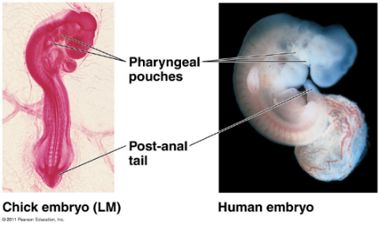
  - Homology
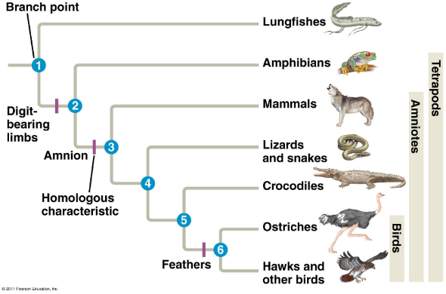
    - Descent with modification theory (theory of evolution) explains the resemblance between certain traits even if the functions are different. Structures are homologous and reflect from a common ancestor.
    - Post -anal tail, we have it up to week 7 but it’s a homologous feature found everywhere
    - The picture to the right is proof of evolution, there are still traces of breathing of this embryo.
    - The pic to the left: For ex. Lungfishes have no digits

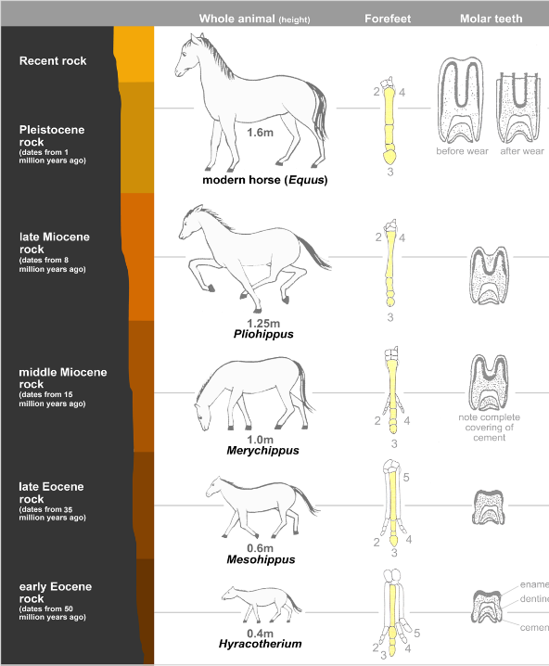
  - Fossils
    - Evolution of horse:
      - Foot became simpler, adaptions for an animal that got out of the forest and started to live on planes. There is now more simple limbs now that they walk on their toes
      - Wear and tear on feet/teeth can be measured and age of horse can be determined
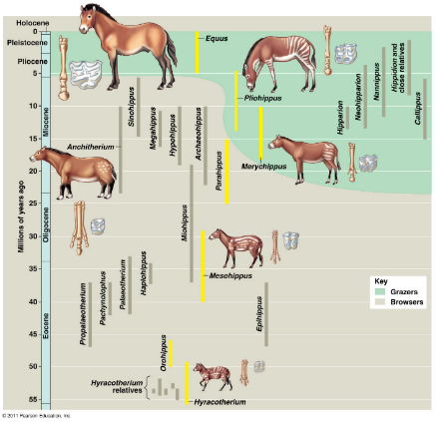
      - The smaller pic shows the reality, evolution is not linear. Take in vision of tree when thinking about the evolution of a group.
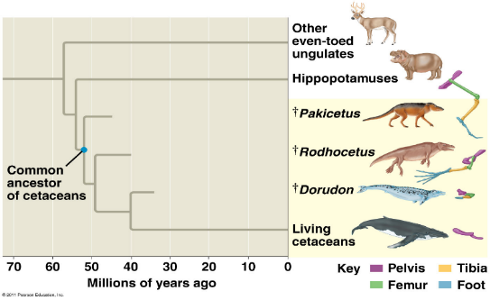
      - New stage does not replace old stage
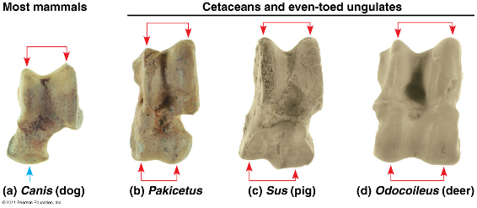
    - hippopotamus are the closest living species to whales. (Look at hind legs).
  - Vestigial structures
    - Remnants of evolutions
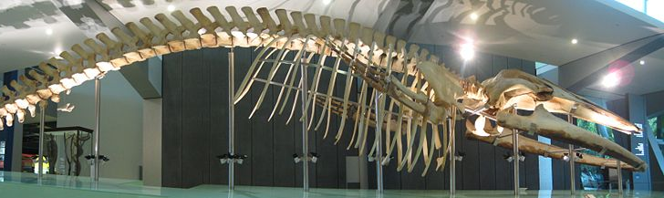
    - Anatomic structure that has lost almost all its initial function. There is a reduced vestigial posterior limb on skeleton of a dwarf subspecies of a blue whale. The pelvis reduced to a floating pelvic bone under the spine.
    - Hips present in flesh play no role in function
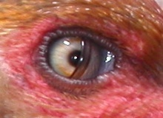
    - Examples
      - Nictitating membrane of a third eyelid. Also, the skin in human eye is a vestigial feature. Fish, birds or crocodiles have it
      - Appendix – Remnant of a structure that was much larger. Cow’s stomach for ex. Have a large caecum. Humans lost the caecum and now its much smaller and we have a small remnant of it – the appendix. No vital role for survival other than killing us if appendix inflames. This was a minor functional value in ancestors but not anymore to us now.
      - Goosebumps- to preserve heat we should have thick coat of hair on arms, tips or hair will form a layer that will ensure the air from the tip to root is a form of heat. We have lost the hair on our body; the kept hair now is vestigial as there is no important role/extreme need other than the goosebumps.
      - Hiccups- Heritage from fish and amphibians. Nervous reaction. Getting rid of it you make a movement that can move your organs so your diaphragm is no longer squeezed. Respiratory system progressively moved down our body, no new nerves ours just moved/modified. The design is not optimal, there is no reason to have a phrenic nerve that long coming from the diaphragm, hiccup are indications of evolution.
  - Discovery of a fossil in the wrong place in the geological archives would be sufficient to refute our concept of evolution.
Lecture 5, Ch.4 – Transmission of Traits (inheritance): Pre-Mendel Perspectives
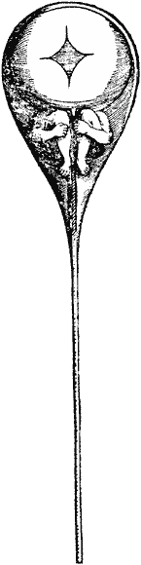
Preformism and Theory of Blending Inheritance
homoncule
- The development of individuals: Preformist theory until 19th century. The accepted theory today is Epigenesis.
- Preformism
  - Idea made before we had microscopes. Within the sperm there would be a miniature of an adult human meaning we already existed in sex cell
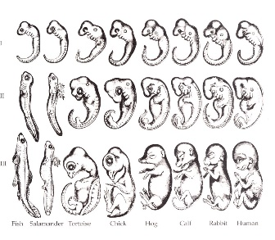
  - Theorized: miniature human already within a man and the woman gives it nutrients. Everything was already created before even out
  - Then people said miniature beings are in ovum/ eggs and sperm is only the substance that stimulates growth of embryo so life wouldn’t get lost. They were confused ppl.
- Embryo go through a lot of cell differentiation. It’s a gradual development, not a miniature.
- But, preformism was pushed and theory was questioned once microscopes were invented. We saw what was inside the sperm.
- Theory of blending inheritance: universally accepted theory until end of 19th century.
  - Both parents participate equally in genetic makeup of offspring
  - For each trait, child would show an intermediate value (avg) btwn traits of its parents
  - Thus, rapidly, all individuals (after every generation) would become identical or very similar, which is not consistent with what we observe. Progeny is a mixture of their parents
- Darwin’s Pangenesis
  - Theory of gemmules (Hereditary particles) produced by each part of the body and concentrates into the sex cells.
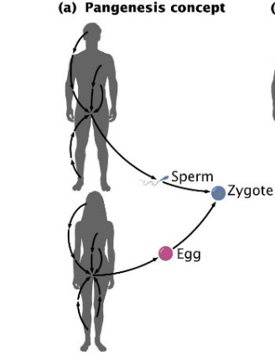
  - When an organ is used, it grows and more gemmules it contains. The contrary is also applicable.
  - The gemmules would be transported in the blood stream from all parts of the body and assembled in the gametes when they are formed
  - Gemmules would be transported in the bloodstream from all parts of the body and assembled in the gametes when they are formed.
  - Gemmules would be the particles associated with the transmission of heredity.
  - Francis Galton’s (1822-1911) exp refuted Darwin’s hypothesis.
- August Weismann’s Theory (1834-1914)
  - Proposed that only the sex cells were responsible for heredity, whereas the rest of the organism was only a structure doomed to disappear with the death of the individual. Rest of body there to carry sex cells.
    - Livings beings are divided into 2 parts, with distinct outcomes: germline (gametes) and the soma (remainder of the body)
    - Germline is impervious to environmental influences and heredity is simply the continuity of the germline. Thus, the germline and environment can influence the phenotype, but the soma and the environment have no influence on the genotype.
    - Natural selection is the only mechanism that an eventually modify the germline of a pop. It will favour a genotype relative to others.
- Sexual life of the Monkfish (lantern fish)
  - Example showing that soma is first and foremost the receptacle of the germline
  - Produces light that will attract prey
  - Females only would look like this. The lantern fish had eggs so they’re female species
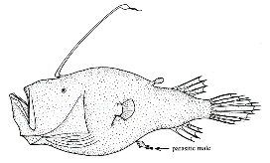
  - Males found to attach themselves to females (small), they become like a sperm bat. They lose organs and fins. Females can easily pick and choose a sperm that will maximize fertility of their eggs
  - Sexual dimorphism
Mendelian Inheritance
- Gregor Mendel (1822-1884) Founder of genetics, Austrian monk
- Formulated his laws on the creation of hybrids (laws of heredity) in 1866
- His work was only recognized in 1900
- Work made with exemplary scientific rigour. His choice of experimental material was judicious
  - Peas (many varieties available, possibility of crossbreeding, cheap, generation time is short, descendants are plentiful)
- Abundant data and the use of mathematical analysis to verify his hypotheses.
- Mendel talks about hereditary factors (genes were still unknown at that time)
- All traits he studied were dominant recessive
- Variation of genetic traits is explained by the different shapes genes can have
- Each gene occupies a specific locus on a given chromosome
- The DNA sequence of the locus can show variants (alleles). Genetic variance.
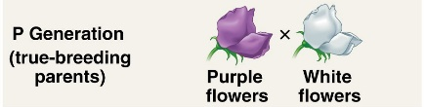
- For example, the alleles for white flowers and the alleles for purple flowers are situated on one of the peas chromosomes
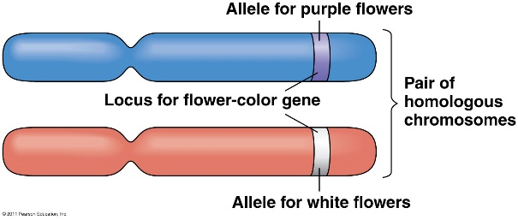
- All organisms inherit 2 copies of a gene (different or identical), one from “father” and other from “mother”
- Each copy is an allele. Each individual has 2 alleles, population has several.
- Hereditary factors: Genetics
  - An individual with 2 alleles for one gene
  - There are 23 pairs of chromosomes in humans
  - There are 2 possible alleles in the case of the two types of ears, attached or unattached
  - If both alleles of a locus are different, one of them, the dominant allele determines the appearance of the organism; whereas the other, recessive allele, has no notable effect on appearance. Only dominant will manifest itself.
  - Law of uniformity of hybrids of the first generation
  - If both hereditary factors are different, one of them, the dominant one determine the appearances of the organism; whereas the other, recessive factor, has no notable effect on the appearance. The dominant factors for ears would be unattached one
  - Punnet square- allows you to do all combinations of alleles.
  - There is no manifestation of traits

