Topic 1
How did life evolve into organisms and cells? (Review from BIO1130 and/or BIO1109)

What are the different types or classes of organisms?
  - Prokaryotes(eubacteria), archaea, eukaryotes

What is a cell?
  - Smallest unit of life that can
    - Membrane bound organelles(compartments
    - Reproduce
    - Replicate on its own
    - Self assemble into the structures in need in the cell
    - Have DNA or RNA
      - Storing all their hereditary information
  - All basic structures starts from proteins
    - Maintaining structure
    - Generating movements
    - Sensing signals
  - All cells have some sort of genetic information, cytosol, and ribosomes
  - They are small because increase surface area but the same volume
What is a cell made of?
  - Phospholipid bilayer membrane
time
0.067s
6.7 s
10.9 min
78 d
X
0.1 mm
1 mm
1 cm
1 m
    - Amphiprotic- both hydrophobic(tail) and hydrophilic(head)

  - Carbohydrate and protein receptors like glycoprotein

Why are cells small
-increasing rate of diffusion

What are the different scales/sizes for cells and organelles?
  - Mitochondria and Chloroplast same size as bacteria(name of bacteria
  - Nucleus is the largest organelle in animals next ER
  - I think vacuole is the largest in plants

Explain the theory of the cell and the theory of endosymbiosis – can you provide some examples?
  - Mitochondria and chloroplast
    - has its own DNA
    - doubled membrane
    - reproduce by dividing in two cell by binary fusion
    - ribosomal RNA is more closely related to bacteria than eukaryotes
    - similar size in bacteria
    - contain their own genetic systems, which are distinct from the nuclear genome of the cell
    - ribosomes and ribosomal RNAs of these organelles are more closely
    - related to those of bacteria than to those encoded by the nuclear genomes of eukaryotes.
    - genes they encode are transcribed within the organelle and translated on organelle ribosomes
    - they have ETC
    - Morphology: Shape of mitochondria and chloroplasts and size (μm) are similar to bacteria and archea
    - Reproduction: Only by binary fission
    - Genome: circular mDNA and cpDNA
    - Transcription and translation: machinery in place
    - Electron transport: double membrane with ETC
Sequence: bacterial branch on tree of life (mitochondria = proteobacteria; chloroplasts =cyanobacteria
What are the main groups or types of cells and how do they differ?
Bacteria
- spiral, rod shape, spherical
Prokaryotes
  - Variety of ecological niches ex. Organotrophic(organic food),phototrophic, lithotrophic(inorganic ex.C)
  - Lack nuclear envelope
  - Generally smaller(1-5um)
  - Don’t contain cytoskeleton
  - Highly adaptable(extremophiles)
  - Small genome(Plasmids)
  - Bacteria
    - Non-membrane bound nucleus to contain DNA, RNA
    - Could have capsid
    - Cell wall
    - Little to know organelles
    - Divide by binary fusion
    - Small and simple outward appearance (sphere or rod)
Archaea
    - Extremophiles the only different from bacteria because of their structure
    - Cells wall
    - Non-membrane bound nucleus to contain DNA
    - archaea seem to resemble eukaryotes more closely in their machinery for handling genetic information (replication, transcription, translation)
    - resemble rRNA and phospholipids eukaryotes
Eukaryotes
  - All have plasma membrane
  - Ribosomes
  - More complex containing nucleus, cytoskeleton, organelles, membrane bound organelles
  - Generally bigger(10-100um)
  - Transport
  - Large genome
  - Have some sort of energy like mitochondria or chloroplast
Cell parts
Nucleolus
- Chromosomes are packed in one area of the chromosomes
- Contains ribosomal rna
- Where ribosomes are assembled
Nucleus
-contains genetic information (DNA)
-controls the cells, making proteins
-has holes/pores so material go in out
-the membrane is continuous to the rough ER

Ribosomes
-small subunit bottom, large protein on the top
-protein synthesis
Vesicle
-membrane bound contain
-and maybe move material around, transport
-could be a vacuole, but can be small
Rough ER
-membranes that is continuous of the membrane of the nucleus
-contains the ribosomes
-where protein synthesis
Golgi body apparatus
-extensive network of intracellular membrane
-package in Rough er and traported by vesicles
-add proteins, carbohydrate, finishing the protein
-protein folding?
-transport it to the specific location like ups delivery
Cytoskeleton
-helps the structure of the cells, shape, movements
-microtubule- (thick) helps for compressional support, and transport
-microfilaments-(thin) tensional support
-intermediate
Smooth ER
-synthesis of fatty acids and phospholipids
-producing lipids and cholesterol
-help detoxification, breaking down toxins
Mitochondria
-generating ATP
-endosymbiosis
Vacuole
-both has it but plants has it very large
-storage waste and nutrients
-digest macromolecules
-turgor pressure
-also has a acidic pH, has a proton pump, and degradative enzymes
-solute concentration is very high causing turgor pressure, water going it
Cytosol
Lysosomes
-contains digestive enzymes
-and it will digest
-or cell kill its cell
-very acidic low pH in order to denature proteins

Centrioles
-positioning of the c
-important for the cell divides
-no in plants

Animal

  - Plant
    - Vacuole
    - Cell wall
    - Chloroplast (only in plants
Evolution of metabolism
Glycolysis
-was the first metabolism because no atmosphere did not contain a lot of oxygen as a result main source of energy is form glucose to ATP
Photosynthesis
-next is photosynthesis gets energy from the light and use CO2 and H2S and H2O as food causing to releases of oxygen causing the change of the atmosphere, responsible of todays atmosphere
Oxidative
- as a result of abundance of oxygen was used a food source
Membranes function
-
- Understand the different types of microscopy and their requirements for use in cell biology

Electron microscope –detailed structures of the membrane, a beam of electrons
Optical microscope
Fluorescence microscope
  - Light microscope- - Cells that have been fixed and stained can be studied
Florescence- with the antibodies coupled to fluorescent dyes can be used to locate specific molecules in the cells, Microscope designed to view material stained with fluorescent dyes. Similar to a light microscope but the illuminating light is passed through one set of filters before the specimen, to select those wavelengths that excite the dye, and through another set of filters before it reaches the eye, to select only those wavelengths emitted when the dye fluoresces.

  - Phase- contrast microscope/Interference-Contrast microscope
  - Microscopy
  - Florescence microscope
  - Optical microscope
  - Confocal microscope-
  - Electron microscope
  - Immunogold electron microscopy
  - Scanning Electron microscope
  - Transmission electron microscopy

Topic 2
- Understand the role, identify areas and determine the importance of a molecule’s polarity (electronegativity) of different biologically relevant macromolecules (particularly amino acids and proteins)
  - Membrane (outside stays outside, inside stays inside) fluidity
  - Membrane transport(protein transport)
  - Direction of motor protein
  - Diffusion
  - Affects if it can go through the membrane or not like integral proteins go through the membrane because both polar and non polar(ampiphatic)

- Explain the relationship between polarity, molecular structure, cellular location and function – particularly for proteins and lipids
  - membrane
- What are the types of chemical bonds present in cellular macromolecules and how are they relevant to cell biology
  - Ionic bonds
  - Hydrogen bonds
  - Van der waals
  - Hydrophobic force- bringing two nonpolar surfaces together reduces their contact with water, the force is a rather nonspecific one

- What is the importance of water in biology
  - It’s a polar
- Know and identify the main classes of macromolecules, recognize their general structures, and interpret these in relation to their cellular location and their roles in cells
  - Sugars(monosaccharides)
-primary source of chemical energy for cells, polysaccharides for energy storage
- structure, energy
-polar it can go through the membrane
  - Fatty acid
- also for energy storage but critical formation is the cell membranes
- it takes more energy to break bonds
- double bonds cause kinks causing more fluidity of membrane
  - Amino acid(Proteins)
-backbone – amine and carboxyl group, and a R- radical group
-peptide bond
-the folds are held by non covalent bonds so it can be change very easily less energy, also it determine the shape of the protein
FOLDS
-primary -chain
-secondary- helix(a) or sheets(B)
-tertiary-non covalent bonds
-quantum

Functions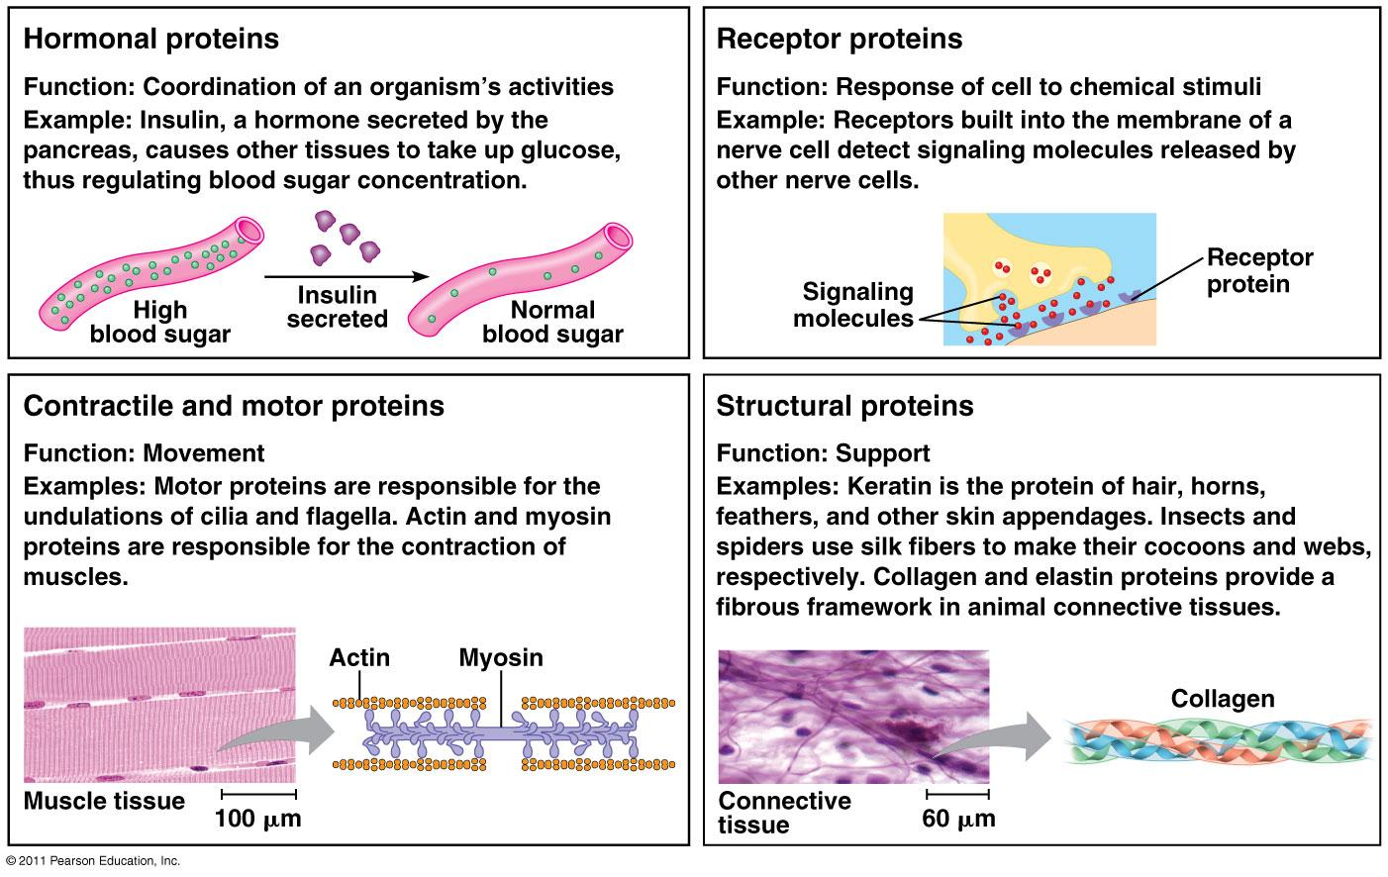
-hormonal proteins
-receptor
-contractile and motor
-structural
-enzymatic 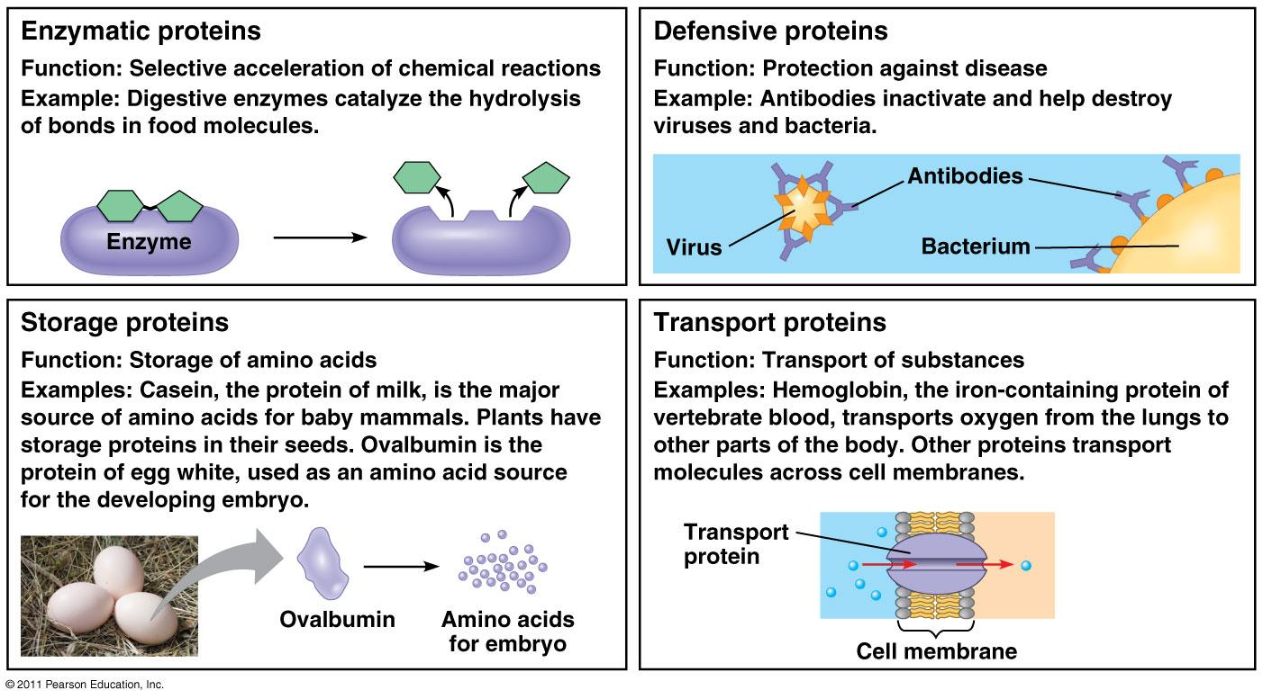
-defensive
-storage
-transport
Functions
-
-The use of smaller subunits to build larger structures has several advantages:
- A large structure built from one or a few repeating smaller subunits requires only a small amount of genetic information.
- Both assembly and disassembly can be readily controlled, reversible processes, since the subunits associate through multiple bonds of relatively low energy.
- Errors in the synthesis of the structure can be more easily avoided, since correction mechanisms can operate during the course of assembly to exclude malformed subunits.
- This folding process creates unique surfaces, and it depends on a large set of weak interactions produced by noncovalent forces between atoms

  - Nucleic acid
-subunits for DNA and RNA
Topic3
- Cytoskeleton
ff
- Provide structure and
- How is the cell’s interior organized?
- Compare how each component of the cytoskeleton is formed
Cytoskeleton
- Dynamic structures, they need to adapt quickly, growing or shrinking
- Provide structure and support (1)
  - Scaffolding, anchoring,
- Intracellular transport(2)
- Position organelles (4)
- Generate movement for cell movement, shape
- Contribute to cell division
- No in prokaryotes
- No covalent bonds
  - it need to be fast/rapid for to change shape, length or orientation
  - less energy
- 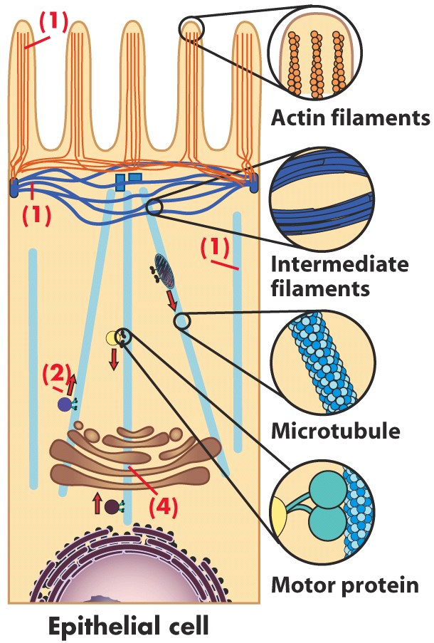

Microtubules
- found in the cytoplasm a joining with near the ER
- few make it to the membrane
- don’t go through organelles
- basic units are tubulin dimers (a and b tubulins), not different, same, but one is expose GTP(beta(+)) and imbedded (alpha(-))
- Originate from a central point, the MTOC (microtubule organization center) at the centrosome (near nucleus) (at the ‘-’ end)
- hollow tube
- bonding at the beta
- alpha is the anchor
- chain of tubulin protofilaments, stack them together 13 makes a tube, microtubules
- cilia and flagella for movement
- 13 hetrodimers forming a tube
Microfilaments
- it gives the appearance of a helix, not two strand, just a staggered manner
- made of 2 strands of actin
- covers throughout the cell to the ends of membrane
- anchored and in(centerosome)
- has positive and negative
  - it gives direction for molecular motors
  - grow at positive
  - shrink in negative
Intermediate filament
- don’t have polar ends
- form a cage around the nucleus, when compression or stretch like rope
- rope like structure
- formed by keratin protein
- spontaneous assembly
Motor proteins
- Mechanoenzymes-use ATP as fuel
microtubules
-kinesin walks towards the positive(anterograde)
-dynein walks towards the negative(retrograde)
Microfilaments
-Myosin
Intermediate
-non, no motor proteins, because lack of direction, as a result the don’t transport
  - carry cargo to transport, like vesicle
  - move by ATP
  - can’t be covalently bound because to strong, in order to be dynamic it needs to be flexible, non-covalently bonds give that structure of fluidity
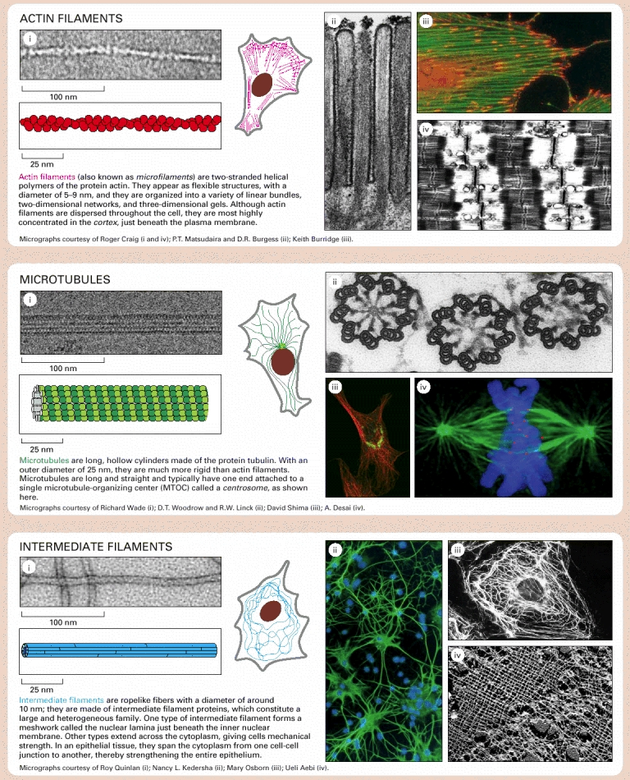

Centrosome/centriole
  - Each cell has a centrosome, made up of 2 centrioles, at a right angle with respect to each other (L-shape)
  - Made of microtubule
  - Centrioles are made of 9 microtubule triplets, arranged in a ring structure (no central triplet)
  - Can serve as anchor to cilia(motility) and flagellum(mobility)
    - 9+2=9 microtubules doublets
    - it needs its anchors between doublets so its not all over the place
    - they move because of motor proteins going on them
  - Are the beginning of MTOC
  - Mitotic spindle formation(microtubule)
Junctions
  - organize physical interaction between cells:
    - Tight junctions: Fusion of proteins on external plasma membranes. Seals that area – even ions cannot pass
    - Anchoring junctions: Plaques of proteins interact and anchor cells together. (Adherens – Actin and cadherins) (Desmosomes – IF, keratins) (Mechanical force)
    - Gap junctions: Channels formed by proteins bridging cells (connexins). Allows passage of ions and small molecules – cell communication!

- Discuss how cellular motility and mobility are different and how they are accomplished
- Describe what the extracellular matrix is made of, and interpret why it is important to cells

Topic 4
- Discuss the role of membranes, and in particular the plasma membrane, in a cell.
  - Boundary-selective permeability
  - Organize and scaffold
  - Regulate solute concentration
  - Receive Signals
  - Communication
- Understand and explain the fluid mosaic model. Include the membrane’s properties in the discussion.
Membrane
  - Proteins or any structure can’t be embedded in the membrane if their polar
  - To be embedded it need to have both hydrophilic and hydrophobic areas
Fluid
-lipid is always moving
-determines the permeability of the membrane by the lipid structure
-non covalently bound
-free floating
Mosaic
-combination of all structure, proteins and carbohydrates,
-all have different functions
Outer
-for communication between cells
-detect foreign stuff or food
-glycolipids
Inner
-need to interact with carrier proteins
-cytoskeleton
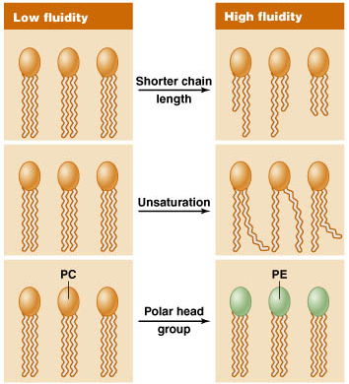
Lipid bilayer
- Membrane is not symmetrical
- Membrane fluidity
  - Length and saturation of fatty acid chains
  - Polar head groups (variable polarity)
  - Sterols (buffering effect)
  - Temperature
- Dynamic
  - Homeoviscous adaptation:
The ability to change the membrane’s lipid composition in response to the environment in order to maintain membrane fluidity.
      - A desaturase is an enzyme that introduces a double bond

- What is the membrane made of? Describe and organize the different macromolecules involved and link them to the membrane’s properties.
Lipids
Phospholipids
-1 polar head and 2 hydro carbon tail
- presence of a double bond makes it have a kink, influencing fluidity
- the more the double bonds the more permeable
- Phosphatidylethanolamine
- Phosphatidylserine (-)(inside)
- Phosphatidylcholine
- Sphingomyelin

Sterols
- 4-ring hydrocarbon
- only in eukaryotes
- Play an important role in fluidity; both in terms of arrangement and in relation to temperature (buffers)
- When cold it prevents the membrane to be impermeable, creating space
- Hot temperatures it holds it together helps not to be more permeable

Proteins
-transport
-enzymes(catalytic activity)
-signal transduction
-attachment/ recognition

Carbohydarates
Glycolipid
-1 or two fatty acid chain
-important for cellular recognition
-like antigen

- How are membrane dynamics important for transport?
- How is the membrane potential formed and how is it useful in a cell?
  - Concentration gradient ?

Membrane Protein
  - Structure of amino acids with Radical groups phasing the membrane nonpolar radical groups
  - Inside the tertiary structure the core is polar(polar radical groups )

Integral
-does not face the inside or the outside
-goes through the membrane
Peripheral
-one side of the membrane
-can provide structural support
-interact with other protein, membrane, or cytoskeleton
-can by ether sides of the membrane
-non-covalent bound to another element like(integral proetein or cytoskeleton
-creating a link between the cytoskeleton, giving it structure and fleixibilty
-this allows by the interaction of membrane, cytoskeleton, and peripheral proteins
-ex blood cells going through small capillaries
Lipid anchored
-covalently bond
-could be anchored both side
-different types anchors for each layer to accommodate/accomplish different things each layer
-Extracellular proteins
-covalantly bound by the protein (not the membrane)
-GPI anchors (glycosyl phosphatidyl inositol)
- assist for cell adhesion or recognition
-intracellular proteins
-Fatty acid or prenyl groups
-how it divides, grows,

Study of membranes
  - Microscopy
  - Freeze-fracture
    - Freezing the cell killing the cell
    - And separating both layers with a knife
    - Anchored in the bottom is the bottom, top is top

  - FRAP(Fluorescence Recovery after Photobleaching)
    - Still alive
    - Bleaching certain areas
    - Fluorescently labeled
    - Because of the dynamic fluidity of the membrane, it is displaying the fluidity of the membrane
    - Measuring this difference can determine the rate of

Movement across membrane
  - Ions can’t get through the membrane because it charges even though its small
Concentration gradient vs electrochemical gradients
Gradients can store potential energy
Both ATP
Primary transport (ATP pumps)
Uses energy ATP
Secondary transport
Uses the energy from the other concentration gradient
Symporter
-coupled transport protein
-both come in at the same time,from one side, same direction
-high to low concentration(passive)
-Na/ Glucose
-
Antiporter
-uses both sides opposite direction at the same time
-Na/Ca
Passive transport
Simple diffusion
Channel mediated
Carrier mediated

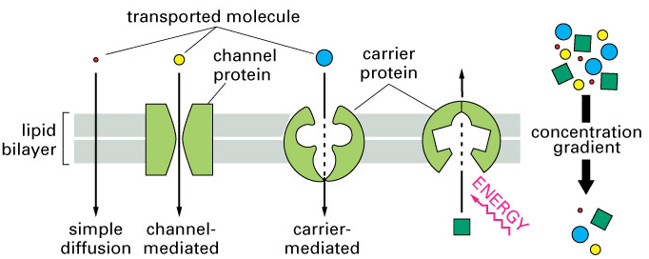

- Compare the different types of transport across the membrane and give examples for each.

Class of ATPase | Solute | Location | Function
P-type ATPase | Na⁺ and K⁺ | Plasma membrane | Pumps Na⁺ out and K⁺ into cytosol
 | Ca²⁺ | Plasma membrane | Pumps Ca²⁺ out of cell
 | Ca²⁺ | Sarcoplasmic reticulum (SR) | Pumps Ca²⁺ into SR
V-type ATPase | H⁺ | Membrane of secretory vesicles | Pumps H⁺ into vesicle lumen
F-type ATPase | H⁺ | Mitochondrial IM | H⁺ gradient drives ATP synthesis
ABC transporters | Many (ions, sugars, amino acids, proteins) | Plasma membrane | Nutrient uptake, protein export.
Active transport

Active transport
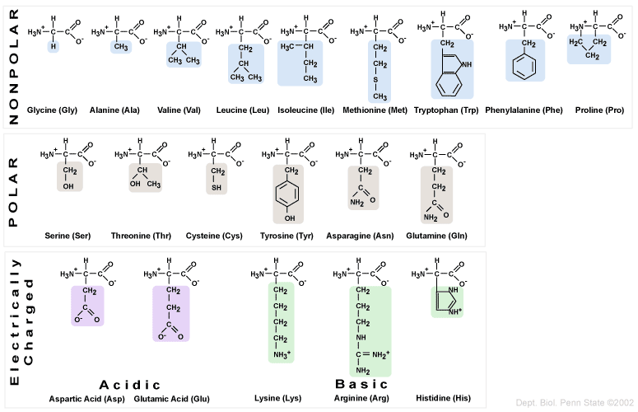

Topic 5
- Explain, contrast and compare, the role of mitochondria and chloroplasts in cells with regards to energetics

Mitochondria are essential
- Metabolism
- Response to stress
- Cell death
- Calcium storage
Chloroplast

- Understand the importance of calcium homeostasis
  - Availability, Storage, regulation (later with signal transduction)
  - Provide examples of cellular functions that rely on calcium
- What is mitophagy and how/why does it occur?
  - when you don’t need a mitochondria
  - is a means to selectively remove damaged or reduced the number of mitochondria by autophagy
  - lecture 9
- Describe and differentiate the two cell-death mechanisms and explain the role of mitochondria and calcium in both

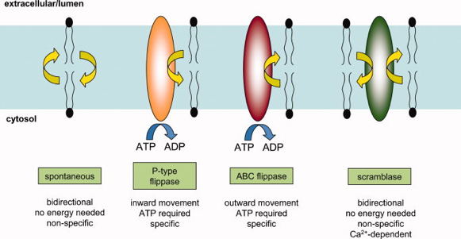

What triggers cell death
-chemical messenger (growth factors and stuff)
-stress
-cell cycle check points

Apoptosis
- well organized death, apoptic bodies occur then phagocytic cell engulfs it
Structural changes
-Chromatin condenses
-nucleus fragmenting, “laddering”(degrading the dna), blebbing cell fragmentation
-phagocytosis, phosphatidylserine goes outside the membrane signaling
macrophages
- Scramblase requires activation: Ca2+ and caspase dependant
Caspases
-DNA fragmentation + DNAse
-Change cell shape and size - Cytoskeleton
-disassembly of nuclear envelope - Lamins
-disruption cell adhesion - Protein kinases
BCl2/ bad
  - BCl2 is anti-apoptotic, inhibits IP3(prevent the release of Ca from ER
  - Bad, bax, and bak are pro apoptotic
    - Bax/ bak activate IP3(promotes ca releases

Mitochondria and ER

Steps
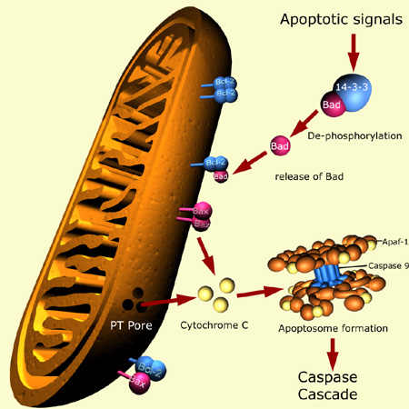
1.NO, Toxins, Hormones, Cytokines, etc (Bad released)
2.Inhibition of BCL-2 and Activation of BAX and BAK (IP3)
3.Increase in Ca2+Opening of PTP (permeability transition pore) Release of CytoC
4.Apoptosomes are formed (CytoC, Apaf-1, Cas9)
5.Caspase cascade Nuclear condensation DNA fragmentation Cytoplasmic shrinkage Apoptotic bodies Phagocytosis

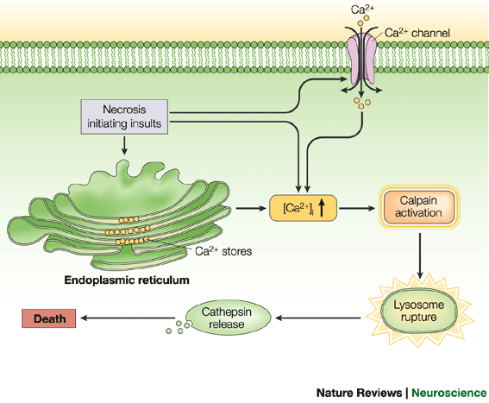

Necrosis
-swelling occur until it is irreversible, the cell burst causing the enzymes in the cytosol to be released harming the neiboring cells
- calpain-cathepsin pathway
-Ca increases is needed
-Calpain(Ca dependent protease) degrades the membrane of the lysosome
-causing Cathspin to release (activates in more neutral pH)digesting the cellular content
- Relate cell death to the cell cycle (We will discuss this further later in the cell cycle regulation LSs)
- apoptosis
- Form of cell death, also known as programmed cell death, in which a ‘suicide’ program is activated within the cell, leading to fragmentation of the DNA, shrinkage of the cytoplasm, membrane changes and cell death without lysis or damage to neighboring cells. It is a normal phenomenon, occurring frequently in a multicellular organism
- 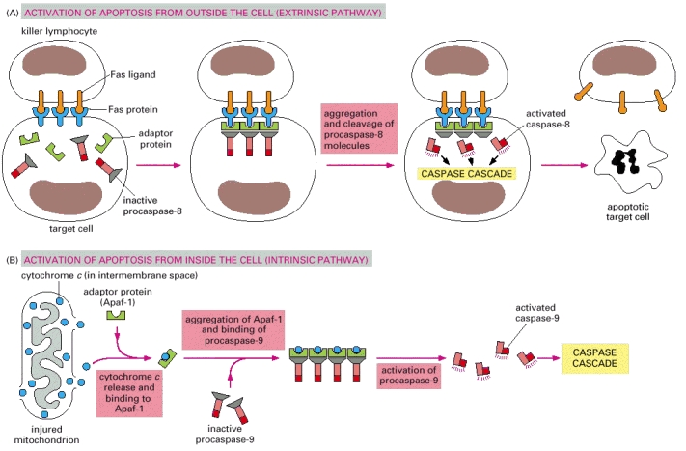
- Figure 17-39Induction of apoptosis by either extracellular or intracellular stimuli
- (A) Extracellular activation. A killer lymphocyte carrying the Fas ligand binds and activates Fas proteins on the surface of the target cell. Adaptor proteins bind to the intracellular region of aggregated Fas proteins, causing the aggregation of procaspase-8 molecules. These then cleave one another to initiate the caspase cascade. (B) Intracellular activation. Mitochondria release cytochrome c, which binds to and causes the aggregation of the adaptor protein Apaf-1. Apaf-1 binds and aggregates procaspase-9 molecules, which leads to the cleavage of these molecules and the triggering of a caspase cascade. Other proteins that contribute to apoptosis are also released from the mitochondrial intermembrane space (not shown).
- 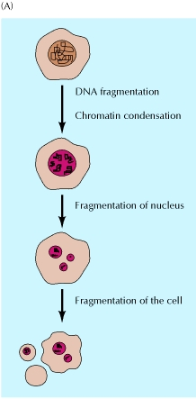

Topic 6
- Explain and give examples of cellular communication and the role it plays in cellular biology

- Define the 3 steps of cell communication
  - Messenger- who, where, how message is sent
  - Receptor- how message is received/ interpret leads to(transduction, relay, and amplify)activation of proteins leading to cascade of proteins
    - Maximum cellular response with minimal ligand
    - Ligand(messenger) binding will induce a change in confirmation of the receptor protein

  - Response- act upon the message

- Know and differentiate the 6 paths of communication between cells
Modes of communication
-private
-public
-inbtween
Signalling events
-theses depends on signal molecule travels, distance between signal and target cell

Endocrine
-public
-small localized endocrine cells
-secreted in the bloodstream
-broadcasting throughout the organism
-contact with every cell in the body
-signal molecules is called hormones
-these messages require the action of multiple types of target cells
-called endocrine signalling
Paracrine
-inbetween
-cell releases signal molecules to its environments
-diffuses locally to nearby cells
-doesn’t go to the blood stream
-only travel diffusion will allow
-only signalling neighbouring cells, called paracrine signalling
Autocrine
-inbetween
-paracrine signalling might affect it self
-a cell that send out the signal but also possess the receptor

Cell communication
-private
-direct contact with each other
-communicate by membrane interacting proteins
-not by secreting signalling

Neuronal signalling
-private
-can deliver message over long distance to a specific target cells in a short amount of time
-electrical signal to a chemical signal, the chemical molecules signals called neurotransmitters
-release directly to the target cell membrane

- Identify and differentiate the 6 messenger classes and their characteristics
  - Steroids-
    - Lipophilic, cannot be stored in vesicles
    - Membrane permeable- can reach intracellular receptors
    - Acts gene transcription factors
  - Lipids
  - Eicosanoids
    - most are derived from arachidonic acid( phospholipid broken down to eicosanoids)
    - it is in PIP/IP3 pathway
    - paracrine
    - two main classes
      - pain: Prostaglandins
      - inflammation: leukotrienes
  - Peptides / Proteins
    - Hydrophilic
    - Packaged in secretory vesicles
    - Enzymes are packaged with inactivate proteins in vesicles
  - Purines
    - Nitrogenous bases adenine or guanine
    - Need a transporter or can use exocytosis
    - Paracrine and endocrine
  - Amines
    - Amine NH2 group
    - Most are hydrophilic
    - Many neurotransmitters are amines
    - Epinephrine, histamine, GABA and Thyroid hormones (These are hydrophobic!
  - Gases
    - Small molecules, short half- life
    - Passively diffuse easy
    - Direct and indirect paths
    - NO, O2, CO etc.
    - Don’t need any specific receptors

- Know and recognize the 4 different classes of receptors
  - intracellular receptors
    - can be found in cytoplasm or in the nucleus
    - ligand-receptor complex acts as a transcription factor
      - in the nucleus, bind to specific areas of DNA (the gene promoter sequence)
      - activate Or inhibit gene transcription
      - LS 13-15
Transmembrane receptors
-integral proteins that span the membrane
-ligand binding domain outside the cell
- Domain- interact makes a particular shape for the ligand, also determines the affinity, tightly
-mostly hydrophilic
- Ligand binding induces a change in conformation that relays the message inside the cell second messengers
-the ligand itself never enters the cell

  - Ligand gated ion channels (many types)
    - very important for nervous system- used by neurotransmitters
    - ex Ach ligand-gated ion channels
      - can be excitatory or inhibitor(depending on receptor/ cascade)
      - both binding site needed to be filled, resulting to conformation change
      - causing a membrane potential and can lead to action potential
      - NEED TO REVIEW STEP
  - Enzyme receptors (3 main classes)
    - Acts as an enzymes
    - Initiates a cascade of phosphorylation-dephosphorylation that amplifies the ligand’s impact on target cell
      - Guanylate cyclase
      - Tyrosine kinase
      - Serine/Threonine kinase
Tyrosine kinase
    - Largest family of enzyme receptors
    - Involve in pathways to survival, growth, proliferation, metabolism
    - Second messenger RAS
    - use a lot in insulin and growth factor
    - NEED TO REVIEW STEP ras pathway and growth factor
  - G-protein coupled receptors (GPCRs; many types)
    - One ligand translates to multiple responses
    - cAMP pathway
    - PIP(IP3)
- Define what is cellular signalling and transduction
- Describe in detail an example of a signal transduction cascade starting from ligand binding to cellular response (ongoing objective for the course)

Recognize and describe the mechanisms (6) that terminate a cellular response
Ending a response
-ligand removed by distant tissues
- ligand taken up by adjacent cells
- ligand degraded by extracellular enzymes
-ligand receptor complex removed by endocytosis
-receptor in activation
-inactivation of signal transduction pathway
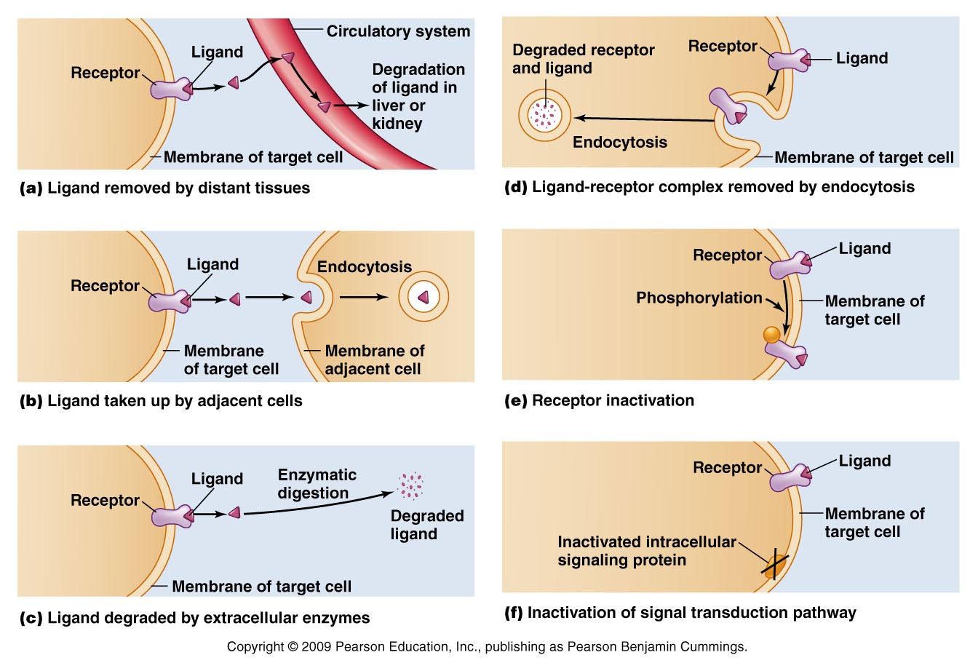
https://www.youtube.com/watch?v=pH_ibPHK0y0

-all organism need to detect signals and respond to avoid predators, mate, and acquire nutrients
-cell communication affect structure and function
-each cell posses many types of receptors and many copies of it, therefore detect certain molecules or ignore
How Cell communicates
-information is send between cells in form of molecules to target cells, and response to the appropriate manner
-most cells send and receive signals
-so most cells acts both signalling and targeting cells for different signals
Signalling molecules
-each different molecule serves as a different message
-proteins
-peptides
-amino acids
-

Receptor
-each molecule is recognize be a specific receptor and specific target cell
- turns the extracellular signal to a intracellular signal
-intracellular signal
-initiates activation or deactivation of certain proteins, leads to response
Response
-depends on signaling molecule, receptor, and intracellular events which all depend to cell types ex.
-gene expression
-metabolism
-cytoskeleton
-motility
-DNA synthesis
-survival, growth, differentiation
-programmed cell death

Three categories of receptors
-structure is directly related to their function
-
Ion coupled receptors
G proteins couples receptors
Enzyme couples receptors
-each type can be used in different types signalling
Ion coupled receptors
-regulate e flow of ions across the membrane
- different receptors regulate different ions
-varied in shape, but usually surrounded by subunits with a central channel
-all have transmembrane domain proteins
-the opening and closing is regulated by binding the specific signalling proteins
-are used by muscle cells and neurons
-its is driven by electrochemical gradient, can change the membrane potential in as quick as milliseconds
-can convert chemical signal to electrical signal the change in membrane potenitial

G proteins couples receptors(GPCRs)
-all structurally similar
composed
-of a single polypeptide chain
-extracellular ligand- bonding
-7 transmembrane alpha helixes
-intracellular G-protein-binding domain

-response to extracellular signalling activate heterotrimeric G-proteins, which then transmit the signal through a downstream signalling cascade.
-signalling cascade could eventually lead to the activation of an ion channel
Enzyme couples receptors
-most common are tyrosine kinases receptors(RTKs)
composed
-two polypeptide chains that dimerize only upon ligand-binding
-receptors of two polypeptide chains, each possessing an extracellular ligand binding domain
-single transmembrane apha helix
-intracellular tyrosine kinase domain

-kinase domain is initially inactive in each monomer. Binding of signalling molecule to each monomer causes a conformal change in the extracellular domain, allowing the extracellular domains to dimerize.
-naturally this brings together the intracellular kinase domains, resulting in their activation

Intracellular switches
-receptors acts as molecular switches, in activate or inactivated state

Two main types of switches use
ATP(on/of) switch
-phosphorylation/dephosphorylating
-phosphorylation- is the covalent attachment of a phosphate group from ATP to a specific residue on a target protein
-this is performed by kinases

RTK uses atp via intracellular kinase domains
- ATP molecule enters the active site of the kinases
- Kinase removes the third phosphate from the ATP
- The third phosphate covalently attaches into the target protein
-this alters the conformation of the protein leading to activation or deactivation, depending on the target protein
-kinase can phosphorylate one or multiple residues on the target protein
-phosphate can be removed by proteins called phosphatases, the level of the activity of the target protein is determined by the net effect of its specific kinases and phosphatases
specific kinases and phosphatases
-recognize their specific substrate with great accuracy
- from other kinases, ion channels, structural proteins , transcription factors
-50%transmembrane and cytoplasmic are phosphorylated at one or more sites
Kinases
-Serine/threonine kinases
- phosphorylate serine or threonine
-tyrosine kinases
- phosphorylate tyrosine
GTP- binding protein

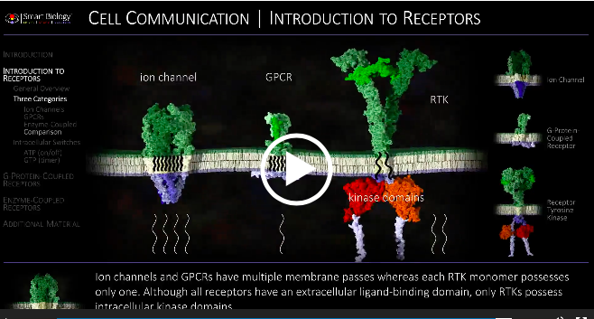

Topic 7
- Understand, describe and demonstrate the steps involved in transcribing DNA to mRNA
- Initiation
  - Within the promoter, some proteins and transcription factors bind to specific sequences and form the Transcription initiation complex 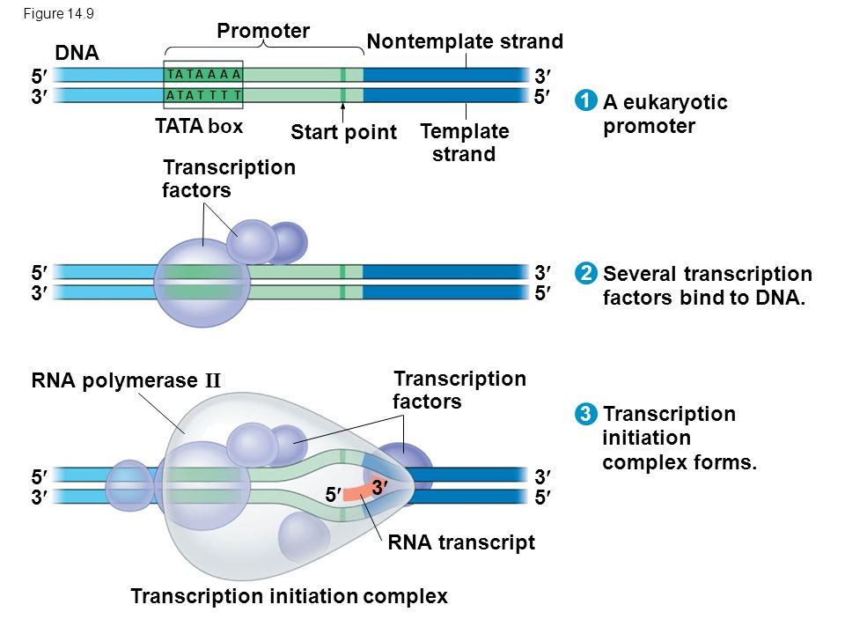

- Elongation
  - RNA pol II adds 20-60 nucleotides per second!
  - Contrary to DNA polymerase, it does not proofread or make corrections…
  - 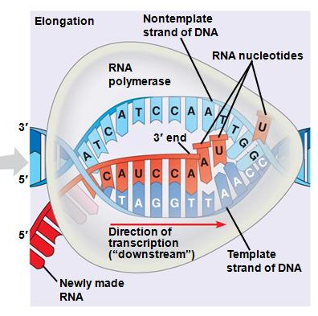
  - in prokaryotes only transcription and transcribing
  - transcription are very fast , causing a high chance of mistake so there are proteins that correct it
- Termination
  - Prokatyotes
    - Rho (ρ) dependant
      - ATP-dependant unwinding enzyme at 3’ end 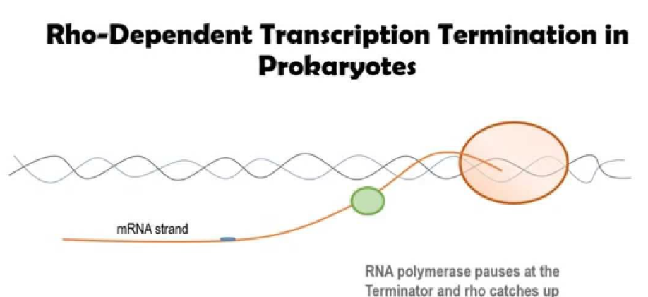
    - Rho independent (Intrinsic)
      - GC rich sequences at end
      - Hairpin loop which pulls RNA away from DNA 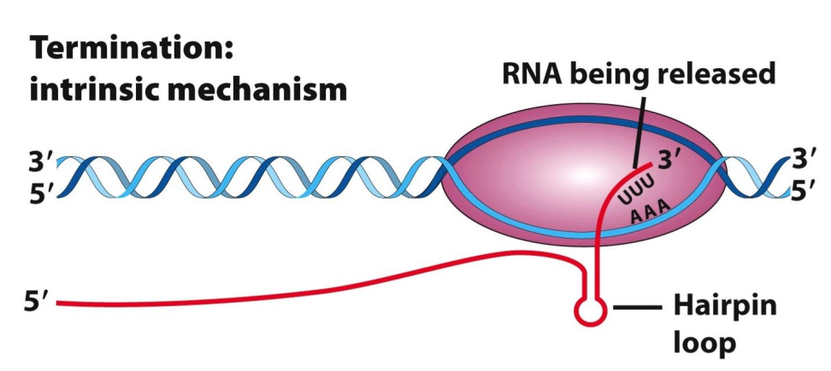

  - Eukaryotes
    - Specific sequences that differ depending on which RNA polymerase(have a sequence to end like terminating codon ?)terminator sequence, resulting to adding the poly a tail
    - For example, for mRNA, sequence of AAUAAA to which proteins bind, this triggers end of transcription (this is related to the polyA tail)
    - The main difference in prokaryotes its already mature ready for translation but in eukaryotes is not mature
      - 5’ cap and poly a tail- prevent from digestive enzyme
      - leaves the nucleus matured mRNA through the nuclear pore
        - having a poly a tail signals the pore so it can go through of not it cannot go through this regulated what goes in and out
- Be familiar with the elements comprised in a transcription initiation complex and its role
  - These help with the rate and duration of transcription of the gene
  - Prokaryotes
    - Sigma factor- bind to the promoter of the gene,
      - help place the RNA polymerase correctly,
        - stabilizes the RNA bound to DNA, making sure lined up properly so its starts transcription
  - Eukaryotes
    - 1st)TBP(TATA box Binding Protein) –binds to the TATA sequence on the DNA This position the helix for transcription
    - 2nd) Additional protein come and complete the Transcription Initiation Complex (these include transcription factors and regulatory elements)
      - this provides stability and allows RNApol II to come and start transcription
      - Activators- these proteins bind to genes called enhancer region,
        - This enhance the speed of the transcription
      - Repressors- these proteins to select sets of gene called silencer region
        - this slow down transcritption

- Explain and demonstrate RNA maturation and splicing
    - The main difference in prokaryotes its already mature ready for translation but in eukaryotes is not mature
      - 5’ cap and poly a tail- prevent from digestive enzyme
      - leaves the nucleus matured mRNA through the nuclear pore
        - having a poly a tail signals the pore so it can go through of not it cannot go through this regulated what goes in and out

  - Maturation –need more information
  - Spicing – splicosomes, snRNPs, small nuclear ribonucleic proteins
    - it recognizes the ends of introns and catalyse their cleavage
    - these removes the intron, excised the intron a loop, causing the exons ends to bind to gether having a continuous coding sequence
    - alternative splicing- results in a single gene coding for multiple proteins. In this process, particular exons of a gene may be included within or excluded from the final, processed messenger RNA (mRNA) produced from that gene.
    - Causing multiple isomers
    - The advantage is keeping the size of the gene manageable and have multiple RNA and proteins
    - 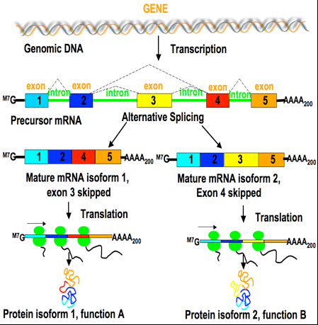

- Compare and contrast RNA transcription in prokaryotes vs eukaryotes

- Know, describe and/or compare the different elements of control for gene expression in prokaryotes vs eukaryotes
  - Activators, Repressors (enhancers, silencers)
  - Alternative splicing
  - Operons
Regulating of gene expression
Prokayotes
  - Regulation is achieved through Operons- genetic switches that transcription(on/of)
  - It is in between the promoter and the gene sequence called the operator
  - To control this there is a protein called Repressor it stops or let polymerase
    - Acts a sensor letting or stoping
    - The product is of transcription are mRNA that codes for several proteins
  - Lac operon- need to know the steps
  - Need to know operon in readings
Eukaryotes
- Activators and reprssors control which gene are ex[ressed and the rate at which transcription occurs
- Need to work more LS15
- A LOT!!! Cuz she spend a decent time on it

- Know the components and roles of a ribosome
Ribosome
  - Job is for protein synthesis
  - made by rRNA and 2 protein subunits
  - recruit tRNA, catalyse peptide-bond formation
  - are not assembled when they’re not transcribing

  - A site
    - Aminoacyl tRNA arrives with proper amino acid
  - P site
    - Peptide bond is formed
  - E site
    - Exit of empty tRNA

- Understand and demonstrate the different steps involved in translation
  - Initiation
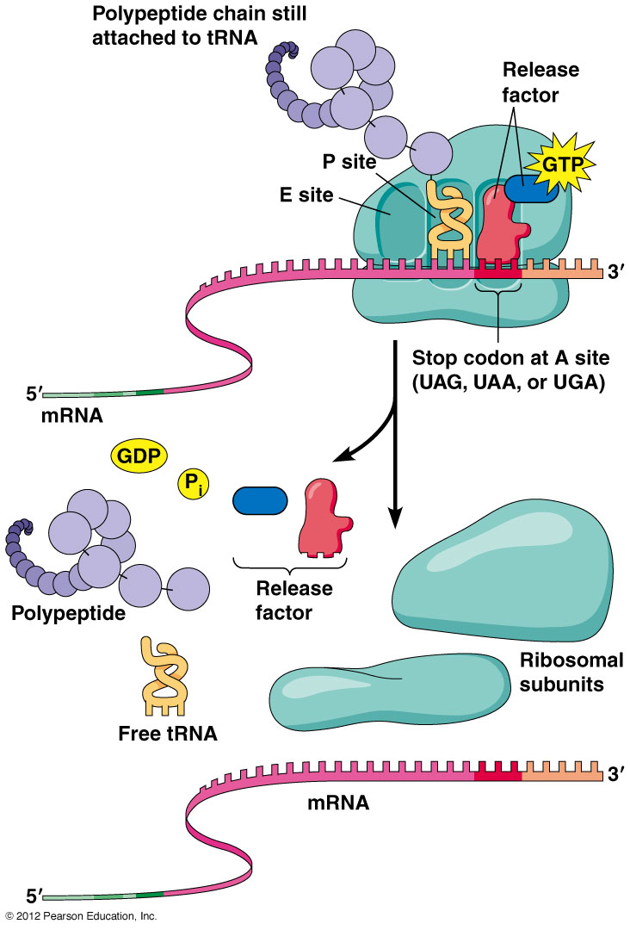
    - Met is the first amino acid and is the only one that goes straight to the P site
    - mRNA is recruited and large subunit then completes the ribosomes
    - Elongation
      - Elongation factors (EF)-proteins that help guide the tRNA to empty A site
    - Termination
      - Stop codon is reached, no tRNA with that anticodon
      - Release factor RF protein occupies the A site promoting last peptide bond
      - After translocation everything dissembled
      - Recycling components
    - Polysomes(polyribosomes)
      - An mRNA can be translated by more than one ribosomes at a time giving multiple polypeptides

- Using the codon table, be able to obtain the amino acid sequence corresponding to a given DNA strand (via mRNA)
- Define and explain, using an example, the different genetic point-mutations and possible mutagens
  - Missense mutation
    - Change in nucleotide sequence leads to change in amino acid
    - Altered amino acid
  - Nonsense mutation
    - Codon is change to a stop codon prematurely stop the polypeptide
  - Silent mutation
    - Codon is change to another but same amino acid
  - Frame shift
    - Deletion or insertion
- Discuss/Compare the possible scenarios for protein sorting following translation
- Relate vesicular transport to the cytoskeletal elements and motor proteins previously discussed

- Analyze a cascade of events from a messenger molecule to a nuclear response, including protein secretion

Topic 8
- Understand the structure and organisation of DNA (including nucleotides etc.)
  - About 2 m DNA
Organize it
    - -wrapping it around histones
    - -they form structures called nucleosomes
    - -size and space of nucleosomes are the same
    - -it can wrap again and again into compact
    - -it can unravel some or all
- Understand and demonstrate(how draw them) the steps involved in DNA replication
  - Replication happen before mitosis
  - the mechanism by which DNA is replicated(why?)
  - Meselson stahl experiment(explain with diagram what would happen if one of the three)
    - Semi conservative
    - Conservative
    - Dispersive

- Replication
  - Plasmid(prokaryotes)
    - Origin or replication – only replicated on a single point
  - Eukaryotes
    - Multiple origin
    - Multiple replication fork one DNA, not like ribosomes multiple proeteins
Replication
- Origin of replication
- Replication bubble
- Origin to the fork
  - Leading strand 5’ to 3’
  - Lagging strand 3’ to 5’( cant be towards the fork)
    - Has to be in segments
- Helicase-
- unwinds and separates double stranded DNA as it moves along the DNA.

- SSBs-attached to unraveled region to prevent reannealing of base pairs
- Topiosemerse-prevents supercoiling, relieve tension

- Primase-adds primer
- DNA polymerase III adds complementary free bases 5’ to 3’ direction
- DNA polymerase I takes off RNA primers, and replace appropriate base pairs
- DNA ligase adds the gaps of okazaki fragments
- I and III proof read and repair

Sliding clamp protein(don’t get last couple slides)
- 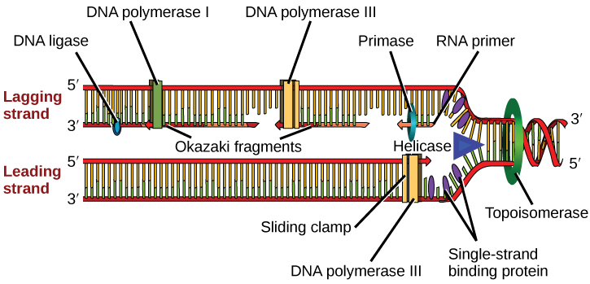
- Explain DNA protection and correction mechanisms

Proof reading
- DNA polymerase
  - Endonuclease activity –when there is a mismatched the shape does not fit (wide or narrow)
  - To correct the mismatch it need to take a couple base pairs in each side, leaving with a gap
  - It is filled with another polymerse, so it leaves with a nick so DNA ligase

Telomeres
- Repetitive coding with no coding, buffer , extension of dna, when replication dna is shortened every replication
- When you remove the last primer, there is not where DNA polymerase can attached
- To solve this adds more dna that does not code for anything
- Hayflick limit or Hayflick phenomenon is the number of times a normal human cell population will divide until cell division stops. Empirical evidence shows that the telomeres associated with each cell's DNA will get slightly shorter with each new cell division until they shorten to a critical length.

Telomeres polymerase
- Caries its own primer
- Extends the dna with non coding DNA
- Dna polymerase 3

Restriction enzymes
- Cuts DNA
- Blunt
- Sticky ends
  - Has a over hang, look for a specify region of dna

Polymerase chain reaction
Topic 10
- Describe and compare the role of the different phases of the cell cycle, including the various molecular checkpoints
- Explain how the cell cycle is regulated (internal and external signals)
- Understand and discuss the relationship between the cell cycle’s regulation and the cell’s mechanisms for survival vs death

