EC255 Midterm 1 Notes
Content: chapters 1-6, weeks 1-4, check the course outline for textbook sections and topics (note: chapter 3 - *skip* Chebyshev’s Theorem), PPT files within the weeks 1-4 folders in MyLS, WileyPlus quizzes 1-3

Chapter 1
Qualitative data: Name for a characteristic
Quantitative data: measure of quantity (either discrete or continuous)
Nominal Level: Name or label a series of values (Eye colour = Red, Married = no)
Ordinal Level: Values that convey <, = and >, relative ranks of elements (e.g. a>b, a<b, rating 1-4)
Interval Level: Value convey how much more/less than one another (difference in temperature)
Ratio Level: values can take on natural or absolute zero (How much A/B? accounts payable)
Discrete Ratio: whole number
Continuous: decimal numbers (Ratio is absolute value, Interval can be +/-)

Population: Collection of all possible elements of interest
Census: Collection of values that correspond to all elements of a population (denoted: N)
Parameter: Summary measure used to describe values of a variable for entire population
Sample: Collection of subset of population (denoted: n)
Statistic: Estimate of parameter based on a sample

Descriptive Statistics: Graphical numerical methods used to summarize characteristics of population/sample
Inferential Statistics: Using data through sampling to estimate value or test a hypothesis about parameter

Chapter 2
Ungrouped: raw data, not summarized
Grouped: Organized into freq. distribution, organized into histogram
Frequency Distributions: List or table. Group data into classes (often between 5-20)
Histograms: Class shown on horizontal axis, Frequency on vertical axis (bar graph)

Chapter 3
Mean: $\frac{Σx}{N}$
Median: Middle value of ordered numbers (if even, take 2 middle terms and average it)
Mode: Most freq. value (may have 0 or several)
Reminder – Population uses µ (mean) and N (numbers). Sample uses x̄ (mean) and n (numbers).
Range: x_{max} - x_{min} (not commonly used)

Mean Absolute Deviation: $\frac{∑\left|x-μ\right|}{N}$ , x is your observation value, µ is mean, N is total observations
Population Variance: avg of square of deviations from the mean
$σ^{2}=\frac{∑{\left(x-u\right)}^{2}}{N}$ $σ^{2}=\frac{Σx^{2}-\frac{{\left(∑x\right)}^{2}}{N}}{N}$
Standard Deviation: Square root of population variance, $σ=\sqrt{σ^{2}}$
Sample Population Variance:
$s^{2}=\frac{∑x^{2}-\frac{{\left(Σx\right)}^{2}}{n}}{n-1}$ $s^{2}=\frac{∑{\left(x-\overline{x}\right)}^{2}}{n-1}$
Sample Standard Deviation: $s=\sqrt{s^{2}}$
68% observations fall within 1 stdev of the mean
95% observations fall within 2 stdev of the mean
99.7% observations fall within 3 stdev of the mean
z-score: Observation that number’s deviation from the mean expressed in term of standard deviations
$$z=\frac{x-\overline{x}}{s}$$
Coefficient of Variation: Useful for comparing variables measured in different units or different means
$$CV=100⋅\frac{σ}{μ} cv=100⋅\frac{s}{\overline{x}}$$

Chapter 4a
Probability of event A must lie between 0 to 1: $0≤P\left(A\right)≤1$
Classical Method: based on rules and laws, games of chance. E.g. rolling a die, the experiment has n possible equally-likely outcomes. E.g. if company has 200 workers and 70 are female, there is a 70/200 = 0.35 chance of randomly selecting a female.
Relative Frequency Method: Based on experimentation or historical data
Subjective probability: comes from persons intuition or reasoning.
Complement of event: elementary events are not in event E are in is complement event E’. $P\left(E^{'}\right)=1-P(E)$, $P\left(E\right)+P\left(E^{'}\right)=1$
Union of events: Event that contains all outcomes that are in A or B or both $P\left(A∪B\right)$
Intersection of events: Outcomes that are both in A and B
Mutually Exclusive Events: No common outcomes
Independent Events: Occurrence of one event does not affect the other event (coin flip)
Dependent Events: Occurrence of one affects the occurrence or non-occurrence of the other (E1 = rain forecasted, E2 = take umbrella to work. Probability of second event is affected by first event)

Chapter 4b
General Law of Addition: states that probability of union of two events A and B is
$$P\left(A∪B\right)=P\left(A\right)+P\left(B\right)-P\left(A∩B\right)$$
Special Law of Addition: Involves two mutually exclusive events, remove the intersection
$$P\left(A∪B\right)=P\left(A\right)+P\left(B\right)$$
Conditional Probability: Probability where one event is affected from the other
$$P\left(E_{1} | E_{2}\right)=\frac{P(E_{1}∩E_{2})}{P(E_{2})}$$
Law of Multiplication: for events E1 and E2
$P\left(E_{1}∩E_{2}\right)=P\left(E_{1}\right)P(E_{2}|E_{1}$)
Bayes’ Rule:
Prior Probabilities New information Application of Bayes’ Rule Revised Probabilities
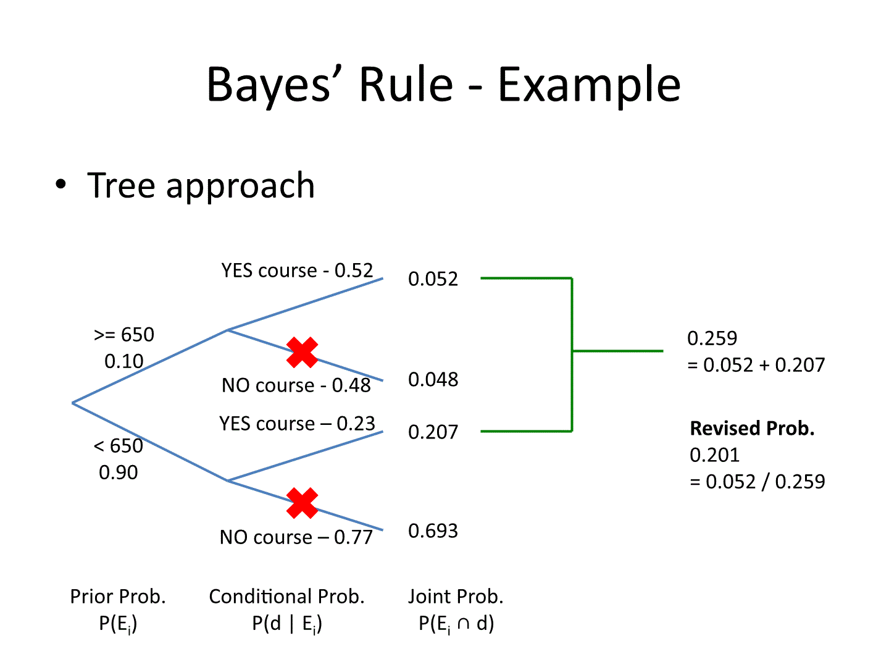
Chapter 5
Random variable: variable which contains outcomes of a chance
Discrete random variable: set of all possible values is finite or countably infinite number of possible values (# of absent employees on a day, new magazine subscribers)
Continuous random variable: takes on values at every point over given interval (weight of person)
Discrete probability distributions: Binomial or Poisson
Continuous probability distributions: Uniform, Exponential, Normal
Mean of a Discrete Distribution: $E\left(X\right)=\sum_{i=1}^{N}{[x_{i}∙P\left(x_{i}\right)]}$ (Variance, expected value)
Standard Deviation of a Discrete Distribution: $σ^{2}=\sum_{i=1}^{N}{\left[{\left(x_{i}-μ\right)}^{2}\right]}⋅P\left(x_{i}\right)$
Binomial Distribution: Involves n identical trials. Only two outcomes. Each trial is independent of previous trials. p is probability of success, q = (1-p) is probability of failure. p and q are constant throughout experiment. x is number of successes in the n trials/sample size.
- $Mean=μ=n⋅p$ $Variance= σ^{2}=n⋅p⋅q$
P(x<=2) = P(0)+P(1)+P(2) P(x>=2)=1-P(x<=2)
Uniform Distribution: Equal probabilities for all possible outcomes of the random variable
$$P\left(x\right)=\frac{x_{2}-x_{1}}{b-a}$$
Where b represents max, a represents min. x2 and x1 represent the interval you’re looking to find the probability for.
Uniform Standard Deviation: $σ=\frac{b-a}{\sqrt{12}}$
Poisson Distributions: describes the values that a random variable can take and their respective probability. Number of successes that occur in an interval e.g. What is probability of getting 10 customers in an 8-minute interval (use for x), lambda is the original data.
$$λ=3.2 customers/4 minutes$$
$$x=10 customers/8 minutes$$
Need to correct to 8 minutes!
$$λ=6.4 customers/8 mintues$$

$$P\left(x\right)= \frac{λ^{x}e^{-λ}}{x!}$$

Normal Distribution: Distribution of bell shape.
Example: Random variable is normally distributed with µ = 494 and σ = 100; Find P(x <= 550)
Step 1: Find z score: $z= \frac{x-μ}{σ}; \frac{550-494}{100}=0.56$
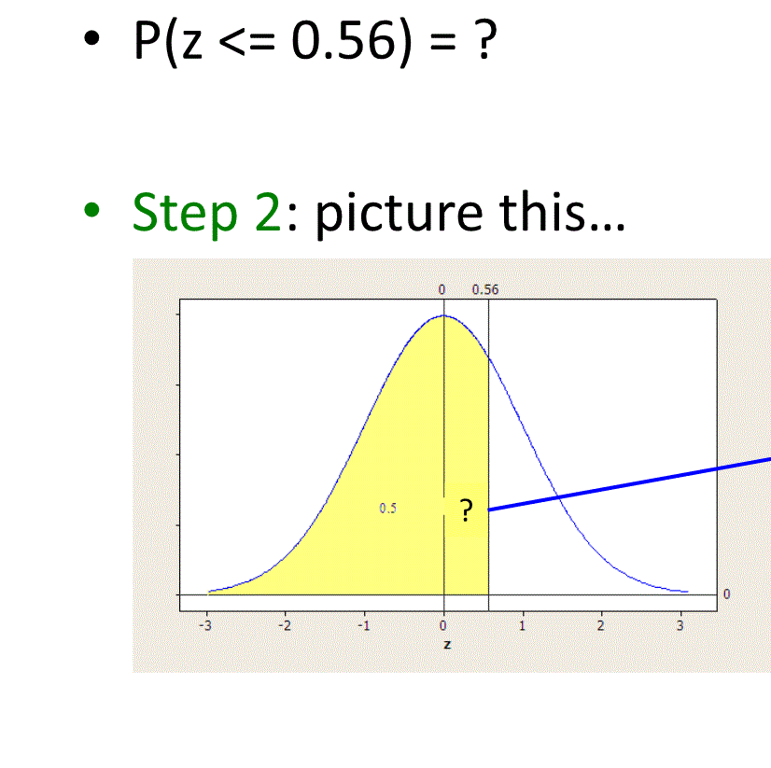
P(z <= 0.56) = 0.5 + z-score from table (Vertical look to 0.5, then look at 0.06 on horizontal)
= 0.5+ 0.2123 = 0.7123

*Other examples are similar, just visualize the distribution graph to know when to add/subtract correct*

