Experiment 4
Stereochemical Analysis
of the Reduction of Benzil
March 7, 2017

Introduction
Mechanism for reduction with NaBH4
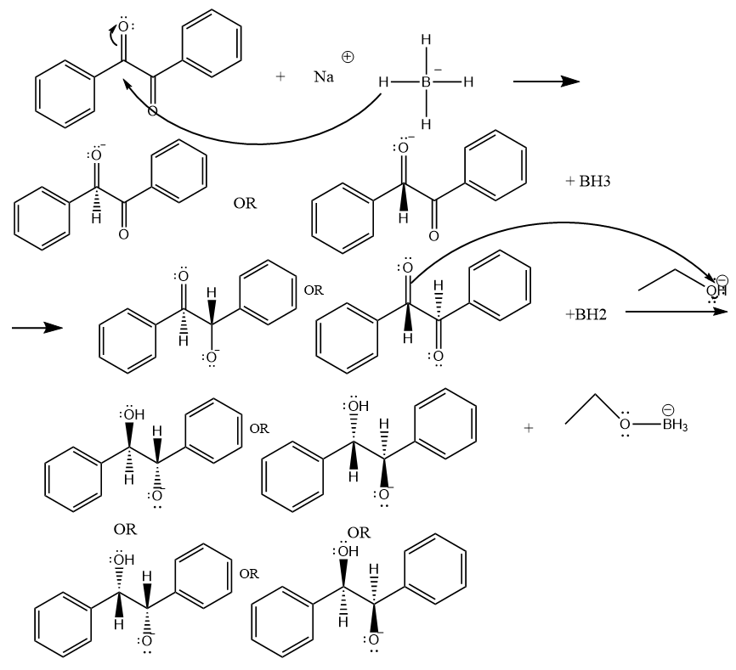
The hydrogen from NaBH4 is added one at a time during the reaction.
The diastereomer is present in different forms since there is an equal probability that the hydrogen from the NaBH4 to approach from the top of the bottom face. The two compounds that are anti, are the same so they represent a meso compound, having the same Rf values.

General Equation for Acetallization
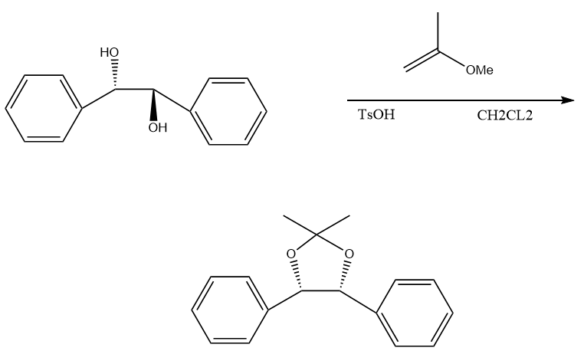
Purified from recrystallization, from benzil, a derivative of acetonide is produced. The melting point is approx. 95 °C and the boiling point is approximately 346 °C.
Procedure
- Refer to lab manual pages 40-41
Observations
- benzil is very yellow
- ethanol transparent
- colour gradually diminishing when mixing ethanol, benzil and sodium borohydride
- after removing from the ice bath and stirring, the yellow disappears and a lot of froth happens
- on step 9, water was added and it caused the mixture to become totally transparent
- adding the chemicals in step 14 caused the solution to go an orange brown.
- Let mixture cool to 33 degrees Celsius instead of to room temperature.
Table of Reagents
Reduction of NaBH4
Reagent | Amount (g or ml) | Molecular weight (g/mole) | # Mole | Density (g/ml)
Benzil | 1.00g | 210.232 | 0.0048 | --
NaBH4 | 0.400g | 37.83 | 0.0106
Ethanol | 10.0ml | ------------------------ | ------------------------

Acetallization
Reagent | Amount (g or ml) | Molecular weight (g/mole) | # Mole | Density (g/ml)
Diphenyl Acetonide | Was not calculated, 0.6g of diol added | *could not be found*

TLCs
TLC 1
Legend:
Reference- benzil in dichloromethane
Co-spot- benzil in dichloromethane and benzil in ethanol
Sample- benzil in ethanol

Solvent Front: 4.7cm
To TLC’s- Reference- 1.9cm Sample- 0

TLC 2
Legend:
Reference- Dichloromethane
Co-spot- Dichloromethane and acetone and diol product
Sample- Acetone and Diol product

Solvent Front:4.9cm
To TLC’s-Reference-1.9cm Sample- 0

TLC 3
Legend:
Reference- Diol Product
Co-spot- Diol product and
Sample- CH2Cl2 and rest of mixture

Solvent Front: 4.8cm
To TLC’s-Reference-0cm Sample-2.3cm

TLC 4
Legend:
Reference- cyn acetonide
Co-spot- cyn acetonide and reaction mixture
Sample- reaction mixture

Solvent Front: 4.5cm
To TLC’s-2.6cm

TLC 5
Legend:
Reference- anti acetonide
Co-spot- anti acetonide and reaction mixture
Sample- Reaction mixture

Solvent Front: 4.9cm
To TLC’s- Sample -2.5cm Reference-3.2cm

Table 1: Rf Values
TLC | R_{f} Value
TLC 1 | Reference- 0.4043
 | Sample-0
TLC 2 | Reference-0.387
 | Sample-0
TLC 3 | Reference-0
 | Sample-0.479
TLC 4 | 0.577
TLC 5 | 0.510

Table of Results
Reduction of NaBH4
Reagent | Amount (g or ml) | Molecular weight (g/mole) | # Mole | % Yield
Benzoine | 1.09 | 212.24 | 0.00513 | 107&

Calculations
Percent Yield
Yield percent= (#mol of B/ # mol of A)*100
Mole A: 0.0048mol Mole B: 0.00513mol
Percent Yield=0.00513/0.0048*100
=106.88%
Discussion
In this experiment, the reduction of benzyl then the acetallization was played out. The reduction was done by the addition of borohydride in a solution. This results in the transfer of a hydride from the borohydride to the carbonyl group then a nucleophilic of the hydride ion forming an alcohol on either oxygen. Sodium borohydride was used because it is a good nucleophile and a reducing agent so it can act as both. It can also reduce 4 functional groups. The purpose for the reduction transform substances to a different form.
In this reduction, there was a stereochemistry factory to it. The hydrogen from the NaBH4 can either bond from the top of bottom face, making 2 different shaped compounds as shown above in the introduction. This gives 4 different projections of the substance. But once flipped, the anti is most common in the solution since there is less repulsion and once the acetallization happens, it yields a cyn conformer which is the most stable form.
Acetallization occurred in order to block the polarity of the substance. Before acetallization, the different conformers have a very similar Rf value since they are all so polar. Thus blocking the oxygens by making a chiral group, it makes the conformation very different and affects it polarity, changing the Rf.
After acetallization, recrystallization was preformed. This purifies organic compounds using substances with different hot and cold solubility. It is done by heating a solution, letting the substance fully dissolve, then letting the solution cool, which is a less soluble state for the compound and precipitates out. To get the crystals formed, suction filtration was used to remove the solution and leave the precipitate.
It was determined that the product was cyn. This was determined through the TLC, ignoring the prominent TLC dots, the cyn TLC dots all lined up. This could have also been predicted because while the polar form is protected, the cyn is more prominent in the solution since it is easier for the structure to be cyn since there are less interactions from the phenyl groups. While if they were anti, the phenyls can not line up causing interactions between the functional groups.
While measuring the diol product, more product was created than what was added. This gives a percent yield of over one hundred percent. This could possibly be because the product precipitated around the impurities in the solution, giving it a heavier precipitate. To avoid this, if enough time was given to let the solution fully cool, it could have become purer. Also another way to improve the result was to do another round of recrystallization and filter the hot solvent to get rid of more impurities. Another source of error was that some of the crystals sticks to the thermometer, thus altering the mass. Overall, the lab was a success, giving a large amount of diol product. Therefore, this lab states true to the manual.

Questions
- You are given a mixture containing two compounds, A and B. Both compounds have a solubility of 1 g/ 100 mL of solvent at 20 °C and 16 g/ 100 mL of solvent at 100 °C. The sample is composed of 3.5 g of A and 10 g of B. At 100 °C the entire sample just dissolves in a minimum amount of solvent. The solution is cooled to 20 °C and crystals are collected. Calculate the composition of the crystals and the yield of the process. What is the composition of the mother liquor? (Hint: find the minimum amount of solvent needed to dissolve the component that is present in excess; that should be enough to also dissolve the other component).

10g/X=16g/100mL Y/62.5mL=1g/100mL
X=62.5mL Y=0.625g

Mass B:10g-0.625g=9.375g
Mass A:3.5g-0.625g=2.875g
Total=12.25g

Percent Composition A: 2.875/12.25*100=23.5%
Percent Composition B: 9.375/ 12.25*100=76.5%
12.25g/13.5g*100= 90.7%
Composition of Mother liquor is the liquid that remains after filtration, thus the mother liquor is 62.5mL
- If the crystals obtained in question (1) are recrystallized from 100 mL of solvent, what will be the yield and composition of the crystals obtained?
X/100mL=1g=100mL
X=1g

It will also be 1g at 20 degrees.

Mass B:9.375g-1g=8.375g
Mass A:2.875g-1g=1.875g
Total=8.375g+1.875g
= 10.25g

Percent Composition A: 1.875/1*100=18.3%
Percent Composition B: 9.375/ 1*100=81.7%

Total percent composition: 10.25/12.25*100=83.7%

3. A student dissolves 80 mg of a crude product in 4.5 mL (the minimum required) of methanol at 25 °C. She cools the solution in an ice bath and obtains crystals. The crystals are recovered by filtration and rinsed with 0.5 mL of ice-cold methanol. After drying, the weight of the crystals is 5 mg. Why was the recovery so poor? What could she do to improve the process?

- The point of recrystallization is to dissolve an impure material into a hot solvent and then it is crystallized once the solvent cools. The boiling point of methanol is 65 degrees, which the student heated it to nowhere near its boiling point. This didn’t let the product dissolve the impurity, if the student heated the solution more, the recovery would have been less poor. Also part of the crystal formation is to let the solution then cool slowly since it produces impure material. The student rapidly cooled it by putting it in an ice bath, not letting the crystals form at their own pace. So the other improvement could be for the student to wait for the hot solution to cool naturally by just waiting.

4. When butanoic acid reacts with sodium borohydride, 1-butanol is not obtained. However, bubbling is still observed and heat is produced.
a. Why is 1-butanol not obtained?
b. What is the product of this reaction?

- 1-butanol is not obtained because sodium borohydride was not an ideal reducer. It is too basic of a substance and not a strong enough reducing agent to remove the double bonded O. This substance actually caused the butanoic acid to remove a hydrogen from the alcohol.
- The product of this reaction is dehydro-2-butanone.

5. Predict the configurations of each stereo centre in the product of the following and provide a justification for your choice.

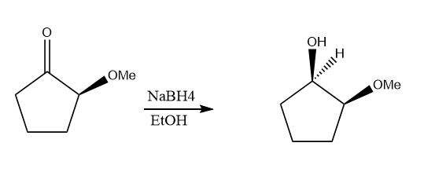
- The hydrogen would come from behind to push the now alcohol to the front. This is because the ether functional group is at the front so it is blocking the way from the hydrogen to enter from the front.

