Chapter 2: Cost Terms, Concepts, and Classifications
Indirect = MOH
MOH+DL=Conversion Cost
DL+DM= Prime Cost
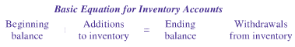
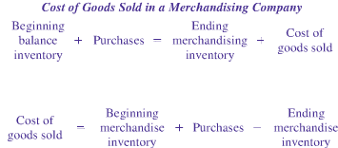
COGS in a manufacturing company
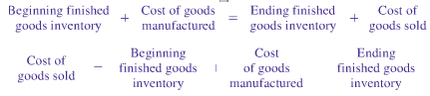
Product Cost Flow
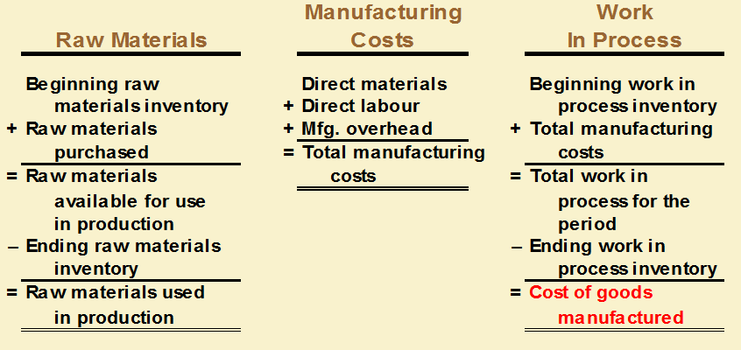
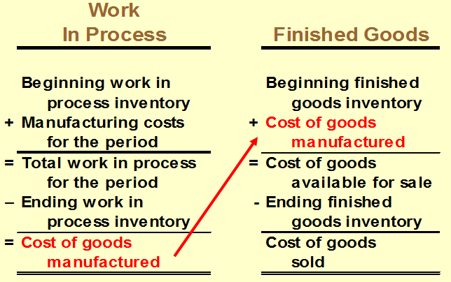

Chapter 3: Systems Design: Job-Order Costing
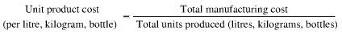
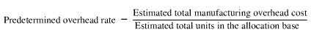
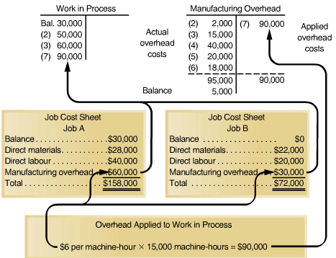
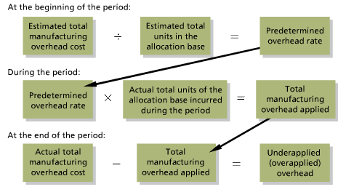
3 Methods: Close out to COGS, Allocate among amounts, or carry balance forward
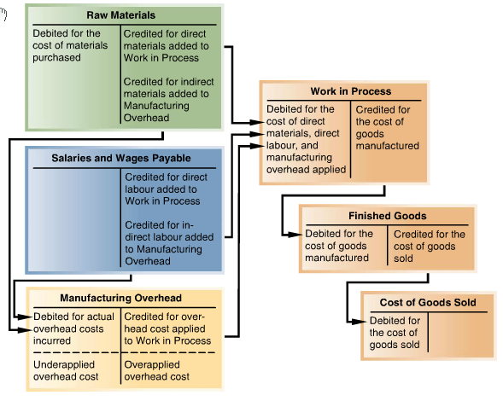
Chapter 4: Systems Design: Process Costing
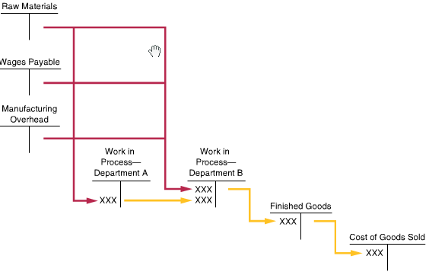
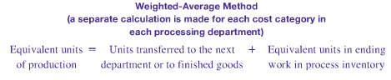
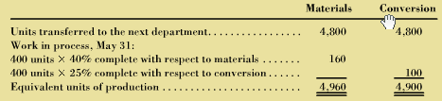
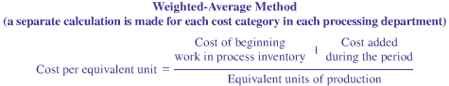
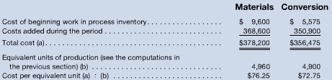
Applying costs-WA method
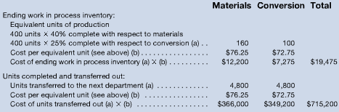
Cost Allocations:
Direct Method:
Under the direct method, any of the allocation base attributable to the service departments themselves is ignored; only the amount of the allocation base attributable to the operating departments is used in the allocation.
Step down method:
in both the direct and step down methods, any amount of the allocation base attributable to the service department whose cost is being allocated is always ignored. In the step down method, any amount of the allocation base that is attributable to a service department whose cost has already been allocated is ignored.
Reciprocal Method:
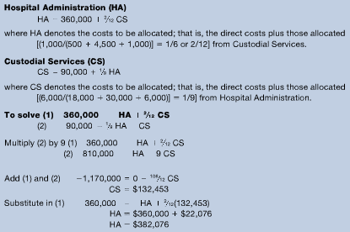
Chapter 5: Activity-Based Costing: A Tool to aid decision making
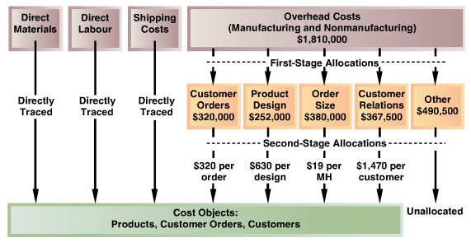
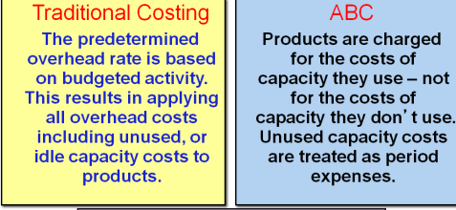
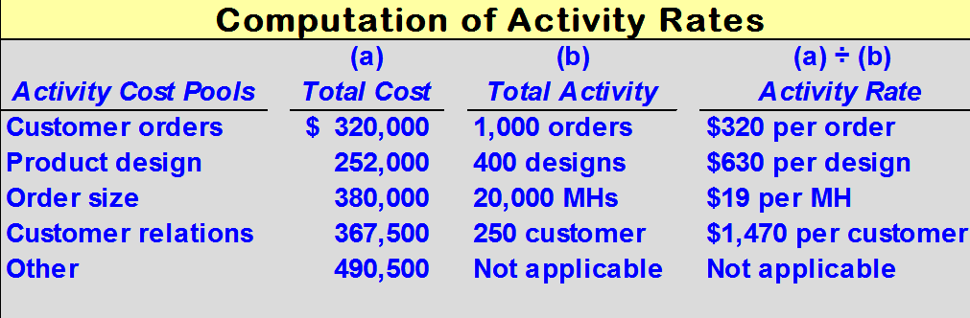
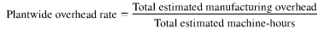
Chapter 6: Cost Behaviour Analysis and Use
Committed Fixed Costs: investment in facilities, equipment etc. That cannot be significantly reduced, even for short periods of time.
Discretionary Fixed Costs: costs that arise from annual decisions by management to spend in certain areas, such as advertising and research.
Mixed Costs:
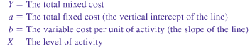
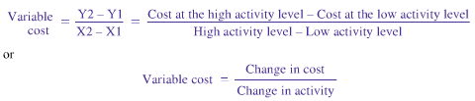
Least Squares Regression
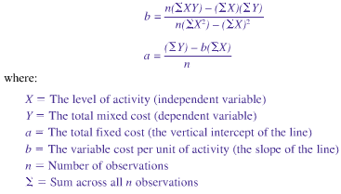
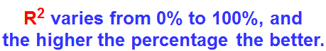
Chapter 7: CVP analysis
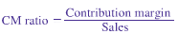
Bulk sale

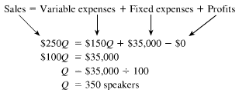
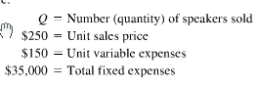

In terms of B/E dollars
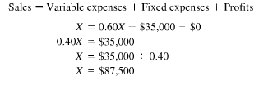
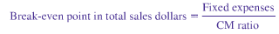
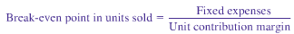
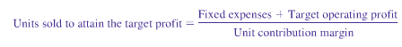
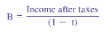

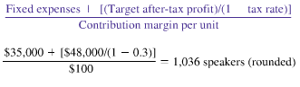
Margin of Safety
sales = %of MoS = x – B/E in dollars
X
Where x = sales
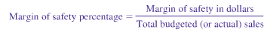
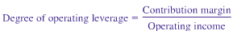
Operating leverage x % increase in sales = %increase in Operating Income

Indifference analysis

