UOttawa’s Gee Gee’s Sport and Health Drinks
Stephen Marchewka
TA: Chris
CHM 1311

Introduction

Standard enthalpy of formation of any substance, is defined as the amount of heat absorbed and change in enthalpy at standard conditions of 25 Degrees Celsius, and pressure of 1 bar, when 1 mole of a compound is formed from its initial reactants in standard states. The equation for this definition is:
$Δ^{H}reaction=\sum{}Δh_{f}(products)-\sum{}ΔH_{f}(Reactants)$
When heat is released from these reactions, the reaction is considered to be exothermic, and when heat is being absorbed, the reaction is considered to be endothermic.

What was used in this experiment was something called a “coffee cup calorimeter”. This device was used to measure the quantity of thermal energy that was being lost in the experiment. It consisted of a large styrofoam cup with a smaller aluminum pop can inside, sealed off with a styrofoam lid on top, and a thermometer through the top of the lid to measure the temperature inside.

Specific Heat Capacity

The specific heat capacity of an object is the amount of heat required to raise the temperature of one gram of a substance by one degree. This can be used to measure the thermal energy initially in the substance. The specific heat capacity of a substance also does not change due to change in variables such as volume and mass. However the heat capacity of a substance such as a large body of water, does change due to volume and mass. The equation used to determine the energy required to change the temperature of a substance is:
$q=m×c×ΔT$
Where c equals the specific heat capacity of the substance, m equals the mass of the substance, and T equals the change in temperature of the substance.

Enthalpy of Solution

Depending on the lattice energy of a salt, and the hydration energy, the dissolution of a salt can either be exothermic or endothermic. Lattice energy occurs during enthalpy change when 1 mole of an ionic solid dissociates completely into a gaseous ion, which is endothermic. And hydration energy is the energy is the energy released when one mole of a gas ion dissociates in a solvent, which is exothermic. What we gain from these two quantities is the enthalpy of solution, which can be measured by
$Δ{}_{s}^{}H^{∘}=(-heast loss of H_{2}O) + (-heat loss of salt)$
And another way to calculate the enthalpy of solution is:
$Δ_{s}H^{∘}=\frac{-(m_{solution})(c_{solution})(Δ_{solution}T)}{n_{salt}}$
Where c is the specific heat capacity, m is the mass, $Δ$T is the change in temperature, and n is the amount in mol.

For the lab, 2 options of chemicals were presented to choose from. The first being ammonium chloride ($NH_{4}Cl)$, with a solubility of 37.2g/100g of water, at a price of $62.40/500g. The second option was ammonium nitrate($NH_{4}NO_{3})$, which has a solubility of 192g/100g of water, priced at $64.62/500g. Initially looking at these two options, in terms of cost of the product, the obvious winner was ammonium chloride, since our product was going to need a lot of supply of either chemical. However in terms of solubility, more than 5 times the amount of ammonium nitrate is able to be dissolved in 100g of water than ammonium chloride, therefore making the slightly more expensive price of the chemical negligible. In spite of this very big and important factor, the lab assignment left a very important clue that revealed what chemical was supposed to be chosen. The text read “Please include with your final product design an explanation of which chemical you decided most suitable and why, including careful consideration of the Health and Safety implications of your chosen design.” After very extensive, it was discovered that ammonium nitrate is a component of explosive mixtures used in mining and civil construction. Which means that our product could not consist of explosive materials for obvious reasons. Therefore after all these factors were taken into consideration, ammonium chloride was chosen as the chemical to use.

Procedure

- First the chemical needed to be chosen, and as stated, ammonium chloride was the chemical chosen to use.
- Next the number of moles needed to decrease the temperature of the water by 5 degrees Celsius needed to be found. Therefore with the amount of moles needed, it was possible to calculate how much of the ammonium chloride we needed. The amount of ammonium chloride collected was calculated with a scale.
- After this was found the calorimeter had to be prepared. This was done by filling an aluminum pop can up with 100ml of water, and placing inside a larger styrofoam cup with a lid on top. Through the top of the lid there was a hole that allowed the thermometer to poke through and measure the temperature of the water.
- Next the minimum amount of water needed to dissolve the amount of ammonium chloride needed to be found. This amount of water was added on the outside of the aluminum can inside the styrofoam cup.
- After all variables were found, the ammonium chloride was added and stirred into the water on the outside of the can, the lid was placed and data collection started.
- Steps 1-5 were repeating using trial and error until the temperature of the water decreased by 5 degrees within 5 minutes.

Observations/data/results:

While weighing the ammonium chloride, it was difficult to collect the exact amount of grams needed for the experiment. Also it was difficult to quickly close the lid on the styrofoam cup and add the thermometer to the lid, right after the chemical was added and mixed with the water.

Trial #1:
- 100ml of water outside of can. 15.2g ammonium chloride
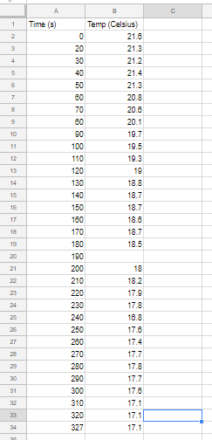
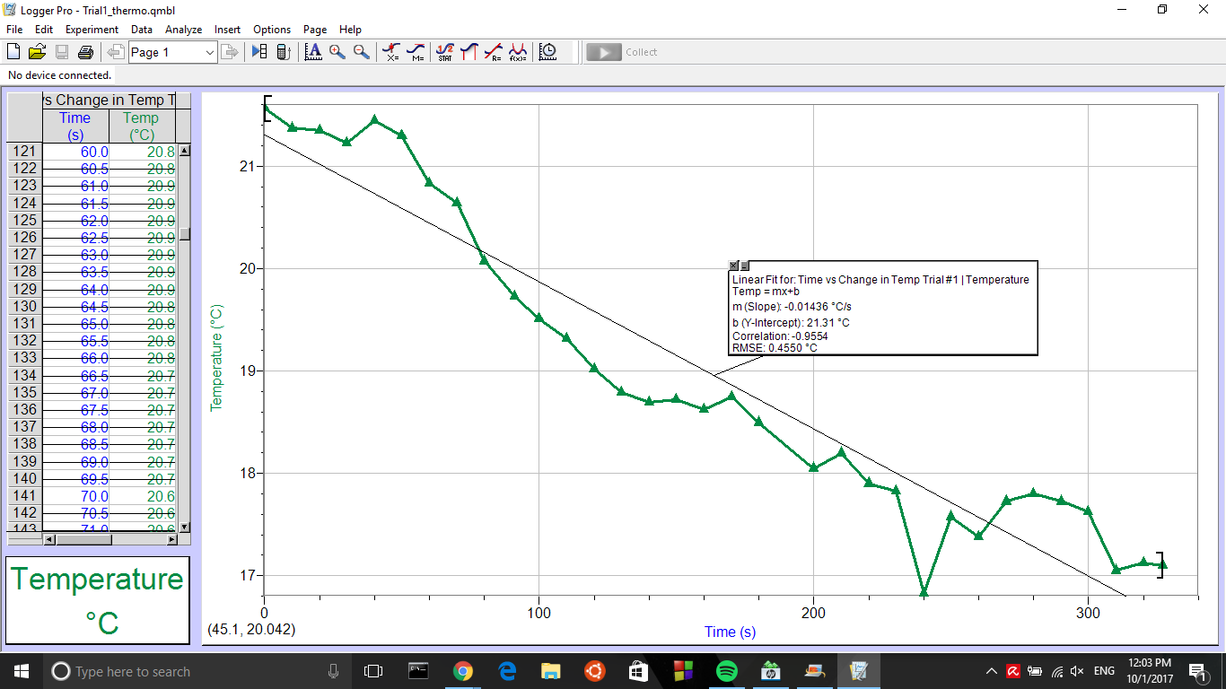
- 4.5 degrees Celsius temperature drop in 5 minutes
Trial #2:
- 100ml of water outside can. 15.2g of ammonium chloride
- 4.4 degree temperature drop in 5 minutes

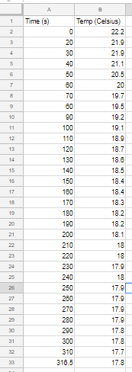
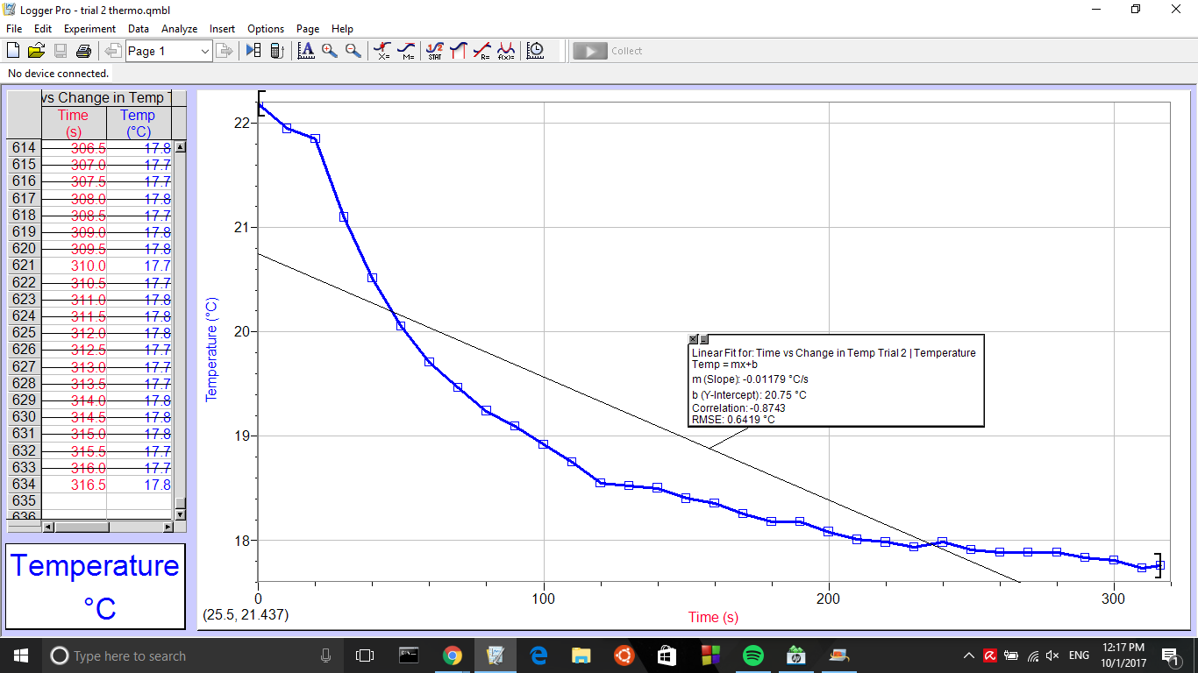

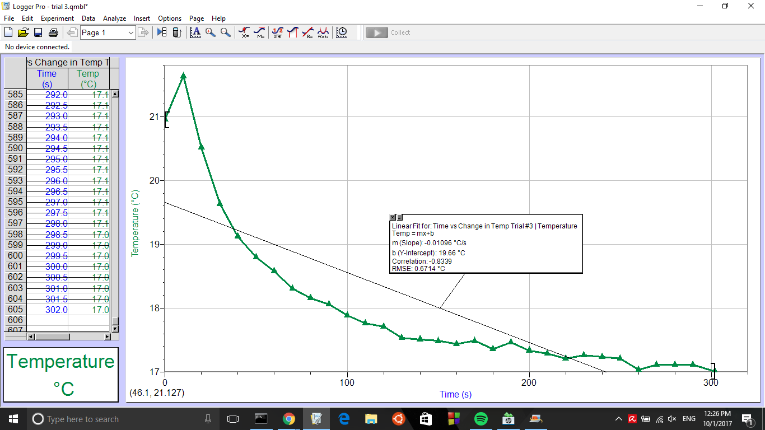
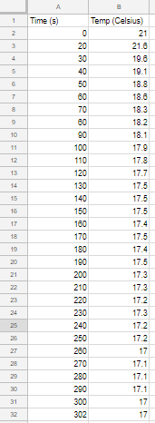

Trial #3:
- 100ml of water outside can. 17.01g ammonium chloride
- 4 degree temperature drop in 5 minutes
Calculations

- $H{}_{2}O: q=100g×4.18×\left(-5\right)= -2090J$ (heat capacity of water is 4.18)
- $Can: q=7.87g×0.9×\left(-5\right)= -35.4J$ (heat capacity of aluminum is 0.9)
- $-2090J-35.4J= -2125.4J$ =$2.1 kJ$
- $\frac{q}{ΔsH{}^{∘}}=\frac{2.1}{14.78}=0.142mol$
- $m=nM=(0.142mol)(53.8g/mol)=7.6g$
- $(7.6g/37.2)×100=20.43mL$

Discussion

Before starting the lab, the expected result were that the water inside the can was going to decrease temperature at increasingly faster rates as more ammonium chloride was added to the mixture. However much to the groups disbelief, as more ammonium chloride was added to the mixture, the water’s temperature did not fall as much in 5 minutes as the water with less ammonium chloride did. Both times when 15.2 grams of ammonium chloride was added to the mixture, the temperature dropped roughly 4.4 degrees celsius in 5 minutes. But when the amount of salt was increased to 17.2 grams, the temperature of the water only decreased 4 degrees celsius in 5 minutes.

Much of these odd results are due to errors in the lab. Errors can either be due to lack of attention to detail while performing the lab, or sometimes due to faulty equipment or materials provided in the lab. The first error observed in the lab was the loss of heat to the surroundings due to the homemade calorimeter used. Obviously our calorimeter system was not perfect, and in result the system lost heat due to the design. The lid on top of the styrofoam cup was not completely sealed on top, and the thermometer also did not completely seal the opening in the lid, which both would have resulted in heat and temperature loss.

Another error observed during the lab was the inability to simultaneously mix the salt in with the water, while recording the temperature of the water drop. During the time that the salt was being mixed, and trying to put the lid on, drop the thermometer in, and start the recording, the water could have dropped fractions of a degree celsius and this could have added to our temperature loss that we were not able to achieve in 5 minutes. Instead of the calorimeter having to open from the top of the lid where the thermometer is placed, maybe the styrofoam could have some kind of capsule at the bottom of the cup where you can pour the mixture in and slide it back into the cup. This way the thermometer would already be in place, and the recording could already be started.

Conclusion

After data was collected and calculations were made, the mixtures used were not able to drop the temperature by 5 degrees in 5 minutes. The hypothesis made at the beginning of the lab turned out to be inaccurate due to errors encountered in the lab.

References
Libretexts. “Standard Enthalpy of Formation.” Chemistry LibreTexts, Libretexts, 9 Feb. 2017, chem.libretexts.org/Core/Physical_and_Theoretical_Chemistry/Thermodynamics/State_Functions/Enthalpy/Standard_Enthalpy_Of_Formation. Accessed 2 Oct. 2017.
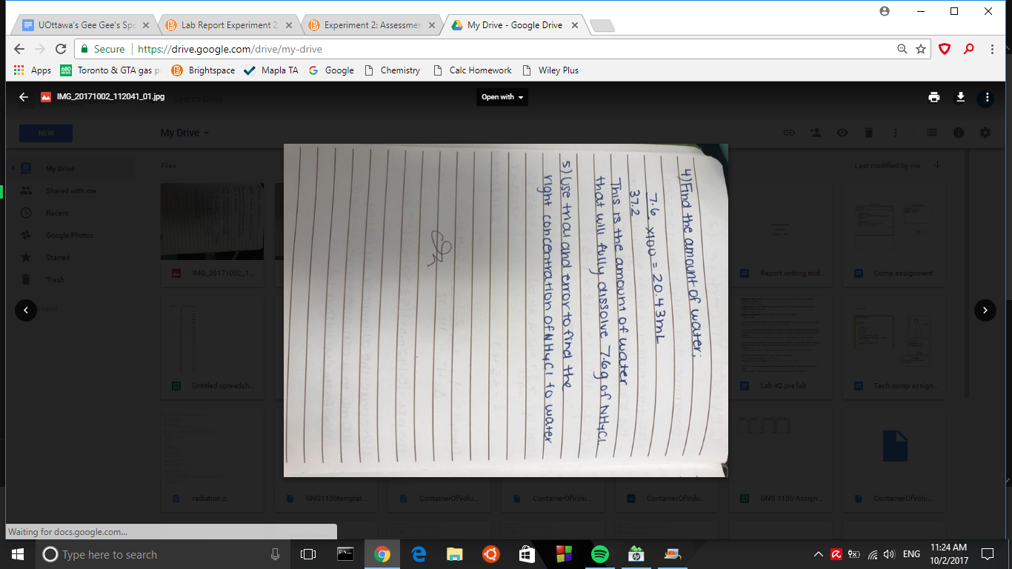
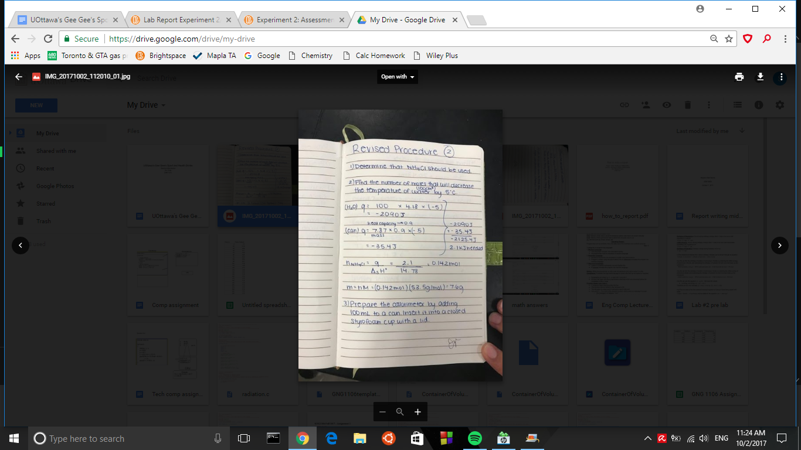
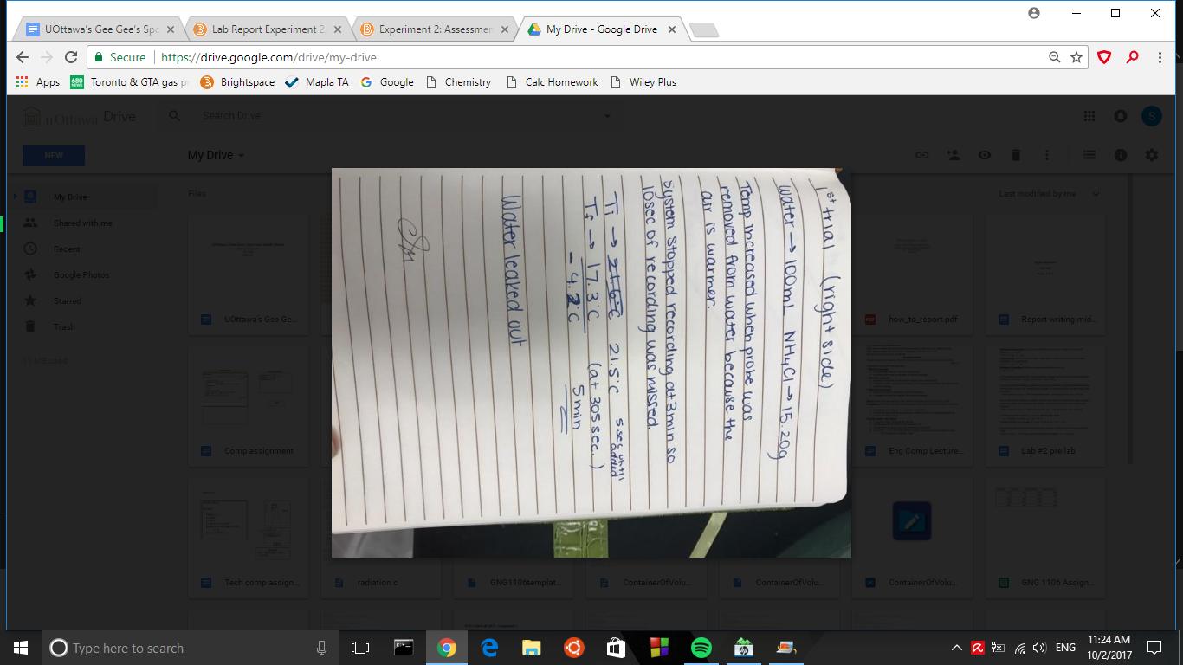
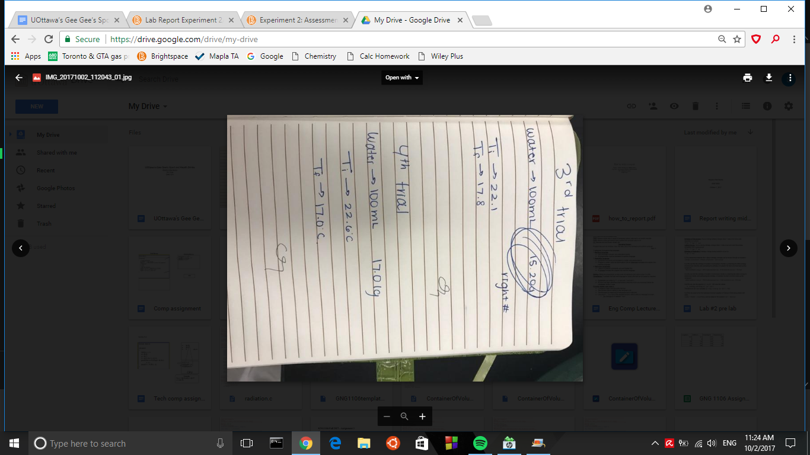
Creative aspect:
Label
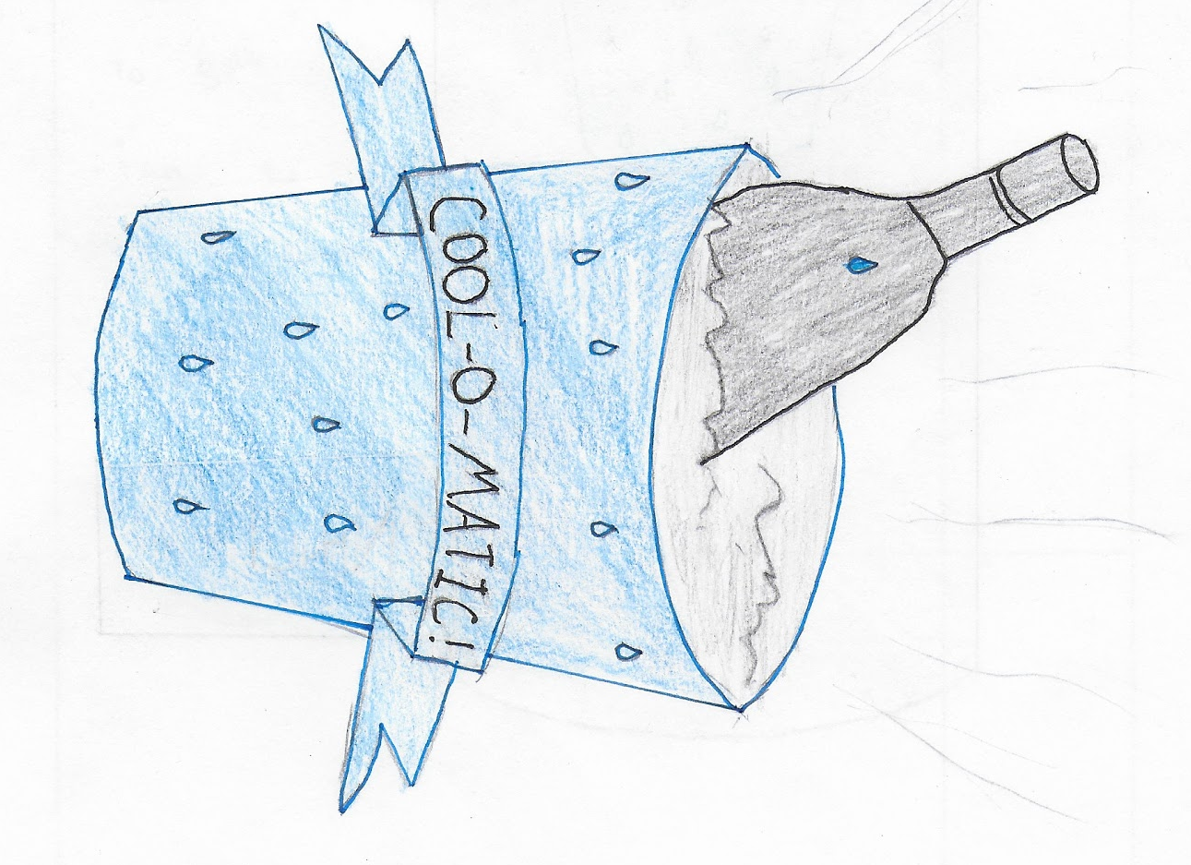

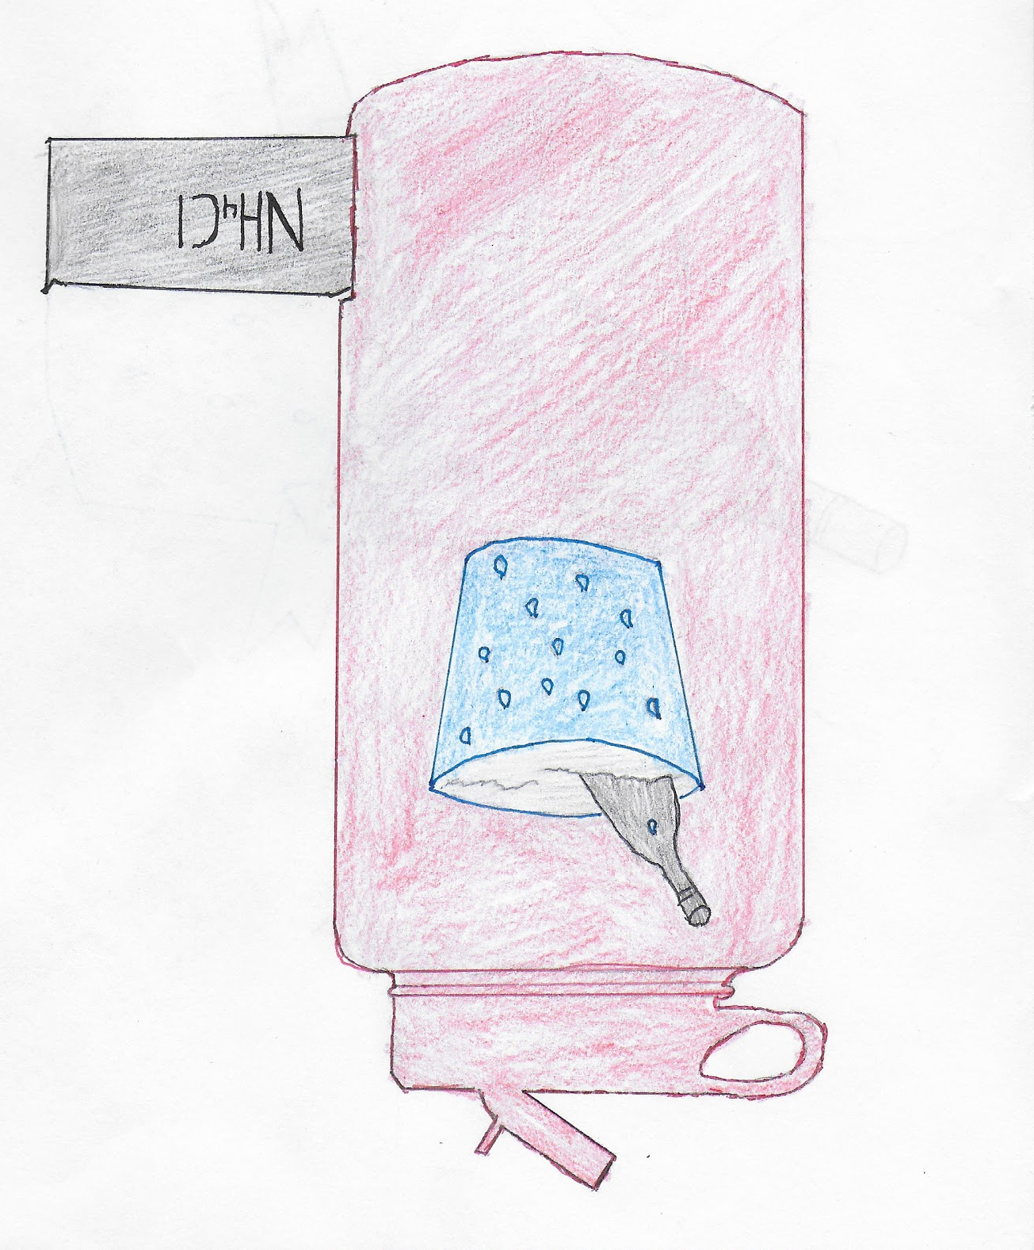
Design:



