Experiment 1. Verification of Boyle's Law September 21, 2017
Anthony Rankin
8916541
Introduction:
Boyle's law is a formulaic representation of the inverse proportionality between the volume and pressure of a gas when keeping temperature constant. Using a Vernier Gas Pressure sensor attached to a syringe we can determine a Boyle's Law constant by recording the pressure at a several different fixed volumes and using the formula PV=k. By increasing the volume of the gas in the syringe we should see a decrease in pressure inside the syringe. We can also determine approximately what the pressure will be if were to increase the volume to a point by using the formula P₁V₁=P₂V₂. The limitation to this theory is that temperature is remaining constant so it doesn’t account for the behaviour of the gas if the experiment were to take place in various extreme conditions. It also doesn't account for the collision between the gas molecules and assumes they are elastic, therefore, energy is always conserved.
Procedure:
*Lab Quest Procedure as described in the lab manual (What in the World ISN’T Chemistry, Dr. Rashmi Venkateswaran, 2017, Exp. 1,).
1. Prepare Gas Pressure Sensor
a) Connect sensor to Lab Quest 2.
b) Move plunger of plastic syringe to chosen volume and note which side of plunger is being measure from.
c) Attach syringe to valve of gas pressure sensor. A half turn will lock into place.
2. Collect Measurements
a) Hold plunger at chosen volume.
c) Wait for pressure to stabilize and enter volume. “OK” to proceed.
d) Move plunger to change volume and hold. Wait to stabilize and tap “keep” and record volume.
e) Continue doing this until repeated 8 times. For final volume measuremen , move plunger back to initial volume mark. Stop data collection.
Observations/Data/Results:
Table 1. Data Results in the Determination of Boyle’s Law Constant
Volume of Gas (mL) | Pressure (kPa)
 | Trial 1 Trial 2 Trial 3
5.8 | 100.27 | 101.15 | 100.60
7.8 | 75.71 | 77.65 | 74.82
9.8 | 59.26 | 60.76 | 59.20
11.8 | 49.20 | 49.82 | 49.11
13.8 | 41.89 | 41.91 | 41.91
15.8 | 36.61 | 36.77 | 36.61
17.8 | 32.48 | 32.69 | 32.61
19.8 | 29.05 | 29.44 | 29.27

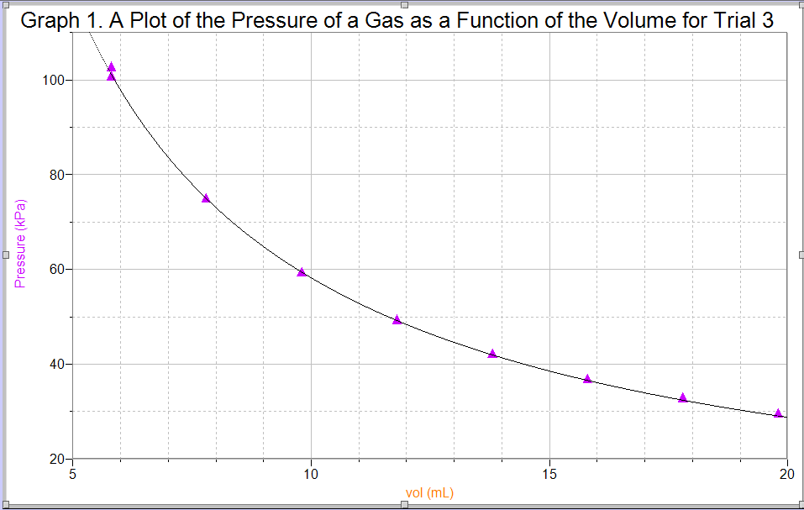
Calculations:
a) PV=k
(59.26 kPa)(9.8 mL)=580.748
b) P₁V₁=P₂V₂
(59.26kPa)(9.8 mL)=P₂(11.8 mL)
P₂=46.72 kPa
Discussion:
We were able to obtain a Boyle's Law constant by taking the pressure readings of the three trials and then multiplying them by their respective volumes (PV=k) resulting in a constant of 580.748 (Trial 3). The constants varied for each trial because of the uncertainty from using the syringe. This proves that Boyle's Law illustrates how the pressure of a gas fluctuates multiplicatively and inversely proportional to its volume. See Graph 1 for a visual representation of Trial 3. It shows that as the volume decrease, the pressure increases. We took multiple readings at the same independent variable to ensure we had a sufficient amount of data to confirm the theory. One trial would not be enough. Boyle's Law requires that temperature, as a gas variable, remains constant, however, we performed the lab at room temperature but did do anything to ensure the temperature did not fluctuate. It's possible that our hands manipulating the syringe could have cause an increase in temperature slightly skewing our data results. However, we can ignore this since the change would be minimal and we could still observe the relationship between the pressure of the gas and its volume.
An experimental source of error would be the lack of precision and uncertainty when manipulating the volume of the syringe. It would be nearly impossible to adjust the volume to the exact same value every time. It also depends on the judgement of whoever is manipulating the volume inside the syringe.
Conclusion:
The value obtained for the Boyle's Law constant (k) was 580.748 for Trial 3 with a pressure of 59.26 kPa and a volume of 9.8 mL.
Reference: Warren, Warren S. “Physical Basis of Chemistry”, 7, 153, 2000.


