GEO1111 2016 PRACTICE EXAM ANSWERS
____________________________________________________________________
Do not open this packet until instructed to do so.
You may separate this formula sheet from the exam to use it for easy reference.
Read the questions carefully.

GEO1111 Exam Formula Sheet

Radioactive decay N(t) = N(0)e^{-λt}
Radioactive decay constant λ = ln(2)/t_{1/2}
Parent Daughter dating t = ln[(P+D)/P]/λ
Driving Force: Fdriv = mg sin θ
Resisting Force: Fres = μfric N = μfric mg cos θ
Runoff: = Input - Losses
Unit Discharge: Discharge/Drainage Area
Residence time = volume/total input OR volume/ total output
Hydologic Gradient: i=Δh/L
Darcy’s Law: v=-(K/η)i
Velocity = Distance/Time
Travel Time: Δt=L/V
Wave Velocity: C = λ/T

Unit Conversions

1MJ=1,000,000 J
1W= 1 J/s
1 kWh = 3.6x10⁶ J
1 cal = 4.2 J
1L = 1000mL
1m³ = 1,000 L
1 Calorie = the energy to heat 1g of water 1°C
1 Joule = Energy to accelerate 1kg to 1m*s⁻²

Name : ___________________________
Student ID number : ___________________

Instructions:
• Write your name and student number on this cover page and on the scantron card and on the exam answer book
• This is a closed book exam; no books, or notes, are allowed.
• University of Ottawa approved calculators can be used during this exam.
• Multiple choice questions are worth 2 points. Write the answers to all of the multiple choice (Questions #1 to #40) on the scantron card.
• Short answer questions are worth 5 marks each
• Write the answers to Questions 51 to 76 in the separate exam answer book.

Multiple Choice. Answer all of these questions on the SCANTRON card.

1. The two important types of weathering are:
a. metamorphism and volcanism
b. chemical and mechanical weathering
c. dissolution and clay formation weathering
d. surface fractures and mechanical weathering
e. None of the above

2. A clean, 2400 mL volume of dry sediment was saturated with 600 mL of water of density 1 g/cm3. What is the porosity of the sediment?
a. 0.25%
b. 12%
c. 25%
d. 50%
e. 75%

3. The volume of water in Lake Loveit is constant and it is 9 *10⁶ m³. The total input per year of precipitation and runoff from the catchment is 3 *10⁶ m³. The evaporation rate from the lake surface is 1.5 *10⁶ m³ per year. The residence time of water in the lake is:
a. 1 a
b. 2 a
c. 3 a
d. 5 a
e. None of the above

4. Rivers and streams may flood when
a. channels are widened to increase river cross section area
b. point bars are eroded away
c. the water input to the stream is greater than the stream discharge
d. ice jams at a bridge
e. answers C and D are both correct

5. What typically happens to a glacier if the amount of ablation is greater than snow accumulation?
a. retreat
b. advance
c. remains in equilibrium
d. does not change
e. answers C and D are correct

6. Why do tectonic plates move?
a. movement of rigid continental crust on molten mantle
b. electromagnetic pulses radiating from the earth’s core
c. Earth’s orbit imparting rotational velocity on plates
d. planetary cooling and contraction (shrinking) of Earth through time
e. slab pull and ridge push

7 The Earth’s magnetic field is caused by:
a. an offset of the core’s rotational axis with respect to Earth’s rotation
b. a large Fe-rich deposit near the North pole
c. disseminated magnetite in the crust
d. convection of the liquid metallic outer core
e. none of the above.

8. Which of the following is false?
a. plates are composed of brittle material
b. plates are consumed at spreading centers
c. deformation occurs at convergent plate margins
d. plates move over top of a viscoelastic core
e. all of these answers are correct

9. Which of the following is (are) a precursor to a volcanic eruption?
a. increase in ground water temperature
b. increase in microseismicity
c. bulging of topography
d. local changes in magnetic field
e. all of the above

10. The volcanism on the island of Hawaii is
- Caused by the recent collision of the Pacific Plate boundary with the Hawaian plate
- Due to a hot spot in the earth’s crust
- From subduction of very old ocean crust
- Caused by a huge shield volcano
- B and D are both correct.

11. A scientist measures the amount of the isotope lead-210 in a sample of barite and finds that it is 25% of the initial concentration. Lead-210 is radioactive and has a radiological half-life of 22 years. The age of the sample is
a. 11 years
b. 22 years
c. 44 years
d. 66 years
e. Unknown unless the amount of Pb-206 is also measured.

12. The assumptions that the scientist makes to age the sample described in question #11 are
a. The radiological half-life is correct
b. There is no input of Lead-210 once the mineral is formed
c. There is no leaching of Lead-210 from the mineral once it is formed
d. A, b and c are correct
e. None of the above

13. What do Jovian and Terrestrial planets have in common?
a. They have similar densities
b. They have similar numbers of moons
c. They have similar sizes
d. They all have similar orbital radii
e. They have none of the above in common

14. Which of the following ages is closest to the age of the solar system?
a. 2.55 Ga
b. 3.85 Ga
c. 13.25 Ga
d. 4.58 Ga
e. 8.48 Ga

15. At a seafloor spreading centre
a. Plates slide by each other
b. Plates converge
c. Continental crust is formed
d. Plates subduct
e. None of the above
16. Volcanic rocks:
a. Sometimes contain glass
b. Are often composed of basalt
c. Form at seafloor spreading centres
d. B and C are correct
e. All of a, b, and c are correct

17. Igneous rocks:
a. Are often silicates
b. Always include the mineral quartz
c. Consist of siltstone and sandstone
d. Can contain limestone
e. A and B are both correct

18. The Bowen Reaction series
a. Describes the formation of a sequence of minerals from a magmatic melt
b. Starts with minerals that are very stable on the earth’s surface.
c. Start by forming quartz
d. A and B are correct
e. All of a,b and c are correct

19. The four most abundant elements in the earth’s crust by weight are:
a. O, Si, Al, Fe
b. C, O, Si, Mn
c. O, Fe, Si, K
d. Al, K, Mg, O
e. N, O, C, S

20. Oceans are an important component of the earth’s climatic system because they
a. are a source of water for precipitation
b. have a large latent heat capacity
c. have a large surface area
d. store large amounts of heat
e. All of the above

21. When waves reach a shore line they
a. are refracted
b. transport sediment along shore
c. reduce their friction with the bottom sediment
d. A and B are correct
e. A, B and C are correct

22. The Coriolis force
a. Is caused by the earth’s rotation from west to east
b. Is caused by the earth’s rotation from east to west
c. Is affected by solar winds
d. A and C are both correct
e. None of the above

23. Global Winds
a. Redistribute heat from the poles to the tropics
b. Redistribute heat from the tropics to the poles
c. Are generated by pressure differences in the ocean
d. Cool the glaciers in Antarctica
e. None of the above

24. Ekman Spirals
a. Describe the effect of Coriolis forces on wind-driven surface currents
b. Cause net water movement that is 90 degrees from the direction of the wind
c. Are best developed in deeper water away from the coast
d. Cause northward-moving winds parallel to the east coast of North American to drive surface water offshore
e. All of A, B, C, and D are correct

25. Deep ocean currents
a. Redistribute heat in the ocean
b. Are slow moving density driven currents
c. Result when warm water rises to the surface
d. Trap nitrogen from the atmosphere
e. A, and B are correct

- Hurricanes are
- Responsible for tsunami waves
- Cyclonic tropical storms
- Most abundant in polar regions
- Most abundant in the southern Atlantic ocean
- A, B and C are correct

27. A negative feedback
a. amplifies the initial forcing
b. suppresses the initial change
c. tends to promote disequilibrium
d. increases solar activity
e. None of these statements are correct

28. If a climate cycle has a period of 110,000 years, which of the following is most likely to be driving the cycle?
a. Tectonics
b. Volcanism
c. Milankovich cycles
d. Solar cycles
e. Milky Way spiral arm encounters
29. Which of the following does not affect climate?
a. Tectonics
b. Orbital variations in the Earth-Sun system
c. Earth’s encounters with spiral arms of the Milky Way
d. Solar eclipse
e. All of the above affect climate

30. Tides are the result of forces caused by:
a. Winds
b. Storms
c. Sun
d. Moon
e. C and D

31. Tsunamis
a. Are caused by Earthquakes beneath the ocean floor
b. Create high waves in the deep ocean
c. Are very destructive when they hit land
d. A and B are correct
e. A and C are correct

32. The greenhouse effect
a. Warms the earth’s surface
b. Cools the earth’s surface
c. Is increased by higher concentrations of atmospheric CO₂
d. Is increased by higher concentration of O₂
e. A and C are both correct

33. Which of the following is true?
a. Tides only effect the coastal zone.
b. Tides only effect the surface of the ocean.
c. Tides only effect the first 100 km from the shore of the ocean.
d. Tides are felt in all depths and parts of the ocean.
e. None of the above

34. Spring tides
a. Have the highest high tides
b. Have the lowest low tides
c. Occur when the sun and moon align
d. Occur once per year annually
e. A, B and C are correct

35. Which of the following is NOT associated with the changing of the Earth’s climate?
a. Increase in greenhouse gas concentration
b. Milankovitch cycles
c. Decrease in greenhouse gas concentration
d. Reversal of magnetic field polarity
e. Increased intensity of solar flares

36. You have collected a sediment core from the ocean and measured the oxygen isotope ratio in some marine plankton found in the core. The organisms have lower O-18/O-16 than the global marine average value. The ocean temperature when the organism lived was
a. Warmer than average
b. Cooler than average
c. Dryer than average
d. A and C are correct
e. None of the above

37. Low elevation cloud cover in the earth’s atmosphere
a. Is correlated with the cosmic ray flux from space
b. Causes the temperature of the earth’s atmosphere to decrease
c. Does not produce a greenhouse effect
d. is correlated with sun spot activity
e. A and D are correct

38. Albedo is
a. A measure of solar radiation reflected from a surface
b. Lower on the moon than the earth
c. Higher on the land surface than the ocean
d. Lower on snow covered surfaces
e. A and B are both correct

39. Global climate change models
a. Use mass balance equations
b. Include feedback loops
c. Incorporate cosmic ray fluxes as a forcing function
d. A, B and C are all correct
e. A and B are correct

40. Global climate change models predict that
a. The temperature of the earth is about 0.5 degrees warmer today due to human activity
b. The temperature in the Antarctic will rise more rapidly than in other locations on earth
c. CO₂ concentrations will fall
d. A and B are correct
e. None of the above are correct

Answer four of the five questions below in the exam booklet

41. Describe four factors that influence the formation of low level clouds. How can clouds alter the earth’s energy balance?
Four factors influencing low level cloud formation are
(1) Cosmic ray flux. As the flux goes up, more ionization occurs in the atmosphere and this leads to more sites for cloud nucleation.
(2) Atmospheric aerosol input from volcanoes. Aerosol particles act as nucleation sites for cloud formation.
(3) Evaporation and evapotranspiration from plants / forests. As more water is released into the atmosphere, cloud formation increases.
(4) Orographic cooling. As moist air rises over a mountain chain, the temperature decreases as higher elevation. This increases condensation and cloud formation.

Clouds can reflect incoming radiation and decrease the quantity of incoming radiation. This can cool the earth. Clouds can also trap radiation and re-emit it as a greenhouse gas. This second process will increase earth’s temperature.

42. What is a Milankovitch Cycle? Describe three processes that control the cycles.
Milankovitch cycles are changes in the earth’s orbit that result in changes in the distribution of solar radiation on earth. Three processes are.
  - Tilt of the earth on its axis.
  - Precession (or wobble) of the earth when it rotates on its axis.
  - Eccentricity of the earth’s orbital path around the sun.

The orbital changes affect the contrast between seasons. With lower seasonal contrast, ice sheet growth is promoted. This explains many glacial and interglacial periods observed in earth’s history.

43 Explain the function of a greenhouse gas (GHG) in three sentences? Give three examples of GHGs and two examples of other major gases in the atmosphere that are not greenhouse gases.
GHGs in the Earth’s atmosphere absorb incoming radiation from the sun. They then reemit energy in the infrared spectrum. Some of the reemitted radiation is directed back to the earth’s surface so it warms the earth by about 33ºC.
Three GHGs are water vapour, CO₂ and CH₄
Two major gases in the atmosphere are O₂ and N₂

44. What is Ekman transport? Explain where and how (1) upwelling and (2) down welling can occur due to Ekman transport on the east and west coasts of North America.
Ekman transport is the deflection of surface ocean currents on average 90 degrees to the right relative to the wind direction in the Northern Hemisphere and the opposite direction in the southern hemisphere. Ekman transport is caused by the Coriolis Effect which is the apparent movement of objects due to the rotation of the earth from west to east.

Upwelling occurs along a coast when Ekman transport moves warm water off shore and it is replaced by cold water that is from deeper in the ocean.

Down-welling occurs along a coast when Ekman transport moves warm water towards the coast. The movement of the water towards the land drives warm water deeper along the ocean bottom.

45. List 4 properties of the water molecules and describe in one sentence the effect that each property has on the earth’s climate.
1. Water has high heat capacity.
2. Water vapour absorbs incoming radiation and acts as GHG.
3. lliquid water (and ice) is an agent of weathering.
4. Water freezes at 0ºC storing precipitation in glaciers.
Note, Other answers are also possible. For example: water has a high latent heat capacity so freezing/ melting ice (glaciers/ice sheets) can release / consume a large amount of energy. Ice is less dense than water so ice floats.

Answer four of the five questions below in the exam book

51. Describe the different stages in a Wilson cycle. Give a example (i.e. a geographic location) where 3 different stages are happening today on the earth.
There are six stages to a Wilson cycle. They are shown in the diagram in Lecture 21 (slide #41). Slide #42 of the same lecture shows where these processes are occurring on the earth today. Three different stages and examples are: (1) Thinning and rifting of the continental plate (Rift Valley in Eastern Africa), (2) Spreading and Opening of an ocean (Gulf in the middle east) (3) Continental collision (India into Eurasia).

52. Draw a cross section of the earth. (a) Label the different layers. (b)Give one different seismic property of three layers. (c) What happens to waves as they cross the boundaries between different layers?

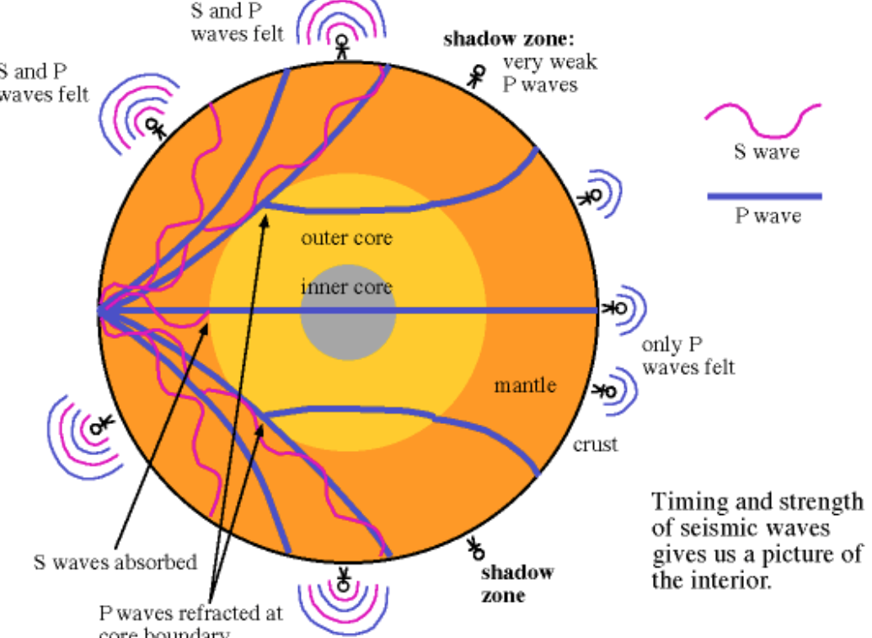

52 B) 3 seismic properties:
1. P waves can travel through mantle, outer core and inner core
2.S waves cannot cross through outer core (iquid)
3. P waves refract at core boundries

52C) Waves are refracted when they cross different boundaries.

53. Describe Bowen’s reaction series.

Bowens reaction series describes the formation of minerals from a magmatic melt in a mafic to felsic sequence of mineral crystallization. There are two pathways that minerals form minerals and both are shown in the diagram below. There is a continuous series and a discontinuous series. The discontinuous series changes from one mineral to another under different temperature –pressure conditions as it cools. One example is olivine. In this series olivine is the first to crystalize from the melt as you cool it, and then as you cool further you crystalize out of the melt a rock of pyroxene composition then amphibole composition and so on. In contrast, the continuous series changes the composition of the mineral (more Na or Ca in the crystal structure). Ex. Plagioclase is a transition from Anorthrite (Ca rich) to albite (Na rich) in the continuous series.

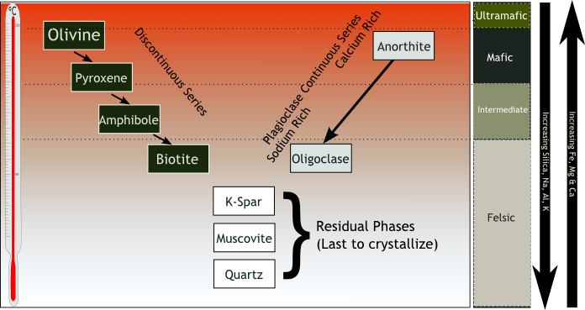

54. Describe three different ways in which sedimentary rocks can be formed.

a)Sedimentary rocks can be formed as
(1)Detrital sedimentary rocks. – This occurs when igneous and metamorphic rocks are eroded to detrital grains which are transported and re-deposited as sediments that are buried where they undergo compression and compaction to lithify into sedimentary rocks.
(2) Chemical sedimentary rocks -The creation of calcium carbonate (Limestones) is a good example and occurs when CaCO3 is precipitated through biologic or abiotic processes.
(3) Evaporite rocks including Halite can be formed by the precipitation of NaCl when it saturates in shallow warm seas and salt deposition on the bottom occurs.

Coal formation by the deposition of organic rich biological material would be a 4th example of a sedimentary rock.

55. Draw a diagram of the rock cycle to show the relationship of metamorphic rocks to other types of rocks and the ways that metamorphic rocks can be formed.

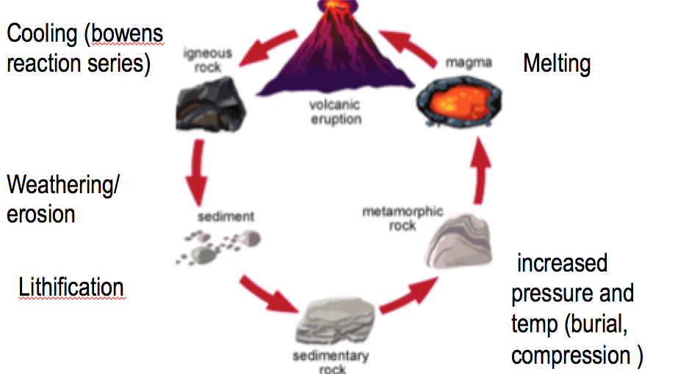
Answer four of the Five questions below in the exam book.

61. A zircon collected from Northern Canada has 5000 atoms/gram of U-238 and 4500 atoms/gram of the Pb-206 decay product. The half-life of U-238 is 4.468 Ga.
(a) How old is the mineral?
(b) List two key assumptions you make when you do this calculation.

Parent Daughter dating From Forumla sheet t = ln[(P+D)/P]/λ

Parent daughter dating
p atoms | 5000
D atoms | 4500
half life | 4.468 | B Byears
λ | 0.155136
Age | 4.137 | Billion years

Two key assumptions are:
1. That no Pb206 has been added to the sample over time
2. There has been no gain of U238 over time
In other words, there has been no event reset of this mineral.

62. Using the cross section shown below.
(a) List the order that the geologic rock units (B,C,D,E,G) were formed in the cross section starting with the oldest rock unit
(b) Where in the time sequence did the fault F form?
(c) Where in the time sequence did the fault A form?
(d) What type of rock is ‘B’

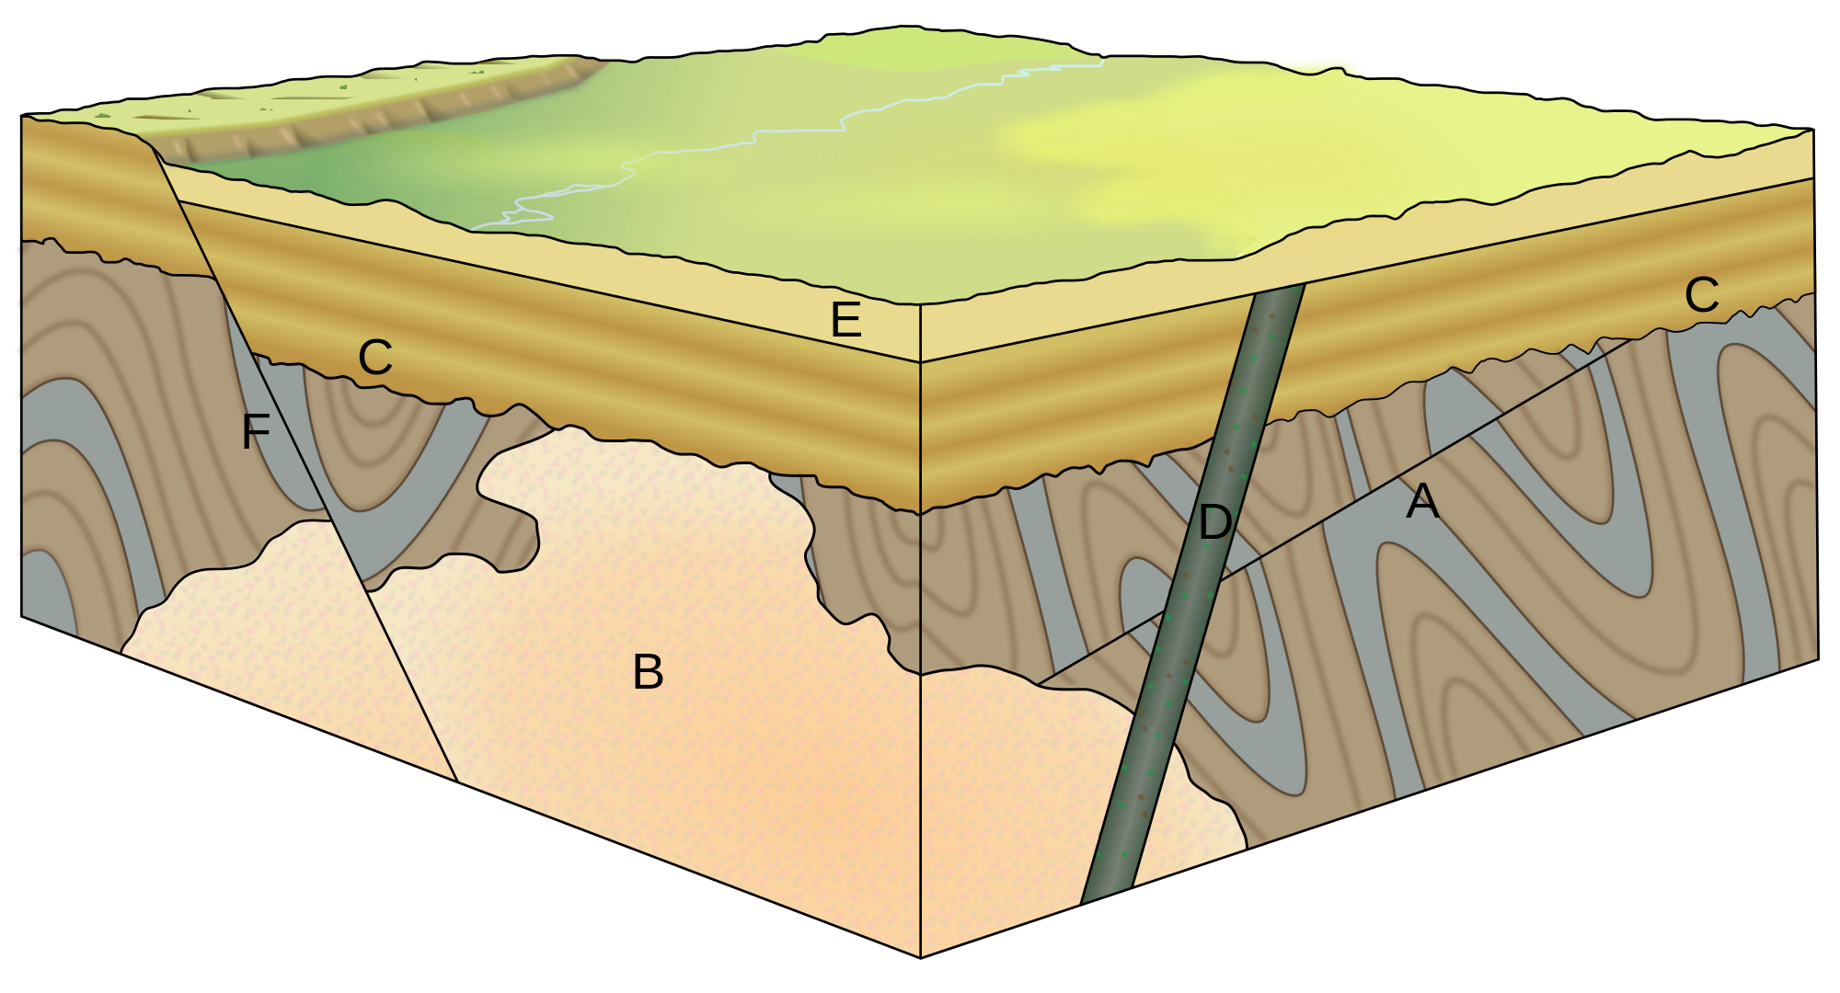
G

Overall: G was deposited then G was folded then A faulted G then B intruded G then G was eroded then C was deposited then D was intruded then E was deposited then F was folded
- GBCDE
- F faulted last (it cross cuts BGCand E)
- A faulted after G was folded but before B intruded
- B is an igneous rock

63. A septic tank is located on a small hill (5 m high) and it is leaking waste into a groundwater system. The height of the water table measured in a well located right beside the septic system is 10 m below the land surface. One hundred meters away at the base of the 5 meter high hill, the water table is 16 m below the surface. Assume that the hydraulic conductivity is 5* 10⁻⁵ m/s and the porosity is 0.30 for the gravel.
(a) Draw a diagram and label the elevations and the water table.
(b) Calculate the groundwater flow velocity between the two sites.
(c) Will the bacteria in the sewage move at the groundwater velocity or slower or faster?

A)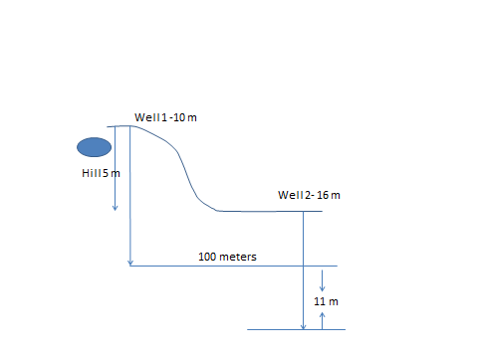

B)
Delta H | -11 | meters
Distance | 100 | meters
i | -0.11
porosity | 0.3
Kh | 0.00005 | meters/sec
Velocity | -1.8E-05 | m/sec

C) Bacteria will be filtered out of the groundwater by the sand so they will move much slower than the water on average.

64. A boy and girl count 20 waves pass in front of them in 100 seconds while they lie on the beach of Desert Island. They estimated the height of the wave as 5 meters from trough to peak and the distance between the wave crests as 10 m.
(a) What is the frequency of the waves in hertz?
(b) What is the speed of the waves they observed?
(c) What depth of water will feel the effects of the waves?
(d) What type of waves did they see?

(a) What is the frequency of the waves in hertz?
Frequency = 20waves/100s =0.2 Hz

(b) What is the speed of the waves they observed?
V= wavelength /Time
V= 10m/5s = 2m/s

(c) What depth of water will feel the effects of the waves?
Wavelength/ 2 = negligible water movement
Therefore
10m/2 = 5m
You will feel the effect of the waves until 5m depth

(d) What type of waves did they see?
You saw a wind wave because the period of the waves was between 1 and 30

65. Four students are trying to decide whether to stay in the same apartment next year or move to a new place. They are looking at their electricity and heating bills. They paid $1.10 per litre of heating oil and $0.11 per kwatt hour of electricity. They used 2000 L of oil and 6000 kwatt hours of electricity. The new place uses just electricity and the landlord says it used 20000 kwatt hours last year and it will be 15% more efficient when they move in because he just reinsulated the attic.
(a) How much money did they spend on energy for their current apartment?
(b) What is the estimated cost for energy at their new place?
(c) Should they stay or move to save money?

(a) How much money did they spend on energy for their current apartment?
$1.10 / Loil X 2000 Loil +$0.11/kwhr X 6000Kwhr =$2860

(b) What is the estimated cost for energy at their new place?
Efficnecy = 1-0.15= 0.85 X20 000= 17000 kwhrs X$0.11/kwhr = $1870

(c) Should they stay or move to save money?
They should move to save money

