Experiment 1: Verification of Boyle’s Law

Introduction:
Gases are composed of molecules in constant random motion whose shape and volume are affected by temperature and pressure. According to the kinetic-molecular theory, the particles in gases are very far apart, meaning that they have relatively no attraction between them and essentially no volume. Any gas where the molecules do not exert a significant amount of force on each other is referred to as an “ideal gas” which can be defined in terms of four interdependent variables (pressure, temperature, volume, moles) using the equation $pV=nRT$.
In practice, gases only behave as an “ideal gas” at low pressure and high temperature. This is because in reality, gas particles do exert force on other gas particles meaning that at lower temperatures and higher pressures, the attractive forces between the particles are no longer negligible, leading to deviations from the “ideal gas” behaviour. The equation $pV=nRT$ was derived from three individual gas laws relating one of the variables to another, while keeping the other 2 variables constant. One of such laws is Boyle’s Law, credited to Robert Boyle who demonstrated that the volume (V) occupied by a fixed amount of gas is inversely proportional to pressure (p) at constant temperature (T) and amount (moles): $V∝1/p$. Thus, in an enclosed container at constant temperature and amount, as volume is changed, the pressure exerted by the gas will also change. As the volume decreases, the gas particles collide more frequently with one another and the sides of the container in which it is enclosed. The increase in the number of collisions leads to an increase in pressure. This relationship indicates that the product of pressure and volume is a constant; $pV=k$, where k is a constant.
In this experiment, we will be verifying Boyle’s law by analysing the relationship between the pressure and volume of air in a 20mL syringe. The volume of the gas in millilitres (mL) is the independent variable and the pressure in kilopascals (kPa) is the dependent variable. From this experiment, one would expect to get a graph which demonstrates an inverse relationship between the two variables; as the volume of the gas in the syringe increases, the pressure decreases and vice versa.

Procedure:
- Wear appropriate safety glasses and lab coat.
- Remove plastic cover from LabQuest 2.
- Tap Mode on the screen and change to Events with Entry.
- Enter Volume under Name and Millilitre under Units.
- Enter OK.
- Move the plunger of the 20 mL syringe to 12 mL so that the lowest layer of rubber is at the 12 mL mark.
- Attach the tip of the 20 mL syringe to the valve of the Gas Pressure Sensor and make half-turn in order to secure the valve and syringe.
- Click the Start button to begin collecting data.
- Hold the plunger at the 12.0 mL mark and press the Keep button once the pressure reading stabilizes.
- Enter the 12.0 mL volume plus an additional 0.8 mL to make up for space inside the Gas Pressure Sensor and press the OK button.
- Continuously decrease volume by increments of 1.0 mL and repeat steps 9 and 10 until plunger reaches the 5.0 mL mark.
- For the final volume measurement, pull the plunger back to the 12.0 mL mark and repeat steps 9 and 10.
- Keep both the initial and final measurements until calculations are made afterwards and the more accurate reading is determined.
- Press the Stop button to stop data collection.
- Enter the graph menu and press the Analyze button.
- Press Curve Fit for Run 1 and select an inverse function.
- Press the OK button and observe the difference between the plotted points and the inverse curve fit.
- Remove the 20 mL syringe from the Gas Pressure Sensor.
- Repeat steps 6 - 18 for 2 more runs.
- Pack up all equipment and clean work station.

Data and Observations:

Table 1. Raw Data for Volume and Pressure for each Trial (Quantitative)
Trial 1 |  | Trial 2 |  | Trial 3
Volume (mL) | Pressure (kPa) | Volume (mL) | Pressure (kPa) | Volume (mL) | Pressure (kPa)
12.80 (1st time) | 101.59 | 12.80 (1st time) | 101.53 | 12.80 (1st time) | 101.22
11.8 | 108.50 | 11.8 | 110.58 | 11.8 | 109.65
10.8 | 118.49 | 10.8 | 120.61 | 10.8 | 118.58
9.8 | 131.61 | 9.8 | 133.76 | 9.8 | 132.39
8.8 | 148.58 | 8.8 | 149.15 | 8.8 | 146.42
7.8 | 166.86 | 7.8 | 167.8 | 7.8 | 165.78
6.8 | 191.49 | 6.8 | 192.66 | 6.8 | 192.91
5.8 | 226.04 | 5.8 | 226.03 | 5.8 | 226.03
12.8 (2nd time) | 102.0 | 12.8 (2nd time) | 101.72 | 12.8 (2nd time) | 102.19

Table 2. Qualitative Observations
- Air in syringe was clear and colourless
- Temperature of the lab was room temperature
- As the volume of the gas decreased in the syringe it became more difficult to push and hold the plunger down (on account of the increase in pressure) and it would bounce back up if not held steady

The pressure for the initial volume (12.8mL) was tested twice – once at the beginning and again at the end of each run. Then, one value was chosen and the other removed based on how well they lined up against the inverse curve of best fit when the data collected was graphed. For the first trial, the first pressure measurement for the initial volume was kept (101.60. For the second trial, the second pressure measurement was kept. For the final trial, the first measurement was kept.

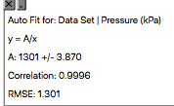
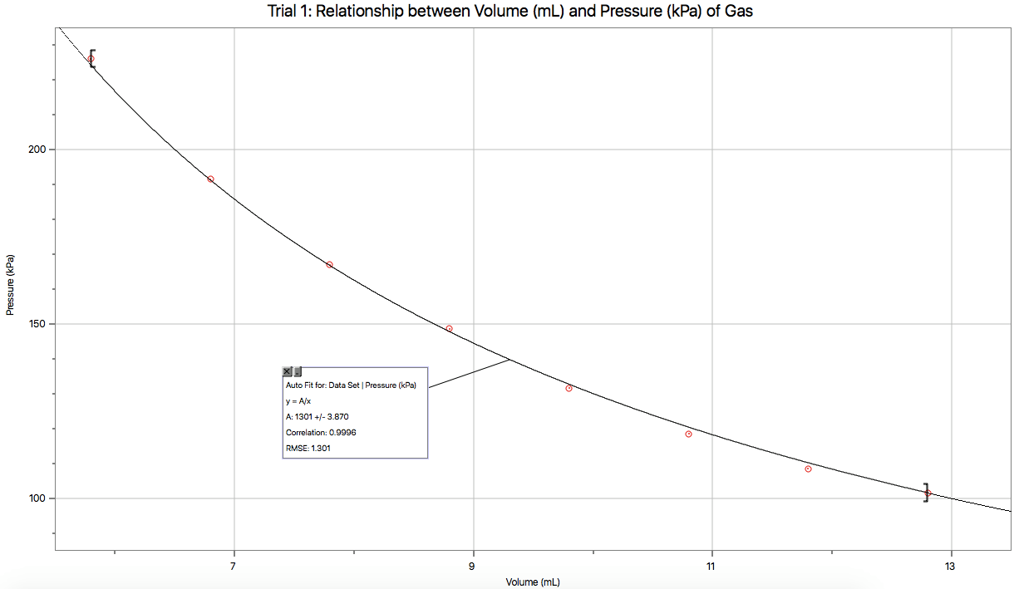
Figure 1
Figure 2

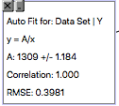
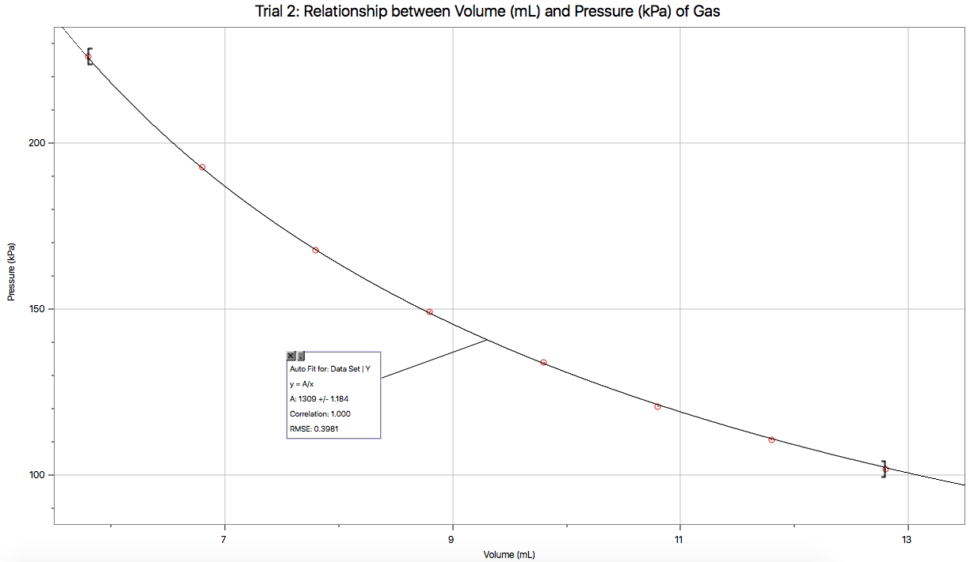
Figure 3

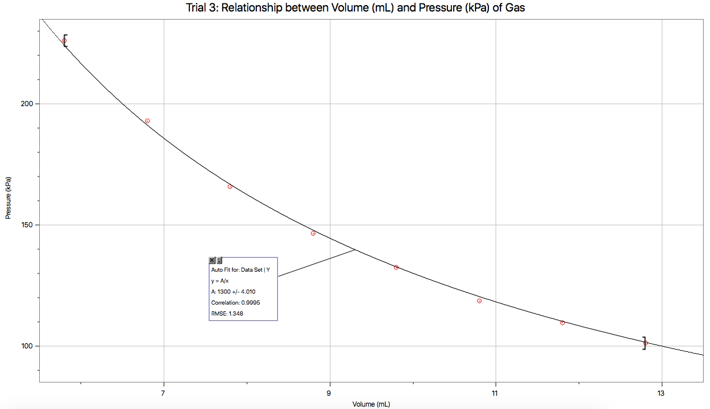

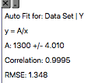

Calculations:
As described by Boyle’s law, the product of the pressure (p) and volume (V) of a gas is equivalent to a constant (k); $pV=k$ which is also an inverse function of the form $p=k/V$.
Using this equation, when graphing the pressure (y-axis) against the volume (x-axis) using Logger Pro and fitting the data points to an inverse function model (curve of best fit), the value of Boyle’s constant was generated as seen in figure1 to 3 (as indicated by the variable A). Since the value of the constant (k) is equivalent to the sum of pressure and volume, the units are $kPa∙mL$.

Table 3. Calculated Boyle’s Constant Value for all Trials
Trial | Constant (kPa mL)
1 | 1301
2 | 1309
3 | 1301
Average constant value for all three trials (k_{avg}) | $$k_{avg}= \frac{k_{trial 1}+ k_{trial 2}+k_{trial 3}}{3} \\ = \frac{1301+1309+1300}{3} \\ ≈ 1303.66 \\ =1304 kPa∙mL$$

This method of calculating for Boyle’s constant was preferred over the method of calculating the value of k for each individual volume for each trial and then finding the average as it was generated from a curve of best fit which takes into account variability, average, and gives less accountability to each individual set of data points.
To test the validity of the results the standard deviation was calculated. Standard deviation is a quantity calculated to determine the extent of deviation in a set of data. In this situation, if the calculated standard deviation is a large value then the k constants calculated in each trial are spread out in comparison to the mean (large deviation between values), and thus less precise. In order to calculate the standard deviation of the data, the Boyle’s law constant for each set of data points for the three trials was calculated using the equation $pV=k.$ To calculate the standard deviation for each trial the equation $σ=\sqrt{\frac{1}{n}\sum_{i=1}^{n}{{(k_{i}-μ)}^{2}}}$was used where k is equivalent to the Boyle’s law constant, $μ$ is the mean, n is the number of terms (8 data points per trial), and $σ$ is the standard deviation.

Table 4. Sample calculations for Boyle’s constant for each Data Setoint
Trial 1 | V = 11.80 mL k = PV  P = 108.50 kPa = (108.50 kPa) (11.80 mL)  k = ? = 1280  ∴ Boyle’s Law constant is 1280
Trial 2 | V = 11.80 mL k = PV  P = 110.58 kPa = (110.58 kPa) (11.80 mL)  k = ? = 1305  ∴ Boyle’s Law constant is 1305
Trial 3 | V = 11.80 mL k = PV  P = 109.65 kPa = (109.65 kPa) (11.80 mL)  k = ? = 1294  ∴ Boyle’s Law constant is 1294

Using the calculation method shown in table 4, the other k constants for the other data sets were calculated for all three trials.

Table 5. Standard deviation for Trial 1
Volume (mL) | Pressure (kPa) | Boyle’s Law Constant (k)
12.8 | 101.59 | k₁ = 1300
11.8 | 108.50 | k₂ = 1280
10.8 | 118.49 | k₃ = 1280
9.8 | 131.61 | k₄ = 1290
8.8 | 148.58 | k₅ = 1308
7.8 | 166.86 | k₆ = 1302
6.8 | 191.49 | k₇ = 1302
5.8 | 226.04 | k₈ = 1311

$$μ$$ | $$=\frac{k_{1}+k_{2}+k_{3}+k_{4}+k_{5}+k_{6}+k_{7}+k_{8}}{n}$$  $$= \frac{1300 + 1280 + 1280 + 1290 + 1308 + 1302 + 1302 + 13118}{8}$$  $$=1297$$
$$σ$$ | $$=\sqrt{\frac{(k1-μ)² + (k2-μ)² + (k3- μ)² + (k4- μ)²+ (k5-μ)² + (k6-μ)² + (k7-μ)² + (k8-μ)²}{n}}$$  $$=\sqrt{\frac{{\left(1300-1297\right)}^{2}+ {\left(1280-1297\right)}^{2}+ {\left(1280- 1297\right)}^{2}+ {\left(1290-1297\right)}^{2}+ {\left(1308-1297\right)}^{2}+ {\left(1302-1297\right)}^{2}+ {\left(1302-1297\right)}^{2}+ {\left(1311-1297\right)}^{2}}{8}}$$  $$=7.289$$  ∴ The standard deviation of Boyle’s Law constant is 7.289 for trial 1.

Table 6. Standard deviation for Trial 2
Volume (mL) | Pressure (kPa) | Boyle’s Law Constant (k)
12.8 | 101.72 | k₁ = 1300
11.8 | 110.58 | k₂ = 1305
10.8 | 120.61 | k₃ = 1303
9.8 | 133.76 | k₄ = 1311
8.8 | 149.15 | k₅ = 1313
7.8 | 167.80 | k₆ = 1309
6.8 | 192.66 | k₇ = 1310
5.8 | 226.03 | k₈ = 1311

$$μ$$ | $$=\frac{k_{1}+k_{2}+k_{3}+k_{4}+k_{5}+k_{6}+k_{7}+k_{8}}{n}$$  =$\frac{1300 + 1305 + 1303 + 1311 + 1313 + 1309 + 1310 + 13118 }{8}$  $$=1308$$
$$σ$$ | $$=\sqrt{\frac{(k1-μ)² + (k2-μ)² + (k3- μ)² + (k4- μ)²+ (k5-μ)² + (k6-μ)² + (k7-μ)² + (k8-μ)²}{n}}$$  $$=\sqrt{\frac{{\left(1300-1308\right)}^{2}+ {\left(1305-1308\right)}^{2}+ {\left(1303- 1308\right)}^{2}+ {\left(1290- 1308\right)}^{2}+ {\left(1308-1308\right)}^{2}+ {\left(1302-1308\right)}^{2}+ {\left(1302-1308\right)}^{2}+ {\left(1311-1308\right)}^{2}}{8}}$$  $=4.272$ ∴ The standard deviation of Boyle’s Law constant is 4.272 for trial 2.

Table 7. Standard deviation for Trial 3
Volume (mL) | Pressure (kPa) | Boyle’s Law Constant (k)
12.8 | 101.22 | k₁ = 1296
11.8 | 109.65 | k₂ = 1294
10.8 | 118.58 | k₃ = 1281
9.8 | 132.39 | k₄ = 1297
8.8 | 146.42 | k₅ = 1288
7.8 | 165.78 | k₆ = 1293
6.8 | 192.91 | k₇ = 1312
5.8 | 226.03 | k₈ = 1311

$$μ$$ | $$=\frac{k_{1}+k_{2}+k_{3}+k_{4}+k_{5}+k_{6}+k_{7}+k_{8}}{n}$$  =$\frac{1296 + 1294 + 1281 + 1297 + 1288 + 1293 + 1312 + 13118 }{8}$  $$=1297$$
$$σ$$ | $$=\sqrt{\frac{(k1-μ)² + (k2-μ)² + (k3- μ)² + (k4- μ)²+ (k5-μ)² + (k6-μ)² + (k7-μ)² + (k8-μ)²}{n}}$$  $$=\sqrt{\frac{{\left(1296-1297\right)}^{2}+ {\left(1294-1297\right)}^{2}+ (1281+ 1297)² + (1297 + 1297)²+ (1288-1297)² + (1293-1297)² + (1312-1297)² + (1311-1297)²}{8}}$$  $=$9.899 ∴ the standard deviation of Boyle’s Law constant is 9.899 for trial 3.
Based on the calculations, the standard deviation for all three trials were relatively small; trial two being the smallest (4.272) when compared to trials 1 (7.289) and 3 (9.899). This indicates that the values of k for each data set were close to the mean value (low deviation), meaning that the final k values are valid and precise.

Discussion:
From figures 1,2, and 3, based on the line of best fit (inverse function) one can see that as volume increased, the pressure decreased. According to Boyle’s law, the product of pressure and volume of a gas system is equivalent to a constant; $pV=k$. For trial 1and 3 the k constant was calculated to be $1301 kPa∙mL$ and was $1309 kPa∙mL$ for trial 2 thus, the average k constant for all three trials was $1304 kPa∙mL$. Therefore, the final equation for Boyle’s law is $p={1304 kPa∙mL}/V$. The values of k were quite similar across all three trials (with only a small standard deviation) which indicates that the data collected is valid.
Despite the valid results, there are some limitations related to the methodology of this experiment which may explain why the calculated constant (k) for Boyle’s law was not the same throughout all three experimental trials and why the pressure results varied.
Firstly, one of the main restrictions of Boyle’s law is that the temperature must be kept constant. Pressure is directly proportional to temperature; as temperature increases, the amount of kinetic energy increases, causing gas particles to hit their container with more force and leading to an increase in pressure. Although this variable was noted prior to experimentation, there was no way to accurately measure and control the temperature throughout the lab. There were no major fluctuations in temperature throughout the experiment as it was conducted within an hour in the same enclosed environment and there was limited contact with the actual tube of the syringe (to avoid transferring body heat). However, any slight changes would have impacted the overall pressure (if temperature increased the pressure would have increased and vice versa). If the experiment was repeated, to have better control over the temperature of the gas, it should be conducted in a more controlled environment and the temperature of the room should be measured simultaneously with the pressure.
Another restriction mentioned in Boyle’s law is that the number of moles of gas must be kept constant. As the number of moles of gas is increased, there are more collisions between gas particles causing an increase in pressure. For each individual run, the amount of gas was kept constant as it was in the enclosed space of the syringe which was securely attached to the Gas Pressure Sensor (to avoid gas leaks). However, since the syringe was detached and then re-attached to the sensor between each trial, the number of moles of gas (n) tested across all three trials may have varied. As it was not possible to accurately measure the moles of gas in the syringe, this may explain the variability in the measured pressures for each trial despite the volumes tested being constant.
Throughout the experiment, data was collected for the volumes of 12.8mL to 5.8mL, going down by increments of 1.0mL. In general, it was easy to collect data for this experiment because the methodology was simple and the equipment was easy to use. This made the experiment easily reproducible and enabled us to conduct multiple trials to ensure greater accuracy in our results. However, if the experiment was to be repeated, the volumes tested should vary by increments of 0.5mL rather than 1.0mL as that would give a more precise curve of best fit when graphing the data, leading to a more accurate calculated constant.
For each trial, the pressure for the initial volume of 12.8mL was measured twice – once at the beginning and once at the end of each run. The second pressure value for the initial volume of each run was higher than the first pressure value for all three trials. This raises the question of whether other factors are affecting the values of the pressure in the syringe; whether the direction the plunger is moved (push or pull) or the changing of volume throughout each trial affects the pressure of the initial volume. From the limited data collected for each initial volume, one cannot determine these factors nor the nature of their impact. However, the collection of supplementary data for the initial volume per trial increased the accuracy of the results.
Another factor which may have affected the accuracy of the data is that there are limits to how much one can compress a gas which caused some inherent difficulties in measuring the pressure of the air in the 20mL syringe. At around 6.8mL of gas, the plunger of the syringe began to get incredibly difficult to hold in place due to the large amount of pressure (190-195 kPa). At this point any slight adjustment of the syringe plunger drastically changed the pressure. Also, the pressure measured by the sensor never fully stabilized and kept fluctuating within a range of about 5kPa. These factors may have affected the accuracy of the data.

Conclusion:
From this experiment, it can be concluded that volume and pressure are inversely proportional to each other which is in accordance to Boyle’s law. The calculated average constant for this experiment is $1304 kPa∙mL$ and the general equation for Boyle’s law is ${1304 kPa∙mL}/V$.

References:
Ivanov, D. T. (2007). Experimental verification of Boyle’s law and the ideal gas law. Physics
Education, 42(2), 193-197. Retrieved from https://journals-scholarsportal-info.proxy.bib.uottawa.ca/pdf/

Silberberg, Martin S., et al. Chemistry: The Molecular Nature of Matter and Change, McGraw-
Hill Education, 2016.
The Ideal Gas Law. (9 January, 2017). University of California. Retrieved from
https://chem.libretexts.org/Core/Physical_and_Theoretical_Chemistry/Physical_Properties_of_Matter/States_of_Matter/Properties_of_Gases/Gas_Laws/The_Ideal_Gas_Law

Venkateswaran, Rashmi. (2017). What in the World isn’t Chemistry? General Chemistry
Laboratory Manual. University of Ottawa.

