The Respiratory System

Objectives:
1 Describe the structure of each one of the components of the conduction and respiratory zones (pp.808- pp.821)
6.2 Describe the gross structure of the lungs and the pleural coverings (pp.821-822)
6.3 Define & explain the following: intrapulmonary, intrapleural and transpleural pressures (pp.823- 824)
6.4 Explain the roles of the diaphragm & accessory muscles during inspiration and expiration (quiet & forced) (pp. 824- pp.825)
6.5 Explain the 3 factors that influence pulmonary ventilation (pp.826- pp.828)
6.6 Describe how lung volumes and capacities are measured and indicate their physiological significance (pp. 828- pp. 830)
6.7 Define dead space and indicate its importance in minute and alveolar ventilation (pp. 828- pp. 830)
6.8 Explain the mechanisms underlying some of the non-respiratory air movements (pp.826)
6.9 State Dalton’s Law and use it to describe the composition of atmospheric & alveolar air (p. 830- 831
6.11 List and describe 3 factors that influence the exchange of oxygen and of carbon dioxide at the level of the lungs (external respiration) (pp. 831- pp. 833)
6.12 Describe the partial pressure gradients that drive oxygen and carbon dioxide movements at the level of the tissues (internal respiration) (pp. 834)
6.13 Describe completely the transport of oxygen in the blood (pp. 834)
6.14 Explain the sigmoidal nature of the oxygen-hemoglobin dissociation curve (pp. 835)
6.15 Describe completely the 3 ways in which CO₂ is transported in the blood (pp. 838- pp. 840)
6.17 Associate carbon dioxide levels with blood pH; explain how respiration can regulate blood pH (pp. 838)
6.18 Describe how respiration is controlled by the nervous system (840- pp.841)
6.20 Indicate the influences of PCO₂, PO₂ & arterial pH on respiration rate (pp. 842- pp.844)
6.19 Indicate the effects of the following factors on respiration: Hering Breuer reflex, hypothalamus, cortex (pp. 844- pp.845)
6.21 Discuss the mechanisms controlling respiration during intense exercise (pp. 845- pp. 846)

Introduction
- The upper respiratory system: nose, paranasal sinuses and pharynx
- The lower respiratory system: larynx, trachea, branchial tree, alveoli, lungs and pleurae
- Major function of respiratory system is to supply O₂ and dispose of CO₂
4 distinct processes:
- Pulmonary ventilation: movement of air in and out of lungs
- External respiration: exchange of gases between blood and air of alveoli
- Transport of respiratory gases: role of blood in transport of gases between lungs and tissues of body
- Internal respiration: at the level of the tissues, exchange of gases between blood in systemic capillaries and tissue cells
- First 2 functions handled by respiratory system; other two by CV system

Describe the structure of each one of the components of the conduction and respiratory zones
- Respiratory zone: site of gas exchange. Composed of respiratory bronchioles, alveolar ducts and alveoli (microscopic)
- Conducting zone: passageways. Nose, nasal, cavity, pharynx, larynx, trachea, bronchi, bronchioles, terminal bronchioles
- As well as providing a passageway, conducting zone organs also cleanse, humidify and warm incoming air
Nose
Functions
- Airway for respiration
- Moistens and warms incoming air
- Filters and cleans inspired air
- Resonating chamber for speech
- Olfactory (smell) receptors
- Structure of external nose: differences in nose size/shape due to differences in nasal cartilages
- Skin covering dorsal/lateral aspects of nose is thin; contains many sebaceous glands
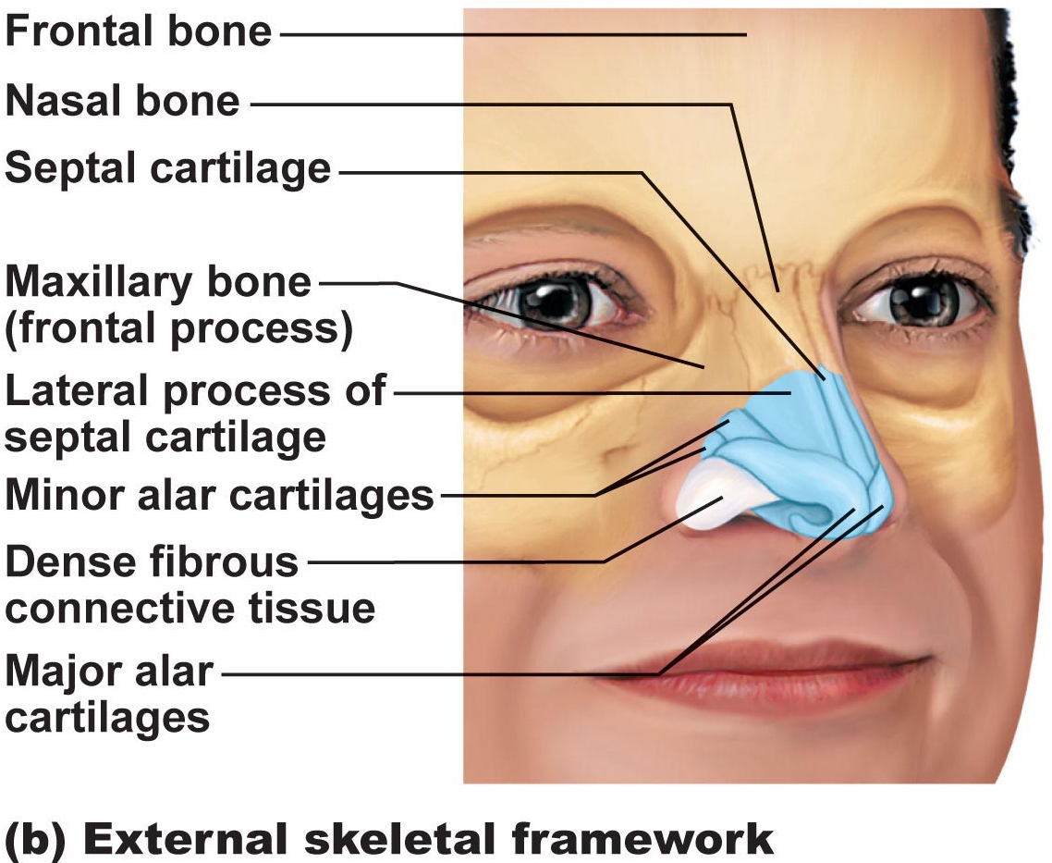

- Air enters nasal cavity via external nares (nostrils)—divided by midline nasal septum (cartilage >> bone); are then goes via internal nares to nasopharynx
- Roof of nasal cavity formed by ethmoid and sphenoid bones of skull
- Floor of nasal cavity formed by palate (anterior is hard; posterior is soft)
- Vibrissae: what are these?
- Nasal cavity lined by 2 types of mucosa
a) Olfactory mucosa: contains receptors for sense of smell
b) Respiratory mucosa: pseudostratified ciliated columnar epithelium with goblet cells; lamina propria has mucous and serous gland (1L/day sticky mucus containing lysozyme)
- Resp mucosa cilia move contaminated mucus posteriorly to pharynx
- Cold air slows cilia runny nose
- Thin-walled veins under nasal epithelium. Role? Cold air and nose bleeds?
- What are nasal conchae?
- Nasal mucosa richly supplied with sensory nerves; irritants trigger sneeze reflex
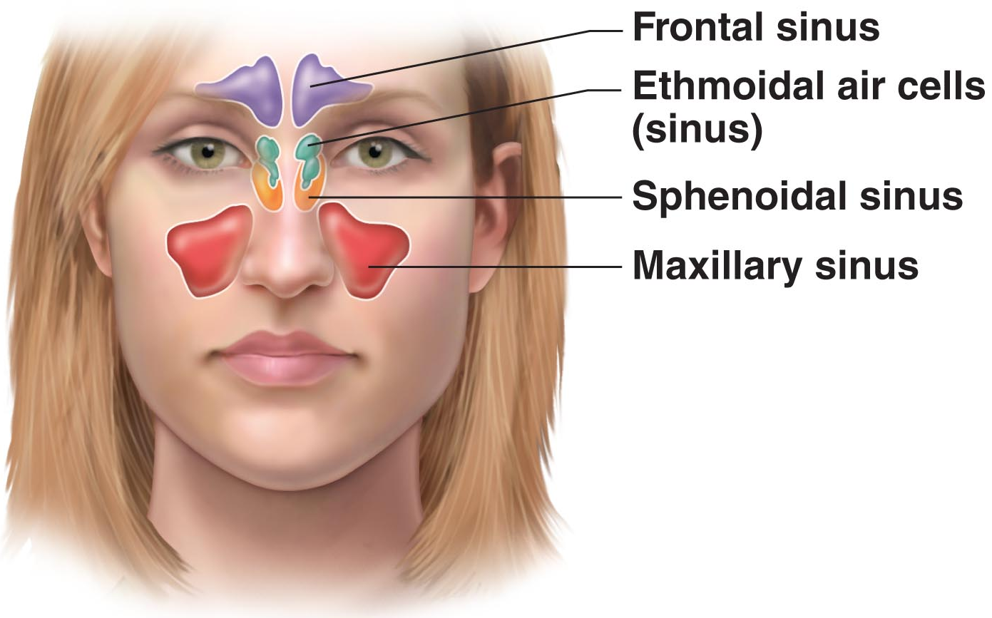

Paranasal Sinuses
- Surround nasal cavity
- Frontal, sphenoid, ethmoid, maxillary bones
- Lighten skull, produce mucus, warm and moisten air
- Sinus mucosa continuous with nasal mucosa; spread of infections
- Sinus headache: passageways connecting sinuses to nasal cavity blocked; air in sinus absorbed; partial vacuum

Pharynx
- Common pathway for food and air
- Wall composed of skeletal muscle throughout ~13 cm length; mucosal lining varies
- Nasopharynx
- Below sphenoid bone, above soft palate
- Only an air passageway
- What happens when swallowing?
- Pseudostratified ciliate epithelium
- Pharyngeal tonsils
- Pharyngotympanic (auditory) tubes drain from middle ear
- Oropharynx
- Fauces connect oral cavity with oropharynx
- From soft palate to epiglottis (air and food)
- Epithelium becomes stratified squamous
- Paired palatine tonsils + single lingual tonsil
- Laryngopharynx
- Also both food and air
- Stratified squamous
- From epiglottis to larynx—then respiratory and GI pathways diverge
- During swallowing, food has “right-of-way”

Larynx
- ~5cm (4th-6th cervical vertebrae)
- Attached to hyoid bone (above); continuous with trachea (below)
Functions
- Open, 2-directional airway
- Act as a switching mechanism to route air and food into the proper channels
- Voice production
- 9 cartilages in total
- Thyroid cartilage: large, shield-shaped cartilage in front (puberty in males?)
- Arytenoid cartilages (2): lateral, pyramid-shaped, anchor vocal cords
- 9th cartilage is epiglottis: elastic cartilage, anchored to anterior rim of thyroid cartilage and extends up to base of tongue
- True vocal cords: white (avascular); vibrate in response to air movement up from lungs (what is the glottis)
False vocal cords: above true vocal cords
- Epithelial lining of upper versus lower larynx?

Voice production
- Speech = intermittent release of expired air + opening and closing of glottis
- Length of vocal cords and size of glottis altered by action of laryngeal muscles that move arytenoid cartilage
- Male voice at puberty: vocal cords vibrate more slowly—why?
- Loudness of voice: force of air across vocal cords
- Laryngitis: inflammation of vocal cords vibration impaired
- Sphincter functions of vocal cords:
- Epiglottis closes respiratory tract during swallowing
- Valsalva’s maneuver: what is this?
- What is the Heimlich maneuver?
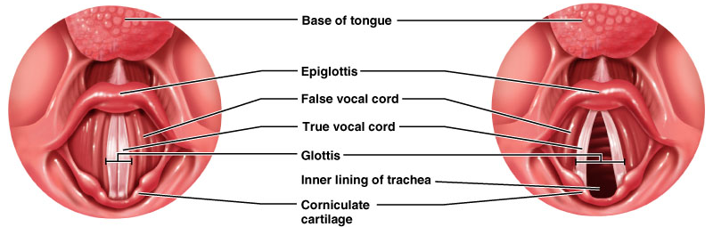

Trachea
- 10-12 cm long; ~2.5 cm diameter; flexible, mobile
- Pseudostratified ciliated columnar; cilia move mucus up pharynx
- Smoking inhibits and then destroys cilia; only coughing to clear mucus
- Submucosa is CT with seromucous glands
- Outer adventitia reinforced internally by 16-20 C-shaped cartilaginous rings; keep airway open during pressure changes associated with breathing

The bronchial tree
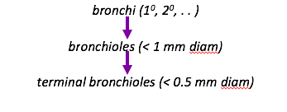
- Conducting zone structures
- Right primary bronchus is wider, shorter, more vertical than left
- Air in bronchi is warm, cleansed of most impurities and humidified
- ~23 orders of branching air passages in lungs = bronchial or respiratory tree

- Changes in wall composition as one moves through tree:
a) Cartilage: rings to plates to none
b) Epithelium: pseudostratified columnar to columnar to cuboidal; no cilia or mucous cells in bronchioles
c) Smooth muscle: relative amount increases as passages become smaller

Respiratory zone
- Terminal bronchioles branch into respiratory bronchioles
- ~300 million alveoli = huge surface for gas exchange
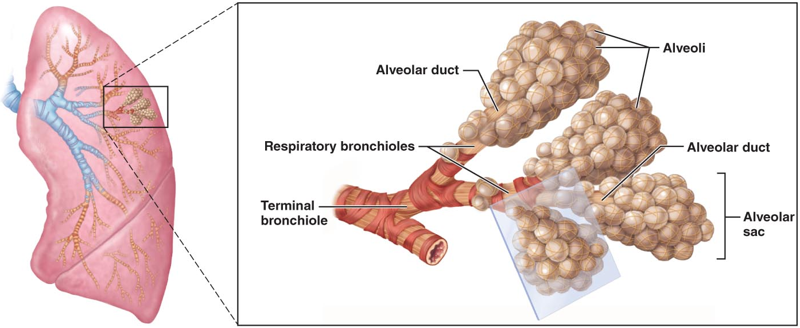

Identify the cell types shown in this diagram
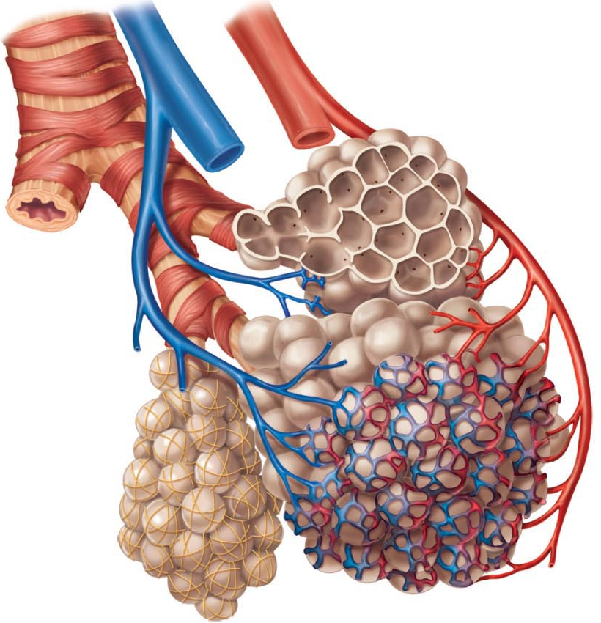
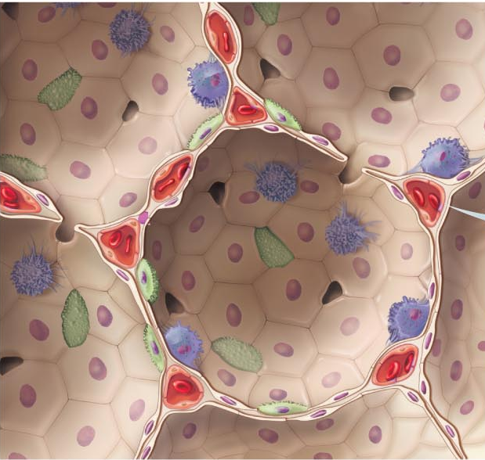

- Respiratory membrane = alveolar wall + capillary wall + basal laminae
- Respiratory membrane is an air-blood barrier; gas exchange by simple diffusion
- Type II cells: scattered among type I cells; secrete surfactant
- Other characteristics of lung alveoli
i) Surrounded by fine elastic fibers
ii) Alveolar pores: allow equalization of air pressure throughout lung; alternate air routes if bronchi collapse
iii) Alveolar macrophages = dust cells; inner alveolar surface; clear and swallow > 2 million dust cells/hours

6.2 Describe the gross structure of the lungs and the pleural coverings
- Paired lungs occupy entire thoracic cavity except mediastinum
- Each lung suspended in own pleural cavity; connected to mediastinum by vascular and bronchial attachments (=root)
- Costal surface = anterior, lateral and posterior lung surfaces in close contact with ribs
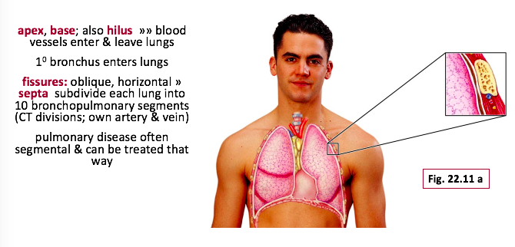

- Lobule: smallest subdivision seen with naked eye; hexagon ~ size of pencil eraser; served by large bronchiole
- Lung: primarily air spaces; rest is elastic CT
Blood supply and innervation
- Pulmonary arteries bring blood to be oxygenated
- Pulmonary veins return oxygenated blood
- Bronchial arteries provide systemic blood to lungs bronchial veins
- Innervation primarily parasympathetic (effect?) + some sympathetic (effect?)

Pleura
- Thin, double-layered (parietal and visceral) serosa
- Pleural fluid: serous secretion that fills pleural cavity >> lungs slide easily during breathing; surface tension keeps pleurae from separating
- 3 chambers: central mediastinum + 2 lateral pleural compartments
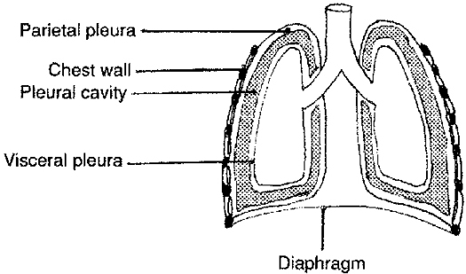
- Pleurisy: inflammation of pleurae

