Geography Unit 1/2 Notes

1.1 What is Geography?

- Geography is the study of spatial variation, how and why things differ from place to place on the surface of the earth
- Study of how observable spatial patterns evolved through time
- Geographers focus on the interaction of people and social groups with their environment – planet Earth – and one another
  - Want to understand how and why physical and cultural spatial patterns evolved through time and continue to change
  - Sensitive to variety of forces affecting a place and interactions among them
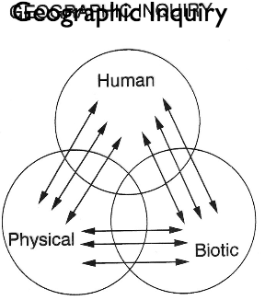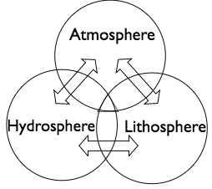
1.2 Evolution of Geography

- Eratosthenes over 2200 coined geography as “the earth, to write”
  - Focused on both the physical structure of earth and on nature and activities of the people who inhabited the various lands of the known world
- Strabo (64 BC – 20 AD) “describe several parts of inhabited world…to write assessment of countries of world and treat their differences”
- Herodotus (484-425 BC) writing devoted to lands, peoples, economies, and customs of various parts of Persian empire to understand causes and course of Persian wars
- Early geographers measured earth, divided into latitudes and longitudes, and drew world that they new
  - Did most modern geography stuff, as well as studying cultural similarities and differences
- Even ancient Chinese involved in geography, Muslim scholars analyzed their known world in physical, cultural, and regional variations
- European exploration voyages renewed interest in geography
Subfields of Geography

- 19th century brought rise to human geography so subfields like political geography, urban geography, and economic geography came to light
- subfields closely interrelated:
  - spatial variation of physical and human phenomena on surface of the earth (relationships between human societies and natural environments that they occupy and modify)
  - systems that link physical phenomena and human activities in one area of the earth with other areas
  - regional analysis: geography studies human-environmental (ecological) relationships and spatial systems in specific locational settings
- systematic geographers focus attention on one or a few related aspects of physical or human environments
- physical geography directs attention to natural environmental side of human-environmental structure (landforms, atmospheric conditions, soils, etc.)
- human geography emphasizes people (where, what, interactions, etc.)

Why it Matters

- only discipline concerned with understanding why and how physical and cultural phenomena differ from place to place on earth
- grasp of broad concerns and topics of geography is vital to understanding national and international problems that dominate news reports (global warming)
- broad field of study means greater diversity of job opportunities for those pursuing college training in discipline

1.3 Core Concepts

- spatial is essential modifier in framing their questions and forming concepts
  - the way things are distributed, way movements occur, way processes operate over whole or part of earth’s surface

Location, Direction, and Distance

- location of places and things is starting point of all geographic study as well as of our personal movements and spatial actions in everyday life
  - absolute location is identification of place by precise and accepted system of coordinates (mathematical, latitude longitude)
  - relative location is position of a place or thing in relation to that of other places or things (special interconnection nand interdependence and may carry social and economic implications)
  - site refers to physical and cultural characteristics and attributes of place itself – more absolute
  - situation refers to relations between place and other places – more relative
- absolute direction is based on cardinal directions
- relative directions are culturally based and locationally variable “Far East, Down South”
- absolute distance refers to spatial separation between two points on earth’s surface, measured by unit
- relative distance turns these into more useful units like time
Size and Scale

- scale tells us relationship between size of area on a map and actual size of mapped area on surface of the earth – feature of every map
  - implies degree of generalization represented (large-scale vs small-scale issues)
  - macroscopic process: large area
  - microscopic process: shows small area
  - mesoscopic process: shows in between area
- density: number of objects per unit area
- dispersion: how near or far objects are to each other
- pattern: a theme of recurring events or objects

Physical and Cultural Attributes

- physical characteristics of a place are natural aspects
  - provide setting within which human action occurs – shape but don’t dictate how people live (resource base vs how it is used)
- cultural landscape
  - natural landscape altered by human activity or marked with cultural society

Attributes of Place Are Always Changing

- physical environment is always changing whether we notice it or not
  - glacial retreat, deforestation

Interrelations between Places

- places are connected with other places in structured and comprehensible ways
- everything is related to everything else but relationships are stronger when things are near one another according to Tobler’s First Law of Geography
  - interaction between places diminishes in intensity and frequency as distance increases
- accessibility refers to relative ease to which one place can be reached from another; opportunity for spatial interaction
- connectivity is directness of routes linking pairs of places, all tangible and intangible ways in which places are connected
- networks are patterns of routes connecting sets of places
- special diffusion is process of dispersion of an idea or a thing from center of origin to more distant points
  - rate and extent of diffusion affected by distance separating origin to other places, as well as population densities, communication, innovation, etc.
- globalization is increasing interconnection of more and more peoples and parts of the world as the full range of social, cultural, political, and economic, and environmental processes becomes international in scale and effect

Place Similarity and Regions

- no places can be exactly the same
- regions are earth areas that display significant elements of internal uniformity and external differences from surrounding territories
  - everywhere is different but use regions to generalize to make it simpler to talk about places
- special distributions are spatial arrangements of environmental, human, or organizational features selected for study
- spatial association occurs when spatial distributions are closely related
- Administrative regions are created by laws, treaties, or regulations (states)
- Formal (uniform) region is area of essential uniformity for a single physical or cultural feature or a limited combination of physical or cultural features (Corn Belt)
- Functional (nodal) region is spatial system
  - Independent parts, dynamic organizational unit (paper route, area that receives health care or television)
- Perceptual regions are less rigorously structures
  - Exist and have reality in perceptions of societies (Midwest, Little Italy)

1.4 Geography’s Themes and Standards

- Five fundamental themes:
  - Location: meaning of relative and absolute position on the earth’s surface
  - Place: distinctive and distinguishing physical and human characteristics of locales
  - Relationships within places: development and consequences of human environmental interactions
  - Movement: patterns and change in human spatial interaction on the earth
  - Regions: how they form and change
- Environmental determinism is the contention that the natural environment is the sole determining factor in shaping all human culture
- Possibilism maintains that in any aspect of culture, nature presents humans with a number of alternatives from which to choose and thus in some sense allows them to determine their own futures
- Probabilism is a combination of both

1.5 Traditions of Geography

- William Pattison at opening session of annual convention of national council for geographic education, November 29, 1963
- Spatial tradition
  - Mapping, spatial analysis, boundaries and densities, areal distribution
- Area studies tradition (regional)
  - Description of regions or areas, world regional geography, regions differ
- Man land tradition
  - Human impact on nature and vice versa, natural hazards, perception of environment, environmentalism, cultural/political/population geography
- Earth science tradition
  - Physical geography, lithosphere, hydrosphere, atmosphere, biosphere, earth-sun interaction, other ologies, study of earth as home to humans
1.6 Scientific Method

- Postulate a conceptual model of nature from which observable behavior of nature can be accurately predicted
  - Postulate model based on existing experimental observations and measurements
  - Check predictions of model against further observations and measurements
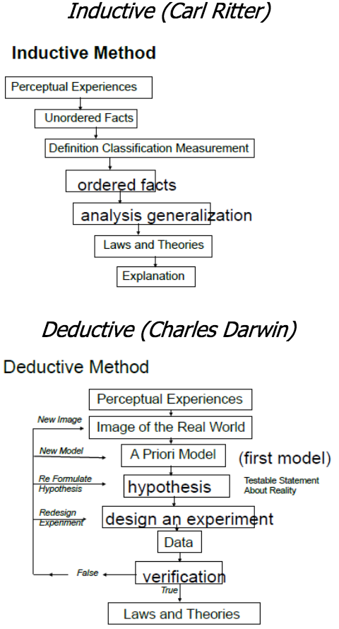
  - Adjust or replace model as required by new observations and measurements
- Inductive method: general laws from individual observations
- Deductive method: models -> prediction -> test against observation (certain phenomena from general laws)
- Paradigm: intellectual structure or body of knowledge that identifies set of beliefs within a science that have been agreed upon by its practitioners to define that science
- Models: representation of the thing under study, 3 basic types and 2 different flavors, in order of increasing abstraction (real world -> iconic -> analogue -> symbolic), reverse is realism
  - Iconic – represent properties of real world with only changes in scale
  - Analogue – one property is represented by another (contour lines for elevation)
  - Symbolic – properties expressed by symbols usually in mathematical form
  - Flavors
    - Static: concerned with one period of time (statue)
    - Dynamic: predict future patterns and those which change over time (movement)
- Data collection
  - Experimental: control as many factors as possible
  - Normative: observation and measurement without control, observe vents with a view of establishing constant relationships
  - Historical: no control but involves sequences over time, relies heavily on accurate observations in time
- Advantages of scientific method
  - Logical, objective, can be reproduced, mathematical precision

