BIO1140 LAB EXAM – FSS 2005 – 1-2:30 PM
FORMAT
50 questions (MCQs, short answers, basic calcs) displayed on room screen + LOT of pictures of structures observed during each lab to ID + 1 min average/question
Microscopes | Name/function of parts, setting/use, taking digital pictures
Labs | Lab activities + material covered in the lab/printed in the manual + content of lab assignments
Lab manual | Lab chapter + appendices (not intro): how to graph data, trace a table, nomenclature rules
Pictures | ID organism, cell type, biological process
Measurements/units | Convert SI units, how to measure samples on a microscope
No calculator, lab manual, textbook allowed – 50% of lab component

Lab 1 – Introduction to the Microscopy & Observation of Prokaryotic and Eukaryotic Cells
Types of microscopes used
CX41 Compound microscope | Stereoscope (Dissection) | ImagePro Express
Image J/Qcapture
Oculars | Screen
- Greater resolution + wider field of view | - Share observations + more comfortable + pics
- Observations done via computer through Image J (program) + Qcapture (capture plugin)
- Log on computer connect microscopes/computer start program
- Colour dot facing up
- Image J Analyze Qcapture Acquire Q-cam snap
Compound Microscope
- Place between computer/end of counter
- Best image = clearest ≠ largest
- Ensure light intensity control is at min before turning power on – prolongs light bulb life
- Adjust interpupillar distance adjust diopter ring until other eye can see in focus too
- Start on lowest objective work way up
- Never use coarse focus when at the highest objective
- Always readjust illumination whenever you change objectives
- Resolving power = ability to see 2 very close objects as 2 separate things
Orientation/working distance
- Working distance = distance between objective lens/slide – as you change to greater objectives, the working distance gets smaller
- Images inverted UPSIDE DOWN only
- Moving slide up/down or left/right produces opposite motions in microscope
Depth of field/focus
- Depth of focus = number of planes where object is in focus; when focused on one surface, all the others are out of focus – depth of field inc @ lower objectives
Magnification
- Total magnification = production of magnification of each lens
- $Magnification factor=\frac{measured size of object}{actual object size}=\left(\right)X$
Specimen size and Magnification of the Picture
- 2 objects have the same relative (ratio) size in the real world/microscope
- $\frac{Actual size of A}{Actual size of B}=\frac{on-screen size of A}{on-screen size of B}$ Can use the field of view (FOV) length
- $\frac{Actual size of object}{Actual size of scale bar}=\frac{On-screen size of object}{On-screen size of scale bar}$
Revolving nosepiece | Support objectives – only use 4X, 10X, 40X
Stage | Supports observed specimen – X/Y knobs on top
Coarse focus knob | Rapid change in specimen/objective distance
Fine focus knob | Small change in specimen/objective distance, final focus
Ocular/eyepiece | 10X magnifying element, microscopes = parfocal (focus ~same between objectives)
Objectives | Magnifying element
Condenser | Lenses that concentrates light from illuminator
Condenser height adjustment knob | Light concentration adjustment on specimen
Aperture iris diaphragm | Reduce glare via adjusting light angle cone from ^, match this value with the “numerical aperture” engraving from the objective
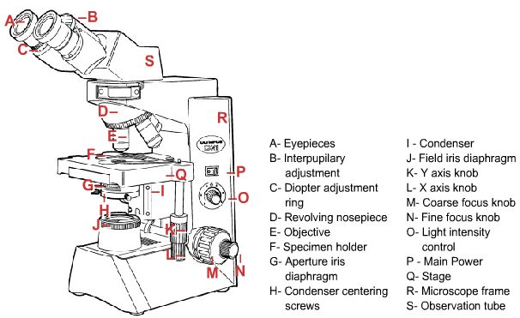
Stereoscopic microscope (dissecting microscope)
- To view objects that are too large/thick for the compound microscope
- IMAGE IS NOT INVERTED + 3D image
- Moving the dial = continuous change of magnification
- 2 options:
- Reflected light: for opaque specimens (from above)
- Transmitted light: for translucent specimens (from beneath the stage)

Prokaryotic/Eukaryotic cells
- Prokaryotic: archea and eubacteria, smaller (1-5 um), most abundant on earth
  - No membrane-bound organelles (nucleus, mito/chloro)
  - Genetic material = 1 circ chromosome + plasmids
- Eukaryotes: more complex/numerous organelles, larger genome
- Organelles
Plasma membrane | Semi-permeable protoplasm layer (phospholipid bilayer + proteins)
Cell wall | Ridged wall surrounding PM in bacteria/fungi/algae
Protoplast | Nucleus, cytoplasm, PM
Cytoplasm | Cytosol + memb-bound organelles (outside nucleus)
Nucleolus | Body in nucleus of euks containing rRNA templates
Chloroplasts | Subject to cytoplasmic streaming/cyclosis (cytosol flow – move nutrients)
Observed eukaryote = Elodea (plant)
- PM = too thin to see treat with salt solution see protoplast = plasmolysis
Observed prokaryote = Oscillatoria (eubacteria - cyanobacteria)
- Prepared wet mount: small amount on slide + water drop + placed coverslip
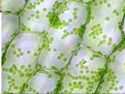
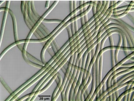
- Green + moving filaments
Measurement Notes
- 1 um = 1x10^⁻⁶ m
- 1 nm = 10x10^⁻⁹ m
Lab 2 – Permeability of the Red Blood Cell (Erythrocytes)
- RBC/Erythrocytes contain pigment hemoglobin
Osmosis
- Osmosis = spontaneous water movement across semi-permeable memb;
- Movement via aquaporins (special proteins)
- Movement driven by tonicity adjustments: will move from -[solute] to +[solute]
- Tonicity = ability of sol’n to create water movement
Diffusion
- Diffusion = spontaneous movement of molecs in a sol’n against conc gradient
- Some molecs cross PM more difficultly or easier than others
Hemolysis
- Hemolysis = when RBC vol exceeds max rupture pigment released
  - Happens in extremely hypotonic sol’ns OR in isosmotic sol’ns
- Isosmotic sol’n = same solute concs (penetrating/non-penetrating) than cellular fluid
  - Osmotic P equal at onset
  - As penetrating subst enters, tonicity/osmotic P changes hypotonic sitch
- Hemolysis times = reflection of memb permeability to those substs
- When 75% of cell pop is hemolysis RBC suspension = transparent
Procedure A – Using sheep’s blood
- 5 sol’ns x 3 times each = 15 total expts mean/standard error per time
- Ex. Distilled water, glycerol 0.3M, ethylene glycol 0.3M, sucrose 0.3M, urea 0.3M
- Add 1 drop of blood cover top invert once + start timer line is clear + stop timer
- Factors that effect solute diffusion: molecular size, polarity, tonicity
  - Smaller solute easier to pass PM
  - +Polar characteristics (hydroxyl, carboxyl) harder to pass PM hydrophobic core dominates the PM
    - Water = exception (very small + special aquaporins) fast time
    - Urea = polar but very small fast time
    - Ethylene glycol = carbonyl group + H bonding decent time
    - Glycerol = 3 OH groups slow time
    - Sucrose = very large/polar slowest time
  - Tonicity: as molecs diffuse through, water follows +vol/hemolysis (isosmotic)
Procedure B – RBCs subjected to various osmotic conditions
- Small quantity of blood + 1 drop of 0.145M NaCl on slide + add coverslip
- Repeat with 0.350M NaCl + 0.065M NaCl
- Observe shape + measure diameter of RBCs
  - As conc got higher cell shape got smaller
*Lab Report
- Table for solution with their hemolysis time (mean average, standard error)
- Questions on factors effecting solute diffusion + how they effect
Lab 3 – Cellular Processes in Amoeba proteus
- Ameoba proteus = single celled protist, found in ponds/lakes, pseudopodia for movement/food, 600 um in length, easy to culture, good model for +cell processes
Amoeboid Movement
- Small chambers of parafilm melted onto a microscope slide to prevent crushing
- Need low light intensity – amoebas = very sensitive to light
- Distinguish between regions of: hyaline ectoplasm + granular endoplasm (fluid/gelatinous) + uroid + hyaline cap (cytoplasm)
- Locate/ID function of following organelles:
Pseudopodium | More (l) centered endoplasm streams fwd, hits hyaline cap, deflects to the side ectoplasm
Uroid (posterior region) | Accumulates waste, detaches from rest of cell
Plasmalemma (Cell memb) | Restricts molecs from passing through, transports
Ectoplasm | Outer, non-granulated part of cytoplasm
Hyaline cap | Tip of pseudopodia
Granular endoplasm (gelatinous/fluid) | Inner layer of cytoplasm
Contractile vacuole | Fights entry of water via osmosis
Triuret crystals (highly birefringent) | Crystalline compound
Nucleus + Digestive/food vacuole
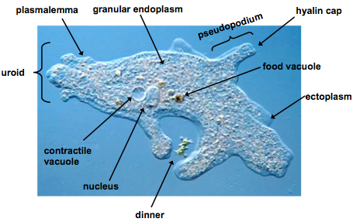
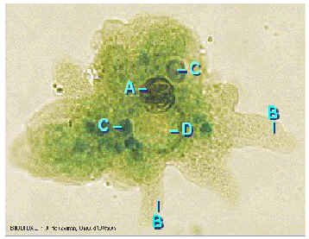

A – Nucleus
B – Pseudopodia
C – Food vacuole
D – Water expulsion vesicle

Contractile Vacuole
- Amoebas live in water must fight entry of water via osmosis (ECF = hypoosmotic)
- Contractile vacuole cycle: take in water in cytosol release it to ECF
  - Ameoba proteus has only ONE vacuole
- Time 0 = time when amoeba empties CV contents = systole
  - Diastole = coalescence + continual growth
- Typical cycle lasts 4-6 mins
*Procedure
- Track CV during 2 full cycles + take pictures every 30 seconds
- Use snapshots to measure CV diameter (in um)
Endocytosis
- Endocytosis 1st described in Amoeba
- Bulk-phase/nonspecific endocytosis: induced by large variety of substs: protein, AAs, salts, stains
*Procedure - Endocytosis
- Place amoebas with water into 1 well of multi-welled plate, fill next well with inducting sol’n (0.05% Alcian blue pH 4.4 with 1% bovine plasma albumin) transfer amoeba
- Prepare wet mount
- Inducing agent causes endoplasm flow to stop + formation of pseudopodia (small feet)
- Observe formation of small canals + accumulation of Alcian blue in endocytic vesicles
- *Phagocytosis may be observed if amoeba is hungry
*Lab Report
- Plot CV volume (average +/- SE) over time using class data + caption
Lab 4 – Mitosis
- Prokaryotes/unicellular euks: cell division to reproduce
- Multicellular euks: cell division to develop an embryo, grow, replace cells
- Eukaryotes cell division = mitosis OR meiosis
- Times in each stage = proportional to cell number found in each stage relative to others
Cell cycle
Interphase | Separates 2 cell divisions – growth/preparation for M phase, most cellular processes carried out here – LONGEST STAGE  * Clear nucleus, dark staining nucleoli + heterochromatin
G1 (first gap) | Growth, active synthesis, organelles duplicate  Some cells stop here (most higher plants/animals)
S (synthesis) phase | DNA replication, DNA protein synthesis, microtubule protein synthesis chromosome made of 2 chromatids joined by cohesion proteins
G2 (gap 2) | Protein synthesis, spindle fiber production
G0 | Stage designated to cells that left the cell cycle (permanent/temp)
M Phase/Cell division | Nuclear (mitosis) + cytoplasmic (cytokinesis) divisions IDENTICAL  After 1 round, cells may:  - Divide continually (ex. epithelium, germ skin layers)  - Leave cell cycle, G0 (ex. nerve cells)  - Enter rest state (G0/G1/G2) + return/divide later
Prophase | Chromos shorten/thicken, 2 chromatids attached at centromere, mitotic spindle forms, nucleoli disappears, centrioles find cell poles
Prometaphase | Nuclear memb breaks down, kinetichore (centromere + spindle fiber from opposing centrioles), migrate to equatorial plate
Metaphase | Chromo centromeres all at metaphase plate, centromeres start separating
Anaphase | Daughter chromos move to opposite poles via microtubule shortening
Telophase | Chromos recondense, nuclear membrane/nucleolus reappears
Cytokinesis | Division of cytoplasm beginning in late anaphase telophase  Animal cells: cleavage furrow in the middle  Plant cells: cell plate at the equator
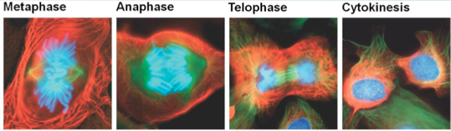
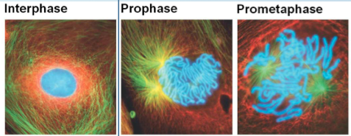

Microscopic observation of mitosis
- More easily seen in plants chromosomes are clearer + confined to certain areas
- Growth centers: root tips + apical meristems (stem tips)
- *Squash preparation: tissue 1st fixed/stained + squashed by coverslip single layer
  - Feulgen stain used for chromosomes
*Procedure – Feulgen squash of broad bean (Vicia faba) root tip
- *Squash preparation: tissue 1st fixed/stained + squashed by coverslip single layer
- Wash root tip 1st in alcohol
- Feulgen stain used to colour chromosomes magenta red
  - “Schiff base” to react with the aldehyde groups coloured rxn product
  - DNA has deoxyribose sugar molecs (chemically linked via aldehydes to bases)
  - To react with stain, hydrolyze DNA with hot 60°C 1N HCl to remove purine bases “apurinic acid” (also softens tissue)
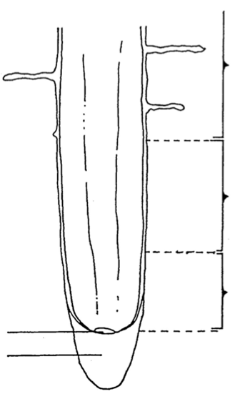
    - 10 mins – too little won’t free enough + too long destroys the tissue
- Remove HCl + add cold water to stop hydrolysis + remove water/add stain (½ h)
- Cut off 2 mm of the tip of the stained root tip + prepare squash
*Procedure – study the longitudinal section of an onion (Allium cepa)
- Younger cells = square/smaller + no nuclei at the root cap
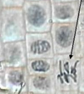  Root cap | Protects apical meristem of root tip as pushed into soil
Region of apical meristem | Just above ^, cell division zone
Quiescent center | At ^ base, inactive region (arrested in G1)
Region of elongation | Above region of cell division, long cells inc root length
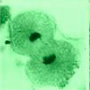  Region of maturation | Where most primary tissue cells mature, root hairs found here
Xylem cells | Bundles transporting water/salts from soil rest of plant
Phloem cells | Transport carbs from photosynthetic leaves roots  *Roots don’t have chloro can’t make their own food
*Procedure – study prepared slides of whitefish blastula (embyros) (Coregonus clupeaformis)
*Procedure – counting cell stages
*Lab Report
- Graph (2 panels) representing % cells in each of 6 cell cycles phases for 3 diff organism
- Conclusion: comparison of data (group/class data), find relative length of each phase
Lab 5 – Meiosis
- Only occurs in sexually reproducing organisms
- Alternation of generation in plants (sporic meiosis): 2n sporophyte meiosis n spore mitosis n multicellular gametophytes gametes fuse 2n zygotes mitosis 2n sporophyte
- Alteration of ploidy level in animals (gametic meiosis): 2n individual meiosis n gametes fuse 2n zygote mitosis 2n organism
Stages of Meiosis I
Premeiotic Interphase | ~Mitotic interphase, S phase 20x longer, chromo replication (DNA/proteins) sis chromatids joined, centriole replicate
Prophase I | Homologous chromosomes pair, recombination, LONGEST stage (weeks)
Leptotene | Initial chromo condensation
Zygotene | Homologous pairs line up along length = synapsis  Non-sister chromatids intertwine = synaptonemal complex
Pachytene | Crossing over (genetic swap) – sites = chiasmata, homologues = tetrads
Diplotene | Homologue separation inc to become visible
Diakinesis | Chromo condensation stops, nucleolus disappears
Metaphase I | Nuclear membrane breaks down, homologues line at equatorial plate, each chromo gets 1 microtubule spindle fiber
Anaphase I | Complete homologues are pulled away from each other
Telophase I | Chomo decondense, spindle breaks down, nuclear memb forms  Cytokinesis continues 2 daughter cells with ½ chromo numbers
Interkinesis | Interphase-like stage between meiosis I/II no DNA replication
Stages of Meiosis II
Prophase II | Nuclear memb breaks down, chromo recondense, chromo begin to move
Metaphase II | Chromo lines up at equator
Anaphase II | Sister chromatids separate + Cytokinesis begins
Telophase II | Chromo decondense, nuclear memb/nucleoli reforms 4 n cells made
Meiosis in plants
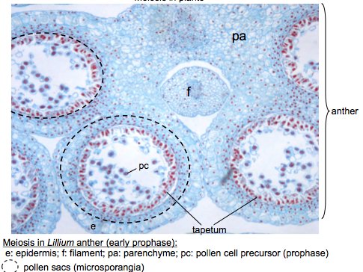
- In angiosperms (flowering plants), both male spores (microspores)/female spores (megaspores) involved
- In Lilium, male gametophytes form on anthers
  - 4 sporogenous cells made in pollen sacs, surrounded by +layers sterile layers
  - Tapetum = innermost layer that develop into nutritive source
  - Outermost form wall of the microsporangium
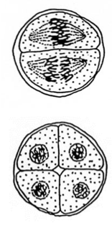
  - Sporogenous cells microsporocytes meiosis 4 microspores mitosis [tube cell+ generative cell (microgametophyte) = pollen grain]
  - (http://www.iasprr.org/old/iasprr-pix/lily/male.shtml)
Meiosis in Animals
- Spermatogenesis = formation of male gametes 4 viable sperm are produced
- Oogenesis = formation of female egg + 2 polar bodies
  - 1st division: 1 large egg (with most cytoplasm) + polar body
  - 2nd division: large egg large egg + polar body
Meiosis in Animals (Ascaris) (roundworm)
- 2n = 4 chromosomes = easy to follow
- Spermatozoa in male testes meiosis leaves testes + up female seminal vesicle
- Female egg shoved from the ovary in Prophase I
- Copulation: sperm reaches egg + penetrates moves into egg center/loses its memb
- Sperm entrance stimulates the egg to resume meiosis/enter Metaphase I
  - Here that egg secretes its protective shell
- One set of chromos pinch off as 1st polar body again next set of chromos pinch off
  - Pinch off in the space between the oocyte and the shell
- N egg and sperm in interphase for a while as “male and female pronuclei” zygote
  - Divides via mitosis embryo of 2, 4, 8 cells
- http://www.uoguelph.ca/zoology/devobio/210labs/meiosis1.html pictures to recognize
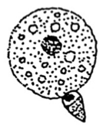
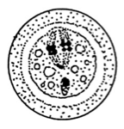
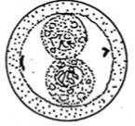
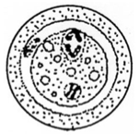
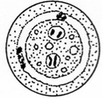
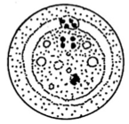
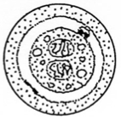

Gametogenesis in mammals – Spermatogenesis in rats (Rattus norvegicus)
- Continuous process orderly fashion from outside seminiferous tubule to lumen
Spermatogonia (2n) | Darkly stained outer cells, divide by mitosis to produce more  ½ go on to meiosis while the rest keeps dividing
Primary spermatocytes (2n) | Just below ^, not as dark, undergoing 1st meiotic division
Secondary spermatocytes (n) | Smaller, further twd tubule lumen, 1st meiotic division product
Spermatids (n) | Small, circ, will differentiate into functional spermatozoa
Spermatozoa (n) | Easily recognizable – long thin flagellum bordering the lumen
Nurse cells (Sertoli cells) | In seminiferous tubule walls, feed/regulate ^^^^^
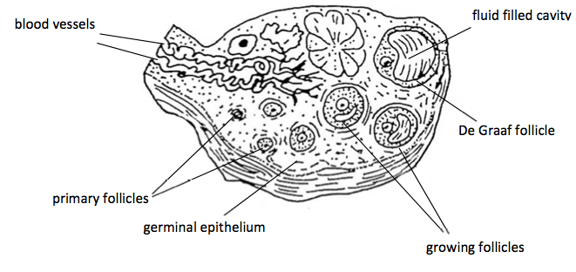
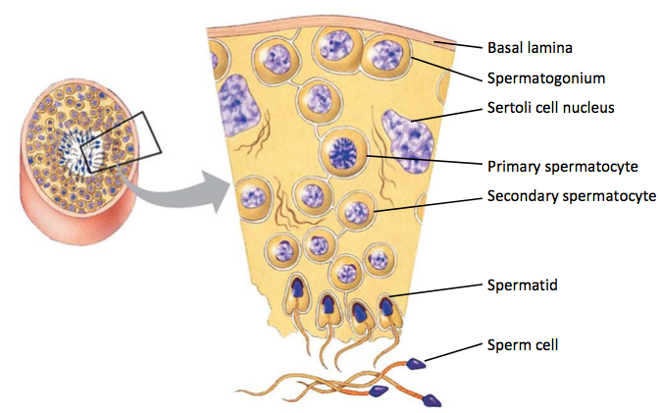
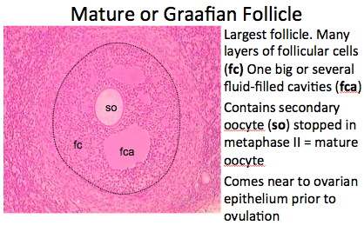
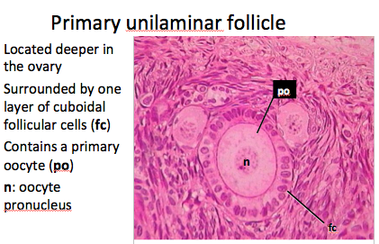
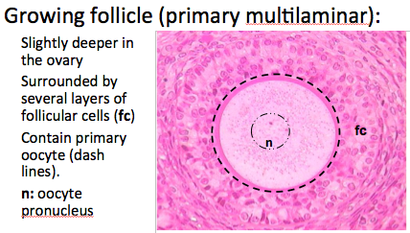
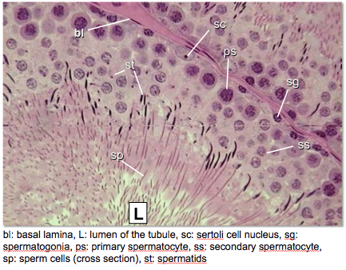

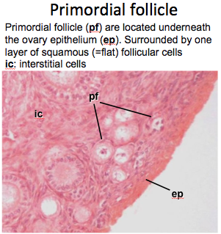

Gametogenesis in mammals - Oogenesis in rabbits (Sylvilagus floridanus)
- Ovaries = struc where egg-forming cells grow in cavities called follicles
- Newborn mammalian females contain all oogonia ever needed
Oogonium | Primordial oocyte in female fetus
Primary follicle | Oogonium + follicular cells  At ovary periphery
Primary oocyte | When Oogonium enlarges after meiosis I
Growing follicle | Primary oocyte + proliferating follicular cells  Few layers of follicular cells + Larger
Mature/Graafian follicle | Following hormone stimulation of primary oocyte after MetII  Enlarged + most space filled by large fluid-filled cavity
- Cytokinesis of primary oocyte large secondary oocyte + 1st polar body
- Secondary oocyte stops at Metaphase II + waits for female hormone stimulation
- Mature follicle ruptures at surface of ovary via “ovulation” release mature oocyte
- Mature oocyte continue Metaphase II only if penetrated by sperm
*Lab Report
- Annotated picture printout + biological drawing

APPENDICES
Graphical representation of quantitative data
- Bar graphs: quantitative variables on ONE axis only
- Histograms: used to analyze/study distributions + quantitative scales on both axes
- 2 Panel bar graph/histogram:
  - X panel label on lower panel only (tick marks on both X axes)
  - Y axis scale same on both panels
- Straight-line graphs: (n>30) connected data points are available to see trends/changes
- Scatterplots: to see relationship between 2 sets of data
- Page layout: graph = 2/3rds of portrait page, bottom 1/3 for caption
- Data:ink ratio: maximize by reducing amount of non-data ink
- Data:
  - Symbols = more prominent than lines linking them together
    - Distinguish overlapping ones (ex. superscripted numbers)
  - Symbol key in area devoid of data
- Axis Units:
  - Scale that gives data points most available space
  - Scale breaks only when necessary don’t connect points on either side
  - 3-5 tick marks on quantitative axis (y-axis)
  - Unlimited tick marks on non-quantitative axes (x-axis)
  - Tick marks point outwards + each should be labeled
- Axis identification (labels)
  - Units between brackets to be included after label text
- Caption DO NOT DESCRIBE TRENDS IN THE DATA
  - Starts with figure number (Fig1.)
  - 1st sentence = type of data on each axis + complete name of organism
  - Explain how the data was collected/analyzed
  - Indicate sample size (n=20)
  - If means presented, should state (Mean average ± standard deviation)
- Binomial nomenclature: Genus species/Genus species (1st = capital, 2nd = lowercase)
Preparation of Tables
- Items that are compared = vertical + comparative criteria = horizontal
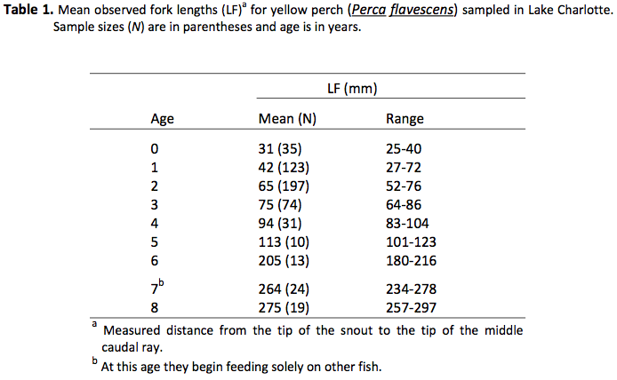
- Items closer together = more related
- Caption:
  - Above table body + Begins with: table number, specific title
  - ID/explain non-standard symbols/abbreviations in caption/footnotes
- Column/row headings
  - NO VERTICAL LINES
- Body
  - Horizontal lines rarely used
Drawing biological specimens
- Layout:
  - Centered or slightly to the left to of the center of the page
  - ½ one page in size
  - NO FRAME
- Drawing:
  - Continuous lines + deep structures by dotted lines
  - No stippling, shading, cross-hatching, ink or colours
- Labeling:
  - Can label in sequence (A, B, C) or take letters from strucs: O or Ov (Ovary)
  - Avoid writing whole struc names
  - Put as many labels directly on the drawing (only off to side if unreadable)
  - Scale bar with right conversion included (bottom right of diagram)
- Caption:
  - Scientific organism name, sex, aspect (dorsal/ventral), type of preparation
  - DO NOT WRITE “a drawing of…”

