Experiment 1: Verification of Boyle’s Law

Rayyan Akhand (300013228)
Ananya Ramesh (300013242)

CHEM 1311 Section A05

Lab Assistant:
Patrick Berro

September 20, 2017

University of Ottawa

Introduction:
Boyle’s Law describes the correlation between the volume and pressure of a gas by stating that the volume occupied by a gas is inversely proportional to the external pressure given that the amount of gas and temperature remain constant, within a closed system. This law is one of the three gas laws which constitute the ideal gas law. The ideal gas law describes the behaviour of an ideal gas.

pV=nRT

Therefore, Boyle’s Law is under the assumption that a gas behaves ideally where its particles do not possess any intermolecular forces between one another and only interact in perfectly elastic collisions. Although gases do not behave ideally in reality, for the sake of simplicity this assumption is held to be true for the gases experimented.

Procedure:

- Connect the gas pressure sensor to LabQuest 2.
- Adjust the syringe to 6 mL mark.
- Attach the syringe to the valve of the gas pressure sensor.
- With a half turn, lock the syringe in place, connected to the gas pressor sensor.
- Input the variables (volume and pressure) and units (mL and kPa) into LabQuest2.
- Start the data collection.
- Hold the syringe at the initial mark.
- Allow the pressure to stabilize, then press “keep”
- Record the start volume and pressure in table 1
- Increase volume of syringe by increments of 2 mL.
- Allow the pressure to stabilize.
- Record volume and pressure in table 1.
- Repeat steps 10 through 12, 9 times in total, and use the initial volume (6 mL) for the final trial.
- Stop the data collection.
- Repeat steps 4 through 14, using the same increments of increase.

Observations:

Table 1: Trial 1 Data for Determination of Relationship between Volume and Pressure of a Gas
Volume (mL) | Pressure (kPa)
6.8 | 84.19
8.8 | 65.15
10.8 | 50.12
12.8 | 42.03
14.8 | 36.04
16.8 | 32.34
18.8 | 29.08
20.8 | 26.42
6.8 | 95.72

Figure 1: Trial 1 Graphical Interpretation of Data for Determination of Relationship between Volume and Pressure of a Gas

Table 2: Trial 1 Data for Determination of Relationship between Volume and Inverse of Pressure of a Gas
Volume (mL) | 1/Pressure (kPa^-1)
6.8 | 1/84.19
8.8 | 1/65.15
10.8 | 1/50.12
12.8 | 1/42.03
14.8 | 1/36.04
16.8 | 1/32.34
18.8 | 1/29.08
20.8 | 1/26.42
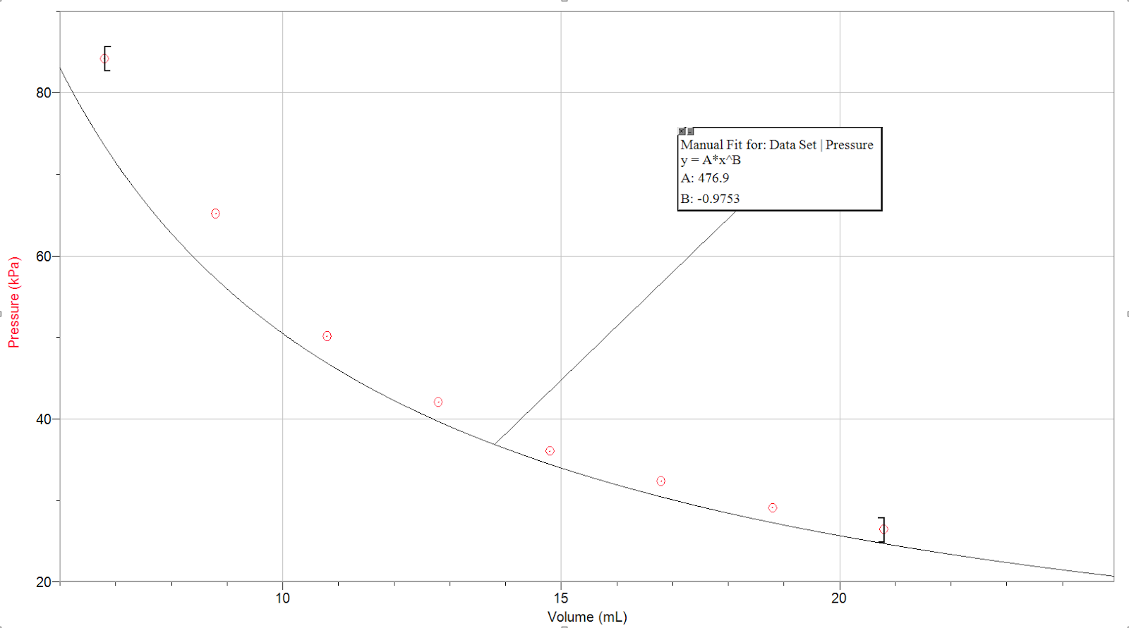  6.8 | 1/95.72

Table 2: Trial 1 Data for Determination of Relationship between Volume and Inverse of Pressure of a Gas
Volume (mL) | 1/Pressure (kPa^-1)
6.8 | 1/84.19
8.8 | 1/65.15
10.8 | 1/50.12
12.8 | 1/42.03
14.8 | 1/36.04
16.8 | 1/32.34
18.8 | 1/29.08
20.8 | 1/26.42
6.8 | 1/95.72

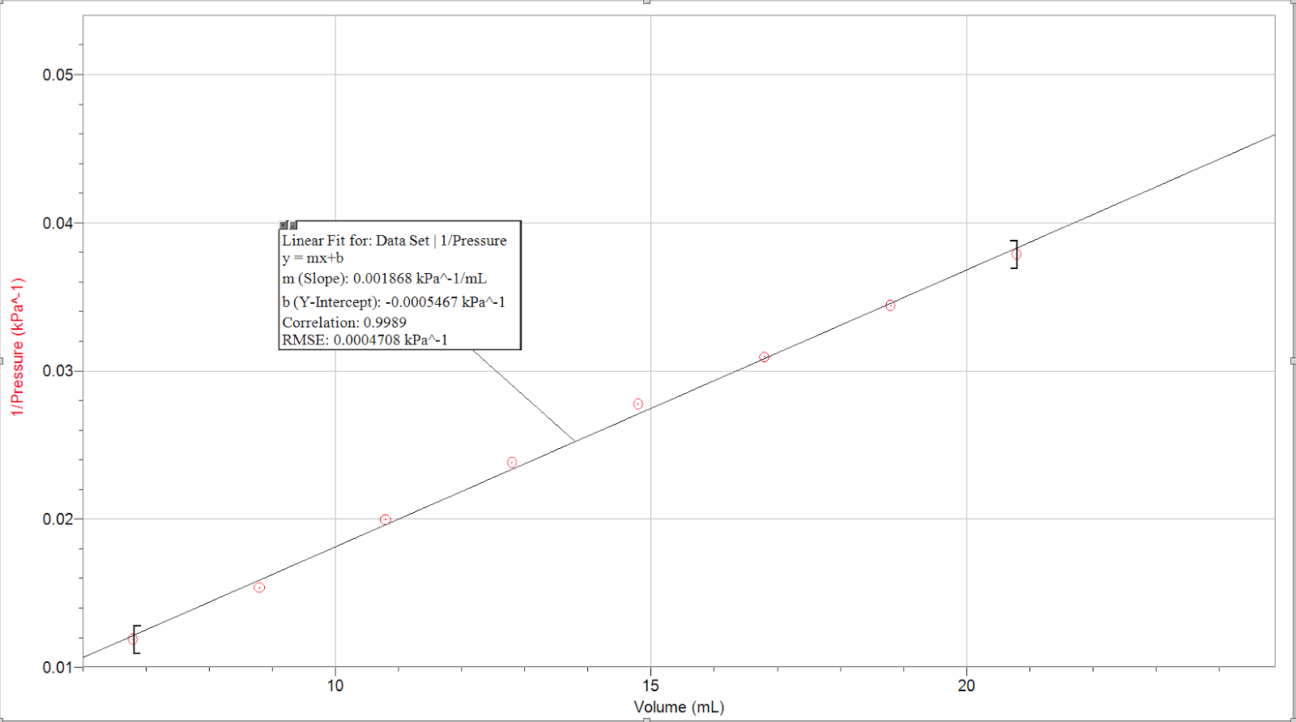
Figure 2: Trial 1 Graphical Interpretation of Data for Determination of Relationship between Volume and Inverse of Pressure of a Gas

Table 3: Trial 2 Data for Determination of Relationship between Volume and Pressure of a Gas
Volume (mL) | Pressure (kPa)
6.8 | 85.68
8.8 | 65.37
10.8 | 51.52
12.8 | 42.93
14.8 | 40.26
16.8 | 33.21
18.8 | 29.87
20.8 | 27.70
6.8 | 93.98

Table 3: Trial 2 Data for Determination of Relationship between Volume and Pressure of a Gas
Volume (mL) | Pressure (kPa)
6.8 | 85.68
8.8 | 65.37
10.8 | 51.52
12.8 | 42.93
14.8 | 40.26
16.8 | 33.21
18.8 | 29.87
20.8 | 27.70
6.8 | 93.98

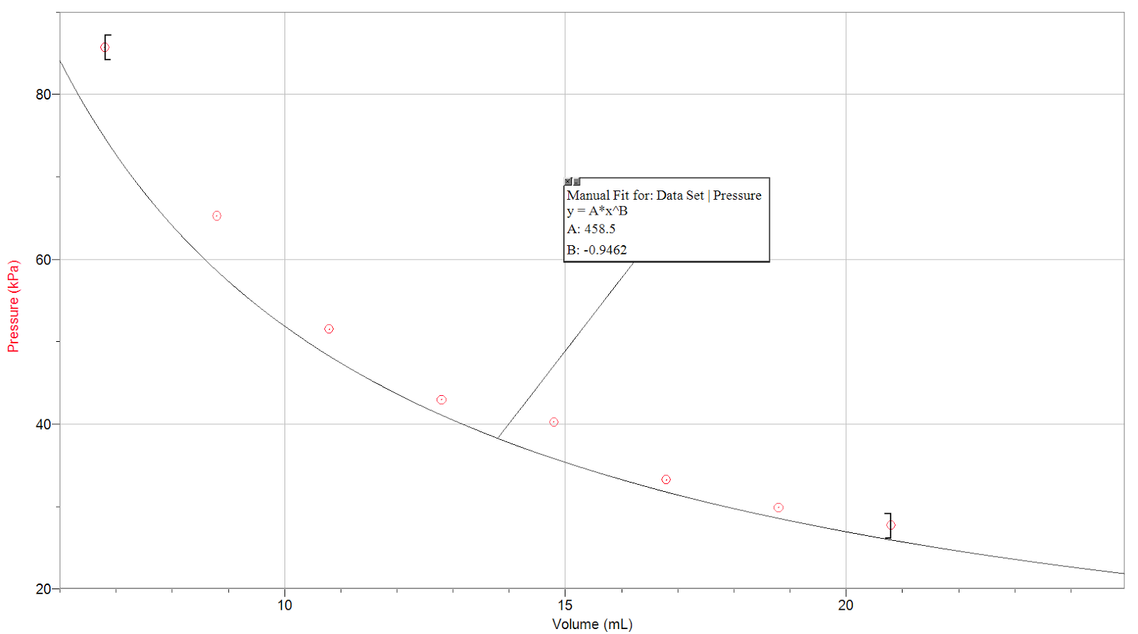
Figure 3: Trial 2 Graphical Interpretation of Data for Determination of Relationship between Volume and Pressure of a Gas

Table 4: Trial 2 Data and Results for Determination of Relationship between Volume and Inverse of Pressure of a Gas
Volume (mL) | Pressure (kPa)
6.8 | 1/85.68
8.8 | 1/65.37
10.8 | 1/51.52
12.8 | 1/42.93
14.8 | 1/40.26
16.8 | 1/33.21
18.8 | 1/29.87
20.8 | 1/27.70
6.8 | 1/93.98

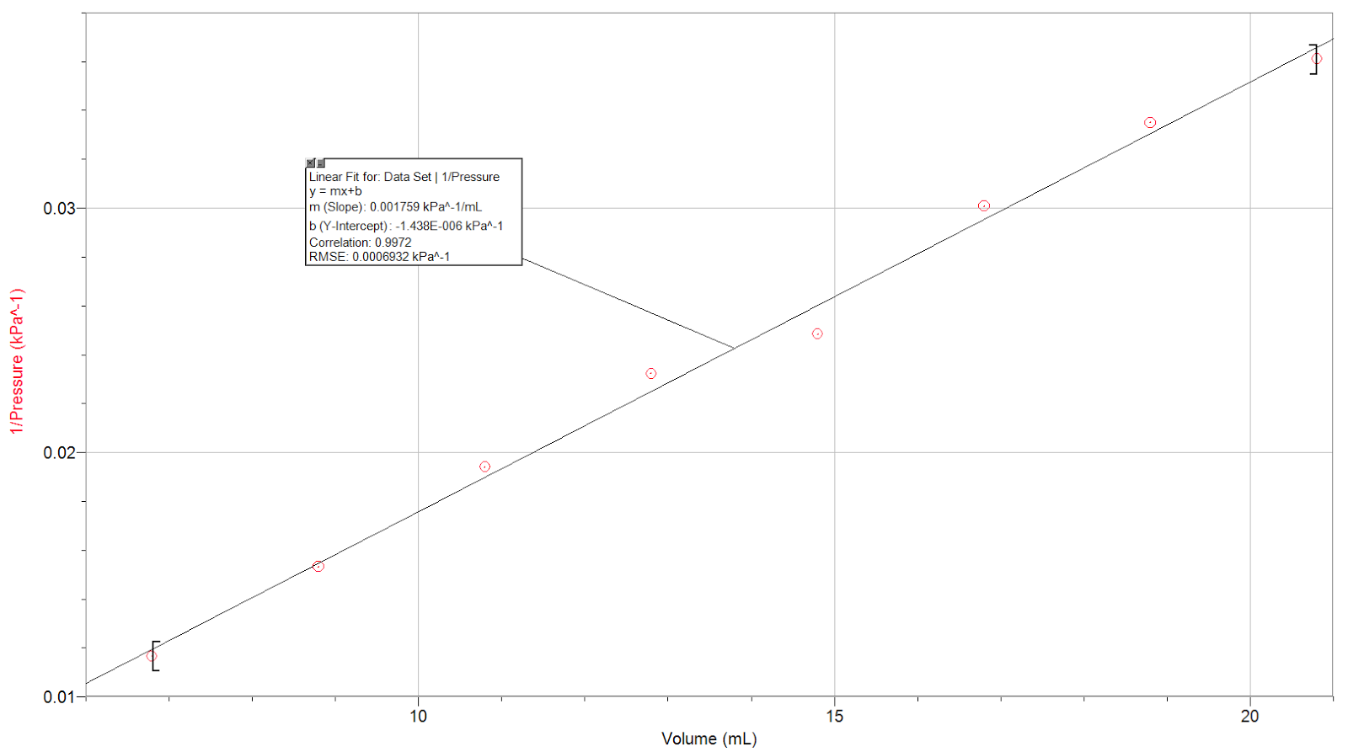
Figure 4: Trial 1 Graphical Interpretation of Data for Determination of Relationship between Volume and Inverse of Pressure of a Gas

Table 5: Calculations for Boyle’s Law Constant using Trial 1 Data
Trial Number | Volume (mL) | Pressure (kPa) | k = PV (kPa*mL)
1 | 6.8 | 84.19 | 6.8 x 84.19 = 572.49
2 | 8.8 | 65.15 | 8.8 x 65.15 = 573.32
3 | 10.8 | 50.12 | 10.8 x 50.12 = 541.30
4 | 12.8 | 42.03 | 12.8 x 42.03 = 537.98
5 | 14.8 | 36.04 | 14.8 x 36.04 = 533.39
6 | 16.8 | 32.34 | 16.8 x 32.34 = 543.31
7 | 18.8 | 29.08 | 18.8 x 29.08 = 546.70
8 | 20.8 | 26.42 | 20.8 x 26.42 = 549.54
9 | 6.8 | 95.72 | 6.8 x 95.72 =650.89
Average  Not including trial 9 | - | - | 553.46

Table 6: Calculations for Boyle’s Law Constant using Trial 2 Data
Trial Number | Volume (mL) | Pressure (kPa) | k = PV (kPa*mL)
1 | 6.8 | 85.68 | 586.62
2 | 8.8 | 65.37 | 575.26
3 | 10.8 | 51.52 | 556.42
4 | 12.8 | 42.93 | 549.50
5 | 14.8 | 40.26 | 595.85
6 | 16.8 | 33.21 | 557.93
7 | 18.8 | 29.87 | 561.56
8 | 20.8 | 27.70 | 576.16
9 | 6.8 | 93.98 | 639.06
Average  Not including trial 9 | - | - | 586.19
Determining K: Average of k constant between two trials: (553.46 kPa*mL + 586.19 kPa*mL)/2 = 569.83 kPa*mL

Data Analysis:

- Through the data it is seen that volume and pressure of a gas are inversely proportional to one another. This relationship can be described as:
V ∝ 1/P or P∝1/V
Or it can be described as:
PV = k, where p is external pressure, V is volume, and k is the Boyle’s Law constant
A Boyle’s law constant calculated for this experiment is 569.83 kPa*mL. Refer to Table 5 and 6 calculations above.

- Boyle’s law states that pressure is inversely proportional to volume (P∝1/V), such that k=PV. The constant k, 569.83 kPa*mL, can be subbed in this mathematical equation to derive PV. This equation states that the product of pressure and volume is a constant for a given mass of confined gas, as long as the temperature and amount of gas are constant. For comparing the same substance under two different sets of conditions, the law can be expressed as:
P₁V₁ = P₂V₂

- Due to different sources of error, there is a slight possibility that an error might have occurred when measuring the volume and/or the pressure, so taking another reading provides us with a reference point to compare the rest of the data to. It is important to take multiple readings of the dependent variable (pressure) for the same value of the independent variable (volume). This further establishes that the data recorded is reliable, and increases its accuracy.

- Boyle’s law demonstrates that, as volume increases, the pressure of the gas decreases in proportion, and as volume decreases, the pressure of the gas increases. However, since pressure and temperature are directly proportional, as temperature increases, the pressure of the gas also increases in proportion, and as temperature decreases, the pressure of the gas decreases as well. Similar to the pressure and temperature relationship, the amount of gas in a system (moles of gas) is also directly proportional to the pressure. Therefore, certain conditions regarding the pressure, volume, and temperature need to be met to validate Boyle’s Law, which entails the amount of gas in the syringe and the temperature to be constant. Some assumptions were made for the purpose of this experiment. We assumed the gas pressure sensor which was attached to the syringe was a closed system, therefore not allowing any gases to enter or escape the system. Some precautions we took to ensure this was by making sure the syringe was properly connected to the sensor (screwed on correctly), to keep the gases within the system. Also, we assumed that the temperature of the room remained the same throughout our experiment, and if there were any minute changes, they were small enough to be negligible. Since the lab was fairly big, any changes in temperature would be very minute, therefore can be neglected. We also made sure to only record the pressure shown on LabQuest after the pressure stabilized, ensuring we used the proper pressure value in our calculations for determining the constant.

- Refer to figures 1 to 4 above.

Discussion:

In our lab, we measured the pressure of the initial volume (6.8 mL) twice- once at the beginning of the trial, and once again at the end. We kept the values we attained for the first volumes (trial 1 in each table), instead of the remeasured pressure, since the constant derived from first volumes were closer to the average constant for that trial.

Boyle’s law only exists when temperature and the quantity (number of moles) of gas is constant. Theoretically, all the constants in this experiment are supposed to be of the same value. An example of a possible source of error would be associated with the drawing of air into the syringe. We assumed that the syringe and the sensor was a closed system, but there always that possibility of drawing more air into the syringe, thus changing the quantity of gas, thereby decreasing the pressure, resulting in the constant to be higher as well (by a very small amount). Another source of error is the calibration of the syringe.

Even though it was expected that the k values would all be the same (since we assumed this was a closed system), in our experiment, they ranged from 541.4 kPa to 595.86 kPa, because of our sources of error mentioned above. Regardless of the different k values, figures 1-4 illustrate the pressure and volume of a gas have an inverse relationship, when temperature is held constant. If volume increases, then pressure decreases, and vice versa. Based on this, we can conclude that P₁V₁ = P₂V₂ is a good equation to use to approximate a new volume/pressure.

Conclusion:
Through the observations, it has been confirmed that the pressure and volume of a gas are inversely proportional to one another, given the amount of gas and temperature remain constant; therefore, proving Boyle’s Law.

Sources Used:
West, J. B. (1999). Special communication. The Original Presentation of Boyle's Law, 1543.
http://jap.physiology.org/content/jap/87/4/1543.full.pdf

Petrucci, Ralph H., et al. General Chemistry: Principles and Modern Applications. Macmillan Publishing Company, New Jersey: 2007.

Appendix:
Raw Data
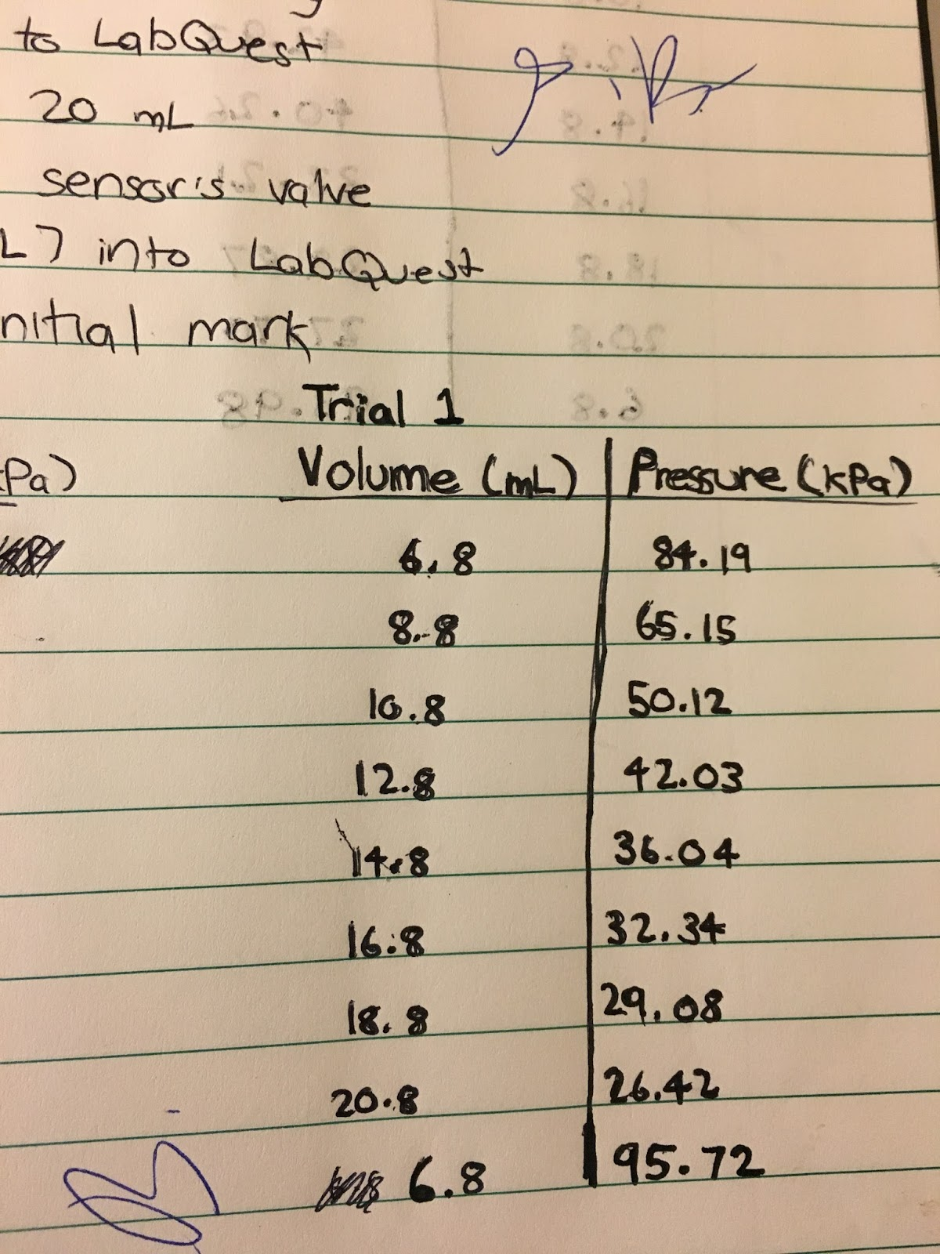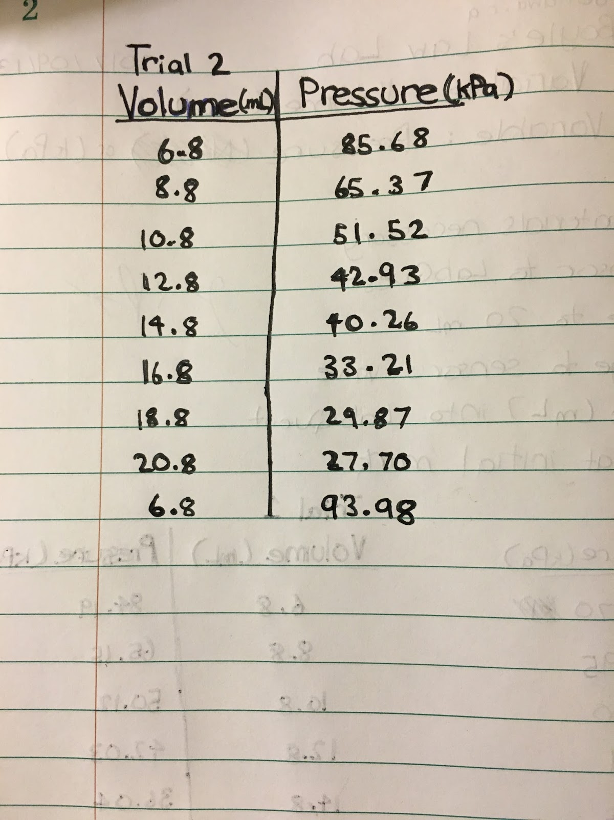

Peer Evaluation:


