Assignment #1: Mechanism Description of Pedal Bin
Submission Date: 2/2/2017

Statement of originality:
I declare that the work presented in this assignment is, original. Furthermore, this work has not been submitted either whole or in part, at this or any other university.

A pedal bin is a container for storing garbage which can be opened up easily by pressing its pedal by foot. The purpose of using pedal bins is not only to faster and easier remove trash but also to keep places cleaner as it helps the container always to be closed. This kind of bin is widely used in different indoor and outdoor, private or public places such as homes, schools, hospitals, parks and so on. A pedal bin may have six major components: an outer skin, pedal, pivots, levers, linkages and a lid.
To better describe the mechanism of a pedal bin we should define its different components:
- Skin:
The outer skin of a pedal bin is the body of the bin which stores garbage in itself. It can be made of plastic or metal, in different colors and sizes, generally shaped cylindrical or cubical. On the outer skin of a pedal bin, there should be two slots (a narrow opening for something to be inserted) placed exactly faced to each other.
- Pedal:
Pedal is a moving part of a pedal bin which is being used to open up the lid. It is usually shaped rectangular or hemicyclic, in different colors, made of plastic or metal. On a pedal, there should be an opening to let a lever bar pass so that it can be attached to the pivots.
- Pivots:
Pivots are parts attached to the body of the pedal, linkages, and lid; which connect pedal and lid via linkages. They are made of plastic or metal. A thin lever bar passes through an opening on each pivot to attach it to the connecting part (i.e. pedal, lid or linkages). Four pivots are operating in a pedal bin, three moving pivots, and a fixed pivot.
- Levers:
Levers are steel or plastic bars, passing through openings on pivots, used to attach different components (i.e. pedal, lid and linkages) to each other.
- Linkages:
Linkages are metal bars which connect pedal and lid to each other. There are two linkage bars in a pedal bin, usually having a square section. The first linkage bar is placed horizontally used to connect the pedal to the moving pivot and the second linkage bar is vertical oriented, connecting the same moving pivot to the lid. As already described, linkages also have openings to let a lever pass through.
- Lid:
The lid of a pedal bin is the moving top part of the bin, usually, carries the same material and color and sectional shape as the container's skin has. The lid is connected to the vertical linkage via a moving pivot and a lever.

In the below figure the different components of a pedal bin are illustrated:

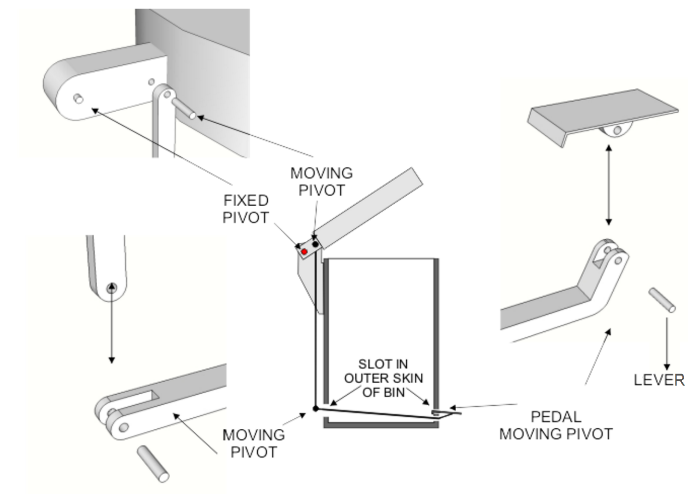
Figure 1: Components of a pedal bin (from www.technologystudent.com/rmprep09/ped1.html)

Figure 2 illustrated below is used to describe the operation of each component in a pedal bin mechanism in opened and closed lid position:
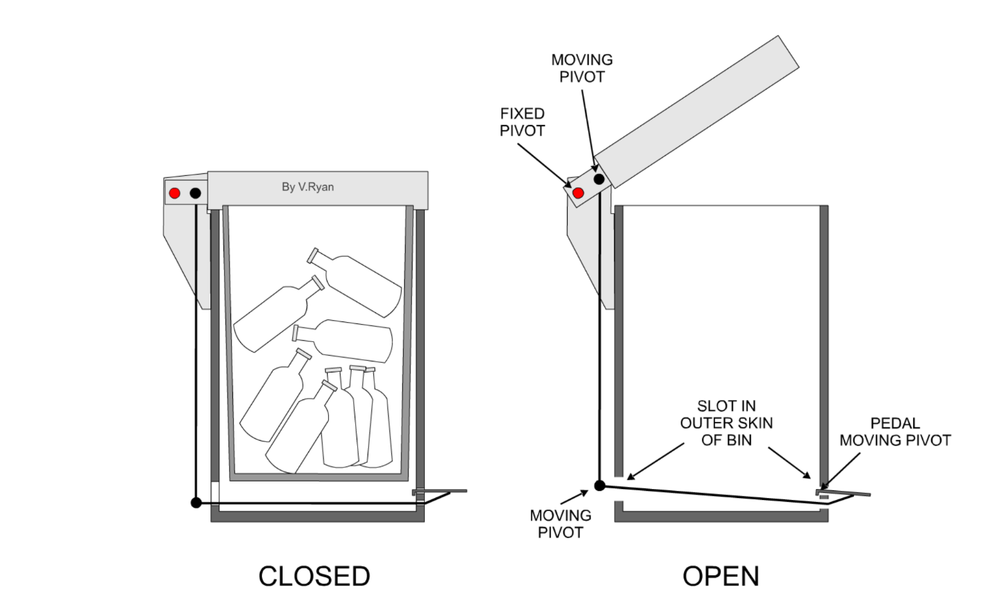
Figure 2: Components of a pedal bin in operation (from www.technologystudent.com/rmprep09/ped1.html)

Regarding figure 2, as a foot is pressed on the pedal, the horizontal linkage moves downwards which results in the upwards moving of the vertical linkage. Vertical linkage, as described before, is connected to moving pivot which is attached to the lid. The other pivot on the lid is fixed so it allows rotation of the lid and consequently it opens up the lid.
In conclusion, a pedal bin is a container which can be used to store garbage. The six components of a pedal bin work together via a mechanism which helps us open the container’s cap by our feet. By pressing down the pedal, linkages rotate the lid through the fixed pivot so that it opens up.

