Handout II: Biol206 (Winter 2017) Instructor: Dr. Aida Abu-Baker TA: Hassan Damen
1. Below is a schematic of gene Hemoglobin beta subunit (HBS), which encodes protein HBS. The promoter region is indicated by the dotted box. Transcription begins immediately following the promoter.

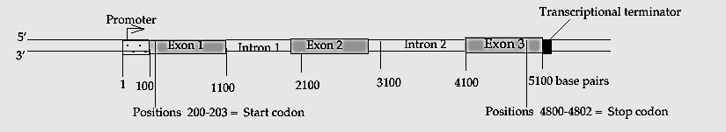
The mature mRNA produced by this gene would be approximately how many nucleotides long?
A) 100
B) 200
C) 3000
D) 5000
E) 7000

2. A spontaneous mutation usually originates as an error in
A) DNA replication.
B) DNA transcription.
C) At the beginning of translation.
D) reverse transcription.
E) At the end of translation.

3. When a triplet of bases in the coding sequence of DNA is GCA, what is the anticodon for the tRNA that would be used in translation?
A) GCA
B) GCT
C) CGT
D) CGU
E) CGA

4. Regulatory sequences of DNA that are responsible for the speed at which a gene is transcribed are known as
A) enhancers
B) promoters
C) exons
D) repressors
E) 5’capG and 3’ poly(A)tail

5. A mutation converts an AGA codon to a TGA codon (in DNA). This mutation is a:
A) Termination mutation
B) Missense mutation
C) Frameshift mutation
D) Nonsense mutation
E) Non coding mutation

6. RNA processing involves all of the following except
A) addition of a 5' cap
B) removal of introns
C) addition of a poly A tail
D) removal of exons
E) A and C

7. The genetic code is degenerated. Which of the following codons represents the principle of degeneracy?
A) UAA and UAC
B) AUG and AUA
C) CAU and CAC
D) UUA and UUC
E) None of the above

8. Regulation of gene expression can be accomplished by controlling:
A) the rate of translation of mRNA.
B) the activity of a protein product.
C) the amount of mRNA that is available.
D) the rate of mRNA degradation.
E) All of these.

9. In eukaryotic cells, transcription cannot begin until
A) the two DNA strands have completely separated and exposed the promoter.
B) several transcription factors have bound to the promoter.
C) the 5' caps are removed from the mRNA.
D) the DNA introns are removed from the template.
E) DNA nucleases have isolated the transcription unit.

10. Apparently, our muscle cells are different from our nerve cells mainly because
A. they contain different genes
B. they express different genes
C. they use different genetic codes
D. they have unique ribosomes
E. they have different chromosomes

11. Which of the following helps to stabilize mRNA by inhibiting its degradation?
A) TATA box
B) histones
C) exons
D) DNA polymerase
E) poly(A) tail

12. Sickle cell anemia is caused by a change in the amino acid sequence of the two beta chains in the hemoglobin molecule. How many amino acids have been changed in each beta chain, compared to normal hemoglobin?
A) 1
B) 5
C) 10
D) hundreds
E) thousands

13. Base analogs
A) often cause frameshift mutations.
B) lead to single-nucleotide substitution mutations.
C) resemble the sugars found in DNA nucleotides.
D) cause breakage of DNA strands.
E) resemble the phosphate groups found in DNA nucleotides.

14. What is the function of DNA polymerase?
A) to unwind the DNA helix during replication
B) to seal together the broken ends of DNA strands
C) to add nucleotides to the end of a growing DNA strand
D) to degrade damaged DNA molecules
E) to rejoin the two DNA strands (one new and one old) after replication

15. An anticodon is
A) located on miRNA
B) a group of nucleotides in mRNA that encodes the information for a specific amino acid in a protein
C) a group of nucleotides in a tRNA molecule
D) a chemical link formed between amino acids
E) the enzyme that carries out transcription

Short Questions
Shor Question 1
Describe 3 different regulatory mechanisms that can explain differential gene expression in a cell

Answer
Here are examples of gene regulation mechanisms (your answer should include the name of each mechanism with specific details on each).

1.Gene transcription:
-control regions regulating which genes are or are not made into RNA
-chromatin organization (histones) regulating access to RNA polymerase
-transcription factors regulating gene transcription

2.RNA processing:
-differential splicing regulating which exons are used to make protein
-differential nuclear export to the cytoplasm regulating if the RNA will make protein

3. mRNA translation :
-microRNA-mediated mRNA degradation that interferes with protein translation

Short Question 2.
The nucleotide sequence of a hypothetical eukaryotic gene (template strand) is:
TACATACTAGTTACGTCGCCCGGAAATATC
If a mutation in this gene were to change the fifteenth nucleotide (underlined) from guanine to thymine, what effect do you think it might have on the expression of this gene? Hint for your answers:
1.write the DNA double helix,
2.write the mRNA sequence,
3.write the corresponding amino acid for each codon (use the genetic codon table), 4.explain the mutation.

Answer:
Since the sequence given is a template one, then we will transcribe it directly.

First: write the DNA double helix with matching base pairs

5’ ATGTATGATCAATGCAGCGGGCCTTTATAG 3’ (coding strand)
3’ TACATACTAGTTACGTCGCCCGGAAATATC 5’ (template strand)

Second: write the mRNA sequence: transcription of the template strand
The mRNA sequence of this gene is:
AUG UAU GAU CAA UGC AGC GGG CCU UUA UAG

Third: write the corresponding amino acid for each codon (use the genetic codon table)
The amino acid sequence for this sequence of codons is:
Met-Tyr-Asp-Glu-Cys-Ser-Gly-Pro-Leu-Stop

Fourth: explain the mutation
If the underlined guanine was changed to thymine, then the mRNA sequence for this codon would be UGU and the amino acid encoded by UGU is Cysteine, the same amino acid encoded by UGC, therefore there would be no effect of this mutation on the production of the protein (silent mutation).

Note that the first, second and third answers refer to the normal (wild-type) sequence. The fourth one refers to the mutated sequence

Short Question 3.
The Cystic Fibrosis Transmembrane Conductance Regulator (CFTR) protein is a chloride (Cl) facilitated
transporter made up of 1480 amino acids and hose gene is located on the long arm of chromosome 7. In
healthy humans, the protein is found in the plasma membranes of the cells that line the lungs, allowing the
movement of Cl. In people with cystic fibrosis, no functional CFTR is made.

A) Do you expect cystic fibrosis to be inherited in a dominant or recessive fashion? Autosomal or sex
linked? Explain your answer.

An allele which results in synthesis of no protein could probably be recessive to a normal allele (it
couldn’t do anything to block or interfere with the normal allele). Chromosme #7 is not the X
chromosome, so this trait will be autosomal.

B) The CFTR gene is approximately 82,500 bp long. However, CFTR mRNA isolated from the cytoplasm is only 6,500 nucleotides in length. Please explain what happened to the missing 76,000 bp.
The gene probably contained introns, which ere spliced out before the mRNA left the nucleus.
C) A variety of mutations can lead to a defective CFTR protein and the disease. Describe one type of mutation that could lead to a nonfunctional protein.
An Insertion of one nucleotide at any position of the DNA coding sequences. This could cause a frameshift mutation: it alters the reading frame so that not only one codon but all subsequent codons are affected. This certainly could produce a non functional protein.
Short Question 4.
Below are descriptions of several different mutations. Match each with the one term that could be the best classification for this mutation. You may use the terms once, more than once, or not at all.

- A mutation changes a G to a C within an intron
- A mutation changes a TCA codon to TCG
- A mutation changes a TCA codon to CCA
- A mutation changes a TCA codon to TAA.
- A mutation occurs between the +1 nucleotide and the start codon of a gene
- This kind of mutation changes every amino acid in the protein beyond the point here it occurs

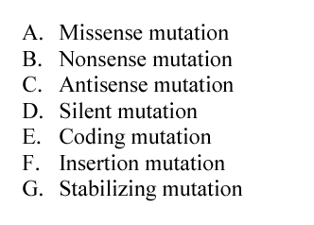

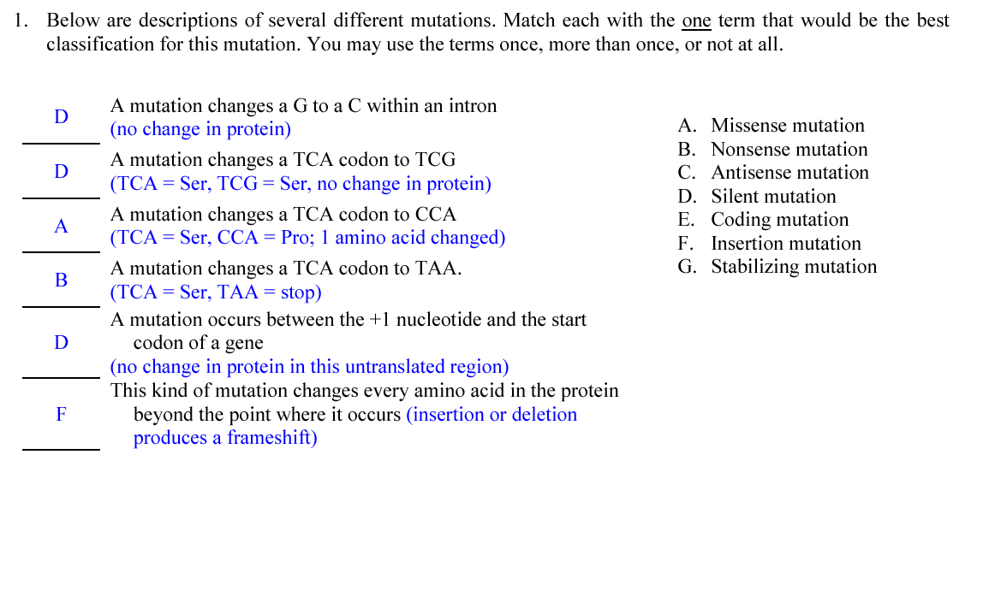

Short Question 5.
Many antibiotics are compounds that interfere with the transfer of genetic information from RNA to protein. Streptomycin is a compound that affects the small ribosomal subunit in prokaryotes (bacteria). Streptomycin interferes with the binding of all Methionine-tRNAs to ribosomes. What one specific effect will streptomycin have on protein synthesis in prokaryotes?
Streptomycin will prevent the correct initiation of protein synthesis since it prevents association of the Met-tRNA with the ribosome. Streptomycin will also lead to inaccurate translation (insertion of incorrect amino acids) in those proteins that were in the process of being translated.

