STUDENT NAME ______________________ STUDENT ID# ________________________
COURSE Elementary Genetics NUMBER Biol 206 Winter 2017
INSTRUCTOR Aida Abu-Baker
EXAMINATION Midterm DATE Feb.16th, 2017 TIME 10:15 - 11:35 am
Total marks 1000. Number of pages 6.
SPECIAL INSTRUCTIONS: Answer all 15 MCQs on the scantron using a pencil + 2 short answer questions on the exam sheet. Return All.
For short answer questions: Explain your answer briefly: answer the question as completely, and specific as possible.

MULTIPLE CHOICE. Choose only one answer that best completes the statement or answers the question. 40 marks each.
1. At its simplest, meiosis could be described as
A) Duplication-division
B) Duplication-duplication-division
C) Duplication-division-division
D) Division

2. If you examined gene expression in different cell types you would see different sets of
A) genes
B) mRNAs
C) proteins
D) B and C

3. To produce an individual with Kleinfelter syndrome (47, XXY),
A) a nondisjunction event must have occurred during spermatogenesis.
B) a nondisjunction event must have occurred during oogenesis.
C) this must have been caused by uniparental disomy.
D) a nondisjunction event could have occurred during spermatogenesis or oogenesis.

4. Cytosine makes up 38% of the nucleotides in a sample of DNA from an organism. Approximately, what percentage of the nucleotides in this sample will be thymine?
A) 12
B) 24
C) 38
D) It cannot be determined from the information provided.

5. Alisha and Scott have two sons and three daughters. Each son has three daughters. Each daughter has one son. How many of the grandchildren will have Alisha's mitochondria?
A) 0
B) 3
C) 6
D) 12

6. If temperament was genetically based, which of the following would have the greatest degree of similarity?
A) monozygotic twins
B) dizygotic twins
C) parents and children
D) cousins

7. What would be the best way to distinguish between two alleles and two genes?
A) Determine their chromosomal location; alleles will be on different chromosomes, but genes will be on different copies of the same chromosome.
B) You can't; there's no actual difference between alleles and genes.
C) Examine their DNA; the DNA sequences of two different alleles would be more similar than the sequences of two different genes.
D) Examine the proteins they produce; most genes would produce very similar proteins, but two alleles would produce very different proteins.

8. A duplicated homologous chromosome pair at the beginning of meiosis contains how many copies of each gene?
A) 92
B) 46
C) 2
D) 4

9. Individuals with complete androgen insensitivity
A) menstruate after reaching puberty.
B) often have testes present in their abdomens.
C) usually have no problems reproducing.
D) have a set of XX sex chromosomes.

10. Ian and Joan are both carriers for two autosomal recessive disorders, PKU (chromosome 12) and cystic fibrosis CF (chromosome7). They are expecting a daughter. What is the probability that she will have PKU but not CF?
A) 3/4
B) 1/16
C) 3/16
D) 1/4

11.
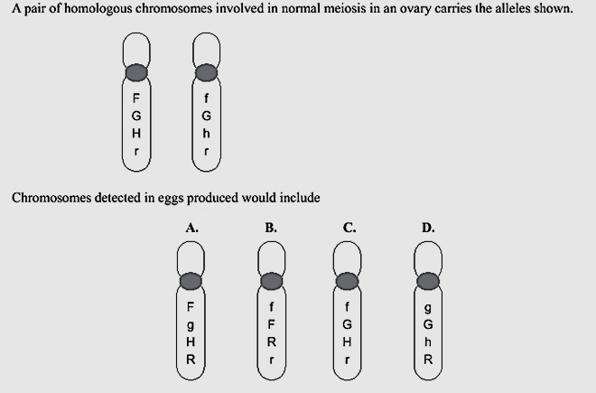
C
12. Which is correctly listed from smallest to largest?
A) nucleus-nucleotide-gene-chromosome-genome
B) nucleotide-gene-chromosome-genome-nucleus
C) gene-chromosome-genome-nucleus-nucleotide
D) nucleotide-gene-genome-chromosome-nucleus

13. The sequence of one strand of DNA is 5’ TCGATC 3’. The sequence of the complementary strand would be
A) 5’ AGCTAG 3’
B) 5’ CTAGCT 3’
C) 5’ GCUCGA 3’
D) 5’ GATCGA 3’

14. Offspring inherit from parents
A) Gametes, that then fuse to form the new individual.
B) Pure information provided in a sequence of codons that replicate the parents' genome.
C) Genes, a set of coded information that guides the orderly sequence of development along with the environment.
D) The phenotype, since only this is expressed in the new organism.

15. If a human who is a tongue roller (T) and has unattached ear lobes (E) marries a person who cannot roll their tongue and has attached earlobes, could they produce an offspring that was also a non-tongue roller with attached earlobes? What would be the genotype of the first parent? the second parent?
A) yes; TtEe; ttee
B) yes; TtEE; ttEe
C) no; TTEE; ttee
D) yes: TTEe; ttee

Short Answer Question 1:
The following is a portion of a mature mRNA sequence:
3′-AUCGUCAUGCCG-5′
- During transcription, was the adenine at the left-hand side of the sequence the first or the last nucleotide added to the portion of mRNA shown? Explain how you know. 50 marks.
Last.
The synthesis of RNA from DNA by the enzyme RNA polymerase is called transcription. The RNA polymerase binds on a 3’-5’ template strand of DNA, and then it adds its first nucleotide to the 5’ of mRNA and last nucleotide to 3’ end of mRNA.

B) Write out the sequence of the DNA duplex that encodes this mRNA segment. Label the coding and template DNA strands. Indicate their 5’and 3’ ends. 100 marks.
Your mRNA is: 5’ GCCGUACUGCUA 3’

Therefore, the DNA duplex is:
5’ GCCGTACTGCTA 3’ Coding strand
3’ CGGCATGACGAT 5’ Template strand

- On your answer from B: Identify the direction in which the promoter region for this gene will be located. Use an arrow. What is the function of the promoter? 50 marks.
The arrow should point to the upstream of the gene (i.e. left-side of the DNA duplex). As the promoter is located at 25-30 bp upstream of transcription start site. This sequence is almost always located just upstream from the starting point for transcription (the 5' end of the DNA).

-The promoter is a DNA sequence where an RNA polymerase binds and initiates transcription.
-The purpose of the promoter is to bind transcription factors that control the initiation of transcription. When transcription factors bind to the promoter region, RNA polymerase is placed in an orientation that allows transcription to begin.

Short Answer Question 2:
A) If children obtain half their genes from one parent and half from the other parent, why aren’t siblings identical? List at least two different genetic reasons. Explain each reason briefly. 50 marks.

- Cross over (genetic recombination)
The process of recombination (cross over) mixes up the chromosomes, so it would be rare that I'd receive a chromosome identical to that of any of my grandparents. This process also makes it even more unlikely that two siblings would receive the exact same combination of chromosomes from their parents.

- Independent assortment
In independent assortment, the cells produced by meiosis can possess any combination of chromosomes based simply on how the chromosomes were separated in meiotic anaphases. With 23 pairs of chromosomes, this independent assortment of chromosomes can result in a large variety of combinations, along with crossing-over.

- Random fertilization
Because not all sperm/egg cells from a parent are identical.
Meiosis (the process by which gametes - in humans, sperm and egg cells - are formed) involves the randomization of genetic information.
Because the “half” inherited is random, the chances of receiving exactly the same half are vanishingly small.
Ignoring recombination and focusing just on which chromosomes are inherited from one parent (for example, the one they inherited from their father or the one from their mother?), there are 2²³ = 8,388,608 possible combinations!
In other words, all possible siblings that are made from different sperm & eggs are genetically unique.

- Dominnt vs Recessive
You also have two different genes for each trait (called alleles). Some are dominant and some are recessive. So, if you have brown eyes, and you carry a recessive gene for green eyes, and your partner has blue eyes, you might have kids with blue, green, or brown eyes. Each child only inherits one of your two genes, but which one is random each time.

These four reasons (crossing-over, independent assortment, random fertilization, and dominant versus recessive genes) all contribute to the differences in the genetic makeup of the offspring from the parents.

- Red-green color-blindness is a human X-linked recessive disorder. Jill has normal color vision, but her father is color-blind. Jill marries Tom, who also has normal color vision. Jill and Tom have a daughter who has Turner syndrome (45,XO) and is color-blind. How did the daughter inherit color-blindness? Explain your answer clearly. Support your answer with a punnett square/drawings. 50 marks.

The daughter, with Turner syndrome, is 45,XO. A normal egg cell with a color-blind X chromosome was fertilized by a sperm carrying no sex chromosome. Such a sperm could have been produced by a nondisjunction event during spermatogenesis.

The color-blind daughter must have inherited her X chromosome from Jill. Tom is not color-blind and therefore could not have a color-blind allele on his single X chromosome. Jill’s father was color-blind, so Jill must have inherited a color-blind X chromosome from him and passed it on to her daughter.

C) You are studying a genetically inherited trait. The pedigree for a family with this trait is shown below. This trait shows complete penetrance (penetrance is defined as the percentage of individuals with a given genotype who exhibit the phenotype associated with that genotype). 100 marks.
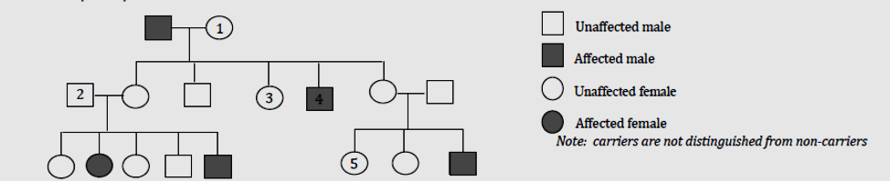

Complete each table below ONLY if that mode of inheritance is possible.

i) Could this trait be inherited in an Autosomal Dominant manner? Yes or No?

If Yes, give all the possible genotype or genotypes for the individuals listed in the table below. Use A for the allele associated with the dominant phenotype and a for the allele associated with the recessive phenotype.
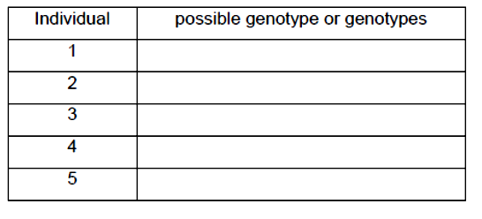
ii) Could this trait be inherited in an Autosomal Recessive manner? Yes or No?

If Yes, give all the possible genotype or genotypes for the individuals listed in the table below. Use A for the allele associated with the dominant phenotype and a for the allele associated with the recessive phenotype.

iii) Could this trait be inherited in an X-linked Recessive manner? Yes or No?

If Yes, give all the possible genotype or genotypes for the individuals listed in the table below. Use X for the allele associated with the dominant phenotype and X* for the allele associated with the recessive phenotype.
Answer

