CHM1311 Experiment 2: Prelab

  - Enthalpy of dissolution: The change in enthalpy that results upon dissolving the ionic compound X⁺Y⁻ in a solvent, usually water.
X⁺Y⁻(s) → X⁺(aq) + Y⁻(aq) [1]
  - Lattice Energy: The energy required to form the ionic crystal X⁺Y⁻ given the gaseous ions X⁺ and Y⁻.²
X⁺(g) + Y⁻(g) → X⁺Y⁻(s) [2]
  - Enthalpy of hydration: Chemguide quotes the definition as “The hydration enthalpy is the enthalpy change when 1 mole of gaseous ions dissolve in sufficient water to give an infinitely dilute solution.” Essentially, the energy change if the ion Z+ (g) dissolves in water and bonds with the water molecules. It has to be a lot of water such that the enthalpy change is fully exhibited.¹
X⁺(g) + Y⁻(g) → X⁺(aq) + Y⁻(aq) [3]

- The enthalpy of hydration is the sum of the enthalpies of dissolution and the lattice energy. If one starts with gaseous ions, one can choose to form a crystal with the ions, resulting in an enthalpy change, and then proceed to dissolve the crystal, leading to a second ion change. Or, one can take the gaseous ions and immediately dissolve it in water, resulting in the same product and thus the same enthalpy change. Enthalpy is a state function: It does not matter the path a reaction or a series of reactions taken to reach a goal.
Enthalpy of dissolution
Lattice Energy
Ionic crystal X⁺Y⁻(s)
Dissolved ions X⁺(aq) and Y⁻(aq)
Gaseous ions X⁺(g) and Y⁻(g)

Enthalpy of hydration

Fig 1: The relationship among the terms in question 1.

- ΔH_{lattice} + ΔH_{solution} = ΔH_{hydration}
ΔH_{solution} = ΔH_{hydration1} + ΔH_{hydration2} - ΔH_{lattice}

NH₄Cl:
ΔH_{solution} = (-307 kJ/mol) + (-381 kJ/mol) – (-705 kJ/mol)
ΔH_{solution} = 17 kJ/mol

NH₄NO₃:
ΔH_{solution} = (-307 kJ/mol) + (-314 kJ/mol) – (-646 kJ/mol)
ΔH_{solution} = 25 kJ/mol

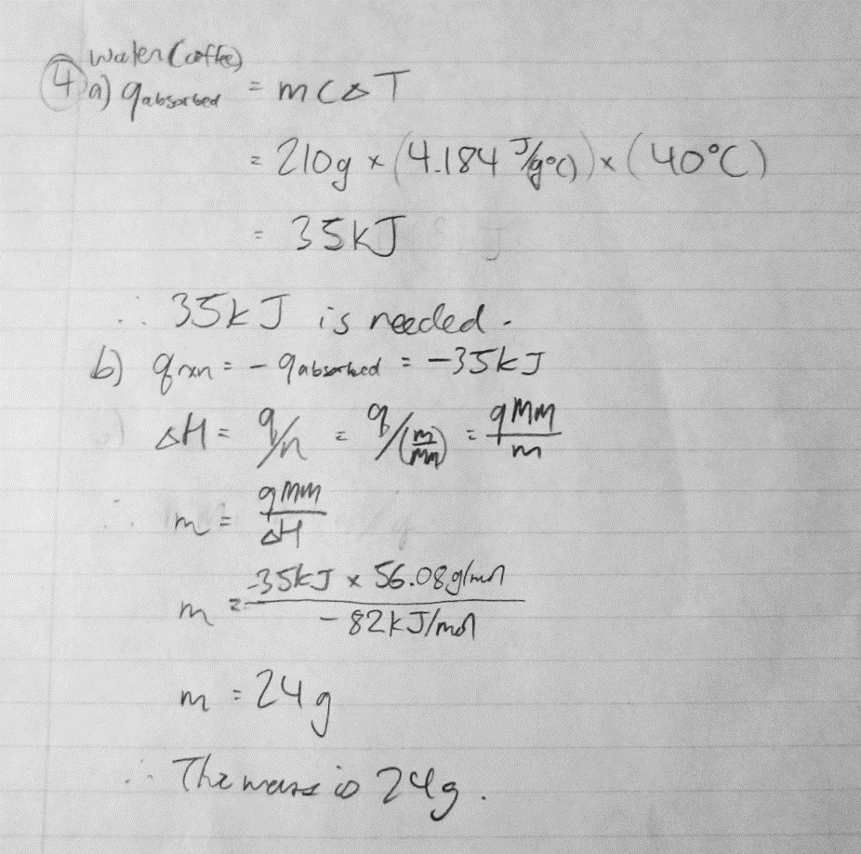

References
¹Enthalpies of solution and hydration. (n.d.). Retrieved from http://www.chemguide.co.uk/physical/energetics/solution.html
²Lattice Energy: The Born-Haber cycle. (2017, February 15). Retrieved from https://chem.libretexts.org/Core/Inorganic_Chemistry/Crystal_Lattices/Thermodynamics_of_Lattices/Lattice_Energy:_The_Born-Haber_cycle

