Chapter 2: Atoms, Molecules and Ions

The Beginning of the Atomic Theory
- 460 BCE - Greek Philosopher, Democritus speculated that matter was made of elementary/indivisible particles called atoms.
- His ideas were based on intuition and reason not experimentation.
- 1808 - John Dalton proposed the first modern atomic theory:
- Elements consist of atoms which cannot be created, destroyed or divided.
Billiard Ball Model
- Atoms of the same element have identical size, mass and other properties.
- Atoms of different types combine in specific ratios to form products.
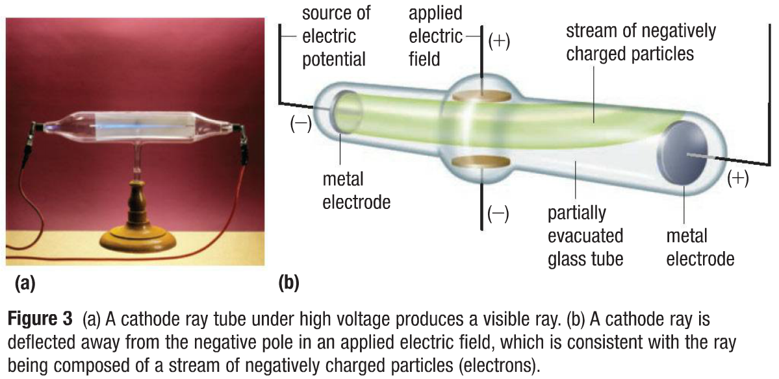
- Billiard Ball Model served to explain:
- Law of Conservation of mass
- Law of Definite Composition / Proportion
- Law of Multiple Proportions
Discovering the Electron
- JJ Thompson was the first to provide evidence for the existence of the electron.
- Electron is a negatively charged subatomic particle.
- Cathode Ray Tube Experiment
- High voltage was applied to a partially evacuated tube with a metal electrode at each end.
- A ray was produced that started from the negative electrode (cathode).
- Negative pole of an applied electric field repelled the ray.
- Particles that make up the cathode ray are 1000x smaller than an atom.
- He explained that the ray was composed of a stream of negatively charged particles.
- Thompson was able to determine the charge-to-mass ratio of an e-, by measuring the deflection of the beam of e-‘s in a magnetic field. (e/m = -1.76x10⁸ C/g )
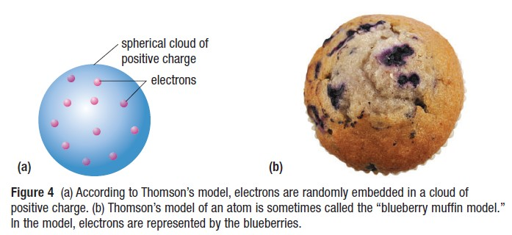
- Since e-‘s could be produced from electrodes made from various metals, all atoms must contain e-‘s.
- Since atoms are neutral, atoms must also contain a positive charge.
- Raisin Bun Model
- Atom consists of a diffuse cloud of positive charge with negatively charged electrons embedded randomly.
- In a raisin bun model, the electrons are the raisins and
the bun is positively charged.
- Milikan's Oil Drop Experiment
- Robert Milikan used charged oil drops to determine the charge of an electron. (-1.6x10⁻¹⁹ C)
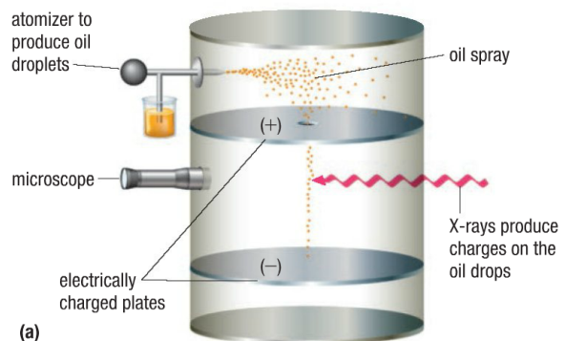
- In his experiment he discovered that the fall of charged oil droplets due to gravity could be halted by adjusting the voltage across two charged plates.
- Mass of the e⁻ was also determined to be 9.11 x 10^{–31} kg.
Exploring Radioactivity
- 1896 - Becquerel found that in the absence of light, a piece of mineral containing uranium produces an image on a photographic plate.
- He attributed this phenomenon to uranium atoms spontaneously emitting radiation: energy, particles, or waves that travel through space.
- Radioactivity is the spontaneous decay of the nucleus of an atom.
- This idea was first proposed by Rutherford who showed that it resulted
from the disintegration of atoms. He also discovered the alpha (α) - ${}_{2}^{4}{He}$ - ,beta (β) and gamma (γ) particles.

Discovery of the Nucleus
- Gold Foil Experiment
- 1911 - Rutherford fired positively charged alpha articles - smaller than an atom - at a thin sheet of gold foil.
- Rutherford hypothesized that if Thompson’s model was accurate, the α particles should break through the thin foil like bullets through paper, with only minor deflections.
- Most of the alpha particles passed straight through, some were deflected at various angles, and some were reflected back to source.
- The only possible explanation to the results was a concentrated +ve charge at the centre of the atom.
- The atom must be made of mostly empty space since most of the α particles passed directly through.
- Positive centre must be small in volume relative to the atom.
- Positive charge must contain most of the atomic mass, accounting for the deflection of the α particles.
- Deflected α particles must have travelled close to the +vely charged centres of the atoms - repel.
- α particles that bounced back must have made a direct hit on the much more massive +vely charged centres.
- Thus, atoms must have a nucleus held by nuclear energy that the e⁻s orbit, like planets orbiting sun.
- Nucleus is the dense centre of an atom with a +ve charge.
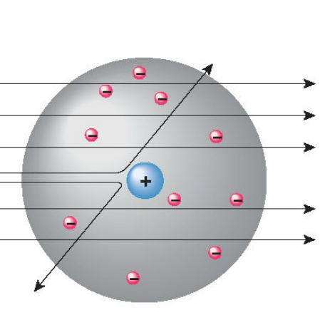
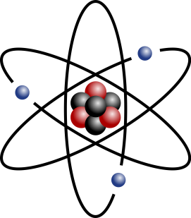
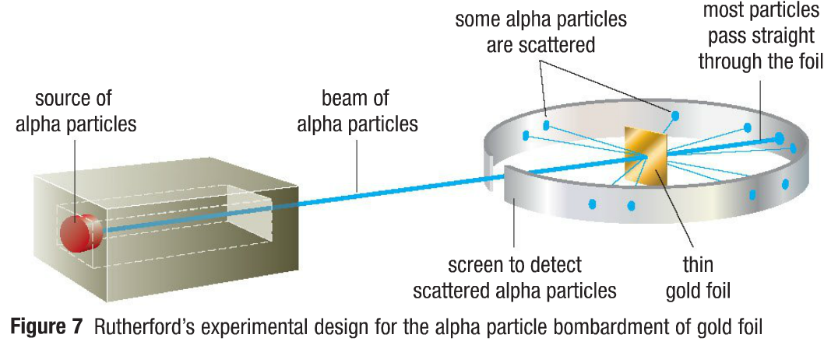
- Proton is a positively charged subatomic particle.
Planetary Model

Discovery of the Neutron
- In his experiment, Chadwick fired α particles at B, Be and Li atoms and observed release of radiation (no charge).
- When the radiation striked a sheet of parafilm wax, protons shot out! These were neutrons!
- This showed that neutrons have no charge, so neutral and had the same mass as protons.
- Chadwick found that the observed masses of the nuclei were not the same as the sum of the masses of protons.
- He concluded that a nucleus must contain not only +vey charged protons, but also neutral neutrons.
- Neutron is an electrical neutral subatomic particle.
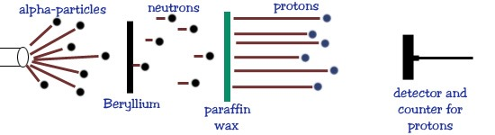

Atoms and Isotopes
Chemical
symbol for
an element

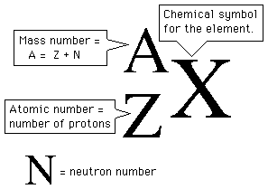
- The atom has a small, dense nucleus containing protons and neutrons.

- The number of protons equals to the number of electrons.

Mass Number
- Electrons reside outside the nucleus in relatively large remaining atomic volume.
- Atomic number (Z) is the number of protons in an atom’s nucleus.

Atomic Number
- Atomic mass (A) is the total # of protons and neutrons in an atom’s molecules.
- Isotopes of an element have the same atomic # but diff. mass #s.
- Radioisotopes have unstable nuclei that decay and emit radiation.

Patterns in Periodic Table
- Periodic Table is a tabular arrangement of elements in rows and columns, highlighting the regular repetition of properties of the elements.
- There are 7 periods/rows in the periodic table that run from left to right. (horizontal)
- There are 18 columns/groups in the periodic table and each column is a group of elements with similar properties. They run from top to bottom. They are sometimes referred as families.
- The period the element is in represents its number of shells and the column represent the number of electrons in their valence shell.
- Periodic Law is a rule that states that when elements are arranged in the order of increasing atomic number, their properties show are periodic recurrence and gradual change.
- Elements in the same vertical column tend to have same chemical and physical properties. Eg. Reactivity
- Metal - substance that has a characteristic luster, shine & is a good conductor of heat & electricity.
- Non-Metal is an elements that does not exhibit the characteristics of a metal.
- Group 1: Alkali Metals
- Soft, Silver-coloured metals
- Solids at room temperature
- Highly reactive with water
- Groups 2: Alkali Earth metals
- Light, Very reactive metals
- Group 17: Halogens
- Highly Reactive non-metals
- Solids, liquids and gases at room temp.
- Not lustrous, non-conductors of electricity
- Exist as diatomic molecules
- Group 18: Noble Gases

- Solids at room temperature
- Reacts with water to produce hydrogen gas
- Group 3-15: Transition metals
- Gases at room temperature
- Low melting and boiling point
- Extremely Unreactive
- Strong, hard metals, variable reactivity
- High melting points, conductors of electricity.
- Form Multi-Valent ions
Arrangement
- Metals are towards the left side and non-metals on the right.
- Metalloids are elements that have properties of both metals and non-metals. They are present right next to the staircase that separates metals and non-metals.
- Hydrogen is found on the left side but it generally behaves like a non-metal.
Chemical and Molecular Formula
- Empirical Formula is a formula that show the simplest whole number ratio of the elements in compound
- Molecular Formula is a formula that shows the element symbols and exact number of each type of atom in the molecular compound.
Atoms and ions
- Atom is the smallest particle of an element.
- Atoms bond to form compounds with other elements to become stable.
- When an element gains or loses an electron to reach stability it becomes an ion.
- Ion is a charged particle that results when an atom gains or loses one or more electrons.
- Bohr-Rutherford Diagram is a model representing the arrangement of electrons in orbits around the nucleus of an atom.

Cations and Anions
- Cation
- Cation is a positively charged ion formed by the removal of electrons from the valence shell.
- An atom that loses an electron becomes a cation (positive ion).
- Metals tend to lose electrons in order to achieve a stable electron arrangement.

- Anion
- Anion is a negatively charged ion formed by gaining one or more electrons to a neutral atom.
- An atom that gains an electron becomes a anion (negative ion).
- Non-metals tend to gain electrons in order to fill their valence shells.

Cation
Anion
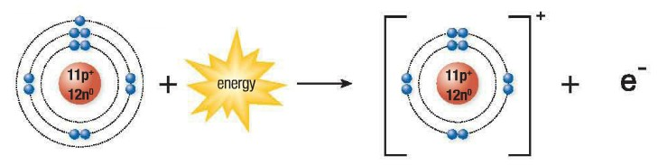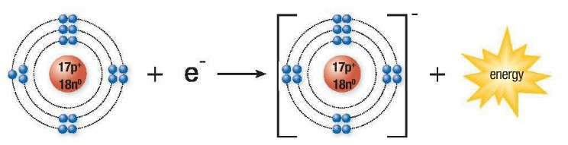

Octet Rule
- A stable octet is an electron arrangement where the valence shell is filled with 8 valence electrons.
- Octet Rule is a generalization stating that when atoms combine, they tend to have 8 valence electrons.
- The 3 possible ways an atom can have a stable arrangement is by sharing, losing or gaining electrons.
Isotopes and Isotopic Abundance
- Isotope is a form of an element in which the atoms have the same number of protons as all other forms of that element but a different number of neutrons.
- Isotopic abundance is the percentage of a given isotope in a sample of an element. (Average)
- Mass Spectrometer is a measuring instrument used to determine the mass and abundance of isotopes.
Calculating Atomic mass
- Atomic mass is the weighted average of the masses of all the naturally occurring isotopes of an element.

AM = % abundance of isotope 1 (mass of isotope 1) + % abundance of isotope 2 (mass of isotope 2)…

Radioisotopes
- Radioisotope is an isotope that spontaneously decays to produce 2 or more smaller nuclei and radiation.
- All of the isotopes of Uranium are isotopes, there are no stable uranium isotopes.
- All radioisotopes are radioactive, meaning they have the potential to emit nuclear ration upon decay.
Nuclear Radiation
- Radioactive Decay is the spontaneous disintegration of unstable isotopes.
- Nuclear Radiation is the energy or small particles emitted from the nucleus of a radioisotope as it decays.
- The three most common types of nuclear radiations are:
- Gamma ray
- Form of high-energy electromagnetic radiation emitted by certain radioisotopes.
- Have no mass and travel at the speed of light.
- Particles are blocked by lead.

- Alpha Particle
- Positively charged particle
- Same structure as the nucleus of a helium atom.
- Particles are blocked by paper.
- Beta particle
- Negatively charged particle
- Identical to an electron.
- Particles are blocked by aluminum

Metals | Non-metals
Low Ionization energy | High Ionization energy
Low electron affinity | High electron affinity
High Atomic Radius | Low Atomic Radius
Periodic Trends in Atomic Properties
- Atomic Radius
- Atomic radius is a measurement of the size of an atom, usually expressed in picometers (pm). The distance from the center of an atom to the outermost electrons.
- Atomic Radius increases from right to left and from top to bottom.
- A proton is added in each element on the same energy level, adding to the power of the nucleus to pull electrons inward. This will increase the nuclear effective charge.
- Effective nuclear charge is the net force experienced by an electron in an atom due to the positively charged nucleus.
- Energy levels are added when moving down a group causing the additional orbits to be at a greater distance from the nucleus. Electrons in the inner energy levels create a shield effect causing the electrons in the outer energy levels not being attracted by the nucleus as strongly. Resulting in larger atomic radius.
- Ionic Radius
- Ionic Radius is a measurement of the size of an ion, usually expressed in picometers (pm). It is the distance from the center of an ion to the outermost electrons.
- Cations (Positive ions) are always smaller than their original neutral atoms as there is a decrease in the number of electrons being pulled by the nucleus. The net result is that the nucleus pulls each electron a little closer creating a decrease in the ionic radius.
- Anions (Negative ions) are always larger than their original neutral atoms. The net result is that the repulsion of the electrons increases as the attraction exerted by the nucleus is slightly weaker.
- Ionization Energy
- Ionization energy is the quantity of energy required to remove an electron from an atom or ion in the gaseous state. The unit used to measure Ionization energy is kilojoules(kJ) and moles(mol).
- It increases from bottom to top and from left to right.
- More energy is needed to remove electrons from a smaller atom due to the strong attraction to the nucleus.
- Less energy is required to remove electrons from larger atoms as there is a weak attraction to the nucleus.
- The further away an electron is from the nucleus, the easier it is to remove it.
- As the atomic radius decreases, ionization energy increases because there is less shield effect.
- Electron Affinity
- Electron Affinity is the energy change that occurs when an electron is added to a neutral atom in the gaseous state. The unit used to measure Ionization energy is kilojoules(kJ) and moles(mol).
- It increases from bottom to top and from left to right.
- Smaller atoms have a greater ability to attract electrons while larger atoms have less attraction.
- Noble gases have no room for another electron in their valence shell.
Ionic Compounds
- Ionic Compound is a pure substance composed of positively and negatively charged ions in a fixed ratio.
- Chemical Bond is the force of attraction between two atoms or ions.
- Ionic bond is the electrostatic attractive force between positive and negative ions in an ionic compound.
- Electrolyte - separates into ions when dissolved into water, producing a solution that conducts electricity.
- Formula Unit is the smallest repeating unit in an ionic crystal.
Properties of Ionic Compounds
- Solids at room temperature and have high melting points because their ions are held together by strong electrostatic forces. (ionic bonds)
- They are hard and brittle because their bonds resist being "stretched"
- Can break or shatter easily due to the repulsive force against the ions of the same charge.
- Non-Conductor of electricity as a solid as ions are in a rigid lattice structure and are not able to move.
- Conduct electricity when dissolved in water. When ionic crystal is dissolved in water, the crystal breaks releasing its ions. Therefore, they can carry electric charges.

Formation of Ionic Compounds
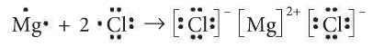
- Lewis Symbols can be used to show how stable octets form as e⁻ transfer from a metal to a non-metal.
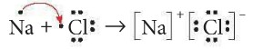
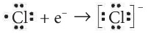
Types of Ionic Compounds
Multiple Charge Elements
Charge | Element | Symbol | Classical
+1, +2 | Copper | Cu | Cupr-
+1, +2 | Mercury | Hg
+1, +3 | Gold | Au | Aur-
+2, +3 | Chrome | Cr | Chrom-
+2, +3 | Iron | Fe | Ferr-
+2, +3 | Cobalt | Co
+2, +3 | Nickel | Ni
+2, +4 | Tin | Sn | Stann-
+2, +4 | Lead | Pb | Plumb-
+1, +2, +3 | Aluminum | Al
+1, +2, +3 | Zinc | Zn
+1, +2, +3 | Silver | Ag
+2, +3, +4, +6, +7 | Manganese | Mn
- Binary Compounds
- A Binary Compound is a compound that contains 2 elements. Usually a metal and a non-metal.
- Metals form cations and Non-metals form anions.
- When naming binary compounds, the name of the metal is unchanged and the ending of the non-metal is changed to "ide". Example, NaCl is Sodium Chloride.
- To determine the chemical formula of a compound, the Criss-Cross method is used.
- Strontium Sulphide → Sr⁺² S⁻² → Sr₂S₂ → SrS
- Multi-Valent Metals
- Multi-Valent Metals are metals that have a property of having more than one possible valence.
- Aluminum, zinc and silver aren't multi-valent.
- Transition Metals often have >1 possible charge.
- Roman Numerals are used to indicate the charge on the metals. FeCl₂ → Iron (II) Chloride
Polyatomic Ions
Bromate | BrO₃ | -1 | Acetate | C₂H₃O₂ | -1
Cyanide | CN | -1 | Chlorate | ClO₃ | -1
Ammonium | NH₄ | +1 | Bicarbonate | HCO₃ | -1
Sulphate | SO₄ | -2 | Hydroxide | OH | -1
Carbonate | CO₃ | -2 | Nitrate | NO₃ | -1
Thiosulphate | S₂O₃ | -2 | Permanganate | MnO₄ | -1
Chromate | CrO₄ | -2 | Iodate | IO₃ | -1
Dichromate | Cr₂O₇ | -2 | Phosphate | PO₄ | -3
- Zero-sum rule - sum of the positive charges equals the sum of the positive charges equals the sum of the negative charges in an ionic compound.
- In Classical System, use -ous ending for lower charge and -ic ending for higher change.
- Polyatomic Compounds
- Polyatomic ion is an ion made up of more than one atom that acts as a single particle.
- Polyatomic Compounds are compounds that consist of ions of more than two elements.
- Polyatomic ions end with "ate" and do not change their element ratio.
- Nick the Camel ate a Clam Super in Phoenix.
- (# of consonants = # of O), (# of vowels = charge)
Compound | 1 more oxygen | Base Anion | 1 less oxygen | 2 less oxygen
Nitrate | NO₄⁻  Pernitrate | NO₃⁻  Nitrate | NO₂⁻  Nitrite | NO⁻  Hyponitrite
Chlorate | CLO₄⁻  Perchlorate | CLO₃⁻  Chlorate | CLO₂⁻  Chlorite | CLO⁻  Hypochlorite
Carbonate | CO₄²⁻  Percarbonate | CO₃²⁻  Carbonate | CO₂²⁻  Carbonite | CO²⁻  Hypocarbonite
Sulphate | SO₅²⁻  Persulphate | SO₄²⁻  Sulphate | SO₃²⁻  Sulphite | SO₂²⁻  Hyposulphite
Phosphate | PO₅²⁻  Perphosphate | PO₄²⁻  Phosphate | PO₃²⁻  Phosphite | PO₂²⁻  Hypophosphite
- Oxyanions
- Many Polyatomic Ions belong to oxyanions.
- An oxyanion is a negatively charged polyatomic ion that contains oxygen.
- If another oxygen atom is added to the Base anion, per- is added before the compound. (Ex. Pernitrate)
- If there is one less oxygen atom from the base anion, then "ate" is replaced by "ite".(ex. Carbonite)
- If there are 2 less oxygen atoms from the base anion, then "Hypo" is added to the beginning. (Ex. Hypochlorite)

Number | Prefix
1 | Mono
2 | Di
3 | Tri
4 | Tetra
5 | Penta
6 | Hexa
7 | Hepta
8 | Octa
9 | Nona
10 | Deca
- Hydrates
- Hydrate is an ionic compound that contains water as a part of its crystal structure.
- Some Ionic compounds release water when heated.
- The water molecules are loosely bonded within the solid crystal at regular intervals.
- The traditional naming convention for hydrates specifies the name of the ionic compound, a Greek prefix and the word hydrate. (Ex. Sodium carbonate trihydrate)
- The chemical formula is written as Na₂CO₃ ∙ 3 H₂O. The "∙" indicates a weak bond between the Na₂CO₃ and the 3 water molecules.
- First of the compound named according to the IUPAC rules. Second part is the number of the water molecules using the prefix system.
Binary Acids (HA_{(aq)})
- Acid is an aqueous solution tastes sour and conducts electricity.
- React with most metals and produces hydrogen (H⁺¹).
- Also reacts with carbonates and produces Carbon dioxide (CO₂).
- When acids are dissolved in water they form hydrogen ions (H⁺¹).
- Hydrogen is usually the first elements in the chemical formula of an acid.
- Binary acids are formed when Hydrogen reacts with a non-metal. (HA_{(aq)}).
- When writing binary acids, hydro- is added in the beginning and -ic to the ending. (Ex, hydrochloric acid).
Type | Ending | Example
Per- | -ic acid | Percarbonic acid
-ate | -ic acid | Nitric acid
-ite | -ous acid | Phosphorous acid
Hypo- | -ous acid | Hypochlorous acid
- The chemical formula is determined criss-cross method. H⁺ Cl⁻ → HCl_{(aq)}
- It is important to remember that these hydrogen compounds are not acids until they are dissolved in water.
- Example, HCl_{(g)} → Hydrogen Chloride , HCl_{(aq)} → Hydrochloric Acid

Oxyacids (HAO_{x(aq)})
- Oxyacids are formed when hydrogen combines with polyatomic ion.
- The name of the oxyacid depends on the name of the polyatomic ion.
- Example, HNO_{3(aq)} → Nitric Acid , H₂SO_{3(aq)} → Sulphurous Acid
- The chemical formula can be determined by using the criss-cross method. Example, H⁺ PO₄³⁻ → H₃PO_{4(aq)}

Molecular Compounds
- A molecule is a particle in which atoms are joined by covalent bonds.
- Diatomic Molecule is a molecule consisting of only two atoms of either the same or different elements. (HOFBrINCl) is an acronym for the diatomic molecules.
- Molecular element is composed of molecules made up of two or more atoms of the same element.
- Molecular Compounds are formed when two or more non-metals combine forming covalent bonds.
- Covalent bonds are bonds that result from the sharing of outer electrons between non-metal atoms.
- Bonding electron is an electron in the valence shell, available to form a covalent bond with another atom.
- Bonding Capacity is the number of covalent bonds that an atom can form.
- Uses prefixes based on the number of atoms of each element when naming compounds. Prefix mono is only used on the second element as long as the first element is not hydrogen.
- Second non-metal always ends in "ide". Molecular compounds do not reduce and common names are used.
- The Chemical formula for a molecule indicates the number of atoms covalently bonded in a molecule.

Properties of Molecular Compounds

- Molecular compounds exist as gases, liquids and solids at ambient temperatures.
- Variable Hardness and Brittleness.
- Attractive forces vary in strength.

- Low melting and boiling points.
- Many molecular compounds do not dissolve readily in water.
- Poor conductors of electricity as a liquid.
Lewis Structures
- Lewis Structure is a representation of covalent bonding based on the Lewis Symbols. It is a model in which shared electron pairs (covalent bonds) are shown as line and unshared electrons as dots.
- A double covalent bond is formed when two atoms share two pairs of electrons.
- Lone pair is a pair of electrons that is not involved in covalent bonding.
- The number of lone pairs can be determined by looking at their location in the periodic table.
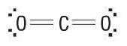
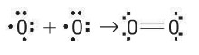
- Structural Formula is a representation of the number, types and arrangement of atoms in a molecule, with dashes representing covalent bonds.
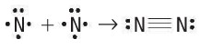
Element | EN
H | 2.2
C | 2.6
N | 3.0
O | 3.4
F | 4.0
Na | 0.9
Mg | 1.3
Cl | 3.2
Ca | 1.0

Electronegativity
- Electronegativity is the ability of an atom to attract bonding electrons to itself.
- It increases from bottom to top and left to right.

Electronegativity Difference
- Electronegativity difference (ΔEN) is the difference in the electronegativities of two bonded atoms or ions.
- To calculate the difference between the electronegativities of two atoms, the smaller electronegativity is subtracted from the larger electronegativity.
- ΔEN = Larger EN (δ+)- Smaller EN(δ-)

Describing Equations
- Word equation is a way of describing a chemical reaction using the names of the reactants
- Chemical equation is a way of describing chemical reaction using chemical formulas of reactants and products.
- Chemical Equation provides the chemical formula. reactants, products, their state and specific conditions required for the reactions to occur.
- Reactant is a chemical present at the start of a chemical reaction , that is used up during the reaction.
- Product is a chemical that is produced during a chemical reaction.
- State symbol is a symbol indicating the physical state of the chemical at room temperature. (s) represents solids, (g) represents gas, (l) represents liquids and (aq.) represents aqueous solution - dissolved in water.
- Skeleton equation is just a way of using the formulas to indicate the chemicals that were involved in the chemical reaction. It uses chemical symbols or chemical formulas to substitute the chemicals. Often referred as an unbalanced equation. Eg. CH₄ + O₂ → CO₂ + H₂O
- Balanced Equation represents a chemical reaction in which the reactants and products contain equal number of atoms of each element. Eg. KClO₃ → KCl + O₂ → 2KClO₃ → 2KCl + 3O₂
- As a result it obeys the law of conservation of mass.

