Chapter 1: Chemistry and Measurement
Laws of Chemistry
- Experiment is an observation of natural phenomena carried out in a controlled manner, so that the results can be duplicated and rational conclusions obtained.
- Law is a statement or mathematical equation about a fundamental relationship or regularity of nature.
- Hypothesis us a tentative explanation of some regularity of nature.
- Theory is tested explanation of basic natural phenomena
Matter: Physical State and Chemical Constitution
- Mass is the quantity of matter in a material.
- Matter is whatever occupies space and can be perceived by our senses.
- Law of Conservation of mass states that in any given chemical reaction, the total mass of the reactants equals the total mass of the products.
- States of Matter are comprised of a solid, liquid and gas.
- Solid is the form of matter that is characterized by rigidity.
- Liquid is the form of matter that is a relatively incompressible fluid.
- Gas is a form of matter that is an easily compressible fluid.
Qualitative And Quantitative Properties
- Qualitative Properties
- Qualitative Properties are non-numerical properties that describe qualities of objects & events.
- Quantitative properties
- Quantitative Property is a numerical property based on measurements or counting.
Physical and Chemical Properties
- Physical Property
- Physical Property is a description of a substance that does not involve forming new substances.
- Ex color, texture, density, smell, solubility, taste, melting point and physical state.
- Chemical Property
- Chemical property is a description of what a substance does as it changes into one or more new substance(s). Example Combustibility (the ability to burn), Reaction of an acid with a base, bleaching ability, corrosion
- A useful chemical property of hydrogen peroxide is that it bleaches colored substances.
Physical Changes
- Physical Change
- Physical change is a change in which no new substances are formed.
- Properties may change but the particles are not changed
- Most of the time can be reversed
- Examples: changes of state, melting ice, cutting carrots
- Chemical Change
- Chemical Change is when at least one new substance with new properties is formed.
- It is very difficult to reverse - recharging batteries is reversible
- Examples: burning toast, burning paper.

Five indicators of a chemical change
- Chemical indicator is any substance that gives a visible sign, usually by a color change, of the presence or absence of a threshold concentration of a chemical species, such as an acid or an alkali in a solution. It is a substance that changes color in the presence of an acid and an alkali
- Bubbles are produced (formation of gas)
- Heat or light is produced or absorbed
- Color changes
- A solid material forms in a liquid - precipitate.
- Difficult to reverse - Starting material is used up.
Homogenous Mixtures
- Homogenous mixtures are solutions made up of two or more substances and has one phase.
- It is called Homogenous because only one phase is observed and the components are uniformly mixed.
- Solutions can be solids, liquids or gases. Liquid and gaseous solutions are transparent as their particles are too small to block light as it passes through.
- Solutions may be colored or colorless depending on the substances they contain.
Heterogeneous Mixtures
- Heterogeneous Mixtures are mixtures that contain two or more phases.
- Phase is one of the several different homogeneous materials present in portion of matter under study.
- All mixtures that are translucent or opaque are heterogeneous mixtures - Blood.
- All is a mixture that can be homogenous and heterogeneous depending on its composition.
Alloys
- Alloy is a solution of two or more metals.
- Amalgam is an alloy of mercury with other metals.

Elements and Compounds
- Substance is a kind of matter that cannot be separated into other kinds of matter by any physical processes.
- Element is a substance that cannot be decomposed by any chemical reaction into simpler substances.
- Compound is a substance composed of two or more elements chemically combines.
- Law of Definite Proportions (Constant Composition) states that a pure compound always contains definite or constant proportions if the elements by mass.
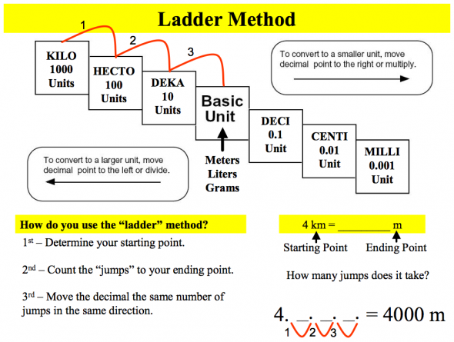
Metric Conversions
- 1 inch = 2.54 cm
- 1 yard = 0.9144 m
- 1 mile = 1.609 km
- 1 lb = 0.4536 kg
- 1nm = 1.0 x 10⁻⁷ cm

