.

ADM 2352 B Finance Theory
Assignment #4

For: Professor Saadi
December 9, 2015
Personal Ethics Statement Concerning Telfer School Assignments
Group Assignment:
By signing this Statement, I am attesting to the fact that I have reviewed not only my own work, but the work of my colleagues, in its entirety.
I attest to the fact that my own work in this project meets all of the rules of quotation and referencing in use at the Telfer School of Management at the University of Ottawa, as well as adheres to the fraud policies as outlined in the Academic Regulations in the University’s Undergraduate Studies Calendar. I further attest that I have knowledge of and have respected the “Beware of Plagiarism”
To the best of my knowledge, I also believe that each of my group colleagues has also met the rules of quotation and referencing aforementioned in this Statement.
I understand that if my group assignment is submitted without a signed copy of this Personal Ethics Statement from each group member, it will be interpreted by the Telfer School that the missing student(s) signature is confirmation of non-participation of the aforementioned student(s) in the required work.
______________ _______________
Signature Date
________________________________ _______________
Last Name (print), First Name (print) Student Number

______________ _______________
Signature Date
________________________________ _______________
Last Name (print), First Name (print) Student Number

Chapter 14
8. You own a put option on Ford stock with a strike price of $10. The option will expire in exactly six months’ time
- If the stock is trading at $8 in six months, what will be the payoff of the putt?
Payoff=$10-$8
=$2
Therefore the payoff is $2 if the strike price is $10 and if the stock is trading at $8.

b) If the stock is trading at $23 in six months, what will be the payoff of the put?
If the stock is trading at $23 than they payoff is zero because the owner would sell the stock at $23.

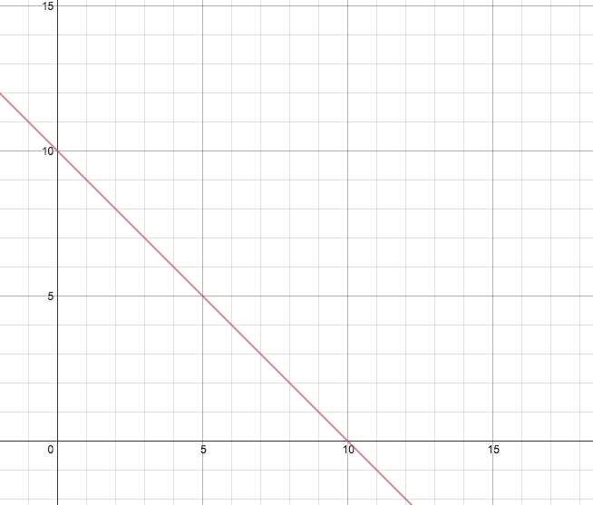
c) Draw a payoff diagram showing the value of the put at expiration as a function of the stock price at expiration.

9. Assume that you have shorted the put option in Problem 8.
Explain the difference between the types of risk each bank faces. Which bank faces less risk? Why?
a) If the stock is trading at $8 in three months, what will you owe?
Payoff= $10-$8
=$2
If the stock is trading at $8, you owe $2 because you have to buy back at the exercise price of $10 but sell at $8.

b) If the stock is trading at $23 in three months, what will you owe?
If the stock is trading at $23 you owe nothing because the owner would rather sell.
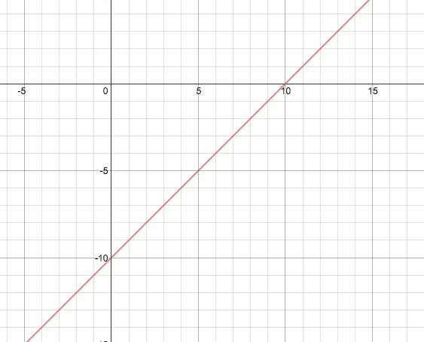
c) Draw a payoff diagram showing the value you owe at expiration as a function of the stock price at expiration.
12. You are long both a call and a put on the same share of a stock with the same expiration date. The exercise price of the put is $45. Plot the value of this combination as a function of the stock price on the expiration date.
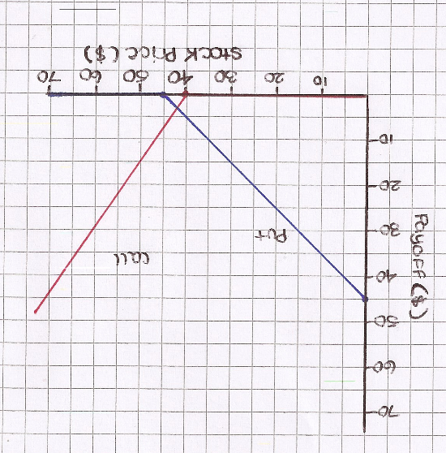
The line to the left represents the put’s payout, while the line to the right represents the calls payout. In this case you will receive money if the stick price is in-between the two strike prices (i.e. strangle).

15. You own a share of Costco stock. You are worried that its price will fall and would like to insure yourself against this possibility. How can you purchase insurance against this possibility?
You can purchase insurance against this possibility by purchasing a put option, which is referred to as a protective put. By doing so, you will get the upside while insuring against a price drop in the stock.

18. You happen to be checking the newspaper and notice an arbitrage opportunity. The current stock price of Intrawest is $20 per share and the one-year risk-free interest rate is 8%. A one-year put option on Intrawest with a stick price of $18 sells for $3.33, while the identical call sells for $7. Explain what you must do to exploit this arbitrage opportunity.
I must solve this problem using the put-call parity:
C = (P+S) – (K / (1+r))
Where:
C = price of the call
P = Price of the put
S = market value of the stock
K = strike price
r = one-year risk free interest rate
C = (3.33+20) – (18 / (1.08))
= $6.66
The arbitrage opportunity exists because the value of $7 is greater than the call which sells for $6.66. This means that the call is overpriced while comparing it to the portfolio of put, stick, and risk-free borrowing. To exploit the arbitrage opportunity you would sell the call option, buy the put and the stock, and borrow $16.67 (the PV of $18 (18 / 1.07)). The net amount left after doing these operations is $0.34, with no cash flows when the options expire.

22. You are watching the option quotes for your favourite stock, when suddenly there is a news announcement. Explain what type of news would lead to the following effects:
a) Call prices increase, and put prices fall.
This would be caused by good news about the stock, which raises its stock price.

- Call prices fall, and put prices increase.
This would be caused by bad news about the stock, which lowers the stock price.

c) Both call and put price increase.
This would be caused by news that increases the volatility of the stock.

24. Explain why an American call option on a non-dividend paying stock always has the same price as its European counterpart.
An American call option on a non-dividend paying stock always has the same price as its European counterpart because, it is never optimal to exercise an American call on a non-dividend paying stock early, therefore the right to exercise the call early is worthless. The price of a call option on a non-dividend-paying stock always exceeds its intrinsic value – and when you exercise your option, you get the intrinsic value. Therefore if you want to liquidate your position in a call on non-dividend paying stock early, you will get a higher price if you sell it rather than exercise it.

