Ba assignment 3
Q1.
- A_{12,} A_{11,} A₂₁
- A₁₂ + A₁₁ + A₂₁
- E₃₁ + E₃₂ + E₃₃ + E₄₁ + E₄₂ + E₄₃ = 1
- The first week availability constricts the amount of movies to be shown in week 1. A_{11,} A_{12,} B_{12,} C₁₁ ≤ 2
- B₂₂ + B₃₁ + D₂₂ + D₃₁ + D₃₂ + E₃₁ + E₃₂ + E₃₃ + F₃₁ + F₃₂ + F₃₃ ≤ 2

Q2. Let Xi represent the building decision location of the neighborhoods in London where i = the number representing each neighborhood.

Minimize z = X1 + X2 + X3 + X4 + X5 +X6 + X7 + X8 +X9 + X10
Subject to constraints
Neighborhood 1
X1 + X2 + X3 ≥ 1
X1 + X2 + X3 + X4 + X5 + X7 + X10 ≥ 1
X1 +X2 + X3 + X9 + X10 ≥ 1
X2 + X4 + X7 +X8 + X10 ≥ 1
X2 + X5 + X6 + X7 ≥ 1
X5 + X6 + X7 ≥ 1
X4 + X5 +X6 + X7 + X8 ≥ 1
X4 + X7 + X8 + X9 + X10 ≥ 1
X3 + X8 + X9 + X10 ≥ 1
X2 + X3 + X8 + X9 + X10 ≥ 1
X1, X2, X3 ,X4,X5,X6,X7,X7,X8,X9,X10 ≥ 0

The total number of restaurants to be made are 2 and they should be made in area 3 and area 7.
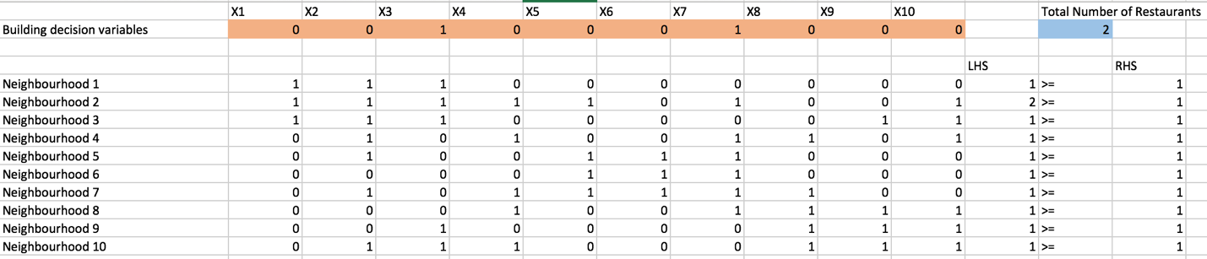
Microsoft Excel 15.29 Answer Report
Worksheet: [Workbook2]Sheet1
Report Created: 2017-03-24 3:20:20 PM
Result: Solver found a solution. All constraints and optimality conditions are satisfied.
Solver Engine
 | Engine: Simplex LP
 | Solution Time: 0.20834 Seconds.
 | Iterations: 9 Subproblems: 0
Solver Options
 | Max Time Unlimited, Iterations Unlimited, Precision 0.000001, Use Automatic Scaling
 | Max Subproblems Unlimited, Max Integer Sols Unlimited, Integer Tolerance 1%, Assume NonNegative
Objective Cell (Min)
 | Cell | Name | Original Value | Final Value
 | $M$2 | Build Decision Total Number of Resturants | 2 | 2
Variable Cells
 | Cell | Name | Original Value | Final Value | Integer
 | $B$2 | Build Decision X1 | 0 | 0 | Binary
 | $C$2 | Build Decision X2 | 0 | 0 | Binary
 | $D$2 | Build Decision X3 | 1 | 1 | Binary
 | $E$2 | Build Decision X4 | 0 | 0 | Binary
 | $F$2 | Build Decision X5 | 0 | 0 | Binary
 | $G$2 | Build Decision X6 | 0 | 0 | Binary
 | $H$2 | Build Decision X7 | 1 | 1 | Binary
 | $I$2 | Build Decision X8 | 0 | 0 | Binary
 | $J$2 | Build Decision X9 | 0 | 0 | Binary
 | $K$2 | Build Decision X10 | 0 | 0 | Binary
Constraints
 | Cell | Name | Cell Value | Formula | Status | Slack
 | $L$5 | Neighbourhood 1 LHS | 1 | $L$5>=$N$5 | Binding | 0
 | $L$6 | Neighbourhood 2 LHS | 2 | $L$6>=$N$6 | Not Binding | 1
 | $L$7 | Neighbourhood 3 LHS | 1 | $L$7>=$N$7 | Binding | 0
 | $L$8 | Neighbourhood 4 LHS | 1 | $L$8>=$N$8 | Binding | 0
 | $L$9 | Neighbourhood 5 LHS | 1 | $L$9>=$N$9 | Binding | 0
 | $L$10 | Neighbourhood 6 LHS | 1 | $L$10>=$N$10 | Binding | 0
 | $L$11 | Neighbourhood 7 LHS | 1 | $L$11>=$N$11 | Binding | 0
 | $L$12 | Neighbourhood 8 LHS | 1 | $L$12>=$N$12 | Binding | 0
 | $L$13 | Neighbourhood 9 LHS | 1 | $L$13>=$N$13 | Binding | 0
 | $L$14 | Neighbourhood 10 LHS | 1 | $L$14>=$N$14 | Binding | 0
 | $B$2:$K$2=Binary

Let Xij represent the variables for the locations for transportation where i=1,2,3,4,5 ( Toronto, Hamilton, Quebec city) and j = 1,2,3 where j is the regional distribution centers.
Minimize z = 5x_{(1,1)} + 2x_{(1,2)} + 3x_{(1.3)} + 4x_{2,1)} + 3x_{(2.2)} + 4x_{(2,1)} + 3x_{(2,2)} + 4x_{(2,3)} + 9x_{(3,1)} + 7x_{(3,2)} + 5x_{(3,3)} + 10x_{(4,1)} + 4x_{(2,2)} + 2x_{(4,3)} + 8x_{(5,1)} + 4x_{(5,2)} + 3x_{(5.3)} + 175,000y1 + 300,000y2 + 375,000y3 + 500,000y4
Y variable is used to denote the fixed cost if we were to use those locations
Subject to constraints
Supply nodes
X_{(1,1)} + X_{(1,2)} + X_{(1,3)} ≥ 10,000
X_{(2,1)} + X_{(2,2)} + X_{(2,3)} ≥ 20,000
X_{(3,1)} + X_{(3,2)} + X_{(3,3)} ≥ 30,000
X_{(4,1)} + X_{(4,2)} + X_{(4,3)} ≥ 40,000
X_{(5,1)} + X_{(5,2)} + X_{(5,3)} ≥ 30,000
Demand Nodes
X_{(1,1)} + X_{(2,1)} + X_{(3,1)} + X_{(4,1)} + X_{(5,1)} = 30,000
X_{(1,2)} + X_{(2,2)} + X_{(3,2)} + X_{(4,2)} + X_{(5,2)} = 20,000
X_{(1,3)} + X_{(2,3)} + X_{(3,3)} + X_{(4,3)} + X_{(5,3)} = 20,000
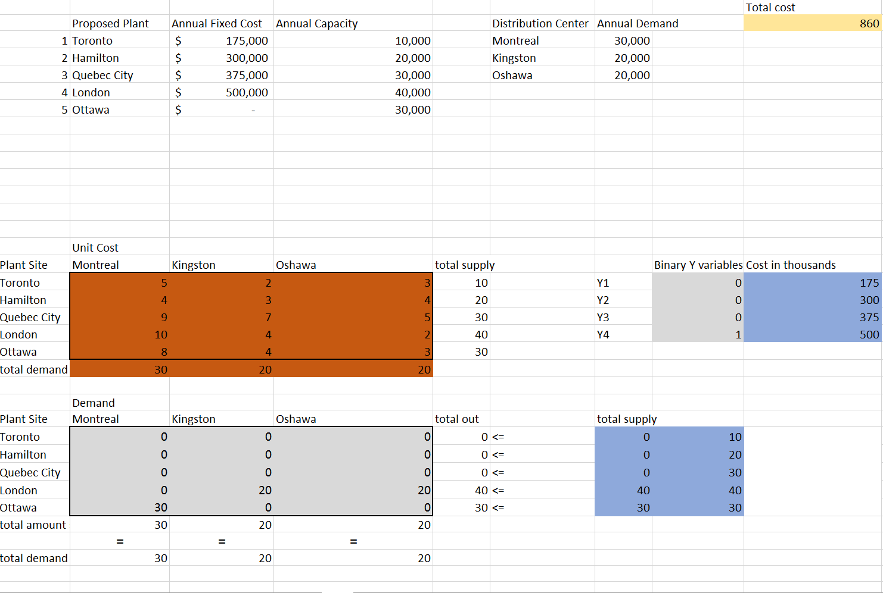

The optimal cost is 860,000
10,000 units will be shipped from (????)

Microsoft Excel 16.0 Answer Report
Worksheet: [BA A3.xlsx]Q3
Report Created: 2017-03-25 4:29:21 PM
Result: Solver found a solution. All Constraints and optimality conditions are satisfied.
Solver Engine
 | Engine: Simplex LP
 | Solution Time: 0.031 Seconds.
 | Iterations: 2 Subproblems: 2
Solver Options
 | Max Time Unlimited, Iterations Unlimited, Precision 0.000001, Use Automatic Scaling
 | Max Subproblems Unlimited, Max Integer Sols Unlimited, Integer Tolerance 1%, Assume NonNegative
Objective Cell (Min)
 | Cell | Name | Original Value | Final Value
 | $B$35 | total cost = | $ 860 | $ 860
Variable Cells
 | Cell | Name | Original Value | Final Value | Integer
 | $B$26 | Toronto Montreal | 0 | 0 | Integer
 | $C$26 | Toronto Kingston | 0 | 0 | Integer
 | $D$26 | Toronto Oshawa | 0 | 0 | Integer
 | $B$27 | Hamilton Montreal | 0 | 0 | Integer
 | $C$27 | Hamilton Kingston | 0 | 0 | Integer
 | $D$27 | Hamilton Oshawa | 0 | 0 | Integer
 | $B$28 | Quebec City Montreal | 0 | 0 | Integer
 | $C$28 | Quebec City Kingston | 0 | 0 | Integer
 | $D$28 | Quebec City Oshawa | 0 | 0 | Integer
 | $B$29 | London Montreal | 0 | 0 | Integer
 | $C$29 | London Kingston | 20 | 20 | Integer
 | $D$29 | London Oshawa | 20 | 20 | Integer
 | $B$30 | Ottawa Montreal | 30 | 30 | Integer
 | $C$30 | Ottawa Kingston | 0 | 0 | Integer
 | $D$30 | Ottawa Oshawa | 0 | 0 | Integer
 | $H$17 | Y1 variable Yi | 0 | 0 | Binary
 | $H$18 | Y2 variable Yi | 0 | 0 | Binary
 | $H$19 | Y3 variable Yi | 0 | 0 | Binary
 | $H$20 | Y4 variable Yi | 1 | 1 | Binary
Constraints
 | Cell | Name | Cell Value | Formula | Status | Slack
 | $B$31 | total in Montreal | 30 | $B$31=$B$33 | Binding | 0
 | $C$31 | total in Kingston | 20 | $C$31=$C$33 | Binding | 0
 | $D$31 | total in Oshawa | 20 | $D$31=$D$33 | Binding | 0
 | $E$26 | Toronto total out | 0 | $E$26<=$G$26 | Binding | 0
 | $E$27 | Hamilton total out | 0 | $E$27<=$G$27 | Binding | 0
 | $E$28 | Quebec City total out | 0 | $E$28<=$G$28 | Binding | 0
 | $E$29 | London total out | 40 | $E$29<=$G$29 | Binding | 0
 | $E$30 | Ottawa total out | 30 | $E$30<=$G$30 | Binding | 0
 | $B$26:$D$30=Integer
 | $H$17:$H$20=Binary

Q4. Let d₁⁻ represent underachieving on proposal 1
Let d₁⁺ represent overachievement of surplus allocation for proposal 1
Let d₂⁻ represent underachievement of surplus allocation for proposal 2
Let d₂⁺ represent overachievement of surplus for proposal 2
X₁ = Dollar amount allocated to proposal 1
X₂ = Dollar amount allocated to proposal 2

Goal
Allocate 3.5 million to proposal 2
Allocate 4.5 million to proposal 1

Minimize total deviation: 66.6d₂⁻ + 33.4d₁ ⁻
Subject to constraints
X₁ + X₂ = 8,000,000
X₁ ≤ 4,000,000
X₂ ≤ 6,000,000
2,000,000 + X₁ ≤ X₂
X₁ + 2/3X₂ ≤ 6,
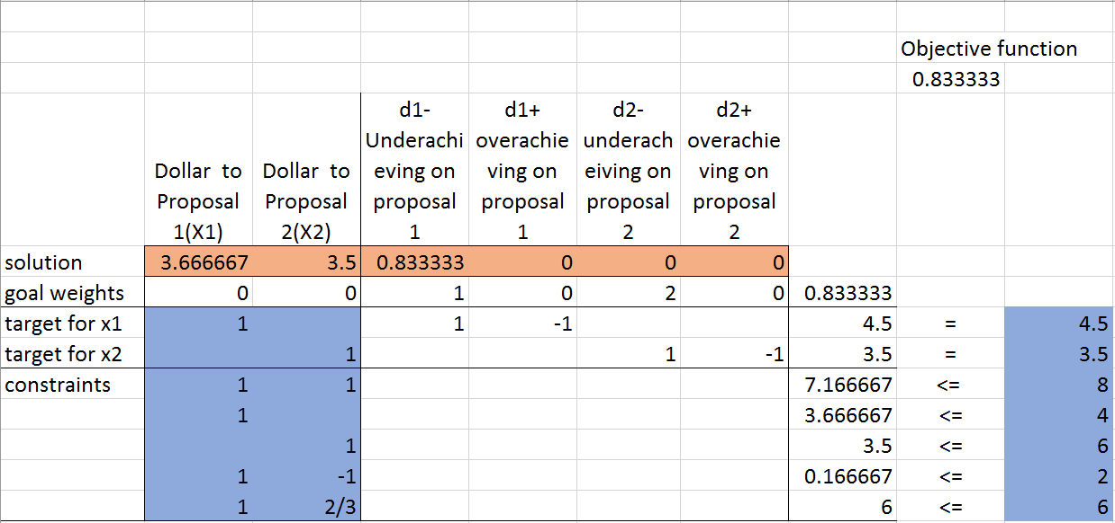

Microsoft Excel 16.0 Answer Report
Worksheet: [BA-A3 (1).xlsx]Q4
Report Created: 3/26/2017 2:52:42 PM
Result: Solver found a solution. All Constraints and optimality conditions are satisfied.
Solver Engine
 | Engine: Simplex LP
 | Solution Time: 0.047 Seconds.
 | Iterations: 5 Subproblems: 0
Solver Options
 | Max Time Unlimited, Iterations Unlimited, Precision 0.000001
 | Max Subproblems Unlimited, Max Integer Sols Unlimited, Integer Tolerance 1%, Assume NonNegative
Objective Cell (Min)
 | Cell | Name | Original Value | Final Value
 | $I$3 | Objective function | 0.833333333 | 0.833333333
Variable Cells
 | Cell | Name | Original Value | Final Value | Integer
 | $B$5 | solution Dollar to Proposal 1(X1) | 3.666666667 | 3.666666667 | Contin
 | $C$5 | solution Dollar to Proposal 2(X2) | 3.5 | 3.5 | Contin
 | $D$5 | solution d1-Underachieving on proposal 1 | 0.833333333 | 0.833333333 | Contin
 | $E$5 | solution d1+ overachieving on proposal 1 | 0 | 0 | Contin
 | $F$5 | solution d2-underacheiving on proposal 2 | 0 | 0 | Contin
 | $G$5 | solution d2+ overachieving on proposal 2 | 0 | 0 | Contin
Constraints
 | Cell | Name | Cell Value | Formula | Status | Slack
 | $H$10 |  | 3.666666667 | $H$10<=$J$10 | Not Binding | 0.333333333
 | $H$11 |  | 3.5 | $H$11<=$J$11 | Not Binding | 2.5
 | $H$12 |  | 0.166666667 | $H$12<=$J$12 | Not Binding | 1.833333333
 | $H$13 |  | 6 | $H$13<=$J$13 | Binding | 0
 | $H$7 | target for x1 | 4.5 | $H$7=$J$7 | Binding | 0
 | $H$8 | target for x2 | 3.5 | $H$8=$J$8 | Binding | 0
 | $H$9 | constraints | 7.166666667 | $H$9<=$J$9 | Not Binding | 0.833333333

