Student Name:

Student Number:

Partner’s Name and Student #:

Demonstrator's Name: \

PLEASE NOTE: If ANY of the above information is UNCLEAR or not provided, your grade will NOT be recorded!!

Lab Day (circle): Tues aft Tues night Wed Thurs aft Thurs night Fri

Lab Week (circle): 1 2

Laboratory Report Cover Page

Experiment 2.

Enthalpy of Various Reactions

Checklist:
- Raw Data Sheet written in pen, signed by TA and attached
- 8 curves [2 for metal; 2 for acid 1; 2 for acid 2; 2 for salt] attached
- Completed formal report typed and attached
Student’s Initials MC

Experiment 2

Enthalpy of Various Reactions

\
\
CHM1311E – Lab Section 1
Faculty of Health Sciences
University of Ottawa
October 6th, 2015

Introduction
Thermochemistry is a branch of chemistry that studies the amount of heat energy used or created during a chemical reaction. Furthermore, enthalpy is the quantity that expresses the amount of heat energy created or used during a chemical reaction at a constant pressure. Reactants can combine to create an endothermic reaction (absorption of heat) or they can combine to create an exothermic reaction (release of heat). Although we may not realize it, we are surrounded by endothermic and exothermic reactions daily. From ice cubes melting in a drink, to the burning of gasoline to power vehicles, applications of thermochemistry are common in our lives. Thus, an understanding of thermochemistry and its applications is essential. This lab will look at four reactions that involve a change in enthalpy.
The first experiment concerns determining the specific heat capacity of a metal. By placing the heated metal in the calorimeter we can use the formula q = m x c x ∆T to determine the q value for the water. We can then apply q_{water} = -q_{metal} to determine the amount of heat lost by the metal. Knowing q_{metal} will allow us to determine the specific heat capacity of the metal. After finding the specific heat capacity of the metal we can then apply Dulong and Petit’s equation c_{metal} x MM_{metal} = 25J/mol°C to identify the molar mass of the metal.
In the second experiment you will determine the enthalpy of a neutralization reaction. By reacting a base with two different acids in separate trials you will measure the change in heat, and thus the change in enthalpy of the two reactions respectively. Again by using q = m x c x ∆T, with a known mass and c values and a measured ∆T, we can determine n_{eutralization.} After finding the amount of moles of water created in the reaction we can then apply $∆_{N}H°= \frac{q_{N}}{H2O}$ to determine the heat of neutralization per mole of water.
Lastly, in the fourth experiment you will determine the change in enthalpy of a dissolution reaction by reacting a salt and distilled water. By using q = m x c x ∆T we can determine the temperature change in the water after adding the given salt. After finding the change in heat, we can then solve for the heat of dissolution of the salt by calculating $∆_{s}H°=\frac{q_{s}}{n_{salt}}$ .
In this lab the heat change will be monitored using a thermometer probe that will be placed inside a calorimeter. Changes in enthalpy can be both exothermic and endothermic and throughout this lab you will see examples of both of these reactions. In order to successfully complete this lab, you will effectively need to apply the formulas above. A strong understanding of the formula q=mc∆T is essential. This formula can determine the change in enthalpy from a reaction. Furthermore, the data can be applied further to determine the heat change per mole in various situations.

Procedure
As described in the lab manual. (“But A Hot Temper Leaps O’er A Cold Degree”: Enthalpy of Various Reactions), Dr. Rashmi Venkateswaran, 2015, Exp. 2, pp. 32-37).
Data, Observations and Results
Given Data

Table 1. Mass of Metal Required for Part 1 of the Experiment

Metal | Mass Required (g)
Copper, Cu | 8 - 15
Zinc, Zn | 8 - 15

Table 2. Unknown Salts for Part 3 of the Experiment

Substance | Molar Mass (g/mol) | Mass Required (g) | Specific Heat Capacity of Solution of Substance in Water (J/g°C)
Water | 18.0 | 20 | 4.184
Unknown Salt A | 74. 55 | 1.5 | 3.815
Unknown Salt B | 166.0 | 2.5 | 3.662
Unknown Salt C | 101.11 | 1.5 | 3.877

*The values for the specific heat capacities of the salt solutions were obtained from the following source:
Randall, Merle, Rossini, Frederick D., The Journal of the American Chemical Society, Vol. 51(2), February 1929, Table VII, pp334-335.

EXPERIMENT 1 – ENTHALPY OF METAL, ZINC (Zn)

Table 3a. Raw Data Measured from Experiment 1 – Enthalpy of a Metal

 | Trial 1 | Trial 2
Metal | Zinc, Zn | Zinc, Zn
Mass of Zinc (g) | 8.8415 | 11.0605
Volume of Water (mL) | 20.00 | 20.00
Mass of Cup (g) | 1.8390 | 1.8390
Temperature of Water (°C) | 100.00 | 100.00

Tables 3b. Data from Labquest 2 for Experiment 1 – Enthalpy of a Metal

Experiment 1 – Trial 1
Notes | Time (s) | Temperature (°C)
Water | 0 | 24.44
Water | 15 | 24.41
Water | 30 | 24.56
Water | 45 | 24.44
Water | 60 | 24.44
Water | 75 | 24.44
Water | 90 | 24.44
Water | 105 | 24.51
Water | 120 | 24.51
Water | 135 | 24.32
Water | 150 | 24.34
Water | 165 | 24.44
Water | 180 | 24.44
Water | 195 | 24.44
Water | 210 | 24.46
Time of Mixing | 225 | 27.37
Solution (Water and Zinc) | 240 | 27.59
Solution (Water and Zinc) | 255 | 27.57
Solution (Water and Zinc) | 270 | 27.71
Solution (Water and Zinc) | 285 | 27.54
Solution (Water and Zinc) | 300 | 27.52
Solution (Water and Zinc) | 315 | 27.61
Solution (Water and Zinc) | 330 | 27.52
Solution (Water and Zinc) | 345 | 27.52
Solution (Water and Zinc) | 360 | 27.47
Solution (Water and Zinc) | 375 | 27.35
Solution (Water and Zinc) | 390 | 27.47
Solution (Water and Zinc) | 405 | 27.47
Solution (Water and Zinc) | 420 | 27.42
Solution (Water and Zinc) | 435 | 27.43
Solution (Water and Zinc) | 450 | 27.47
Solution (Water and Zinc) | 465 | 27.47
Solution (Water and Zinc) | 480 | 27.40

Experiment 1 – Trial 2
Notes | Time (s) | Temperature (°C)
Water | 0 | 24.15
Water | 15 | 24.035
Water | 30 | 24.05
Water | 45 | 24.035
Water | 60 | 24.13
Water | 75 | 24.01
Water | 90 | 24.01
Water | 105 | 23.98
Water | 120 | 24.05
Water | 135 | 24.05
Water | 150 | 24.05
Water | 165 | 24.17
Water | 180 | 24.03
Water | 195 | 24.05
Water | 210 | 23.86
Time of Mixing | 225 | 26.13
Solution (Water and Zinc) | 240 | 27.76
Solution (Water and Zinc) | 255 | 27.85
Solution (Water and Zinc) | 270 | 27.78
Solution (Water and Zinc) | 285 | 27.83
Solution (Water and Zinc) | 300 | 27.73
Solution (Water and Zinc) | 315 | 27.71
Solution (Water and Zinc) | 330 | 27.71
Solution (Water and Zinc) | 345 | 27.71
Solution (Water and Zinc) | 360 | 27.68

Figure 1 – Graph 1 & 2
Please see appendices

Table 3c. Observations from Experiment 1 – Enthalpy of a Metal

While the zinc sample was being heated in the test tube there was no apparent change. The zinc was solid, in flakes, and it had a greyish color. When it was placed in the calorimeter there was a quick spike in temperature and then the temperature leveled out. There was nothing noticeable in terms of sight, smell, or sound.

Table 3d. Calculated Data from Experiment 1 – Enthalpy of a Metal

 | Trial 1 | Trial 2
Temperature Change of Water (°C) | 2.940 | 3.820
Energy Gained by the Water (J) | 246 | 319
Temperature Change of Zinc (°C) | -72.60 | -72.32
Approx. Heat Capacity Zinc (J/g°C) | 0.383 | 0.398
Approx. Molar Mass of Zinc (g/mol) | 65.3 | 62.7
Percent Error of Heat Capacity Zinc (%) | 1.8 | 2.1
Percent Error of MM of Zinc (%) | - 0.2125 | - 4.143

EXPERIMENT 2A – ENTHALPY OF NEUTRALIZATION – NaOH and HCl

Table 4a. Raw Data Measured from Experiment 2A – Enthalpy of Neutralization

 | Trial 1 | Trial 2
Acid Used | 1.1 Mol HCl | 1.1 Mol HCl
Base Used | 1.0 Mol NaOH | 1.0 Mol NaOH
Volume of Acid (mL) | 35.0 | 35.0
Volume of Base (mL) | 35.0 | 35.0
Mass of Cup w/ Solution (g) | 61.1575 | 61.1490

Tables 4b. Data from Labquest 2 for Experiment 2A – Enthalpy of Neutralization

Experiment 2A – Trial 1
Notes | Time (s) | Temperature (°C)
NaOH | 0 | 23.72
NaOH | 15 | 23.70
NaOH | 30 | 23.70
NaOH | 45 | 23.70
NaOH | 60 | 23.70
NaOH | 75 | 23.67
NaOH | 90 | 23.67
NaOH | 105 | 23.67
NaOH | 120 | 23.67
NaOH | 135 | 23.67
NaOH | 150 | 23.67
NaOH | 165 | 23.70
NaOH | 180 | 23.70
Time of Mixing | 195 | 30.66
Solution (NaOH and HCl) | 210 | 30.76
Solution (NaOH and HCl) | 225 | 30.76
Solution (NaOH and HCl) | 240 | 30.71
Solution (NaOH and HCl) | 255 | 30.69
Solution (NaOH and HCl) | 270 | 30.66
Solution (NaOH and HCl) | 285 | 30.64
Solution (NaOH and HCl) | 300 | 30.61
Solution (NaOH and HCl) | 315 | 30.59
Solution (NaOH and HCl) | 330 | 30.59
Solution (NaOH and HCl) | 345 | 30.59
Solution (NaOH and HCl) | 360 | 30.56
Solution (NaOH and HCl) | 375 | 30.56
Solution (NaOH and HCl) | 390 | 30.54
Solution (NaOH and HCl) | 405 | 30.52

Experiment 2A – Trial 2
Notes | Time (s) | Temperature (°C)
NaOH | 0 | 24.10
NaOH | 15 | 24.03
NaOH | 30 | 24.05
NaOH | 45 | 24.05
NaOH | 60 | 24.05
NaOH | 75 | 24.03
NaOH | 90 | 24.05
NaOH | 105 | 24.05
NaOH | 120 | 24.05
NaOH | 135 | 24.03
NaOH | 150 | 24.05
NaOH | 165 | 24.05
NaOH | 180 | 24.08
NaOH | 195 | 24.08
Time of Mixing | 210 | 30.56
Solution (NaOH and HCl) | 225 | 30.71
Solution (NaOH and HCl) | 240 | 30.69
Solution (NaOH and HCl) | 255 | 30.69
Solution (NaOH and HCl) | 270 | 30.66
Solution (NaOH and HCl) | 285 | 30.61
Solution (NaOH and HCl) | 300 | 30.59
Solution (NaOH and HCl) | 315 | 30.56
Solution (NaOH and HCl) | 330 | 30.56
Solution (NaOH and HCl) | 345 | 30.56
Solution (NaOH and HCl) | 360 | 30.54
Solution (NaOH and HCl) | 375 | 30.54
Solution (NaOH and HCl) | 390 | 30.52
Solution (NaOH and HCl) | 405 | 30.49

Figure 2 – Graph 3 & 4
Please see appendices.

Table 4c. Observations from Experiment 2A – Enthalpy of Neutralization

When the HCl was added to the NaOH there was a sudden spike in temperature, and then the temperature leveled out. Both solutions were clear, and there was nothing noticeable about smell, or sound.

Table 4d. Calculated Data from Experiment 2A – Enthalpy of Neutralization - HCL

 | Trial 1 | Trial 2
Temperature Change of Solution (°C) | 6.820 | 5.690
Final Volume of the Solution (mL) | 70.0 | 70.0
Final Mass of the Solution (g) | 70.0 | 70.0
Energy Released (J) | -1.9x10² | -1.6x10²
No. of Moles of NaOH (mol) | 3.85x10⁻² | 3.85x10⁻²
No. of Moles of H₂O Formed (mol) | 3.85x10⁻² | 3.85x10⁻²
Heat of Neutralization (J/mol H₂O) | -4.9x10² | -4.1x10²
% Error for Exp. Heat Neutralization (%) | - 14 | - 28

EXPERIMENT 2B – ENTHALPY OF NEUTRALIZATION – NaOH and HNO₃

Table 5a. Raw Data from Experiment 2B – Enthalpy of Neutralization

 | Trial 1 | Trial 2
Acid Used | 1.1 Mol HNO₃ | 1.1 Mol HNO₃
Base Used | 1.0 Mol NaOH | 1.0 Mol NaOH
Volume of Acid (mL) | 35.0 | 35.0
Volume of Base (mL) | 35.0 | 35.0
Mass of Cup w/ Solution (g) | 71.3488 | 72.5916

Tables 5b. Data from Labquest 2 for Experiment 2B – Enthalpy of Neutralization

Experiment 2B – Trial 1
Notes | Time (s) | Temperature (°C)
NaOH | 0 | 23.82
NaOH | 15 | 23.82
NaOH | 30 | 23.84
NaOH | 45 | 23.86
NaOH | 60 | 23.86
NaOH | 75 | 23.89
NaOH | 90 | 23.91
NaOH | 105 | 23.91
NaOH | 120 | 23.91
NaOH | 135 | 23.89
NaOH | 150 | 23.89
NaOH | 165 | 23.89
NaOH | 180 | 23.89
NaOH | 195 | 23.86
NaOH | 210 | 23.89
NaOH | 225 | 23.89
NaOH | 240 | 23.89
Time of Mixing | 255 | 29.58
Solution (NaOH and HNO₃₎ | 270 | 30.54
Solution (NaOH and HNO₃₎ | 285 | 30.49
Solution (NaOH and HNO₃₎ | 300 | 30.47
Solution (NaOH and HNO₃₎ | 315 | 30.44
Solution (NaOH and HNO₃₎ | 330 | 30.40
Solution (NaOH and HNO₃₎ | 345 | 30.37
Solution (NaOH and HNO₃₎ | 360 | 30.37

Experiment 2B – Trial 2
Notes | Time (s) | Temperature (°C)
NaOH | 0 | 23.72
NaOH | 15 | 23.67
NaOH | 30 | 23.67
NaOH | 45 | 23.67
NaOH | 60 | 23.67
NaOH | 75 | 23.67
NaOH | 90 | 23.67
NaOH | 105 | 23.67
NaOH | 120 | 23.67
NaOH | 135 | 23.67
NaOH | 150 | 23.67
NaOH | 165 | 23.67
NaOH | 180 | 23.67
Time of Mixing | 195 | 30.40
Solution (NaOH and HNO₃₎ | 210 | 30.47
Solution (NaOH and HNO₃₎ | 225 | 30.47
Solution (NaOH and HNO₃₎ | 240 | 30.40
Solution (NaOH and HNO₃₎ | 255 | 30.40
Solution (NaOH and HNO₃₎ | 270 | 30.40
Solution (NaOH and HNO₃₎ | 285 | 30.37
Solution (NaOH and HNO₃₎ | 300 | 30.45
Solution (NaOH and HNO₃₎ | 315 | 30.32
Solution (NaOH and HNO₃₎ | 330 | 30.30
Solution (NaOH and HNO₃₎ | 345 | 30.28
Solution (NaOH and HNO₃₎ | 360 | 30.30

Figure 3 – Graph 5 & 6
Please see appendices.

Table 5c. Observations from Experiment 2B – Enthalpy of Neutralization

When the HNO₃ was added to the NaOH there was a sudden spike in temperature, and then temperature leveled out. Both solutions were clear, and there was nothing noticeable about smell, or sound.

Table 5d. Calculated Data from Experiment 2B – Enthalpy of Neutralization

 | Trial 1 | Trial 2
Temperature Change of Solution (°C) | 6.470 | 6.740
Final Volume of the Solution (mL) | 70 | 70
Final Mass of the Solution (g) | 70 | 70
Energy Released (J) | -1.89x10³ | 1.96x10³
No. of Moles of NaOH (mol) | 3.85x10⁻² | 3.85x10⁻²
No. of Moles of H₂O Formed (mol) | 3.85x10⁻² | 3.85x10⁻²
Heat of Neutralization (J/mol H₂O) | -5.36x10⁴ | -5.13x10⁴
% % Error for Exp. Heat Neutralization (%) | -5.96 | -10.5

EXPERIMENT 3 – ENTHALPY OF DISSOLUTION OF A SALT – SALT A

Table 6a. Raw Data from Experiment 3 – Enthalpy of Dissolution of a Salt

 | Trial 1 | Trial 2
Salt | Salt A | Salt A
Mass of Salt (g) | 1.500 | 1.500
Molar Mass Salt (g/mol) (given) | 74.55 | 74.55
Heat Capacity of Salt (J/g°C) (given) | 3.815 | 3.815
Mass of Cup w/ Water (g) | 20.7783 | 20.2563
Mass of Cup w/ Water and Salt (g) | 22.2661 | 22.1370

Tables 6b. Data from Labquest 2 for Experiment 3 – Enthalpy of Dissolution of a Salt

Experiment 3 – Trial 1
Notes | Time (s) | Temperature (°C)
Water | 0 | 23.29376016
Water | 30 | 23.27050544
Water | 60 | 23.29376016
Water | 90 | 23.29376016
Water | 120 | 23.27050544
Water | 150 | 23.29376016
Water | 180 | 23.29376016
Water | 210 | 23.31846691
Time of Mixing | 240 | 19.48505772
Solution (Water and Salt) | 270 | 19.14510762
Solution (Water and Salt) | 300 | 19.14510762
Solution (Water and Salt) | 330 | 19.24273138
Solution (Water and Salt) | 360 | 19.29152103
Solution (Water and Salt) | 390 | 19.4126927
Solution (Water and Salt) | 420 | 19.48505772
Solution (Water and Salt) | 450 | 19.55886735
Solution (Water and Salt) | 480 | 19.65624693
Solution (Water and Salt) | 510 | 19.70491601

Experiment 3 – Trial 2
Notes | Time (s) | Temperature (°C)
Water | 0 | 23.4376211
Water | 30 | 23.4376211
Water | 60 | 23.46086701
Water | 90 | 23.46086701
Water | 120 | 23.48556449
Water | 150 | 23.48556449
Time of Mixing | 180 | 21.34938779
Solution (Water and Salt) | 210 | 19.43632555
Solution (Water and Salt) | 240 | 19.3388182
Solution (Water and Salt) | 270 | 19.36393925
Solution (Water and Salt) | 300 | 19.4126927
Solution (Water and Salt) | 330 | 19.48505772
Solution (Water and Salt) | 360 | 19.58247963
Solution (Water and Salt) | 390 | 19.65624693
Solution (Water and Salt) | 420 | 19.72850823
Solution (Water and Salt) | 450 | 19.75357146
Solution (Water and Salt) | 480 | 19.82579251
Solution (Water and Salt) | 510 | 19.87441458

Figure 4 – Graph 7 & 8
Please see appendices.

Table 6c. Observations for Experiment 3 – Enthalpy of Dissolution of a Salt

The salt was a solid, white, powdery substance. Upon adding the salt to the water in the calorimeter you immediately noticed the temperature drop quickly. The temperature then leveled out. After the reaction the salt was completely dissolved in the water.

Table 6d. Calculated Data from Experiment 3 – Enthalpy of Dissolution of a Salt

 | Trial 1 | Trial 2
Temperature Change of Solution (°C) | -3.62 | -3.73
Energy Absorbed by Solution (J) | 2.86x10² | 2.87x10²
Enthalpy of Dissolution (J/mol) | 1.42x10⁴ | 1.43x10⁴
% Error from Literature Value (%) | 52.4 | 53.4

Calculations

Experiment 1 – Trial 1 – Enthalpy of a Metal

- $∆T_{water}=Final{ T}_{water}-Initial T_{water}$
$$∆T_{water}=27.40℃-24.46℃$$
$$∆T_{water}=+2.940℃$$

- $q_{water}=m_{water}×c_{water}×{∆T}_{water}$
$$q_{water}=20.0g×4.184J/g℃ ×2.94℃$$
$$q_{water}=246J$$

- $∆T_{Zinc}=Final{ T}_{Zinc}-Initial T_{Zinc}$
$$∆T_{Zinc}=27.40℃-100.0℃$$
$∆T_{Zinc}=-72.60℃$

- ${-q}_{Zinc}=q_{water}$
$${-q}_{Zinc}=246J$$
$$q_{Zinc}=-246J$$
$$c_{Zinc}=\frac{q_{Zinc}}{m_{Zinc}×{∆T}_{Zinc}}$$
$$c_{Zinc}=\frac{-246J}{8.8415g×-72.6℃}$$
$$c_{Zinc}=0.383 J/g℃$$

- ${MM}_{Zinc}=\frac{25J/mol℃}{c_{Zinc}}$
$${MM}_{Zinc}=\frac{25.0J/mol℃}{0.383 J/g℃}$$
$${MM}_{Zinc}=65.27g/mol$$

- $\% {Error}_{c}=\frac{\left|{Experimental Value}_{c}- {Theoretical Value}_{c}\right|}{{Theoretical Value}_{c}}×100\%$
$$\% {Error}_{c}=\frac{\left|0.383J/g℃-0.39J/g℃\right|}{0.39J/g℃}×100\%$$
$$\% {Error}_{c}=- 1.8\%$$

$$=\frac{\left|{Experimental Value}_{MM}- {Theoretical Value}_{MM}\right|}{{Theoretical Value}_{MM}}×100\%$$
$$\% {Error}_{MM}=\frac{\left|65.27g/mol-65.409g/mol\right|}{65.409g/mol}×100\%$$
$$\% {Error}_{MM}=- 0.2125\%$$

$7.$ Increasing the mass off of the zinc resulted in more energy gained by the water. This makes sense because increasing the mass of zinc directly increases the q value for zinc, which in turn increases the q value for the water (-q_{zinc} = q_{water).}

Experiment 2A – Trial 1 – Enthalpy of Neutralization – NaOH & HCl

$$8. ∆T_{solution}=Final{ T}_{solution}-Initial T_{solution}$$
$$∆T_{solution}=30.52℃-23.70℃$$
$$∆T_{solution}=+6.820℃$$

9. ${Volume}_{solution}= {Volume}_{NaOH}+{Volume}_{HCl}$
$${Volume}_{solution}= 35.0mL+35.0mL$$
$${Volume}_{solution}= 70.0mL$$

$$10. {Mass}_{solution}= {Volume}_{solution} x {Density}_{solution}$$
$${Mass}_{solution}= 70.0mL×1.00g/mL$$
$${Mass}_{solution}= 70.0g$$

The measured mass was 71.3488g; this seems to be accurate because this mass included the styrofoam cup. I believe the calculated mass is more accurate as long is our volume measurement is accurate. The mass does matter because mass will have an affect on the calculated q value (q= m x c x ∆T).

11. $q_{solution}=m_{solution}×c_{water}×{∆T}_{solution}$
$$q_{solution}=70.0g×4.184J/g℃ ×6.820℃$$
$$q_{solution}=-1.9x{10}^{3} J$$

12. HCl (_{aq}) + NaOH(_{aq}) H₂O + NaCl(_{aq})

Mol NaOH = (0.035 L) (1.0mol/L)
Mol NaOH = 3.5x10⁻² mols

Mol HCl = (0.035L) (1.1mol/L)
Mol HCl = 3.85x10⁻² mols

Therefore, NaOH is the limiting reagent.

13.${ N}_{H2O}=Moles of NaOH ×\frac{1molH2O}{1molNaOH}$
$$N_{H2O}=3.85x{10}^{-2}mol×\frac{1molH2O}{1molNaOH}$$
$$N_{H2O}=3.85x{10}^{-2}mol H20$$

14.${ ∆}_{N}H°= \frac{q_{N}}{n_{x}}$
$$∆_{N}H°= \frac{-1.9x{10}^{3}J}{3.85x{10}^{-2}mol H20}$$
$$∆_{N}H°= - 4.9x{10}^{4}J/mol H20$$

Experiment 2B – Trial 1 – Enthalpy of Neutralization – NaOH & HNO₃

8. $∆T_{solution}=Final{ T}_{solution}-Initial T_{solution}$
$$∆T_{solution}=30.37℃-23.90℃$$
$$∆T_{solution}=+6.47℃$$
9.${Volume}_{solution}= {Volume}_{NaOH}+{Volume}_{HNO3}$
$${Volume}_{solution}= 35.0mL+35.0mL$$
$${Volume}_{solution}= 70.0mL$$

10. ${ Mass}_{solution}= {Volume}_{solution}+{Density}_{solution}$
$${Mass}_{solution}= 70.0mL×1.00g/mL$$
$${Mass}_{solution}= 70.0g$$

As compared to our measured mass to the mass of our cup with the solution (71.3488g) this calculated mass seems reasonable. I believe the calculated mass is more accurate as long is our volume measurement is accurate. It does matter because mass will have an affect on the calculated q value ( q= m x c x ∆T).

11. ${-q}_{solution}=m_{solution}×c_{water}×{∆T}_{solution}$
$${-q}_{solution}=70.0g×4.184J/g℃ ×6.47℃$$
$q_{solution}=-1894.9J$ = -1.89x10³J

Therefore, the water gained 1.89x10³J of heat energy..

12. HNO_{3(aq)} + NaOH_{(aq)} H₂O_{(l)} + NaNO_{3(aq)}

Mol NaOH = (0.035 L) (1.0mol/L)
Mol NaOH = 3.5x10⁻² mols

Mol HCl = (0.035L) (1.1mol/L)
Mol HCl = 3.85x10⁻² mols

Therefore, NaOH is the limiting reagent.

13.$N_{H2O}=Moles of NaOH ×\frac{1molH2O}{1molNaOH}$
$$N_{H2O}=3.85x{10}^{-2}mol ×\frac{1molH2O}{1molNaOH}$$
$$N_{H2O}=3.85x{10}^{-2}mol$$

14.${ ∆}_{N}H°= \frac{q_{N}}{n_{x}}$
$$∆_{N}H°= \frac{-1.89x{10}^{3}J}{3.85x{10}^{-2}mol H20}$$
$$∆_{N}H°= - 5.36x{10}^{4} J/mol H20$$

15. Heat of Neutralization of H20 with HCl = -$4.9x{10}^{3}$J/mol
Heat of Neutralization of H20 with HNO3 = -$5.36x{10}^{3}$J/mol

16. % Error for HCl:

* The literature value for the heat of neutralization for HCL was 57 KJ/mol

$\% Error=\frac{|Experimental Value-Theoretical Value|}{Theoretical Value}×100\%$
$$\% Error=\frac{|-\frac{4.9x{10}^{4}J}{mol}—-5.7x{10}^{4} j/mol|}{-5.7x{10}^{4}J/mol}×100\%$$
$$\% {Error}_{c}=-14 \%$$

% Error for HNO₃

*The literature value for the heat of neutralization for HCL was 57 KJ/mol

$\% Error=\frac{|Experimental Value-Theoretical Value|}{Theoretical Value}×100\%$
$$\% Error=\frac{|-5.36x{10}^{4}J/mol—5.7x{10}^{4} j/mol|}{-5.7x{10}^{4}J/mol}×100\%$$
$$\% {Error}_{c}=- 8.8 \%$$

17. The % error for the Experiment 2A (trial 1) with HCl was 14%, and the % error for Experiment 2B (trial 1) with HNO₃ was 8.8%. The volume of NaOH never changed so it had no affect on the result. The values for enthalpy of neutralization are similar between the two acids. This was expected because both acids had the same molarity, and the same volume of the acids and base were used in every trial.

Experiment 3 – Trial 1 – Enthalpy of Dissolution of a Salt

18. $∆T_{solution}=Final{ T}_{solution}-Initial T_{solution}$
$$∆T_{solution}=19.70℃-23.32℃$$
$$∆T_{solution}=-3.62°C$$

19.$q_{solution}={- ((m}_{cup+water}-m_{cup})×c_{water}×{∆T}_{water})$
$$q_{solution}=- \left(20.7783g-1.8390g\right)×\frac{4.184J}{g}℃×6-3.62℃)$$
$$q_{solution}=2.86x{10}^{2} J$$

When Salt A was added the solution gained $2.86x{10}^{2}$J of energy

20. $∆_{s}H°=\frac{q_{s}}{n_{salt}}$
$$∆_{s}H°=\frac{2.86x{10}^{2}J}{(1.500g/74.55g)mol}$$
$∆_{s}H°=1.42x{10}^{4}J/mol$ Salt

The enthalpy of the dissolution of Salt A is $1.42x{10}^{4}$J/mol

21. A literature value for $∆_{s}H°$of KCl (74.55 g/mol) is 695 J/Kg.

Find J/Mol:
695 J/Kg x (1000g/74.55)
695 J/Kg x 13.41 mol/ Kg
= 9.32x10³ J/mol (theoretical)

$$\% Error=\frac{|Experimental Value-Theoretical Value|}{Theoretical Value}×100\%$$
$$\% Error=\frac{|1.42x{10}^{4}J/mol—9.32x{10}^{3}j/mol|}{9.32×{10}^{3}J/mol}×100\%$$
$$\% {Error}_{H}= 52.4\%$$

22. The mass of the salt didn’t change over our two trials; however, a greater mass would of caused a greater change in temperature if the volume of water stayed the same. That said it should not affect the overall enthalpy of the dissolution ($∆_{s}H°)$ because although there would be a greater energy released by the dissolution, there would be a greater number of moles used. Realistically it should have the same energy released-to-mole ratio no matter what mass is used.

Discussion
Several experiments were completed for this lab; all experiments involved monitoring for temperature change within a calorimeter. The first experiment was aimed towards finding the specific heat capacity of a given metal. The given metal was zinc. First, the sample of zinc was heated in a test tube to 100°C using boiling. The zinc was then quickly placed in the water within the calorimeter. By monitoring the increase in water temperature in the calorimeter it was apparent that this reaction was exothermic. A heat transfer between the zinc and water caused the exothermic reaction. Also, by measuring the change in temperature of the water one could calculate the total amount of energy lost by the sample of zinc. This value could then be applied to calculate an experimental heat capacity for zinc, which was 0.383(J/g°C). Furthermore, the experimental heat capacity was used to calculate an experimental molar mass for the zinc, which was 65.3g/mol. All in all, these values were quite accurate in comparison to the theoretical values of heat capacity for zinc and the theoretical molar mass for zinc respectively. This suggests that experiment 1 was done quite effectively to reflect the theoretical values.
Experiment 2 was done to calculate the enthalpy of neutralization between a base, NaOH, and two acids, HCl and HNO₃. When combined with the base both acids reacted to form an exothermic reaction. Both reactions created very similar values within change in temperature, amount of energy released (J), and heat of neutralization per mole of water. It can be deduced that the exothermic reaction was a result of bonds breaking and bonds forming. That said, there was inaccuracy when the experimental results were compared to theoretical values found in literature. There was an average % error of - 21% for the trials with HCl and an average of 8.23% for the trials with HNO₃. It is possible the calculated masses of the solutions (NaOH + acid solution) were inaccurate. Density was used to find the mass, and this is inaccurate compared to using masses found by using a scale. That said, one could also suggest that the volumes used were not completely accurate. This could have caused a lower change in temperature. In the end the lower changes in temperature could explain the lower values of experimental heat neutralization per mole in comparison to values found in literature.
The enthalpy of dissolution of a salt was the third and final experiment. In this experiment the unknown salt was placed within the water and the water temperature lowered. Thus, it was an endothermic reaction as the water lost heat energy. Since it was endothermic, one can deduce that the ∆H values for bonds broken were greater than the ∆H for the bonds formed. When assessing for % error in trials 1 and 2 the values were 52.4% and 53.4% respectively. These are very high results, which suggest that the literature value that was found could have been wrong. That said it is possible that the measurement for the mass of the salt was off. This would explain for the high enthalpy of dissolution in comparison to the theoretical value found in the literature.
In general throughout this lab it is possible that errors occurred that would of affected the results. For instance, when transferring solutions from beaker, to graduated cylinder, to calorimeter it was difficult to ensure that no liquid remained in each container after transferring. This could explain why all the error values were negative, which essentially suggests there was a shortage in something. Secondly, after each trial the cup within the calorimeter had to be rinsed and dried. It was difficult to ensure, in a fast paced lab, that this was done thoroughly each time. All in all the % errors from experiment 1 were very low (-0.2125%, -4.143%), the % error in experiment 2 were moderately high (-14%, -28%; -5.96%, -10.5%), and in experiment 3 a % error could not be determined because theoretical values could not be found.

Conclusion
In conclusion, for experiment 1, trial 1 the specific heat capacity and molar mass for zinc was 0.383(J/g°C) and 65.3 g/mol, with a percent error of 1.8% and 0.2125% respectively. For experiment 1, trial 2 the specific heat capacity and molar mass for zinc was 0.398(J/g°C) and 62.7 g/mol, with a percent error of 2.1% and 4.143% respectively. For the second experiment (2A) the heat of neutralization of water in a reaction with HCl was -4.9x10⁴ (J/mol) with a - 14% error in trial 1, and in trial 2 the heat of neutralization was -4.1x10⁴ with a - 28% error. For the second experiment (2B) the heat of neutralization of water in a reaction with HNO₃ was -5.36x10⁴ (J/mol) with a –5.96% error in trial 1, and in trial 2 the heat of neutralization was -51.x10⁴ with a –10.5% error. Lastly for the third experiment the enthalpy of dissolution for the salt (Salt A) was 1.42x10⁴ in trial 1 and 1.43x10⁴ in trial 2, and once again no percent error could be calculated because no literature value could be found.

Appendices
Figure 1

Graph 1
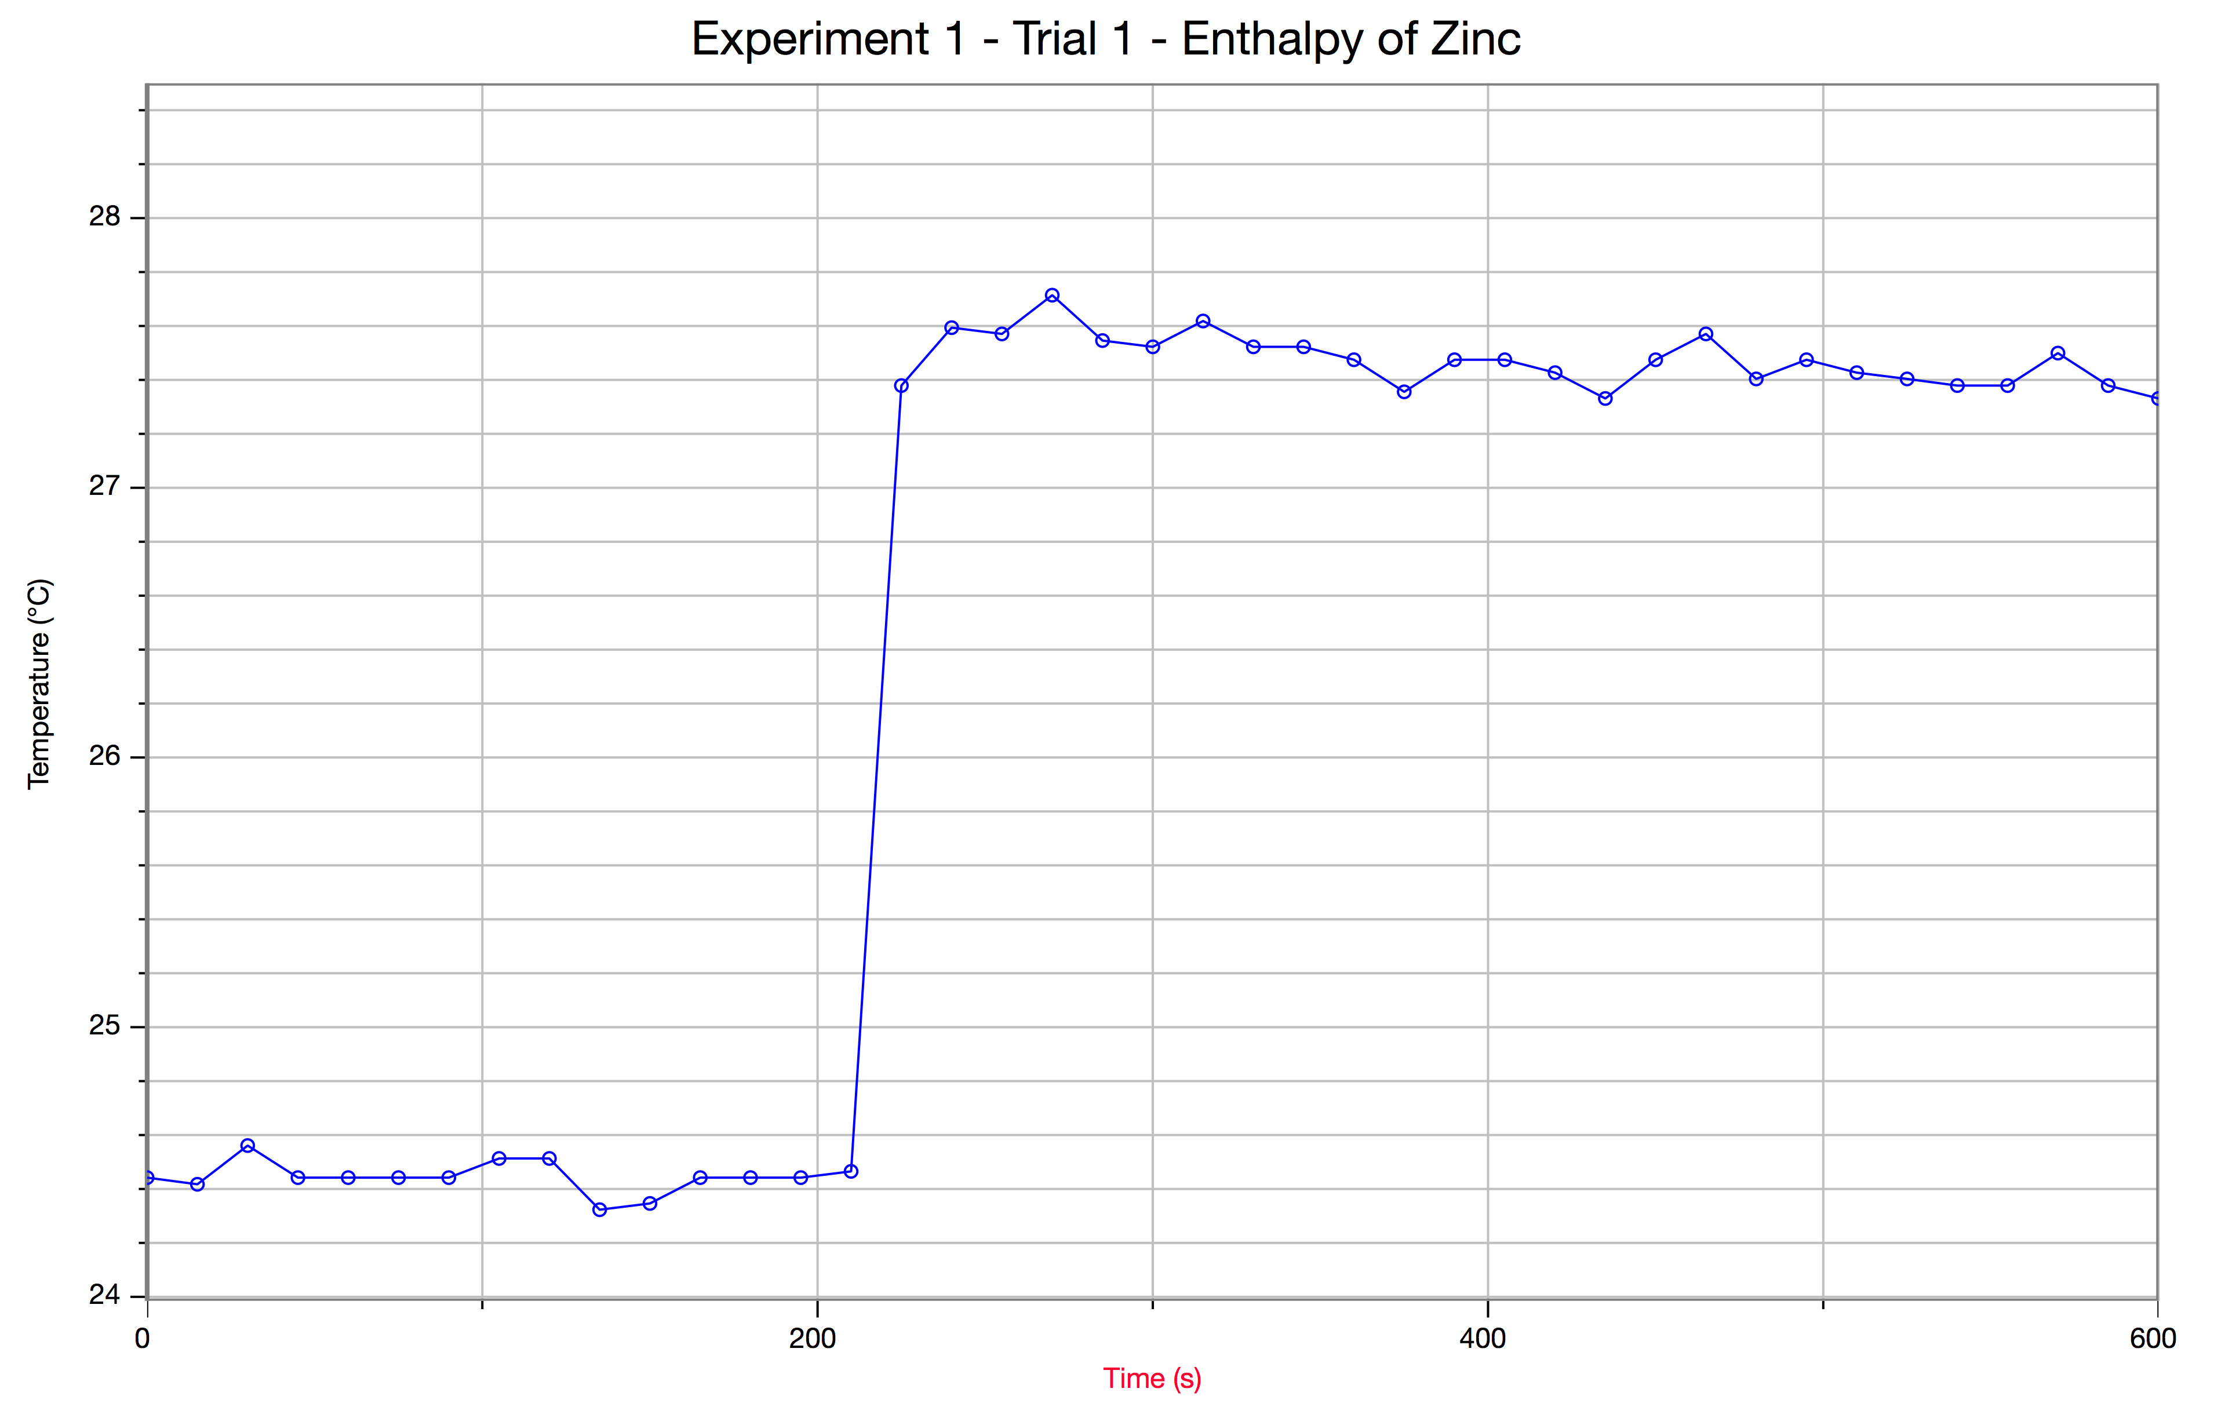
Graph 2
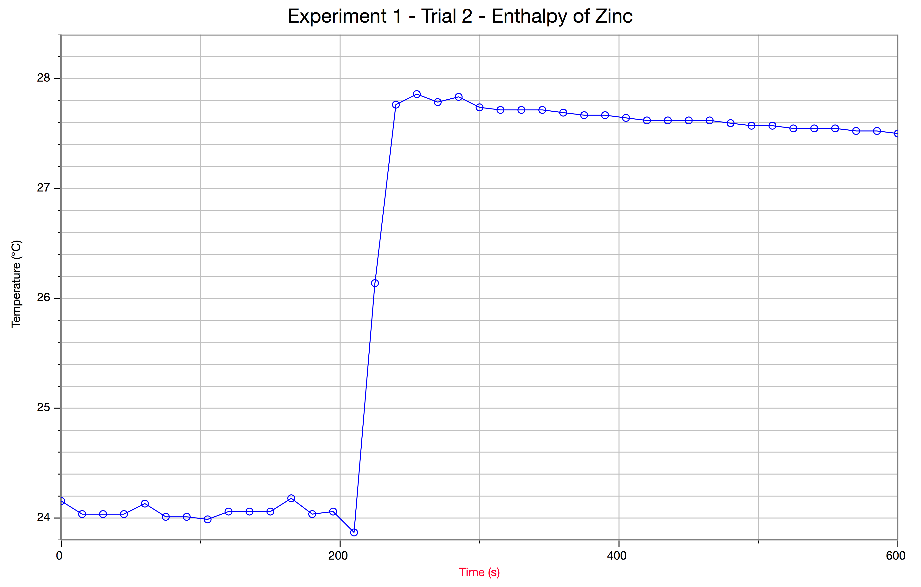

Figure 2

Graph 3
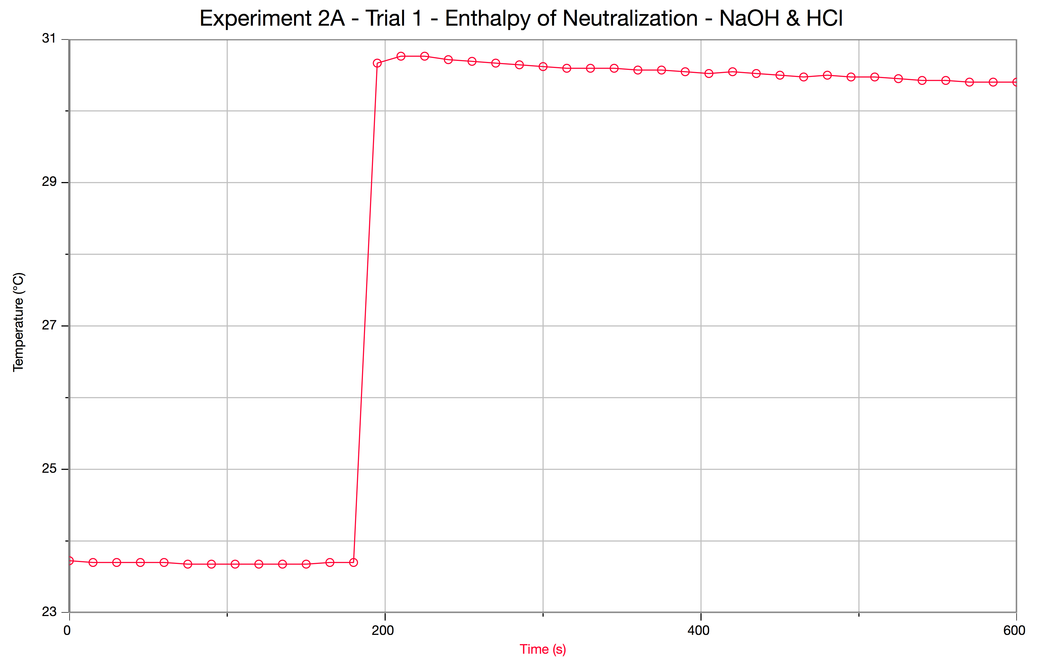

Graph 4
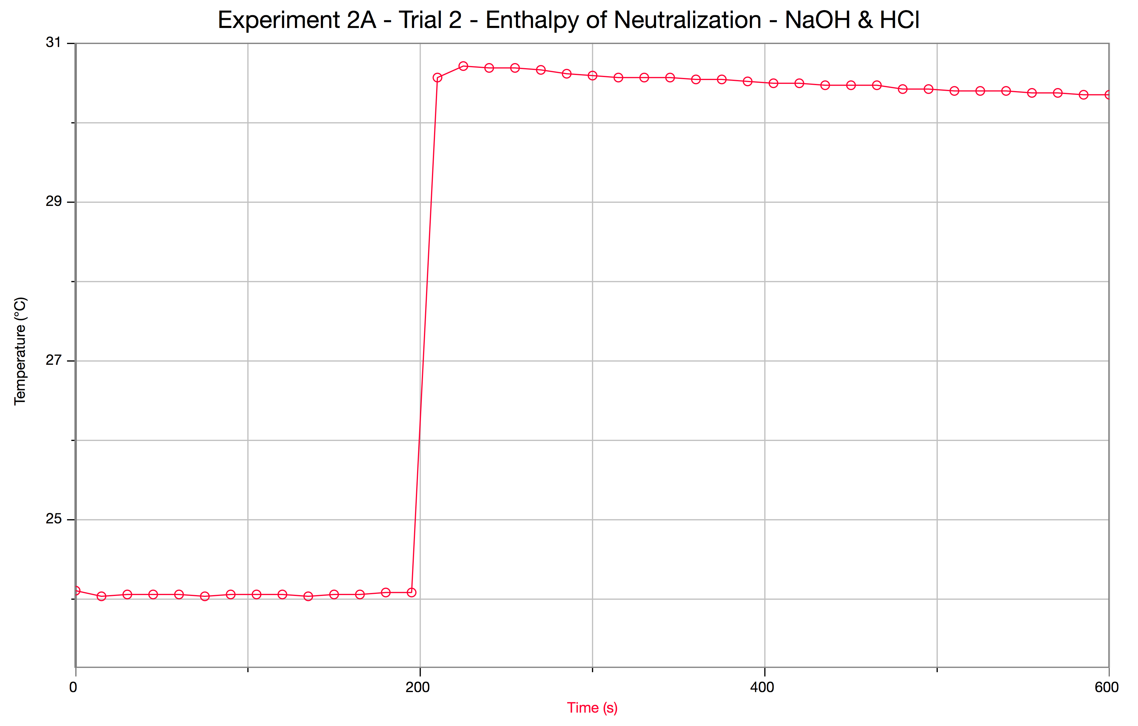

Figure 3

Graph 5
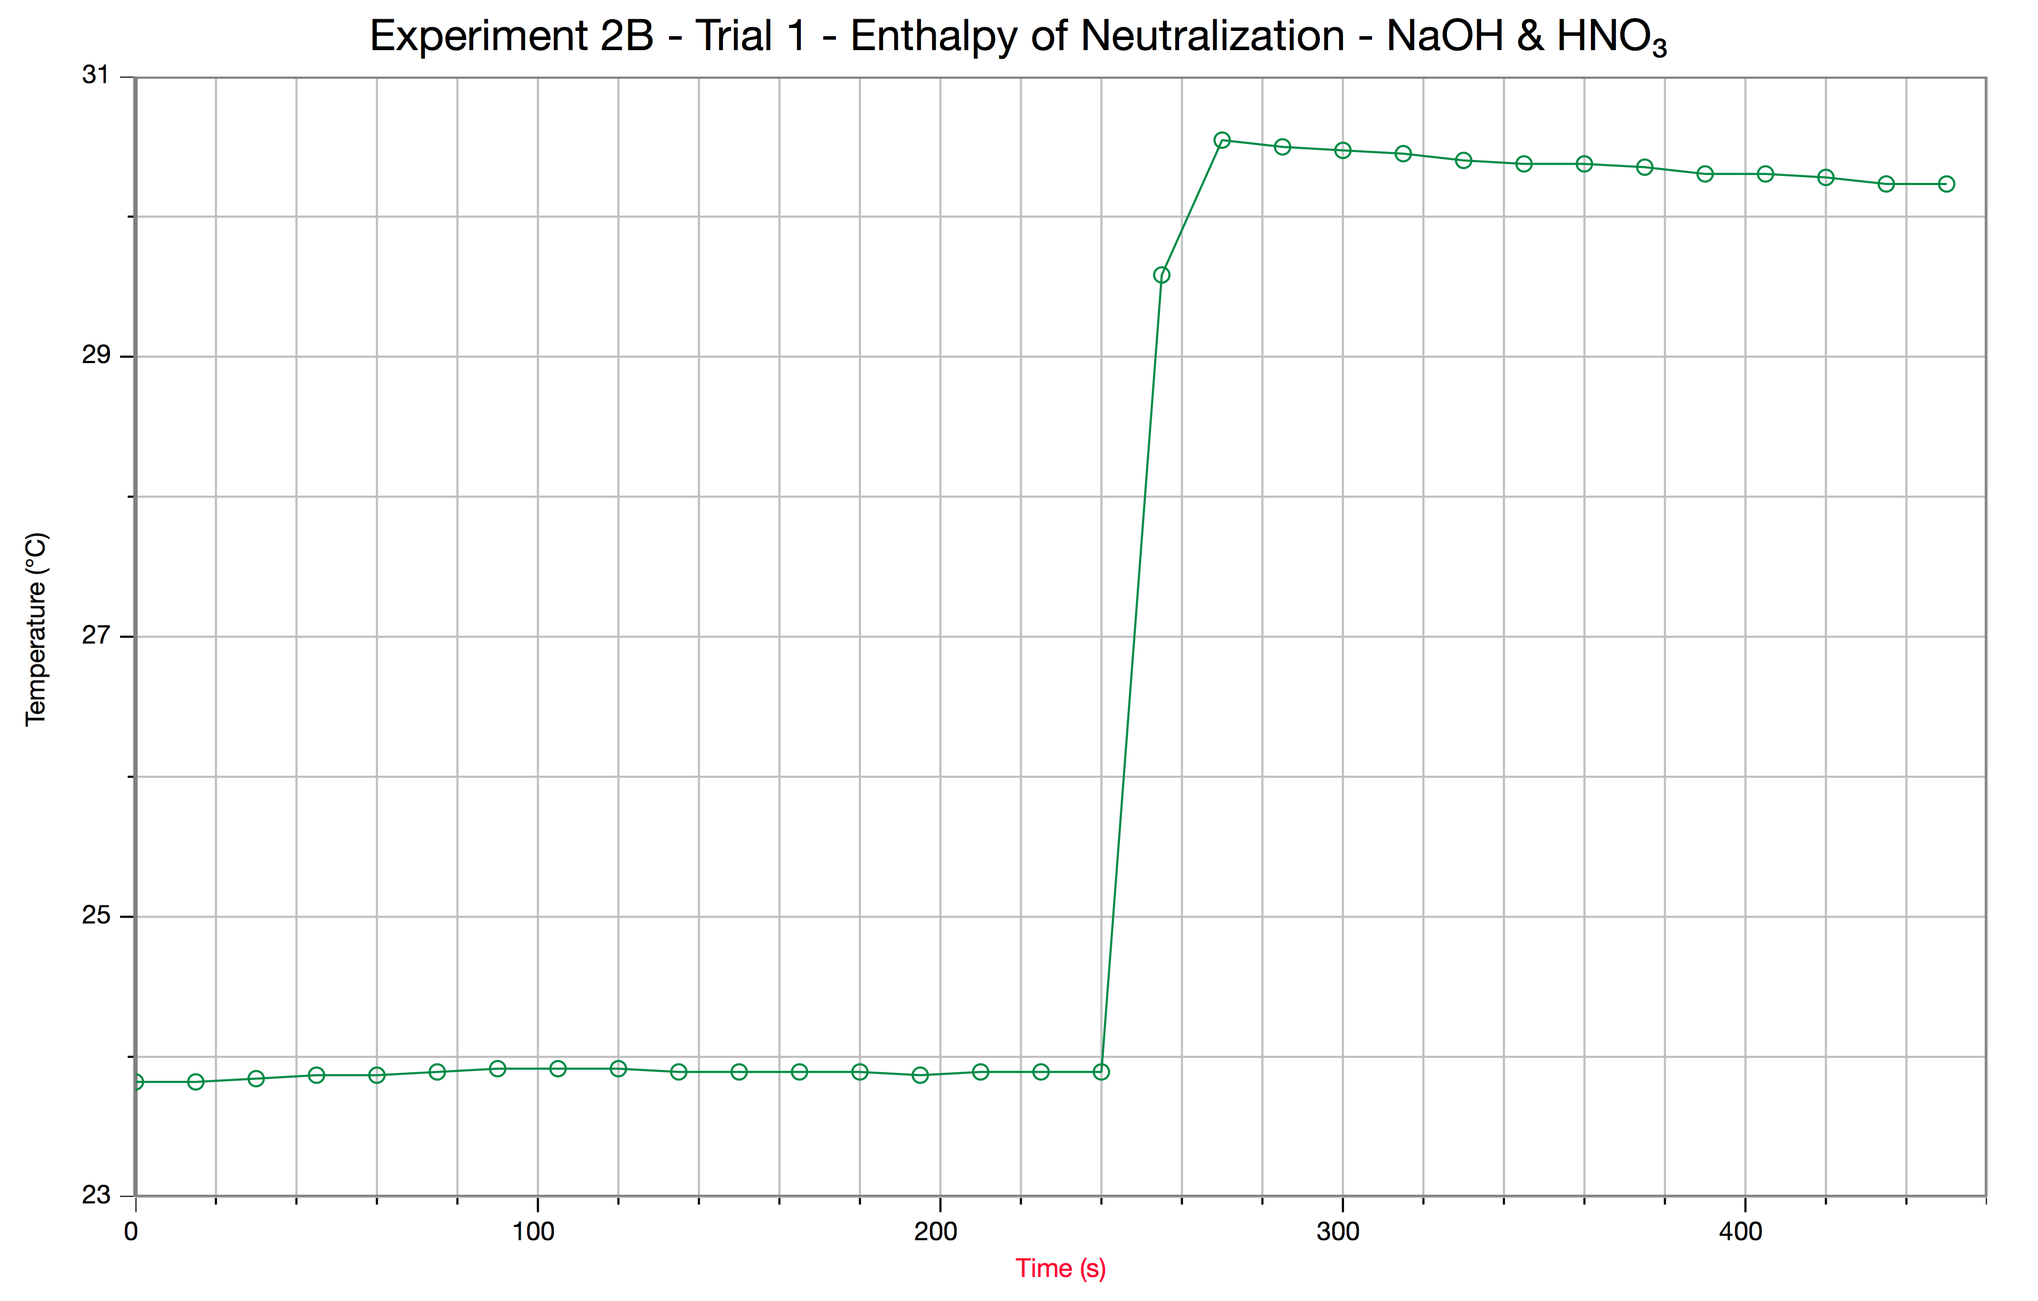
Graph 6
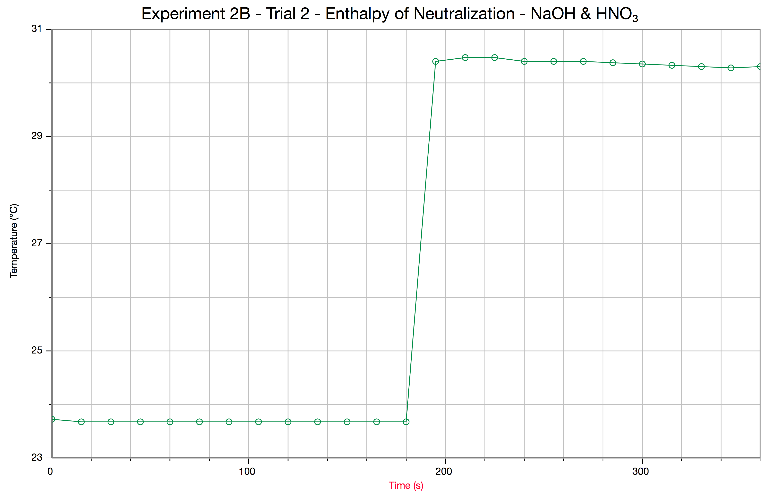

Figure 4

Graph 7
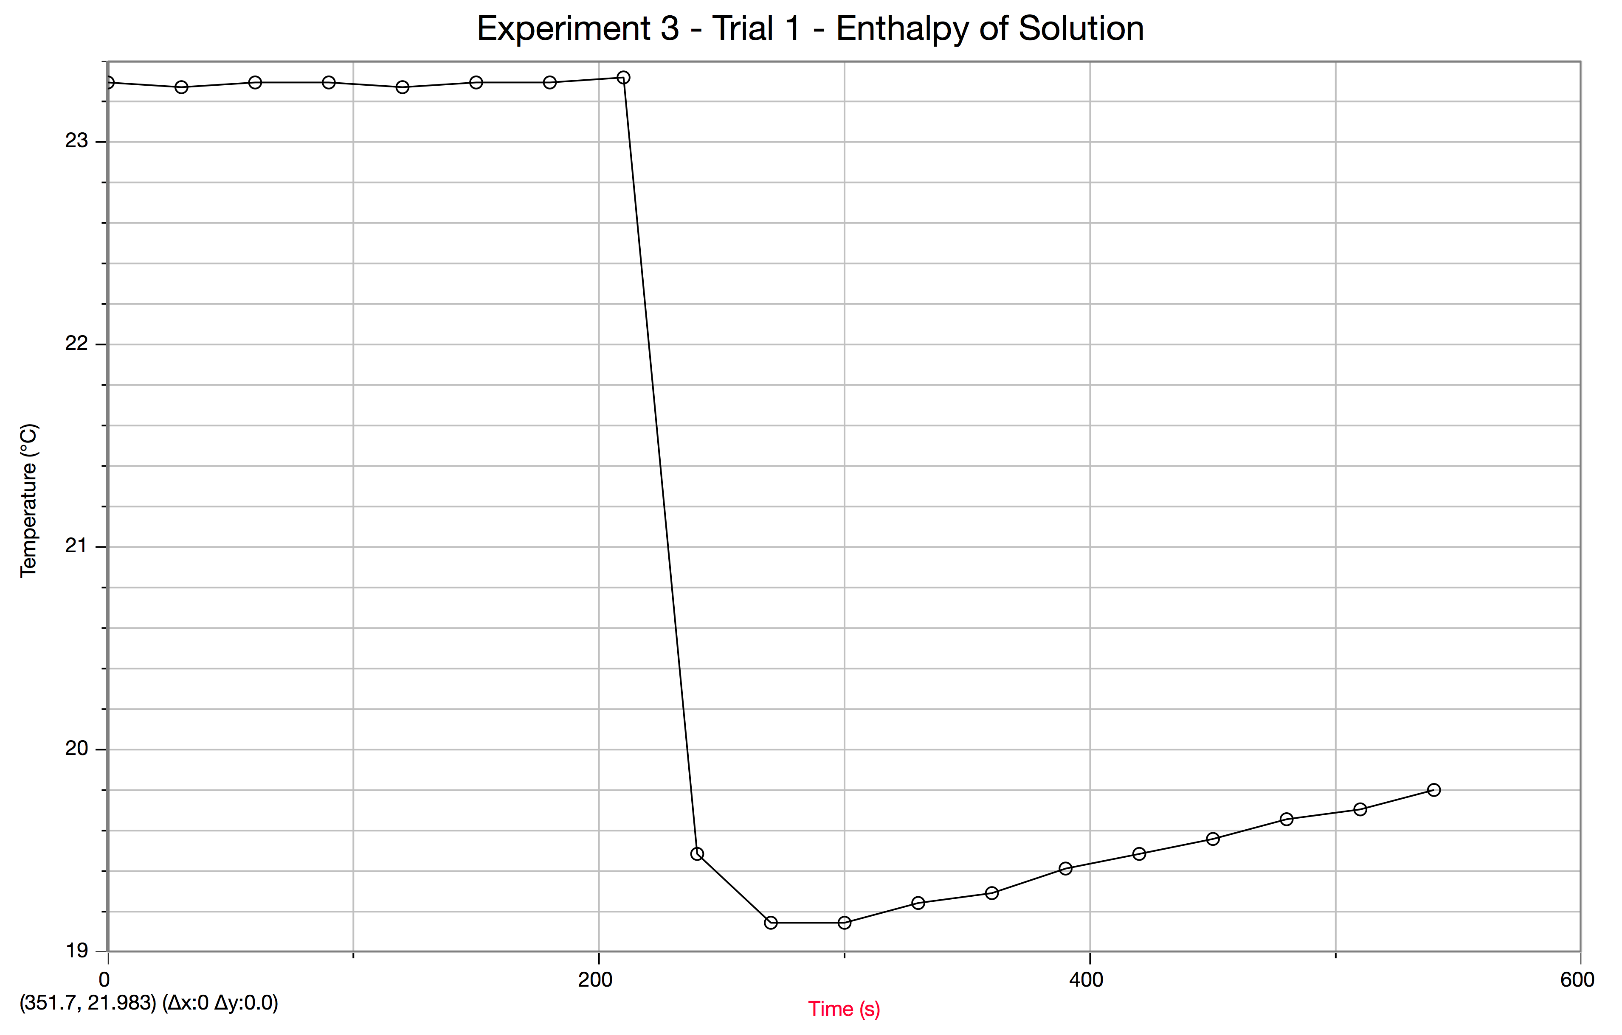
Graph 8
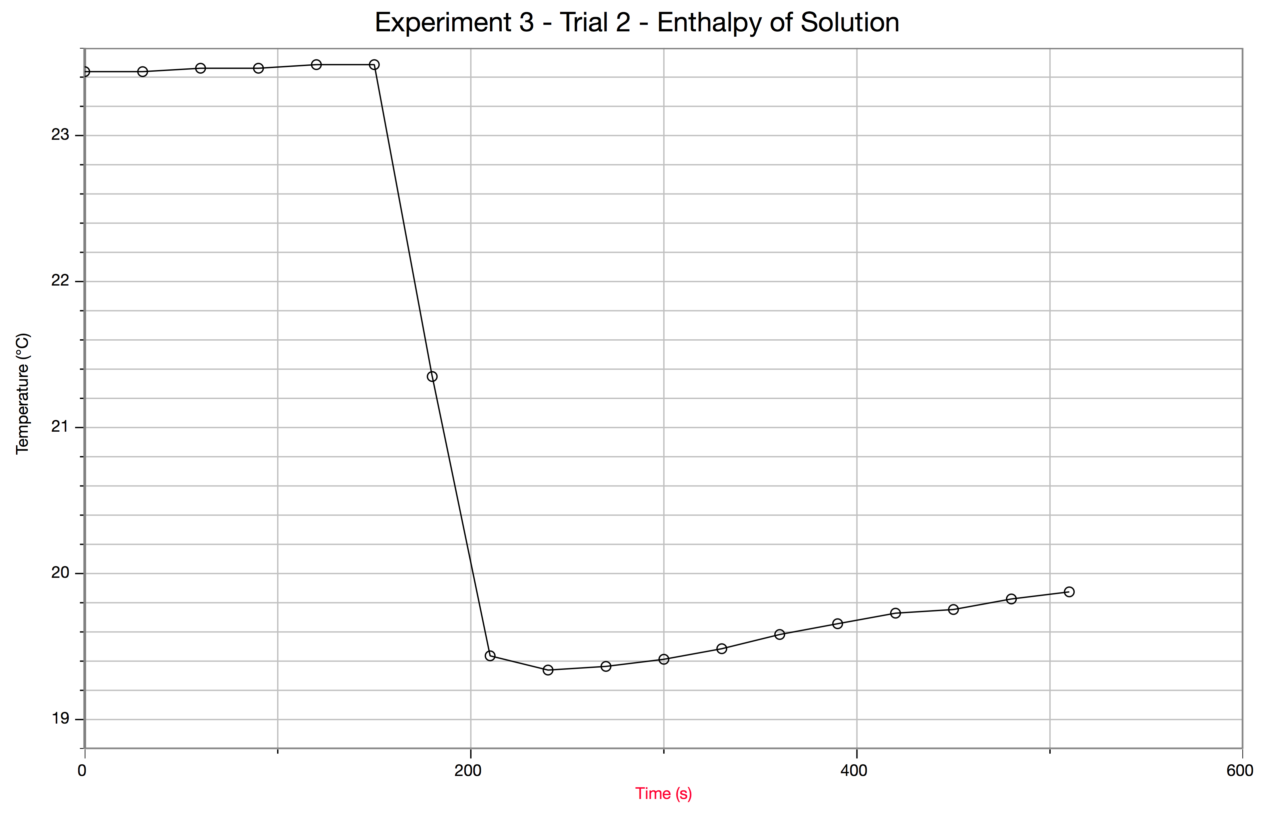
References
UOttawa, Lab Report. Venkateswaran, R., n.d. Web. 8 Oct. 2015, Ottawa Ontario, University of Ottawa/ Faculty of Science. https://uottawa.blackboard.com/bbcswebdav/pid-871438-dt-content-rid-17562867_1/courses/20159_OS00366_CHMLAB/.pdf

“Potassium Chloride.” Janis, nd. Web. 7 Oct. 2015. <http://www.janis.com/Libraries/Window_Transmissions/PotassiumChloride_KCl_TransmissionCurveDataSheet.sflb.ashx>

Randall, Merle, Rossini, Frederick D., The Journal of the American Chemical Society, Vol. 51(2), February 1929, Table VII, pp334-335.
Silberberg, Martin S., Venkateswaran R., Lavieri S. “Chapter 5 Thermochemistry.” Chemistry: The Molecular Nature of Matter and Change. Canadian Edition ed. United States: McGraw Hills, 2013. 202. Print

Tyagi, Praveen. Thermochemistry. New Delhi: Discovery Pub. House, 2006. Print.



