Anatomy and Physiology Intro Slide Study Sheet
  - Introductory terms
- Anatomy: study of structure of body parts and their relationships
- Physiology: study of functions of said parts
- Regional Anatomy: all structures in a specific area
- System anatomy: looks at one system and structures associated
- Surface anatomy: study of internal structures and relationship with their visibility on the external surface (muscle, veins)
- Microscopic anatomy: structures too small to be seen by naked eye
  - Cytology: microscopic study of cells
  - Histology: microscopic study of tissues
- Developmental anatomy: anatomical + physiological development t/o life
  - Embryology: study of developments before birth
  - Must know anatomical terms in order to
- Observe
- Manipulate
- Palpate
- Auscultate
  - Principle of complementarity of structure and function
- Function will always reflect the structure
- What structure can do depends on its properties (ex. Bone supports body because of hard mineral deposits, blood in one direction because of structure of heart valves)
  - Structural Organization of the Human Body
- AtomMoleculeOrganelleCellTissueOrganOrgan System
- Tissue
  - Groups of cells similar in structure and function
  - 4 types
    - Epithelial
      - Covers the body surface (skin) and forms lining for most internal cavities
      - Major functions are:
        - Protection
        - Secretion
        - Absorption
        - Filtration
    - Connective
      - Most abundant/widely distributed
      - Functions are support and protection
    - Muscular
      - Three types
        - Skeletal
          - Voluntary
          - Contraction of skeletal parts
        - Smooth
          - Involuntary
          - Found in walls of internal organs and blood vessels
        - Cardiac
          - Involuntary
          - Found only in walls of the heart
    - Nervous
      - Specialized cells which receive and conduct stimuli and impulses all around body
      - Long and string like
- Organ
  - Composed of at least (usu. 4) tissue types that perform certain function for the body
  - Ex. The brain is made of many nervous tissues which help conduct and receive stimuli + impulses to perform internal and external bodily functions
- Organ System
  - Organs working together to accomplish common purpose
  - 11 organ systems in the body
- Integumentary
  - skin, hair, subcutaneous fat and nails
  - protection from the environment, provides form and individual recognition characteristics and aids in temperature and water regulation
  - skin is the site where vitamin D is generated
  - Integument (skin) func. as anchor for sensory receptors (part of the nervous system) that detect pain, cold, warmth and pressure
- Muscular
  - includes the skeletal muscles // excludes smooth and cardiac muscles
  - provides locomotion and support, allows manipulation of our surroundings
  - due to its high metabolic activity produces heat
- Skeletal
  - composed of bones, joints, cartilage, ligaments and tendons
  - provides structural support and protection for internal organs
  - In coop. w/ muscular system, skeletal system participates in movement and locomotion
  - serves as a reservoir for calcium, phosphorus, magnesium and other minerals
- Nervous
  - brain, spinal cord, autonomic and somatic nerves (ex. involuntary and voluntary nerves) and all sensory organs, including those that serve vision, smell, sensation, balance, hearing and taste
  - coordinates your movements and controls your responses to both external and internal stimuli
  - storehouse and processing center for memories, regulates mood and provides mechanisms for social interaction and development
- Circulatory
  - heart, blood vessels and blood
  - delivering oxygen and nutrients to every cell, tissue and organ in your body
  - directly communicates with the lymphatic system, leading many to count these two systems as one
- Lymphatic
  - lymphatic vessels, travel w/ your blood vessels and lymph nodes, where immune cells are produced
  - returns a clear fluid called 'lymph' from your tissues and organs to your heart
    - produced by the leakage of a small amount of fluid from your blood vessels into the surrounding tissues
  - transports fats absorbed from your intestine and carries immune cells from one place to another in your body
- Respiratory
  - organs of breathing, which include your nose, pharynx (mouth), larynx (throat), trachea (windpipe), bronchi and bronchioles (airways), lungs, sinuses, and diaphragm
  - principal site of gas exchange in your body // oxygen absorbed into bloodstream and CO2 removed
  - Air moving through respiratory system also provides the ability to vocalize (ex. speak and sing).
- Endocrine
  - hormone-producing organs, or 'glands,' such as the thyroid, pituitary, pancreas, adrenals, hypothalamus, gonads and pineal
  - Hormones produced by these organs released directly into your bloodstream
  - chemical messengers travel t/o body and help regulate the activities of other organ system
- Urinary/excretory
  - responsible for the elimination of wastes produced by homeostasis
  - Regulation of acid-base homeostasis
  - Regulation of electrolyte balance (e.g. sodium, potassium and calcium)
  - controlling blood volume and maintaining blood pressure
- Reproductive
  - Female
    - Two functions
      - produce egg cells
      - protect and nourish the offspring until birth
  - Male
    - produce and deposit sperm
- Digestive
  - Ingestion is the process of eating
  - Propulsion: movement of food along the digestive tract.
    - Major means of propulsion is peristalsis, a series of alternating contractions and relaxations forces food to move forward.
  - Secretion of digestive enzymes and other substances liquefies, adjusts the pH of, and chemically breaks down the food
  - Mechanical digestion: process of physically breaking down food into smaller pieces
    - begins w/ chewing of food, continues w/ the muscular churning of the stomach
    - Additional churning occurs in the small intestine through muscular constriction of the intestinal wall, called segmentation, is similar to peristalsis, except that the rhythmic timing of the muscle constrictions forces the food backward and forward rather than forward only
  - Chemical digestion is the process of chemically breaking down food into simpler molecules
    - process carried out by enzymes in the stomach and small intestines
  - Absorption: movement of molecules (by passive diffusion or active transport) from the digestive tract to adjacent blood and lymphatic vessels.
    - Absorption = entrance of the digested food (now called nutrients) into the body.
  - Defecation: eliminating undigested material through the anus
- Opt: immune system (could be cons. Part of lymphatic sys.)

  - Summary of cells and organelles
Structure |  | Function
Cell membrane/plasma membrane |  | Double phospholipid bilayer barrier embedded with proteins;  provides boundary and shape
cytoplasm |  | Area outside the nucleus and inside the PM; includes the cytosol  and organelles; site of most cellular activities
mitochondria |  | ‘Powerhouses” of the cell; Carry out reactions where O₂ is used to  break down food to make ATP
ribosomes |  | Made of protein & RNA; site of protein synthesis
A network of interconnected tubes and parallel membranes that coils and twists throughout the cytoplasm.
Continuous with the outer nuclear membrane. Functions like a little circulatory system within the cell for the
transport of molecules. 2 types
1. Rough ER  2. Smooth ER | Studded with ribosomes; site where building materials of cellular membrane are formed  Free of ribosomes. Functions in cholesterol synthesis and breakdown, fat metabolism,  and detoxification of drugs
Golgi apparatus |  |  | A stack of flattened membranous sacs  Modifies and packages proteins
lysosomes |  |  | Membranous sacs of acid hydrolases: enzymes that  digest unusable materials within the cell/ abundant in  phagocytes
peroxisomes |  |  | Membranous sacs of catalase and oxidase enzymes  Detoxify harmful substances/ neutralize free radicals

Structure |  |  | Function
cytoskeleton |  |  | Network of protein structures; extend throughout the cytoplasm;  provides internal framework of the cell.  Made up of 3 types of proteins.
- microfilaments  - Motor proteins  - microtubules |  |  | - Fine filaments composed of actin; involved in muscle contraction  - Protein fibers of various compositions  - Cylindrical structures made of tubulin supports the cell & gives  it shape  - Anchored at one end near the nucleus called the centrosome  (cell center)
centrosome |  |  | - Microtubule organizing center. Contains paired cylindrical bodies  called centrioles
CELLULAR EXTENSIONS
cilia | numerous, fine, hair like projections; coordinated movement creates current that  propels substances across cell surface
flagella | Whip like tail; propels the cell (only sperm has flagellum)
microvilli | Finger like extensions of the PM; bundle of actin filament; increases surface area for absorption
nucleus |  | Largest organelle; control center of the cell; contains  the genetic information that provides instructions for protein synthesis
Phospholipid bilayer |  | double phospholipid membrane barrier punctuated by pores that allow;  separates nucleoplasm and cytoplasm
nucleoli |  | Dense spherical bodies made of ribosomal RNA & proteins; site of  ribosome synthesis
chromatin |  | Composed of DNA and histone protein

  - Tissues: General Facts
- Tissue: groups of structurally similar cells that perform common/related function
- Epithelial tissue: sheet of cells that covers a body surface or lines a body cavity
  - Creates boundaries
  - Location: “EPI” therefore above//connective tissue layer (ex. Epidermis covers the body)
  - inside of hollow organs and the outside of all organs (covering & lining)
  - Functions of epithelial tissue
- Protection: Cells of the skin protect underlying tissue from
- Absorption: Cell epithelial cells lining the gastrointestinal tract absorb nutrients from digested food
- Filtration
- Excretion: Epithelial tissues in the kidney excrete waste products from the body and reabsorb needed materials from the urine. Sweat is also excreted from the body by epithelial cells in the sweat gland
- Secretion: In glands, epithelial tissue is specialized to produce secretion e.g. enzymes, hormones and lubricating fluids
- Sensory Reception: Specialized epithelial tissue containing sensory receptors is found is in the skin, eyes, ears, nose, and tongue
- special structural characteristics of epithelial tissue
- Polarity
  - All epithelia have apical (higher) and basal (lower) surfaces creating apical basal polarity.
  - Apical surface
    - has microvilli which increase s/a
  - Epithelia that absorb or secrete substances, the microvilli attached are extremely dense giving the cells a fuzzy app // called brush border
  - Other epithelia have motile cilia (hair like projections) that push substances along their free surface.
  - Next to the basal surface = basal lamina (thin supporting sheet)
    - Basal lamina = filter allowing and inhibiting certain molecules from passing into the epithelium (think: membrane)
    - Primarily glycoproteins + collagen.
    - Two fxns are filter and structural support
- Specialized contacts
  - Epithelial cells fit close together to form a continuous sheet (ex. glandular epithelia)
  - Tight Junctions: form the close contact b/w the epithelial cells
    - Keep the proteins in the apical region of the plasma membrane
    - W/o tight junction, there is no control over the absorption (using intestine as example)
  - Desmosomes: connect plasma membrane to the intermediate filaments in cytoplasm
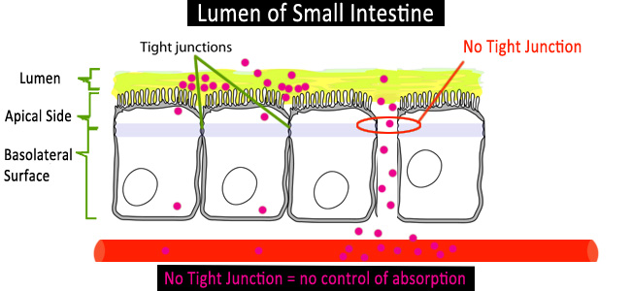

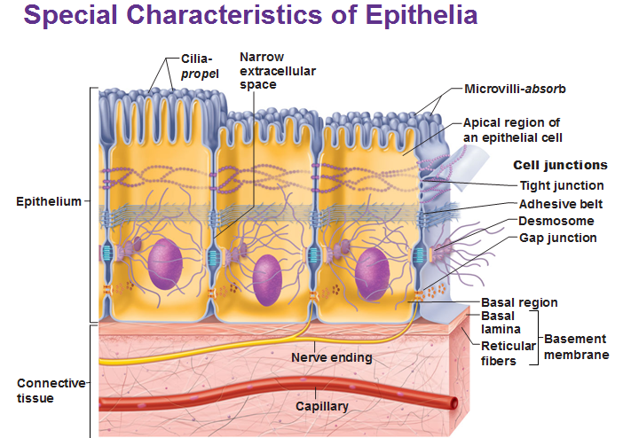

- Supported by connective tissue
  - All epithelia supported by connective tissue
  - One layer deeper to basal lamina=the reticular lamina
      - Extracellular material cntn collagen protein fiber, forms basement membrane
        - Basement membrane: reinforces the epithelium, resists stretching + tearing

an important feature of cancerous epithelial cells is failure to respect the boundary imposed by the basement membrane (metastasis)

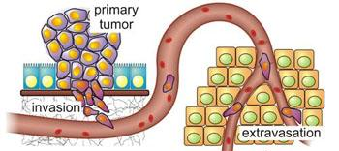
- Avascular but innervated
  - Epithelial tissue = no blood vessels
  - Filled with nerve fibers
  - Receive nourishment via diffusion of substances from underlying connective, through the basement membrane
- Regeneration
  - Epithelium = high regenerative capacity w/ right nutrition
  - Epithelial tissues = harsh external environments
    - Rely on stem cells to replenish and repair wounds, replace dead cells

  - Criteria to classify epithelial cells
- First by # of layers, then by cell shape
- In stratified classified by cell shape in apical layer
  - Simple (one layer of cells)
  - Stratified (multiple layers of cells)
    - Squamous
    - Cuboidal
    - Columnar

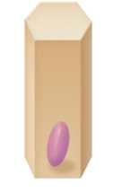

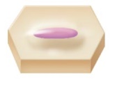
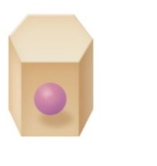
Squamous
Columnar
Cuboidal

- Types of Simple Epithelia
  - Squamous
    - Close fitting, flattened
    - Found where filtration occurs (ex. Kidney, lungs)
    - Two Types
      - Endothelium
        - Lines the lymphatic vessels and hallow organs of the cardiovascular system
      - Mesothelium
        - Found in serous membrane (membrane lining the front body cavity (ventral) and covering organs w/in it)
  - Simple Cuboidal
    - Single layer of cells, same height and width
    - Fxn: secretion and absorption (located in small ducts of glands in kidney tubules)
  - Simple Columnar
    - Single layer of tall, closely packed cells
    - Line digestive tract of stomach through rectum
    - Absorption and secretion
    - Have dense microvilli on apical surface (some cilia)
  - Pseudostratified columnar
    - Single layer of differing heights (illusion of multiple layers = pseudo (fake))
    - All cells rest on the basement membrane (only tallest reach the apical surface)
    - Most cntn cilia on apical surface, line respiratory tract
Transitional epithelium (not simple!):
- forms the lining of hollow urinary organs, stretch as they fill with urine.
- Cells in the basal layer are cuboidal or columnar.
- Cells by the apical surface vary in appearance depending if the organ is stretched at the time// become increasingly flattened & squamous-like as filling occurs
- Transitional cells have the ability to change their shape which allows more urine to flow through

  - Structure of Stratified Squamous Epithelium
- Key features
  - Stratified squamous epithelium (like you would find in the skin) is adapted for protection, not absorption from the external environment.
  - 2+ cell layers
  - Regenerate from the basal area
  - More durable than simple epithelia
  - Protection is major role
  - Most common = squamous cells of stratified epithelia
  - Apical surface cells = squamous and deeper layers are cuboidal or columnar
- Two subtypes
  - Keratinized Stratified Squamous Epithelium
    - Dead layers of cells on top surface
    - Top surface of epidermis
    - Difference is keratin
  - Non-keratinized Stratified Squamous Epithelium
    - No dead layers
    - Makes up lining of oral cavity, anal, and vaginal cavity
  - Glandular epithelia
- Gland: 1+ cells that make and secrete a particular product (hormones, enzymes)
- Endocrine glands:
  - Ductless
  - Secrete internally (endo)
  - Not all endocrine glands are epithelium
  - products are called hormones, secreted by cells by exocytosis into extracellular space enter bloodstream or lymphatic fluid travelling to organ
- Exocrine glands
  - Secrete externally
  - Secrete products onto body surfaces (skin) or body cavities
    - Ex. Mucous, sweat, oil/salivary glands, liver, pancreas
- Unicellular exocrine glands
  - No ducts, one cell
  - Secretion by exocytosis
  - Goblet look, mucus cells
  - Found in epithelial linings of GI and resp. tracts
  - Produces mucin:
    - Complex glycoprotein
    - Dissolves in water
    - When mucin dissolves mucous (protects + lubricates)
- Multicellular exocrine glands
  - Epithelium-derived duct and secretory unit (acinus)
    - Surrounded by supportive CT
    - Brings blood vessels and nerve fibers
    - Classified by
      - Structure (branched vs unbranched)
      - Mode of secretion (thru duct on epithelial surface)
  - Mode of secretion
    - Merocrine/eccrine
      - Secrete products by exocytosis
      - Most common
      - Ex. Pancreas, salivary glands, most sweat glands
    - Holocrine
      - Accumulate products until cells rupture
      - Ex. Sebaceous glands (oil)
    - Apocrine
      - Accumulate products, but only cell apex pinches off w/ secretory product
      - Whether exists in humans controversial
      - Ex. Mammary glands (milk) are apocrine

  - Connective tissues
- Common origin (mesoderm)
- Extracellular matrix (surrounded and supported by, in tissue)
- Degree of vascularity (blood vessels)
- 4 types
  - CT proper
  - Cartilage
  - Bone
  - Blood
- Functions
  - Binding or support
  - Protection
  - Insulation/ storing fuel reserve
  - Transportation
- Structural elements
  - Ground substance
    - Fluid that fills space between cells and fibers
    - Composed of proteoglycans and cell adhesion proteins
    - Allows the CT to act as glue for cells to attach to the matrix
    - GS = molecular sieve (membrane) for travel b/w blood capillaries and cells
  - Fibers
    - Provide support
    - Collagen fibers: provide high tensile strength to the matrix
    - Elastic fibers: in CT role is to provide flexibility, elasticity, and resiliance
    - Reticular fibers: thin collagen protein, fine network to support blood vessels and soft tissues
    - Thicker fibers the stronger they are
  - cells
TYPE OF CONNECTIVE TISSUE | CELL TYPE
TYPE OF CONNECTIVE TISSUE | “BLAST” | “CYTE”
1. CT PROPER | Fibroblast | Fibrocyte
2. CARTILAGE | Chondroblast | Chondrocyte
3. BONE | Osteoblast | Osteocyte
4. BLOOD | Hemocytoblast | Erythrocyte (RBC)  Leukocyte (WBC)  Thrombocyte (Platelet)

  - Loose connective tissue
- Areolar CT
  - Gel-like matrix
  - All 3 fiber types
  - Under epithelia
  - Cells
    - Fibroblasts
    - Macrophages
    - Mast cells
    - WBC
  - Description:
    - Loose arrangement of fibers
    - Reservoir of salts + H2O
    - Prime site of edema (swelling by excess fluid trapped in body) during inflammation
  - Fxn:
    - cushioning of organs
    - immunity (macrophages) and inflammation
    - fluid reservoir
- Adipose CT
  - Store nutrients; adipocytes
  - Under skin, around kidneys, in bones, w/in abdomen, in breasts
  - 15% men, 22% women
  - Description
    - Fat-filled adipocytes
    - Do not reproduce
    - Scanty matrix
  - Fxn:
    - Fuel reservoir
    - Insulation
    - Support and protect organs
- Reticular CT
  - Similar to areolar, but only reticular fibers
  - Lymphoid organs (lymph nodes, bone marrow, spleen)
  - Fxn: fibers form soft internal skeleton that supports free blood cells
  - Ex. Tonsils have reticular fibers which have immune cells which sit on the tonsils, multiply to deal with infection (swelling)
  - Dense Connective Tissue
- Dense Regular CT
  - Bundles of collagen fibers in same direction
  - w/ tensile strength of collagen, tissue forms tendons, aponeurosis, and ligaments
  - forms fascia membrane which wraps around muscles, blood vessels, and nerves
  - tendons: connect muscle to bone
  - ligaments: connect bone to bone
- Dense Irregular CT
  - Same as regular, but collagen bundles thicker and irregular
  - Location:
    - Dermis
    - Submucosa of digestive tract
    - Fibrous capsules of organs and joints
  - Fxn:
    - Withstand tension exerted in many directions
    - Strength
- Elastic CT
  - Like regular, but lots of elastic fibers
  - Found in elastic ligaments and walls of arteries (ex. Aorta)
  - Cartilage
- b/w bone and dense CT
- cells: chondroblasts and chondrocytes
- 3 types
  - hyaline
    - most abundant
    - matrix = transparent, glassy under microscope
    - strong support while providing pads for shock absorption
    - major part of the embryonic skeleton, the costal cartilages of the ribs, and the cartilage of the nose, trachea, and larynx
  - elastic
    - elastic in nature
    - fxn =maintain shape while allowing flexibility
    - found in external ear and epiglottis
  - fibrocartilage
    - blend of hyaline cartilage and dense regular connective tissue
    - Because compressible and resists tension well, fibrocartilage found where strong support and the ability to withstand heavy pressure are required
    - Found in the intervertebral discs of the bony vertebrae and knee meniscus
  - Avascular, no nerve fibers
  - ground substance contains lots of the GAGs: chondroitin sulfate & hyaluronic acid - also chondronectin, (adhesive protein)
  - collagen fibers
  - up to 80% water
  - Bone
- calcium salts create hardness + strength
- support/protection for softer tissues
- cavities for fat storage and synthesis of blood cells
- Bone terms
  - Osteoblasts: immature cells, make bone matrix
  - Osteocytes: maintain bone matrix
  - Osteoclasts: degrade bone matrix
  - Blood
- CT because surrounded by cells and non-living fluid matrix: blood plasma
- Fiber components
  - Soluble protein molecules (only visible during clotting)

