CHAPTER 1
Figure 1.1: Example of a Human Resources System

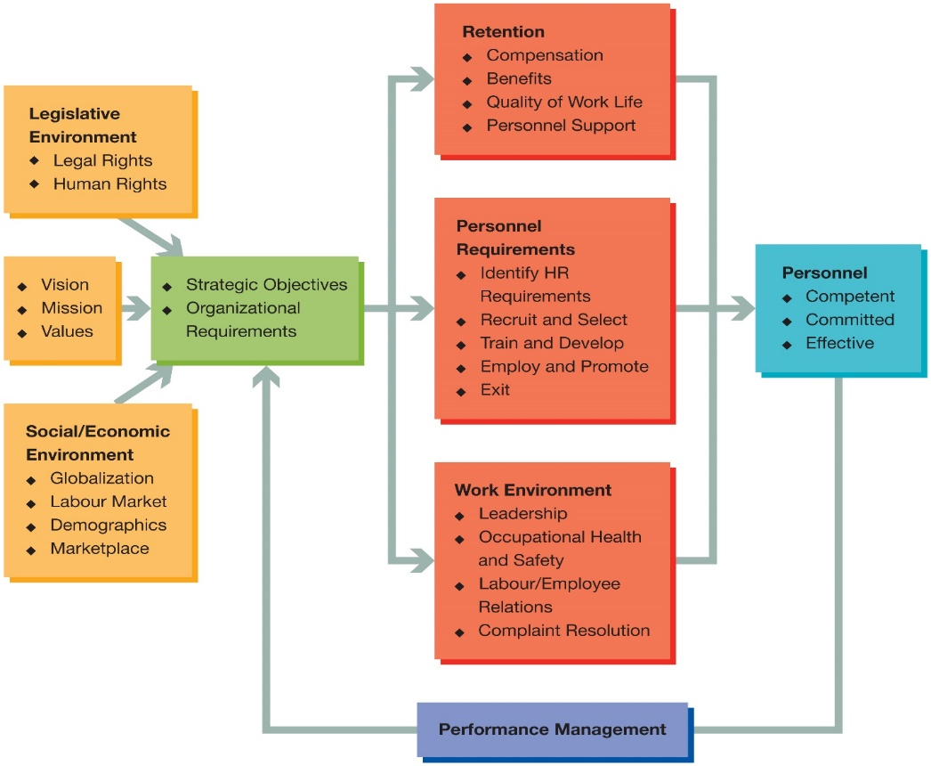
Two Basic Principles Underlie the Model
- Principle 1: HRM must carefully coordinate its activities with the other organizational units and people if the larger system is to function properly
- Principle 2: HR managers must think in systems terms and have the welfare of the whole organization in mind
Recruitment: The generation of an applicant pool for a position or job in order to provide the required number of candidates for a subsequent selection or promotion program
Selection: The choice of job candidates from a previously generated applicant pool in a way that will meet management goals and objectives as well as current legal requirements
Best practices:
- Involve the ethical treatment of job applicants throughout the recruiting and hiring process
- Result from HR professionals following the accepted standards and principles of professional associations
- Are legally defensible (e.g., human rights legislation)
- Reduce employee turnover and increase productivity
- Are responsible for a firm’s relative profit
- Correlate with an organization’s long-term profitability and production ratios
- Help to establish employee trust
- Improve the knowledge, skills, abilities (KSAs) of current and future employees, increase motivation, and retain high-quality workers
Elements of a Recruitment and Selection Action Plan
- Develop Recruitment Strategy
- Develop the Applicant Pool
- Screen the Applicant Pool
- Review and Selection of Job Applicants
- Evaluate the Recruiting and Selection Effort
Social/Economic Factors Affecting Recruitment and Selection:
- Global Competition
- Rapid Advances in Technology and the Internet
- Changing Workforce Demographics
- The Economic Context
- Type of Organization
- Organizational Restructuring
- Redefining Jobs
- Unionized Work Environments
- Best Practices
HR functions:
- Must keep abreast of developments in their field through continuous learning
- Responsible for knowing the latest legal and scientific information related to R & S
- Responsible for implementing policies and procedures in accordance with accepted professional standards
The CHRP Edge-----There are six characteristics that define a profession:
- A common body of knowledge
- Agreed performance standards
- A representative professional organization
- External perception as a profession
- A code of ethics
- An agreed certification procedure

CHAPTER 2:
A Selection Model
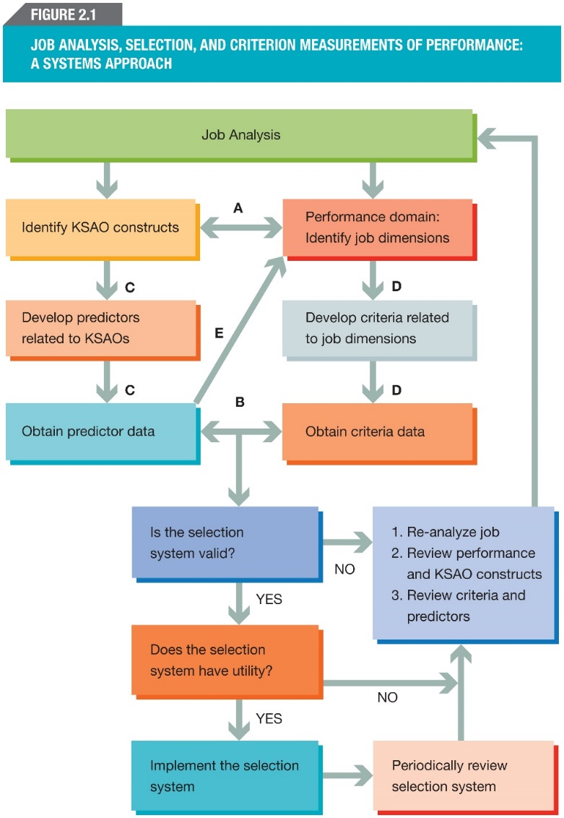
Reliability: The degree to which observed scores are free from random measurement errors; an indication of the stability or dependability of a set of measurements over repeated applications of the measurement procedure
- Interpreting Reliability Coefficients:
- True score: The average score that an individual would earn on an infinite number of administrations of the same test or parallel versions of the same test
- Error score (or measurement error): The hypothetical difference between an observed score and a true score
- Factors Affecting Reliability:
  - Temporary Individual Characteristics
  - Lack of Standardization
  - Chance
- Methods of Estimating Reliability:
  - Test and Retest
  - Alternate Forms
  - Internal Consistency
  - Inter-Rater Reliability
Validity: The legitimacy or correctness of the inferences that are drawn from a set of measurements or other specified procedures; the degree to which accumulated evidence and theory support specific interpretations of test scores in the context of the test’s proposed use
- Construct and content validity: Validation strategies that provide evidence based on test content
- Criterion validity: Related validity provides evidence based on relationships to other variables
Predictive evidence: Obtained through research designs that establish a correlation between predictor scores obtained before an applicant is hired and criteria obtained at a later time, usually after an applicant is employed
Concurrent evidence: Obtained through research designs that establish a correlation between predictor and criteria scores from information that is collected at approximately the same time from a specific group of workers
Validity generalization: The application of validity evidence, obtained through meta-analysis of data obtained from many situations, to other situations that are similar to those on which the meta-analysis is based
Factors Affecting Validity Coefficients:
- Range Restriction
- Measurement Error
- Sampling Error
Bias: systematic errors in measurement, or inferences made from those measurements that are related to different identifiable group membership characteristics such as age, sex, or race
Fairness: the value judgments people make about the decisions or outcomes that are based on measurements
- Principle that every test taker should be assessed in an equitable manner
- Different Views of Fairness:
  - Fairness as equitable treatment in the testing process
  - Fairness as lack of bias
  - Fairness in selection and prediction

CHAPTER 3:
Four Legal Sources Affecting Canadian Employment Practices:
- Constitutional law
- Human rights law
- Employment equity legislation
- Labour law, employment standards, and related legislation
Employment Equity: the elimination of discriminatory practices that prevent the entry or retention of members from designated groups in the workplace, and the elimination of unequal treatment in the workplace related to membership in a designated group (e.g., women, visible minorities, Aboriginal peoples, and people with disabilities).
Developing and Implementing an Employment Equity (EE) Plan:
- Obtain support of senior management for the EE effort
- Conduct a survey to determine the present representation of designated groups in the organization’s internal workforce
- Set future representation targets for designated groups based on availability of qualified workers in the labour market
- Remove systemic employment barriers to increase representation for designated groups in the internal workforce
- Monitor the changing composition of the internal workforce over time
- Make necessary changes to the EE intervention to bring designated group representation up to future targets
Benefits of Implementing Employment Equity:
- A workforce representative of Canadian culture and diversity
- An increase in global competitiveness and productivity
- High employee morale and decreased absenteeism
- Amicable relationships with customers and clients
- Enhanced corporate reputation
- Increased profitability and a better bottom line
Discrimination: refers to any refusal to employ or to continue to employ any person on the basis of that individual’s membership in a protected group
Direct discrimination: occurs where an employer adopts a practice or rule that, on its face, discriminates on a prohibited ground
KEY LEGAL CONCEPTS
Indirect discrimination: occurs when an employer, in good faith, adopts a policy or practice for sound economic or business reasons, but when it is applied to all employees it has an unintended negative impact on members of a protected group
Protected groups: those who have attributes that are defined as “prohibited grounds” for discrimination under the human rights act that applies to the employing organization
Designated groups: The Employment Equity Act defines these groups as women, visible minorities, Aboriginal peoples, and persons with disabilities
Employment equity: refers to the elimination of discriminatory practices that prevent the entry or retention of members from designated groups in the workplace
Adverse impact: occurs when the selection rate for a protected group is lower than that for the relevant comparison group
Bona fide occupational requirement (BFOR): requirement(s) that a person must possess to perform the essential components of a job in a safe, efficient, and reliable manner
- Bona fide occupational requirements are those that a person must possess to perform the essential components of a job in a safe, efficient, and reliable manner.
- To defend employment practice or policy on the grounds that the policy or practice may be perceived as discriminatory, the employer must show that the practice or policy was adopted in an honest and good-faith belief that it was reasonably necessary to ensure the efficient and economical performance of the job without endangering employees or the general public.
- BFORs are sometimes referred to as bona fide occupational qualifications (BFOQs).
Accommodation: the duty of an employer to put in place modifications to discriminatory employment practices or procedures to meet the needs of members of a protected group being affected by the employment practice or procedure
Sufficient risk: an employer may argue that an occupational requirement that discriminates against a protected group is reasonably necessary to ensure that work will be performed successfully and in a manner that will not pose harm or danger to employees or the public
Undue hardship: the limit beyond which employers and service providers are not expected to accommodate a member of a protected group
Adverse effect discrimination: refers to a situation where an employer, in good faith, adopts a policy or practice that has an unintended, negative impact on members of a protected group

CHAPTER 6:
Recruitment as Part of the HR Planning Process
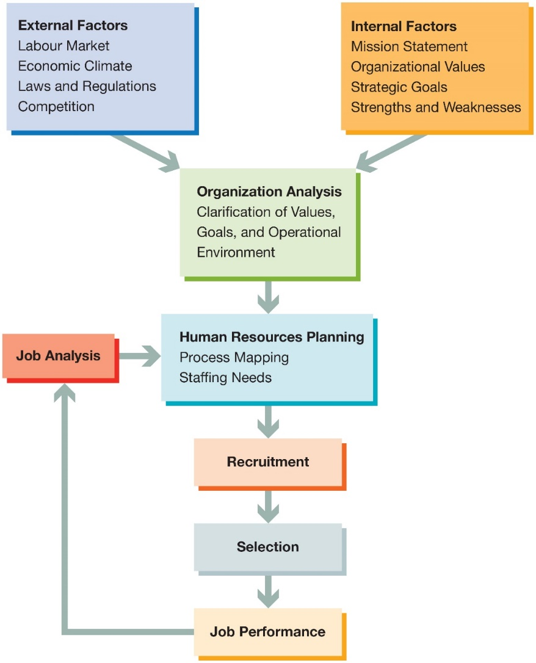
External Factors:
- The Legal Environment
- Systemic Discrimination
- Diversity Recruitment
Internal Factors:
- Business Strategy/Plan
- Job Level and Type
- Recruiting Strategy and Organizational Goals
- Describing the Job

Developing a Recruitment Strategy:
- Based on our business plan:
  - How many positions will we need to staff?
- Based on the job analysis:
  - What is the nature of the position that must be filled?
  - What qualifications must job candidates possess?
- Based on organization analysis:
  - What percentage of the positions can, or should, be staffed with internal candidates?
- Based on the labour market:
  - Is there an available supply of qualified external candidates?
- Based on the labour market:
  - How extensively will we have to search for qualified applicants?
- Based on legal considerations:
  - What are our goals with respect to employment equity?
- Based on the business plan, organization analysis, and job analysis:
  - What information and materials will we present to job candidates?
Elements of a Recruitment and Staffing Action Plan:
- Develop a recruitment strategy
- Develop the applicant pool
- Screen the applicant pool
- Conduct a review of job applicants
- Evaluate the recruiting effort

CHAPTER 7
APPLICANT SCREENING:
- Screening: The first step of the selection process; involves identifying individuals from the applicant pool who have the minimum qualifications for the target position(s)
  - Candidates “passing” this first hurdle then undergo more extensive assessments
- Minimum qualifications (MQ): Knowledge, skills, abilities, experiences, and other attributes and competencies deemed necessary for minimally acceptable performance in one or more positions; designed for making the “first cut” in screening job applicants; sometimes referred to as selection criteria
- Designated targeted groups: The four groups (women, visible minorities, Aboriginal peoples, and people with disabilities) designated in the federal government’s Employment Equity Act that receive legal “protection” in employment policies and practices because of their underrepresentation in the workplace
RECRUITMENT, SCREENING AND SELECTION:
- Selection ratio: The proportion of applicants for one or more positions who are hired
- False positives: Individuals who are predicted to perform successfully in a given position (based on pre-selection assessment scores), but who do not perform at satisfactory levels when placed on the job
- False negatives: individuals who are predicted to perform unsuccessfully in a given position (based on pre-selection assessment scores), but who would perform at satisfactory levels if hired
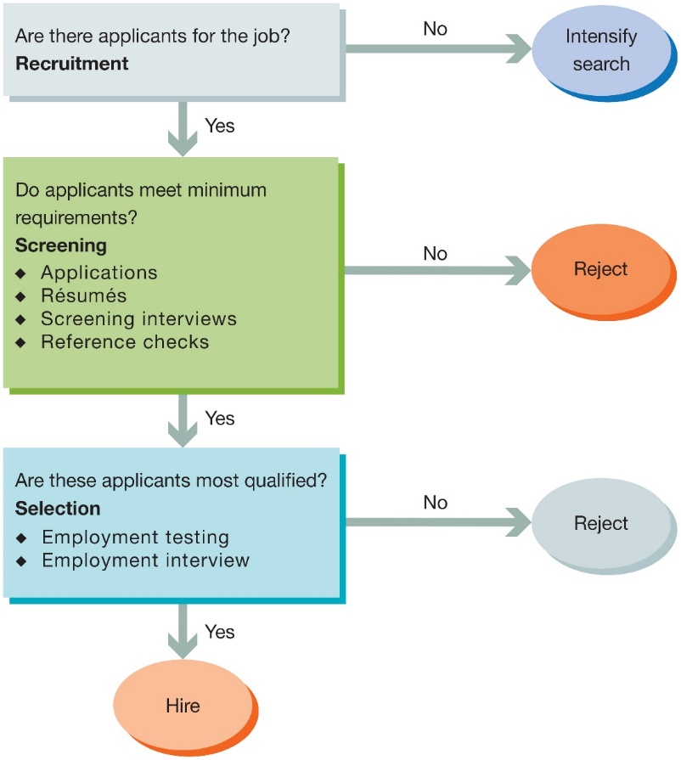
SCREENING METHODS:
- Application Forms (Blank)
- Weighted Application Blanks
- Biographical Data
- Biodata
- Biographical Information Blank (BIB)
- Résumés
- Reference Checks
- Background Checks
Application Forms (Blank): A form completed by job candidates to provide an employer with basic information about their knowledge, skills, education, or other job-related information
Weighted Application Blanks: A method for quantitatively combining information from application blank items by assigning weights that reflect each item’s value in predicting job success
- Benefits: Good predictors for many types of work behaviour
- Concerns: May not adequately represent a job’s complex performance domain
- When to Use: Often used for rapid screening and may be combined with other predictors
- Criterion Measures: Measures of employee work-related outcomes typically important to an organization--including, for example, turnover, absenteeism, and supervisory ratings--are used to establish the validity of screening and selection tools.
Biographical information blank (BIB): A pre-selection questionnaire that asks applicants to provide job-related information on their personal background and life experiences
Biodata: Biographical data for job applicants that have been gathered from BIBs, application blanks, or other sources
- BIB dimensions: Based on the view that past behaviour is the best predictor of future behaviour
  - Dimensions appear relatively stable
  - Explain why certain applicants are more successful than others
- Concerns Over the Use of Biodata:
  - Questions of legality, invasiveness, affability, and generalizability
  - Many BIB items may request personally sensitive information on family background and experiences that borders on violating human rights legislation
- When to Use BIBs:
  - Appropriate for organizations hiring large number of employees
  - For similar kinds of jobs
  - Where large numbers of applicants are competing for few positions (e.g., when there is a low selection ratio)

RESUMES AND COVER LETTERS:
Résumés:
- Intent of the résumé is to introduce the applicant to the organization through a brief, written self-description
  - Applicants voluntarily provide autobiographical information in their résumés
  - Résumés are not standardized
  - Résumés are unique
  - Electronic résumés are more popular today
First Impressions with Résumés: Résumés create the first impression of the applicant and they should be accompanied by a well-written covering letter
Covering Letters Guidelines:
- Should be addressed to a particular person ( research who the person in charge of hiring is and address to them)
- Show that you know what the company is and how you would be an asset to that particular company, be specific to what the company does and what you in particular bring to the table.
- Explain gaps in employment or education
- Should not be more than a page at most
- Demonstrate your enthusiasm for the job
- Review for errors and typos
Writing a Résumé:
- A résumé should include:
  - The applicant’s name, address, and phone number
  - Education and training
  - Employment history
  - Names of references and their contact information (or you can put references will be submitted upon request)
  - A brief statement of employment goals and objectives
  - Information on hobbies and interests (only if there is an added value to having it)
- It should be well organized
- It should highlight key information
- It should use a typeface size (usually a 12-point font) that is easy to read
Five Steps to Writing an Effective Business Résumé:
- Complete a self-assessment and create a skills inventory
- Define your accomplishments: use the STAR method (situation, time, action, result)
- Use résumé sections/headings to emphasize your value
- Ensure your résumé is easy to read and error-free; review the packaging, positioning, power information, personality, and professionalism
- Ensure your résumé reflects exactly what you want to represent to the employer. Consider: Does my résumé reflect the brand I want to represent, and does it effectively communicate this brand to employers?
Screening Résumés:
- Difficult today because of the volume of résumés
  - Organizations have had to develop procedures for efficiently and systematically processing résumés
What to Look for When Examining a Résumé:
- Unexplained gaps in work or education chronology
- Conflicting details or overlapping dates
- Career regression
- Use of qualifiers such as “knowledge of” and “assisted in” to describe work experience
- Listing of schools attended without indicating receipt of a degree or diploma
- Failure to provide names of previous supervisors or references
- Substantial periods in a candidate’s work history listed as “self-employed” or “consultant”
Reference Check: information gathered about a job candidate from supervisors, coworkers, clients, or other people named as references by the candidate
- The information is usually collected from the references through telephone interviews
- Questions should be prepared as to avoid any discriminatory information collection
- A great question is “if you had to would you hire this employee again”
Negligent Hiring: refers to putting someone that was unfit for the position in the role and in doing so you placed other, unsuspecting humans, at potential risk.
Guidelines for Avoiding Negligent Hiring:
- Train staff on selection and hiring
- Implement a hiring and reference check policy
- Require applicants to sign an authorization form to contact references
- Conduct reference checks in keeping with employment and human rights legislation
- Ask about past job performance
- Ask questions on recent job performance
Guideline for Avoiding Negligent Hiring:
- Verify all licences (e.g., driving records)
- Verify degrees/certificates
- Check references by telephone
- Verify gaps in résumé (e.g., work experience)
- Use qualified professionals or trained staff to check references
- Avoid invasive/discriminatory questions
CHAPTER 8:
TESTING:
Before Administrating the Test:
- Qualified personnel to administer
- Get proper consent
- Allow employee to access results
- Respect data privacy laws
- Language issues
- Provide reasonable accommodations
Which Test to Choose:
- Do a job analysis to determine the KSAOs
- Consult an information resource on testing to identify tests that are relevant to your job needs
- Obtain information on several tests related to what you want to measure
- Read the technical documentation
- Read independent evaluations of the tests
- Examine a specimen set from each of the remaining tests
- Determine the skill level needed to purchase the test, administer the test, and interpret test scores correctly
- Select and use only those tests that are psychometrically sound, that meet the needs of your intended test-takers, and that you have the necessary skills to administer, score, and interpret correctly
Examples of Psychological Assessments Used to Select Employees:
- Personality Inventories
- Honesty/Integrity Inventories
- Tests of Emotional Intelligence
- Vocational Interest Inventories
- Cognitive Ability Tests
- Aptitude Tests
- Psychomotor Tests
- Physical Ability and Sensory/Perceptual Ability Tests
SKILLS ABILITIES AND APTITUTEDS:
Abilities: Enduring general traits or characteristics on which people differ and which they bring to a work situation (What you possess?)
Skill: An individual’s degree of proficiency or competency on a given task, which develops through performing the task (What you have developed?)
Aptitude: A specific, narrow ability or skill that may be used to predict job performance (how you use what you possess and have developed)
Cognitive Ability Tests: assess intelligence, general mental ability, or intellectual ability
- Abilities include verbal and numerical ability, reasoning, memory, problem solving, and processing information
- Paper-and-pencil tests available
- Ex. Wonderlic Personnel Test
Ability and Aptitude Tests:
- Aptitude tests are tests for which no preparing is required
- Tests are timed
- Normally all multiple choice
- Best when combined with personality tests
- Some common known tests include testing for abstract/conceptual reasoning, verbal reasoning and numerical reasoning.
- Ex. The GMAT for the MBA program
Psychomotor Abilities: traits or characteristics that involve the control of muscle movements
- Examples include:
  - Finger dexterity
  - Multi-limb coordination
  - Reaction time
  - Arm-hand steadiness
  - Manual dexterity
Physical Abilities: traits or characteristics that involve the use or application of muscle force over varying periods of time
- Example: strength, endurance and quality of movement
Sensory/Perceptual Abilities: traits or characteristics that involve different aspects of vision and audition, as well as the other senses
- Ex. Color discrimination, speech recognition
- Physical and Sensory/Perceptual ability tests are usually used in the police force, firefighters, soldiers, paramedics etc.
Practical Intelligence/Job Knowledge:
- Practical intelligence: The ability to apply ideas in “real world” contexts…how to get things done, street smarts
- Tacit knowledge: Derived from experience when learning is not the primary objective
- Job knowledge: Knowledgeable of issues and/or procedures deemed essential for successful job performance Ex. The bar exam for lawyers, the PMP for project management etc.
EMOTIONAL INTELLIGENCE (IQ):
Emotional Intelligence: The ability to accurately perceive and appraise emotion in oneself and others; to appropriately regulate and express emotion
- Can lead to better leadership
- The Mayer Salovey Caruso Emotional intelligence test (MSCEIT) has 4 components:
  - The ability to perceive emotions
  - The ability to use emotions to facilitate thoughts
  - The ability to understand emotions
  - The ability to manage emotions
Emotional Intelligence Appraisal: Looks at both the emotional and social intelligence
- Self-awareness – the ability to know one's emotions, strengths, weaknesses, drives, values and goals and recognize their impact on others while using gut feelings to guide decisions.
- Self-regulation – involves controlling or redirecting one's disruptive emotions and impulses and adapting to changing circumstances.
- Social skill – managing relationships to move people in the desired direction
- Empathy – considering other people's feelings especially when making decision
- Motivation – being driven to achieve for the sake of achievement
Emotional quotient inventory (EQ-i):
- Uses 133 questions
- Uses the Likert scale
- Has a 360 degree assessment
Physical Fitness Tests: ensure that an applicant meets minimum standards of health to cope with the physical demands of the job
- Tests should be administered only after the applicant has been given a conditional offer of employment
- Offer of employment made conditional on the applicant’s passing the test or exam
Need for accommodation: Canadian employers cannot discriminate on the basis of a medical, genetic, or physical condition unless that condition poses a serious and demonstrable impediment to the conduct of the work or poses serious threats to the health and safety of people. Employers have an obligation to accommodate workers with medical or physical conditions on an individual basis

Drug and Alcohol Testing:
- Random or mandatory drug testing by Canadian companies is not common
- It is discriminatory, unless it ties directly to the job
- Substance abuse on the part of employees is considered a disability that must be accommodated
Work Samples and Simulation Tests:
- Tend to be used to assess skills and competencies
- Require the job candidate to produce behaviours related to job performance under controlled conditions that approximate those found in the job
- Simulations are required when the consequences of performance are important (ex. Pilot and flight simulators)
Situational Exercises: Assess aptitude or proficiency in performing important job tasks by using tasks that are abstract and less realistic than those performed on the actual job
- Designed to assess problem-solving ability, leadership potential, and communication skills
- Generally used for management or consulting positions
Situational Judgment Test: A type of situational exercise designed to measure an applicant’s judgment in workplace or professional situations; paper-and-pencil tests that ask job candidates how they would respond in different workplace situations
- Looking for the best answer to a given problem
- Can be video based as well
- Leaderless group discussion: present the group with a problem, do not give any directions and see who emerges as the leader
- In basket test: provide the candidates various different tasks, papers, emails, projects etc and see how the candidate prioritizes what needs to be completed
ASSESSMENT CENTRE:
Assessment Centre: a standardized procedure that involves the use of multiple measurement techniques
- Multiple assessors to evaluate candidates for selection, classification, and promotion
- Generally used for in house promotions
- Can take up to three days of testing to complete
Essential Elements of an Assessment Centre:
- Job analysis is used to identify job dimensions, tasks, and attributes that are important to job success
- Behaviour displayed by candidates must be categorized by trained assessors and related to dimensions, aptitudes, attributes, or KSAOs
- Assessment techniques must provide information related to the dimensions and attributes identified in the job analysis
- Multiple assessment procedures are used to elicit a variety of behaviours and information relevant to the selected dimensions and attributes
- A sufficient number of job-related simulations must be included in the procedure to allow opportunities to observe behaviour on the selected dimensions
- Multiple assessors, diverse in ethnicity, age, gender, and functional work areas, are used to observe and assess each candidate
- Assessors must receive thorough training and meet performance standards before being allowed to evaluate candidates
- Systematic procedures must be used by assessors to record specific behavioural observations accurately at the time of their occurrence.
- Assessors must prepare a report or record of observations made during each exercise in preparation for consolidating information across assessors
- Data from all assessor reports must be pooled or integrated either at a special meeting of assessors or through statistical methods
PERSONALITY INVENTORIES:
Personality: A set of characteristics or properties that influence, or help to explain, an individual’s behaviour
Personality Traits: Stable, measurable characteristics that help explain ways in which people vary
Personality Tests:
- Type A: Competitive, high achiever, aggressive, nervous, impatient, haste, restless, hyper-alert, always under pressure, driven, does not accept failure, stressed, edgy, great at multi-tasking
- Type B: Calm, accepting, reflective, innovative, allow failures, relaxed, even tempered, less stressed, work hard, achieve goals, and enjoy achievements.
- Self-report inventory: Short, written statements related to various personality traits
  - Issue of faking answers
RECRUITMENT AND SELECTION
Holland Job Fit test: RIASEC
- Helps to determine which career is the right choice for you:
  - Realistic : practical, physical, hands-on, tool oriented
  - Investigative: analytical, intellectual, scientific, explorative
  - Artistic: creative, original, independent, chaotic
  - Social: cooperative, supporting, helping, healing, nurturing
  - Enterprising: competitive, leaders, persuasive
  - Conventional: detail oriented, organized, clerical
The Big Five Personality Dimensions:
- Conscientiousness: loyal, hard working
- Emotional stability: calm, relaxed
- Openness to experience: creative, insightful
- Agreeableness: works well in groups, aware of others emotions
- Extraversion: outgoing, approachable
Sixteen Personality Factor Questionnaire (16PF):
- Warmth (reserved vs outgoing)
- Reasoning (less intelligent vs more intelligent)
- Emotional Stability (reactive emotionally vs emotionally stable)
- Dominance (submissive vs dominant)
- Liveliness (serious vs cheerful)
- Rule Consciousness (no conforming vs conforming)
- Social Boldness (shy vs uninhibited)
- Sensitivity (unsentimental vs sentimental)
- Vigilance (trusting vs suspicious)
- Abstractedness (practical vs imaginative)
- Privateness (open vs discreet)
- Apprehension (self-assured vs self-doubting)
- Openness to change (traditional vs experimental)
- Self-Reliance (group-oriented vs self-reliant)
- Perfectionism (undisciplined vs perfectionistic)
- Tension (relaxed vs tense)
Honesty/Integrity Testing: self-report inventories designed to assess employee honesty and reliability
- Increasingly popular method of screening out potentially dishonest employees
- No adverse impact
- However, can be open to misinterpretation
- Invasion of privacy
- False positives

CHAPTER 9:
Purposes and Uses of the Interview:
- Interviews:
  - Used at the beginning or end of the selection process
  - Used to explore and expand information from the résumé/application form
  - Employ standard questions during the interview process
  - Panel interviews include the HR professional
  - Used to sell the job to the applicant
- Best suited to the assessment of non-cognitive attributes
- Provide the applicant a chance to ask questions about the job and organization
- Provide an opportunity to see if there is a suitable fit
- Used in the termination of employees
- Used to determine who is best qualified
The Cost of Interviewing
- Time preparing for the interview (supervisor/managers)
- Actual interviewing time
- Time spent by clerical staff on interview-related tasks
- Use of office space and equipment
- Time spent developing interview questions and scoring guides
- Travel time
TYPICAL SCREENING INTERVIEW
Screening Interviews: Preliminary interviews designed to fill gaps left on the candidate’s application form or résumé; sometimes serving recruitment as well as selection functions
Screening Interview Format:
- Follow a set of preplanned questions during the interview
- Review the applicant’s file before the interview
- Begin with some opening remarks by recruiter to put the applicant at ease
- Design questions to focus on applicant’s previous work experience, educational background
- Closing: gives applicant an opportunity to ask questions about the job and the organization
  - Recruiter discusses timeframe of when they are getting back to applicant
- Review the applicant with a rating form
Interviewee Behaviours That Influence Interviewer Impressions:
- Find out location and be on time for the interview
- Wear appropriate clothing, professional attire
- Be prepared for the interview by having done homework on the company and anticipating common interview questions
- Think about how you would answer the questions you might be asked, rehearse with a friend
- Make direct eye contact with the interviewer
- Remain confident and determined
- Provide positive information about yourself when answering questions
- Answer questions quickly and intelligently
- Demonstrate interest in the position and the organization
Applicant Behaviours That Influence Negative Impressions:
- Present a poor personal appearance or grooming
- Display an overly aggressive, know-it-all attitude
- Fail to communicate clearly
- Lack career goals or career planning
- Overemphasize monetary issues
- Be evasive or do not answer questions completely
- Show a lack of maturity, tact, courtesy, or social skills
Speed interviewing: Typically consists of a series of short (5-15 minute) consecutive interviews
- Used by recruiters who need to fill several positions quickly and cost effectively
- Ascertains a candidate’s fit with position requirements
A Model of Information Processing/Decision Making:
- Prior Information and Interviewer and Candidate Expectations
  - Knowledge Structures
- The Social Interaction of Interviewer and Candidate
- Interviewer and Candidate Information Processing and Assessments
- Interviewer and Applicant Decisions
- The Context of the Interview
Unstructured Interview: A traditional method of interviewing that involves no constraints on the questions asked
- No requirements for standardization
- A subjective assessment of the candidate (feeling or hunch about the candidate)
Commonly Used Interview Questions:
- Why did you leave your last job? Why do you want to leave your current job?
- What do you consider to be your strengths? What are your weaknesses?
- What were your strongest/weakest subjects at school? What did you learn in school that you could use in this job?
- How would other people (or someone who knows you or worked with you) describe you as an individual?
- What is your greatest accomplishment (or most meaningful work experience)?
- What were the most enjoyable aspects of your last job? What were the least enjoyable aspects?
- Why do you want this job? What are you looking for from this job (or from us)?
- Why should we hire you? What can you do for us? (or Why are you the best candidate for this position?)
- What are your long-range plans or goals? (Where do you plan to be five years from now?)
- Tell me about yourself.
Structured interview: Consists of a standardized set of job-relevant questions; a scoring guide is used Remains popular with employers
Structured Employment Interviews:
- Interview questions focus on behaviours or work samples rather than opinions or self-evaluations
- Interviewer access to ancillary information
- Questions from the candidate are not allowed until after the interview
- Each answer is rated during the interview using a rating scale tailored to the question
- Rating scales are “anchored” with behavioural examples to illustrate scale points
- Total interview score is obtained by summing across scores for each of the questions
- Detailed notes are taken during the interview
The Structured Interviewing Process:
- Preparing for the interview:
  - Determine the amount of time available and how many questions you can ask without rushing
  - Make a standardized list of interview questions to ask all applicants in the same order
  - Develop a scoring guide with benchmark or sample answers
  - Use an office/interview room where you can have privacy, freedom from distractions, and quiet
  - Schedule the interviews with sufficient time for a brief break between interviews and to allow for some interviews to run a little over
  - Arrange to hold all calls and prevent interruptions during the interview
- Conducting the interview:
  - Spend a few minutes at the beginning of the interview putting the applicant at ease
  - Ask each question in turn without omitting or skipping any
  - Take detailed notes, focusing on recording what the applicant says
  - Allow the applicant to ask questions at the end of the interview and answer them to the best of your ability
  - Follow the same procedures for each applicant and retain interview documentation for future reference
- Closing the interview:
  - Tell the candidate when and how he should expect to hear from you
  - Tell the candidate if you will be contacting references or conducting a second interview
  - Thank the applicant for coming
  - Review your notes and make your ratings
  - Make sure you inform all candidates of your decision when you have made it
Panel interview: An interview conducted by two or more interviewers together at one time
Serial interviews: A series of interviews where the applicant is interviewed separately by each of two or more interviewers
Situational Interview: A highly structured interview in which important or decisive situations employees are likely to encounter on the job are described
- Applicants are asked what they would do in these situations
Scoring guide: A behavioural rating scale consisting of sample answers to each question that is used by the interviewer to evaluate and score the applicant’s answers
Behaviour description interview: A structured interview in which the applicant is asked to describe what he did in given situation in the past
Probes: Follow-up questions or prompts used by the interviewer to guide the applicant’s descriptions of situations to provide scorable elaboration of answers
Other Approaches to Interviewing
- Long-Distance Interviews
- Puzzle Interviews
- Multiple Mini-Interviews

CHAPTER 10
The Context of Selection Decisions:
- Satisficing: making an acceptable or adequate choice rather than the best or optimal choice
- Organizational fit: an applicant’s overall suitability for the organization and its culture
Selection Errors:
- Implicit Theories: Personal beliefs that are held about how people or things function, without objective evidence and often without conscious awareness
Outcomes of the Selection Process:
- False positive error: Occurs when an applicant who is assessed favourably turns out to be a poor choice
- False negative error: Occurs when an applicant who is rejected would have been a good choice
Methods of Collecting and Combining Applicant Information:
- Pure judgment Approach: An approach in which judgmental data are combined in a judgmental manner
- Trait Rating Approach: An approach in which judgmental data are combined statistically
- Profile interpretation: An approach in which statistical data are combined in a judgmental manner
- Pure statistical approach: An approach in which data are combined statistically
- Judgmental composite: An approach in which judgmental and statistical data are combined in a judgmental manner
- Statistical composite: An approach in which judgmental and statistical data are combined statistically
Group Decision Making:
- Researchers conclude that groups are generally better at problem solving and decision making than the average individual
- Groups make better decisions collectively than do individuals
Abilene Paradox:
- A situation when a group makes a collective decision that is counter to the thoughts and feelings of its individual members.
- Involves a communication problem within the group
- Individuals go along with the group even though they have their reservations
- Concept of “do not rock the boat”
  - Do not against the other group members wishes since they want to be part of the group
  - No one speaks up due to fear of being rejected
Making Selection Decisions:
- Top-down selection: Involves ranking applicants on the basis of their total score, selecting from the top down until the desired number of candidates has been selected
  - Based on the assumption that individuals scoring higher will be better performers on the job than those scoring low
  - Considered the best approach for maximizing organizational performance
- Selection systems are made more effective by the following recommendations:
  - Use valid selection instruments
  - Dissuade managers from making selection decisions based on gut feelings or intuition
  - Encourage managers to keep track of their own selection “hits” and “misses”
  - Train managers to make systematic selection decisions
  - Periodically evaluate or audit selection decisions in order to identify areas needing improvement
RECRUITMENT AND SELECTION NOTEBOOK 10.2:
Making the Selection Decision:
- Identify all of the sources of information about the applicant available to you
- Use reliable, valid selection instruments whenever possible
- Determine which decision-making model you will use
- If using the regression or combination models, collect and save data over a period of time for all predictors as well as job performance data for those applicants who are hired
- If using multiple cut-off or multiple hurdle models, determine appropriate cut-off scores for each predictor
- Combine data from different predictors statistically to yield an overall score
- Offer the position(s) to the candidate(s) with the highest overall score(s)
Making a Job Offer:
- Move quickly
- Hold off on contacting others until first offer is made
- Contact the top candidate by telephone
- Be enthusiastic and positive
- Ensure the job offer is attractive
- Try to get an oral commitment
- Be ready to negotiate (if necessary)
- Provide support and guidance
- Follow up in writing
- Set a deadline for the candidate to accept the offer
- Need an answer as soon as possible
- Make a counter offer if the candidate has a better offer
- Never push a candidate to renege on acceptance of an offer from another employer
- If no further negotiation, indicate that this is your final offer
- If your final offer fails, move on to your second-choice candidate
- Once you have received a signed acceptance of the written offer, let the other candidates know the position has been filled
Employment Letters and Contracts:
- Offers of employment by letter or contracts
- Verbal offers are just as binding as written offers
- Best to have a signed written agreement on terms and conditions of employment

