Lecture 10 Outcomes
Characteristics of Mendel's work that set him apart as a genetic researcher
- Unlike others Mendel’s used a quantitative approach to study the science of inheritance. His techniques were especially rigorous and involved the use of statistical analysis in an era when qualitative, purely descriptive science was the accepted practice.
- He knew nothing about mutation, meiosis, cells/nuclei 􏰀
- He came up with fundamental model of inheritance 􏰀
- Careful experimentation with controlled crosses and quantitative analyses...
Components of Mendel's explanatory model
- Variation in traits due to different alleles
- The principle of segregation (First Law): The two members of a gene pair (alleles) segregate (separate) from each other in the formation of gametes. Half the gametes carry one allele, and the other half carry the other allele.
- The principle of independent assortment (Second Law): Genes for different traits assort independently of one another in the formation of gametes.
- In practice, the manifestation of Mendel's laws is seen by characteristic ratios of phenotypic classes, such as 3:1 and 9:3:3:1. Further, the Mendelian principles just stated include the simple assumption that one allele is dominant to the other allele.
- Organisms inherit two alleles for each trait
- The appearance of heterozygotes determined by dominant alleles
Distribution of progeny, given parental genotypes in monohybrid and sex-linked cross
- Monohybrid cross: cross that involves single character
- Dihybrid cross: cross involving two characters 9:3:3:1 Ratio
- True breeding: Homozygous Recessive or Homozygous Dominant
- Sex Linked Genes (Reciprocal cross): inherited differently in males and females.
- In Mendel’s pea-plants it didn’t matter which parent had which trait, it matters in sex linked traits
- Sex linked traits are not carried on the Y-chromosomes

Parental genotypes, given distribution of progeny in monohybrid and sex-linked crosses
- See Problems 1-17 on mindtap at end of Lecture 5

Location of various alleles on homologues
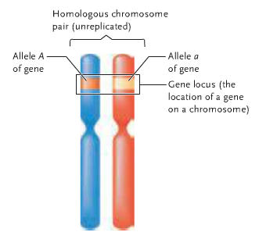
- Alleles are located at the same spots on the homologous chromosomes, but they are DIFFERENT

Segregation of various alleles during meiosis

Arrangement of genes and alleles on homologous chromosomes in a dihybrid organism

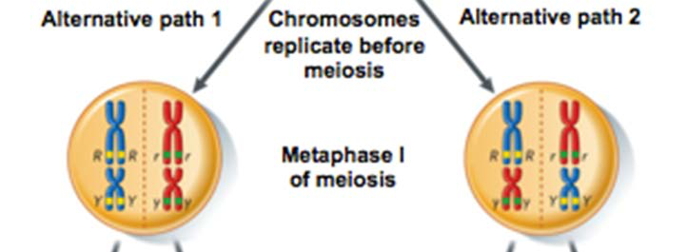

How independent assortment creates 4 different products of meiosis from a dihybrid parent
- See above diagram of meiosis
- Chromosomes occur in pairs in sexually reproducing, diploid organisms, as do the alleles of each gene.
- The chromosomes of each pair are separated and delivered singly to gametes, as are the alleles of a gene.
- The separation of any pair of chromosomes in meiosis and gamete formation is independent of the separation of other pairs (see Figure 10.10), as in the independent assortment of the alleles of different genes in Mendel’s dihybrid crosses.
- Finally, one member of each chromosome pair is derived in fertilization from the male parent, and the other member is derived from the female parent, in an exact parallel with the two alleles of a gene
- From this total coincidence in behaviour, Sutton correctly concluded that genes and their alleles are carried on the chromosomes, a conclusion known today as the chromosome theory of inheritance.

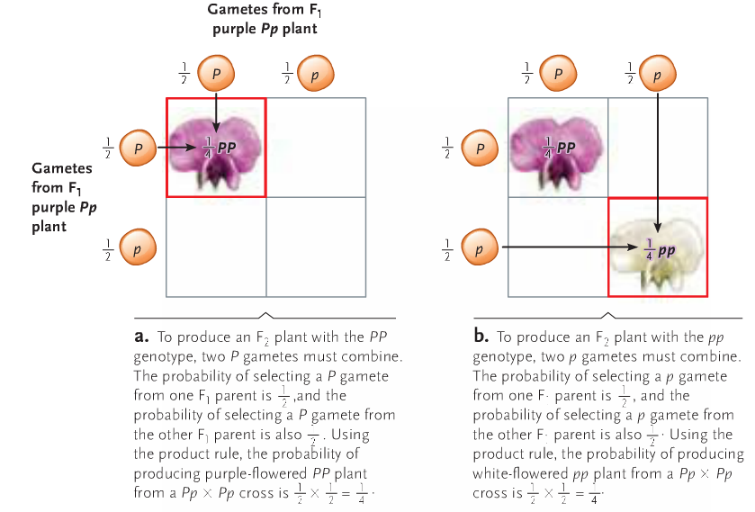
Application of the sum and product rule of probability
Product Rule: Individual probabilities are multiplied

􏰀

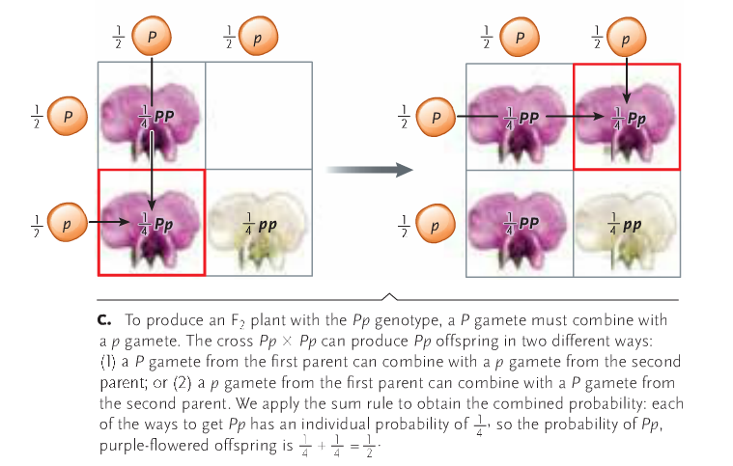
Sum Rule: applies when several different events all give the same outcome (i.e. identifying the chance of getting Pp in a monohybrid cross,you can get P from mom, p from dad, or p from mom, P from dad)

Pattern of offspring expected, given mechanism of epistasis
- Epistasis is the interaction between different genes. If one allele at one locus masks the expression of an allele of the second gene at another locus, that allele or allelic pair is epistatic to the second gene, resulting in some of the expected phenotypes not appearing among offspring.
- For example, Labrador retrievers may be black (homozygous dominant or heterozygous for how much melanin is produced, or chocolate brown (if the allele for the production of melanin is homozygous recessive), or yellow (if the gene that controls the deposition of pigment in hairs is homozygous dominant, or heterozygous). The dominant E allele of this second gene permits pigment deposition, so that the black colour n BB or Bb individuals, or the chocolate colour in bb individuals doesn’t appear, instead the fur appears to be yellow.

Distinction between codominance and incomplete dominance
- Incomplete Dominance is when the effects of a recessive allele are still visible in a phenotype. The dominant trait is not dominant enough to completely mask the recessive/ produce a strong enough change in phenol type, resulting in another phenotypic result, one that is neither of the two alleles. In complete dominance is denoted by super script. I.e C= Colour. W=White allele. R= Red allele. The genotype for red plants is C^{R}C^{R}. White plants C^{W}C^{W}. C^{W}C^{R} results in a hybrid colour, in this case pink since the Red allele isn’t fully dominant
- The combination of both alleles always results in a partially active form of the active allele, not necessarily as dominant as a characteristic as the full active version but it is still active
- Co-Dominance occurs when the heterozygote has both of its allele’s characteristics being present and distinguishable.
- Both genes are expressed equally, which differs from incomplete dominance which results from the dominant allele not having full gene expression due to not enough protein or enzymes being produced by a single gene.

Way in which inheritance of polygenic traits show that inheritance is not "blended"
- Typically polygenic traits such as height that result in a continuous distribution of this type is the result of polygenic inheritance, in which several to many different genes contribute to the same characteristic. Other characteristics that undertake a similar continuous distribution include skin colour and body weight in humans, ear length in corn, seed colour in wheat, and colour spotting in mice. These characteristics are also known as quantitative traits. It may seem that the wide variation shown in a quantitative trait might appear to support the old idea that the characteristics of parents are blended in their offspring. For example, it is often thought that children in a family with one tall and one short parent will be of intermediate height, which is most likely, careful genetic analysis of hundreds of such families shows that their offspring actually range from short to tall, forming a typical bell-shaped curve. Some children are not intermediate relative to their parents and are either taller or shorter than both parents. The inheritance of skin colour produces the same result, with Although the skin colour of children is most often intermediate between that of their parents, a typical bell-shaped distribution is obtained in which some children at the extremes are lighter or darker than either parent. Thus, genetic analysis does not support the idea of blending or mixing of parental traits in quantitative/polygenic characteristics such as body size or skin colour.

Description of pleiotropic genes
- Pleiotropic genes are single genes that affect more than one characteristic of an organism. One such gene is the recessive sickle cell anemia

Mechanism by which X inactivation accomplishes dosage compensation for X linked genes
- By inactivating one X chromosome per cell. Dosage Compensation is the equalization of gene expression between the males and females of a species. Because sex chromosomes contain different numbers of genes, different species of organisms have developed different mechanisms to cope with this inequality. Replicating the actual gene is impossible; thus organisms instead equalize the expression from each gene. In humans, the females (XX) silence the transcription of one X chromosome of each pair, and transcribe all information from the other, expressed X chromosome. Thus, human females have the same number of expressed X-linked genes as do human males (XY), both genders having essentially one X chromosome per cell, from which to transcribe and express genes.
- Female mammals have two different types of cell lines. One line inactivates the paternal X, the other line inactivates the maternal X. (Note that inactivation is not complete; some genes on the X escape inactivation.

