DNA REPLICATION
Pre Lecture (12.2, 12.3)
1. purine and pyrimidine base-pairing in DNA/RNA
- base pairing is complimentary (A pairs with T; C with G)
- Purines (Adenine and Guanine)
- Pyrimidines (Cytosine and Thymine)
- Base pairing forms H-bonds
2. design, outcome and conclusions of the classic Meselson and Stahl experiment
- DNA purine bases are composed of carbon and nitrogen
- Meselson and Stahl’s experimented by growing bacteria in ¹⁵Nitrogen isotope, then replicating twice in ¹⁴Nitrogen to get double band pattern
- Used a cesium chloride gradient to separate heavier DNA from light DNA
- Results of the density gradient were only compatible with the semi-conservative DNA replication model → → demonstrated that DNA replication is semiconservative

3. direction of movement of DNA polymerase on the template strand
- DNA polymerase reads the template strand 3’ to 5’
- DNA polymerase can only add on to 3’ ends

4. meaning of bi-directional, semi-conservative, semi-discontinuous, leading and lagging strand

Bi-directional: DNA replication happens in two directions (starting at the origin) at the same time. 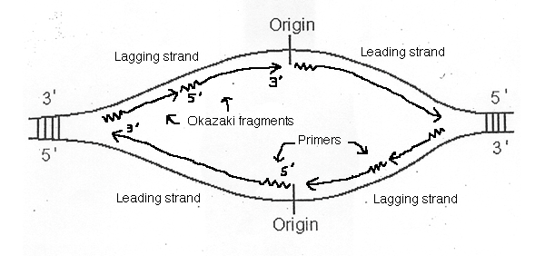
Semi-conservative replication: When DNA replicates, one strand is composed of parental DNA and one strand is composed of newly synthesized DNA.
Semi-discontinuous: In the lagging strand, because the replication has to be made using Okazaki fragments, the replication is discontinuous, but the replication between the Okazaki fragments is continuous
Leading strand:
- Strand of DNA that is synthesized continuously because its parent strand is oriented in the 3’ → 5’ direction and therefore the newly synthesized strand will be 5’ → 3’
- Since DNA replication happens in the 5’ → 3’ direction, polymerase can continuously move down replication fork on the leading strand.
Lagging strand:
- Strand of DNA that is synthesized in fragments because its parent strand is oriented in the 5’ → 3’ direction away from the fork
- Polymerase can only add new anti parallel bases in the 5’ → 3’ direction therefore has to move away from fork to add bases in the 5’ → 3’ direction
- If polymerase is moving away from fork then what happens to the newly uncovered DNA at the fork? → DNA get replicated in fragments that move away from fork, with each subsequent fragment replicated closer to the receding replication fork.
- 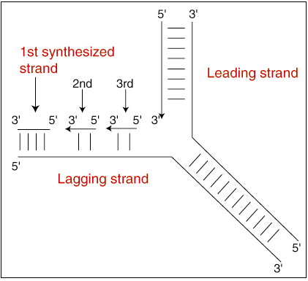

5. general action of proteins in Fig. 12.15 (Table 12.1).

Protein | Function
Helicase | Unwinds DNA helix
Single-stranded binding proteins | Stabilizes single-stranded DNA; prevents the two strands from recombining back to a double strand
Topoisomerase | Enzyme goes ahead of replication fork, making sure that DNA doesn’t twist; cuts and rebinds DNA
Primase | Adds a RNA primer to the 3’ end to initiate DNA Polymerase III to add nucleotides  In an RNA nucleotide (Uracil would replace Thymine; Uracil is complementary to Adenine)
DNA Polymerase III | Main enzyme in DNA Replication; adds nucleotides by extending RNA Primers 5’ -> 3’
DNA Polymerase I | Removes RNA Primers off Okazaki fragments, replacing them with DNA nucleotides; uses its 5’ -> 3’ exonuclease activity to remove RNA nucleotides
Sliding Clamp | Holds DNA Polymerase III to the template, making replication more efficient
DNA Ligase | Seals gaps “nicks” left after RNA primers are replaced with DNA

6. 3' vs. 5' polarity of nucleic acid chains involved in DNA replication
- 3’ ends have a free OH group
  - nucleotides can be added to 3’ ends because the OH groups are capable of forming ester linkages
- 5’ ends have a phosphate group
- Nucleotides are always added on the 3’ end of a new strand

7. components necessary for DNA synthesis
- DNA synthesis requires:
  - A template strand to replicate from
  - DNA polymerases to add nucleotides to 3’ ends
  - RNA Primer off which to build from
  - Enzymes that facilitate DNA replication (see table above)

8. direction of elongation of a given DNA strand
- DNA strands are always elongated at their 3’ ends
- Polymerases can only add to 3’ ends
- Therefore whenever a new strand is written it always has to be elongated in the direction of the 3’ end

9. structure of a replication bubble
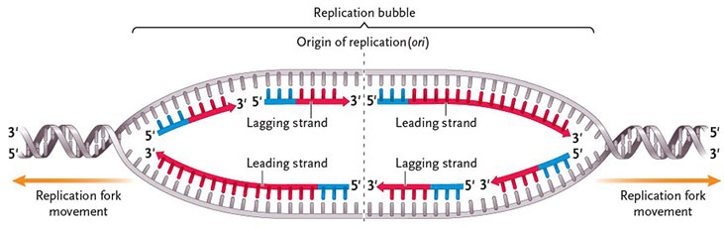
- a `QAZ 5tfcvyuboth strands technically replicate continuously and discontinuously
- a replication bubble is formed when two replication origins diverge on opposite sides
- Leading and Lagging strands alternate between the different parent strands

10. Why chromosomes shorten at each replication
- Chromosomes shorten because at the end of DNA replication, there will always be a portion on the 5’ end of a strand that is too short after the removal of the RNA primer
- Since polymerases cannot extend the 5’ ends, the region left after the primer is removed will be empty, and as a result the strand and chromosome will shorten after each cycle

11. mechanism by which telomerase adds telomeres to chromosomes
- Telomerase is another polymerase that adds nucleotides to the 3’ ends of DNA
- After the main replication is done, there will always be a single stranded component left on the DNA after the last RNA primer is removed because there will be a gap in the 5’ end of one strand which cannot be added onto
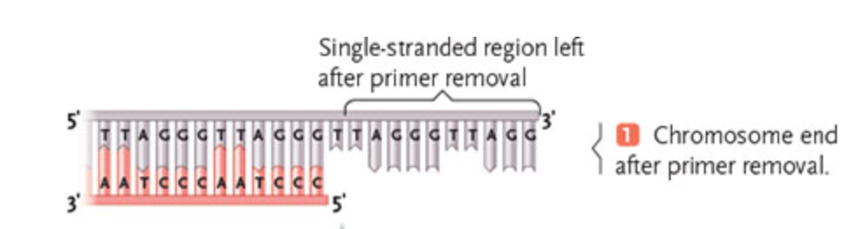
- Telomerase ensures that this does not affect coding DNA by adding a non-coding (telomere) sequence to the 3’ strand to elongate it
- This allows DNA synthesis to continue on the “shorter” strand via discontinuous replication
- Since Telomerase doesn’t have a template to write off of, it carries around its own RNA template for DNA synthesis to be based off of
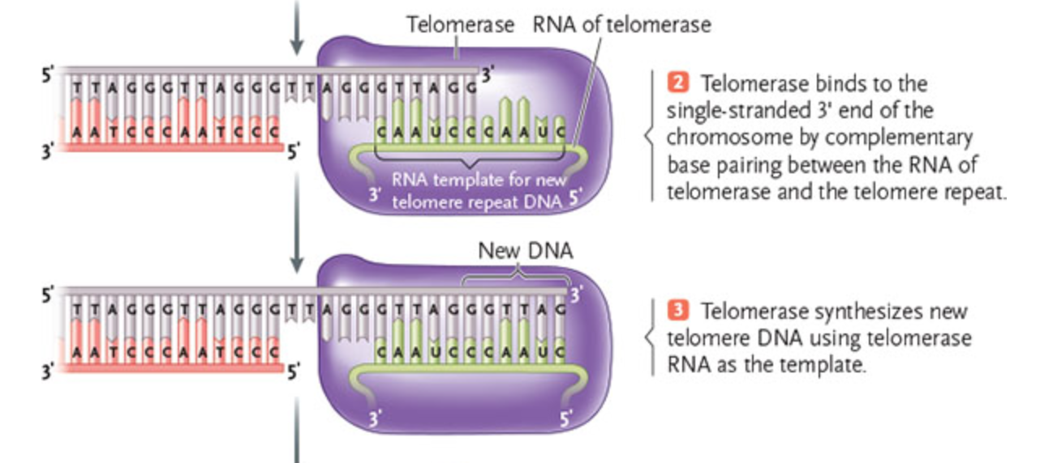
- Telomerase acts as a mechanism to protect the cell from the shortening of DNA by extending strands; it does not directly prevent this problem, rather, acting as a protective measure
During Lecture
1. structure of replication bubble
2. timing, role and mechanism of telomerase activity
- Telomerase is active towards the end of DNA replication
- Acts as a protective measure to prevent the loss of coding DNA
- Telomerase adds a noncoding strand (telomere) to the 3’ end of one strand which acts as a template for the other complementary strand

