Experiment 1:
Thin Layer Chromatography
Rhyanna Melanson- 8194624
CHM 1321 B2

Partner Natalia Titkova- 8222808

Demonstrator Yixin Zhang

Procedure
Part A
- Using about 10 mg of unknown sample #95, it was dissolved in approximately 1.2 mL of the dicholormethane solution.
- Using a capillary the sample solution was then spotted onto both prepared TLC plates in the sample lane and the co-spot lane.
- Using the same methods as previously described, a reference solution of benzophenone was spotted on one TLC plate in the reference and co-spot lanes.
- The TLC plate was then placed in the developing jar filled with 10 mL 2:8 EtOAc:hexanes.
- This was repeated with a reference solution of biphenyl in the reference and co-spot lanes.
- The spots on the plate were made visible once illuminated by a UV light.
- They were then circled making it possible to calculate the R_{F} values.

Part B
- The sample solution from Part A was placed in the sample lane and the co-spot lane of two TLC plates; one with biphenyl and the other benzophenone in the reference and co-spot lanes.
- The TCL plates were then alternatively placed the developing jar filled with 10 mL of EtOAc
- These steps were then repeated however the developing jar was filled with 10 mL of Hexanes
- The spots on the plate were made visible once illuminated by a UV light.
- They were then circled making it possible to calculate the R_{F} values.

Part C

- Around 2 mL of unknown sample XX were obtained.
- The unknown sample XX was then spotted in the sample and co-spot lanes of three different TLC plates.
- Each TLC plate was then spotted with, o-bromonitrobenzene, m-bromonitrobenzene, or p-bromonitrobenzene in the reference and co-spot lanes.
- The TLC plates were placed alternatively in a developing jar filled with a 10 mL solvent system of 9:1 hexanes:EtAOc.
- The spots on the plate were made visible once illuminated by a UV light. They were then each taken a photo of.
- They were then circled making it possible to calculate the R_{F} values.

CHM 1321 Lab Manual 2016. “Experiment 1: Thin Layer Chromatography”. Blackboard Learn. September 2014
Results and Observations
Part A
 | Benzophenone | Biphenyl
Unknown | #95  -white crystal of various sizes  -around 1.2mL of dichloromethane was used (crystals dissolved almost immediately to form a clear colourless solution
Solvent System | ETOAc:Hexanes: 2:8
Observations | -Clear and colourless  -Fairly fast rising | -Clear and colourless  -Fairly fast rising
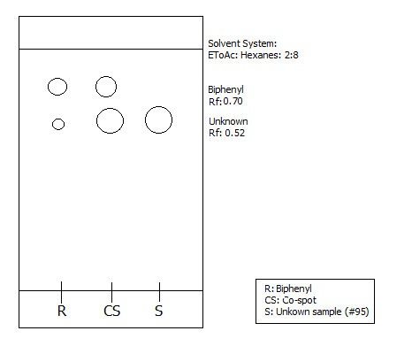
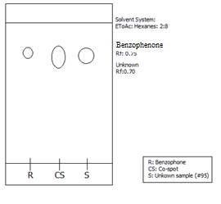

Part B
 | Benzophenone | Biphenyl
Unknown | #95
Solvent System | ETOAc  -clear, colourless and strong odour
Observations | -Clear and colourless  -rose faster than part A | -Clear and colourless  - rose faster than part A

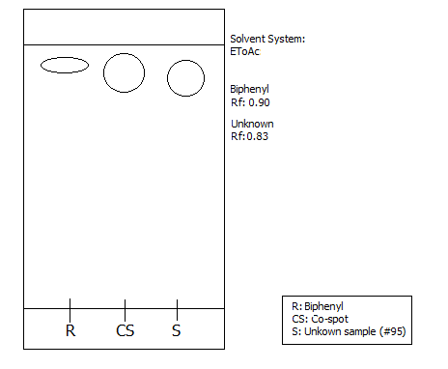
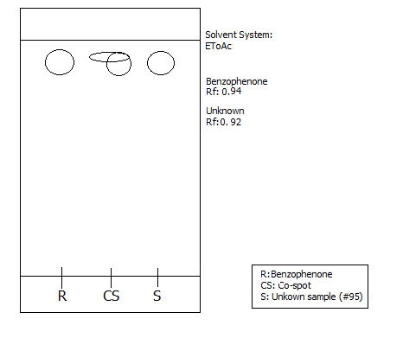
 | Benzophenone | Biphenyl
Unknown | #95
Solvent System | Hexanes  -clear, colourless and strong odour
Observations | -Clear and colourless  -fairly fast riser | -Clear and colourless  - fairly fast riser
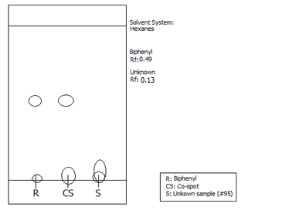
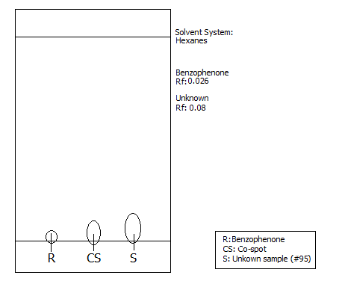

Part C
 | m-bromonitibenzene | o-bromonitibenzene | p-bromonitibenzene
Unknown | XX  -mixture is yellow/green in colour and translucent
Solvent System | Hexanes: Ethyl Acetate: 9:1  -clear, colourless and strong odour
Observations | -Clear and colourless  - fast riser | -Clear and light yellow in colour  - fairly fast riser | -Clear and colourless  - very slow riser
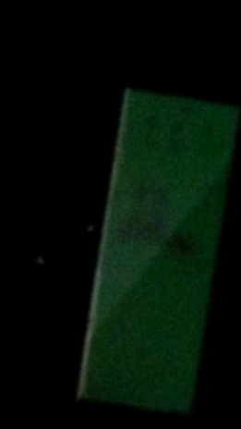
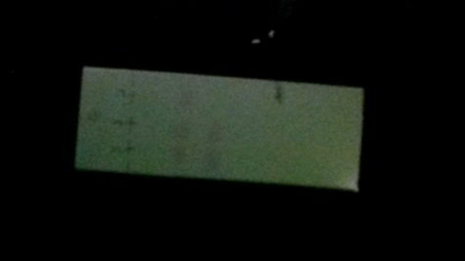
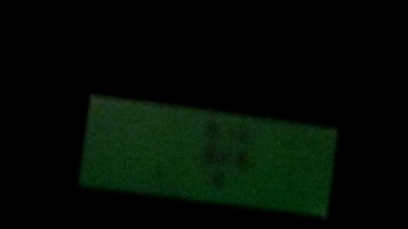
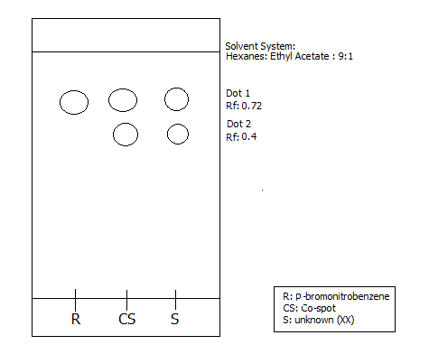
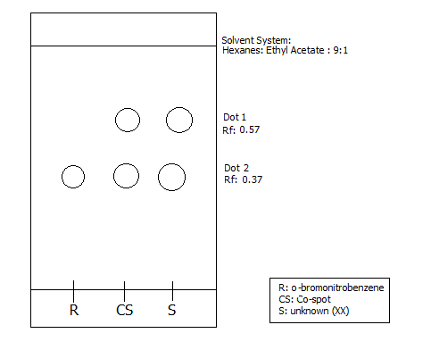
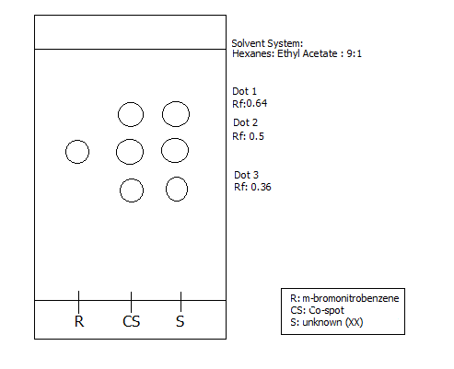

Calculations
Rf Values
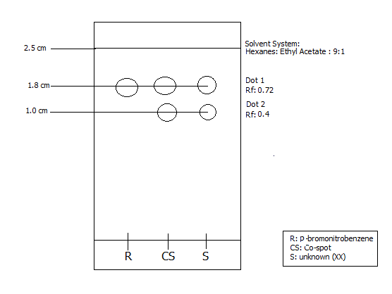
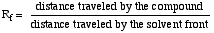
Dot 1
R_{f} = 1.8/2.5 = 0.72
Dot 2
R_{f} = 1.0/2.5 = 0.40

Part C calculations
*for the purpose of this lab our photos were too low quality to use so for the next part data from Isabel Glasgow student #8263372, lab Wednesday at 10:00, week 2 is used. Her unknown was also XX. Below are her images.
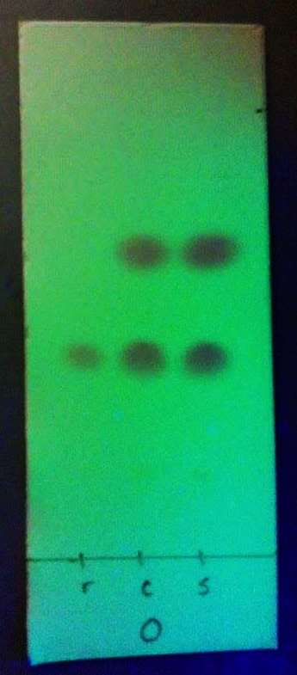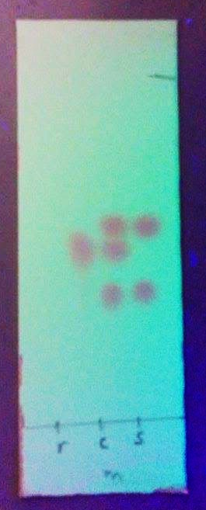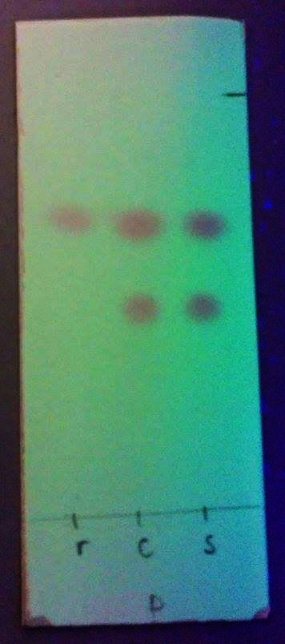

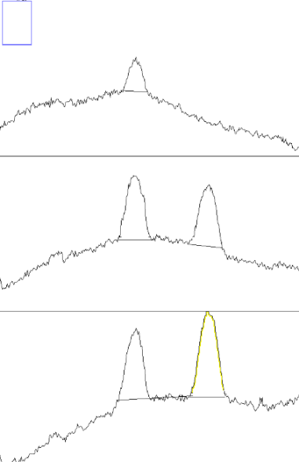
o-bromonitrobenzene
% peak 2 = (area of peak 2 / (area of peak 2 + area of peak 3)) x 100%
= (5042.841 / (5042.841 + 4462.790) ) x 100%
= 53.0 %
% peak 3 = (area of peak 3 / (area of peak 2 + area of peak 3)) x 100%
= (4462.790/ (5042.841 + 4462.790) ) x 100%
= 46.9%
Mole percent of o-bromonitrobenzene
Y= 1.0114x - 2.0208
53 = 1.0114x - 2.0208
X= 54.58 %

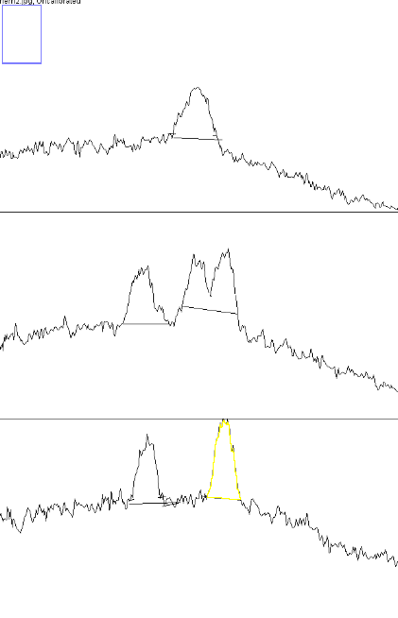
m-bromonitrobenzene
% peak 2 = (area of peak 2 / (area of peak 2 + area of peak 3)) x 100%
= (3408.912/ (3408.912+ 5135.903) ) x 100%
= 39.9%
% peak 3 = (area of peak 3 / (area of peak 2 + area of peak 3)) x 100%
= (5135.903/ (3408.912+ 5135.903) ) x 100%
= 60.0%
*Peak do not line up therefore there is no mole percent

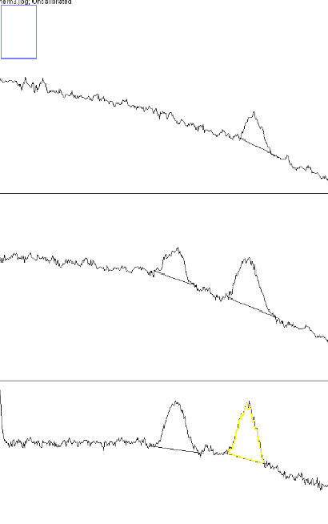
p-bromonitrobenzene
% peak 2 = (area of peak 2 / (area of peak 2 + area of peak 3)) x 100%
= (1763.104/ (1763.104+ 3431.368) ) x 100%
= 33.9 %
% peak 3 = (area of peak 3 / (area of peak 2 + area of peak 3)) x 100%
= (3431.368/ (1763.104+ 3431.368) ) x 100%
= 66.0 %
Mole percent of p-bromonitrobenzene
X = 100% - Mole percent of o-bromonitrobenzene
X = 100 - 54.58
X = 45.42 %
Discussion
Part A
- Most likely to be benzophenone as the R_{f} values are the closest in value
- Biphenyl is a non-polar substance compared to the polar benzophenone
- This results in a higher R_{f} value for the biphenyl than benzophenone (as it is less likely to “stick” to the polar silica gel)
- Referring to observations and results the biphenyl had a larger R_{f} value than the unknown
Part B
- Hexanes are non-polar compounds as they are symmetrical and have no functional groups to bond with water
- Ethyl Acetate is a polar substance as it has both a keytone and two lone pairs on an oxygen that can bond with the polar silica gel
- Due to the silica gel being very polar the non-polar hexane cannot break the dipole-dipole bonds that the gel makes with the sample solution
- This results in a smaller Rf value compared to the polar Ethyl Acetate
Part C
- According to the graphs both p-bromonitrobenzene and o-bromonitrobenzene line up with the reference, therefore both of those compounds are in the unknown mixture
- Functional groups at different orientations can affect the polarity
- Polarities that are opposing directions can cancel each other out making the substances less polar and thus increasing the Rf value.
Sources of error
- The dot sizes were not all the same, some being larger than others. The larger the dot the more likely it will be to run or merge with another dot effect the Rf value as it must be measured from the center of the dot
- If the concentration of the sample is too great the spots could also merge and streak together
- Human error in drawing the dots under the UV light could cause the distance measurement to be inaccurate
- A human error might have occurred in Part A where the sample might have been placed on the co-spot mixing with the other sample prior to being placed on the reference spot
- Sources of improvement- have a system that does not rely on human observation or use polar/nonpolar solutions that are not clear and colourless.
Questions
- How does increasing the polarity of the solvent system affect the results of a TLC?
The TLC plate is coated with the polar substance of silica gel. As it is polar, the dominant interactive forces are dipole-dipole forces. Other highly polar substances will interact with these forces better than lower polar substances thereby increasing the polarity of the solvent system will stick/absorb better. This will in turn affect the results of the TLC as the more polar a substance is the less distance it will travel resulting in a smaller R_{f} value.
2. In the following sets of compounds, which would have the smallest R_{f} on silica gel? Use a sentence to explain your reasoning. Draw line structures of each compound
a. Benzyl alcohol, benzaldehyde, benzyl acetate
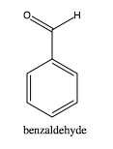
Out of the three, benzyl alcohol is the most polar therefore it would have the smallest R_{f.} As seen above the benzyl alcohol has the hydroxyl group which is more polar than the other functional groups of the other two compounds.
b. Aniline, N,N-dimethylaniline, naphthalene
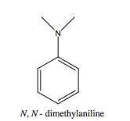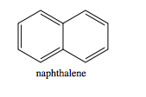
The smallest R_{f} value would belong to N,N-dimethylaniline. As seen above naphthalene is perfectly symmetrical benzene rings therefore it is non-polar. Between the two other compounds there are more electrons available for the N,N-dimethylaniline therefore resulting in more bonding opportunities.
c. Benzophenone, Biphenyl, Benzoic acid
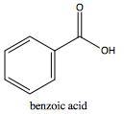
Benzoic acid is the most polar out of the above compounds therefore it would have the smallest R_{f.} The hydroxyl group on the end of the benzoic acid would result in better bonding opportunities with the silica gel then the keytone in the benzophenone.
Conclusion
In conclusion the first unknown (#95) was determined to be benzophenone. ETOAc was the more polar of the two solvents causing larger Rf values as it was able to break the dipole-dipole bonds between the sample and the gel. Finally the unknown XX was determined to be para- ortho- bromonitrobenzene with the composition of 45.42 % para-, and 54.58 % ortho-bromonitrobenzene.



