- Chemosensory information can be used for communication among animals. For many species, the sensory system best suited for this purpose is audition.
- Audition is distant sense in that a stimulus can be detected from quite far away.
- Auditory system operates on the fastest time scale.

- A. The physics of sound
- For us to hear a sound there are three essential requirements:
  - First there must be something that creates the sound.
  - Second, the sound must propagate through a medium from its source.
  - Third: there must be a mechanism to translate sound energy into biological signal that ultimately generates the perceptual experience we refer to as hearing.

- Bell jar experiment: shows that Air was required to serve as a medium for the transmission of sound (boyle)

- 1. The creation of Sound
  - Sound (psychologist definition): a certain physical event that produces the perceptual experience we know as hearing.
  - Physicist (definition): sound is a vibrational disturbance of a medium and is therefore associated with certain physical qualities that can be exactly described.
- Although air is the most common medium for sound transmission, any medium of gas, liquid or solid can serve this purpose.

- Vibrational properties of objects:
- For an object to create a sound, the one necessary condition is that it be able to vibrate and thereby impart a corresponding vibrational disturbance to air.
- Two essential properties that it must, by definition, possess: inertia and elasticity.
  - The greater the mass of an object, the greater its inertia. (All physical objects shave mass and therefore either resist being moved if at rest or resist coming to rest if in motion.
  - The first condition for vibration is that once force is applied, the movement of an object is sustained due to the property of inertia.
  - The distortion in the shape of the object is quickly met by an opposing tendency to return the object to its original state. This is the property of elasticity, and it ensures that the object’s deformation does not continue beyond a certain extent.
  - Interaction between inertia and elasticity makes the object move back and forth after a force is applied, resulting in vibration.

- The tuning fork as a sound source:
- The simple device known as a tuning fork is more convenient and often used to understand the physical characteristics of sound.

- Simple harmonic motion makes the form of a sinusoidal function
- So the pong start at a displacement of 0, the pong moves outward to a maximum displacement and then moves in the opposite direction, only to be reversed again.

- The impact of a sound source on a medium:
- The harmonic motion of a tuning fork imparts a corresponding vibrational disturbance to the air particles that surround it.
  - The outward movement of a tuning fork’s prong will cause air molecules immediately surrounding it to become crowded, resulting in a momentary increase in air pressure known as compression.
  - When the prong begins to move in the opposite direction, the compression is relaxed.

As the prong passes the equilibrium point toward the opposite extremity, air molecules thin out to produce a momentary decrease in air pressure know as rarefaction.
- The momentary compression and rarefactions are passed from region to region and results in a wave of outward vibrational changes in air pressure.
- Compression, rarefaction: The alternating states of increased and decreased pressure, respectively, on a medium produced by a sound source.
- The air molecules are merely oscillating back and fourth in registering the vibrations of the tuning fork.. each air molecule will mimic the original pattern of vibrations

- Pure tone that is characterized by a single sinusoidal function of air pressure change over time.

- Sinusoidal function: a smoothly varying back and forth change in some parameter that is described mathematically in terms of a sine wave. Am object undergoing simple harmonic motion follows a sinusoidal function, as in the vibrational movement of a tuning fork’s prongs.

- 2. The properties of Sound
- Sound is a longitudinal travelling wave of pressure disturbance within a medium.
  - It is these pressure changes that are detected by our auditory system and allow us to hear.
  - The two parameters of a sound wave is amplitude and frequency.

- Amplitude and its relationship to sound
- In a pure tone, the pressure change from the baseline to the peaks of the sinusoidal function is referred to as the amplitude. Definition: the maximum pressure change of sound in one direction relative to the baseline. The greater the displacement of a vibrating body, the greater the amplitude of pressure change in the resulting sound wave.
  - The difference in the two waveforms is apparent from the height and depth of the troughs and crests
- 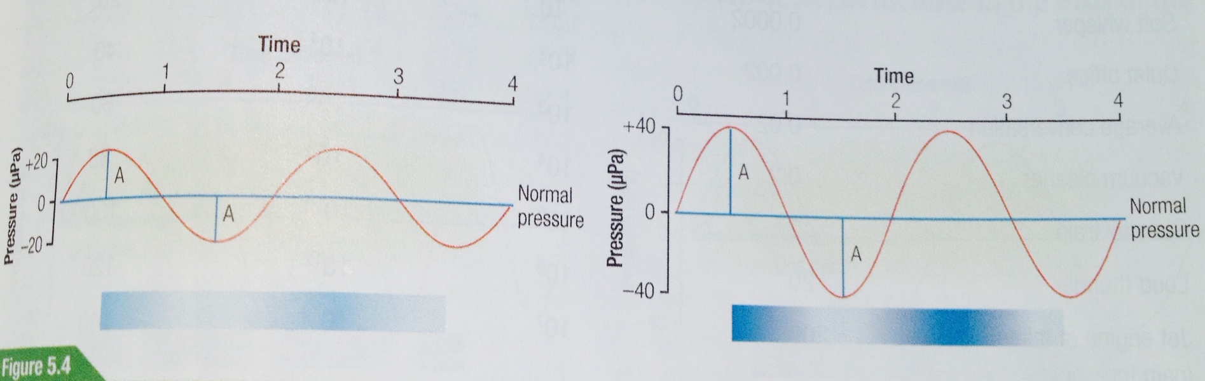
- A loud sound has a waveform in which the pressure changes are greater, and therefore has greater amplitude, than a soft sound.
- Newtons per square metre or pascal (Pa). unit of measurement
- Used to describe the physical characteristic of sound in terms of loudness is

- intensity. Definition: The amount of acoustic energy transmitted through a unit of area in a given time. Sound intensity is related to the square of sound pressure.
  - We don’t consider the absolute intensity, but rather the intensity in relation to a reference level.
- Pressure ratio: Ps^2/Pr^2
  - PS (peak pressure –amplitude) of the sound we want
  - Pr (peak pressure) of the reference sound
    - reference sound: the lowest sound level that can be heard by humans under optimal circumstances. = 20 micropascals
    - All other sounds whose intensity we wish to consider can be related to this reference

To make the values manageable we use a logarithmic scale instead of a linear one.
  - We can used the bel (b) scale Is/Ir
  - Although it reduces the scale… it also reduces the viewing of minor changes… this is why we use a decibel 1 bel = 1- decibels
    - DB= 10 log (Is/Ir)
      - Ir 20 uPA (reference)
      - If DB values are shown as DPspl, then we know the minimal audible reference value was used.

Remember we are using a logarithmic scale not linear so two 40 DBspl is not 80 DBspl but 46 DBspl
- 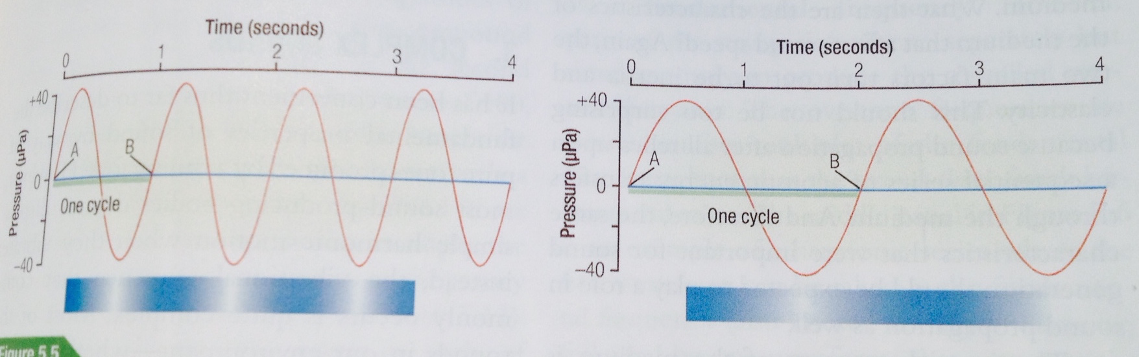
- Sound frequency
- Frequency: the number of complete cycles per unit of time, which is measured in seconds is denoted as hertz (Hz)
  - A second primary property of a pure tone is its frequency.
  - The frequency of the sound produced by any given tuning fork is always the same.
  - A single cycle is represented as a complete vibration containing one instance of compression and one of rarefaction.
  - Humans are only capable of hearing sounds form 20-20000Hz
  - Sound frequency is governed by a vibrational properties of a sound source. A given tuning fork has a single vibrational property and therefore can create a pure tone of only one frequency.
- The two properties that specify the vibrational frequency of a sound source are its mass and stiffness (elasticity).
  - As the stiffness or tension increases, so does the vibrational frequency.
  - However, an increase in the mass of the object results in a decrease in vibrational frequency.
- The vibrational frequency that results from the combination of these two factors for any given object its known as its natural or resonant frequency.
- Increasing the length also decreases the object’s vibrational frequency.

- Speed of Sound
- Light travels faster than sounds
- The accepted value for speed of sound in air at 0degrees is 331.5 meters/second or 742 miles/second
  - Sound frequency depends on the physical characteristics of the sound source and that intensity depends upon its vibrational amplitude.
  - The SPEED of sound has nothing to do with the sound source but only with the CHARACTERISTICS of the MEDIUM
    - Which is always inertia or elasticity
  - Sound of all frequencies and amplitude travel at the same speed in a given medium.
- The speed of sound is inversely related to the density of the medium, as the density increase, sound speed decrease.
  - Temperature decreases density as a result, the speed of sound increases because of the inverse relationship between sound speed and density.
- Sound speed is directly related to elasticity.
  - The greater the elasticity of the medium, the greater the speed of sound propagation.
  - Sound waves will travel faster in steel than in water and faster in water than in air. Because of elasticity

- 3. Complex Sounds
- Can be classified as periodic and aperiodic

- Complex periodic sounds
- A periodic sound occurs when the pattern of pressure change repeats itself at regular intervals over time.
  - Pure tone: Simple periodic wave
  - Vowel sounds have a periodic waveform
- a complex periodic wave is a repeating wave that does NOT have a sinusoidal profile
  - The notes on a musical instrument have highly periodic profile characterized by the summation of a precise series of sine waves known as the harmonic series.
  - A sound-producing musical body such as the sting on a guitar vibrates as a whole at a fundamental frequency.

- Complex aperiodic sounds
- The sounds produced by aperiodic vibrational are also known as noise.
  - An aperiodic waveform can be by combining a large set of sound frequencies that have random, varying amplitudes.
  - If the noise pattern is composed of all the frequencies within a particular range, such as the range of human hearing, then the sound is referred to as white noise. (Traffic, the whirling of a fan, the interference of radio)… this can be soothing too like waves on a beach
- 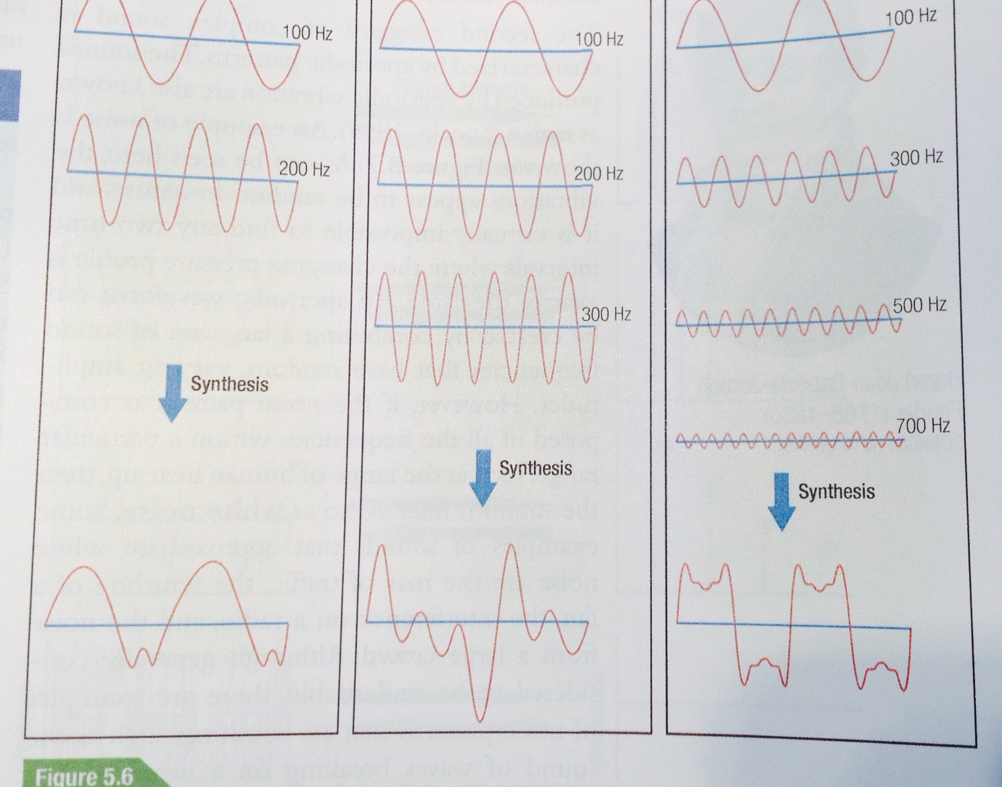
- Fourier Analysis
- Is it possible to deconstruct a complex periodic or aperiodic pattern into its constituent sinusoidal components?
  - Any functions, regardless of its complexity can be decomposed into a series of sine-wave functions.
- Fournier analysis: is that any complex waveform can indeed be decamped without prior knowledge of exactly what those constituent patterns are
- Fourier Spectrum, where the location of each vertical line along the x-axis shows the frequency of a particular sine-wave component, whereas its height gives its amplitude. (amplitude and frequency)
  - A straight line in the spectrum will be white noise, because all freq within the range has equal amplitudes

- Ohm’s law of hearing
- Complex sounds waves could also be subjected to Fourier analysis Ohm’s Law of hearing
  - The ear decomposes complex sound waveforms into their spectral components
- 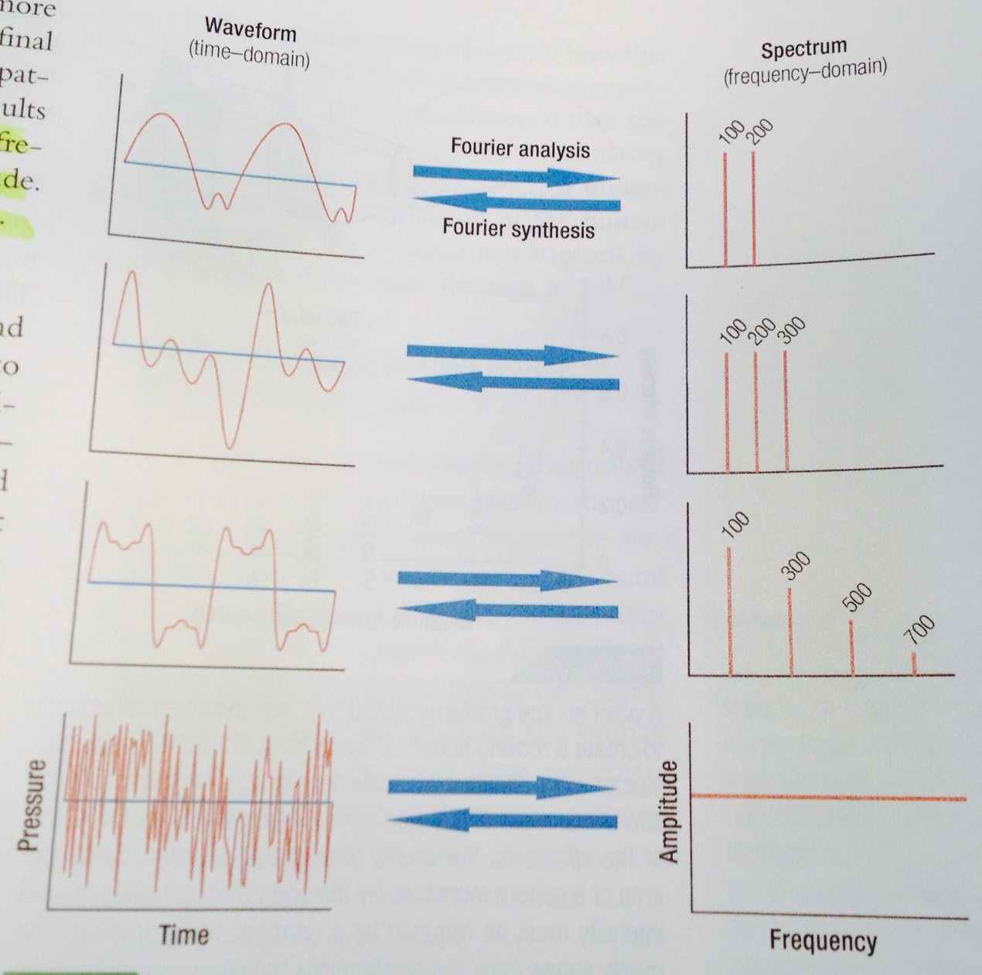
- 4. Sound Transmission
- Sound intensity becomes dissipated with distance
- Sound waves must interact with objects in their path

- The inverse square law
  - Sound intensity diminishes with distance.
  - The energy contained in the sound is dissipated over a larger and larger are because the surface area of the sphere becomes progressively larger as we move away from the sound source.
- Sound intensity is therefore inversely related to the square of the distance from the sound source.

- Interaction of sound with objects
- the inverse square law is strictly true only if sound travels in a medium that is totally free of all other matter… this rarely happends in the environment so
  - The result of this interaction (interference) can take one of three forms- reflection, absorption, or diffraction.
- A boundary can serve as a reflective surface if the second medium offers a greater resistance to sound transmission.
  - Reflected sounds are also called echoes or reverberations.
  - A room with highly reflective walls is known as a reverberant room
- The sound that is not reflected at an interface between two different media is absorbed and may be transmitted through a second medium.
  - A room whose walls are made of material with high sound absorbance is known as an anechoic room.
- A third type of interaction occurs when sound waves encounter an object that is too small for either reflection or absorption to occur. The sound waves then bend around the object in a process called diffraction. like skipping rocks on a lake or halting a wave.

- Architectural acoustics
- People in an enclosed space will hear not only the sound directly from the source but also the various reflection form the flow, walls, and ceilings.
- The most important factor in acoustic suitability is sound reflection, a factor that he quantified using the so-called reverberation time.

- B. Auditory Processing of Sound- Physical Characteristics
- The ear accomplishes (Sound processing) this by transmitting the acoustic pressures that arrive at the outer ear though a series of structures, ultimately causing a similar wave pattern to be generated within a fluid-enclosed chamber located near the middle of the head.

- 1. Anatomical components of the human ear
- each of these structures must retain the original sound stimulus and transmit it in a way that causes the least disruptions in amplitude
- Ear: the outer, middle and inner ear.
- 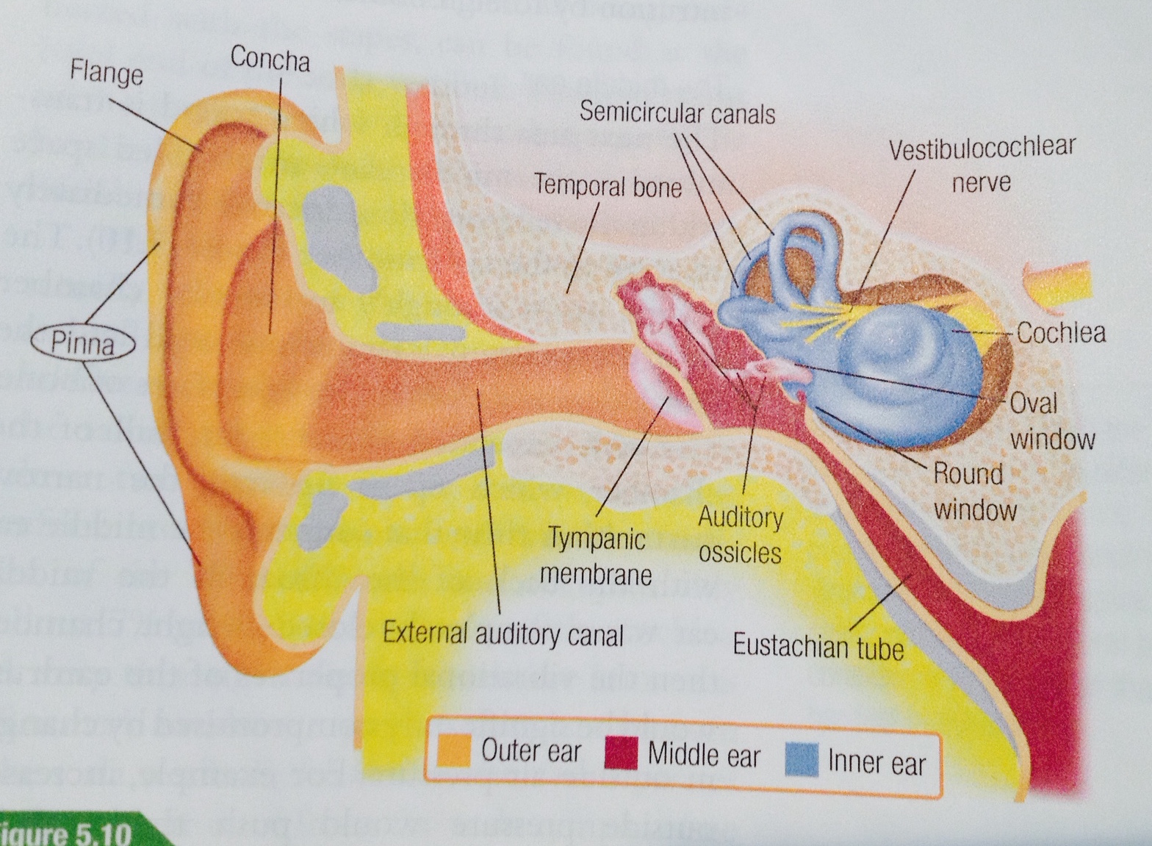
- The outer ear:
- Consists of three parts: the visible part of the ear or pinna, the external auditory canal, and the eardrum or tympanic membrane.
- Pinna: serves as a sound funnel. It lacks any musculature and thus is a passive receptor of sound.
  - It is composed of several visible bumps and grooves that enhance the transmission of sound. Sound waves are funneled through the pinna into the external auditory canal. (s-shaped)
  - The external auditory canal is covered at its innermost end by the eardrum, which serves as the interior boundary of the external ear.
- The ear drum: is a thin elastic membrane, it is attached to the skin of the external canal and complete seals it off. The incoming sound waves set off a similar vibrational pattern in the eardrum. It is then passed to the middle of the ear.

- The middle ear:
- The middle ear is an iar filled space within the temporal bone located immediately adjacent to the eardrum.
- The front wall of the chamber, which opens up into the narrow Eustachian tube that connects the middle ear with the back of the throat.
  - Because the tube is connected to the outside air, it provides a means foro equalizing any pressure differences across the eardrum, and allows it to operate efficiently.
- Sound waves arriving at the eardrum may be subsequently transmitted through the middle ear in one of three ways:
  - 1) the sound can be transmitted through the bony matrix of the head.
  - 2) Can be conducted through the air that is present in the middle ear space.
  - 3) It physically conducts the sound vibrations through a series of bony levers to the inner ear.
    - The three bones involved in this process from the outside-in are called the malleus. Incus, and stapes. Together they are known as the auditory ossicles.
- The vibration of the eardrum is conducted through this ossicular chain and transferred too the inner ear at the oval window.

- The inner ear
  - The bony labyrinth; has two structural subdivision; one of them is the semicircular canals, which are fluid-filled bony cavities that are part of the vestibular system and are used to transmit information about balance and body position in space.
- The cochlea, which is part the second part of the inner ear. Contains the sensory transduction apparatus of hearing.
  - This is where the physical energy contained in sound waves give rise to the electrochemical signals hat are transmitted. Makes almost 2.5 turns
  - The interiror of the cochlea is divided into 3 separate fluid filled channels: scaa vestibule, scala tympani, helicothrema = all have the same fluid.

- The basilar membrane within the cochlea of the inner ear is a stiff structural element that separates two liquid-filled tubes that run along the coil of the cochlea, the scala media and the scala tympani
  - It is here that the physical energy contained in sound waves gives rise to the electrochemical signals that are transmitted to the brain
  - Here there are different fluids in each chamber.

- Sound transmission through the ear
- Sound waves are captured by the pinna and funneled into the external auditory canal, to the ear drum. Sound vibration is conducted through auditory ossicles to arrive at the oval window where it is transmitted to the fluid environment of the cochlea.. there is a back and fourth movement of the oval window.
- The results of the pressure fluctuations in the cochlear fluids is to cause movement of the membrane that separates the 3 channels.
  - One feature of this entire mechanism is to maintain the fidelity of incoming signals with respect to the two principal characteristics of sound, frequency and amplitude.
  - The challenge of the auditory structures of the ear is to ensure that the vibrational pattern ultimately produced in the cochlea fluid accurately portrays the sound stimulus with regard to these two parameters.
- 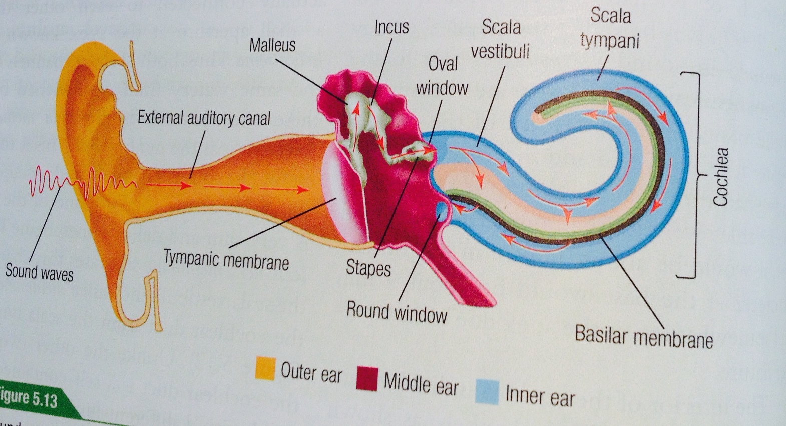
- 2. Amplitude Preservation
- a particular evolutionary challange for the terrestrial auditory apparatus was to develop mechanisms to overcome the vibrational loss that we had when we were sea animals. (4 physical features)

- The lever effect
  - As the sound energy is transferred from the malleus to the incus Mechanical force

- The condensation effect
- The sound collected by the eardrum is challenged through the ossicles onto the footplate of the stapes. As a result, the vibrational pressures condense from a large area to a small, area, producing an amplification that is nearly related to the ration of two surfaces.
  - Thus the lever and condensation effects together produce sufficient amplification to nearly offset the loss that would have otherwise occurred during sound transmission from air to a liquid environment

- The resonance effect
- Sounds of this frequency (2500 Hz) are boosted somewhat

- The Directional effect
- In the absence of an ossicular chain, both the oval and round windows would be equally affected by incoming sound waves, resulting in no real net movement of cochlea fluid.

- 3. Frequency Representation
- The neural elements involved in sound processing lie on top of the basilar membrane and within the cochlear duct
- The frequency theory
- Auditory nerve fibers were stimulated by the basilar membrane and that it was their firing rate that conveyed sound frequency information to the brain.
- Neurons fire in all-or-none manner and that the size of the neural impulse was always constant.

- The place theory
- The fundamental idea behind the place theory is that sounds of different frequencies produce a vibrational pattern whose maximum amplitude occurs at different places along the basilar membrane.
  - A high-frequency sound stimulus will produce maximum vibration at the basal end of the basilar membrane,
  - whereas low-frequency sound will yield maximum displacement toward the apical end.
- There is indeed a direct relationship between sound frequency and the point of maximal displacement along the radical membrane
- The smaller width (size) and higher tension at the basal end produce a higher resonant frequency in this part of the basilar membrane.

- Tonotopic organization
- The actual way that frequency is represented is called the tonotopic map.
- In the auditory system, it is sound frequency that Is mapped onto a key sensory structure
- The vibrational responses of the basilar membrane changes systematically to emcompass nearly the full frequency range that is audible to humans.
- The upper frequency limit of human hearing is represented at the base, whereas the lower limit is represented at the apex, with all intermediate frequencies in between.

- Frequency analysis of complex sounds
- any sound regardless of the complexity of its waveform can be decomposed into a set of sinusoidal functions by way of Fourier analysis.
- When the ear is exposed to a complex sound, a vibrational disturbance is created in the cochlea fluid that allows the complex waveform of the sound stimulus exactly.
- The basilar membrane functions as sort of frequency analyzer.
- The distribution of vibrational perturbations across the basilar membrane can then be analyzed by the neural components of the auditory system.
- The frequency preference of the basilar membrane changes systematically along its entire length to encompass the full frequency range of human hearing.

- C. Auditory Processing of Sound- Biological Mechanism
- 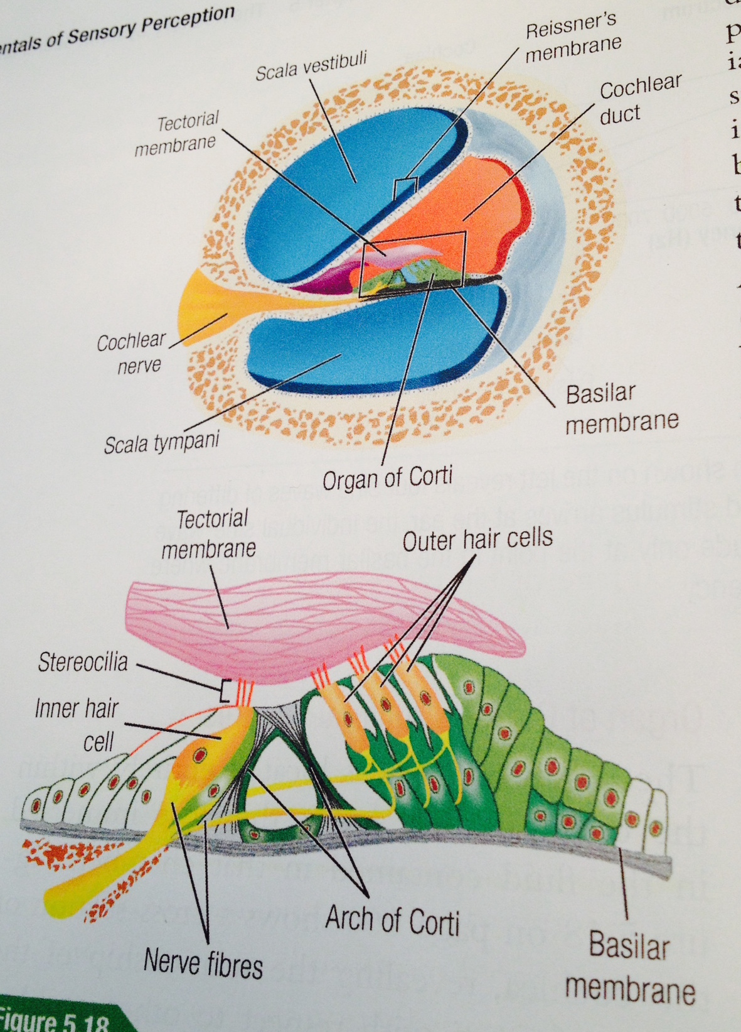
- 1. Auditory Transduction
- The conversion of vibrational to neural signals occurs within a structure that lies on top of the basilar membrane. The organ of Corti: is a group of cells and associated structures that spans the entire length of the cochlea.
- Because of its close proximity to the basilar membrane any vibrational disturbances there is imparted onto the organ of corti. It is this mechanical stimulation that produces the initial bioelectric response, there by generating the first event in the neural processing of sound.

- Organ of Corti- structural features
- Immersed in the fluid contained within the cochlear duct
- The most prominent feature is the arch of corti (V) structure. It divides the corti into inner and outer structures.
  - The most important cells with regard to auditory signal processing are hair cells, of which there are two types;
    - there is a single row of inner hair cells located on the inner side of the arch and extending the full length of the cochlea. (3000,3500)
    - The second type is the outer hair cells, arranged in three separate rows. (1200)
  - Both types contain fine filaments, called stereocilia, that protrude for, their upper surface. Inner 40, outter has 150
- A soft gelatinous structure called the tectorial membrane lies about the cellular components of the organ of Corti.
  - Both the tectorial membrane and the arch of Corti serve a critical function in transferring the vibrational energy in the basilar membrane throughout the organ of Corti, with important consequences for the hair cells where that energy is ultimately transduced into a neural signal.

- Organ of Corti- mechanical response to sound stimulation
- Movement of the basilar membrane also produces movement in the tectorial membrane because of their attachment through the stereocilia of the outer hair cells.
- the hinges (fulcrum) of the tectorial and basilar membrane are laterally displaced. Since this is the pont through which these memebranes pivot, there will be different relative motions of the two membranes depending upon whether the deflection is upward or downward
  - The two membrane do not move in concert but actually slide in opposite directions of each other, thereby producing a shearing motion between the cells in the organ of Corti and the tectorial membrane.
  - These different movements (outward for an upward deflection and inward for a downward deflection) of the stereocilia have a dramatic effect upon signal generation by the hair cells.
  - The net effect upon the stereocilia of the hair cells is that they will bend in the direction of the force

- Transduction mechanism in hair cells
- The shearing forces serve as the ultimate event that triggers a neural signal.
- Most of the neural output from the cochlea actually arises from the inner hair cells.
- Sensory transduction in general involves the production of a bioelectric current in response to some sort of external stimulation.
- In the case of hair cells, it is the bending of the stereocilia that leads to the opening of ionic pores and subsequent depolarization.
- The individual filaments of the stereocilia are themselves connected to each other by way of a very thing fiber known as a tip link.
  - Increased tension o the tip link (rightward bending of the stereocilia due to upward movement of the basilar membrane increases the tension of the tip links) opens the gates, thereby allowing ions such as potassium (K+) and calcium (Ca2+) to flow into the hair cell through the stereocilia
    - Increased intracellular levels of K+ in the hair cell have the effect of depolarizing its membrane potential.
  - If the stereocilia are bent in the opposite direction due to the downward movement of the basilar membrane, then the tension on the tip links is reduced and the ionic gates remain closed.
  - This has the effect of hyperpolarizing the hair cell since even spontaneous openings are less likely to occur.
- This direct gating action on ionic pores provides the fastest possible response to mechanical deflection of stereocilia

  - First depolarization leads to the ionic gates within the hair cells to open further, thereby producing greater depolarization.
  - second, depolarization along with increased calcium levels lead to neurotransmitter release at the base of the inner hair cell. The neurotransmitter, believed to be glutamate crosses the synaptic space to depolarize cochlear nerve fibres that innervate the hair cells,
  - the neurotransmitter that is released is believe to be gluatamate
  - The resulting action potentials produced in these nerve fibres carry auditory information out of the cochlea to higher centers in the auditory nervous system.

- Role of outer hair cells

the cochlear response to sound can be considered to occur in two ways passive and active

the one just mention with inner hair cells is passive

the active process is mediated through outer hair cells.
- The active mechanism in turn is believed to occur in one of two ways-mechanical or electrical.
  - The is actual physical change in its structure when sound stimuli is applied (mechanical)
    - very fast, the net effects of the mechanical changes is to influence the movement of the tectorial membrane. This enhances the cochlear response, especially at higher frequencies.
  - The electrical mechanism. The movement of outer hair cells in response to basilar membrane vibration produces an electrical across the organ of Corti Cochlear microphonic
    - This current is modulated by movement of the stereocilia in the outer hair cells to produce to cochlear microphonic
    - This electrical response its waveform follows the sound wave form exactly.

- 2. Neural Capture of Auditory Signals
- The transmission of auditory signals out of the cochlea to the central nervous system occurs via the vestibulocochlear nerve.
  - There are two distinct components to this nerve, the vestibular branch that innervates the vestibular apparatus and the cochlear branch(nerve).
  - Each cochlear is innervated by 30,000 cochlear fibres these fibers are responsible for transmitting intensity and frequency information, the two principal qualities of sound, to the central nervous system.

- Anatomical organization
- The fibres of the cochlear nerve originate from cell bodies that are located in the cochlear ganglion. (bipolar nerves)
- Spiral Ganglion: the collection of nerve cell bodies that follows the cochlear spiral. Nerve fibres arising for, these neurons innervate hair cells of the cochlea.
- 90% of the cochlear nerves fibres terminate upon the inner hair cells. the Organ of Corti is innervated by both afferent and efferent fibres.
  - The afferent fibres belong to neurons whose cell bodies reside in the spiral ganglion.

These fibres largely terminate on the inner hair (innervated by close to 10 afferent fibres) in such a way that each afferent fibre make contact with only a single inner hair cell. They transmit neural signals form the cochlea to the central nervous system.
  - The efferent fibres originate form the brain stem and make contact largely with the outer hair cells, though there is a sparse innervation of the inner hair cells as well.
- In both cases, these nerve fibres conduct action potential generated at their nerve endings by the release of neurotransmitters following hair cell depolarization.

- Afferent versus efferent nerve fibres
- Each aggerent fibre terminates upon a single inner hair cell. This produces a larger neural divergence, given that the 3,000 inner hair cells end up stimulating the vast majority of the 30,000 afferent fibres.
  - Advantage: differences in processing can occur at each of the synapses by controlling how much neurotransmitter is released there.

- Neural coding of sound intensity
- The greater the amplitude of the sound stimulus, the greater the deflection of the basilar membrane, organ of Corti, and tectorial membrane resulting in greater deflection of the stereocilia, greater depolarization of inner hair cells, and finally greater neurotransmitter release upon the afferent fibres.
  - Some nerve fibres have a high level of spontaneous neural activity, prb caused by greater spontaneous release of neurotransmitter by the inner hair cells. very sensitive to sound
  - At the opposite extremity are afferent fibres that show very low levels of spontaneous activity. Much greater firing threshols
- The full range of audible sound intensity is therefore coded by afferent fibres whose response profiles lie between these two extremes.
  - The mechanism that likely generates such differences in response sensitivity is the amount of neurotransmitter released by the inner hair cell.
  - A key advantage of this multiple innervation scheme is that any given inner hair cell can respond to a particular sound intensity by releasing different amounts of neurotransmitters at its different synapses.
  - So the output from an inner hair cell can trigger different levels of neural activity among parallel set of fibres.

- Neural coding of sound frequency, place theory mechanism
- The central nervous system obtains information about sound frequency from the afferent fibres in two different ways.
  - Basilar membrane shows maximum vibrational amplitude at different places along its length in response to different sounds frequencies.
  - A particular afferent fibre carries signals from hair cell that was depolarized only by the particular sound frequency associated with its place in the tonotopic map.
  - The cochlear nerve, therefore, simply preserves the place coding of frequency selectivity that is found along the basilar membrane.

- 1)The relationship between sound frequency and neural response in a particular afferent fibre can be portrayed by its tuning curve, which shows a plot of the minimum sound intensity required to obtain a sufficient neural response as a function of sound frequency.
  - The lowest point in the curve occurs at the so-called characteristic frequency. Least sound pressure required to evoke a neural response.

Frequency Response Curve; Possible to show frequency at different levels
- Both curves show that’s Auditory fibres in the cochlear nerve are narrowly tuned to a particular frequency.
- The basilar membrane; it alone is largely responsible for generating the narrow frequency tuning functions that are observed in cochlear fibres.

- Neural coding of sound frequency, frequency theory mechanism
- 2)The properties of the basilar membrane do not allow frequency-based mechanism to operate over the full span of the audible frequency range.
- BUT the auditory system does rely on some form of neural freq encoding that is directly linked to the pressure undulations of the sound wave.
- Phase-locked response; Neural firing that has a precise timing relationship to the sound waveform, either linked to each compressive portion or spaced out ever few cycles. It can persist with frequencies of 4000 hz, but since action potentials cannnot be produced at such high rates of firing it is believes that a fibre may fire once every few cycles of the sound wave, there by retaining some form of phase locking though a more dispersed manner.

- 3. Subcortical Auditory Structures
- The more advanced aspects of hearing, such as localization of the sound source, require the interaction of neural signals from both ears.
- That interaction begins in the subcortical auditory structures that together form a hierarchical set of neural processing units in the signal transmission path form cochlea to the auditory cortex.
- These structures have dual functions;
  - first they serve as a relay mechanism that transmit information form one sit to another.
  - And second, through their active role they enhance, modify, and further process the auditory signals, thereby imparting significant consequences for the perceptual experience of hearing.
- 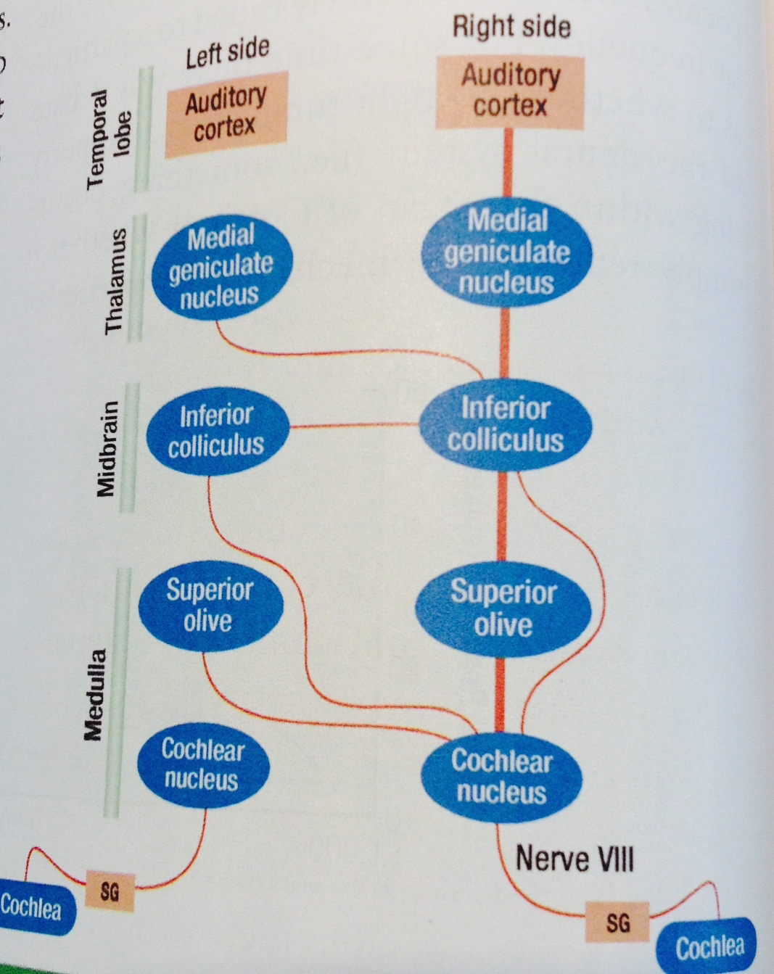
- Ascending pathways
- The ascending transmission pathway begins at the point of neurotransmitter release by inner hair cells upon the cochlear nerve fibres.
- Neural signals in the cochlea are captured by nerve fibres whose cells bodies reside in the spiral ganglion (SG) and then transmitted to the cochlear nucleus. Signal transmission in the ascending pathways occurs through a number of different subcortical structures before arriving at the auditory cortex. These structures are located in the thalamus and at different levels of the brain stem.

- The cochlear nucleus has two major division containing some neurons that act largely as relay cells and others that are involved in enhancing and sharpening the signals.
  - The neurons in the cochlear nucleus on either side of the brain only receive inputs from the cochlea’s of that side alone.

There is no cross over of auditory signals at this level, and therefore these neurons are considered to be monaural.
  - From the cochlear nucleus, the projections diverge into two higher areas, the superior olive and inferior colliculus. The cochlear nucleus projections may be directed to the same side of the brain as well as to the opposite side. The implication of this cross over is that neurons at these levels, and higher, display binaural responses because they are able to integrate auditory signals from both ears.

- The IC (Interior colliculus) is located in the midbrain with functions related to the auditory signal relay and coordination of acoustic reflexes.
- The medial geniculate nucleus is a thalami nucleus that largely serves a relay function and represents the last in the series of hierarchical subcortical structures.
- Form here, there Is a large radial projection of fibres to the auditory cortex

- Response characteristics of subcortical structures
- 3 themes that emerge when considering neural function In the subcortical strucutres:
- response modification:
  - Auditory signals are processed to a certain degree in some structures especially the cochlear nucleus, by ways of excitatory and inhibitory influences within a localized neural network.
  - As a result, the response profile as a function of sound frequency can undergo some modification.
  - One result of this operation is that it helps to sharpen the neural representation, which in turn is thought to be important for sound localization, perceiving sounds in a complex field, and detecting sounds that are present in noisy background.
- Tonotopicity:
  - Second, a topographic organization is evident whereby a progressive change in the characteristic frequency occurs along a particular spatial dimension.
  - This is most prominent in the IC where each layer od neurons is believed to display the same characteristics frequency resulting in the so-called isofrequency sheets.
  - The presence of a tonotopic arrangement in these structures means that the place code propagates through the subcortical pathways all the way up to the cortex.
  - It also ensures that frequency information is retained in much the same manner at multiple levels of the auditory system.
- Laterality:
  - The extent to which subcortical neurons can be seperaetly driven by two ears.
  - Auditory neurons that reside above the cochlear nucleus integrate information from the two ears because of the crossover of projection pathways.
  - In general binaural neurons are excited by contralateral sound stimulation, whereas ipsilateral inputs can produce either excitation or inhibition

Descending pathways
- Signal transmission up the hierarchy of the ear system is accompanied by info flow in the opposite direction.
- These signals originate in the cortex and proceed through essentially the same structures, though the participating neural elements are kept separate form the ascending pathways.= descending system
- They are involved in modulating the auditory response to sound.
- There are two ways in which this is accomplished
  - 1)Olivocochlear neurons; Neurons in the superior olive that belong to the descending system and give rise to efferent fibres that project to the cochlea and innervate the hair cells.
  - these neurons in turn are controlled by descending pathways from higher auditory centers, which exerts ingluence upon firing rates especially at high sound intensities
  - 2)Motor neurons in the brain stem stimulate contractions of these muscles (tympani and the stapedius) in the event of sudden sound burst. (motor activation of 2 small muscles).The muscular contractions lead to decreased sound transmission though the middle ear, thereby protecting the middle and inner ear components from damage.

- 4. The Auditory Cortex
- Whereas the subcortical areas are involved in coding and transmitting the basic qualities of the sound stimulus, the auditory cortex assembles the incoming neural signals into meaningful acoustic events.

- Anatomical organization
  - Area A1: The primary auditory cortex located in the temporal lobe if both cerebral hemispheres. Receives incoming fibres from the mgn.
  - Auditory area A2 immediately surrounds the primary auditory cortex and is believed to process higher order information.
  - Wernicke’s area: located in the temporal lobe, has a distinctive auditory function. Plays and important role in speech comprehension, specialized to serve the unique role of speech analysis in humans. It restricts the dominant (usually left) hemisphere.

- Functional organization
- The two key features that stand out are tonotopic organization and the clustering of binaural features.
  - 1)The systematic arrangement of neurons with regard to characteristic frequency
  - This systematic arrangement (low sound frequencies are present toward the anterior end, and higher frequency are found at the opposite end) produces the so-called isofreqeuncy sheets whereby auditory neurons tuned to the same frequency are segregated along narrow strips.
  - 2)A second functional feature of area A1 concerns the way binaural inputs are combined.
  - The crossover of auditory signals form one side of the brain to the other at earlier levels of the brain stem means that neurons in the auditory cortex receive inputs from both ears.
    - One type of neuron in area A1 shows summation response (i.e., the inputs from both ears are excitatory and therefore the neuron can be driven by sound stimulation of either ear, though there is usually a stronger preference for the on the opposite side).
    - A second type of neuron shows a suppression response (i.e., the neurons is excited by sound input from the opposite side but is inhibited by stimulation on the same side).
  - Thus, area A1 can be thought of as a two-dimensional sheet where sound frequency is represented along one axis and binaural mixing is represented along the other.

- Parallel auditory pathways
- Thus area A1 appears to be directed st representing sound frewuency and binaural interaction.
- An emerging idea in this field is that the twin functions of sound analysis and localization are reflected by processing in separate but parallel neural pathways of the higher auditory system.

- Auditory Dysfunction
- Auditory fatigue: a brief or momentary reduction of hearing
- Hearing loss: a reduction in auditory sensitivity
- Conductive loss occurs when the outer or middle war is affected, leading to reduced transmission of sound to the cochlea.
- Sensorineural loss occurs when there is damage to the cochlea of to the nerves of the inner ear.
- Congenital hearing loss occurs due to either a genetic cause or a problem associated with the birth process
- Acquired hearing loss develops later in life
- Any hearing loss that is present in prelingual children will hinder speech development
- If it is not accompanied by special training, a total loss of hearing in early childhood will lead to deaf-mutism, the absence of language vocalization ability.

- D. auditory dysfunction

- 1. Causes of Hearing Loss
- Simple mechanical blockage of the auditory canal to the complex and unrelenting effects of aging

- Conductive loss:
- The outer/middle ear is affected, leading to reduced transmission of sound to the cochlea.
- Affects the mechanical conduction of sound through the ear
- Middle ear infection, also known as otitis media
  - More serious damage can happen whe there is fluid build up by infection.
  - It is greater in children cuz they have a smaller tube.
- Ostosclerosis, an inherited bone disease that produces abnormal development and functions of the ossicles. Because of increased calcium.

- Sensorineural Loss
- When there is damage to the cochlea or to the nerves of the inner ear.
- In most cases, the effect occurs at the hair cells, which are extremely sensitive to damage. They do not regenerate after damage
  - Ingestion of ototoxic drug; certain antibiotics, even aspirin in large doses can cause ototoxic effects leading to tinnitus, the perception of ringing in the ears in the absence of any eternal sound.
  - Traumatic injury; a kind of head injury such as fracture to the temporal lobe, can affect the cochlear functions
  - Inner ear: might be affected by tumors
  - Exposure to intense environmental noise (Noise-induced hearing loss).
  - Both the amount of noise and the duration of exposure determine the degree of hearing damage.
  - Sounds over 80 dB are potentially dangerous, 120 dB is considered painful

- Hereditary factors and aging
  - The more complex causes of auditory dysfunction generally involve age-related changes to the hearing apparatus and genetic factors.
  - The two major cause of hearing loss are Usher syndrome and Waarenbrug Syndrome.
- US: Defective gene that is passed on in an autosomal recessive manner
- WS: unusual genetic disorder that cause hearing loss and changes in skin and hair pigmentation. Passed from parent to child, occurs in a dominant manner.
- Hearing loss that occurs gradually due to the effects of aging is known as presbycusis.

- D2. Diagnosis and Treatment
- Audiologists: evaluation of hearing functions
- Otolarynologits: Clinical diagnosis
- Bone conduction test

- Hearing aids
- A hearing aid is a device that amplifies incoming sound and delivers them tot the ear

- Cochlear implant
- Consists of a small microphone and a processor that converts the sound signal into an electric current that is actually then delivered to the inner ear though a set of fine wires.
- The idea is for the implant to take over the transductional functions of the cochlea and directly stimulate the auditory nerve fibres. (single channel and multi-channel implants).

