Since the beginning of time, it has been peoples dream to learn how to fly. It all started in the 19th century when many innovators attempted to create the first flying apparatus. Although many succeeded at creating what we now know of as a personal glider, these advancements were very primitive in their nature. It wasn’t until the early 20th century that these concepts were turned from concepts to reality by the Wright brothers. The wright brothers took what most individuals would consider an unrealistic vision, and turned it into actuality. They had built the first controlled, powered and sustained flight ever recorded. It took them many more years to develop these concepts into more practical applications and it took many other innovators to develop the high powered jet airplanes the airline industry now uses on a daily basis.
Air Canada’s Core Strategy (Figure 1)
Air Canada’s has gone through multiple restructuring phases following its bankruptcy protection filing which were crucial to the continuance of Air Canada’s existence. Through these changes Air Canada has expanded its market share in multiple different markets, maintaining its image as a national brand and its continued success.
Air Canada’s has become a very important national corporation offering opportunities to its many stakeholders around the world. It’s ultimate mission and objective is to “keep a laser focus on improving and simplifying the customer experience at every point in their journey. One way of simply putting it is they wish to connect “Canada and the World.” It is necessary to understand the airline industry structure and the competitive environment before analysing the internal core strategy that Air Canada currently instills. The Airline industry has come a long way since it was first established in the early 20th century. It’s given the World opportunities beyond most people’s comprehension, allowing increasing globalization, the possibility to reach further and further destinations to the average North American and even providing opportunities for individuals to build a career in and increase the standard living.
The Airline industry is divided into four categories; international, domestic, regional and cargo flight networks. Air Canada has a leading market share in the international, domestic and regional flight networks and offers a variety of cargo shipping capabilities. In order to comprehend the competitive presence within this industry, the use of the five porter forces analysis can be used to identify these characteristics. The threat of new entrants although at first may seem quite low, it most definitely isn’t true. New Airlines have been emerging in the past decade increasing competition and slowly gaining market share as well as increasing saturation of the markets little by little. This brings emphasis on brand recognition and frequent flyer programs as new airlines like West-Jet or Porter airlines form new low-cost niches to compete with Air Canada’s domestic flights. The power of suppliers is fairly strong as there are only two major manufacturers of airplanes, Boeing and Airbus accordingly. The power of buyers isn’t very high as most airlines offer the same service, with the same chairs, and often time switching company’s costs a great amount in cancelation fees. The Availability of substitutes although very low for international flights as using other modes of transportation are not convenient, the domestic and regional categories have seen increasing use of trains and automobiles. The competitive rivalry in the airline industry has seen increasingly more and more new entrants. These new entrants have positioned themselves in the no frills low-cost niche against Air Canada’s regional and domestic flight networks gaining a moderate market share since their inceptions.
Air Canada’s key competitive market positions include their vast market share in the international flight networks, offering domestic and regional flights, as well as cargo shipment all over the world. Also noted that Air Canada offers premium flight packages to sports teams, and other large groups via Jazz airlines an innovative way of creating value in a competitive industry. Air Canada is also a part of the Star alliance group which demonstrates their international dominance and presence. They are constantly improving the customer experience as well as the customer relationships with such programs as frequent flyer points, business lounges, and quick check-ins, and easy innovative booking methods catered to all different demographics. Air Canada’s Competitive capabilities consist of increased customer satisfaction, rigorous cost reduction programs to improve margins and lower costs returning value to the consumers, unique customer experience, and strong employees/brand. Most of these capabilities have created a unique and dynamic experience for customers; this creates value to the consumer purchasing the service and has leaded this corporation to increasing success. These capabilities are achieved with a dynamic organizational structure, dividing into two categories; one being the operations and the other being the customer experience/relationship.
Academic Paper: The Five Competitive Forces That Shape Strategy
This article outlines the famous Porter Five forces Model, this model was developed and created by Dr. Michael Porter, University professor from Harvard. This model was designed to analyze competitive advantages in different industries and is widely used by many corporate companies and even useful for smaller personal businesses in Canada. This model is very useful in keeping the company’s internal structure, objectives, and capabilities in line with the external forces that are constantly changing. This is why it is essential that most companies actively continue to analyze and re-adjust their alignments with the different characteristics of the market environment.
The article The Five Competitive Forces That Shape Strategy not only describes more specifically the Porter five forces model but also explains how to apply the analysis to properly implementing new strategies to gain a competitive advantage. Some of the key points to outline and a brief description of the article: The article starts by defining the Five Forces and the attractiveness of the industry. Typically an industry will seem attractive if there are weaknesses and opportunities to exploit and market share to gain. The five forces are as follows: (Figure 2)

Threat of New Entrants : “New entrants to an industry bring new capacity and a desire to gain market share that puts pressure on prices, costs, and the rate of investment necessary to compete.” Many different factors will control the level of new entrants of an industry. The threat level can be analyzed by observing certain characteristics of the industry. Some of these characteristics are; the need for entrants to acquire a large amount of capital in order to enter, the buyer’s need for network or reputable standards, economies of scale from either the suppliers side or the industries leaders, efficient distribution channels or supply chain strength and also Government policies or regulations.
The Power of Suppliers: The power of suppliers plays an important role on returns in the designated industry, if they possess higher than average power due to the lack of suppliers or sole patent holder etc. then the supplier will capture more of the profits for themselves by “charging higher prices, limiting quality or services, or shifting costs to industry participants.” This is also true for suppliers of labour and the creation of strong Unions which can have a negative effect on industries margins.
The Power of Buyers: A buyer has power if they can leverage themselves against an organization, this can be seen if they bargain prices down thus giving themselves more value and lower margins for the industry. Some of these leverages are readily available substitutes, low switching costs, or high rivalry.
The Threat of Substitutes: What defines a substitute is a product or service that performs or offers the same function by a different mean. Although sometimes certain substitutes are not as obvious and depend on the situation itself, most industries have substitutes to their products. For example: when automobile companies started using different plastics instead of aluminum, or video conference was introduced versus travelling.
Rivalry among Existing Competitors: Rivalry differs from industry to industry but usually plays a large role in the industries margins. An industry with a larger amount of competitors competing on price levels with heavy discounting will offer more value to customers but lower margins for organizations. Also if services or products don’t differ much in quality, it is important to establish value-added to the service or product to grasp a larger share of the market when there are multiple different companies.
Some other important factors to consider are technological advancements that are equally important in analyzing opportunities to have a competitive advantage against other competitors in the market. Establishing technologies like, supply chain management, enterprise resource planning, online presence or network effects can give an organization that extra edge towards a more profitable model. Governments also play an important role in barriers to entry. If the industry is heavily regulated by governments, the attractiveness of entering the industry by other entities will be much lower. One last factor to consider is the markets saturation levels, if there is little to no growth and no new niches to create, the entrants will find it more difficult to grasp market share.
Air Canada’s Future Concerns and Strategic Challenges
Air Canada has achieved many milestones during its existence and it is with no surprise that they have stared adversity and challenges straight in the face. One major challenge that Air Canada had to overcome was their bankruptcy protection restructuring phase. This was necessary in order for them to continue operating. Considering all the obstacles and challenges Air Canada has overcome since this bankruptcy filing, it is crucial that they take an active role in their strategic alignment in order to continue their success. One of the major issues that Air Canada is currently facing is the increasing competitiveness of such low cost airlines West Jet and Porter in the domestic networks.
The article The Five Competitive Forces That Shape Strategy written by Michael A. Porter demonstrates the importance that these five forces play when dealing with a company’s strategy. Air Canada must continuously analyze their external environment in order to take advantage of opportunities and gain a competitive advantage.
Air Canada is known for their international presence around the world with an elaborate network of flights. They currently hold 39% of the international market share and have been improving their network strength through Star Alliance’s with other airlines in different continents around the world. The current issue that Air Canada is faced with is the emergence of new airlines offering lower costs to clients and captivating bigger market share. These low cost airlines offer short-haul trips in the domestic and regional networks.
With increasing technological advancements, these low cost airlines have developed lower operational costs then the legacy airlines. The key reduction in costs comes from the supply of labour; older airlines have complicated pay structure, pension plans and heavy labour costs. The new airlines start with a clean sheet and can continually control their labour costs as they expand their relatively new fleets of small haul planes. This gives them a cost advantage over Air Canada’s domestic models, as they don’t incur as many costs and can offer lower rates to the buyers.
Air Canada can no longer ignore the fact that these smaller domestic airlines are gaining market share and certain restructuring has to be done in order to gain a competitive advantage against these newer airlines before it is too late. One way of finding opportunities to exploit in the industry is to use the Porter Model to find weaknesses in the market environment. Using some of the main aspects of the Five Forces Porter model, we can identify what new structuring should be undertaken in order to regain the market share that Air Canada has lost in the past decade to these low-cost airlines.
Rivalry amongst competitors and buyer power are the main changes in the market environment are the root of the problem. A quick analysis of these two factors reveals new changes that Air Canada can undertake in order to have a stronger competitive edge.
Buyer Power: The new competitors that have entered the airline industry have shifted the buyer power and given them access to more leverage. The internet booking models these new airlines offer have reduced costs giving them opportunities to offer lower prices and more trips per day.
Rivalry amongst competitors: The intensity of competition has now increased substantially in the airline industry creating lower margins. Market saturation has reached a newer high as well as the potential growth of the airline industry is starting to slow down. This creates more fight for market share lowering prices.
Air Canada’s Necessary Restructuring
Taking a closer look at these two forces in the porter model, demonstrates that increased buyer power and rivalry amongst competitors changes the structure of the domestic, regional and now spilling into the international sun destination network. Air Canada must make swift changes in its internal structure and strategies in order to compete at the price levels that these new organizations have established. Air Canada must make some drastic changes in its cost structure in order to continue to be a sustainable organization.
Cost Structure changes: In order for Air Canada to continue its success they have no choice but to change their cost structure. This starts by cutting costs and becoming a more efficient cost driven company. Air Canada can most certainly match these low cost airlines prices but this itself won’t solve the problem as cutting costs and improving efficiency is the solution. One way of making improvements to cost would be to increase aircraft utilization and turnaround times as well as using hedging techniques to control oil price fluctuations. Lastly one of the highest costs airlines incur are labour costs, new pay structures must be established if Air Canada is to establish a discount airline. One possible possibility would be to give new hired pilots and flight attendants the discount carriers’ routes and as they move up in pay, they would be moved to the more expensive airline routes.
Value Creation: Another way of creating a competitive advantage would be to continue creating unique, innovative customer experiences. This would help differentiate their products and services from the competition and giving the customer a higher satisfaction and willingness to pay more. Air Canada has been fairly strong when it comes to improving its customer appeal and brand name with such premium programs as frequent flyer, business lounges and event premium airline Jazz catering to sports teams, artists and higher paying customers. This being a strong capability they have, they should continue to elaborate and create new products to interest customers to choose them over other low-cost airlines improving chances of gaining value perspective customers who will pay more for quality service.

Appendix
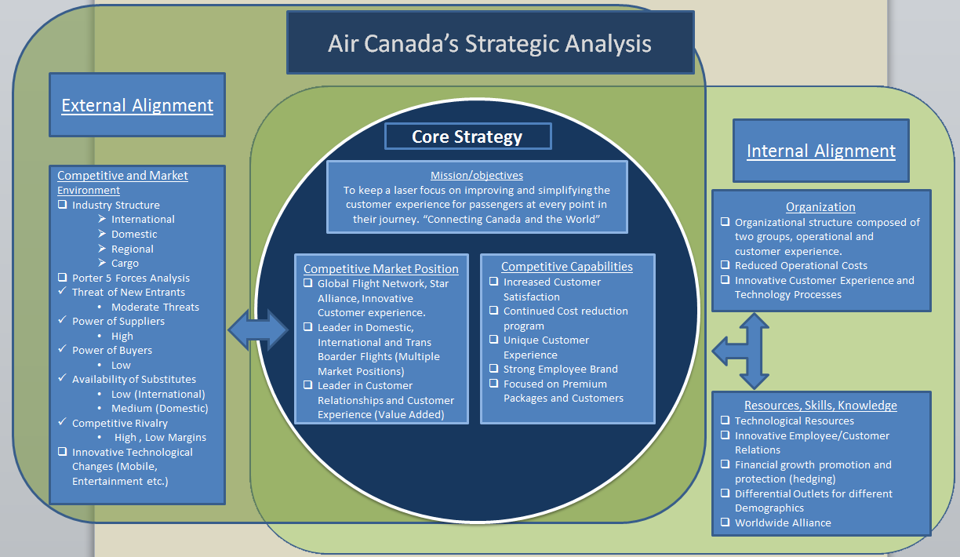
Figure 1.
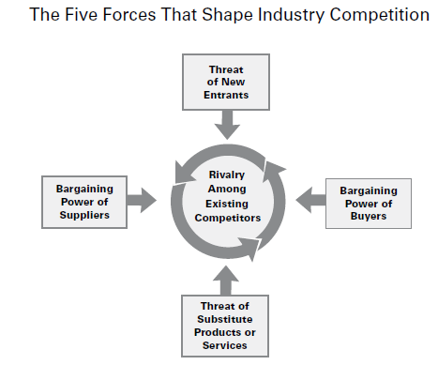

Figure 2.

Work Cited
"Air Canada Industry analysis."Thinking Made Easy . N.p., 21 Feb. 2008. Web. 8 Dec. 2011. <ivythesis.typepad.com/term_paper_topics/2008/02/air-canada-indu.html>.
Murphy, Patrick. "Competing Against Low Cost Airlines." Performance Consultants International. N.p., n.d. Web. 8 Dec. 2011. <http://aviation-performance.com/pdf/PM_Competing%20against.pdf>
Porter, Michael. "The Five Competitive Forces That Shape Strategy." Harvard Business Review 1.R0801E (2008): 8.Harvard Business Review. Web. 8 Dec. 2011.
Rousseau, Micheal . "BANK OF AMERICA MERRILL LYNCH GLOBAL TRANSPORTATION CONFERENCE." Air Canada. N.p., 16 Aug. 2010. Web. 8 Dec. 2011. <www.aircanada.com/en/about/investor/documents.bank_america_june2010_sn.pdf>
"The Industry Handbook: The Airline Industry." Investopedia.com - Your Source For Investing Education. N.p., n.d. Web. 8 Dec. 2011. <http://www.investopedia.com/features/industryhandbook/airline.asp#axzz1fbzJAcAb>
Wright, Dr. Steve , and Dr. Gary Bradshaw. "Wright brothers: Wilbur and Orville Wright." Wright House: Frank Lloyd, Orville and Wilbur, Steven.... N.p., n.d. Web. 12 July 2011. <http://www.wright-house.com/wright-brothers/Wrights.html>.

Wright, Dr. Steve , and Dr. Gary Bradshaw. "Wright brothers: Wilbur and Orville Wright." Wright House: Frank Lloyd, Orville and Wilbur, Steven.... N.p., n.d. Web. 12 July 2011. <http://www.wright-house.com/wright-brothers/Wrights.html>.
Rousseau, Micheal . "BANK OF AMERICA MERRILL LYNCH GLOBAL TRANSPORTATION CONFERENCE." Air Canada. N.p., 16 Aug. 2010. Web. 8 Dec. 2011. <www.aircanada.com/en/about/investor/documents.bank_america_june2010_sn.pdf>
"The Industry Handbook: The Airline Industry." Investopedia.com - Your Source For Investing Education. N.p., n.d. Web. 8 Dec. 2011. <http://www.investopedia.com/features/industryhandbook/airline.asp#axzz1fbzJAcAb>
Porter, Michael. "The Five Competitive Forces That Shape Strategy." Harvard Business Review 1.R0801E (2008): 3.Harvard Business Review. Web. 8 Dec. 2011.
Porter, Michael. "The Five Competitive Forces That Shape Strategy." Harvard Business Review 1.R0801E (2008): 4.Harvard Business Review. Web. 8 Dec. 2011.
Porter, Michael. "The Five Competitive Forces That Shape Strategy." Harvard Business Review 1.R0801E (2008): 8.Harvard Business Review. Web. 8 Dec. 2011.
Rousseau, Micheal . "BANK OF AMERICA MERRILL LYNCH GLOBAL TRANSPORTATION CONFERENCE." Air Canada. N.p., 16 Aug. 2010. Web. 8 Dec. 2011. <www.aircanada.com/en/about/investor/documents.bank_america_june2010_sn.pdf>
Murphy, Patrick. "Competing Against Low Cost Airlines." Performance Consultants International. N.p., n.d. Web. 8 Dec. 2011. http://aviation-performance.com/pdf/PM_Competing%20against.pdf

