BLOOD VESSELS AND HEMODYNAMICS

- Tunica Intima
  - Inner most layer of blood vessel walls
  - Made of a single layer of endothelial cells
- Tunica Media
  - Middle layer of blood vessel walls
  - Made of smooth muscle and elastic tissues
  - Can regulate blood vessel diameter
- Tunica Adventitia
  - Outer most layer of blood vessel walls
  - Wraps outside of vessel with connective tissue
  - Provides anchoring support and protection

- Elastic Arteries
  - At the beginning of the blood pathway
  - Thick walled and have a large diameter
  - Lots of elastic tissue, stretch and recoil with each pump
- Muscular Arteries
  - Farther away from the heart
  - Deliver blood to specific organs depending on their needs
  - Lots of smooth muscle, can regulate their diameter
- Arterioles
  - Pressure is very evened out (No systole and diastole)
  - Lots of smooth muscle, determines what will happen in the capillaries
- Capillaries
  - Continuous capillaries
    - Only small holes through which amino acids and ions can pass
  - Fenestrated capillaries
    - Pores that are intermediate in size, allow transport of larger materials
  - Sinusoidal capillaries
    - Large spaces in the endothelial cells, allowing cells and proteins to pass
- Veins
  - Have valves to push blood up and a large internal diameter to keep it moving
  - 65% of blood in veins at any time, blood reservoirs

- Vascular Shunt
  - Blood travels straight through the direct channel in a capillary (Metarteriole and thoroughfare channel) because the precapillary sphincters have closed
- Blood Flow
  - The volume of blood going past a certain point per unit time
  - Flow = (Initial pressure - final pressure) / (Resistance)

- Resistance
  - Influenced by blood viscosity, blood vessel length and blood vessel diameter
  - Most important factor affecting flow
  - 1/(Blood vessel radius)⁴, cut diameter in half and resistance is 16 times greater
- Blood Pressure
  - The force exerted on the wall of a blood vessel by its contained blood
- Pulse Pressure
  - Systolic blood pressure - diastolic blood pressure
- Mean Arterial Pressure (MAP)
  - Diastolic pressure + (1/3) pulse pressure
- Places to Take Pulse to Know…
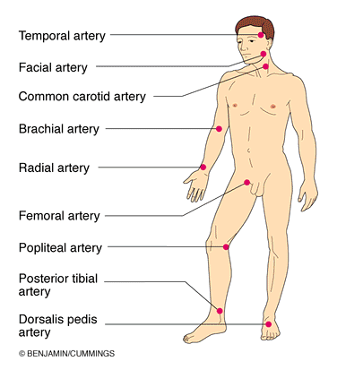

- Taking Blood Pressure
  - Auscultatory method: Brachial artery using stethoscope, makes sounds of Korotkoff
  - Cuff cuts off blood pressure in arm, first noise is systolic blood pressure and second is diastolic
- Factors Affecting Blood Pressure
  - Cardiac output, peripheral resistance and blood volume
  - Blood pressure = Cardiac output x Peripheral resistance
- Vasomotor Tone and Centre
  - Blood vessel diameter can only be controlled by the sympathetic NS
    - Tone: There is almost constant input to the arterioles
  - Centre in medulla respond to input from
    - Baroreceptors (Pressure receptors), chemoreceptors (Levels of CO2, O2 and pH) and higher brain centers (Being angry)
- Hormones and Short Term Regulation of Blood Pressure
  - Adrenal medulla (NE/E, fight or flight)
    - Vasoconstriction, increased cardiac output
  - Angiotensin II
    - Vasoconstriction, increased systemic BP, release of ADH
  - Atrial natriuretic peptide (ANP)
    - Decreased blood volume and pressure
    - Vasodilation
  - Antidiuretic hormone (ADH)
    - Kidney’s conserve water
    - Vasoconstriction

- Kidneys
  - Direct Action
    - Increased blood pressure and volume = Increased rate of filtrate formation, not enough time to reclaim water, increased volume of urine
  - Indirect Action
    - MAP decreases, kidneys release renin, creates angiotensin II, increased blood pressure

- Active hyperemia
  - Muscles are working hard during physical activity, increased muscle activity
  - An excess of blood going to the tissue to provide it with nutrients
- Reactive hyperemia
  - Reducing blood flow to the feet while sitting cross legged because blood vessels are being compressed
  - An excess of blood going to the tissue to regain blood flow

- Capillary Exchange Mechanisms
  - Vesicle transport
    - Large, lipid insoluble molecules
  - Diffusion
    - Dissolved solutes and gasses (O2, CO2, glucose)
- Blood Through Capillaries
  - Arterial end
    - Net filtration, 10 mmHg into the interstitial fluid
    - Hydrostatic pressure of capillary: Pushes fluid out of capillary
    - Osmotic pressure in capillary: Pulls fluid in to capillary
  - Venous end
    - Net reabsorption, 8 mmHg into the capillary
    - Hydrostatic pressure of capillary: Pushes less fluid out of capillary
    - Osmotic pressure of capillary: Pulls same fluid into capillary
  - Some fluid is always left behind, need a mechanism to bring it back into the bloodstream (Lymphatic system)

- Arteries to Know the Names of …
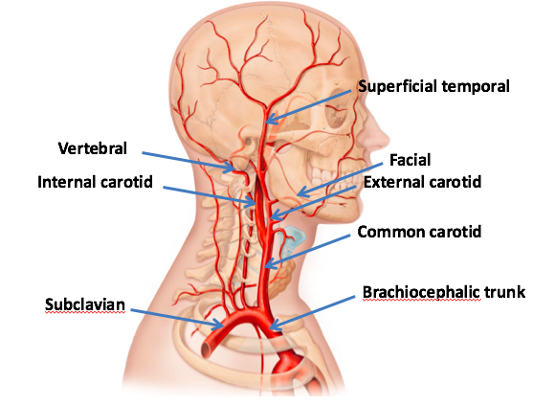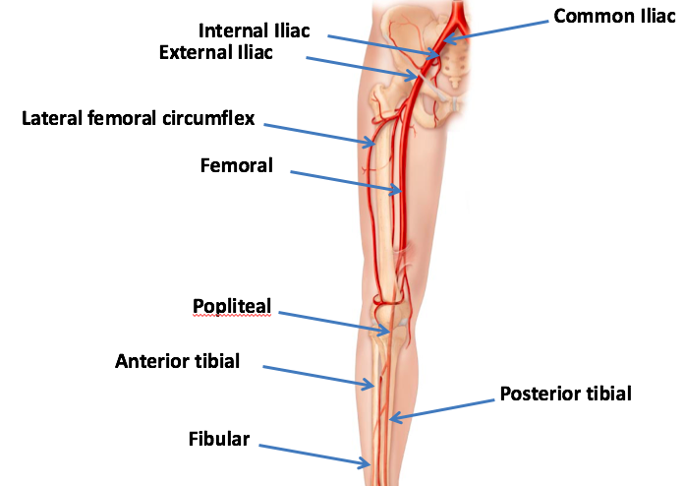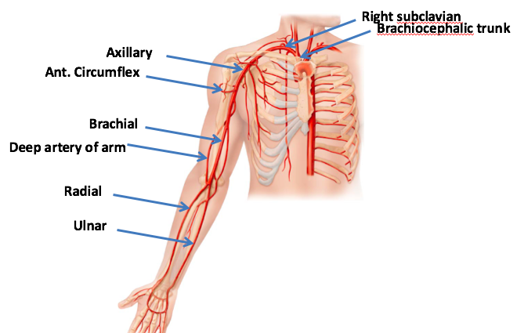
- Veins to Know the Names of…
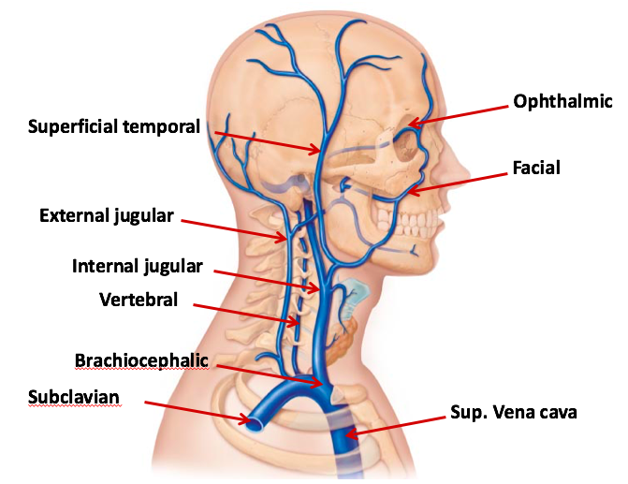
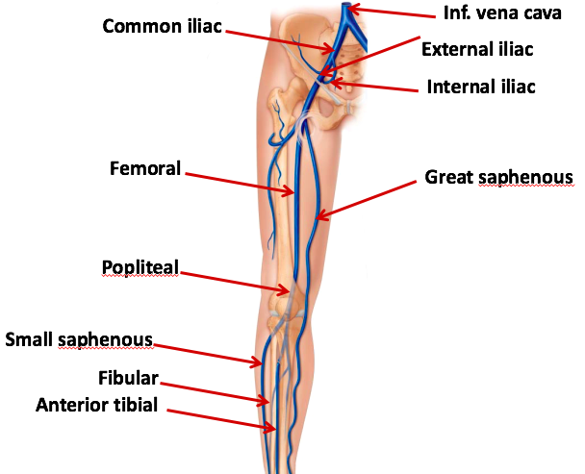
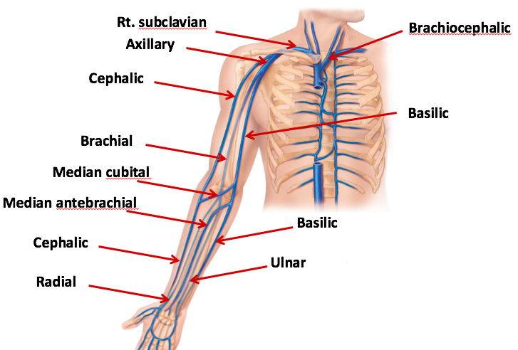
LYMPHATIC SYSTEM

- Route
  - Starts in the capillaries, ends at the end of the venous system
  - Final destination (Besides heart) is either the right lymphatic duct or the thoracic duct (Thoracic duct has a heavier work load)
  - Intersection between internal jugular and subclavian vein is the entry point into the heart
- Parts
  - Lymphatic vessels
    - 3L of leaked fluid returned to circulatory system
    - Microscopic lymph capillaries (Lacteals) are near the capillaries that are extremely permeable and closed at one end
    - When pressure builds up, the gaps in the lacteals are pulled open
  - Lymphatic tissues
  - Lymph nodes
    - Filter lymph with macrophages and active immune system
    - Inguinal, axillary, cervical regions

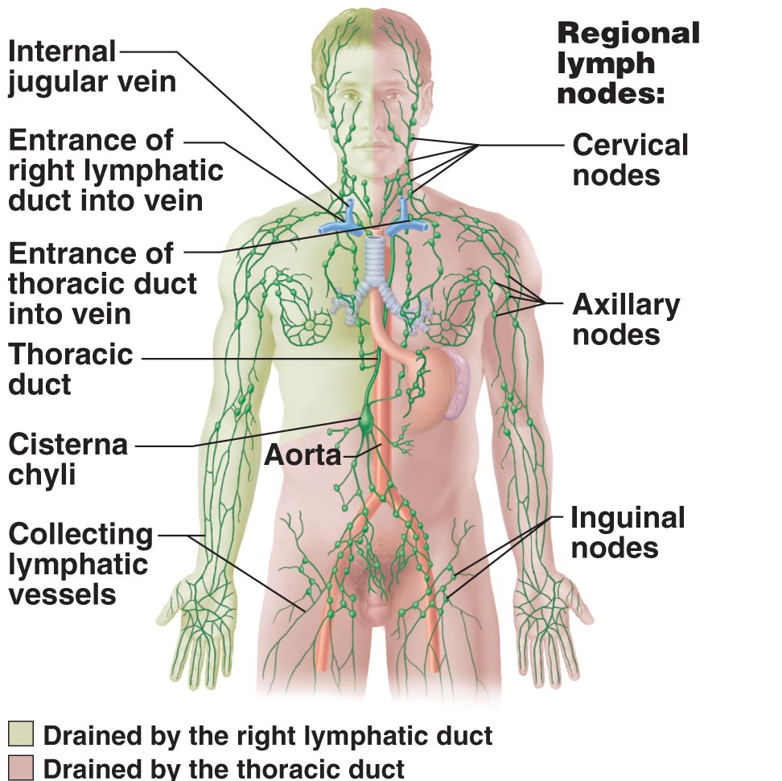

- Lymphoid Cells
  - Lymphocytes
    - Type of white blood cell
    - T-cells: Made in thymus gland, soldiers that will attack another cell
    - B-cells: Made in bone marrow, produce antibodies against pathogens
  - Macrophages
    - T-cells, travel to the thymus to be tested before release, phagocytize foreign substances
- Lymphoid Tissue
  - Reticular connective tissue
  - Has a fine mesh of fibers with attachment points for white blood cells to attach and evaluate the lymphatic fluid as it passes by
- Lymph Nodes
  - Encapsulated collections of diffuse lymphoid tissue
  - Sites of surveillance of lymphatic fluid
  - Trabeculae divide it into sections, the cortex (Outer portion) has germinal centers where the lymphoid cells are made
  - Fewer efferent than afferent vessels so the fluid slows down and has time to be examined before it leaves
- Lymph Organs
  - Spleen
    - Areas of white pulp: Houses cells and is associated with the immune system
    - Areas of red pulp: Associated with cleaning up the old RBCs, maintaining RBC population
    - Capsule is very thin, very vulnerable to bleeding uncontrollably
  - Thymus
    - Maturation of population of T-cells, where they are tested before they are released
  - Tonsils
    - Stop microorganisms before the enter the lungs or digestive system
    - Palatine tonsils: Back of oral cavity
    - Lingual tonsil: Base of the tongue
    - Pharyngeal tonsil: Nasal cavity
    - Tubal tonsils: Between ears and throat
  - Others (MALT: Mucosa Associated Lymphoid Tissue)
    - Peyer’s patches: Clusters of lymphatic tissue in the wall of the ileum
    - Appendix: Cluster of lymphatic tissue where the small and large intestine meet

- Right Lymphatic Duct
  - Lymph from right upper arm, head and thorax
  - Smaller load
- Thoracic Duct
  - Lymph from lower limbs, intestinal trunk, left thorax and upper limb/head
  - Larger load

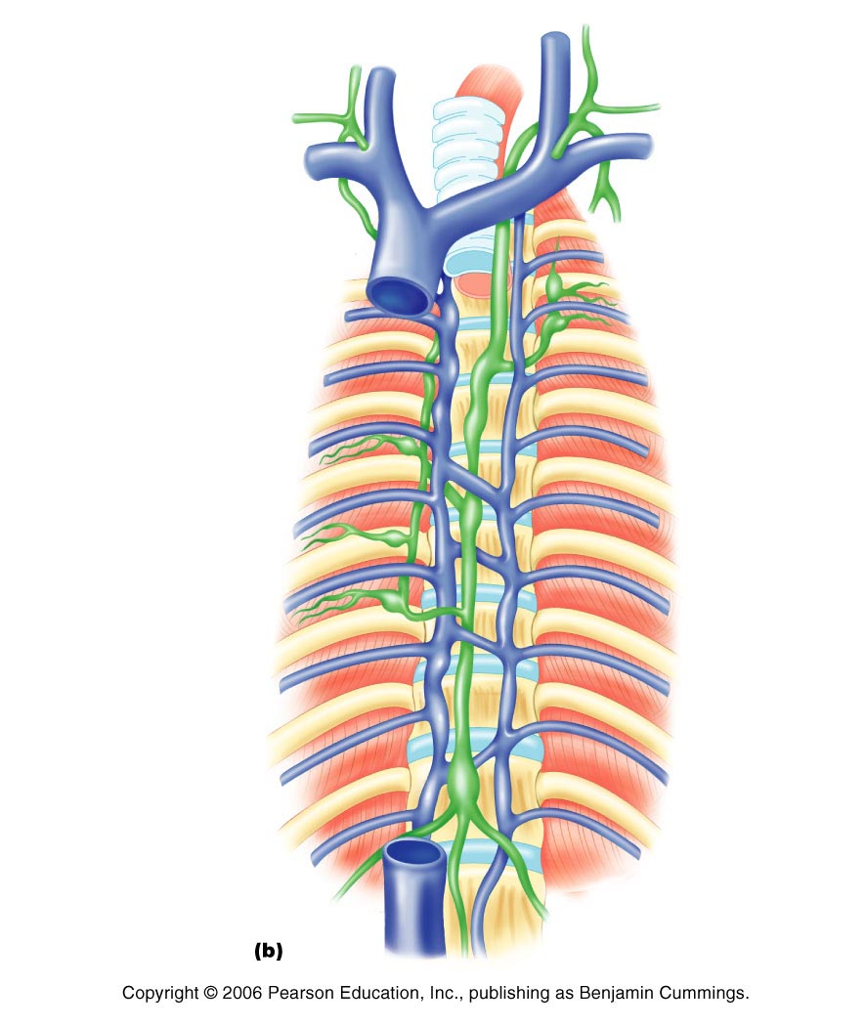
Jugular trunk >

Subclavian trunk >

Bronchomediastinal trunk >

Lumbar trunk (Left) >
Intestinal trunk (Middle) >

RESPIRATORY SYSTEM - ANATOMY

- Processes in Breathing
  - Pulmonary ventilation
    - Movement of air in and out of lungs
  - External respiration
    - Exchange of gases between blood and air of alveoli
  - Transport of respiratory gases
    - Role of blood in transport of gases between lungs and tissues of body
  - Internal respiration
    - At the level of the tissues, exchange of gases between blood in systemic capillaries and tissue cells
- Zones
  - Respiratory zone
    - Site of gas exchange
    - Composed of respiratory bronchioles, alveolar ducts and alveoli
  - Conducting zone
    - Passageways, cleanse, humidify and warm incoming air
    - Nose, nasal cavity, pharynx, larynx, trachea, bronchi, bronchioles and terminal bronchioles

- Nose
  - Functions
    - Airway for respiration
    - Moistens, warms, filters and cleans incoming air
    - Resonating chamber for speech
    - Olfactory / smell receptors
  - Structure
    - Made of cartilage and dense fibrous connective tissue

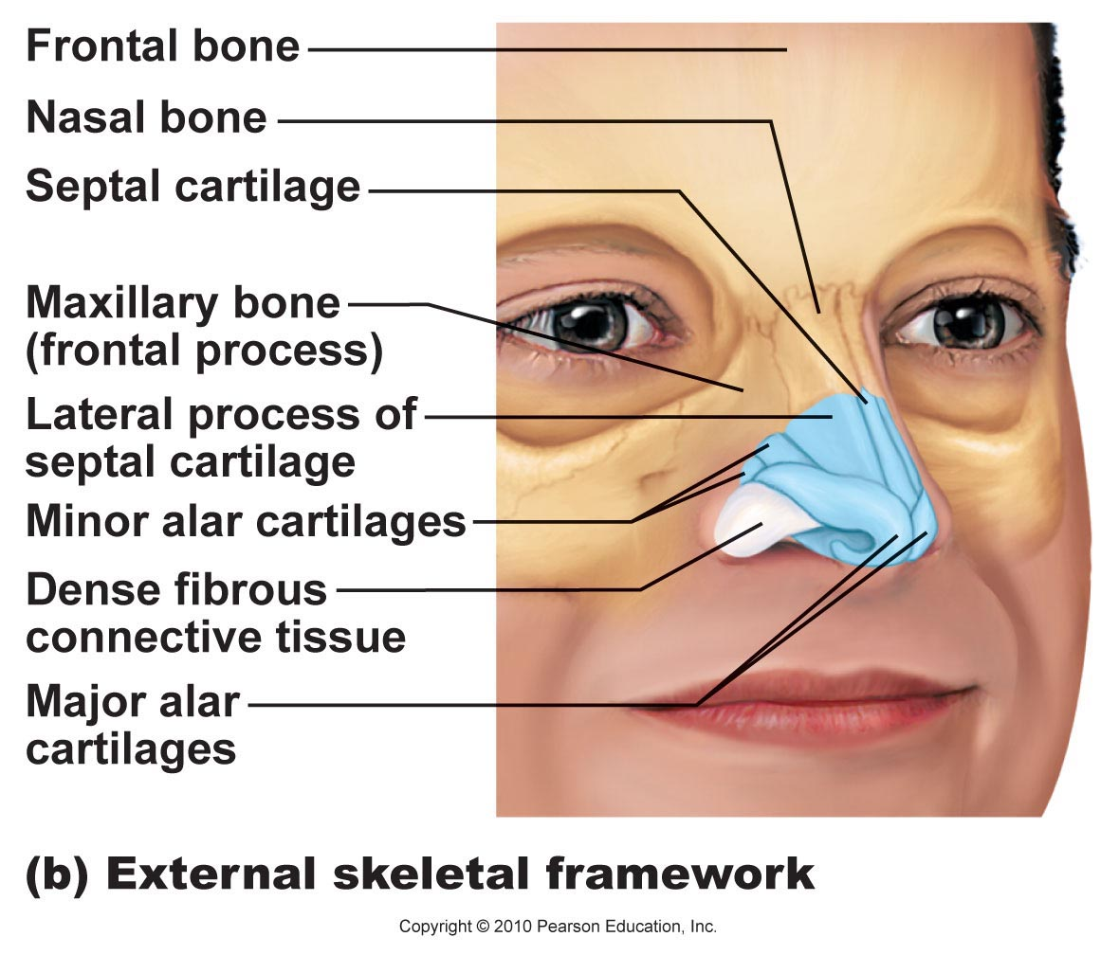
  - Passage way
    - Air enters nasal cavity via external nares (Nostrils) which is divided by the nasal septum down the middle
    - Travels via the internal nares to the nasopharynx
    - Roof of nasal cavity is made by sphenoid (Large sinus) and ethmoid bones (Slits), floor of nasal cavity formed by the palate
    - Passes vibrissae, hairs in the nasal cavity that trap debris
  - Mucosa types
    - Olfactory mucosa: Contains receptors for sense of smell
    - Respiratory mucosa: Pseudostratified ciliated columnar epithelium has goblet cells that secret mucus and move contaminants out of the body

- Paranasal Sinuses
  - Lighten the skull, produce mucus and moisten air
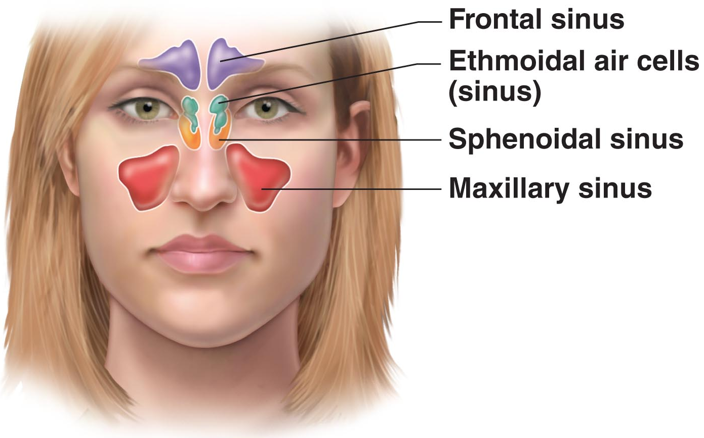

- Pharynx
  - Function
    - Common pathway for food and air
  - Nasopharynx
    - Below sphenoid bone, air passageway
    - Pseudostratified ciliated columnar epithelium
  - Oropharynx
    - Soft palate to the epiglottis, passageway for air and food
    - Stratified squamous epithelium
  - Laryngopharynx
    - Epiglottis to larynx then they diverge, passageway for air and food
    - Stratified squamous epithelium

- Larynx
  - Attached to the hyoid bone, merges into the trachea
  - Important in voice production
    - Length of vocal cords and size of glottis are altered by the laryngeal muscles that move the arytenoid cartilage
    - Valsalva’s maneuver: Closing glottis to force poo out
    - Heimlich maneuver: Use air in lungs to shoot food out from trachea
  - Transition from breathing to eating
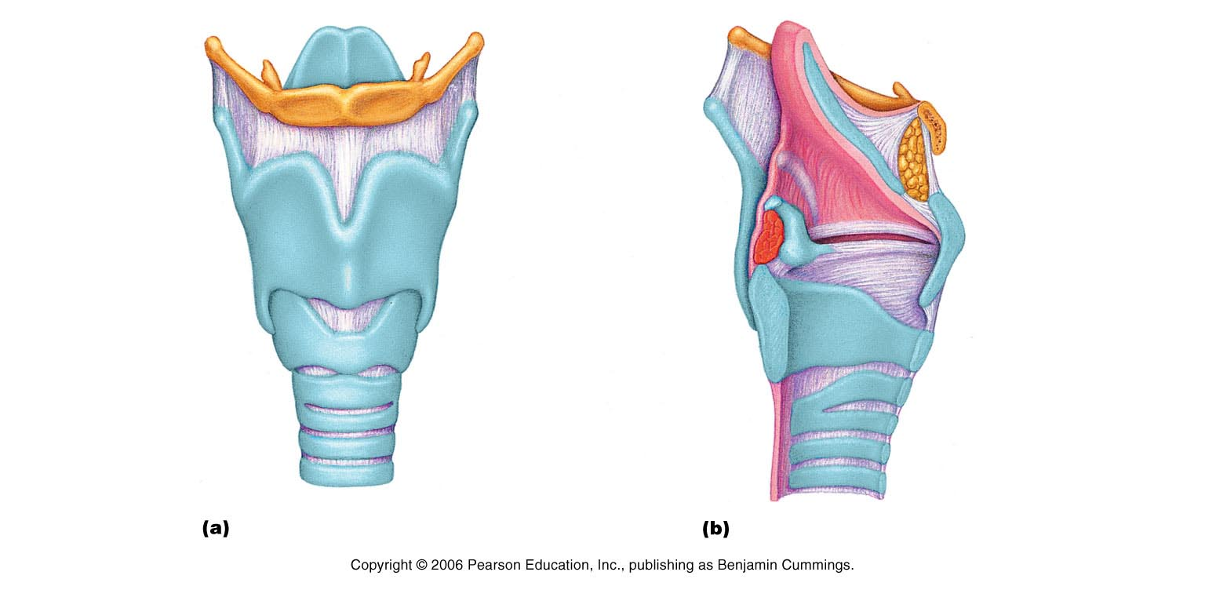

Epiglottis (Flap, \) >>

Thyroid (Shield) >
Arytenoid (L shape) >>
Cricoid (Below shield) >
False vocal cords (Purple) >>
True vocal cords (Purple bottom) >>

- Trachea
  - Pseudostratified ciliated columnar epithelium, cilia move mucus up
  - Cartilagenous rings keep airway open during pressure changes while breathing

- Bronchial Tree
  - Right primary bronchus is wider and shorter
  - As we move downwards…
    - Cartilage turns from rings, plates, none
    - Epithelium turns from pseudostratified columnar, columnar, cuboidal
    - Smooth muscle relative content increases

- Alveoli
  - Structure
    - Small air sacs with three types of cells…
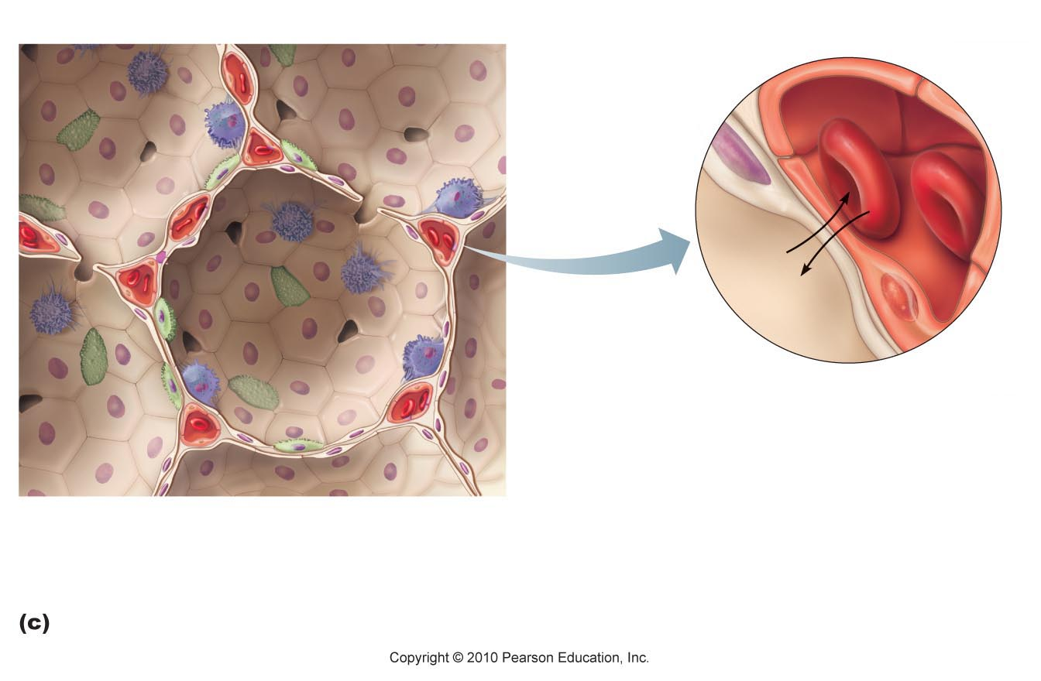
Beige cells (Type 1): Squamous epithelial cells, make up the bulk of the wall

Green cells (Type 2): Produces surfactant

Blue cells (Type 3): Macrophages / dust cells that are on the inner surface to keep the alveoli clean

  - Respiratory membrane: Alveolar wall + capillary wall + basal laminae
  - Alveolar pores: Allows equalization of air pressure throughout lung, alternate air routes if bronchi collapse
  - Surfactant: Molecule that helps to keep the air sacs open when you breath out

- Lung Gross Anatomy
  - Each lung is suspended in its own pleural cavity
    - Pleural membrane: Ensures lungs follow movement of the ribs
    - Pleural fluid: Serous secretion that fills pleural cavity, surface tension
  - Apex facing upwards and hilus (Where blood enters and leaves)
  - Fissures divide each lung into 10 segments
  - Lobule: Smallest subdivision seen with the naked eye (Hexagon shaped)

- Blood Supply
  - Pulmonary arteries bring blood to be oxygenated
  - Pulmonary veins return oxygenated blood
  - Bronchial arteries provide systemic blood to the lungs (And bronchial veins)

RESPIRATORY SYSTEM - PHYSIOLOGY

- Pressures
  - Intrapulmonary pressure
    - Pressure within alveoli of the lungs
    - Rises and falls but equalized with atmospheric pressure (760 mmHg)
  - Intrapleural pressure
    - Pressure within the pleural cavity
    - 4 mmHg less than the pressure in the alveoli
  - Transpleural pressure
    - Intrapulmonary pressure - Intrapleural pressure
  - Factors that influence pressure
    - Natural tendency of lungs to recoil
    - Surface tension of alveolar fluid
    - Surface tension of pleural fluid and elasticity of chest wall
- Quiet Inspiration
  - Diaphragm contracts to increase height of thoracic cavity, external intercostals contract to lift rib cage up and out
  - Air rushes in because intrapulmonary pressure dropped
- Quiet Expiration
  - Passive process, elastic recoiling and no muscle contractions
  - Intrapulmonary pressure increases again, air flows back out of the lungs
- Forced Inspiration
  - Accessory muscles (Neck and chest) help to raise the ribs, straighten spine
- Force Expiration
  - Abdominal muscles contract and depress the rib cage

- Resistance
  - Normally not a problem
  - Parasympathetic: Constricts bronchioles (Asthma or inhaled irritants)
  - Sympathetic: Dilates bronchioles
- Alveolar Surface Tension
  - Molecules of liquid are strongly attracted to each other rather than a gas
    - If it was only water in the alveoli, they would collapse
    - Surfactant (Type 2 cells): Interferes with cohesiveness of water molecules
- Lung Compliance
  - How easily your lungs respond to what you’re doing with the diaphragm and ribs
  - C = (Delta V) / (Delta P)
    - Change in volume is the change in volume over the change in pressure

- Respiratory Volumes
  - Tidal volume: Quiet breathing (500 mL)
  - Inspiratory reserve volume: Forcibly inspired after tidal volume
  - Expiratory reserve volume: Forcibly expired after tidal volume
  - Residual volume: Volume that remains in lungs to prevent collapse (1200 mL)
- Respiratory Capacities
  - Inspiratory capacity: Air that can be inspired after tidal expiration
  - Functional residual capacity: Air still in lungs after tidal expiration
  - Vital capacity: Total amount of exchangeable air
  - Total lung capacity: Sum of all volumes

- Dead Space
  - Air that doesn’t participate in gas exchange
    - 500 mL tidal volume = 150 mL dead space + 350 mL alveolar ventilation
  - AVR measures effective ventilation
    - AVR _{(mL/min)} = frequency _{(breaths/min)} x (tidal volume - dead space) _{(mL/breath)}
    - AVR is usually around 4200 mL/min

- Non-Respiratory Air Movements
  - Hiccups: Spasms of the diaphragm, hits glottis and closes it
  - Yawn: Deep inspiration that ventilates all alveoli
  - Cough: Dislodge foreign particles or mucus from the lower respiratory tract
  - Sneeze: Clear upper respiratory passageways

- Dalton’s Law
  - Total pressure exerted by a mixture of gases = sum of pressures exerted by each gas in the mixture
  - Directly proportional to its percent in the mixture

- External Respiration
  - Rate of exchange depends on…
    - Partial pressure gradients and gas solubilites
      - Steep gradient for O2 pick up
      - Much less steep gradient for CO2
      - Same amount is exchanged because CO2 is much more soluble
    - Structural characteristics of respiratory membrane
      - Increasing thickness decreases the rate of gas exchange
      - Decreased surface area decreases the rate of gas exchange
    - Ventilation / perfusion coupling
      - Coupling between amount of gas reaching alveoli and blood flow in pulmonary capillaries
      - Arteriole diameter is based on pressure of O2, if pressure is low the arterioles constrict so blood is redirected to more O2
      - Bronchiole diameter is based on pressure of CO2, if pressure is high the bronchioles will dilate so CO2 can be eliminated rapidly
- Internal Respiration
  - In tissues pressure of O2 is less than 40 mmHg (104 arterial) and pressure of CO2 is greater than 45 mmHg (40 arterial)
- Oxygen Transport
  - Bound to hemoglobin within red blood cells
    - Hemoglobin is made of 4 polypeptide chains each with an iron heme group that binds O2
    - Affinity of Hb for O2 depends on its level of saturation
      - Fully saturated has all 4 hemes with O2, partially does not
    - Oxyhemoglobin = HbO2 (HHb + O2 > HbO2 + H)
  - Dissolved in plasma (Less than 1.5%)

- Oxygen-Hemoglobin Dissociation Curve
  - Steep slope then plateaus at 70-100 mmHg
  - Hb in blood leaving lungs is 98% saturated
  - At tissues pressure of O2 is less than 40 mmHg (75% saturated)
  - Hb almost completely saturated when pressure of O2 is 70 mmHg
  - Venous reserve: Only 25% O2 is unloaded during the first pass through
  - At high PO2 large changes in PO2 cause only small changes in Hb saturation, while at low PO2 larger changes in PO2 cause large changes in Hb saturation

- Effects on Hb Saturation
  - Influence Hb saturation by altering the 3D structure (Changing affinity)
    - Increase in temperature, PCO2, H+ or BPG… decreases affinity of Hb for O2, increases O2 unloading from blood
    - Decrease in temperature, PCO2, H+ or BPG… increases affinity of Hb for O2, decreases O2 unloading from blood
  - BPG (Bisphosphoglycerate) are produced by RBCs when the metabolize glucose
  - Makes sense because
    - CO2 highest at level of tissue
    - CO2 release increases H+ content of blood
      - CO₂ + H₂O <-> H₂CO₃ <-> HCO₃⁻ + H⁺
    - Heat is a by-product of metabolic activity

- CO2 Transport
  - Dissolved in the plasma
    - Not very important, 7-10%
  - Bound to Hb: CO2 binds to amino acids of Hb not the heme part so there is no competition for binding sites
    - Pressure of CO2: Low in lungs so it dissociates, high in tissues so it binds
    - Hb saturation: HHb binds more CO2 than HbO2
  - Bicarbonate ion in the plasma
    - Incorporated into the bicarbonate structure, 70%

- Blood pH and CO2
  - Slow and shallow breathing
    - CO2 accumulates in blood, carbonic acid accumulates and blood pH drops
  - Rapid, deep breathing
    - CO2 is flushed out of the blood, carbonic acid levels drop and blood pH rises

- Respiratory Controls
  - Ventral respiration group (VRG)
    - In the medullar oblongata
    - Tell you to breath in, turns off for a moment while you breath out
    - Eupnea: Normal rate of breathing (12-15 breaths per minute)
  - Dorsal respiration group (DRG)
    - Function not known
- Influences on Respiratory Rate
  - CO2 (pH)
    - Very closely monitored by medullary chemoreceptors
    - Low pH causes increased rate and depth of breathing
    - Hypercapnia: Increase PCO2
    - Hyperventilation: Increased rate and depth of breathing
  - O2
    - Not as closely monitored by oxygen sensors in aortic arch
    - Hypoxic drive: Oxygen is the driving force in respiration

- Factors on Respiration
  - Hering-Breuer reflex
    - Inflation reflex for protection
    - Stops person from breathing in so much to damage their lungs, causes expiration after a very large inspiration
  - Hypothalamic controls
    - When we are shocked we will gasp, or when we are scared we will hold our breath
  - Cortical controls
    - Contest to see how long we can hold our breath

