Electromagnetic Controls Review
Week 1 Lab Essentials
- What is a relay
  - In simple terms, a relay is a switch but it is controlled by electromagnets
  - Normal refers to switches state when it is de-energised
    - Normally closed
    - Normally open
  - The power circuit is where “big things happen” high current and voltage
  - The control circuit is more intricate low current and low voltage
- Drawings
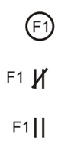


  - Wires are connected by using dots on intersections otherwise they are understood to not have a connection
  - “M” is used for general circuits applied anywhere
  - “F’ typically means the coil controls a fan
  - “CR” usually refers to a control relay
  - “P” typically controls a pump
  - Contacts are to be labeled according to the control coil
  - Power for the control circuit is typically taken from the power circuit
    - Can be on two lines for higher voltage
    - Can be on a line and neutral for lower voltage applications
    - Control transformers are common to reduce voltage
      - Typically, 24 or 120 volts
    - Some cases require the control circuit to be grounded
    - Drawings are high voltage at the top and low voltages at the bottom
- Relays as amplifiers
  - Relays are part of a low power control system which controls large motors and heavy load which in essence makes them similar to an amplifier
- Control devices
  - Normally open
  - Normally closed
  - Combination push buttons
  - Pressure switches
  - Selector switch
- Release and protection circuits
  - A protection circuit means it protects people after loose of power
    - The system must be restarted
    - Typical among large machines and cutting equipment
  - A release circuit means the load continues operation after loose of power
    - The system does not have to be restarted after power is lost
    - Typical for pumps or fans

Week 2 Protecting and controlling motors
- Protecting motor circuits
  - The motor circuit is protected by over loads and heaters
    - The overload and heaters work together to open the coil
  - Melting alloy thermal unit operation
    - Control wire and motor wire run through the heater
      - When excess heat is produced it melts the solder to open the connection
- Stopping and starting
  - A simple start stop station is done with the stop in series with the start button
    - A contact in parallel with the start button the hold the connection
  - If multiple stops are needed they are put in series
  - If multiple starts are needed they are put in parallel
- Jogging (refers to starting the motor for a short period of time)
  - Can be done by using a start button without a contact
  - Or by using a run/jog selector in parallel with the start but in series with the contact
  - A jog button can also be a combination push button that bypasses start and the contact
    - This can be an issue because the jog button can lock into place
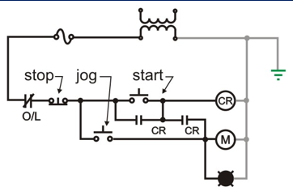
  - This is the best way to have a jog station because it cannot lock in place

- Hand-off auto
  - Hand off auto are usually done using a float or some condition in the auto setting
    - hand simply turns it on
    - off is off
    - auto uses the condition to operate
  - This is a typical application in pumps
- Motor starters
  - Motor starters are used to start and stop the motor and provide overload protection
  - Single Pole manual switch
    - sized with the motor heater and motor FLA, limited to manual control. Single pole is suitable for 120 volts
  - Double pole manual starter, limited to manual control
    - Single phase 240 or 208 volts operation
  - Three pole manual starter
    - Three overloads are needed, also limited to manual control
  - Combination motor starter
    - When overcurrent protection and disconnecting means is in the same enclosure
    - Features include: fused disconnect, motor starter with thermal overloads, through cover reset, controls on cover
- Relay example
  - Controlling loads that are far away with relays are much more cost effective
Week 3 Applications
- Circuit design
  - Design is an iterative process
  - The more complex the design, the more possible variants
  - Run through designs to ensure they accomplish what is needed
- Trouble shooting strategies
  - Don’t panic, be systematic, be aware if assumptions made, document what you have changed
  - Use a meter and test parts of the circuit as needed
- Trouble shooting tips
  - Test everything and ensure they are doing what they are supposed to
  - Go through parts of the circuit piece by piece
- Working from diagrams
  - Piece by piece just like testing and trouble shooting
  - Do the easy things first, grounding and bonding and mark off what you have done
  - One wire at a time
- What happens if
  - Run through the circuit and test it to ensure is operates as required
  - There can be more than one sequence for a set of controls
  - Damaged equipment may operate in a way not obvious from the schematic
Week 4 Digital logic
- Relay logic
  - And means both must be operated
  - Or mean one or the other must be operated
    - If both are push this is fine too
  - Not means this doesn’t have to push to operate (normally closed)
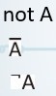
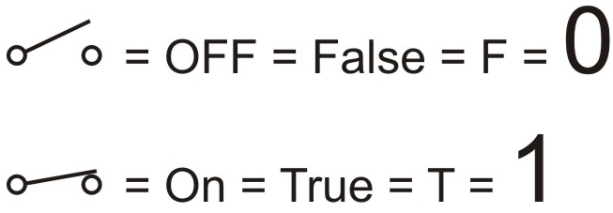
- Representing logic
  - Truth tables
  - Not notation

- Examples Karnaugh maps
  - Explained
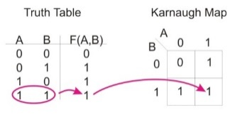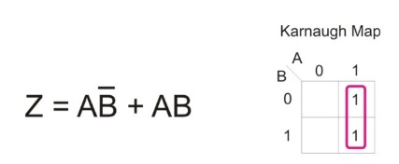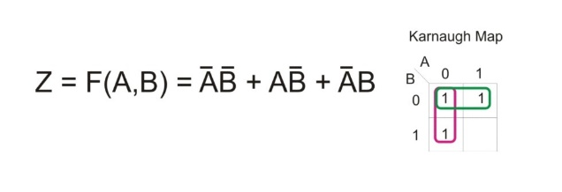
  - Application
    - Could be used in parking lots as an entrance control system
Week 5 Reversing motors
- Reversing a three-phase motor
  - Can be done using a six-point drum switch
- Power circuit
  - The power circuit could use a reversing starter
- Interlocks
  - Interlocks must be used to avoid shorts
    - Mechanical interlock is represented by dotted lines
    - Electrical interlock will be marked
      - Contacts
- Special push button configurations
  - From forward to reverse
    - Combination push buttons can be used N/C of one and N/O of the other
    - Reversing a motor while its running forward causes much higher spikes
      - More heat
      - Heat effects motor life
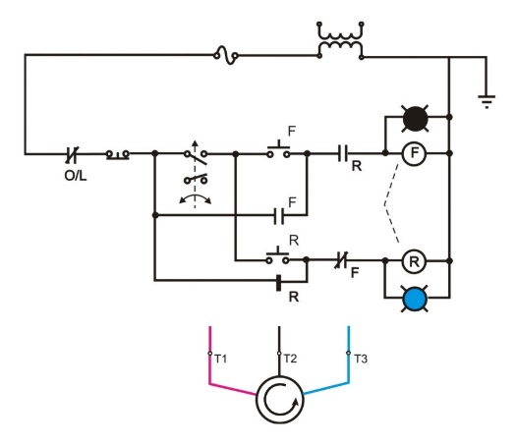
- Plugging: reversing the motor as a form of breaking
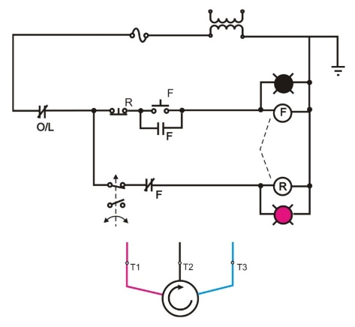
- Anti-plugging: prevents the motor from being reversed while it is turning
- Reversing single phase motors
  - Line and neutral must be switched

Week 6 Timers and transformers
- Pneumatic timers
  - Were a simple and cost-effective solution in it’s day
  - Issues are precision and matching several timers
    - Susceptible to problems caused by dust and moisture
    - Electronic timers are now more cost-effective
  - Timer examples
    - Timers are labelled TR, TR-TO means time to open, TR-TC mean time to close
- Control transformers
  - Controls go in the ungrounded conductor typically, installing the overload in the grounded conductor meet the CEC if the coil and overload are in the same enclosure.
Week 7 (MIDTERM)
Week 8 PICO
- What is PICO
  - A PLC (Programmable Logic Controller)
  - A powerful timer, counter, control relay; is low cost and low power
  - Inputs are listed as “I” terminals
    - Ours have 8, more inputs are available if required
  - Outputs are listed as “Q” terminals
    - Ours have 4, more outputs are available if required
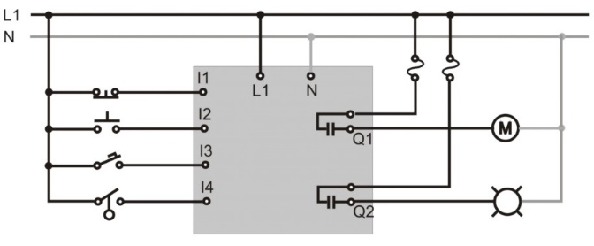
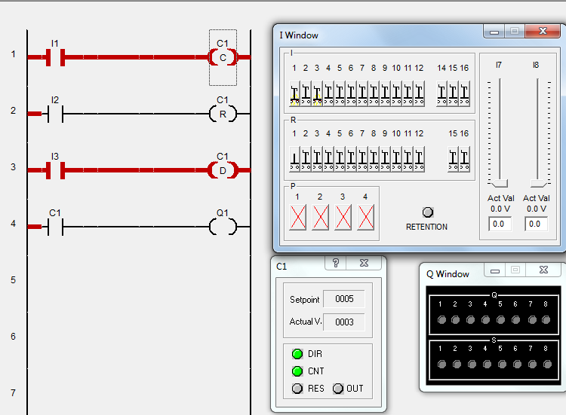
- Intro to PICO
  - This shit doesn’t matter
- Counters
  - If you understand this
    - You should be good
  - Exercise
    - There is a pp exercise

Week 9 PICO Applications
- Timers
  - Types of timers
    - TT and X is On-Delay
    - TT and is Off-Delay
    - TT and is Single Pause
    - TT and is Flasher
  - Exercises are on BB
- Outputs
  - Types of outputs
    - Standard output is Q (there is only power if the output is powered
    - Latching relay has distinct connections
      - SQ turn on (Set)
      - RQ turn off (Reset)
    - is a flip flop (it only requires a pulse to change; on/off)
  - Challenge
    - Available on BB
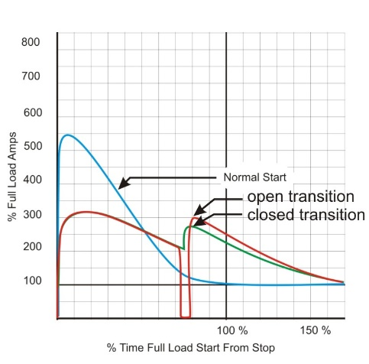
Week 10 Reduced Voltage Starting
- Overview
  - Reduced voltage starting is the process of ramping up the voltage bit by bit in order to manage stating current
- Reduced current starting
  - Part winding starting
    - Requires a special motor that has to complete windings with one rotor
    - May be found in refrigeration and fire pumps
    - Usually two equal windings
    - 1/3 to 2/3 split at times
    - 1 to 5 second delay
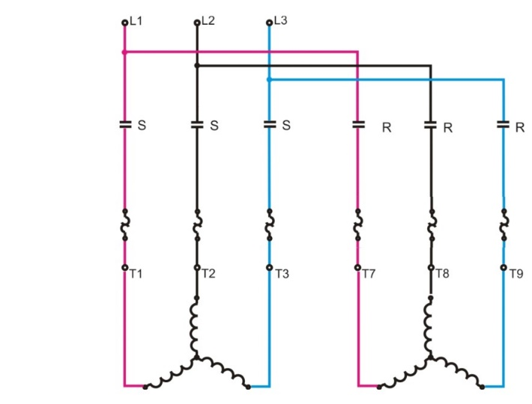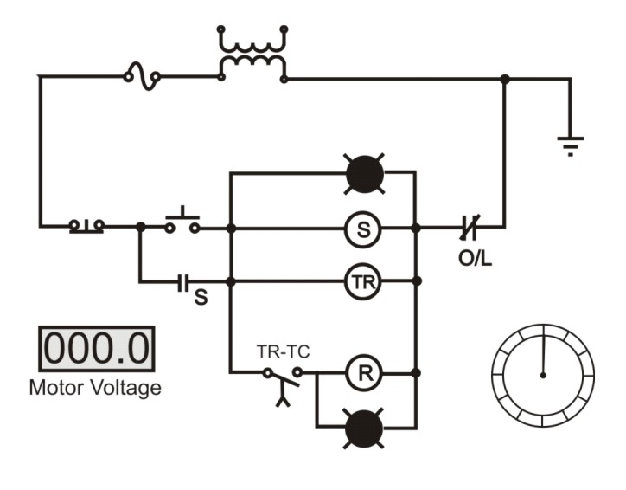
  - Wound rotor motors (WRIM)
    - Rotors are wound, connected to external circuits using slip rings and brushes
    - Connecting resistors in the rotor circuit reduces rotor and stator currents which allows for speed control
    - Resistance in the rotor circuit typically done in many steps to ensure smooth operation to control starting current and/or speed. They use transistor switching in place of contactors
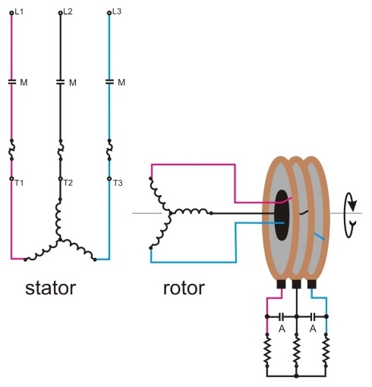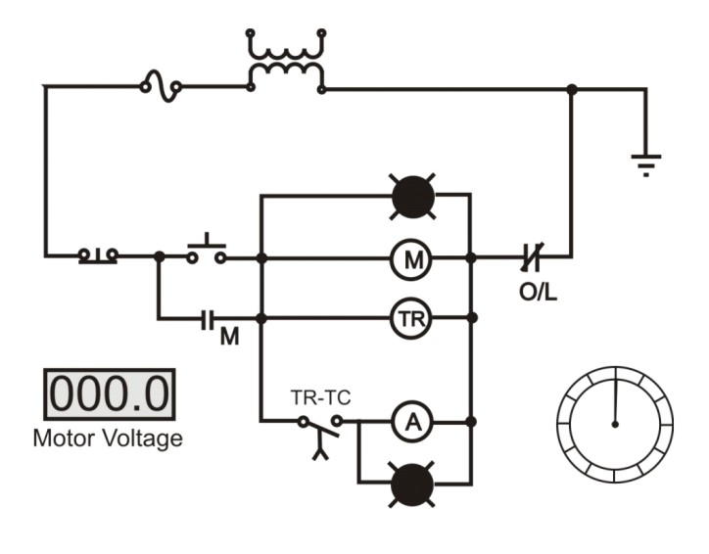

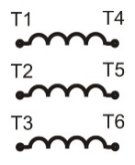
- Wye-delta starting
When both ends of a three-phase winding are brought out to the terminal box lead are labelled T1 – T6
The purpose of WYE-DELTA starting comes from the understanding that a WYE system takes 600 volts in by there are 347 nominal volts on each line where as a DELTA system has 600 volts on each line thus making the starting voltage 58% of the running voltage.
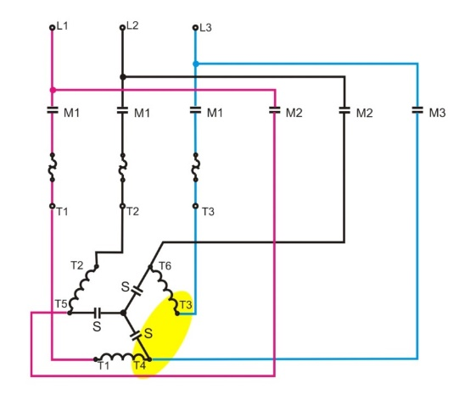
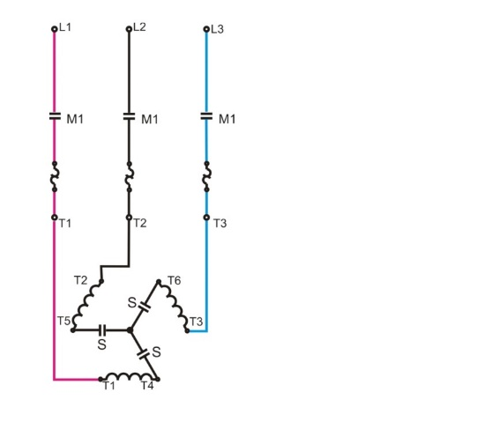
The control circuit:
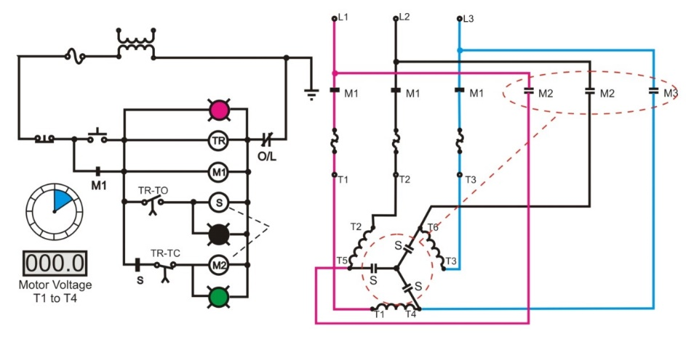
- Starter issues and comparison
These methods for the most part have been replaced by variable frequency drives. T=kE² 10 % drop in voltage gives 19% drop in starting torque
Heat is an issue with and reduced voltage or current staring method
Heat limits the number of starts per hour and the amount of time the motor can be run at lower voltage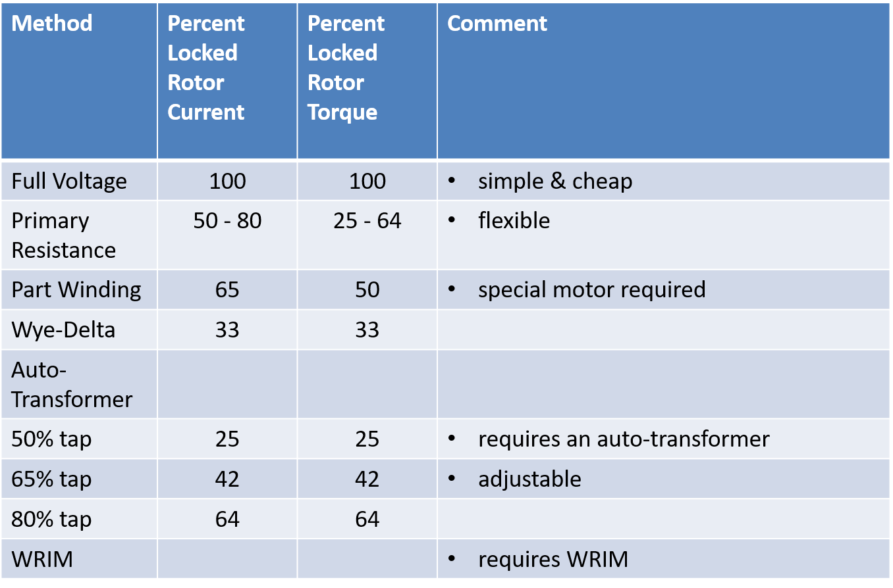

Week 11 Intro to variable frequency drives

What is a VFD
Provides variable speed control of an AC induction motor. By doing this we reduce energy usage and reduce mechanical stress
Only frequency give variable speed control with a squirrel cage induction motor
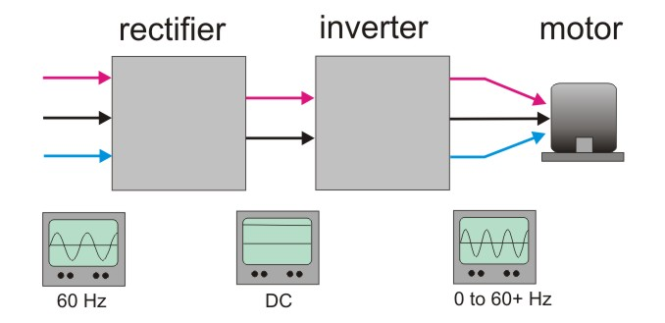
Three-phase is taken into a rectifier to output DC (filtered) then into an inverter (output is a variable frequency three phase voltage, not smooth), the motor can be a standard AC induction motor.
If there is no AC supply we have an issue but if a batter or uninterruptable power supply (UPS) is attached between the rectifier and inverter we in essence end up with a “brushless DC motor”.

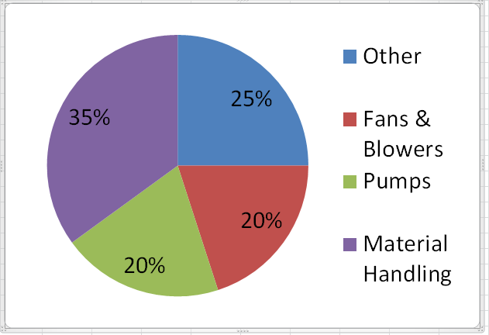
Why VFDs
We know torque is proportional to the square of speed and we know that power is proportional to the cube of speed
A fan uses 10 hp at 1750 rpm what is required to turn at 175 rpm?
T₁₇₅₀ = Hp x 5252 = 10 x 5252 = 30 lb-ft = kN²
1750 1750
T₁₇₅ = kN² = k (175/1750 N)²
= 1/100 kN²
= 0.3 lb-ft
Motors are often oversized; if you need an 8 hp motor you can’t use a 7.5 hp so you need a 10.
If you need a 7 hp motor you may use a 10 hp motor to be sure.
The result of a small drop in speed is huge when comparing it to the power consumed
10 hp motor at 1750 rpm, what happens at 1650 rpm?
- P ∝ N³ or P = kN³
- P₁₇₅₀ = kN³ (so N = 1750)
- P₁₆₅₀ = k(1650/1750 x N)³ = 0.84 kN³ = 0.84 P₁₇₅₀
Some applications must be a constant linear rate, could be winding or cutting operations
Starting and stopping may have to be controlled delicately for handling fragile products or positioning moving parts
Must maintain constant speed regardless of load, voltage variations and temperature
Synchronizing speeds would be necessary in a conveyer belt operation

Pulse width modulation
We are aiming for smooth sinusoidal power to the motor with variable frequency and voltage
This is a relatively easy concept review the slides for duty cycles
Opening and closing a switch rapidly makes for current that isn’t smooth but has a higher average then if it was switched on and off slowly. If the switch is left on slightly longer the average current will be higher.
Using a constant frequency but varying the on-time is called pulse width modulation.
We can get a sin wave by varying the frequency and the on-time
Again, reviewing the slides is probably best for this section as it is a relatively easy concept to grasp

Insulated gate bi-polar transistors (IGBT’s)
In order to make a PWM to work we need a very fast switch that can handle high current and voltage
Instant on and off would be ideal, taking a long time to turn on and off is no where near ideal but having a slight delay is much more reasonable and will do
This graphic demonstrates why it is important to have a fast switch, as the switch is open.
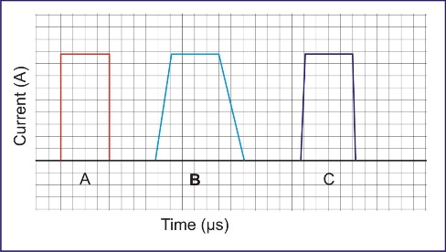
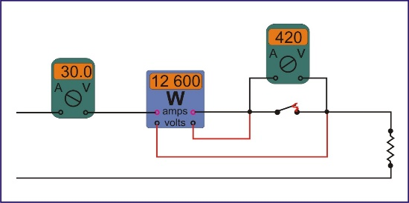
A lot of energy (heat) is dissipated by the switch when it is opening

Transistor: a semiconductor device with three connections, capable of amplification in addition to rectification. It is used to amplify or switch electronic signals and electrical power.
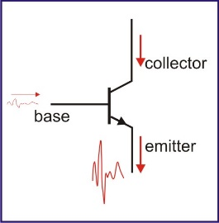
Bipolar Junction Transistor (BJT)
A small amount of current on the base, an amplified current out the emitter
Even brief periods of thermal stress can destroy a transistor, very reliable but not invincible (materials age and fail), rugged in terms of mechanical shock.
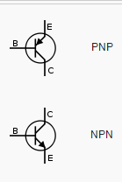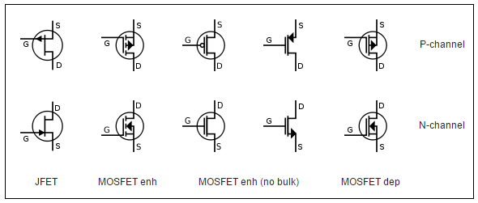
Field Effect Transistors
Controlled by an electric field not current. There are many variations such as MOSFET and CMOS but MOSFET is the most common.
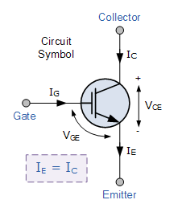
IGBT
Bipolar uses electrons and holes to carry charges, the gate is insulated from the collector and emitter. Collector current equals emitter current, the device is controlled by voltage
Characteristics
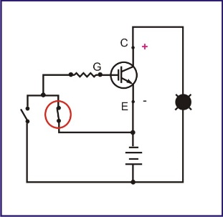
Like MISFET’s they have high input impedance, high switching speed up to 50 kHz range. Like bipolar transistors, the low saturation voltage of a bipolar transistor, once on the voltage drop across the transistor is small.
Turning an IGBT on and off
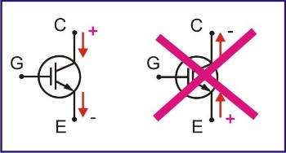
When positive is connected to the gate the IGBT turns on, when the positive is removed then the IGBT is off, usually the negative is connected to the gate to ensure a rapid turn off
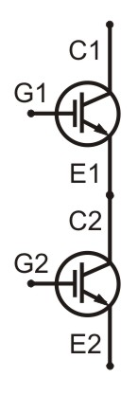
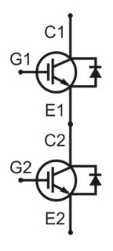
IGBT’s can only switch current flowing from the collector to the emitter
A half bridge package is a building block of many applications, commonly with free-wheeling diodes

Inverters
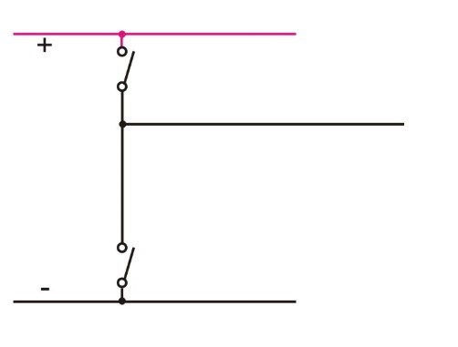
An inverter consists of; a positive bus, a negative bus, a connection to the load and two switches
The two switches are usually IGBTs though other devices are used at times.
Closing the upper switch connects the positive to the load, closing the lower connects the negative
But if you connect both then you end up with a short
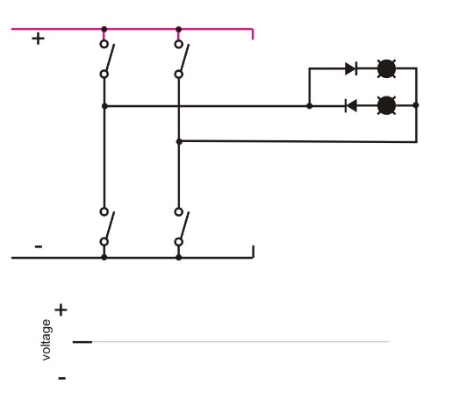
Creating AC Out
Two sets of switches, two lamps with diodes of opposite polarity, upper is positive and lower is negative, open both and connect top on the second set and bottom on the first set.

Three Phase is similar
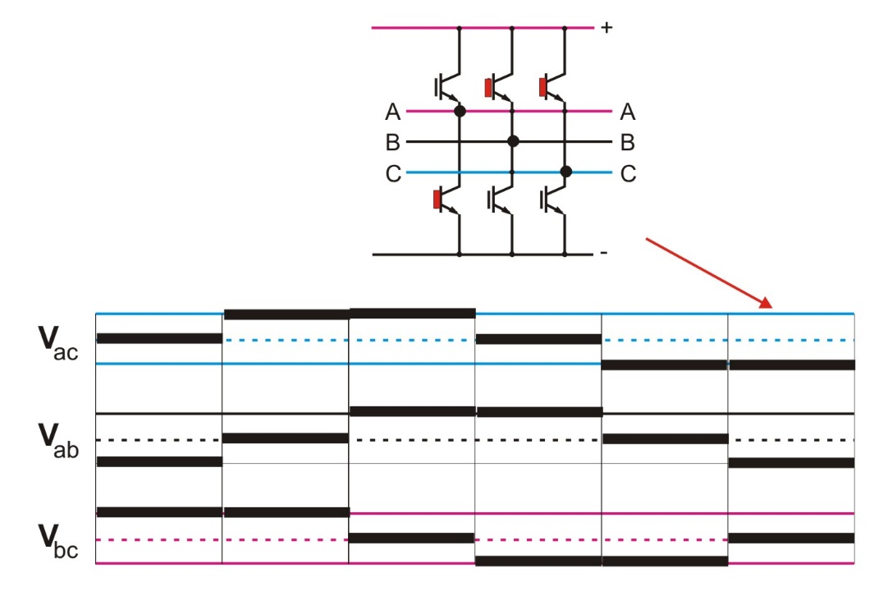

Week 12 VFD Applications and Issues

Drive Duty Motors
Only 10-15 years old, these became necessary as motors began to be driven by VFDs.
An inverter duty motor can withstand the higher voltage spikes produced by all VFDs (amplified at longer cable lengths) and run at very low speeds without overheating.
THESE MOTORS ARE EXPENSIVE AF! About 4 times what a “regular” motor costs
They are inverter-friendly; most manufacturers offer general-purpose, three phase premium efficiency motors that feature “inverter-friendly” insulation systems. These “inverter-ready” motors are suitable for use with variable torque loads over a wide speed range.
Inverter-Duty Motors (defined)
- Inverter-duty motors are wound with voltage spike-resistant insulation systems.
- Some use inverter-grade magnet wire to minimize the adverse effects of waveforms produced by VFDs.
- Other designs are wound with adjacent coils that are separated to minimize voltage potential.
- Improved insulation systems reduce degradation of motors that are subjected to transient voltage spikes.
- A greater thickness or buildup of premium varnish (through multiple dips and bakes) minimizes the potential for internal voids
- A motor with a lower heat rise design has increased resistance to voltage stresses.
- Manufacturing quality also affects the corona inception voltage (CIV), the point at which partial electrical discharges occur because of ionization of air around the conductor.
- CIV is a measure of the ability of a motor’s windings to withstand voltage stresses.
- Damaging reflected waves are generally not a problem when the distance between the motor and the drive is less than 15 feet.
- Voltage overshoots are more likely to occur with smaller motors and drives with faster rise times.
- The potential for damaging reflected waves is especially high when multiple motors are run from a single VFD.
- Inverter-duty motors are also designed for wider constant-torque speed ranges than can be provided with a general-purpose motor.
- While a premium efficiency, totally enclosed fan cooled 10-hp motor may be capable of a 10:1 constant-torque speed range, an inverter-duty motor is capable of providing full-rated torque at zero speed as well as operating well over its base speed.
Existing Motors – suggested actions
Obtain information from motor and drive manufacturers about inverter rise times and effects of cable length. Use this information to evaluate the capacity of existing motors tot withstand drive induced voltage stresses.

NEMA Standard (defined)
- NEMA MG 1-2011, Part 31, specifies that insulation systems for definite-purpose, low voltage (≤ 600 V) inverter-duty motors should be designed to withstand an upper limit of 3.1 times the motor’s rated line-to-line voltage.
- This is equivalent to an upper limit of 1,426 peak volts at the motor terminals for a motor rated at 460 V.
- Rise times must equal or exceed 0.1 microsecond.
- These motors can be used without additional filters or load reactors provided that voltage overshoots do not exceed the upper limit at the motor terminals
Overall
Use of inverter-duty motors for variable torque loads is overkill as inverter-ready general-purpose motors are well suited for VFD control with variable torque loads.
Consider inverter-duty motors for:
- Constant torque loads
- Motors on long cables
- As replacement for motors that have not lasted long

Cables
4 Key cable issues that effect VFDs
- Common mode current
- Cable charging and capacitive coupling
- Reflected wave voltage
- Installation safety and reliability
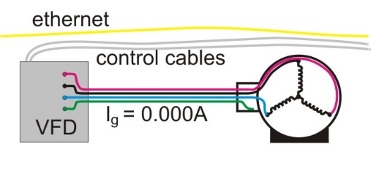
Common mode current is sometimes known as current noise is defined as any current that leaves the drive on the primary motor leads and returns through any ground path (including the cable grounds and shield). The role of VFD cable is to provide the most attractive path for these potentially harmful currents to return to the drive with minimal disturbance to the surrounding networks and instrumentation. A cable that provides the lowest impedance ground path will be most effective in reducing common mode currents.
No Common Mode
All current flows in the conductors to the motor. There is no current in the bonding conductor, no stray currents in control or ethernet cables
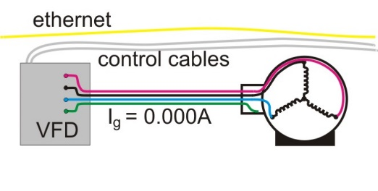
Current on Bonding Conductor
All current flows in the conductors to the motor. There is current in the bonding conductor. No stray currents I control or ethernet cables

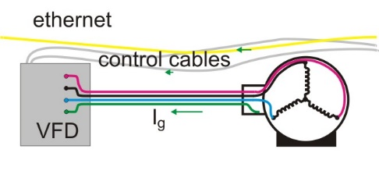
Common Mode Problems
Stray current in the ethernet and control cables. The ethernet and control cables are parallel paths to ground. Noise and failure.
Capacitive Coupling and Cable Charging
These are effects which consume some of the drive output currents in capacitive interaction with either the other motor leads, or other adjacent cable systems.
These phenomena can consume drive power and result in reduced motor torque, drive overload trips, and induced voltages on adjacent cable systems.
Reducing the Cable Losses
The keys to reducing the cable losses associated with capacitive coupling and cable charging are:
- Having the lowest practical cable capacitance
- Ensuring that the motor lead sets are effectively shielded from each other to prevent capacitive interaction.
Capacitive charging losses are proportional to the length or run, the number of conductors with which a given set of motor leads can capacitively interact.
A worst-case scenario is when multiple motor leads with high capacitance (THHN for example) are ganged together in conduit.
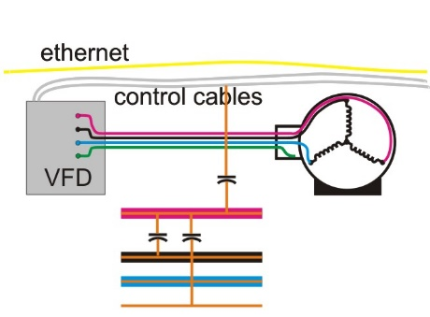
Cable capacitance; consists of two conductors separated by an insulator, two parallel conductors are a capacitor if one of them is insulated. Coupling issue increase with frequency.
Reflected wave voltage is a common problem with VFDs with longer motor leads. Using cables with the lowest capacitance will increase the critical distances (the distance where the cable is fully rung up to two the drive bus voltage), thus potentially reducing the stresses on motor windings and VFD cable.
- When the motor impedance is greater than the impedance of the conductor cable between the motor and the drive, the voltage waveform will reflect at the motor terminals.
- This creates a standing wave (see Figure 1). Longer motor cables favor higher amplitude standing waves.
- Voltage spikes have occurred with peak values as high as 2,150 volts (V) in a 480-V system operating at 10% overvoltage.
Voltage Spikes
These high spikes can lead to insulation breakdown, which results in phase to phase or turn to turn short circuits, and subsequently overcurrent drive sensor trips.

Safety and Reliability
- Installation safety and reliability is ensured when a properly designed cable system is selected.
- It is critical to select a system that can withstand the challenges associated with harsh environments, and electrical challenges, as well as one that will provide the highest degree of safety.
- Induced voltages and system failures as a result of unsuitable cable selection create both risk to personal safety, and operational reliability.

Issues
The nonsinusoidal variable frequency output of PWM drives has several effects, including
- Increased motor losses
- Inadequate ventilation at lower speeds
- Increased dielectric stresses on motor windings
- Magnetic noise
- Shaft currents
These effects can combine to damage a motor’s insulation and severely shorten its useful operating life.
Cooling
If the motor slows down the fan slows down and this allows heat to build up.
If this only happens for a limited time it isn’t something to worry about. If this is going to be continuous though buy a motor with a larger fan and higher temperature insulation (drive rated) and provide additional cooling
The motor runs cool at full speed. When it slows other things need to be added such as an extra fan, at low drive motor speeds the can still keeps the drive motor cool
Bearing Problems
The rotor is supported by bearings in the end bells of the motor, current at this point will flow through the bearings. Motors driven by VFD’s can have current that flows from the rotor to ground.
Bearings become rough due to small arcs. This leads to heat and ultimately motor failure. There are two solutions to this: you can use a brush on the motor shaft to drain off the current and/or you can use ceramic non-conducting bearings.
Insulation issues
The capacitance of the cable to the motor can affect the wave form at the load. The capacitance can cause voltage doubling. Cable selection can be a major issue in planning a VFD installation.
The result of insulation issues are voltage spikes which are small short durations of current flow through the insulation. This is called “partial discharge”.
There are lots of technologies used to deal with insulation issues. Manufacturing quality also affects the corona inception voltage (CIV), the point at which partial electrical discharges occur because of ionization of air around the conductor. CIV is a measure of the ability of a motor’s windings to withstand voltage stresses.
Risk of insulation issues include: aging to the motor, higher voltages, higher operation temperatures, length of feed to motor, feeder cable type.
Electromagnetic Interference (EMI)
The rapid changes in current and consequent changes in elector-magnetic fields can cause radio interference. Inadequate grounding is often associated with this problem.
Harmonics
Non-linear loads such as switch mode power supplies and VFD’s cause non-sinusoidal waveforms on their supplies. The non-sinusoidal waveforms appear as the sum of harmonics, that is integer multiples of 60Hz.
Harmonics cause
- Equipment to overheat at less than rated load
- Overcurrents to trip at less than rating or setting
- Neutral currents that are the sum of line currents
VFD’s that use pulse width modulation are less of an issue than older technologies.
All in all, careful design, using manufacturer’s expertise/experience and monitoring new installations are necessary

Volts per Hertz
A motor is effectively an inductor (wire wrapped around a core)
- ${Z_{motor}}_{}$= $X_{L}$ + R
- Most of the impedance is inductive reactance.
- $X_{L}=2πfL$
  - $2π$ is a constant
  - L is the inductance. It is fixed by the equipment.
  - $X_{L} is proportional to f$
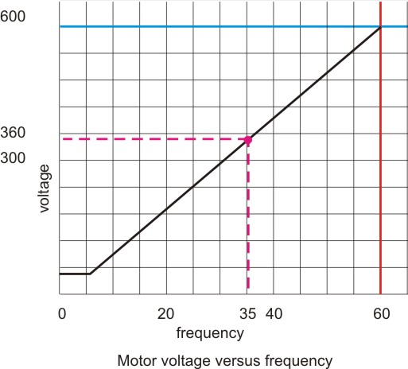
We need to reduce voltage when we reduce frequency
If the frequency is 35 Hz the voltage is reduced to about 350 volts
At very low Hz the voltage remains constant this is the “boost range”
The relationship between voltage and frequency leads to the term
“volts per hertz”.

Controls
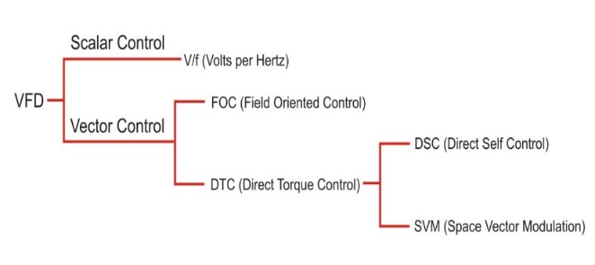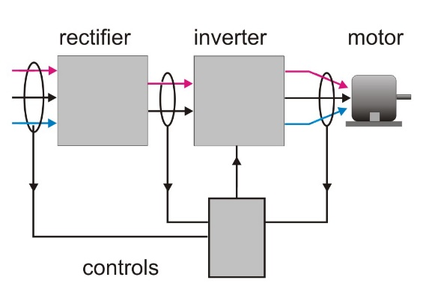
Monitor incoming AC voltage, DC bus voltage and motor current. Input frequency to inverter
Volts per hertz (V/F) is the simplest motor control method, the drive needs little motor data, does not require an encoder, tuning the VFD to the motor is not required (but recommended). This means; lower costs, less wiring, often used in machine tools and spindle applications, most variable torque fan and pump applications in the field used V/f control
V/f is the only control method that lets several motors run from a single VFD. In such cases, all motors start and stop at the same times, and follow the same speed reference (conveyor belts).
Limitations of V/f; no guarantee the motor-shaft is rotating, starting torque is limited to 150% of its output at 3hz, the limited starting torque is more than enough for most variable torque applications.
Speed control ranges control methods have speed-control ranges (expressed as ratios), V/f speed control range is 1:40, multiplying this ratio by he maximum frequency determines the VFD’s minimum running speed at which it can control the motor.
What is the minimum frequency with a 60-Hz maximum frequency and 1:40 speed control range?
- Range = f max/f min
- F min = f max/ range = 60/40 = 1.5 Hz
- This translates to about 45 rpm for a motor rated at 1750 rpm
Applications such as fans and pumps are variable torque loads. A variable-torque V/f pattern increases performance and efficiency. This pattern reduces the magnetized current at low frequencies by lowering the motor voltage at lower frequencies.
V/f with encoder is used for application that require more precise speed regulation, along with the ability to run at a higher reference frequency, an encoder can be added to V/f control. The encoder feedback tightens speed regulation down to 0.03% of the maximum frequency. This control method is not common because it entails the costs of an encoder and feedback card, this advantages over a standard V/f control are minimal.
The encoder itself is a tachometer that produces a signal for the VFD, usually an optical device.
Vector Control (field oriented control (FOC)) is a VFD control method where the stator currents of a three phase AC electric motor are identified as two orthogonal components that can be visualized with a vector. It is used to control AC synchronous and induction motors. Developed for high performance motor applications that need to operate smoothly over the full speed range, generate full torque at zero speed range, generate full torque at zero speed, and have high dynamic performance including fast acceleration and deceleration. This is becoming for attractive for lower performance applications as well due to FOC’s motor size, cost and power consumption reduction superiority. Expected that with increasing computational power of the microprocessors it will eventually nearly universally displace single-variable scalar volts per hertz (V/f) control. One component defines the magnetic flux of the motor, the other component defines the torque. The control system of the drive calculates the corresponding current component references from the flux and torque references given by the drive’s speed control.
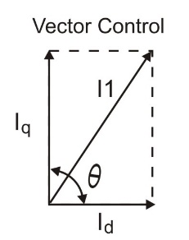
Vector control maximizes torque per amp by keeping torque producing current (Iq) and magnetizing current (Id) at 90 degrees.
- I1 = total motor current (Iq + Id).
- Ө > 90° => sin Ө > 1
- Ө < 90° => then sin Ө > 1;
- Ө = 90° => then sin Ө = 1 and torque is at its maximum.
In a DC motor, the brushes are mechanically positioned 90°from the commutator to constantly produce maximum torque.
Open-loop Vector Control (OLV) is used for greater and more dynamic motor control. It independently controls motor speed and torque, much like DC motors are controlled. When running OLV, motors can produce 200% of their rated torque at 0.3 Hz.
Open-loop vector control offers higher starting torque at lower speeds, allows for four-quadrant torque limits, torque limits primarily restrict motor torque to prevent damage to equipment, machinery, or products. The limits can be set independently for each quadrant, or users can program an overall torque limit into the VFD.
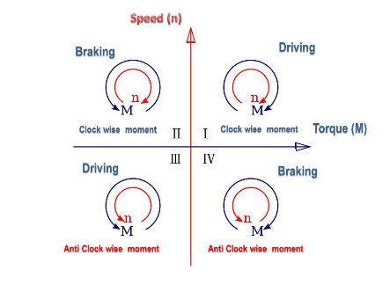
Four Quadrant Control drive operations are characterized by what control is required. A system of four quadrants is used.
- forward accelerating, positive speed & torque
- generating or braking, decelerating - positive speed & negative torque
- reverse accelerating -negative speed & torque
- generating or braking, reverse braking - decelerating negative speed & positive torque.
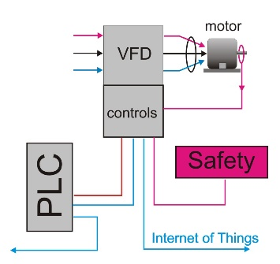
The Future a single VFD at best it has an encoder, at minimum the VFD connects to a PLC the PLC connects to other controls. The VFD becomes part of the “Internet of Things” (IOT)

Week 13 CEC Motor Circuits

Full Load Current
Motor circuit design issues
- Wire size and overcurrent size. One motor or a group of motors.
- Overload size
- Minimum control
What drive motor circuit design
- Motor circuit design is driven by the full load current (FLA) of the motor
- Recently the use of full load current (FLC) has come into use
- Both refer to the current a motor draws at rated horsepower.
- This comes from the motor manufacturer
- If not specified table 44 (CEC)
For full-load currents of 208 V motors, increase the corresponding 230 V motor full-load current by 10%.
- Estimate the FLA of a 20 hp, 208, 3 phase motor
- From T44 the FLA of a 20 hp 230 V motor is 54 A.
- FLA of a 208 V, 20 hp motor would be 54 x 110% = 59.4A
These values for motor full-load current are to be used as guides only. Where exact values are required (motor protection), always use those appearing on the motor nameplate.
These values of motor full-load current are for motors running at speeds typical for belted motors and motors with normal torque characteristics. Motors built for especially low speeds or high torques may require more running current, and multi-speed motors will have full-load current varying with speed, in which case the nameplate current rating shall be used.
For 90 and 80% power factor, multiply the above figures by 1.1 and 1.25, respectively.
The voltages listed are rated motor voltages. Corresponding Nominal System Voltages are 120, 208, 240, 480, and 600 V. Refer to CSA CAN3-C235.
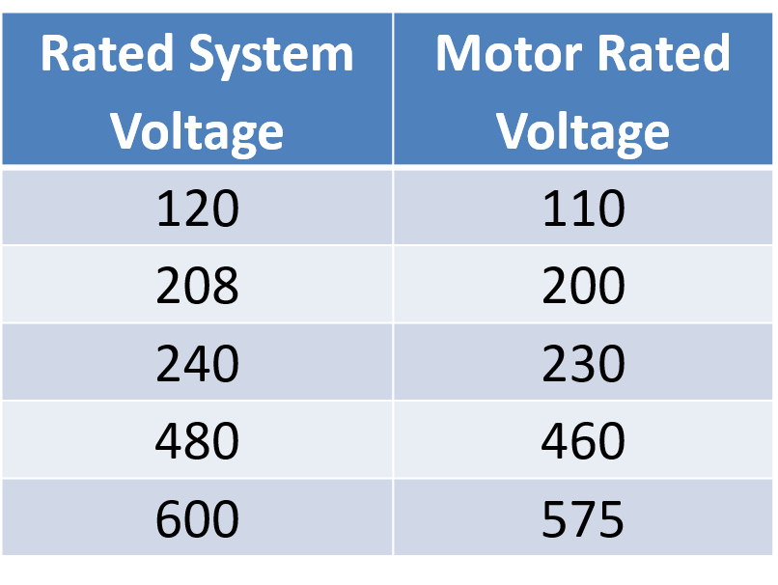
Rated Voltages
- A motor designed for 575 volts, operated on 600 volts, will not over heat.
- A motor designed for 600 volts, operated on 575 volts, will over heat.
Table 45 is for single phase motors
For full-load currents of 208 and 200 V motors, increase the corresponding 230 V motor full-load current by 10 and 15%, respectively. Why? A single-phase motor is operated on 2 lines of a three-phase system.

Single Phase FLC Example
- A single phase, 5 horsepower motor rated at 200 volts is operated on two lines from a three phase 208-volt system. What is the approximate FLA of the motor?
- From Table 45 the FLA of a 5 hp, 230-volt motor is 28 amps
- A 200 volt 5 hp single phase motor would draw approximately 28 x 115% = 32.2 amps
These values of motor full-load current are to be used as guides only. Where exact values are required (e.g., for motor protection), always use those appearing on the motor nameplate.
These values of full-load current are for motors running at usual speeds and motors with normal torque characteristics. Motors built for especially low speeds or high torques may have higher full-load currents, and multi-speed motors will have full-load current varying with speed, in which case the nameplate current ratings shall be used.
The voltages listed are rated motor voltages. Corresponding Nominal System Voltages are 120 and 240 V. Refer to CSA CAN3-C235.
DC Motors are found in Appendix D, not directly part of code, note started voltages (TABLE D2)
These values of full-load current are for motors running at moderate base speeds usual for belted motors and motors with normal torque characteristics. Motors built for especially low speeds may require more running current, in which case the nameplate current rating should be used.
These values of full-load current are to be used as guides only. When exact values are required (e.g., for motor protection), always use those appearing on the motor nameplate.

Motor Supply Conductors
These conductors are heated by the motor. If the insulation is rated for a higher temperature it indicates that the motor is expected to run at a higher temperature. This is associated with high efficiency motors.
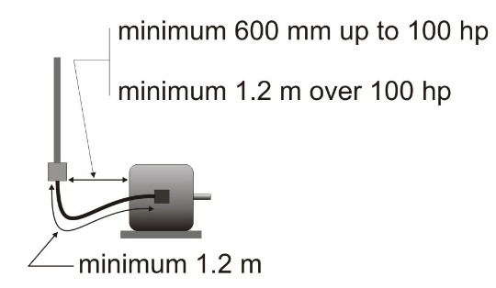
28-104 Motor supply conductor insulation temperature rating and ampacity …….shall have an insulation temperature rating equal to or greater than that required by Table 37 ……….
Table 37 (CEC) conductor insulation must match the conditions. Special rules apply to the conductor ampacity.
28-106 Conductors — Individual motors
(1) The conductors of a branch circuit supplying a motor for use on continuous duty service shall have an ampacity not less than 125% of the full load current rating of the motor.
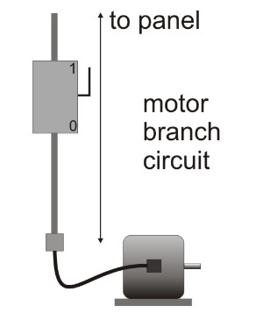
What is the minimum T90 Nylon, copper conductor for the branch circuit that feeds a motor with an FLA of 72 amps? Reasonable assumption: conductors in conduit.
Minimum conductor ampacity = FLC x 125% = 72 x 1.25 = 90 A
From Table 2 (CEC) 3 – 4 AWG conductors are required for the branch circuit. With this you could also find the correct conduit size
Motor supply conductors; a motor with class F insulation. Reference Table 37 to find that 90⁰ insulation is acceptable
BUT 28-104 says “Supply conductors to a motor connection box shall have an insulation temperature rating equal to or greater than that required by Table 37, unless the motor is marked otherwise and their ampacity is based on a 75 °C conductor insulation”
Now to get the required 90 amps we actually have to use one size larger for the motor supply conductors because we must use the 75⁰C column.

Over Loads and Over Currents
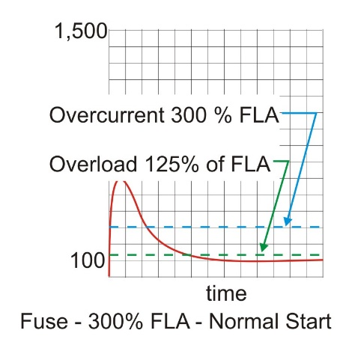
Protection issues include shorts (very high currents, mist be restricted to very short durations) and overloads (slightly over normal current and may be tolerable for limited time)
Normal starting current may hit 600% FLC and after starting the motor should draw FLC only.
If there is a short we can easily see 20 times the FLC. In order to protect a motor, we can’t simply use a fuse rated for 125% because it will blow when started, we also can’t use a bigger fuse because this would allow the motor to run at a higher current and potentially overheat.
What we need to do is use overload protection. Have a built-in time de lay to allow the motor to start.
This would allow the motor to start and run but would eventually trip the overload but this is how the CEC protects motors and motor branch circuits. We just need to get the right settings.

Overcurrent protection
28-200 Branch circuit overcurrent protection
Each ungrounded conductor of a motor branch circuit shall be protected by an overcurrent device complying with the following:
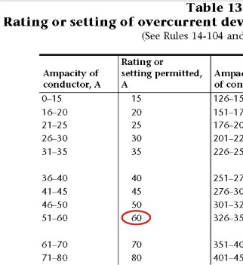
(a) a branch circuit supplying a single motor shall be protected, except as permitted by Item (c), by using an overcurrent device of rating not to exceed the values in Table 29 using the rated full load current of the motor;
Maximum Overcurrent = FLA x T29 value
= 35 x 1.75
= 61.25 amps
Take this value to table 13

Overload protection
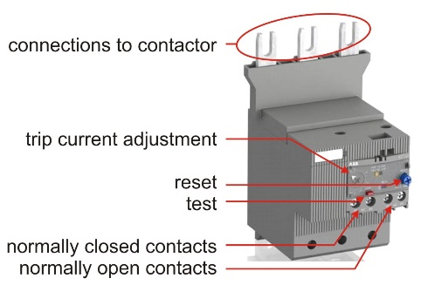
28-302 Types of overload protection
(1) Overload devices shall be either
(a) a separate overload device that is responsive to motor current and that shall be permitted to combine the function of overload and overcurrent protection if it is capable of protecting the circuit and motor under both overload and short-circuit conditions; or
(b) a protective device, integral with the motor and responsive to motor current or to motor current and temperature, provided that such a device will protect the circuit conductors and control equipment as well as the motor.
Responsive to motor current melting solder pots, solder pot mechanism.
Bi-metal overload relays are a common alternative to melting solder relays
Issues the motor could heat up in normal operating range due to poor maintenance.
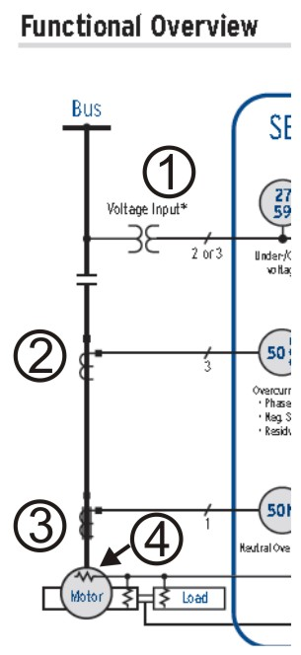
We can combine both overload and overcurrent protection with a single device; a motor protection relay (SEL-701). This is a sophisticated and expensive piece of equipment that would NOT be used on a small motor.
SEL Relay inputs:
- Potential transformers monitor voltage
- Current transformers (CT’s) monitor current
- Neutral current is measured if necessary
- Motor temperature is monitored
This unit would be able to monitor a dusty motor because it would see temperature increase and not just current changes
28-306 Rating or trip selection of overload devices (see Appendix B)
(1) Overload devices responsive to motor current, if of the fixed type, shall be selected or rated or, if of the adjustable type, shall be set to trip at not more than the following:
(a) 125% of the full load current rating of a motor having a marked service factor of 1.15 or greater; or
(b) 115% of the full load current rating of a motor that does not have a marked service factor or where the marked service factor is less than 1.15.

What is the maximum overload that can be used to protect a three-phase induction motor with full voltage starting, an FLA of 35 amps and a service factor of 1.15?
Maximum overload = FLA x 1.25 (if SF >= 1.15)
= 35 x 1.25
= 43.75
Selecting overloads comes from Tables 9, 10 and 11 Motor FLA and Thermal Unit Number are found the Thermal Unit is what is calculated.
What happens if we have a short circuit? The 60-amp fuse will blow. Covered.
What will happen if the motor overloads but not enough to cause the overload to trip? The conductor is large enough to carry the current (up to 125% of FLA). Covered
What will happen if the motor overloads but not enough to cause the overcurrent to trip to trip? The overload opens. Covered

Week 14 CEC Circuits for Multiple Motors

Motor Feeders
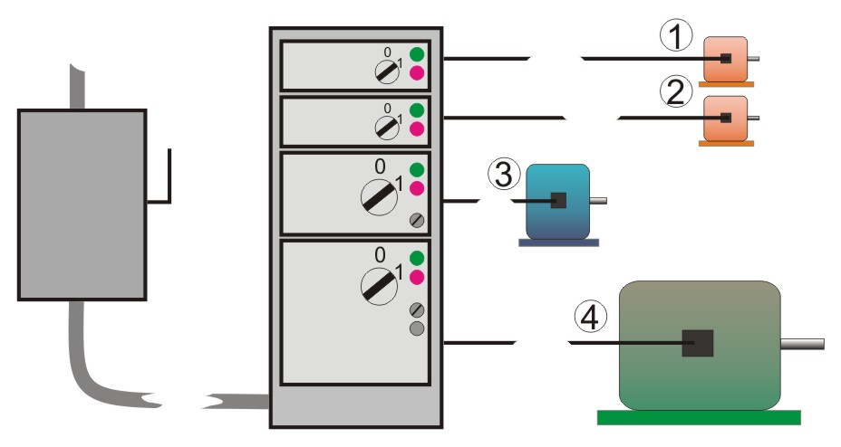
Feeder: any portion of an electrical circuit between the service box or other source of supply and the branch circuit overcurrent device.
Feeding motors
The motor feeder requires a disconnecting means and overcurrent protection
The motor feeder conductors must be able to supply all the connected motors that can run at one time
Individual motors need combination motor starters. Motor Control Centers (MCC’s) are typical
Each section of the MCC feeds an individual motor and provides; motor overcurrent, a motor starter with a contactor and motor overloads, a control transformer, timers, push buttons, control relays etc.
MCCs are built and shipped out, the module sizes can varry a lot
28-204 Feeder overcurrent protection
(1) For a feeder supplying motor branch circuits only, the ratings or settings of the feeder overcurrent device shall not exceed the calculated value of the overcurrent device permitted by Rule 28-200 for the motor that is permitted the highest rated overcurrent devices of any motor supplied by the feeder, plus the sum of the full load current ratings of all other motors that will be in operation at the same time.

Find the feeder overcurrent for the 4 motors listed below. The motors are three phase with full-voltage starting. Use time-delay fuses.
- motor 1 – FLA 18 amps
- motor 2 – FLA 18 amps
- motor 3 – FLA 52 amps
- motor 4 – FLA 144 amps
- Find the largest overcurrent for the individual motors.
Maximum overcurrent = FLA x T29 value
= 144 x 175%
= 252 A
- Add the FLA’s of the other motors to the calculated overcurrent value for the largest motor.
Calc feeder O/C = max O/C_{largest} + FLA _{other}
= 252 + 18 + 18 + 52
= 340 A
Table 13 gives up 300 amps, but a 350 amp fuse is available however; Rule 28-204 says ”the ratings or setting of the feeder current device shall not excced the value” and 350 is obviously greater than 340.
Ignore colums 1 and 3 of table 13 when applying this rule
28-204
(2) Where a feeder supplies a group of motors, two or more of which are required to start simultaneously, and the feeder overcurrent devices as calculated in accordance with Subrule (1) are not sufficient to allow the motors to start, the rating or setting of the feeder overcurrent devices shall be permitted to be increased as necessary, to a maximum that does not exceed the rating permitted for a single motor having a full load current rating not less than the sum of the full load current ratings of the greatest number of motors that start simultaneously, provided that this value does not exceed 300% of the ampacity of the feeder conductors.
28-108 Conductors — Two or more motors
(1) Conductors supplying a group of two or more motors shall have an ampacity not less than
(a) 125% of the full load current rating of the motor having the largest full load current rating plus the full load current ratings of all the other motors in the group, where all motors in the group are for use on continuous duty service;
Find the feeder conductor size for the 4 motors listed below. The motors are three phase with full-voltage starting. The conductors are copper, in conduit with R90 insulation. See the diagram on the previous slide.
- motor 1 – FLA 18 amps
- motor 2 – FLA 18 amps
- motor 3 – FLA 52 amps
- motor 4 – FLA 144 amps
Minimum feeder ampacity
= FLA_{largest} x 125% + sum _{other FLA’s}
= (144 x 1.25) + 18 + 18 +52
= 268 amps
Go to Table 2, CEC =>250 kcmil
28-108 Conductors — Two or more motors
(2) Where the circuitry is interlocked in order to prevent all motors of the group from running at the same time, the size of the conductors feeding the group shall be permitted to be determined for the motor, or group of motors operating at the same time, that has the largest rating selected as determined in Subrule (1).
- This often seen where a motor is critical and has a backup motor in place.

