BChem Notes:

Week 8

Lecture 13: Identification of a DNA-Replicating Enzyme

The Eukaryotic Cell Cycle
- M Phase (Mitosis)
- 4n tetraploid cell -> 2n daughter cells (2 of them)
- $G_{o}$ Phase (Quiescent)
- non-active
- $G_{1}$ Phase
- 2n (Two copies of each chromosome)
- S Phase
- Each chromosome is duplicated
- $G_{2}$ Phase
- 4n tetraploid (four copies of each chromosome)

Beginnings of ‘Replication
How is the DNA polymer made?
- Kornberg et al. used radioactive [14C] thymidine to ensure that radioactive polymer that was made was DNA and not RNA
- They discovered that heat-stable factors (not proteins but nucleoside triphosphates) were needed for DNA synthesis reaction
- Purified DNA polymerase I (Pol I)
- Found that Pol I received instructions on what nucleotides to incorporate from an existing template (parental DNA strands)—need template or else cannot add
- Marked the ‘beginnings of biotechnology’ – ability to manipulate genetics

Kornberg Results Part 1
- Purification of ‘Polymerase” involved a multistep process in which protein concentration and specific enzyme activity (DNA polymerization) were monitored
- GOAL: to measure DNA polymerization (specific activity)
- Steps:
- Need to get rid of nucleotides
- Shock to open cell
- Fractionating (purification) nucleotides, DNA/RNA
- Changing protein solubility—protein can stay in solution of fall out based on salt concentration
- Measure protein [] after every step

- DNA is synthesized—what is doing this?

Fractionating
1. Add streptomycin has +/- charges (causes DNA to precipitate in S or P fraction)

S Fraction- dNMP, dNDP, dTTP, kinases
P Fraction- DNA polymerase & DNA

Observation 1: when separate into S & P fractions there was no activity—DNA synthesis activity is in both fractions

Observation 2: S & P= activity

Hypothesis 1: DNA Pol adds linearly to DNA
--dATP, dTTP, dGTP, dCTP were equally added
AT=GC kept constant
Adding dTTP had no effect on final composition

Template required!

Biochemical Principles
- Enzymes & other active protein components can be identified, purified and have their functions analyzed biochemically

Assays for Activity
- Biochemical studies involve an assay for the activity under investigation, which is usually a measurement of the product of the reaction being catalyzed by the enzyme
- Must be able to measure the product
- Start small and get big

Reporter
- Incorporation Assay:
- Measure the incorporation of radioactively or fluorescently labels dNTP into the high molecular weight polymer DNA to observe the activity of a DNA polymerase
- Incorporate radioactive phosphate group – this group will not come off!!
- Alpha, beta, gamma phosphates
- Gamma & beta will come off during polymerization
- Fluorescently Labeled dNTP
- Product gives off fluorescent signal when exposed to light

- Detection of DNA polymer:
- Precipitation of polymer with a strong acid (trichloroacetic acid)
- Unincorporated nucleotides or nucleosides do not precipitate
- Analyze radioactivity by Geiger counter, scintillation counting, electrophoresis and autoradiography

Separate big from small with strong acid that leaves small in solution
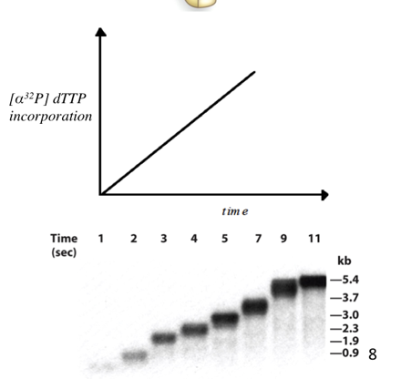
-Activity increases as time increases

-darker line indicates incorporated more radioactive material

3. Detection of DNA polymer:
- This can involve positively charged filter (in low salt) where negatively charged polynucleotide backbone will bind, but unincorporated nucleotides will pass through
- Analyze fluorescence signal by fluorescence detector

Other Methods to study gene formation (RNA):
- Real time PCR
- Quantitative PCR
- DNA micro arrays

Specific Activity
- Each fraction from a chromatographic column is assayed for protein content (e.g. the absorbance at 280 nm) with the ability catalyze the incorporation of [$α32P$] dTTP into DNA (red line)
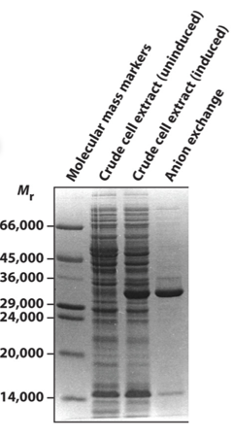
2 major bands shown indicates 2 major proteins

Which one is DNA pol?
--must use fractionation and chromatography to find out!
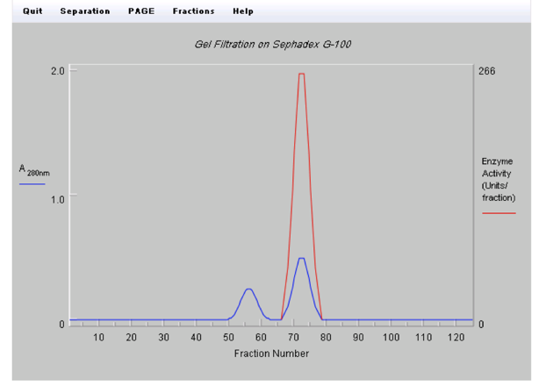
Blue line shows 2 proteins
-first bump comes off first due to larger size

Red line at bump 2 shows that the largest enzyme activity absorbed with protein 2

Kornberg Results Part 2
- Requirements of the “Polymerization Reaction” were deduced by Kornberg et al by showing that the maximal incorporation of labels deoxyribonucleotides into DNA (monitored by amount of precipitated DNA with dTP* incorporated)
- Experimental Conditions:
- Production of polynucleic strand
- No encorporation of radioactivity into growing polymer
- 5) no activity when one is gone
- Conclusion
- You need a template because you could add any dCTP or dGTP etc and would get DNA made but you don’t!
- Requires a temple, co-factor required
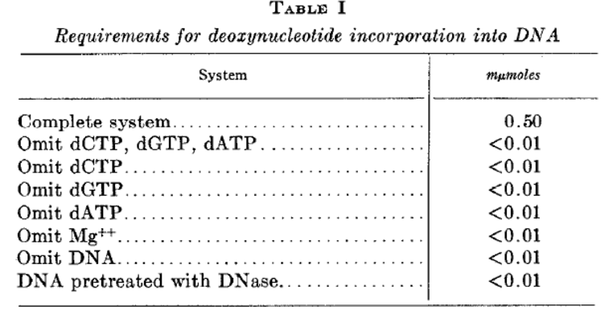
1.
2.
3.
4.
5.
6.
7.
8.

Kornberg Publications
- Got declined because ‘polymerase is a poor name’ and people did not realize that a single enzyme can be used to make DNA

DNA Replication: General Principles
- DNA Replication is semi- conservative
- Need to have a template with instructions & each daughter chromosome contains 1 parental strand and 1 newly synthesized strand
- Replication is initiated at specific sites
- Origin of replication are used to tell polymerase to replicate, bubble is formed
- Eukaryotes have multiple origin sites, prokaryotes have 1
- Replication is typically bidirectional
- ‘Replication fork’ moves away from the origin of replication in both directions
- DNA make 5’3’ but DNA pol only works in one direction
- Replication is continuous on the leading strand and discontinuous on the lagging strand
- Both daughter strands cannot be replicated in the same direction that the replication fork moves
- RNA primers are needed to start DNA replication
- Primer strands must be complementary to the template and contain a free 3’-OH group
- Nucleases, polymerases and ligases replace the RNA primers with DNA and seal the remaining nick

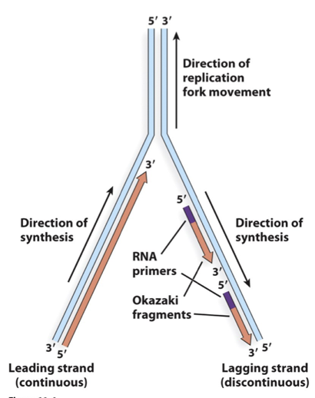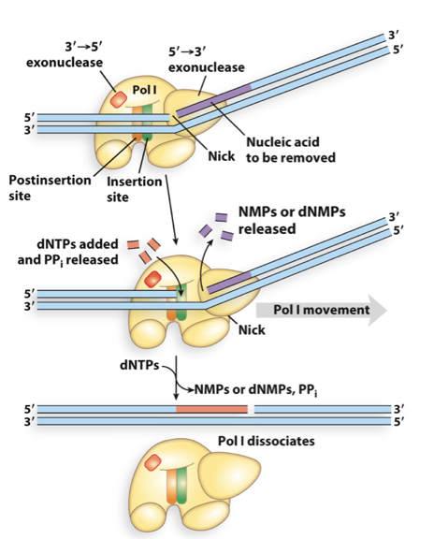
Key Point:
- Polymerases function 5’->3’ linking $α$-5’-phosphate of a new dNTP to the 3’ position of the nucleotide residue at end of the chain (e.g. at the 3’ end)

Lecture 14: DNA Polymerase and the Polymerization Reaction

DNA Polymerase Structure Reveals the Basis for its Accuracy
- Structure represents a ‘right hand’
- Contains separate ‘domains’: palm, thumb, fingers
- dNTPs enter the finger domain and thumb domain grips the DNA to help add dNTPs make sure the polymerase stays attached to add the nucleotide one after another
- DNA slides through the palm (active site) and adds nucleotides by template strand
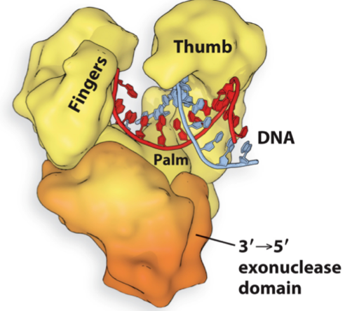

Conformations of DNA Polymerase I
- When a dNTP is acquired for base pairing to the template, a dramatic conformational change occurs
- Open Form – DNA brought in and dNTPs added 5’ to 3’
- Closed Form— rotate in 40 degrees, carrying dNTP to DNA template

Quality Control
Shape Recognition
- A-T and G-C base pairs have shapes that fit well into the closed form of the active site
- Incorrect base pairs do not fit, and prevent complete closure around the DNA
- Polymerase changes conformation of active site (shift amino acids) depending on base in template strand to ensure correct base is added—an incorrect base cannot be added because does not fit and due to van der waals forces
- In correct bases are added at low frequency’s, 1 in every 10e4 to 10e5 nucleotides

Polymerase Active Site (Closed Form)
- Two conserved Asp residues coordinate two Mg2+
- “Two metal ion mechanism”
- Amino acids do not play a direct role in catalysis of polymerization—Mg does
First Mg:
- Deprotonate the 3’ OH of the new strand to form the 3’ O- nucleophile (does this with help of Asp, Mg decrease pKa of OH group that makes it acidic and so H is easily lost becoming –ve as a nucleophile so reacts
Second Mg:
- Binds incoming dNTP (helps enable departure of the PPi leaving group)
- Covalent bond formed (phosphodiester)

The DNA Polymerase Reaction
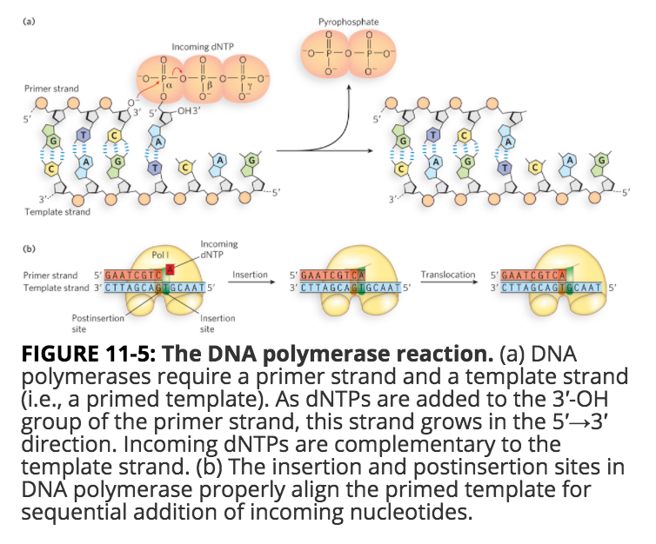
Translocation- high processivity add 1000’s o nucleotides before it unbinds (multiple reactions & still allow it to bind), poly slides along template without getting stuck due to back bone of DNA –ve, lysine +ve electro-transit force= slippery to allow it to slide

Pol that synthesizes Ozakai = low processivity

When wrong base pairs added you can get disease or new function (bad or good)

Effects of Mispairing
- A mispaired 3’ terminus by four nucleotides to allow it to be inserted into the 3’-> 5’ exonuclease site
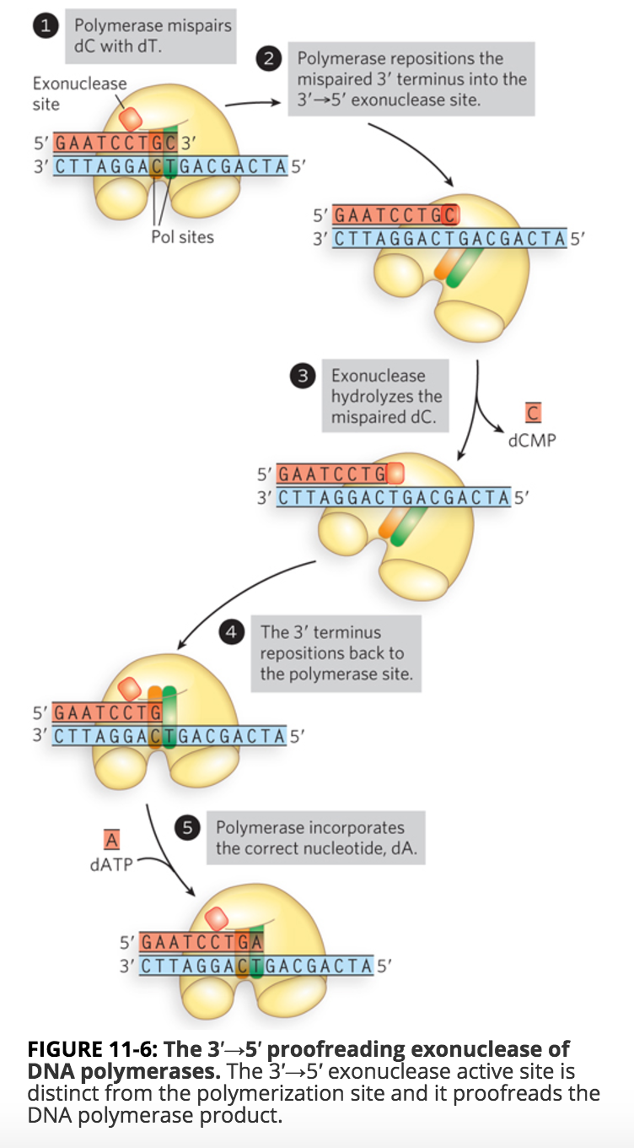

Avoiding Replication Errors
- Proof reading
- The same enzyme that makes DNA also degrades it
- DNA pol I has an active site for the polymerase reaction, one for the 3’->5’ exonuclease reaction, and yet another one for the 5’ -> 3’ exonuclease reaction
Must know diff in Mg in active site of poly and exonuclease active site Mg Ions help reduce pKa of H2O (exonuclease) r 3’ OH (pol reaction)

The 3’-> 5’ Exonuclease Active Site
- Two metal ion mechanism
First Mg:
- Deprotonates H2O to form OH- which acts as nucleophile to mediate hydrolysis of terminal 3’ dNMP that is incorrect
Second Mg:
- Promotes departure of dNMP leaving group

Avoiding Replication Errors

Nick Translation by Pol I (5’-> 3’Exonuclease)
- Pol I contains a second exonuclease that degrades DNA in the 5’->3’ direction, the same direction as DNA synthesis
- 5’->3’ exonuclease is unique to Pol I
Summary:
- A dNTP that correctly base-pairs to the template strand is incorporated into the primer strand with the release of pyrophosphate (PPi)
- DNA polymerases are inherently very accurate, and are made even more accurate by a proofreading 3’->5’ exonuclease
- Lie the polymerase active site, exonucleases sites use two metal ion mechanism for removal of incorrect dNMPs
- Pol I also contains a 5’->3’ exonuclease that degrades DNA while, at the same time, the polymerase synthesizes DNA, in the process of nick translation

Lecture 15: DNA Polymerase and the Polymerization Reaction
The accuracy of DNA pol relies heavily on shape recognition during base pairing
Must know similarities between E. coli and Euk

Structural Elements of the E. coli Replication Origin
- DNA sequences of known origins share two common features:
- Binding sites for initiator proteins
- Stretches of DNA that are AT rich (easily denatured due to weak bond)

  - Activation of the E. coli replication Origin (oriC)
- DnaA oligomerizes on binding the origin and wraps the DNA around to oligomer. HU facilitates open-complex formation
- DnaC loads DnaB helicase onto each strand, forming the prepriming complex.
- DnaB—helicase; keeps from binding to DNA origin bubble
- DnaC-- helicase loading protein

Assembly of the E. coli Replication Forks
- DnaB helicase expands the replication bubble and primase forms RNA primers at each replication fork

Replication Initiation and Leading Strand Synthesis
- RNA primers direct $β$ clamp loading and assembly of the leading-strand Pol III (replicative enzyme add nucleotides 5’->3’) core complexes. Core complexes advance replication to opposite DnaB helicase

Lagging Strand Synthesis in E. coli
- Continued DnaB helicase activity allows lagging-strand priming and Okazaki fragment synthesis
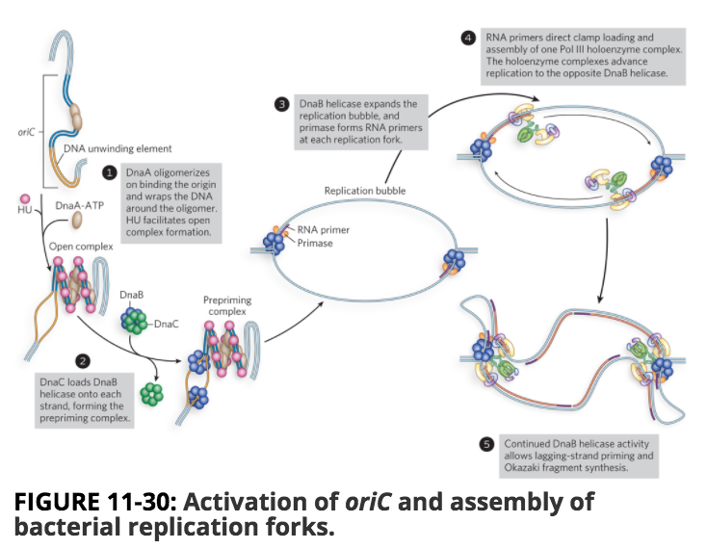

Lecture 16: DNA Replication: Elongation & Termination
- Must know components that recognize origin of replication in euk and e. coli (At rich and protein recognition sites
- There’s diff gates (DNA kinases through signally cascades to tell cell when in S phase) – this can cause cancer to get cells to replicate

Replisome DNA Polymerase III
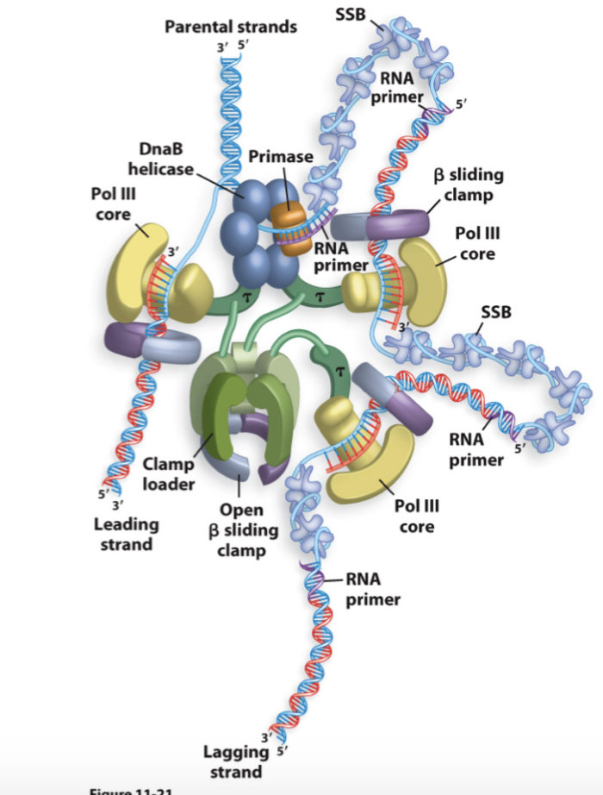
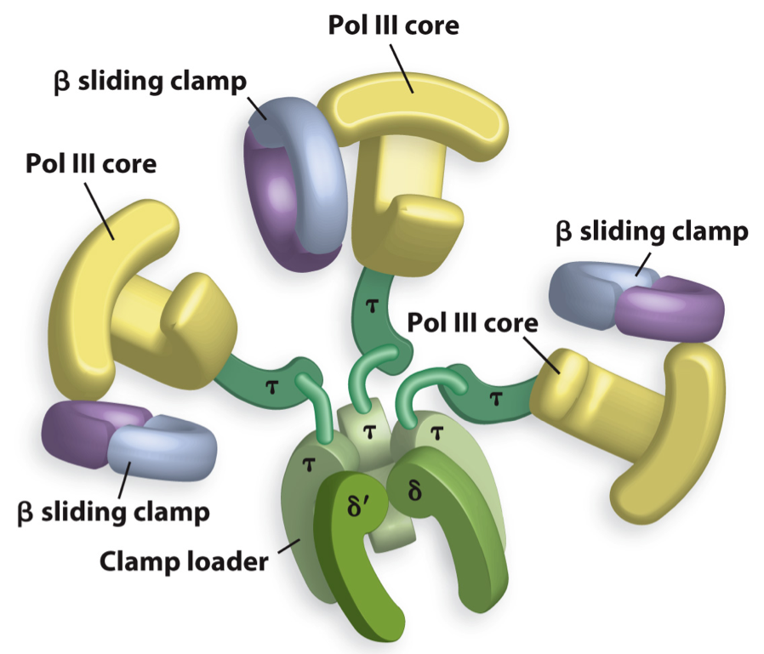

DNA Polymerase III is Replicative Enzyme
- 3 Pol III core—one at each replication fork (2 to make lagging strand and 1 for leading strand)
- Separate sub units add on nucleotides (exonuclease)—this is not the right hand model!
- Beta Clamps- assembles on polymerase to increase processitivity
- Fusion Polymerase- genetically modified, thermal stable polymerase (that represents poly III and beta clamp all in one)
- Clamp Loader- help to grab beta clamp to put on template strand and pol III comes in
- Components:
- 3 Polymerase III cores (3 sub units each)
- 3 beta Clamps (2 subunits)
- 1 Clamp loader

Experiment to demonstrate the requirement of Pol III for a clamp, and its ability to transfer between templates:
- Polymerase dissociates and prefers the strand with the beta clamp—beta clamp increases processivity

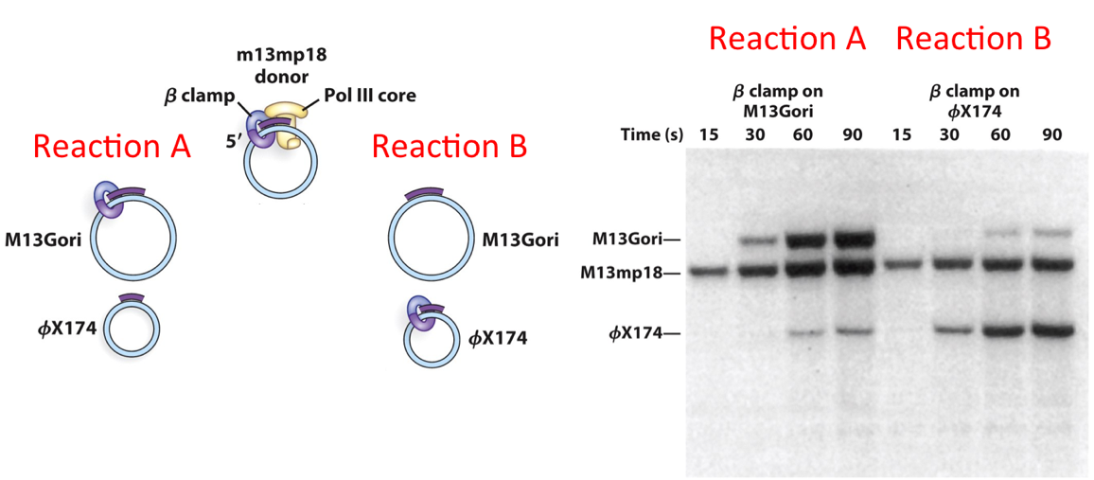
Brightest band increasing over time m13mp18 meaning replication is happening quickly on this band

E. coli $β$ clamp loader
- ATP creates conformational changes in the clamp loader to help open it to assemble on dsDNA
- The ATP bound form of the loader has affinity for beta clamp and will load the primer onto the section to allow for transcription and ADP needed to dissociate beta clamp
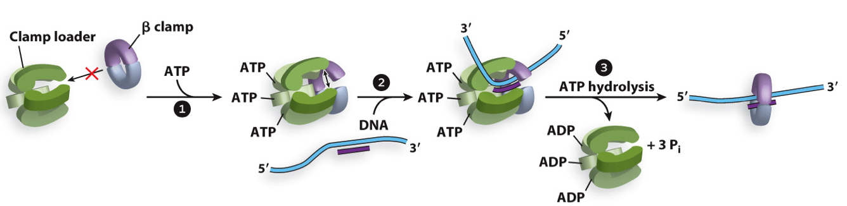

How can the lagging strand Pol III synthesize DNA in the opposite direction to replication fork movement, yet remain tethered to the replisome?
- The Trombone model of the Replication Fork
- DNA loops repeatedly grow and collapse on the lagging strand

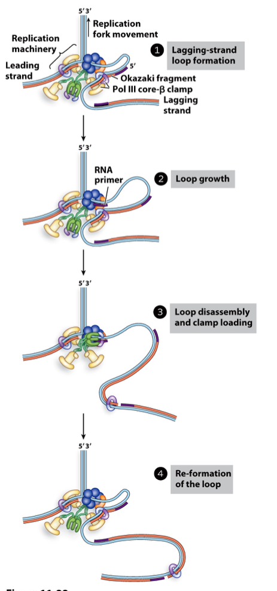
Single Stranded loop starts out small and grows

-What happens to beta clamp?
-- beta clamp gets left behind and associated with RNA and DNA hybrid (it gets recycled and reused by DNA Pol 1)

Clamp Recycling DNA Pol I and Ligase
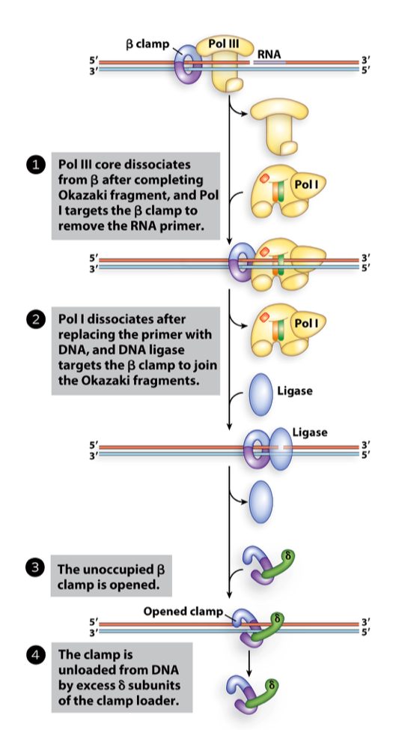
Pol I is an enzyme that has 5’->3’ polymerase activity & 5’->3’ enxonuclease activity

Pol III makes a weak interaction with the beta clamp (can be dissociated) when pol III is gone then pol I can bind

Pol I is removed replacing it with DNA

Single strand break—repaired by ligase

Subunit of clamp loader comes in and prys off beta clamp

Remember Steps Involved in Creating Lagging Synthesis:
Must know the proteins involved

1. Pol III collides with RNA primer & associating, beta clamp leaves to recruit pol I

2. Pol I 5’->3’ exonuclease activity with 5’->3’ synthesis at the same time
3. Recruitment of ligase to seal the break

Homework:
- Researchers who pioneered the use of DNA polymerases for DNA sequencing, PCR and site-directed mutagenesis were awarded Nobel prizes for their ground-breaking achievements, but DNA polymerases play key roles numerous additional indispensable methods including DNA labeling, cloning, whole genome amplification, and diagnostic techniques.

Q: What types of modifications have been made to DNA polymerases that have enabled or improved their usefulness in research applications?
A: DNA sequencing, different polymerase have different roles

Termination of DNA Replication
- In both bacteria and eukaryotes, replication forks meet head-on, at point termination occurs so DNA polymerases dissociate

Termination of E. coli Chromosome Replication
- Replication at one origin of replication in both directions at same speed
- Tus protein will be dissociated at Ter site and replication will continue
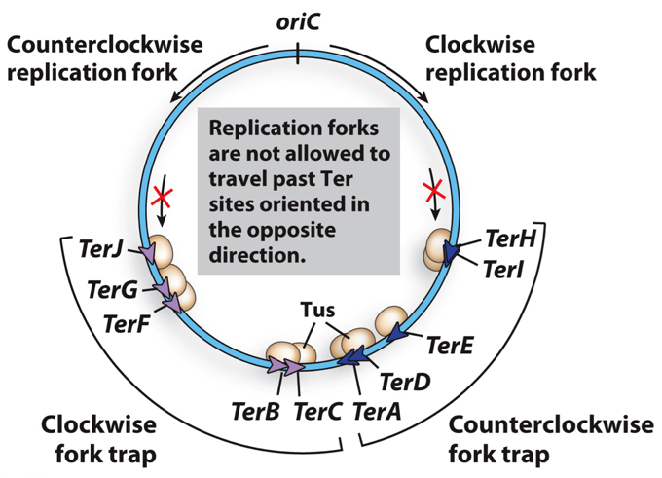

But…
- Replication the last bit of DNA between converging replication forks presents topological problems
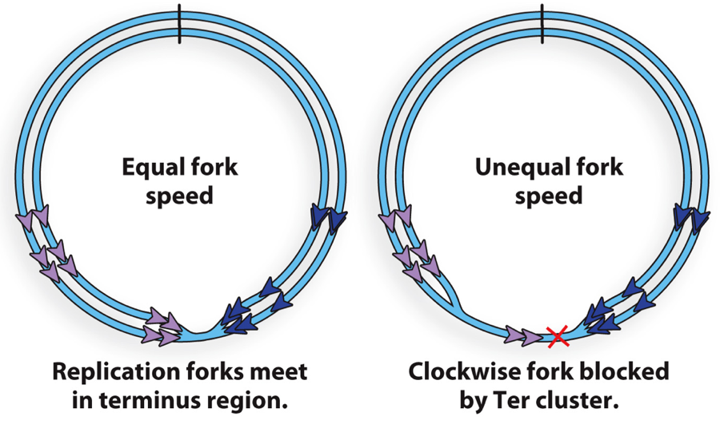
Blue arrow side is moving faster than the purple is (the purple side hasnet replicated the DNA as far yet)

At the X DNA pol is blocked from continuous synthesis

Minimizing Competition Between Transcription and Replication in the E. coli Chromosome
- Genes are orientated in a certain arrangement in chromosome
- Most of transcription is in the same direction as replication
- Open reading frames are genes that make proteins, and are orientated in different directions depending on if CW of CCW side this ensures that replication and transcription can occur at the same time!

Resolution of Catenated Daughter Chromosomes
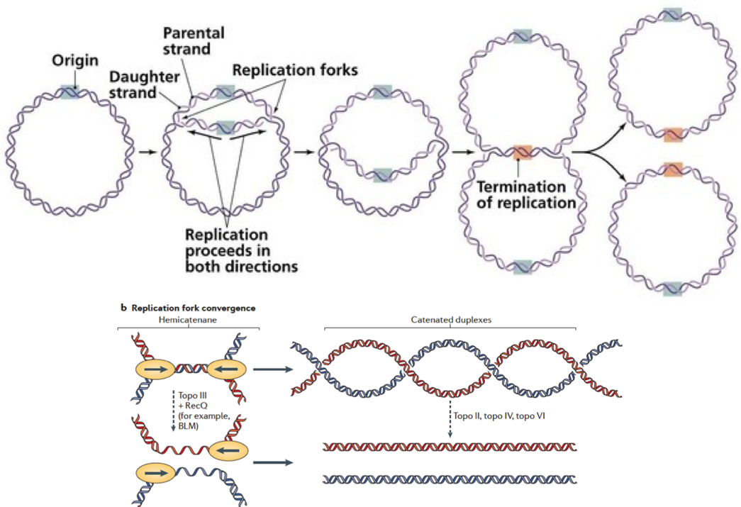
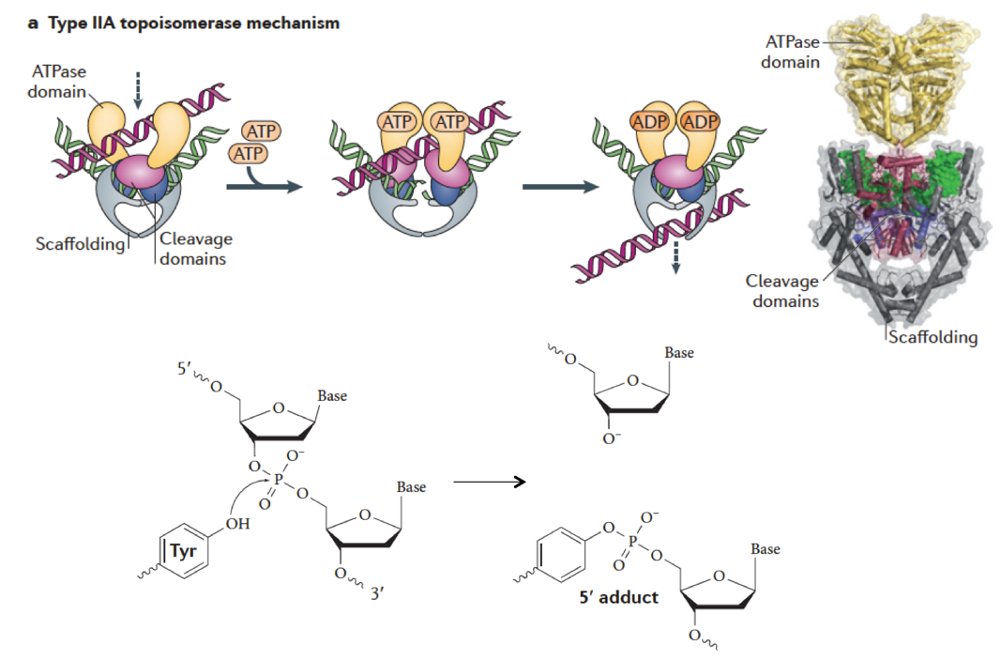

Homework:
- The assembly of bacterial replication forks at the origins of replication occur in steps—What are they?
- Several mechanisms are available to regulate activation of the bacterial replication origin—What are they? (DNA origin undergoes methylation)
- Eukaryotes have many replication origins, whose activation is tightly regulated by cell cycle dependent initiation control (i.e. some initiator proteins bind the origin in one phase or the cell cycle, but not in another)—Which proteins help dictate this level of control? (kinase signalling)
- There is a problem replication the ends of linear DNA—What is the problem and how is it solved? (telomers)

