205 Textbook notes
CHAPTER 1
Single nucleotide polymorphism
- single nucleotide polymorphisms (SNPs), the most common type of variation in most, if not all, organisms

CHAPTER 2
Biological research focuses on how organisms develop from a fertilized egg into an adult AKA what makes an organism the way it is.
In order to figure that ^ out, they study individual biological properties like the development of plant flower colour OR animal locomotion OR nutrient uptake as well as more general things like how a cell works.
How do geneticists analyze biological properties? Gene discovery: finding genes that influence that property. After, these genes have been identified, their cellular functions can be determined with more research.
The basic approach of genetics is to compare & contrast properties of variants, and from these comparisons make deductions about genetic function.
Wild type: most common form of any property
Mutant: differs from the wild type
Mutations create mutants and result in a heritable change in the DNA of the gene.

Polymorphisms: coexistence of two or more reasonably common phenotypes of a biological property.
You can use polymorphisms for genetic analysis- however, it is better to use mutants because it allows researchers to zero in on the property.
General Steps of Functional Analysis by Gene Discovery
- Gather mutants affecting the biological property of interest.
- Cross (mate) the mutants to wild type to see if their descendants show ratios of wild to mutant that are characteristic of single-gene inheritance.
- Deduce the functions of the gene at the molecular level.
- Deduce how the gene interacts with other genes to produce the property in question.
This chapter focuses on step 1 and 2.
Mutants are rare- but you can induce the recovery of mutations.
- Treat the organism with radiation or chemicals that increase the mutation rate. After treatment, most direct way to identify mutants = visually screen large number of individuals for a chance occurrence of mutants in that population.

Not all mutants are caused by lesions within one gene. Therefore, each mutant has to be tested to see it is indeed caused by a single-gene mutation.
Test for single-gene inheritance is to mate individuals showing the mutant property with wild-type and then analyze the first and second generation of descendants.
In each generation, the diagnostic ratios of mutants and wild-type will reveal whether a single gene controls the trait.
Example: mutant plant: white flower, wild-type: red
- Progeny of this cross are analyzed
- Progeny are interbred to produce a second generation
- In each generation, the characteristic ratios of plants w/ red flowers to white flowers will reveal whether a single gene controls flower colour
- If a single gene controls flower colour, then by inference, the wild type would be encoded by the wild-type form of the gene and the mutant would be encoded by a form of the same gene in which a mutation event has altered the DNA sequence in some way
- Other mutations affecting flower color (perhaps mauve, blotched, striped, and so on) would be analyzed in the same way, resulting overall in a set of defined “flower-color genes.”
Using mutants in this way is known as genetic dissection. This is because the biological property (ex:flower colour) is picked apart to reveal its underlying genetic program.
Each mutant ( ex: white flower) helps potentially identify a gene that affects that property.
After identifying genes, molecular methods may be used to establish the function of the genes.
Forward genetics: a strategy to understanding biological function starting with random single-gene mutants and ending with their DNA sequence and biochemical function. (Phenotype gene)
Reverse genetics:
- starts with genomic analysis at the DNA level to identify a set of genes as candidates for encoding the biological property of interest
- induces mutants targeted specifically to those genes
- examines the mutant phenotypes to see if they affect property under study ( gene phenotype)
We also know that single-gene inheritance patterns are produced because genes are parts of chromosomes, and chromosomes are partitioned very precisely down through the generations.
Gene discovery is important in
- experimental organisms
- Agriculture (ex: used to understand a desirable commercial property of an organism)
- human genetics (to know which gene functions are involved in a specific disease or condition- useful info in finding therapies.
2.1 Single-Gene Inheritance Patterns
Mendel’s pioneering experiments (pg 34)
- Garden pea: Pisum sativum
- Mendel did not have to look for mutants of peas – he was able to use mutants found by others that had been used in horticulture.
- Mendel’s work = different from geneticists today It was not genetic dissection he was not interested in the properties of peas- instead, he wanted to know about the way hereditary units that influenced those properties passed down generations
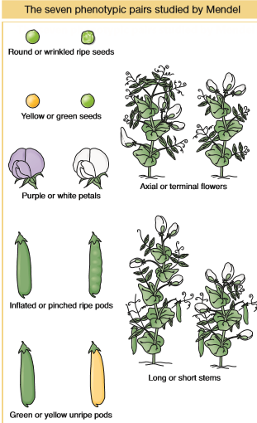
- Mendel’s laws of inheritance are used in modern genetics in identifying single-gene inheritance patterns.

- in genetics, both character and trait = property Mendel studied 7 properties- for each one had two lines with distinctly different phenotypes
- all lines Mendel used = pure lines: for a phenotype, all offspring produced by matings within the members of that line are identical (for example: within the yellow-seeded line, all the progeny of any mating were yellow seeded)
Mendel’s first cross

- To make a cross in plants such as the pea, pollen is simply transferred from the anthers of one plant to the stigmata of another
ANTHERS STIGMATA

- self (self- pollination): special type of mating when pollen from a flower falls on its own stigma
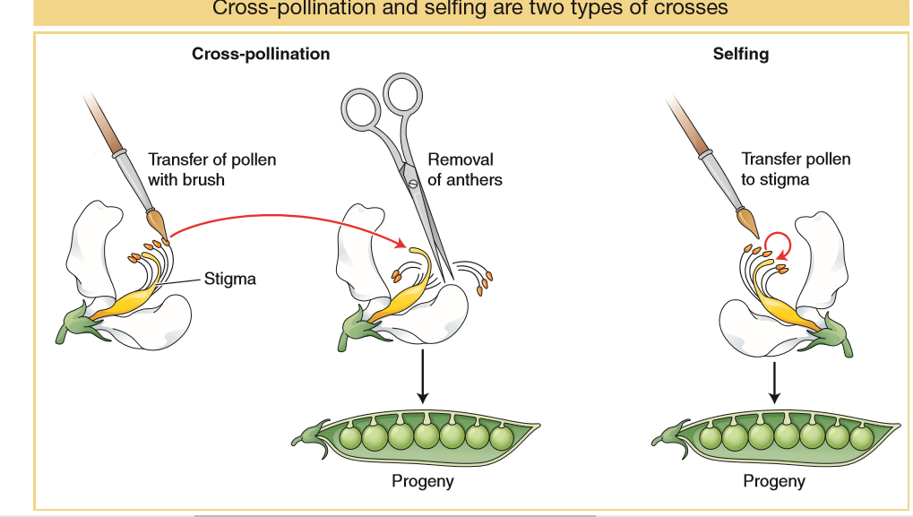
- The first cross made by Mendel mated plants of the yellow-seeded lines with plants of the green-seeded lines. In his overall breeding program, these lines constituted the parental generation, abbreviated P.
- The progeny peas from the cross between the different pure lines were found to be all yellow, no matter which parent (yellow or green) was used as male or female. This progeny generation is called the first filial generation, or F1.
- Mendel grew F1 peas into plants, and he selfed these plants to obtain the second filial generation, or F2.
- There was a 3 : 1 ratio of yellow to green. The green phenotype, which had disappeared in the F1, had reappeared in one-fourth of the F2 individuals, showing that the genetic determinants for green must have been present in the yellow F1, although unexpressed.
- To further investigate the nature of the F2 plants, Mendel selfed plants grown from the F2 seeds
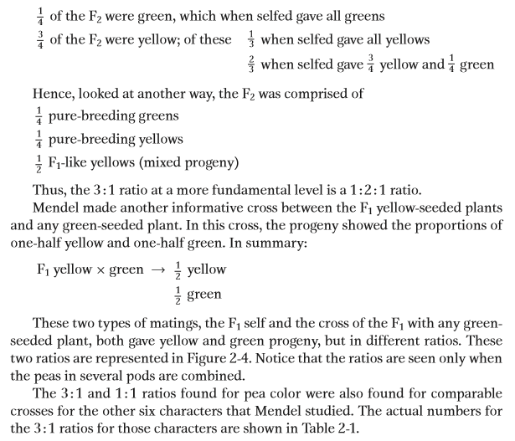

Mendel’s law of equal segregation (pg 36~)
Mendel’s model for the pea-colour example, translated into modern terms, was as follows:
- A hereditary factor called a gene is necessary for producing pea colour.
- Each plant has a pair of this type of gene.
- The gene comes in two forms called alleles. If the gene is phonetically called a “wye” gene, then the two alleles can be represented by Y (standing for the yellow phenotype) and y (standing for the green phenotype).
- A plant can be either Y/Y, y/y, or Y/y. The slash shows that the alleles are a pair.
- In the Y/y plant, the Y allele dominates, and so the phenotype will be yellow. Hence, the phenotype of the Y/y plant defines the Y allele as dominant and the y allele as recessive.
- In meiosis, the members of a gene pair separate equally into the cells that become eggs and sperm, the gametes. This equal separation has become known as Mendel’s first law or as the law of equal segregation. Hence, a single gamete contains only one member of the gene pair.
- At fertilization, gametes fuse randomly, regardless of which of the alleles they bear.

- Sometimes a heterozygote for one gene is called a monohybrid
- In genetics generally, allelic combinations underlying phenotypes are called genotypes. Hence, Y/Y, Y/y, and y/y are all genotypes
- The pure-breeding lines are homozygous, either Y/Y or y/y. Hence, each line produces only Y gametes or only y gametes and thus can only breed true.
- When crossed with each other, the Y/Y and the y/y lines produce an F1 generation composed of all heterozygous individuals (Y/y). Because Y is dominant, all F1 individuals are yellow in phenotype
- Selfing the F1 individuals can be thought of as a cross of the type Y/y × Y/y, which is sometimes called a monohybrid cross.
- Equal segregation of the Y and y alleles in the heterozygous F1 results in gametes, both male and female, half of which are Y and half of which are y. Male and female gametes fuse randomly at fertilization.
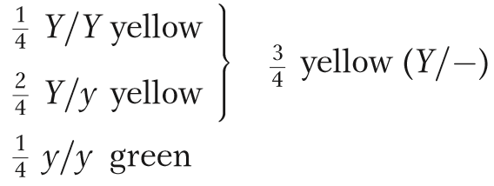
We see that underlying the 3:1 phenotypic ratio in the F₂ is a 1:2:1 genotypic ratio!!

- Equal segregation is detectable only in the meiosis of a heterozygote
- Y/y produces one-half Y gametes and one-half y gametes

- Although equal segregation is taking place in homozygotes too, neither segregation ½ Y: ½ Y nor segregation ½ y :½ y is meaningful or detectable at the genetic level

- equal segregation in the yellow heterozygous F1 gives gametes with a ½Y: ½y ratio
- The y/y parent can make only y gametes, however; so the phenotype of the progeny depends only on which allele they inherit from the Y/y parent.
- Thus, the ½ Y : ½ y gametic ratio from the heterozygote is converted into a ½ Y/y : ½ y/y genotypic ratio, which corresponds to a 1 : 1 phenotypic ratio of yellow-seeded to green-seeded plants
2.2 The Chromosomal Basis of Single-Gene Inheritance Patterns
Single gene inheritance in diploids (pg 40)
- Mitosis can occur in haploids and diploids
- One progenitor cell becomes two genetically identical cells
- Hence, either 2n → 2n + 2n or n → n + n

- Chromosome replicates to make two identical copies of itself
- Two identical copies = sister chromatids
- Each copy pulled to opposite end of cell so that when the cell divides, each daughter cell has the same chromosomal set as its progenitor

- Meiocytes= diploid cells that divide to produce sex cells
  - Sperm and eggs in plants and animals
  - Sexual spores in fungi or algae
- In meiosis, there are two divisions therefore, 4 cells are produced from each progenitor cell
- Meiosis only takes place in diploid cells – the resulting gametes are haploid.
- Hence, the net result of meiosis is 2n → n + n + n + n

This overall halving of chromosome number during meiosis is achieved through one replication and two divisions. As with mitosis, each chromosome replicates once, but in meiosis the replicated chromosomes (sister chromatids) remain attached. One of each of the replicated chromosome pairs is pulled to opposite ends of the cell, and division occurs. At the second division, the sister chromatids separate and are pulled to opposite ends of the cell.

- S PHASE = synthesis= premitotic chromosome replication
Mitosis
The replication produces pairs of identical sister chromatids, which become visible at the beginning of mitosis. When a cell divides, each member of a pair of sister chromatids is pulled into a daughter cell, where it assumes the role of a fully fledged chromosome. Hence, each daughter cell has the same chromosomal content as the original cell.
Meiosis
Before meiosis, as in mitosis, chromosome replication takes place to form sister chromatids, which become visible at meiosis. The centromere appears not to divide at this stage, whereas it does in mitosis. Also in contrast with mitosis, the homologous pairs of sister chromatids now unite to form a bundle of four homologous chromatids. This joining of the homologous pairs is called synapsis, and it relies on the properties of a macromolecular assemblage called the synaptonemal complex (SC), which runs down the center of the pair. Replicate sister chromosomes are together called a dyad (from the Greek word for “two”). The unit comprising the pair of synapsed dyads is called a bivalent. The four chromatids that make up a bivalent are called a tetrad (Greek for “four”), to indicate that there are four homologous units in the bundle.
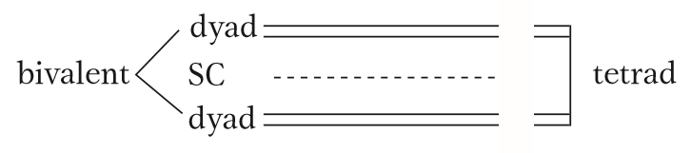
Synapsis: occurs when the homologous pairs of sister chromatids unite to form a bundle of four homologous chromatids. Synapsis relies on the synaptonemal complex (SC), in which runs down the centre of the pair.
Dyad: replicate sister chromosomes together
Bivalent: pair of synapsed dyads
Tetrad: four chromatids that make up a bivalent
Crossing over= not important in this chapter bc even though it changes the combinations of alleles of several different genes, it does not directly affect single-gene inheritance patterns. Note that aside from its allele- combining function, crossing over is critical for the proper chromosome segregation in meiosis 1!
PRACTICE DRAWING OUT MITOSIS AND MEIOSIS
The bivalents of all chromosomes move to the cell’s equator, and, when the cell divides, one dyad moves into each new cell, pulled by spindle fibers attached near the centromeres.
In the second cell division of meiosis, the centromeres divide and each member of a dyad (each member of a pair of chromatids) moves into a daughter cell. Hence, although the process starts with the same genomic content as that for mitosis, the two successive segregations result in four haploid cells.
Each of the four haploid cells that constitute the four products of meiosis contains one member of a tetrad; hence, the group of four cells is sometimes called a tetrad, too.
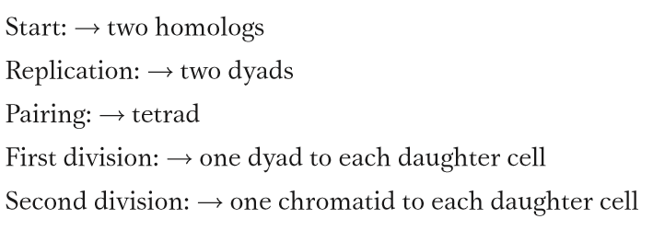

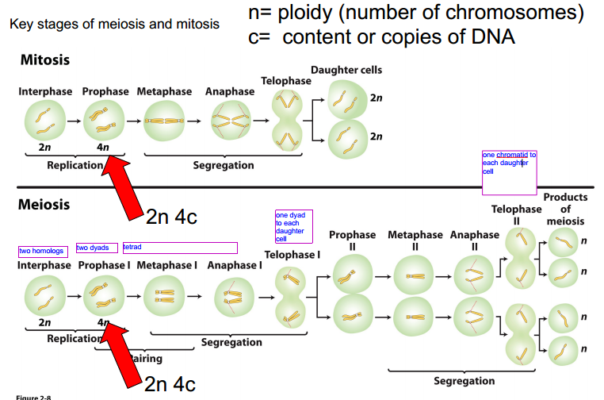

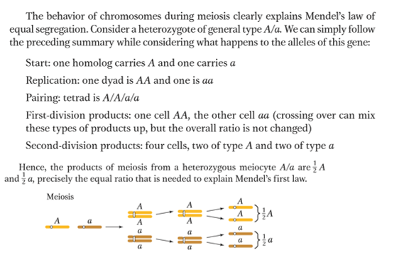
LAW OF SEGREGATION: during the production of gametes, the two copies of each hereditary factor segregate so that offspring acquire one factor from each parent
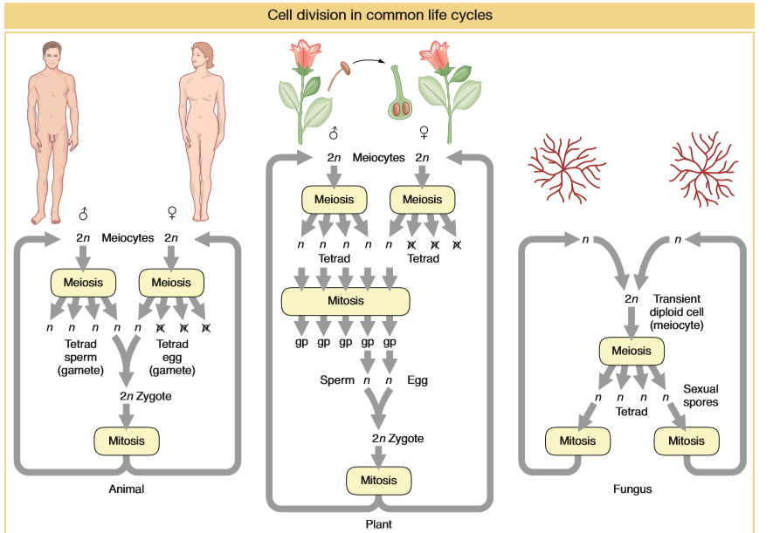
Single gene inheritance in haploids (pg 44)
Fungi and algae are referred to as haploid organisms. They spend most of their lives in haploid state but can mate and form a transient diploid cell that becomes a meiocyte.
In some species, the four products of a single meiosis are temporarily held together in a type of sac.
- Saccharomyces cerevisiae (a fungus)
  - In fungi, there are simple forms of sexes called mating types
  - In S. cerevisiae, there are two mating types, and a successful cross can only occur between strains of different mating types.
  - Normal wild-type yeast colonies are white, but, occasionally, red mutants arise owing to a mutation in a gene in the biochemical pathway that synthesizes adenine.
  - mutant allele r for red
  - wild-type allele for any gene is generally designated by a plus sign, +. This sign is attached as a superscript to the symbol invented for the mutant allele.
  - the wild-type allele in this example would be designated r+, but a simple + is often used as shorthand
  - To see single-gene segregation, the red mutant is crossed with wild type. The cross would be
    - r⁺ × r
  - A diploid cell is formed when two cells of opposing mating type fuse. It is this cell that becomes the meiocyte.
  - In the present example, the diploid meiocyte would be heterozygous, r⁺/r.
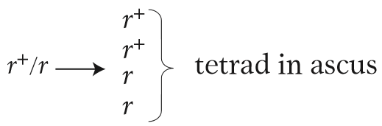
  - Replication and segregation of r⁺ and r would give a tetrad of two meiotic products (spores) of genotype r⁺ and two of r, all contained within a membranous sac called an ascus.
  - If the four spores from one ascus are isolated (representing a tetrad of chromatids) and used to generate four yeast cultures, then equal segregation within one meiocyte is revealed directly as two white cultures and two red.
  - If we analyzed the random spores from many meiocytes, we would find about 50 percent red and 50 percent white.
  - Note the simplicity of haploid genetics: a cross requires the analysis of only one meiosis; in contrast, a diploid cross requires a consideration of meiosis in both the male and the female parent.
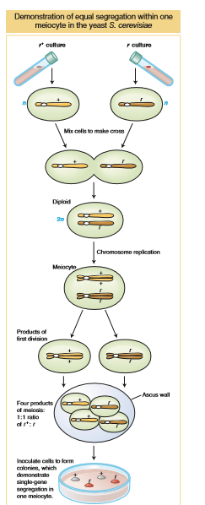
  - This simplicity is an important reason for using haploids as model organisms. Another reason is that, in haploids, all alleles are expressed in the phenotype because there is no masking of recessives by dominant alleles on the other homolog.

2.3 The Molecular Basis of Mendelian Inheritance Patterns (pg 45)
- Mutant alleles can be used to study single-gene inheritance without needing to understand their structural or functional nature.
- However, because a primary reason for embarking on single-gene inheritance is ultimately to investigate a gene’s function, we must come to grips with the molecular nature of wild-type and mutant alleles at both the structural and the functional level
Structural differences between alleles at the molecular level
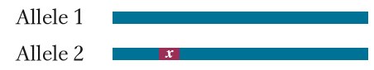
- alleles are truly different versions of the same gene
- the diagram on the right represents the DNA of two alleles of one gene; the letter x represents a difference in the nucleotide sequence:
- If the nucleotide sequence of an allele changes as the result of a rare chemical “accident,” a new mutant allele is created.
- Such changes can occur anywhere along the nucleotide sequence of a gene. For example, a mutation could be a change in the identity of a single nucleotide or the deletion of one or more nucleotides or even the addition of one or more nucleotides.
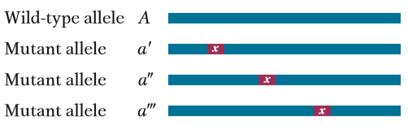
- mutational damage can occur at any one of many different sites
- (pic on right) dark blue indicates the normal wild-type DNA sequence and red with the letter x represents the altered sequence
Molecular aspects of gene transmission (pg 46)
- Replication of alleles occurs during the S phase
- replication is an accurate process and so all the genetic information is duplicated, whether wild type or mutant
- if a mutation is the result of a change in a single nucleotide pair—say, from GC (wild type) to AT (mutant)—then in a heterozygote, replication will be as follows:
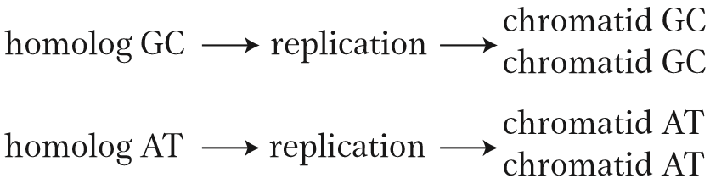
Another way to directly segregate DNA without doing phenotypic segregation is to sequence the alleles (say, A and a) in the parents and the meiotic products.
Alleles at the molecular level
- at the molecular level, the primary phenotype of a gene is the protein it produces
- Phenylketonuria (PKU): inherited as a Mendelian recessive
  - Disease is caused by a defective allele of a gene that encodes the liver enzyme phenylalanine hydroxylase (PAH). This enzyme normally converts phenylalanine in food into the amino acid tyrosine
  - However, a mutation in the gene encoding this enzyme may alter the amino acid sequence in the vicinity of the enzyme’s active site. In this case, the enzyme cannot bind phenylalanine (its substrate) or convert it into tyrosine. Therefore, phenylalanine builds up in the body and is converted instead into phenylpyruvic acid. This compound interferes with the development of the nervous system, leading to mental retardation.
  - The PAH enzyme is made up of a single type of protein.
  - What changes have occurred in the mutant form of the PKU gene’s DNA, and how can such change at the DNA level affect protein function and produce the disease phenotype? Sequencing of the mutant alleles from many PKU patients has revealed lots of mutations at different sites along the gene, mainly in the protein-encoding regions, or the exons
  - What these alleles have in common is that they encode a defective protein that no longer has normal PAH activity.
    - By changing one or more amino acids, the mutations all inactivate some essential part of the protein encoded by the gene
    - The effect of the mutation on the function of the gene depends on where within the gene the mutation occurs
    - An important functional region of the gene is that encoding an enzyme’s active site; so this region is very sensitive to mutation
  - a minority of mutations are found to be in introns, and these mutations often prevent the normal processing of the primary RNA transcript.
  - Many of the mutant alleles are of a type called null alleles: proteins encoded by them completely lack PAH function
  - A null allele is a mutant copy of a gene at a locus that completely lacks that gene's normal function.
  - Other mutant alleles reduce the level of enzyme function; they are sometimes called leaky mutations, because some wild-type function seems to “leak” into the mutant phenotype
Mutations in the parts of a gene encoding enzyme active sites lead to enzymes that do not function (null mutations). Mutations elsewhere in the gene may have no effect on enzyme function (silent mutations). Promoters are sites important in transition initiation.
  - DNA sequencing often detects changes that have no functional impact at all, so they are functionally wild type. Hence, we see that the terms wild type and mutant sometimes have to be used carefully.
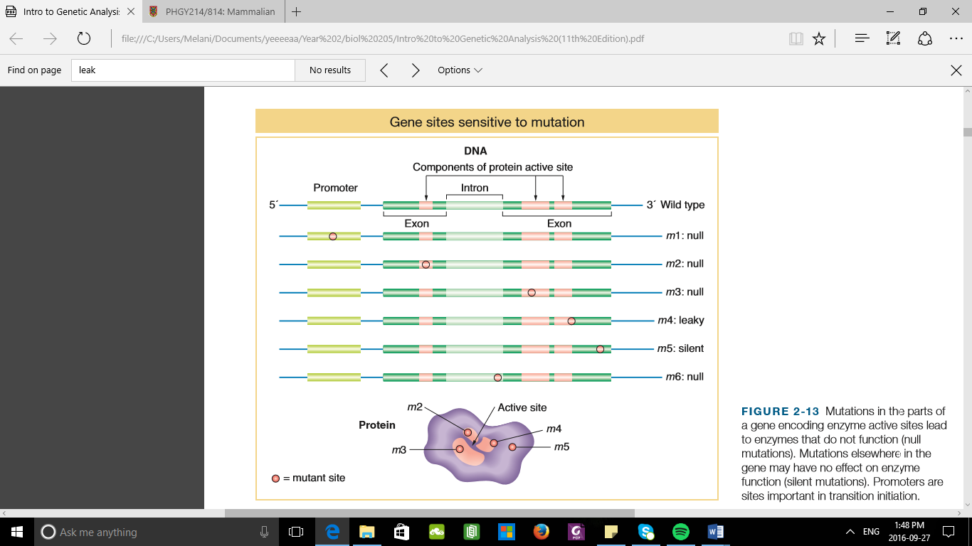
- Haplosufficiency
  - Recessiveness is observed in null mutations in genes that are functionally haplosufficient
  - Haplosufficient: one gene copy has enough function to produce a wild-type phenotype
  - Although a wild-type diploid cell normally has two fully functional copies of a gene, one copy of a haplosufficient gene provides enough gene product (generally a protein) to carry out the normal transactions of the cell
  - In a heterozygote (say, +/m, where m is a null), the single functional copy encoded by the + allele provides enough protein product for normal cellular function.
  - In a simple example, assume a cell needs a minimum of 10 protein units to function normally. Each wild-type allele can produce 12 units. Hence, a homozygous wild type +/+ will produce 24 units. The heterozygote +/m will produce 12 units, in excess of the 10-unit minimum, and hence the mutant allele is recessive as it has no impact in the heterozygote.

- Haploinsufficiency
  - A null mutant allele would be dominant
    - because in a heterozygote (+/P ), the single wild-type allele cannot provide enough product for normal function
  - Let’s assume the cell needs a minimum of 20 units of this protein, and the wild-type allele produces only 12 units. A homozygous wild type +/+ makes 24 units, which is over the minimum. However, a heterozygote involving a null mutation (+/P ) produces only 12; hence, the presence of the mutant allele in the heterozygote results in an inadequate supply of product and a mutant phenotype ensues.
- In some cases, mutation results in a new function for the gene. Such mutations can be dominant because, in a heterozygote, the wild-type allele cannot mask this new function.

- Phenotype= emergent property based on the nature of alleles and the way in which the gene functions normally and abnormally. The same can be said for the descriptions dominant and recessive that we apply to a phenotype.

2.4 Some Genes discovered by Observing Segregation Ratios
CHAPTER 3
- In rice, the following mutations have been crucial in the Green Revolution:
  - sd1: results in short stature
    - this makes plant resistant to falling over (AKA lodging)
    - also, increases relative plant energy in seed (“seed”= the part we eat)
  - Xa4: Dominant allele; resistance to the bacterial blight
  - bph2: resistance to brown plant hoppers (a type of insect)
  - Snb1: tolerance to plant submersion after heavy rains.

- To make a truly superior genotype, mutant lines must be intercrossed two at a time
For instance, a plant geneticist might start by crossing a strain homozygous for sd1 to another homozygous for Xa4. The F1 progeny of this cross would carry both mutations but in a heterozygous state. However, most agriculture uses pure lines, because they can be efficiently propagated and distributed to farmers. To obtain a pure-breeding doubly mutant sd1/sd1·Xa4/Xa4 line, the F1 would have to be bred further to allow the alleles to “assort” into the desirable combination
What principles are relevant here? It depends very much on whether the two genes are on the same chromosome pair or on different chromosome pairs. In the latter case, the chromosome pairs act independently at meiosis, and the alleles of two heterozygous gene pairs are said to show independent assortment.
This chapter explains how we can recognize independent assortment and how the principle of independent assortment can be used in strain construction, both in agriculture and in basic genetic research.
We shall also see that independent assortment of an array of genes is also useful in providing a basic heritable mechanism for continuous phenotypes. These are properties such as height or weight that do not fall into distinct categories but are nevertheless often heavily influenced by multiple genes collectively called “polygenes.”
Lastly, we will introduce a different type of independent inheritance, that of genes in the organelles mitochondria and chloroplasts. Unlike nuclear chromosomes, these genes are inherited cytoplasmically and result in different patterns of inheritance than observed for nuclear genes and chromosomes. This pattern is independent of genes showing nuclear inheritance.

3.1 MENDEL’S LAW OF INDEPENDENT ASSORTMENT
- two genes are on different chromosomes, the gene pairs are separated by a semicolon—for example, A/a; B/b
- If they are on the same chromosome, the alleles on one homolog are written adjacently with no punctuation and are separated from those on the other homolog by a slash—for example, AB/ab or Ab/aB
- An accepted symbolism does not exist for situations in which it is not known whether the genes are on the same chromosome or on different chromosomes. For this situation of unknown position in this book, we will use a dot to separate the genes—for example, A/a·B/b

- a heterozygote for a single gene (such as A/a) is sometimes called a monohybrid: accordingly, a double heterozygote such as A/a·B/b is sometimes called a dihybrid

- Mendel came up with the second law by studying dihybrid crosses
- seed shape and seed color
- (Y/y × Y/y), 3 yellow: 1 green
- Round (R) & wrinkled (r)
- To perform dihybrid cross, Mendel used two pure parental lines
- One line had wrinkled, yellow seeds
  - Because Mendel had no concept of the chromosomal location of genes, we must use the dot representation to write the combined genotype initially as r/r·Y/Y.
- other line had round, green seeds, with genotype R/R·y/y.
- When these two lines were crossed, they must have produced gametes that were r·Y and R·y , respectively. Hence, the F1 seeds had to be dihybrid, of genotype R/r·Y/y. Mendel discovered that the F1 seeds were round and yellow. This result showed that the dominance of R over r and Y over y was unaffected by the condition of the other gene pair in the R/r·Y/y dihybrid. In other words, R remained dominant over r, regardless of seed color, and Y remained dominant over y, regardless of seed shape. INDEPENDENCE!!!
- The results give a 9:3:3:1 ratio
- There are two 3:1 ratios within the 9:3:3:1 ratio

- In what is now known as the law of independent assortment (Mendel’s second law), he concluded that different gene pairs assort independently during gamete formation. The consequence is that, for two heterozygous gene pairs A/a and B/b, the b allele is just as likely to end up in a gamete with an a allele as with an A allele, and likewise for the B allele.

- In hindsight, we now know that, for the most part, this “law” applies to genes on different chromosomes. Genes on the same chromosome generally do not assort independently because they are held together by the chromosome itself.

- If the principle of equal segregation is valid across the board, then we should be able to observe its action in haploids, given that haploids undergo meiosis. Indeed, independent assortment can be observed in a cross of the type A ; B × a ; b. Fusion of parental cells results in a transient diploid meiocyte that is a dihybrid A/a ; B/b, and the randomly sampled products of meiosis (sexual spores such as ascospores in fungi) will be
¼ A; B
¼ A; b
¼ a; B
¼ a; b

Key Concept: Ratios of 1 : 1 : 1 : 1 and 9 : 3 : 3 : 1 are diagnostic of independent assortment in one and two dihybrid meiocytes, respectively.

3.2 WORKING WITH INDEPENDENT ASSORTMENT
Predicting progeny ratios
- Genetics can work in either of two directions:
  - (1) predicting the unknown genotypes of parents by using phenotype ratios of progeny
  - (2) predicting progeny phenotype ratios from parents of known genotype.
- two methods for prediction include: Punnett squares and branch diagrams
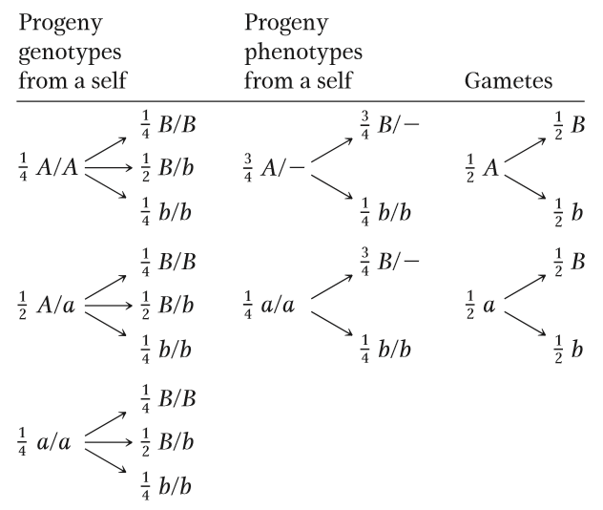
- Punnett squares can be used to show hereditary patterns based on one gene pair, two gene pairs, or more. Such grids are good graphic devices for representing progeny, but drawing them is time consuming. Even the 16-compartment Punnett square that we used to analyze a dihybrid cross takes a long time to write out, but, for a trihybrid cross, there are 23, or 8, different gamete types, and the Punnett square has 64 compartments.
- The branch diagram is easier to create and is adaptable for phenotypic, genotypic, or gametic proportions, as illustrated for the dihybrid A/a ; B/b.

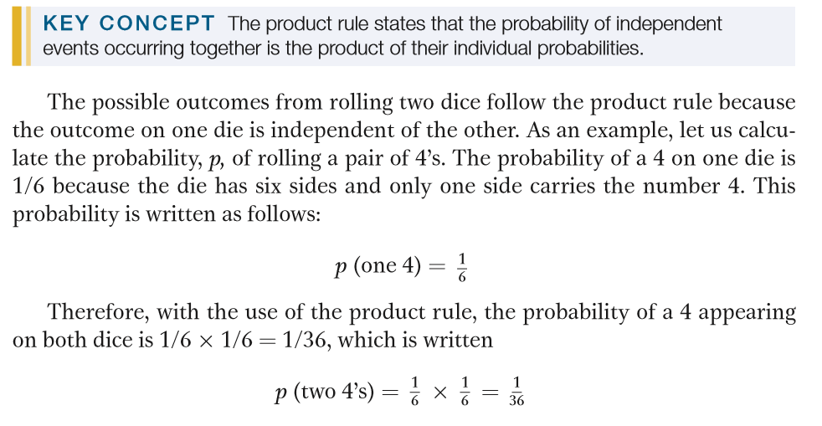
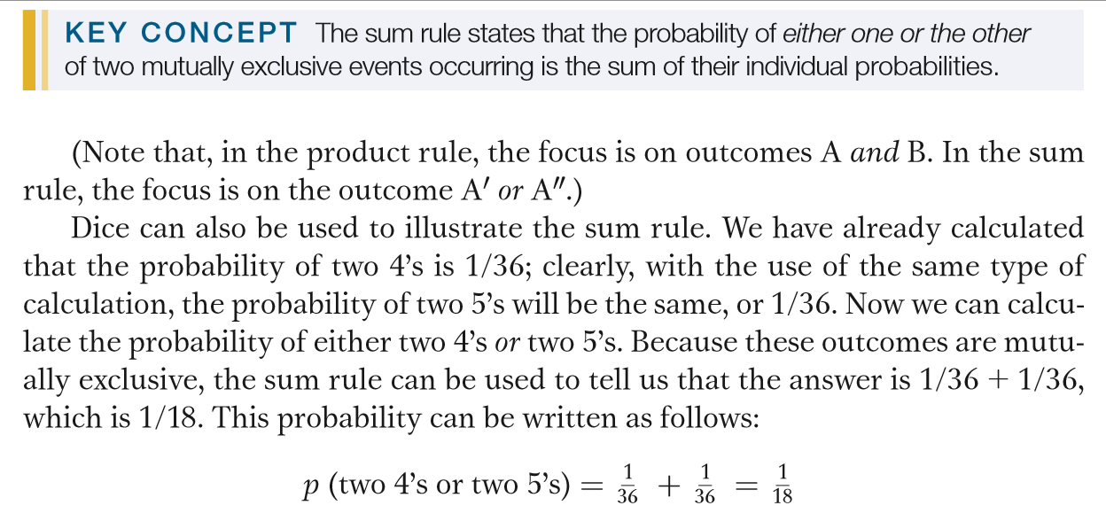
What proportion of progeny will be a specific genotype ( pg 94/120) ?
- This is in the lecture and straight-forward – example given

How many progeny do we need to grow?
- From a practical point of view, a more meaningful question to ask would be, What sample size do we need to be 95 percent confident that we will obtain at least one success? (Note: This 95 percent confidence value is standard in science.)
- The simplest way to perform this calculation is to approach it by considering the probability of complete failure—that is, the probability of obtaining no individuals of the desired genotype.
- In our example, for every individual isolated, the probability of its not being the desired type is 1 - (1/256) = 255/256.
- Extending this idea to a sample of size n, we see that the probability of no successes in a sample of n is (255/256)^{n}. (This probability is a simple application of the product rule: 255/256 multiplied by itself n times.)
- Hence, the probability of obtaining at least one success is the probability of all possible outcomes (this probability is 1) minus the probability of total failure, or (255/256)^{n}.
- Hence, the probability of at least one success is 1 - (255/256)^{n}
- To satisfy the 95 percent confidence level, we must put this expression equal to 0.95 (the equivalent of 95 percent). Therefore, 1 - (255/256)^{n} = 0.95

CHAPTER 4
Chromosome maps are used to zero in on individual “destinations,” or specific genes. In genetics, two different kinds of genome maps are often useful in locating a gene, leading to an understanding of its structure and function.
- several different types of chromosome maps are often necessary and must be used in conjunction
- maps that contain distortions are still useful
- many sites on a chromosome map are charted only because they are useful in trying to zero in on other sites that are the ones of real interest.
Why is obtaining a map of gene positions on the chromosome so important?
- Gene position is crucial information needed to build complex genotypes required for experimental purposes or for commercial applications.

- Knowing the position occupied by a gene provides a way of discovering its structure and function. A gene’s position can be used to define it at the DNA level. In turn, the DNA sequence of a wild-type gene or its mutant allele is a necessary part of deducing its underlying function.

- genes present and their arrangement on chromosomes are often slightly different in related species.
- For example, the rather long human chromosome number 2 is split into two shorter chromosomes in the great apes. By comparing such differences, geneticists can deduce the evolutionary genetic mechanisms through which these genomes diverged. Hence, chromosome maps are useful in interpreting mechanisms of evolution.

The arrangement of genes on chromosomes represented in a 1-D chromosome map. This map shows gene positions, known as loci (sing., locus), and the distances between the loci based on some kind of scale.

Two basic types of chromosome maps are currently used in genetics; they are assembled by quite different procedures yet are used in a complementary way.
- Recombination-based maps
  - map the loci of genes that have been identified by mutant phenotypes showing single-gene inheritance
- Physical maps
  - show the genes as segments arranged along the long DNA molecule that constitutes a chromosome
These maps show different views of the genome, but they can be used together to arrive at an understanding of what a gene’s function is at the molecular level and how that function influences phenotype.

  - DIAGNOSTICS OF LINKAGE
Recombination maps: assembled 2 or 3 genes at a time with the use of a method known as linkage analysis
LINKED: When geneticists say that two genes are linked, they mean that the loci of those genes are on the same chromosome, and, hence, the alleles on any one homolog are physically joined (linked) by the DNA between them.
Using recombinant frequency to recognize linkage
- William Bateson and R. C. Punnett: were studying the inheritance of two genes in sweet peas
  - standard self of a dihybrid F₁ = F₂
  - F2 did not show the 9 : 3 : 3 : 1 ratio predicted by the principle of independent assortment
  - Bateson and Punnett noted that certain combinations of alleles showed up more often than expected, almost as though they were physically attached in some way
- Morgan found a similar deviation from Mendel’s second law while studying two autosomal genes in Drosophila
  - Morgan proposed linkage as a hypothesis to explain the phenomenon of apparent allele association
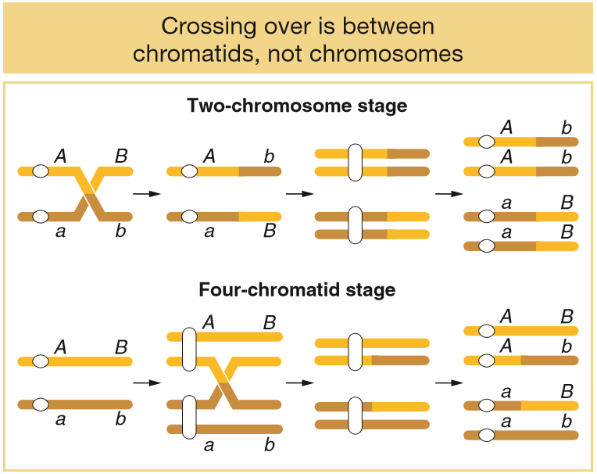
Figure 4-5 Crossing over takes place at the four-chromatid stage. Because more than two different products of a single meiosis can be seen in some tetrads, crossing over cannot take place at the two-strand stage (before DNA replication). The white circle designates the position of the centromere. When sister chromatids are visible, the centromere appears unreplicated.
134 * 160

- in some individual meiocytes, several crossovers can occur along a chromosome pair
- in any one meiocyte, these multiple crossovers can exchange material between more than two chromatids
For any pair of homologous chromosomes, two, three, or four chromatids can take part in crossing-over events in a single meiocyte. Note, however, that any single crossover is between two chromatids.
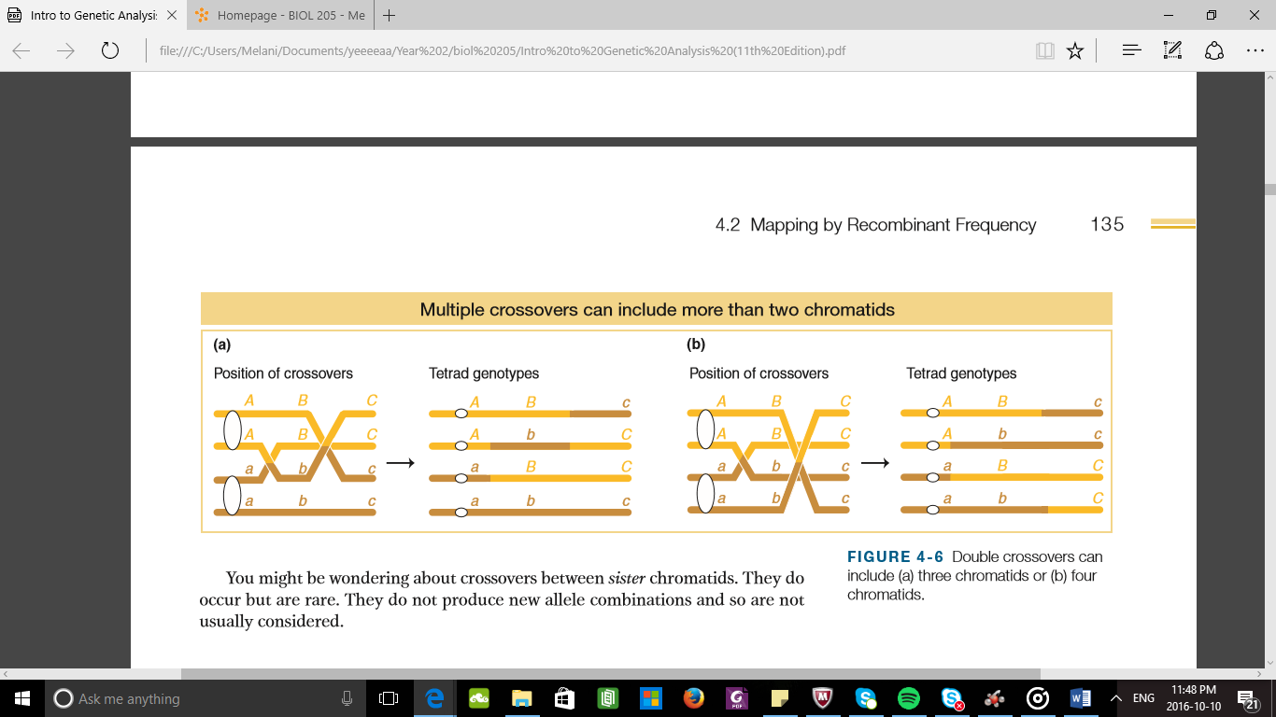

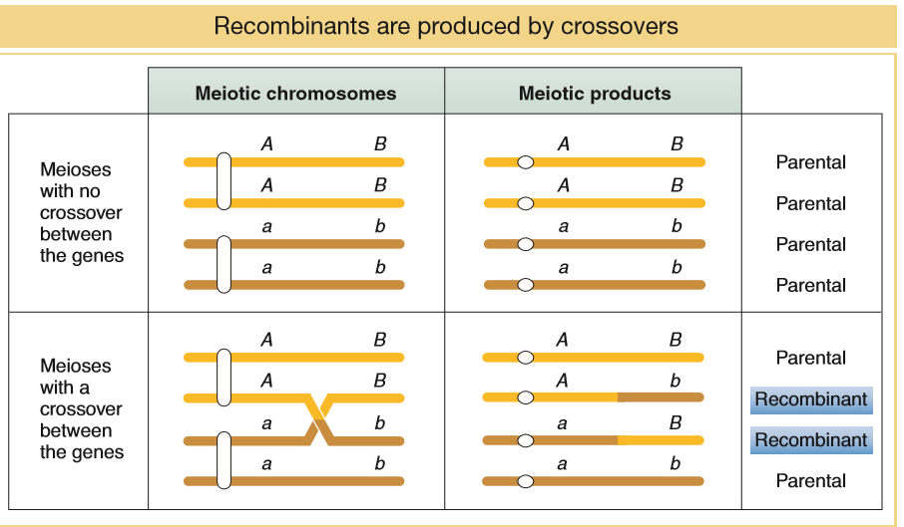
Note in Figure 4-7 that a single crossover generates two reciprocal recombinant products, which explains why the reciprocal recombinant classes are generally approximately equal in frequency. The corollary of this point is that the two parental nonrecombinant types also must be equal in frequency, as also observed by Morgan.

Chapter 1 Questions
4.Figure 1-7 shows a simplified pathway for arginine synthesis in Neurospora. Suppose you have a special strain of Neurospora that makes citrulline but not arginine. Which gene(s) are likely mutant or missing in your special strain? You have a second strain of Neurospora that makes neither citrulline nor arginine but does make ornithine. Which gene(s) are mutant or missing in this strain?
Answer: If the mutant strain makes citrulline, that means genes A and B must be functional. Therefore, the only gene that is missing or mutant in the first Neurospora strain must be gene C.
In the second strain, gene A must be functional since it is able to make ornithine. Gene B must be missing or mutant since it is unable to make citrulline. However, gene C may or may not be missing/ mutant. Enzyme C converts citrulline into arginine (they are in the same sequential pathway), and enzyme C is dependent on the availability of citrulline for its function.
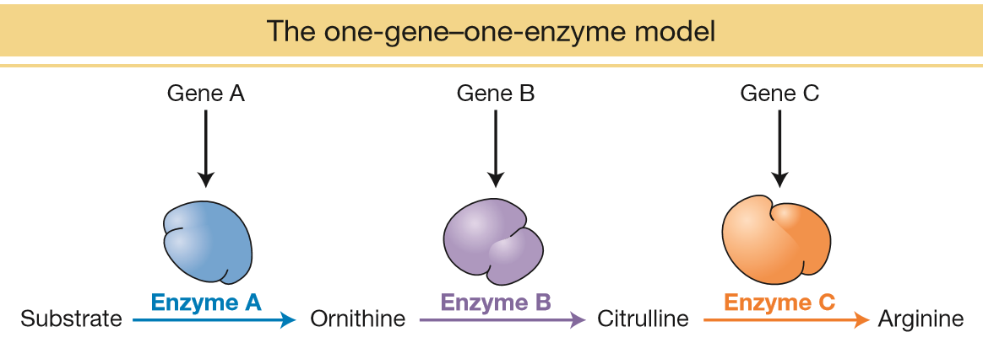

12.If a DNA double helix that is 100 base pairs in length has 32 adenines, how many cytosines, guanines, and thymines must it have?
Answer: Thymines = 32, Cytosines = 68, Guanines = 68
Number of thymines is 32 because thymine and adenine are paired, so the number of adenines equals the number of thymines. The remaining 136 base pairs must be cytosines and guanines. The number of cytosines equals the number of guanines because those bases are paired. Therefore, there are 136 ÷ 2 = 68 base pairs of each.
13. The complementary strands of DNA in the double helix are held together by hydrogen bonds: G≡C or A=T. These bonds can be broken (denatured) in aqueous solutions by heating to yield two single strands of DNA (see Figure 1-13a). How would you expect the relative amounts of GC versus AT base pairs in a DNA double helix to affect the amount of heat required to denature it? How would you expect the length of a DNA double helix in base pairs to affect the amount of heat required to denature it?
Answer: Double-stranded DNA with a high GC content would be more stable because GC pairs have three hydrogen bonds and hence would require more heat to denature compared with a doublestranded DNA with high AT content.
As the length of the double helix increases, the heat required to denature would also increase. This is because there would be more hydrogen bonds to break.

14. The figure that follows shows the DNA sequence of a portion of one of the chromosomes from a trio (mother, father, and child). Can you spot any new point mutations in the child that are not in either parent? In which parent did the mutation arise?
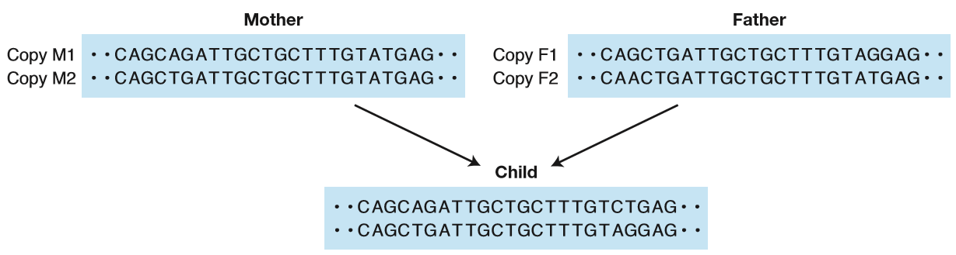
Answer: There is a new point mutation from an A to a C. The child inherited copy F1 from the father without any de novo mutations, as shown on the bottom. The other copy (as shown on the top) must therefore be from the mother. The mother has an SNP (A/T) at the fifth nucleotide shown, so we know the child inherited copy M1 (A). The A-to-C mutation in copy M1 is not observed in either of the parents, so it must be a new mutation.
15. a. There are three nucleotides in each codon, and each of these nucleotides can have one of four different bases. How many possible unique codons are there?
b. If DNA had only two types of bases instead of four, how long would codons need to be to specify all 20 amino acids?
Answer: a. There are 64 unique codons (4 * 4 * 4 = 64).
b. In order to specify 20 amino acids using only two bases, a codon must be five bases long (2 * 2 * 2 * 2 * 2 = 32). This would give 32 unique codons that could specify 20 amino acids.

16. Fathers contribute more new point mutations to their children than mothers. You may know from general biology that people have sex chromosomes—two X chromosomes in females and an X plus a Y chromosome in males. Both sexes have the autosomes (As).
a. On which type of chromosome (A, X, or Y) would you expect the genes to have the greatest number of new mutations per base pair over many generations in a population? Why?
b. On which type of chromosome would you expect the least number of new mutations per base pair? Why?
c. Can you calculate the expected number of new mutations per base pair for a gene on the X and Y chromosome for every 1 new mutation in a gene on an autosome if the mutation rate in males is twice that in females?
Answer:
a. Y chromosome. All, or 100 percent of, Y chromosomes are passed through the male lineage via sperm. The production of sperm (spermatogenesis) continues throughout a man’s life, undergoing many rounds of cell division. Each round of cell division include DNA replication, which provides opportunity for new mutations, so the male lineage has a higher mutation rate than the female lineage, as explained in the text.

b. X chromosome. Two out of every three X chromosomes (66.7 percent) are transmitted through the female lineage, which has a lower mutation rate than the male lineage. By comparison, 50 percent of autosomes are inherited through females with the lower mutation rate and 50 percent through males with the higher mutation rate.

c. Set the male mutation rate (mM) as 2.0 per unit time and the female mutation rate (mF) as 1.0 per unit time. Since autosomes are transmitted equally through males and females, then the autosomal rate is the average of the male and female rates:
(mA) = (2 + 1)/2 = 1.5

For young men of age 20, there have been 150 rounds of DNA replication during sperm production as compared with only 23 rounds for a woman of age 20. That is a 6.5-fold greater number of cell divisions and proportionately greater opportunity for new point mutations. Yet, on average, 20-yearold men contribute only about twice as many new point mutations to their offspring as do women. How can you explain this discrepancy?
While experimental evidence to explain this observation are not available, one hypothesis is that sperm cells are physiologically weak and their normal function is easily disrupted by mutations. Thus, sperm that carry deleterious new mutations are less likely to survive and form a zygote with an egg cell. Therefore, many sperm with new mutations are eliminated prezygotically

MENDEL DOMINANTTT vs recessive
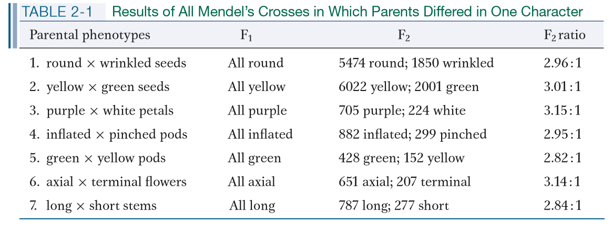

Chapter 2 Questions
10. In Figure 2-17, how does the 3:1 ratio in the bottom-left-hand grid differ from the 3:1 ratios obtained by Mendel?
This is sex – linked.
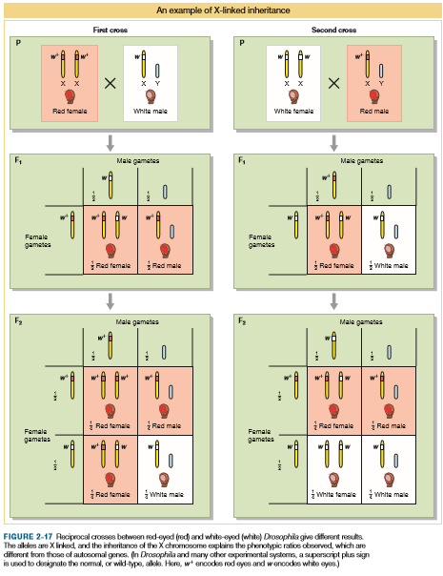

Chapter 6
Dominance is a manifestation of how the alleles of a single gene interact in a heterozygote.


